**Measure of Development Webquest**

Human Development Index (HDI)

The Human Development Index (HDI) is a summary measure of average achievement in key dimensions of human development: a long and healthy life, being knowledgeable and have a decent standard of living.

The indicators they use is: Life Expectancy at Birth, Expected Years of Schooling and Average Years of Schooling, and GNI (Gross National Income) per capita.

It ranges from 0 to 1 - countries with HDI closer to 1 are highly developed with the average citizen living a long and healthy life, everyone has access to higher education, and they have a high standard of living.

** The HIGHER the BETTER **

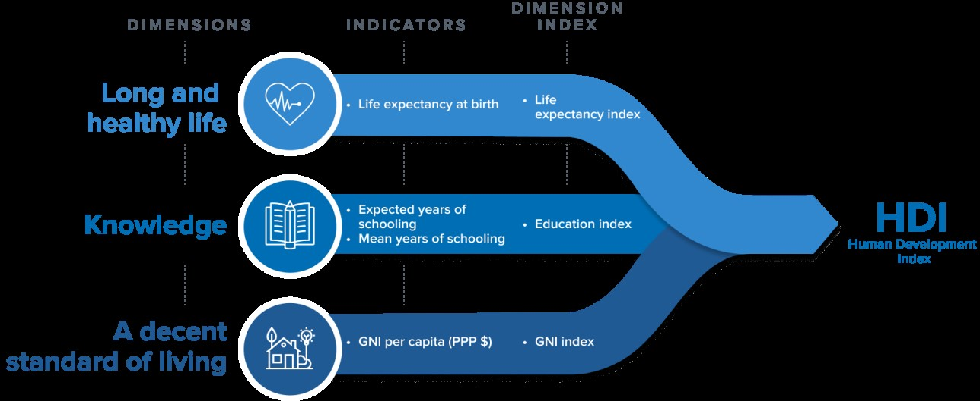

1. Look at picture of people with all their belongings (photos taken in 1994): <https://www.menzelphoto.com/portfolio/G0000GPaxwfSZQ0Q/I0000ENZnLbiIiHU>
2. Sort the first 5 countries pictured from highest (1) to lowest (5) HDI index.
   1. Bhutan - 5
   2. Cuba - 4
   3. Iceland - 2
   4. Japan - 1
   5. Kuwait - 3
3. **Compare**.Now check the HDI index to check your answers. <https://hdr.undp.org/data-center/human-development-index#/indicies/HDI> Click “add a country” on the menu to the left to select and view only the countries you need.
4. **Reflect.** How close were you to the right answers?

**All were correct.**

* 1. What clues in the photos leads people to know whether the country has a high or low HDI?

The photos can lead people to know whether the country has a low or high HDI by the type of housing or clothing. Photographs with cleaner clothes or houses typically mean that the people who live there have a higher income and are cleaner and healthier.

1. **Predict.** Sort the next 5 countries pictured from highest to lowest on the HDI index.
   1. Mali - 5
   2. Mexico - 1
   3. Mongolia - 4
   4. South Africa - 3
   5. Thailand -2
2. **Compare.** Now check the HDI index to verify your answers. <https://hdr.undp.org/data-center/human-development-index#/indicies/HDI>
3. **Reflect.** How did you do the second time?

**I got Thailand and South Africa switched.**

* 1. Why/how do you think these particular countries changed so much in HDI since 1994 (when the photos were taken)?

I think that these countries had a huge change in HDI due to the 4th Industrial Revolution, where they were able to take advantage of different technologies.

1. On the HDI website, look for the tab that says “Data Center.” Hover over it, a dropdown menu pops up. Click on “Country Insights.” Click Afghanistan.
2. **Reflect.** Review the HDI data on Afghanistan. What observations can you make?

I can notice that the HDI has been consistently increasing until 2020, where it started dropping from there.

* 1. Identify the *pattern* and give the *perspective.*

Pattern Gradual improvement followed by a sudden decline after 2020.

Perspective – During 2020, there was a COVID pandemic which completely shut down everything economically. Afghanistan might have less recovery infrastructure making it difficult to come back. Additionally, Taliban’s return to power came in 2021 also affecting the economy.

**Gender Inequality Index (GII)**

GII reflects gender-based disadvantage in three dimensions— reproductive health, empowerment and the labor market.

It ranges from 0, where women and men fare equally, to 1, where one gender fares as poorly as possible in all measured dimensions.

** The LOWER the BETTER **

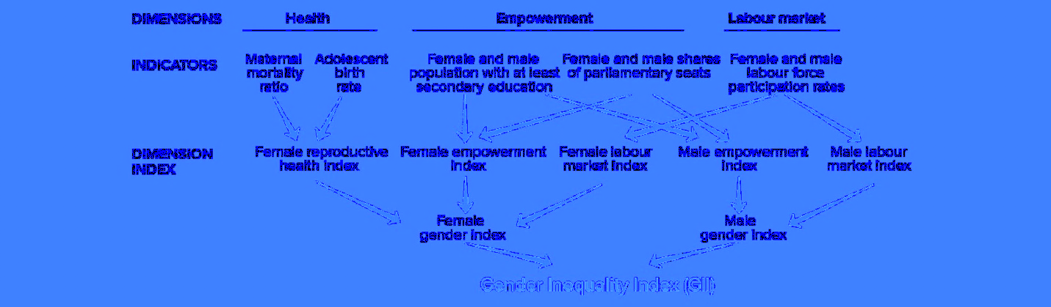

Click on this website and review the country data on the graph.

<https://hdr.undp.org/data-center/thematic-composite-indices/gender-inequality-index#/indicies/GII>

Answer the questions below based on this data.

1. Match the typical Maternal Mortality Ratio with the average GII score.

|  |  |  |  |
| --- | --- | --- | --- |
|  | Est. 60-200 per 100,000 | Est. 200-1000+ per 100,000 | Est. 10-20 per 100,000 |
| .72-.90 (Red) |  | Correct |  |
| .45-.63 (Green) | Correct |  |  |
| .09-.36 (Blue) |  |  | Correct |

1. Scan the number the percentage of females in “Share of Seats in Parliament.”
   1. Write **3 countries** that have the **highest** that you saw, the **percentage**, and the **GII score**. (don’t have to get the actual top 3, just the highest numbers you saw in your quick scan.

Norway – GII 0.101 – 37.8%

Sweden – 0.08 – 42.7%

Denmark – 37.4% - 0.07

* 1. Write **3 countries** that have the **lowest** that you saw, the **percentage**, and the **GII score**. (don’t have to get the actual lowest 3, just the lowest numbers you saw in your quick scan.

Niger – 1.2% 0.8

Yemen – 0.7% 0.8

Pakistan – 2% 0.775