

**MS806 – Business Application Programming**

**Student Name: Varun Dua**

**NUI Galway ID Number: 19230587**

**Assignment:** 1

**Date of Submission:** 26/09/2019

**Assignment 1: Welcome App**

**Screen shots of Application at Runtime:**

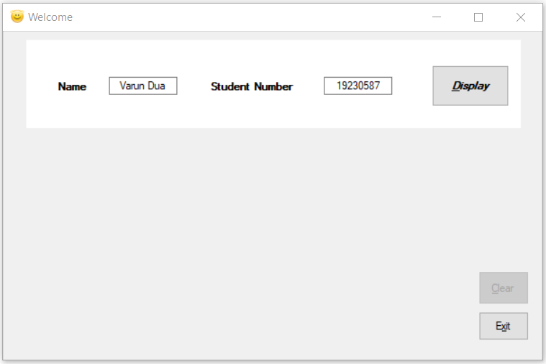

**Fig 1: Project after load, User has input Name and Student Number**

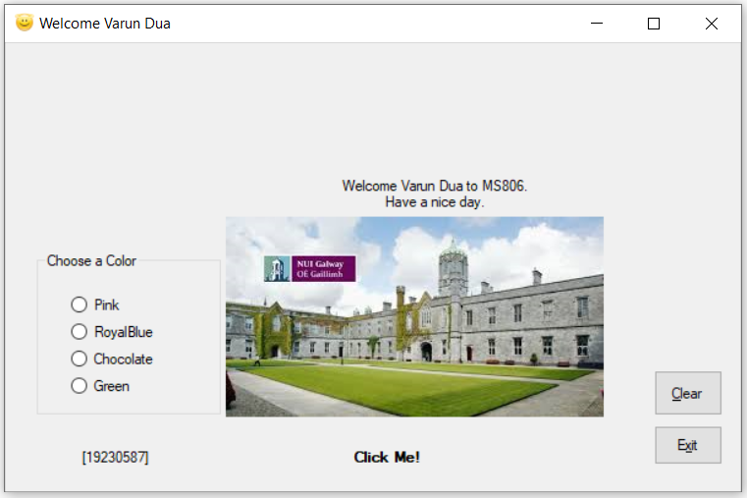

**Fig 2: After Display button is clicked**

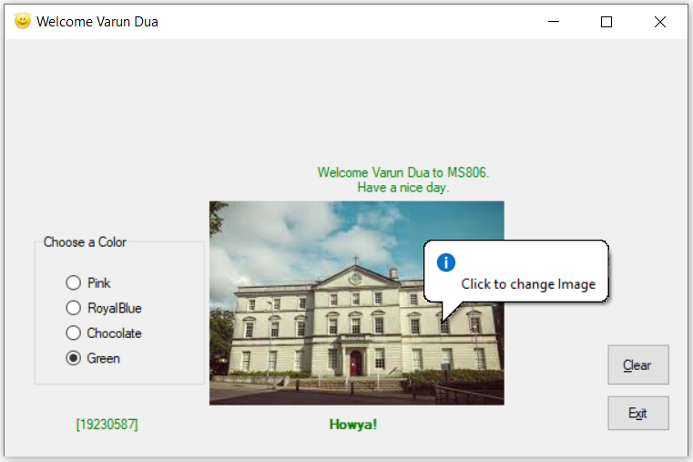

**Fig 3: User clicked on image, and has selected the Green radio button**

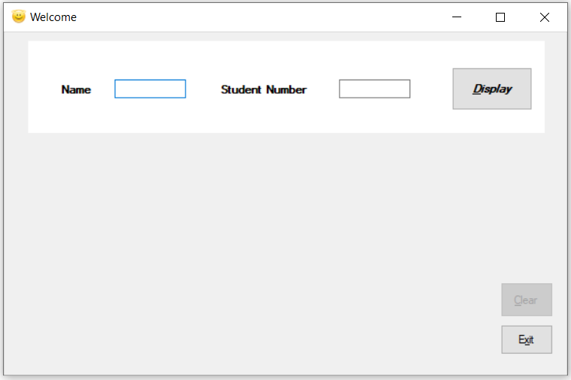

**Fig 4: User clicked on Clear button**

**Source Code:**

/* Student Name: Varun Dua

* Student ID: 19230587

* Date: 23/09/2019

* Assignment: 1

* Assignment: Write a program that allows a user to input their name

* and student number, when the display button is clicked a message

* of your own choosing is displayed which includes the users name in a label.

*/

using System;

using System.Collections.Generic;

using System.ComponentModel;

using System.Data;

using System.Drawing;

using System.Linq;

using System.Text;

using System.Threading.Tasks;

using System.Windows.Forms;

namespace Assignment1

{

public partial class WelcomePage : System.Windows.Forms.Form

{

int count = 0; //Counter for the number of clicks on the image.

public WelcomePage()

{

InitializeComponent();

NameBox.Select(); //Set focus on the Name text box

}

/*Event handler to display Welcome Home page once the application is loaded. Access keys

* are used for Display, Clear and Exit buttons. Clear button is disabled and Image and certain other

* elements are made not visible.*/

private void WelcomeScreen_Load(object sender, EventArgs e)

{

DisplayButton.Text = "&Display";

ClearButton.Text = "&Clear";

ExitButton.Text = "E&xit";

ClearButton.Enabled = false;

ImageBox.Visible = false;

MessageLabel.Visible = false;

IdLabel.Visible = false;

ColorBox.Visible = false;

PicLabel.Visible = false;

}

/*Welcome Panel background color is set to White. Panel contains Labels for Name, Student number

* and text boxes for the same, along with Display button.*/

private void Panel1_Paint(object sender, PaintEventArgs e)

{

WelcomePanel.BackColor = Color.White;

}

/*Event handler for Exit button*/

private void ExitButton_Click(object sender, EventArgs e)

{

this.Close();

}

/*Event handler to change the image and label in the Picture box on a click. It uses the counter (count)

* initilaized above to keep track of the number of clicks on the image,

* and thus change the image and label accordingly.*/

private void ImageBox_Click(object sender, EventArgs e)

{

Image def = Image.FromFile(@"D:\Business Application Programming\Class programs\Assignment1\Assignment1\Resources\Im1.jpg");

Image chg = Image.FromFile(@"D:\Business Application Programming\Class programs\Assignment1\Assignment1\Resources\Im2.jpg");

String LabelDef = "Click Me!";

String LabelChg = "Howya!";

if (count == 0)

{

ImageBox.Image = chg;

PicLabel.Text = LabelChg;

count++;

}

else if(count%2!=0)

{

ImageBox.Image = def;

PicLabel.Text = LabelDef;

count++;

}

else

{

ImageBox.Image = chg;

PicLabel.Text = LabelChg;

count++;

}

}

/*Event handler to Display Image, Message labels and Radio buttons on click of Display button*/

private void DisplayButton_Click(object sender, EventArgs e)

{

WelcomePanel.Visible = false;

ImageBox.Visible = true;

MessageLabel.Visible = true;

IdLabel.Visible = true;

ColorBox.Visible = true;

PicLabel.Visible = true;

ClearButton.Enabled = true;

String StdName = NameBox.Text.ToString();

String StdNum = StudentIdBox.Text.ToString();

MessageLabel.Text = "Welcome " + StdName + " to MS806.\nHave a nice day.";

IdLabel.Text = "[" + StdNum + "]";

WelcomePage.ActiveForm.Text = "Welcome " + StdName;

}

/*Pink button Event handler*/

private void PinkButton_CheckedChanged(object sender, EventArgs e)

{

MessageLabel.ForeColor = Color.Pink;

IdLabel.ForeColor = Color.Pink;

PicLabel.ForeColor = Color.Pink;

}

/*Royal Blue button Event handler*/

private void RoyalBlueButton_CheckedChanged(object sender, EventArgs e)

{

MessageLabel.ForeColor = Color.RoyalBlue;

IdLabel.ForeColor = Color.RoyalBlue;

PicLabel.ForeColor = Color.RoyalBlue;

}

/*Chocolate button Event handler*/

private void ChocolateButton_CheckedChanged(object sender, EventArgs e)

{

MessageLabel.ForeColor = Color.Chocolate;

IdLabel.ForeColor = Color.Chocolate;

PicLabel.ForeColor = Color.Chocolate;

}

/*Green button Event handler*/

private void GreenButton_CheckedChanged(object sender, EventArgs e)

{

MessageLabel.ForeColor = Color.Green;

IdLabel.ForeColor = Color.Green;

PicLabel.ForeColor = Color.Green;

}

/*Event handler to Clear Image, Message labels and Radio buttons, and display the welcome page

* on click of Clear button*/

private void ClearButton_Click(object sender, EventArgs e)

{

ChocolateButton.Checked = false;

PinkButton.Checked = false;

RoyalBlueButton.Checked = false;

GreenButton.Checked = false;

ClearButton.Enabled = false;

ImageBox.Visible = false;

MessageLabel.Visible = false;

IdLabel.Visible = false;

ColorBox.Visible = false;

PicLabel.Visible = false;

WelcomePanel.Visible = true;

MessageLabel.ForeColor = Color.Black;

IdLabel.ForeColor = Color.Black;

PicLabel.ForeColor = Color.Black;

NameBox.Text = null;

StudentIdBox.Text = null;

WelcomePage.ActiveForm.Text = "Welcome";

ImageBox.Image = Image.FromFile(@"D:\Business Application Programming\Class programs\Assignment1\Assignment1\Resources\Im1.jpg");

PicLabel.Text = "Click Me!"; //Change the image back to original image

count = 0;

NameBox.Select(); //Set focus on the Name text box

}

}

}