GET DATA
/TYPE=XLSX
/FILE='D:\Business Analytics Project\MSc. Business Analytics - Capstone Project - Main Data - T1.xlsx'
/SHEET=name 'Sheet3'
/CELLRANGE=FULL
/READNAMES=ON
/DATATYPEMIN PERCENTAGE=95.0
/HIDDEN IGNORE=YES.
EXECUTE.
DATASET NAME DataSet1 WINDOW=FRONT.
FREQUENCIES VARIABLES=Renewal Recall AutoRenewal Requests
/STATISTICS=STDDEV VARIANCE RANGE MINIMUM MAXIMUM MEAN MEDIAN MODE
/HISTOGRAM NORMAL
/ORDER=ANALYSIS.

Frequencies

Notes
Output Created |  | 23-FEB-2020 19:38:46
Comments
Input | Active Dataset | DataSet1
Input | Filter | <none>
Input | Weight | <none>
Input | Split File | <none>
Input | N of Rows in Working Data File | 1202
Missing Value Handling | Definition of Missing | User-defined missing values are treated as missing.
Missing Value Handling | Cases Used | Statistics are based on all cases with valid data.
Syntax |  | FREQUENCIES VARIABLES=Renewal Recall AutoRenewal Requests  /STATISTICS=STDDEV VARIANCE RANGE MINIMUM MAXIMUM MEAN MEDIAN MODE  /HISTOGRAM NORMAL  /ORDER=ANALYSIS.
Resources | Processor Time | 00:00:01.86
Resources | Elapsed Time | 00:00:01.25

[DataSet1]

Statistics
 |  | Renewal | Recall | Auto-Renewal | Requests
N | Valid | 1202 | 1202 | 1202 | 1202
N | Missing | 0 | 0 | 0 | 0
Mean |  | .12 | .04 | .000000000000000 | .19
Median |  | .00 | .00 | -.472068471070745 | .00
Mode |  | 0 | 0 | -.596695376897021 | 0
Std. Deviation |  | .772 | .405 | 1.000000000000000 | .819
Variance |  | .597 | .164 | 1.000 | .670
Range |  | 22 | 9 | 11.216421524364860 | 9
Minimum |  | 0 | 0 | -.596695376897021 | 0
Maximum |  | 22 | 9 | 10.619726147467839 | 9

Frequency Table

Renewal
 |  | Frequency | Percent | Valid Percent | Cumulative Percent
Valid | 0 | 1117 | 92.9 | 92.9 | 92.9
Valid | 1 | 63 | 5.2 | 5.2 | 98.2
Valid | 2 | 13 | 1.1 | 1.1 | 99.3
Valid | 3 | 6 | .5 | .5 | 99.8
Valid | 4 | 1 | .1 | .1 | 99.8
Valid | 8 | 1 | .1 | .1 | 99.9
Valid | 22 | 1 | .1 | .1 | 100.0
Valid | Total | 1202 | 100.0 | 100.0

Recall
 |  | Frequency | Percent | Valid Percent | Cumulative Percent
Valid | 0 | 1177 | 97.9 | 97.9 | 97.9
Valid | 1 | 15 | 1.2 | 1.2 | 99.2
Valid | 2 | 5 | .4 | .4 | 99.6
Valid | 3 | 2 | .2 | .2 | 99.8
Valid | 4 | 1 | .1 | .1 | 99.8
Valid | 7 | 1 | .1 | .1 | 99.9
Valid | 9 | 1 | .1 | .1 | 100.0
Valid | Total | 1202 | 100.0 | 100.0

Auto-Renewal
 |  | Frequency | Percent | Valid Percent | Cumulative Percent
Valid | -.596695376897021 | 480 | 39.9 | 39.9 | 39.9
Valid | -.472068471070745 | 133 | 11.1 | 11.1 | 51.0
Valid | -.347441565244469 | 86 | 7.2 | 7.2 | 58.2
Valid | -.222814659418193 | 72 | 6.0 | 6.0 | 64.1
Valid | -.098187753591916 | 50 | 4.2 | 4.2 | 68.3
Valid | .026439152234360 | 58 | 4.8 | 4.8 | 73.1
Valid | .151066058060636 | 41 | 3.4 | 3.4 | 76.5
Valid | .275692963886912 | 28 | 2.3 | 2.3 | 78.9
Valid | .400319869713189 | 21 | 1.7 | 1.7 | 80.6
Valid | .524946775539465 | 23 | 1.9 | 1.9 | 82.5
Valid | .649573681365741 | 28 | 2.3 | 2.3 | 84.9
Valid | .774200587192017 | 19 | 1.6 | 1.6 | 86.4
Valid | .898827493018293 | 18 | 1.5 | 1.5 | 87.9
Valid | 1.023454398844570 | 11 | .9 | .9 | 88.9
Valid | 1.148081304670846 | 10 | .8 | .8 | 89.7
Valid | 1.272708210497122 | 12 | 1.0 | 1.0 | 90.7
Valid | 1.397335116323398 | 8 | .7 | .7 | 91.3
Valid | 1.521962022149674 | 21 | 1.7 | 1.7 | 93.1
Valid | 1.646588927975951 | 12 | 1.0 | 1.0 | 94.1
Valid | 1.771215833802227 | 6 | .5 | .5 | 94.6
Valid | 1.895842739628503 | 5 | .4 | .4 | 95.0
Valid | 2.020469645454779 | 3 | .2 | .2 | 95.3
Valid | 2.145096551281056 | 8 | .7 | .7 | 95.9
Valid | 2.269723457107332 | 8 | .7 | .7 | 96.6
Valid | 2.394350362933608 | 6 | .5 | .5 | 97.1
Valid | 2.518977268759884 | 2 | .2 | .2 | 97.3
Valid | 2.643604174586161 | 2 | .2 | .2 | 97.4
Valid | 2.768231080412437 | 4 | .3 | .3 | 97.8
Valid | 2.892857986238713 | 2 | .2 | .2 | 97.9
Valid | 3.017484892064989 | 2 | .2 | .2 | 98.1
Valid | 3.142111797891266 | 5 | .4 | .4 | 98.5
Valid | 3.266738703717542 | 2 | .2 | .2 | 98.7
Valid | 3.765246327022647 | 1 | .1 | .1 | 98.8
Valid | 4.014500138675200 | 3 | .2 | .2 | 99.0
Valid | 4.139127044501476 | 1 | .1 | .1 | 99.1
Valid | 4.263753950327752 | 1 | .1 | .1 | 99.2
Valid | 4.388380856154029 | 1 | .1 | .1 | 99.3
Valid | 4.637634667806581 | 1 | .1 | .1 | 99.3
Valid | 4.762261573632856 | 1 | .1 | .1 | 99.4
Valid | 4.886888479459133 | 1 | .1 | .1 | 99.5
Valid | 5.385396102764238 | 1 | .1 | .1 | 99.6
Valid | 5.634649914416791 | 1 | .1 | .1 | 99.7
Valid | 5.883903726069343 | 1 | .1 | .1 | 99.8
Valid | 6.133157537721895 | 1 | .1 | .1 | 99.8
Valid | 6.257784443548172 | 1 | .1 | .1 | 99.9
Valid | 10.619726147467839 | 1 | .1 | .1 | 100.0
Valid | Total | 1202 | 100.0 | 100.0

Requests
 |  | Frequency | Percent | Valid Percent | Cumulative Percent
Valid | 0 | 1118 | 93.0 | 93.0 | 93.0
Valid | 1 | 25 | 2.1 | 2.1 | 95.1
Valid | 2 | 23 | 1.9 | 1.9 | 97.0
Valid | 3 | 14 | 1.2 | 1.2 | 98.2
Valid | 4 | 7 | .6 | .6 | 98.8
Valid | 5 | 11 | .9 | .9 | 99.7
Valid | 6 | 2 | .2 | .2 | 99.8
Valid | 8 | 1 | .1 | .1 | 99.9
Valid | 9 | 1 | .1 | .1 | 100.0
Valid | Total | 1202 | 100.0 | 100.0

Histogram

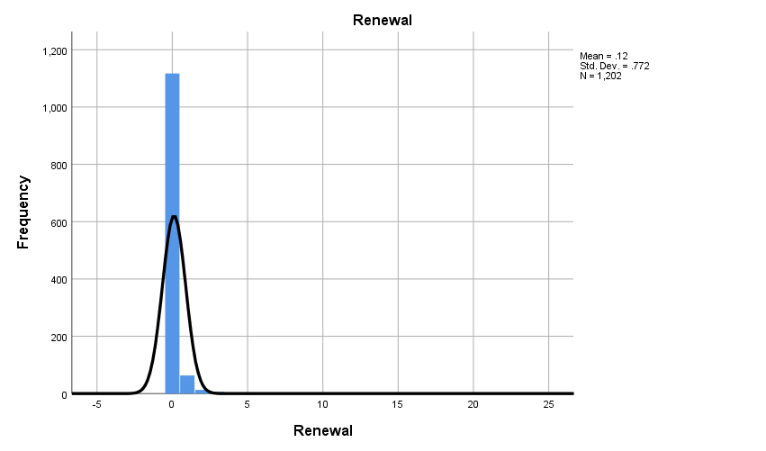

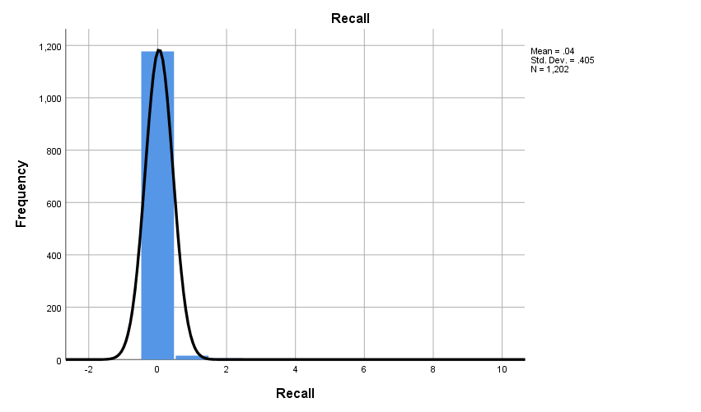

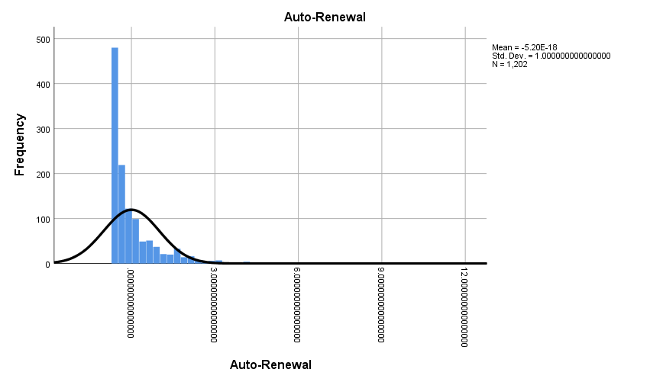

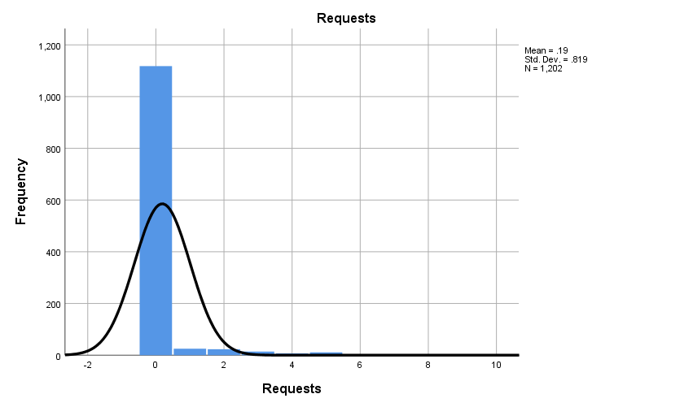

* Chart Builder.
GGRAPH
/GRAPHDATASET NAME="graphdataset" VARIABLES=Requests Recall MISSING=LISTWISE REPORTMISSING=NO
/GRAPHSPEC SOURCE=INLINE
/FITLINE TOTAL=NO.
BEGIN GPL
SOURCE: s=userSource(id("graphdataset"))
DATA: Requests=col(source(s), name("Requests"), unit.category())
DATA: Recall=col(source(s), name("Recall"), unit.category())
GUIDE: axis(dim(1), label("Requests"))
GUIDE: axis(dim(2), label("Recall"))
GUIDE: text.title(label("Simple Scatter of Recall by Requests"))
ELEMENT: point(position(Requests*Recall))
END GPL.

GGraph

Notes
Output Created |  | 23-FEB-2020 19:40:33
Comments
Input | Active Dataset | DataSet1
Input | Filter | <none>
Input | Weight | <none>
Input | Split File | <none>
Input | N of Rows in Working Data File | 1202
Syntax |  | GGRAPH  /GRAPHDATASET NAME="graphdataset" VARIABLES=Requests Recall MISSING=LISTWISE REPORTMISSING=NO  /GRAPHSPEC SOURCE=INLINE  /FITLINE TOTAL=NO.  BEGIN GPL  SOURCE: s=userSource(id("graphdataset"))  DATA: Requests=col(source(s), name("Requests"), unit.category())  DATA: Recall=col(source(s), name("Recall"), unit.category())  GUIDE: axis(dim(1), label("Requests"))  GUIDE: axis(dim(2), label("Recall"))  GUIDE: text.title(label("Simple Scatter of Recall by Requests"))  ELEMENT: point(position(Requests*Recall))  END GPL.
Resources | Processor Time | 00:00:01.05
Resources | Elapsed Time | 00:00:00.42

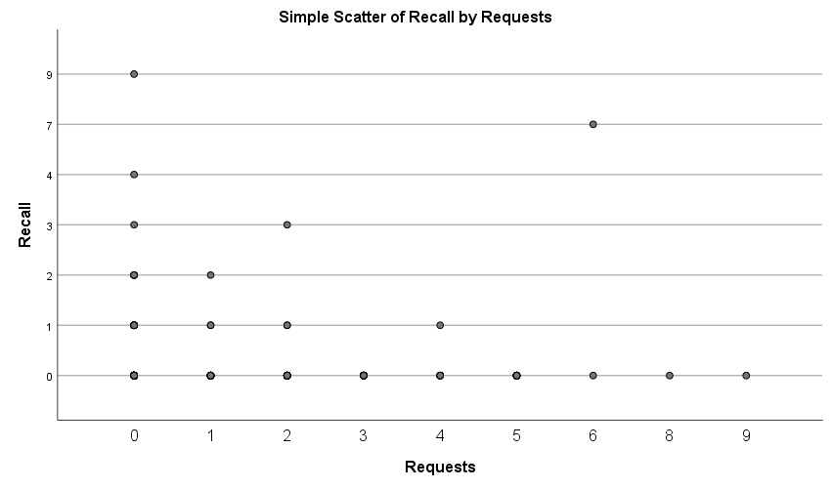

* Chart Builder.
GGRAPH
/GRAPHDATASET NAME="graphdataset" VARIABLES=Requests AutoRenewal MISSING=LISTWISE REPORTMISSING=NO
/GRAPHSPEC SOURCE=INLINE
/FITLINE TOTAL=NO.
BEGIN GPL
SOURCE: s=userSource(id("graphdataset"))
DATA: Requests=col(source(s), name("Requests"), unit.category())
DATA: AutoRenewal=col(source(s), name("AutoRenewal"))
GUIDE: axis(dim(1), label("Requests"))
GUIDE: axis(dim(2), label("Auto-Renewal"))
GUIDE: text.title(label("Simple Scatter of Auto-Renewal by Requests"))
SCALE: linear(dim(2), include(0))
ELEMENT: point(position(Requests*AutoRenewal))
END GPL.

GGraph

Notes
Output Created |  | 23-FEB-2020 19:40:55
Comments
Input | Active Dataset | DataSet1
Input | Filter | <none>
Input | Weight | <none>
Input | Split File | <none>
Input | N of Rows in Working Data File | 1202
Syntax |  | GGRAPH  /GRAPHDATASET NAME="graphdataset" VARIABLES=Requests AutoRenewal MISSING=LISTWISE REPORTMISSING=NO  /GRAPHSPEC SOURCE=INLINE  /FITLINE TOTAL=NO.  BEGIN GPL  SOURCE: s=userSource(id("graphdataset"))  DATA: Requests=col(source(s), name("Requests"), unit.category())  DATA: AutoRenewal=col(source(s), name("AutoRenewal"))  GUIDE: axis(dim(1), label("Requests"))  GUIDE: axis(dim(2), label("Auto-Renewal"))  GUIDE: text.title(label("Simple Scatter of Auto-Renewal by Requests"))  SCALE: linear(dim(2), include(0))  ELEMENT: point(position(Requests*AutoRenewal))  END GPL.
Resources | Processor Time | 00:00:00.47
Resources | Elapsed Time | 00:00:00.39

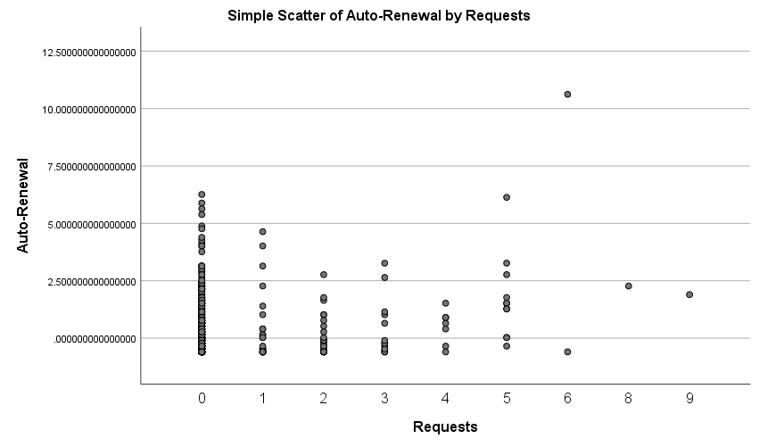

* Chart Builder.
GGRAPH
/GRAPHDATASET NAME="graphdataset" VARIABLES=Requests Renewal MISSING=LISTWISE REPORTMISSING=NO
/GRAPHSPEC SOURCE=INLINE
/FITLINE TOTAL=NO.
BEGIN GPL
SOURCE: s=userSource(id("graphdataset"))
DATA: Requests=col(source(s), name("Requests"), unit.category())
DATA: Renewal=col(source(s), name("Renewal"), unit.category())
GUIDE: axis(dim(1), label("Requests"))
GUIDE: axis(dim(2), label("Renewal"))
GUIDE: text.title(label("Simple Scatter of Renewal by Requests"))
ELEMENT: point(position(Requests*Renewal))
END GPL.

GGraph

Notes
Output Created |  | 23-FEB-2020 19:41:15
Comments
Input | Active Dataset | DataSet1
Input | Filter | <none>
Input | Weight | <none>
Input | Split File | <none>
Input | N of Rows in Working Data File | 1202
Syntax |  | GGRAPH  /GRAPHDATASET NAME="graphdataset" VARIABLES=Requests Renewal MISSING=LISTWISE REPORTMISSING=NO  /GRAPHSPEC SOURCE=INLINE  /FITLINE TOTAL=NO.  BEGIN GPL  SOURCE: s=userSource(id("graphdataset"))  DATA: Requests=col(source(s), name("Requests"), unit.category())  DATA: Renewal=col(source(s), name("Renewal"), unit.category())  GUIDE: axis(dim(1), label("Requests"))  GUIDE: axis(dim(2), label("Renewal"))  GUIDE: text.title(label("Simple Scatter of Renewal by Requests"))  ELEMENT: point(position(Requests*Renewal))  END GPL.
Resources | Processor Time | 00:00:00.34
Resources | Elapsed Time | 00:00:00.35

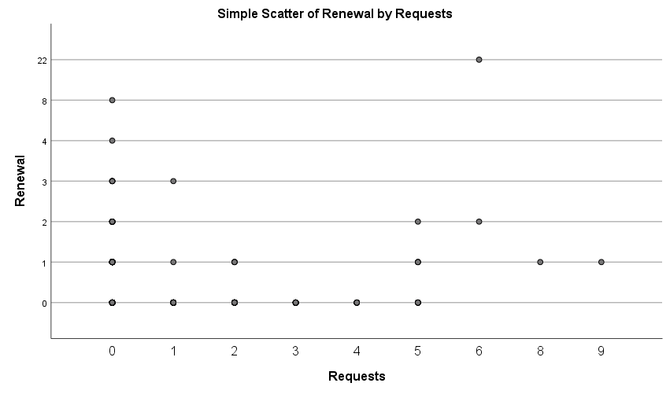

* Chart Builder.
GGRAPH
/GRAPHDATASET NAME="graphdataset" VARIABLES=Recall Renewal MISSING=LISTWISE REPORTMISSING=NO
/GRAPHSPEC SOURCE=INLINE
/FITLINE TOTAL=NO.
BEGIN GPL
SOURCE: s=userSource(id("graphdataset"))
DATA: Recall=col(source(s), name("Recall"), unit.category())
DATA: Renewal=col(source(s), name("Renewal"), unit.category())
GUIDE: axis(dim(1), label("Recall"))
GUIDE: axis(dim(2), label("Renewal"))
GUIDE: text.title(label("Simple Scatter of Renewal by Recall"))
ELEMENT: point(position(Recall*Renewal))
END GPL.

GGraph

Notes
Output Created |  | 23-FEB-2020 19:41:40
Comments
Input | Active Dataset | DataSet1
Input | Filter | <none>
Input | Weight | <none>
Input | Split File | <none>
Input | N of Rows in Working Data File | 1202
Syntax |  | GGRAPH  /GRAPHDATASET NAME="graphdataset" VARIABLES=Recall Renewal MISSING=LISTWISE REPORTMISSING=NO  /GRAPHSPEC SOURCE=INLINE  /FITLINE TOTAL=NO.  BEGIN GPL  SOURCE: s=userSource(id("graphdataset"))  DATA: Recall=col(source(s), name("Recall"), unit.category())  DATA: Renewal=col(source(s), name("Renewal"), unit.category())  GUIDE: axis(dim(1), label("Recall"))  GUIDE: axis(dim(2), label("Renewal"))  GUIDE: text.title(label("Simple Scatter of Renewal by Recall"))  ELEMENT: point(position(Recall*Renewal))  END GPL.
Resources | Processor Time | 00:00:00.45
Resources | Elapsed Time | 00:00:00.39

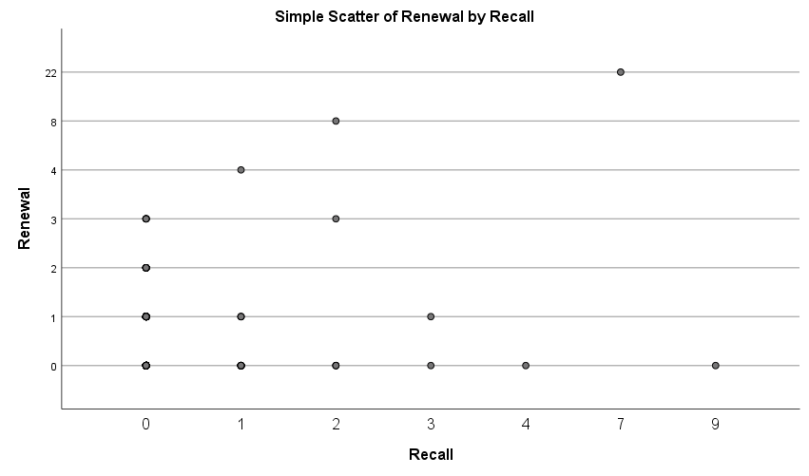

* Chart Builder.
GGRAPH
/GRAPHDATASET NAME="graphdataset" VARIABLES=AutoRenewal Renewal MISSING=LISTWISE REPORTMISSING=NO
/GRAPHSPEC SOURCE=INLINE
/FITLINE TOTAL=NO.
BEGIN GPL
SOURCE: s=userSource(id("graphdataset"))
DATA: AutoRenewal=col(source(s), name("AutoRenewal"))
DATA: Renewal=col(source(s), name("Renewal"), unit.category())
GUIDE: axis(dim(1), label("Auto-Renewal"))
GUIDE: axis(dim(2), label("Renewal"))
GUIDE: text.title(label("Simple Scatter of Renewal by Auto-Renewal"))
ELEMENT: point(position(AutoRenewal*Renewal))
END GPL.

GGraph

Notes
Output Created |  | 23-FEB-2020 19:42:01
Comments
Input | Active Dataset | DataSet1
Input | Filter | <none>
Input | Weight | <none>
Input | Split File | <none>
Input | N of Rows in Working Data File | 1202
Syntax |  | GGRAPH  /GRAPHDATASET NAME="graphdataset" VARIABLES=AutoRenewal Renewal MISSING=LISTWISE REPORTMISSING=NO  /GRAPHSPEC SOURCE=INLINE  /FITLINE TOTAL=NO.  BEGIN GPL  SOURCE: s=userSource(id("graphdataset"))  DATA: AutoRenewal=col(source(s), name("AutoRenewal"))  DATA: Renewal=col(source(s), name("Renewal"), unit.category())  GUIDE: axis(dim(1), label("Auto-Renewal"))  GUIDE: axis(dim(2), label("Renewal"))  GUIDE: text.title(label("Simple Scatter of Renewal by Auto-Renewal"))  ELEMENT: point(position(AutoRenewal*Renewal))  END GPL.
Resources | Processor Time | 00:00:00.44
Resources | Elapsed Time | 00:00:00.33

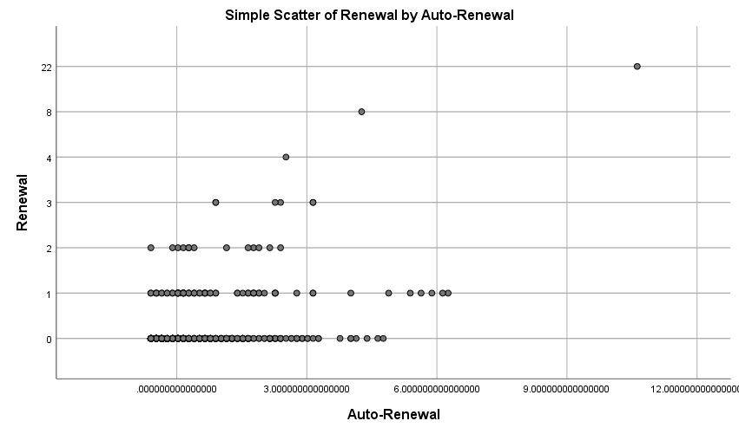

CORRELATIONS
/VARIABLES=Requests Recall
/PRINT=TWOTAIL NOSIG
/MISSING=PAIRWISE.

Correlations

Notes
Output Created |  | 23-FEB-2020 19:43:14
Comments
Input | Active Dataset | DataSet1
Input | Filter | <none>
Input | Weight | <none>
Input | Split File | <none>
Input | N of Rows in Working Data File | 1202
Missing Value Handling | Definition of Missing | User-defined missing values are treated as missing.
Missing Value Handling | Cases Used | Statistics for each pair of variables are based on all the cases with valid data for that pair.
Syntax |  | CORRELATIONS  /VARIABLES=Requests Recall  /PRINT=TWOTAIL NOSIG  /MISSING=PAIRWISE.
Resources | Processor Time | 00:00:00.05
Resources | Elapsed Time | 00:00:00.04

Correlations
 |  | Requests | Recall
Requests | Pearson Correlation | 1 | .127**
Requests | Sig. (2-tailed) |  | .000
Requests | N | 1202 | 1202
Recall | Pearson Correlation | .127** | 1
Recall | Sig. (2-tailed) | .000
Recall | N | 1202 | 1202

**. Correlation is significant at the 0.01 level (2-tailed).

NONPAR CORR
/VARIABLES=Requests Recall
/PRINT=SPEARMAN TWOTAIL NOSIG
/MISSING=PAIRWISE.

Nonparametric Correlations

Notes
Output Created |  | 23-FEB-2020 19:43:14
Comments
Input | Active Dataset | DataSet1
Input | Filter | <none>
Input | Weight | <none>
Input | Split File | <none>
Input | N of Rows in Working Data File | 1202
Missing Value Handling | Definition of Missing | User-defined missing values are treated as missing.
Missing Value Handling | Cases Used | Statistics for each pair of variables are based on all the cases with valid data for that pair.
Syntax |  | NONPAR CORR  /VARIABLES=Requests Recall  /PRINT=SPEARMAN TWOTAIL NOSIG  /MISSING=PAIRWISE.
Resources | Processor Time | 00:00:00.02
Resources | Elapsed Time | 00:00:00.01
Resources | Number of Cases Allowed | 629145 casesª

a. Based on availability of workspace memory

Correlations
 |  |  | Requests | Recall
Spearman's rho | Requests | Correlation Coefficient | 1.000 | .141**
Spearman's rho | Requests | Sig. (2-tailed) | . | .000
Spearman's rho | Requests | N | 1202 | 1202
Spearman's rho | Recall | Correlation Coefficient | .141** | 1.000
Spearman's rho | Recall | Sig. (2-tailed) | .000 | .
Spearman's rho | Recall | N | 1202 | 1202

**. Correlation is significant at the 0.01 level (2-tailed).

CORRELATIONS
/VARIABLES=Requests Renewal
/PRINT=TWOTAIL NOSIG
/MISSING=PAIRWISE.

Correlations

Notes
Output Created |  | 23-FEB-2020 19:43:40
Comments
Input | Active Dataset | DataSet1
Input | Filter | <none>
Input | Weight | <none>
Input | Split File | <none>
Input | N of Rows in Working Data File | 1202
Missing Value Handling | Definition of Missing | User-defined missing values are treated as missing.
Missing Value Handling | Cases Used | Statistics for each pair of variables are based on all the cases with valid data for that pair.
Syntax |  | CORRELATIONS  /VARIABLES=Requests Renewal  /PRINT=TWOTAIL NOSIG  /MISSING=PAIRWISE.
Resources | Processor Time | 00:00:00.14
Resources | Elapsed Time | 00:00:00.04

Correlations
 |  | Requests | Renewal
Requests | Pearson Correlation | 1 | .223**
Requests | Sig. (2-tailed) |  | .000
Requests | N | 1202 | 1202
Renewal | Pearson Correlation | .223** | 1
Renewal | Sig. (2-tailed) | .000
Renewal | N | 1202 | 1202

**. Correlation is significant at the 0.01 level (2-tailed).

NONPAR CORR
/VARIABLES=Requests Renewal
/PRINT=SPEARMAN TWOTAIL NOSIG
/MISSING=PAIRWISE.

Nonparametric Correlations

Notes
Output Created |  | 23-FEB-2020 19:43:40
Comments
Input | Active Dataset | DataSet1
Input | Filter | <none>
Input | Weight | <none>
Input | Split File | <none>
Input | N of Rows in Working Data File | 1202
Missing Value Handling | Definition of Missing | User-defined missing values are treated as missing.
Missing Value Handling | Cases Used | Statistics for each pair of variables are based on all the cases with valid data for that pair.
Syntax |  | NONPAR CORR  /VARIABLES=Requests Renewal  /PRINT=SPEARMAN TWOTAIL NOSIG  /MISSING=PAIRWISE.
Resources | Processor Time | 00:00:00.02
Resources | Elapsed Time | 00:00:00.04
Resources | Number of Cases Allowed | 629145 casesª

a. Based on availability of workspace memory

Correlations
 |  |  | Requests | Renewal
Spearman's rho | Requests | Correlation Coefficient | 1.000 | .095**
Spearman's rho | Requests | Sig. (2-tailed) | . | .001
Spearman's rho | Requests | N | 1202 | 1202
Spearman's rho | Renewal | Correlation Coefficient | .095** | 1.000
Spearman's rho | Renewal | Sig. (2-tailed) | .001 | .
Spearman's rho | Renewal | N | 1202 | 1202

**. Correlation is significant at the 0.01 level (2-tailed).

CORRELATIONS
/VARIABLES=Requests AutoRenewal
/PRINT=TWOTAIL NOSIG
/MISSING=PAIRWISE.

Correlations

Notes
Output Created |  | 23-FEB-2020 19:44:36
Comments
Input | Active Dataset | DataSet1
Input | Filter | <none>
Input | Weight | <none>
Input | Split File | <none>
Input | N of Rows in Working Data File | 1202
Missing Value Handling | Definition of Missing | User-defined missing values are treated as missing.
Missing Value Handling | Cases Used | Statistics for each pair of variables are based on all the cases with valid data for that pair.
Syntax |  | CORRELATIONS  /VARIABLES=Requests AutoRenewal  /PRINT=TWOTAIL NOSIG  /MISSING=PAIRWISE.
Resources | Processor Time | 00:00:00.02
Resources | Elapsed Time | 00:00:00.02

Correlations
 |  | Requests | Auto-Renewal
Requests | Pearson Correlation | 1 | .243**
Requests | Sig. (2-tailed) |  | .000
Requests | N | 1202 | 1202
Auto-Renewal | Pearson Correlation | .243** | 1
Auto-Renewal | Sig. (2-tailed) | .000
Auto-Renewal | N | 1202 | 1202

**. Correlation is significant at the 0.01 level (2-tailed).

NONPAR CORR
/VARIABLES=Requests AutoRenewal
/PRINT=SPEARMAN TWOTAIL NOSIG
/MISSING=PAIRWISE.

Nonparametric Correlations

Notes
Output Created |  | 23-FEB-2020 19:44:36
Comments
Input | Active Dataset | DataSet1
Input | Filter | <none>
Input | Weight | <none>
Input | Split File | <none>
Input | N of Rows in Working Data File | 1202
Missing Value Handling | Definition of Missing | User-defined missing values are treated as missing.
Missing Value Handling | Cases Used | Statistics for each pair of variables are based on all the cases with valid data for that pair.
Syntax |  | NONPAR CORR  /VARIABLES=Requests AutoRenewal  /PRINT=SPEARMAN TWOTAIL NOSIG  /MISSING=PAIRWISE.
Resources | Processor Time | 00:00:00.02
Resources | Elapsed Time | 00:00:00.01
Resources | Number of Cases Allowed | 629145 casesª

a. Based on availability of workspace memory

Correlations
 |  |  | Requests | Auto-Renewal
Spearman's rho | Requests | Correlation Coefficient | 1.000 | .137**
Spearman's rho | Requests | Sig. (2-tailed) | . | .000
Spearman's rho | Requests | N | 1202 | 1202
Spearman's rho | Auto-Renewal | Correlation Coefficient | .137** | 1.000
Spearman's rho | Auto-Renewal | Sig. (2-tailed) | .000 | .
Spearman's rho | Auto-Renewal | N | 1202 | 1202

**. Correlation is significant at the 0.01 level (2-tailed).

CORRELATIONS
/VARIABLES=AutoRenewal Renewal
/PRINT=TWOTAIL NOSIG
/MISSING=PAIRWISE.

Correlations

Notes
Output Created |  | 23-FEB-2020 19:46:30
Comments
Input | Active Dataset | DataSet1
Input | Filter | <none>
Input | Weight | <none>
Input | Split File | <none>
Input | N of Rows in Working Data File | 1202
Missing Value Handling | Definition of Missing | User-defined missing values are treated as missing.
Missing Value Handling | Cases Used | Statistics for each pair of variables are based on all the cases with valid data for that pair.
Syntax |  | CORRELATIONS  /VARIABLES=AutoRenewal Renewal  /PRINT=TWOTAIL NOSIG  /MISSING=PAIRWISE.
Resources | Processor Time | 00:00:00.11
Resources | Elapsed Time | 00:00:00.07

Correlations
 |  | Auto-Renewal | Renewal
Auto-Renewal | Pearson Correlation | 1 | .450**
Auto-Renewal | Sig. (2-tailed) |  | .000
Auto-Renewal | N | 1202 | 1202
Renewal | Pearson Correlation | .450** | 1
Renewal | Sig. (2-tailed) | .000
Renewal | N | 1202 | 1202

**. Correlation is significant at the 0.01 level (2-tailed).

NONPAR CORR
/VARIABLES=AutoRenewal Renewal
/PRINT=SPEARMAN TWOTAIL NOSIG
/MISSING=PAIRWISE.

Nonparametric Correlations

Notes
Output Created |  | 23-FEB-2020 19:46:30
Comments
Input | Active Dataset | DataSet1
Input | Filter | <none>
Input | Weight | <none>
Input | Split File | <none>
Input | N of Rows in Working Data File | 1202
Missing Value Handling | Definition of Missing | User-defined missing values are treated as missing.
Missing Value Handling | Cases Used | Statistics for each pair of variables are based on all the cases with valid data for that pair.
Syntax |  | NONPAR CORR  /VARIABLES=AutoRenewal Renewal  /PRINT=SPEARMAN TWOTAIL NOSIG  /MISSING=PAIRWISE.
Resources | Processor Time | 00:00:00.05
Resources | Elapsed Time | 00:00:00.02
Resources | Number of Cases Allowed | 629145 casesª

a. Based on availability of workspace memory

Correlations
 |  |  | Auto-Renewal | Renewal
Spearman's rho | Auto-Renewal | Correlation Coefficient | 1.000 | .313**
Spearman's rho | Auto-Renewal | Sig. (2-tailed) | . | .000
Spearman's rho | Auto-Renewal | N | 1202 | 1202
Spearman's rho | Renewal | Correlation Coefficient | .313** | 1.000
Spearman's rho | Renewal | Sig. (2-tailed) | .000 | .
Spearman's rho | Renewal | N | 1202 | 1202

**. Correlation is significant at the 0.01 level (2-tailed).

CORRELATIONS
/VARIABLES=AutoRenewal Recall
/PRINT=TWOTAIL NOSIG
/MISSING=PAIRWISE.

Correlations

Notes
Output Created |  | 23-FEB-2020 19:46:58
Comments
Input | Active Dataset | DataSet1
Input | Filter | <none>
Input | Weight | <none>
Input | Split File | <none>
Input | N of Rows in Working Data File | 1202
Missing Value Handling | Definition of Missing | User-defined missing values are treated as missing.
Missing Value Handling | Cases Used | Statistics for each pair of variables are based on all the cases with valid data for that pair.
Syntax |  | CORRELATIONS  /VARIABLES=AutoRenewal Recall  /PRINT=TWOTAIL NOSIG  /MISSING=PAIRWISE.
Resources | Processor Time | 00:00:00.06
Resources | Elapsed Time | 00:00:00.11

Correlations
 |  | Auto-Renewal | Recall
Auto-Renewal | Pearson Correlation | 1 | .202**
Auto-Renewal | Sig. (2-tailed) |  | .000
Auto-Renewal | N | 1202 | 1202
Recall | Pearson Correlation | .202** | 1
Recall | Sig. (2-tailed) | .000
Recall | N | 1202 | 1202

**. Correlation is significant at the 0.01 level (2-tailed).

NONPAR CORR
/VARIABLES=AutoRenewal Recall
/PRINT=SPEARMAN TWOTAIL NOSIG
/MISSING=PAIRWISE.

Nonparametric Correlations

Notes
Output Created |  | 23-FEB-2020 19:46:58
Comments
Input | Active Dataset | DataSet1
Input | Filter | <none>
Input | Weight | <none>
Input | Split File | <none>
Input | N of Rows in Working Data File | 1202
Missing Value Handling | Definition of Missing | User-defined missing values are treated as missing.
Missing Value Handling | Cases Used | Statistics for each pair of variables are based on all the cases with valid data for that pair.
Syntax |  | NONPAR CORR  /VARIABLES=AutoRenewal Recall  /PRINT=SPEARMAN TWOTAIL NOSIG  /MISSING=PAIRWISE.
Resources | Processor Time | 00:00:00.00
Resources | Elapsed Time | 00:00:00.01
Resources | Number of Cases Allowed | 629145 casesª

a. Based on availability of workspace memory

Correlations
 |  |  | Auto-Renewal | Recall
Spearman's rho | Auto-Renewal | Correlation Coefficient | 1.000 | .091**
Spearman's rho | Auto-Renewal | Sig. (2-tailed) | . | .002
Spearman's rho | Auto-Renewal | N | 1202 | 1202
Spearman's rho | Recall | Correlation Coefficient | .091** | 1.000
Spearman's rho | Recall | Sig. (2-tailed) | .002 | .
Spearman's rho | Recall | N | 1202 | 1202

**. Correlation is significant at the 0.01 level (2-tailed).

