ReFound
Campus Lost and Found Management System
Find it. Claim it. Get it back.

1. Abstract
ReFound is a web based Campus Lost and Found Management System designed to help students, faculty, and staff report, search, claim, and recover items that are lost or found within a college campus. In colleges, items such as identity cards, wallets, mobile phones, books, chargers, keys, documents, and other personal belongings are often lost. Information about these items is usually shared through class groups, messaging applications, social media, notice boards, or word of mouth. These methods make it difficult to organize reports, search for a specific item, verify ownership, and know whether an item has already been recovered.
ReFound provides a single platform where users can create a report when they lose an item or when they find an item. A report can contain the item name, category, description, location, date, and an optional image. Users can browse available reports and use search and filter options to find relevant items. This reduces the need to search through multiple informal communication channels.
The system also includes a matching feature that compares lost and found reports using details such as category, keywords, location, and date. When a possible match is identified, the user can review the information and submit a claim. The claim process allows the claimant to provide additional details or proof that can help verify ownership. An administrator or authorized user can review the claim and approve or reject it. After the item is successfully returned, its status can be changed to resolved.
The application uses React.js for the frontend, npm for frontend package management, Axios for communication with the backend, Spring Boot for developing REST APIs, Spring Data JPA and Hibernate for database operations, and MySQL for storing application data. Spring Security with JWT can be used to provide secure login and role based access. The backend follows a layered structure containing controllers, services, and repositories. This makes the application easy to understand, maintain, and extend.
The main objective of ReFound is to create a simple and reliable digital platform that improves the chances of returning lost belongings to their rightful owners. By combining reporting, search, matching, claim verification, and status tracking in one application, ReFound provides a practical solution for managing lost and found items in a campus environment.

2. Objectives
- Provide a centralized platform for reporting lost and found items.
- Allow users to search and filter item reports easily.
- Help users identify possible matches between lost and found reports.
- Provide a controlled claim and ownership verification process.
- Allow administrators to manage reports, claims, and users.
- Track the status of an item from initial report to successful recovery.
- Demonstrate a complete full stack application using React.js, Axios, Spring Boot, and MySQL.

3. Technology Stack
Layer | Technology
Frontend | React.js
Package Management | npm
API Communication | Axios
Backend | Spring Boot
API | REST API
Database Access | Spring Data JPA / Hibernate
Database | MySQL
Security | Spring Security + JWT
Build Tool | Maven

4. Application Architecture
ReFound follows a layered full stack architecture. The React frontend provides the user interface. Axios sends requests to the Spring Boot REST API. The Spring Boot backend processes requests through controller, service, and repository layers. Spring Data JPA communicates with the MySQL database.
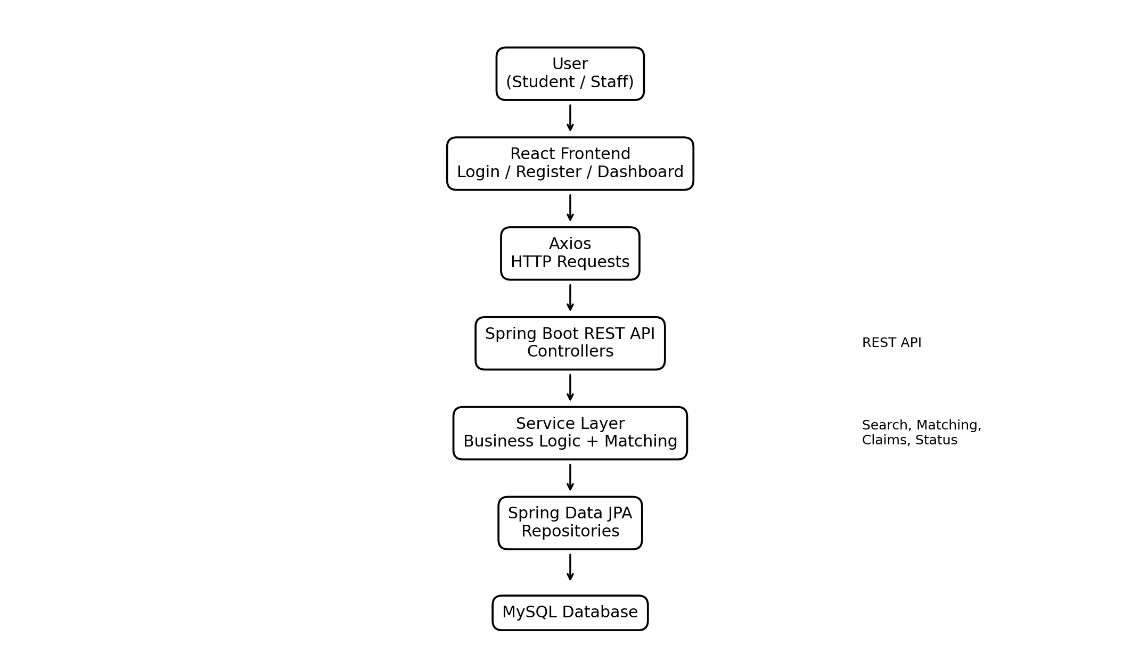

5. Application Flow
1. User Registration and Login: The user creates an account and logs into ReFound. Authentication can be handled using Spring Security and JWT.
2. Dashboard: After login, the user can view lost items, found items, their own reports, claims, and relevant notifications.
3. Report an Item: The user selects Lost or Found and enters details such as item name, category, description, location, date, and image.
4. Store the Report: The React application sends the report through Axios to a Spring Boot REST endpoint. The backend validates the request and stores the information in MySQL.
5. Search and Filter: Users can search active reports using keywords and filter them by category, location, date, or item type.
6. Possible Match: The system compares relevant attributes of lost and found reports and identifies possible matches.
7. Claim Submission: A user who believes an item belongs to them can submit a claim with additional identifying information or proof.
8. Claim Verification: The claim is reviewed by an administrator or authorized user. The claim is either approved or rejected.
9. Item Recovery: If the claim is approved, the item can be returned to the owner and the report is marked as resolved.
10. Status Tracking: The system keeps the current status of the report so users can see whether an item is active, claimed, resolved, or closed.

6. Simple User Flow
Register / Login → Dashboard → Report Lost or Found Item → Search Existing Reports → Possible Match → Submit Claim → Verification → Claim Approved or Rejected → Item Returned → Report Marked as Resolved

7. Backend Request Flow
React Page → Axios Request → Spring Boot Controller → Service Layer → JPA Repository → MySQL → Response to Controller → Axios Response → React UI

8. Main Modules
User Module: Registration, login, profile management, and authentication.
Lost Item Module: Create, view, update, and manage lost item reports.
Found Item Module: Create, view, update, and manage found item reports.
Search Module: Search and filter reports using useful item attributes.
Matching Module: Identify possible relationships between lost and found reports.
Claim Module: Submit, review, approve, or reject ownership claims.
Notification Module: Inform users about possible matches, claims, and status changes.
Admin Module: Manage users, reports, claims, and inappropriate or duplicate listings.

9. Expected Outcome
The completed ReFound application will provide a simple campus platform through which users can report lost and found belongings, search available reports, identify possible matches, submit ownership claims, and track recovery. The project will demonstrate practical use of frontend development, REST API development, database management, authentication, and basic business logic in a full stack Java application.

