

DEPARTMENT OF COMPUTER SCIENCE AND ENGINEERING

OPERATING SYSTEMS - CS235AI

REPORT
Topic : Developing a Memory Leak Detection Tool

Submitted by

Shrivarsha 1RV22CS195
Varun S 1RV22CS227

Computer Science and Engineering

2023-2024
CONTENTS

- Problem Statement
- Introduction
- System Architecture
- Methodology
- System calls used
- Results
- Conclusion
- References

- Problem Statement
Software Aging refers to the gradual accumulation of non-critical errors within long-running applications, which can detrimentally affect performance or functionality over time. One of the primary contributors to Software Aging is memory leak.

Memory leaks, by continuously allocating memory without releasing it, can exhaust available resources over time resulting eventual instability or crashes of the application. As leaked memory accumulates, it diminishes the system’s capacity to allocate memory for essential operations ultimately effecting the application’s reliability and performance. Therefore, vigilant detection and mitigation of memory leaks are crucial to ensure the long-term ability and robustness of the software.

To solve this issue, we propose algorithm for automatic detection of memory leaks in C programs by employing a disjoint sets approach to analyse graphs composed of memory objects as nodes and their references as edges.

- Introduction
Memory leak occurs when dynamically allocated memory or objects are not properly freed even if they are no longer accessed. This can happen when memory fragments or objects become unreachable or obsolete.
Detecting memory leak presents challenges, particularly in determining whether an object will be utilized in future program executions. As a result, memory leak tends to focus on observable effects such as increasing memory consumption. However, this approach has limitations as it takes significant time for memory leaks to manifest and their occurrence can be contingent in the production environment making them threats to long running applications.
There are two problems related to Memory: Memory corruption and Memory Leak. Java has garbage collector. So, it does not allow programmers to access the physical memory directly, but C / C++ does. So, Java does not suffer from memory corruption. A memory leak occurs when a process allocates memory and while releasing does not free the memory. As a result, memory is depleted over time and causes slowing down of the system.
The Memory Leak Detector (MLD) will be implemented as a library which will keep track of Heap Objects the application has created and how they hold references. MLD library will show the leaked objects.

3.System Architecture
Normally, when a C application requests for memory, the kernel/OS will allocate the memory directly.
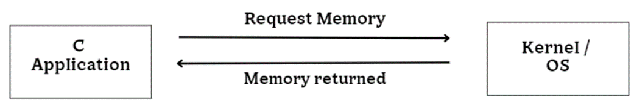

But using MLD Library, we can keep track of the memory objects by manipulating its internal data structures as shown below,
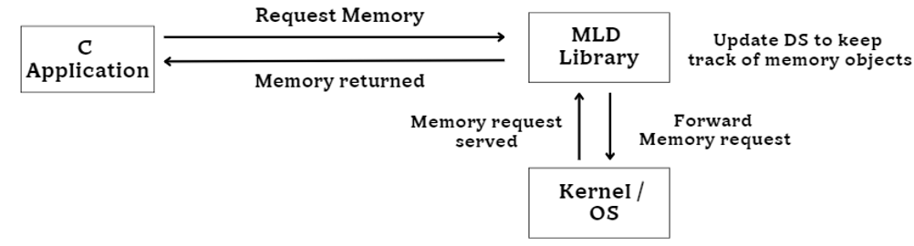

The block diagram shown below explains how Memory Leak Detection Library Participate in the process of serving memory requests.
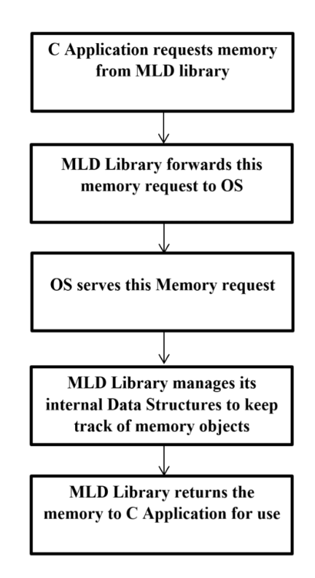
- Methodology
To mitigate the memory wastage , we introduce the MLD library which employs the following algorithm.
- When a C application requests dynamic memory during execution, the request is redirected to the Memory Leak Detector (MLD) library instead of directly to the Operating System.
- The MLD library receives the request and relays it to the underlying Operating System for processing.
- Upon receiving a response from the OS, the MLD library updates its internal Data Structure to monitor memory usage.
- Subsequently, the MLD library returns the allocated memory chunk to the C application, ensuring efficient memory management and leak detection.
The implementation approach for the described intervention of MLD algorithm follows the following workflow:
Initially, we establish a Structure Database, enabling MLD library to manage the information pertaining to all structures utilized by the application.
Subsequently, Object Database is constructed facilitating the MLD library maintaining the records of all memory objects allocated by the application.
Lastly the algorithm is deployed on object database to identify and report the memory leaks.
- Structure Database
The MLD library must know the information about all the structures used by the application. It is the responsibility of the application to tell MLD library during initialization about all structures. The process of registering the structures used by the application to the MLD library is called Structure Registration. The structure database is maintained using a linked list.
The code for the single structure of a single record in the structure database is given below,
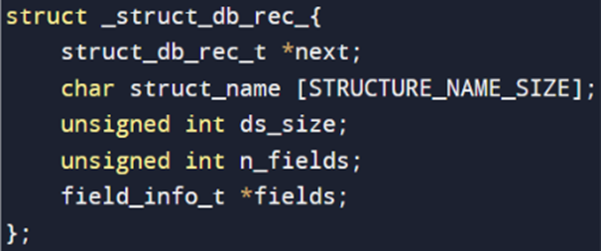

Similarly code for the structure containing various information about the fields is
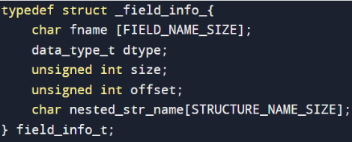

- Object Database
The MLD library should have the information about the all the objects that are created by the application. Whenever the new object is created by the application, MLD library will store the relevant information about the object such as corresponding structure details of the object and address of the object. Object record stores the above information. Object record of individual object in used by the application, will be stored in the object database which is basically a LinkedList.
The code for the structure of a single record in the object database is given below,
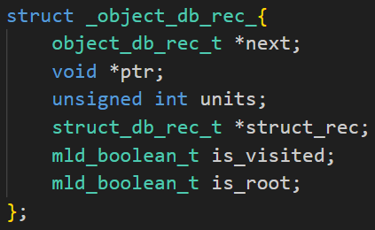
In order to store all the records, we have the object database (LinkedList), which is given by,
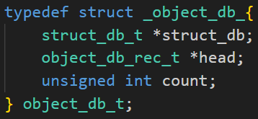

- Memory Leak Detection Algorithm
The MLD algorithm operates on both the Object and Structure Databases, identifying leaked objects as those not connected to the root object. In any application, data structures manifest as disjoint sets of graphs, where nodes and edges represent elements and their relationships. Each graph includes a root node, typically global or static objects accessible across the application. Traversal from the root node should reach all other nodes; any unreachable nodes, typically malloc'd objects, are flagged as memory leaks. This method maintains a comprehensive record of memory leaks for debugging purposes.
To facilitate this process, the application communicates its set of root objects to the MLD library. The application's Data Structure can be conceptualized as a directed cyclic graph, potentially disjoint. Each graph features a special root object, serving as the starting point for traversal. Thus, the MLD library offers an API for the application to register its root objects, which is given below,
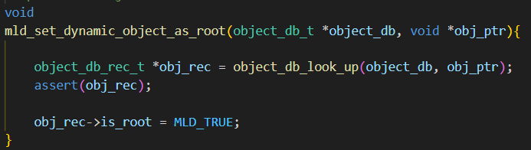
MLD algorithm starts from root object and marks the all reachable objects from root as visited by traversing it. The object whose is_visited field is marked as false are reported as leaked object by the application.
The code for the traversal is given below,
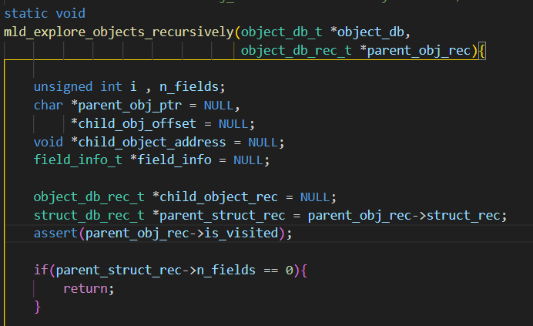

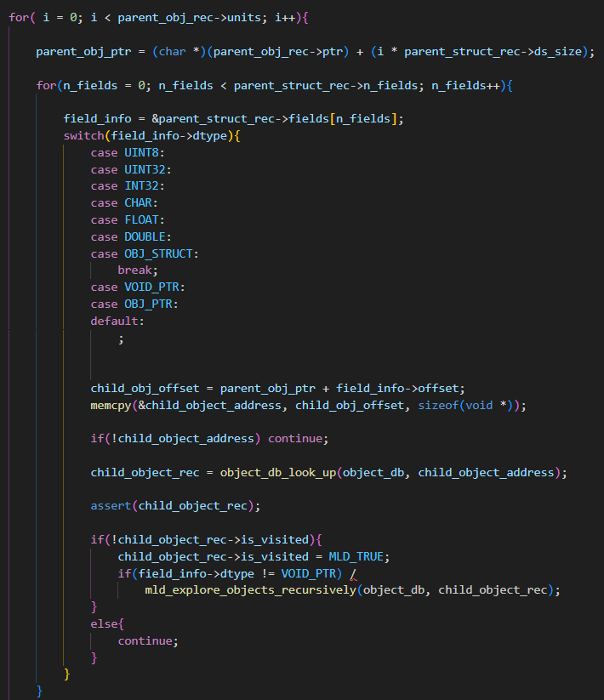

5. System Calls Used
1.mmap()
Inorder to allocate memory for the object , xcalloc function is used , xcalloc is the custom function designed to allocate memory which internally used mmap system call. It is similar to the standard library function ‘calloc’ except for the fact that it also registers the allocated objects with the MLD system dynamically. This function also allows specifying whether the allocated object is a root object or not. The implementation of xcalloc function is given below,
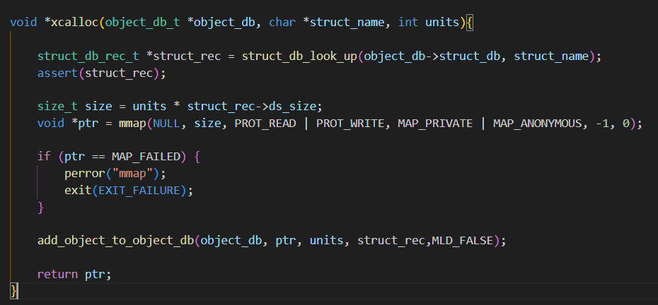
The mmap system call is employed within the xcalloc function to dynamically allocate memory for objects based on a specified structure type. This call effectively maps memory into the process's address space, sizing the allocation according to the requested number of units and the structure's size retrieved from the object database. By granting read and write permissions to the allocated memory through appropriate flags, mmap ensures accessibility and modification capability. Additionally, successful allocations prompt the function to update the object database with relevant memory information. Conversely, if memory allocation fails, the program exits with an error message, demonstrating robust error handling. Overall, mmap plays a crucial role in facilitating dynamic memory allocation and managing memory-related tasks.
2.munmap()
Inorder to deallocate the dynamic memory allocated, xfree() function is used. Internally this is used in xfree function, whose implementation is given below ,
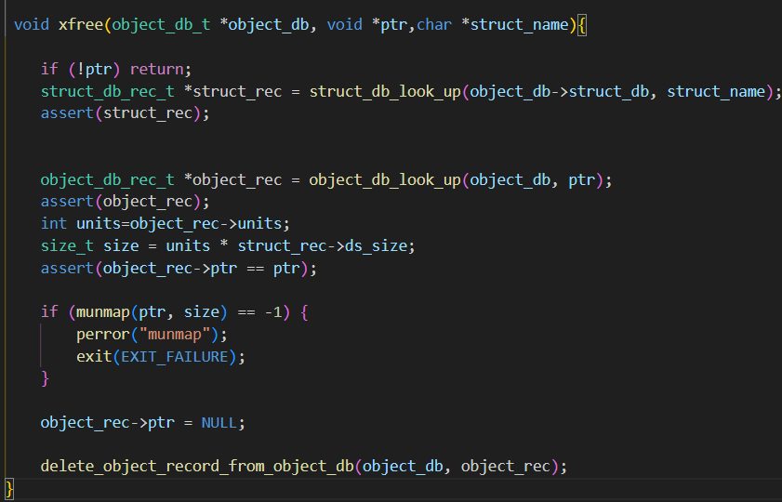
The munmap() call is utilized within the xfree() function to release memory previously allocated by mmap(). It effectively unmaps memory regions from the process's address space, freeing up memory resources. The munmap() call takes the pointer to the allocated memory region (ptr) and the size of the memory region (size) as arguments. Upon successful execution, the memory region is unmapped, and the associated memory is made available for other uses. However, if munmap encounters an error during memory deallocation, it returns -1, triggering an error message and causing the program to exit with a failure status to ensure proper error handling. Overall, munmap is essential for deallocating memory and managing memory-related tasks within the code, ensuring efficient memory management and resource utilization.

6.Results
A simple application was developed to test the MLD library and intentionally an object was leaked and the results are as follows.
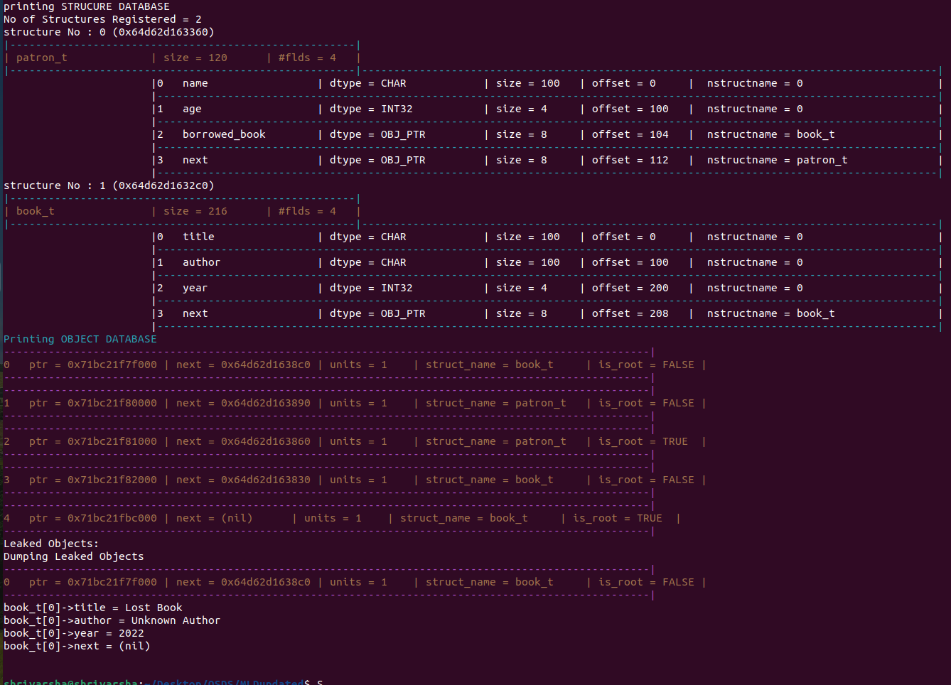
The library prints the leaked object.
When the unused object in the application is freed and again the MLD was run the results are as follows.
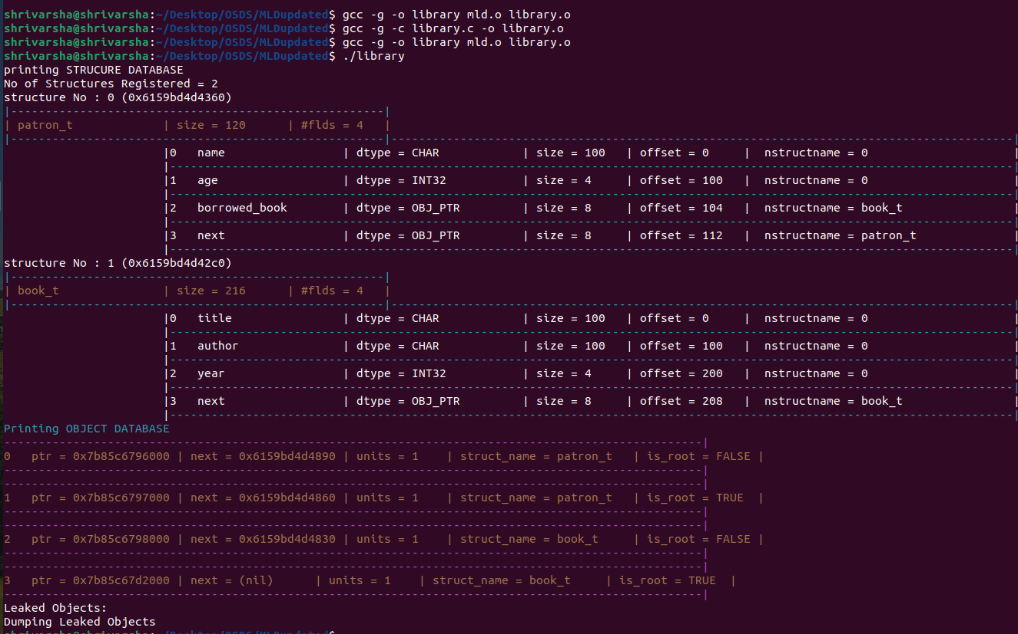
As no object is leaked, no leaked object is printed in terminal.

7.Conclusion
Memory management is a pivotal aspect of software development, particularly in C programming, where manual memory allocation and deallocation are commonplace. Unlike languages with automatic garbage collection like Java, C necessitates meticulous memory management to prevent issues like memory corruption and leaks. Our project addresses these challenges head-on by introducing an MLD (Memory Leak Detection) tool specifically designed for C programs. This tool empowers developers to identify and rectify memory leaks efficiently, mitigating the risk of software aging and enhancing the reliability of their codebases. By implementing the MLD algorithm, we offer a systematic approach to detect leaked objects, allowing developers to diagnose and resolve memory-related issues with precision.
The extendibility of our MLD tool further expands its utility, catering to a broader range of applications within the C programming landscape. With manual memory management prevalent in C, our tool provides an unified solution for identifying and addressing memory leaks across diverse projects. By offering developers a comprehensive toolkit for memory management, we aim to foster robust software development practices and ensure the longevity of software projects. With continuous monitoring and mitigation of memory leaks, our MLD tool facilitates smoother maintenance and optimization of C programs, contributing to overall software reliability and performance.

8.References
- R. Agarwal, N. Kapil, R. K. Jain, and A. Saxena, "Detection of Memory Leaks in C/C++," in Proc. IEEE International Conference on Software Engineering, February 2020.
- D. Gangwar and A. Katal, "Memory Leak Detection Tools: Comparative Analysis," in Proc. IEEE International Conference on Software Engineering, August 2021.
- V. Azhari and S. Bhamra, "Efficient heap monitoring tool for memory leak detection and root-cause analysis," in Proc. IEEE International Conference on Software Engineering, 2021.

