**NAME – OM VAISH**

**ROLL NO. – 214041**

**GROUP - A**

**Q1 . Explore and Write short note on the following network tools :  
  
a. ipconfig**

**ipconfig**, short for "IP Configuration," is a command-line tool in Windows and some Unix-based operating systems (where it is known as "ifconfig") used to display and manage network configuration settings. It provides information about the IP address, subnet mask, default gateway, and other network-related details for all network interfaces on a computer. You can use **ipconfig** to diagnose network connectivity issues, release and renew IP addresses, and more.

**b. ping**

**Ping** is a network utility used to test the reachability of a host (usually a computer or server) on an Internet Protocol (IP) network. It sends ICMP (Internet Control Message Protocol) echo request packets to the target host and waits for an ICMP echo reply. **Ping** is commonly used to check network connectivity, measure round-trip time (latency), and troubleshoot network problems. It's available on most operating systems, including Windows, macOS, and Linux.

**c. telnet**

**Telnet** is a network protocol and a command-line tool that allows you to establish a remote terminal connection to a host over a network. It's often used for remote administration, troubleshooting, and testing network services. However, **telnet** is considered insecure because it transmits data, including login credentials, in plaintext, making it vulnerable to eavesdropping. Secure Shell (SSH) has largely replaced telnet for secure remote access.

**d. ssh**

**SSH**, short for "Secure Shell," is a cryptographic network protocol and a suite of tools that provide secure remote access and secure file transfer capabilities over a potentially unsecured network. SSH encrypts the data exchanged between the client and server, making it highly secure. It's widely used for secure remote administration, tunneling, and data transfer between systems. SSH is available on Unix-like operating systems and can be used on Windows through third-party software.

**e. tracert/traceroute**

**Tracert** (Windows) and **traceroute** (Unix-based systems) are network diagnostic tools used to trace the route that packets take from a source to a destination across a network. These tools help identify network delays, packet loss, and the number of hops (routers or intermediary devices) between the source and destination. They are useful for pinpointing network issues and understanding the path data follows through the Internet.

**#To check IP address use cmd command :**

**ipconfig**

**#To check hostname use cmd command :**

**hostname**

**#IP address found : 192.168.29.194**

**Q2. With the help of ping, check if you are connected to other systems of your network**

#To check ping use cmd command :

ping [ IP Address or Hostname ]

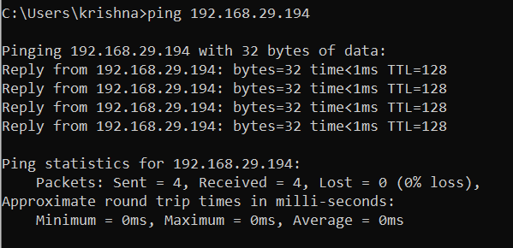

**And find the route to connect to that system using tracert.**

#To check the route to connect to that system using tracert , use cmd command :

Tracert [IP Address or Hostname ]

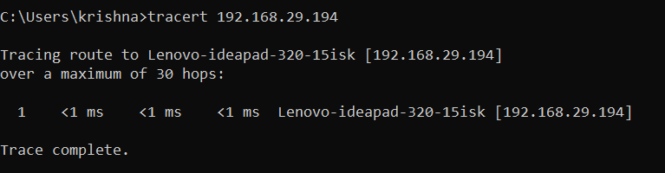

**Explore netstat command and list all the processes which are using ports for TCP protocol.**

**#**The netstat command is used to display network statistics , including active network connections and listening ports .

To list all processes using ports for the TCP protocol along with their associated process IDs (PIDs) ,follow these steps :

Netstat -ano | findstr /R “TCP .*: .*LISTEN”

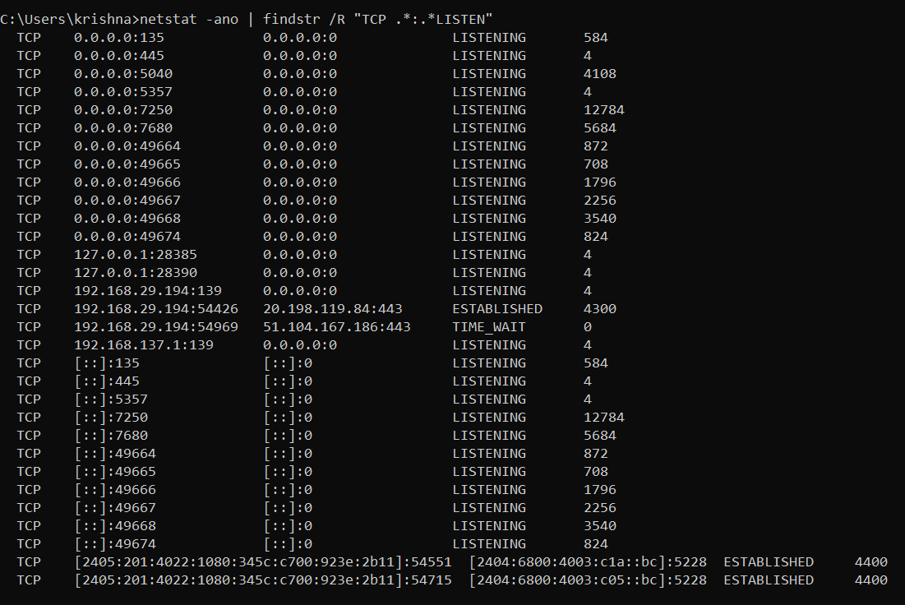

@netstat -ano – Displays network statistics with associated PIDs .

@ | -Redirects the output to the next command

@findstr /R”TCP.*:.*LISTEN” – Filters the output to show only TCP ports in a “LISTEN” state.

**Q3 . Display your systems IP Address , Subnet Mask using ipconfig and find out the following :**

**IP ADDRESS :** 192.168.29.194

**SUBNET MASK :** 255.255.255.0

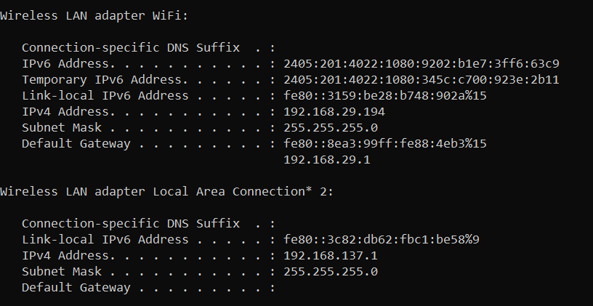

**a.Class of this IP Address**

Class C as Ip address is in range of (192 – 223)

**b.Host ID**

Using **ipconfig /all** command we get ,

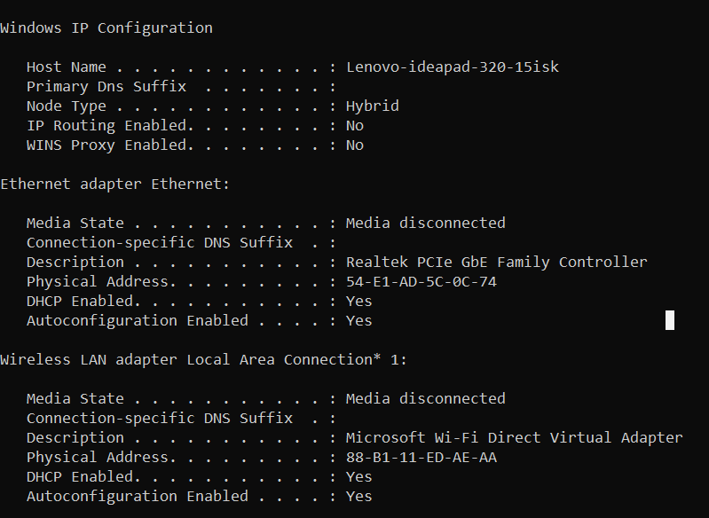

The host id is the physical address without dashes

i.e., 54E1AD5C0C74

1. **Maximum number of subnets and subnet address of your host**

**Max Number of subnets :** 2^n = 2^8 = 256

The subnet address for each subnet can be determined by incrementing the subnet portion of the IP address . Starting with the original IP address (192.168.29.194) and changing last octet to values from 0 to 255 ,

Generating the **subnet addresses** :

Subnet 1 : 192.168.29.0

Subnet 2 : 192.168.29.1

Subnet 3 : 192.168.29.2

: : : : :

: : : : :

Subnet 4 : 192.168.29.255