**AI PRACTICAL**

**OM VAISH**

**214041**

**PRACTICAL-1**

Ques: Write a prolog program to calculate the sum of two numbers.

Code:

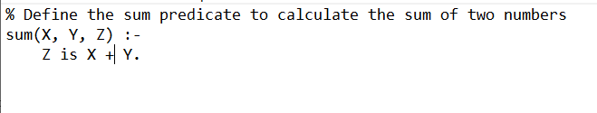

Output:

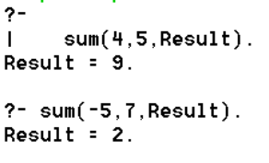

**Practical-2**

Ques: Write a Prolog program to implement max(X, Y, M) so that M is the maximum of two

numbers X and Y.

Code:

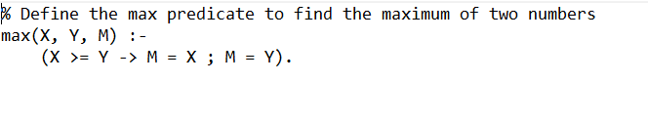

Output :

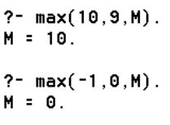

**Practical-3**

Ques: Write a program in PROLOG to implement factorial (N, F) where F represents the factorial of a number N.

Code:

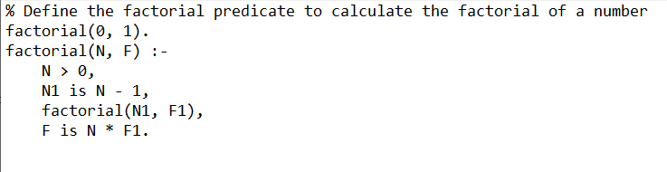

Output :



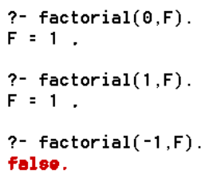

**Practical-4**

Ques: Write a program in PROLOG to implement generate_fib(N,T) where T represents the Nth term of the Fibonacci series.

Code:

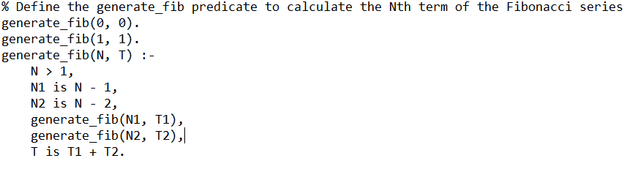

Output :

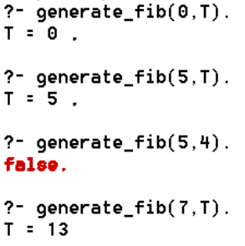

**Practical-5**

Ques: Write a Prolog program to implement GCD of two numbers.

Code:

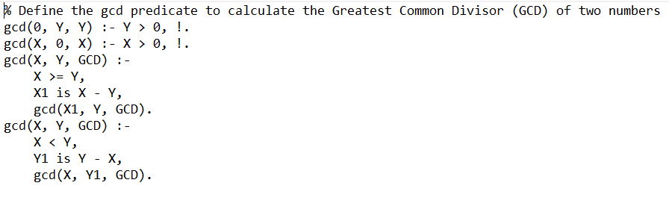

Output :

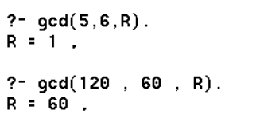

**Practical-6**

Ques: Write a Prolog program to implement power (Num,Pow, Ans) : where Num is raised to the power Pow to get Ans.

Code:

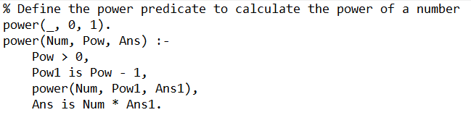

Output :

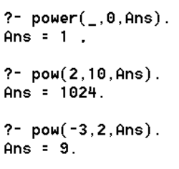

**Practical-7**

Ques: Write a Prolog program to implement multi (N1, N2, R) : where N1 and N2 denotes the numbers to be multiplied and R represents the result.

Code:

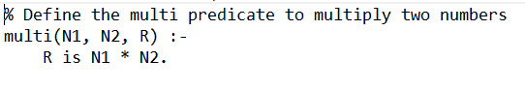

Output :

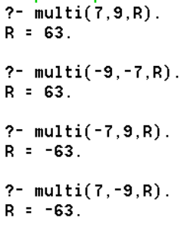

**Practical-8**

Ques: Write a Prolog program to implement memb(X, L): to check whether X is a member of L or not.

Code:

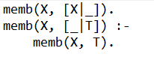

Output :

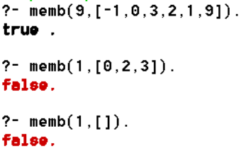

**Practical-9**

Ques: Write a Prolog program to implement conc (L1, L2, L3) where L2 is the list to be appended with L1 to get the resulted list L3.

Code:

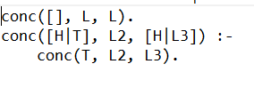

Output :

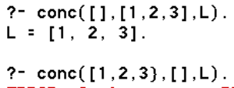

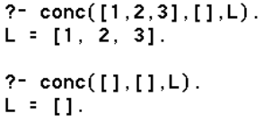

**Practical-10**

Ques: Write a Prolog program to implement reverse (L, R) where List L is original and List R is reversed list.

Code:

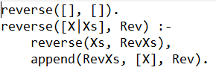

Output :

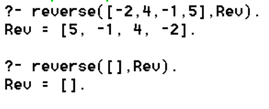

**Practical-11**

Ques: Write a program in PROLOG to implement palindrome (L) which checks whether a list L is a palindrome or not.

Code:

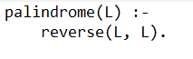

Output :

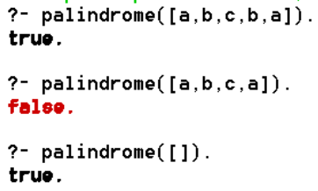

**Practical-12**

Ques: Write a Prolog program to implement sumlist(L, S) so that S is the sum of a given list L.

Code:

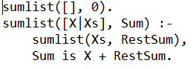

Output :

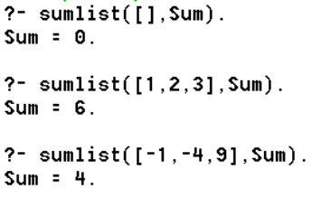

**Practical-13**

Ques: Write a Prolog program to implement two predicates evenlength(List) and oddlength(List) so that they are true if their argument is a list of even or odd length respectively.

Code:

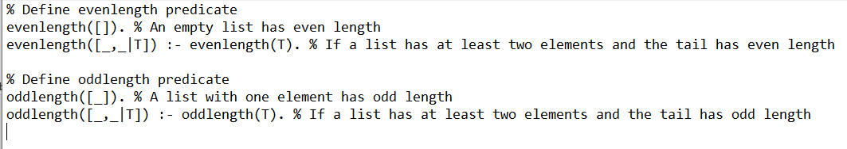

Output :

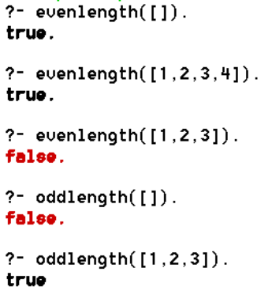

**Practical-14**

Ques: Write a Prolog program to implement nth_element (N, L, X) where N is the desired position, L is a list and X represents the Nth element of L.

Code:

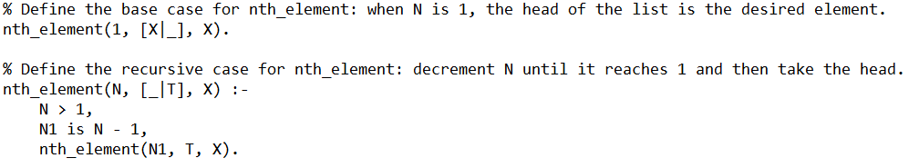

Output :

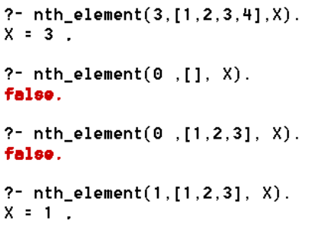

**Practical-15**

Ques: Write a Prolog program to implement maxlist(L, M) so that M is the maximum number in the list.

Code:

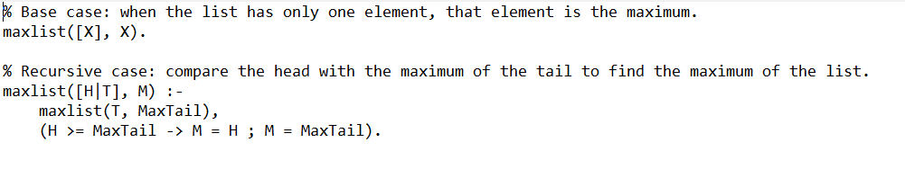

Output :

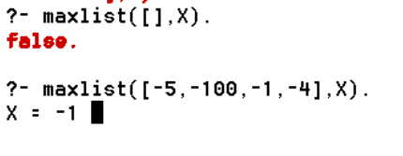

**Practical-16**

Ques: Write a prolog program to implement insert_nth (I, N, L, R) that inserts an item I into Nth position of list L to generate a list R.

Code:

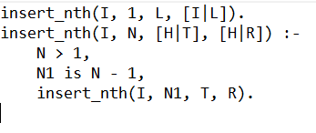

Output :

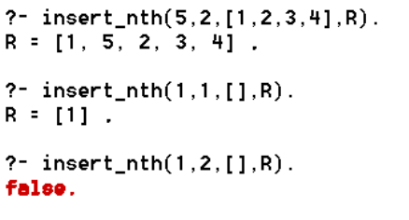

**Practical-17**

Ques: Write a Prolog program to implement delete_nth (N, L, R) that removes the element on Nth position from a list L to generate a list R.

Code:

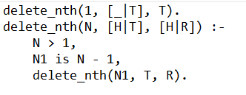

Output :

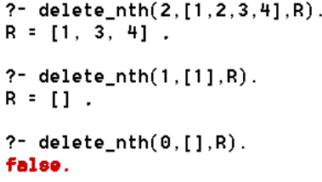

**Practical-18**

Ques: Write a program in PROLOG to implement merge (L1, L2, L3) where L1 is first ordered list and L2 is second ordered list and L3 represents the merged list.

Code:

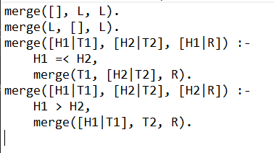

Output :

