2 Dataset
Working draft. The Google Docs report is the master copy; this text is pasted there and kept in sync. Every number and table here comes from files written by code for data version v1 (`data/manifest.json`, `data/processed/v1/cleaning_log.csv`, `reports/DATA_CHANGELOG.md`); the tables are printed by `scripts/data_tables.py v1`. Evidence: experiment E00.

2.1 Source and format
We use ISCXVPN2016 [2], published with Draper-Gil et al. [1] by the Canadian Institute for Cybersecurity, University of New Brunswick. The traffic was captured in 2016 in a lab, with and without a VPN, for seven traffic types: browsing, chat, streaming, mail, VoIP, P2P and file transfer. The authors turned the captures into flows with ISCXFlowMeter and published the flows as 20 ARFF files (Weka's text format). Each row is one flow: 23 numeric time-related features (times in microseconds, rates per second) and a label. We use only these files. They hold no payload, addresses, ports or timestamps. The SHA-256 hash of every file is recorded in data/arff_sha256.txt.
Each scenario is published at four flow timeouts (15, 30, 60 and 120 s). The timeout is a setting of the flow builder, not a flow duration. Flows longer than the timeout exist (up to 646 s) because the timeout closes a flow only after it has been inactive for that long.

2.2 Tasks and files
Task | Files | Labels
A1 | Scenario A1-ARFF, 4 files | VPN, Non-VPN
A2-VPN | Scenario A2-ARFF, 4 -VPN files | 7 VPN traffic types
A2-NonVPN | Scenario A2-ARFF, 4 -NO-VPN files | 7 traffic types
B | Scenario B-ARFF, 4 files | 14 classes (7 types x VPN / non-VPN)
(B-AllinOne) | Scenario B-ARFF, 4 -AllinOne files | 7 types, VPN and non-VPN merged; inventoried, not a task

file | task | timeout | header | rows | classes | core_task
Scenario A1-ARFF/TimeBasedFeatures-Dataset-15s-VPN.arff | A1 | 15 | T | 18,758 | 2 | 1
Scenario A1-ARFF/TimeBasedFeatures-Dataset-30s-VPN.arff | A1 | 30 | T | 14,651 | 2 | 1
Scenario A1-ARFF/TimeBasedFeatures-Dataset-60s-VPN.arff | A1 | 60 | S | 15,515 | 2 | 1
Scenario A1-ARFF/TimeBasedFeatures-Dataset-120s-VPN.arff | A1 | 120 | T | 10,782 | 2 | 1
Scenario A2-ARFF/TimeBasedFeatures-Dataset-15s-VPN.arff | A2-VPN | 15 | T | 9,793 | 7 | 1
Scenario A2-ARFF/TimeBasedFeatures-Dataset-30s-VPN.arff | A2-VPN | 30 | T | 7,734 | 7 | 1
Scenario A2-ARFF/TimeBasedFeatures-Dataset-60s-VPN.arff | A2-VPN | 60 | T | 6,935 | 7 | 1
Scenario A2-ARFF/TimeBasedFeatures-Dataset-120s-VPN.arff | A2-VPN | 120 | T | 5,631 | 7 | 1
Scenario A2-ARFF/TimeBasedFeatures-Dataset-15s-NO-VPN.arff | A2-NonVPN | 15 | T | 8,965 | 7 | 1
Scenario A2-ARFF/TimeBasedFeatures-Dataset-30s-NO-VPN.arff | A2-NonVPN | 30 | T | 6,917 | 7 | 1
Scenario A2-ARFF/TimeBasedFeatures-Dataset-60s-NO-VPN.arff | A2-NonVPN | 60 | T | 8,580 | 7 | 1
Scenario A2-ARFF/TimeBasedFeatures-Dataset-120s-NO-VPN.arff | A2-NonVPN | 120 | T | 5,151 | 7 | 1
Scenario B-ARFF/TimeBasedFeatures-Dataset-15s.arff | B | 15 | T | 18,758 | 14 | 1
Scenario B-ARFF/TimeBasedFeatures-Dataset-30s.arff | B | 30 | T | 14,651 | 14 | 1
Scenario B-ARFF/TimeBasedFeatures-Dataset-60s.arff | B | 60 | S | 15,515 | 14 | 1
Scenario B-ARFF/TimeBasedFeatures-Dataset-120s.arff | B | 120 | T | 10,782 | 14 | 1
Scenario B-ARFF/TimeBasedFeatures-Dataset-15s-AllinOne.arff | B-AllinOne | 15 | T | 18,758 | 7 | 0
Scenario B-ARFF/TimeBasedFeatures-Dataset-30s-AllinOne.arff | B-AllinOne | 30 | T | 14,651 | 7 | 0
Scenario B-ARFF/TimeBasedFeatures-Dataset-60s-AllinOne.arff | B-AllinOne | 60 | S | 15,515 | 7 | 0
Scenario B-ARFF/TimeBasedFeatures-Dataset-120s-AllinOne.arff | B-AllinOne | 120 | T | 10,782 | 7 | 0

Two features of the raw files matter for everything below. A1, A2 and B hold the same flows at each timeout: every A1 row matches an A2 row on seven integer features at all four timeouts (100%), and the labels agree key by key (0 disagreements). B and A1 are identical cell for cell except for one corrupt column (Section 2.4). BROWSING and VPN-BROWSING hold exactly 2,500 flows in every raw A2 file, which suggests the dataset authors capped those classes.

2.3 Column-name check
Problem. The first row of A1 15 s has duration = 9,368,711 us (9.4 s) but total_fiat = 16 and total_biat = 4. A total forward gap of 16 us in a 9-second flow is impossible. The paper's Table 2 [1] and the authors' 2016 poster [15] describe the forward and backward inter-arrival features as min, mean, max and std, with no totals. Yet 17 of the 20 headers list total_fiat and total_biat and no std. The three 60 s files of A1 and B have a second header that matches the paper.
Method. We read every file under both name lists. On every row we tested identities that hold whatever the traffic: min <= mean <= max for each gap statistic, 0 <= std <= max - min, mean flow gap x (packets - 1) = duration, and, for totals, total / mean + 1 per direction = packet count. Means of 10^7 or more are stored to 3 significant figures in the files, so a tolerance of 0.5% is allowed. We also tested the reading that total_fiat is a forward packet count.
check | A1 15 s (T) | A1 15 s (S) | A2-VPN 15 s (T) | A2-VPN 15 s (S) | A2-NonVPN 15 s (T) | A2-NonVPN 15 s (S) | B 15 s (T) | B 15 s (S)
fiat: min <= mean <= max | 0.0 | 100.0 | 100.0 | 18.8 | 100.0 | 5.24 | 0.0 | 100.0
biat: min <= mean <= max | 0.01 | 100.0 | 100.0 | 14.07 | 100.0 | 4.06 | 0.01 | 100.0
flowiat: min <= mean <= max | 100.0 | 100.0 | 100.0 | 100.0 | 100.0 | 100.0 | 100.0 | 100.0
active: min <= mean <= max | 100.0 | 100.0 | 100.0 | 100.0 | 100.0 | 100.0 | 100.0 | 100.0
idle: min <= mean <= max | 100.0 | 100.0 | 100.0 | 100.0 | 100.0 | 100.0 | 100.0 | 100.0
mean_flowiat x (packets - 1) = duration (+-1%) | 100.0 | 100.0 | 100.0 | 100.0 | 100.0 | 100.0 | 100.0 | 100.0
bytes per packet in 40-1500 | 97.72 | 97.72 | 99.26 | 99.26 | 96.06 | 96.06 | 97.72 | 97.72
min_flowiat <= min(min_fiat, min_biat) | 100.0 | 100.0 | 100.0 | 80.98 | 100.0 | 83.1 | 100.0 | 100.0
total_fiat <= duration | 100.0 | - | 100.0 | - | 100.0 | - | 100.0 | -
total/mean + 1, fwd + bwd = packets (+-2%) | 0.0 | - | 100.0 | - | 100.0 | - | 0.0 | -
total_fiat as packet count (+-10%) | 1.98 | - | 0.0 | - | 0.04 | - | 1.98 | -
0 <= std_fiat <= max - min | - | 100.0 | - | 0.0 | - | 0.0 | - | 100.0
0 <= std_biat <= max - min | - | 100.0 | - | 0.0 | - | 0.0 | - | 100.0

The same pattern holds at every timeout (column_name_check in the manifest has all 16 files).
Result. The headers are wrong for 9 of the 12 A1/B files, and the fault is a shift, not a shuffle. These files hold the paper's features in the order min, max, mean, std for fiat and biat, but their header names them total, min, max, mean. Under the corrected names every identity passes on 100% of rows; under the header names, min <= mean <= max passes on at most 0.02%. A2 files are named correctly and hold a different pair of features: total_fiat and total_biat (the sum of the forward and backward gaps) instead of std_fiat and std_biat. The packet-count reading passes on at most 2% of rows in any file, so it is ruled out. COLUMN_MAP in src/blindspy/data.py renames the 9 shifted files. It maps total_fiat->min_fiat, total_biat->min_biat, min_fiat->max_fiat, min_biat->max_biat, max_fiat->mean_fiat, max_biat->mean_biat, mean_fiat->std_fiat, mean_biat->std_biat; the other 15 names are unchanged. All feature names in this report (importances, SHAP, ablation) are the corrected ones.
Units and value ranges. Table 2 gives no units. The data does: with packets = flow packets per second x duration / 10^6, the mean flow gap x (packets - 1) equals the duration within 1% on 100% of rows in all 16 files, which holds only if times are in microseconds and rates per second. Every measured gap, active or idle value is at most the flow's duration (100% of values), as Table 2's definitions require. Under the corrected names the A1/B feature list is exactly Table 2's 23 features; the A2 list differs only in total_fiat and total_biat (reports/data_checks_v1.json).
feature | min | median | p99 | max | exactly_-1 | other_negative | % <= duration
duration | 0 | 14,422,310 | 119,998,194 | 646,565,983 | 0 | 0 | -
min_fiat | -1 | 112 | 45,211,908 | 119,999,708 | 6,308 | 0 | 100.0
min_biat | -1 | 45 | 45,213,098 | 119,999,620 | 10,522 | 0 | 100.0
max_fiat | -1 | 1,650,890 | 104,244,407 | 646,287,731 | 6,308 | 0 | 100.0
max_biat | -1 | 2,294,484 | 63,987,999 | 600,109,667 | 10,522 | 0 | 100.0
mean_fiat | 0 | 158,066 | 45,200,000 | 152,000,000 | 0 | 0 | 100.0
mean_biat | 0 | 83,359 | 45,200,000 | 120,000,000 | 0 | 0 | 100.0
std_fiat | 0 | 27,808 | 34,000,000 | 264,000,000 | 0 | 0 | -
std_biat | 0 | 24,804 | 25,700,000 | 98,000,000 | 0 | 0 | -
flowPktsPerSecond | 0 | 8.96615 | 57,143 | 2,000,000 | 0 | 0 | -
flowBytesPerSecond | 0 | 1,695 | 6,140,974 | 617,000,000 | 0 | 0 | -
min_flowiat | -1,247 | 21 | 1,076,195 | 59,947,704 | 224 | 405 | 100.0
max_flowiat | -1 | 962,728 | 109,547,639 | 646,287,731 | 45 | 0 | 100.0
mean_flowiat | 0 | 144,230 | 19,900,000 | 64,700,000 | 0 | 0 | 100.0
std_flowiat | 0 | 192,278 | 33,700,000 | 204,000,000 | 0 | 0 | -
min_active | -1 | 5,949,131 | 120,988,572 | 646,565,983 | 28,663 | 0 | 100.0
mean_active | 0 | 0 | 110,000,000 | 647,000,000 | 0 | 0 | 100.0
max_active | -1 | 10,316,202 | 122,147,146 | 646,565,983 | 28,663 | 0 | 100.0
std_active | 0 | 0 | 23,200,000 | 184,000,000 | 0 | 0 | -
min_idle | -1 | 4,993,314 | 120,661,941 | 646,287,731 | 28,663 | 0 | 100.0
mean_idle | 0 | 0 | 109,000,000 | 646,000,000 | 0 | 0 | 100.0
max_idle | -1 | 10,000,610 | 121,615,880 | 646,287,731 | 28,663 | 0 | 100.0
std_idle | 0 | 0 | 23,100,000 | 185,000,000 | 0 | 0 | -

This also explains the earlier puzzle that A1 and A2 rows never match. As published (names ignored), 0 A1 rows equal an A2 row in all 23 values at any timeout, and only 2,364 of 18,758 at 15 s (1,501, 2,190 and 494 at 30, 60 and 120 s) contain the same set of values in another order. Two of the 23 values mean different things in the two families, and 9 of the 12 A1/B headers shift the names.

2.4 File-family decision
Because A1/B and A2 hold the same flows with two different feature pairs, we had three options: use each task's own files, rebuild A1 and B from the A2 files, or merge both into 25 features. We use each task's own files: A1 and B with the paper's 23 features, A2 with its 23. These are the files the paper trained on for each scenario, so our comparison with it stays matched. A rebuild would have replaced two of the paper's features, and a merge is ambiguous wherever a key repeats. For the two-step classifier in E10, both steps use the A1/B layout: the 7-class step is trained on B rows split by VPN (the same flows as A2).
One column needed repair. In A1 120 s, flowPktsPerSecond disagrees with A2 on 99.97% of matched rows, while B 120 s, identical to A1 120 s in the other 22 columns of every row, agrees with A2 on 100%. We restore the column from B 120 s, which changes 10,288 of 10,782 rows.

2.5 Cleaning rules
Every rule is in configs/base.yaml and is applied by scripts/prepare_data.py in this order. Each file gets one line per rule in the cleaning log, including rules that change nothing.
# | Step | Rule | Reason
1 | parse | Strip trailing commas from header lines; skip comma-only data lines | Export glitch; a comma-only line (one in each 60 s file of A1 and B) is not a flow
2 | column map | Rename with COLUMN_MAP | Section 2.3
3 | restore | A1 120 s flowPktsPerSecond from B 120 s | Section 2.4
4-5 | missing, infinite | Count; none found | No imputation needed
6-9 | -1 codes | Keep | -1 means "not measurable": fewer than 2 packets in a direction, a single-packet flow, or no active/idle period. The matching mean or total is 0 on the same rows
10 | single-packet flows | Keep duration = 0 flows | Real flows; dropping them would bias the data toward long flows
11 | negative min_flowiat | Keep (down to -1,247 us) | Out-of-order capture timestamps
12 | rounding | Keep means, stds and rates >= 10^7 as stored | Already rounded to 3 significant figures in the source; can't be undone
13 | packet size | Keep flows outside 40-1,500 B per packet | Header-only packets (down to 30 B) and segments merged at capture (up to about 7 kB) are real
14 | exact duplicates | Drop within each file before splitting, keep the first copy | A copy in both train and test would score the model on rows it trained on
15 | conflicting duplicates | Keep (one row per label) | Real ambiguity; removing it would make the test set easier than reality
16-19 | not done | No normalization, no feature selection, no outlier removal, no class balancing | Scaling and resampling run inside the model pipeline on training folds only; all 23 features are kept

Rows each kept-as-is rule applies to:
rule | A1 | A2-VPN | A2-NonVPN | B
fiat_not_measurable | 8,846 | 5,120 | 3,726 | 8,846
biat_not_measurable | 13,857 | 8,056 | 5,801 | 13,857
flowiat_not_measurable | 2,108 | 1,205 | 903 | 2,108
active_idle_not_measurable | 32,228 | 15,753 | 16,475 | 32,228
single_packet | 2,110 | 1,207 | 903 | 2,110
negative_flowiat | 586 | 300 | 286 | 586
rounding | 15,217 | 7,979 | 7,234 | 15,217
packet_size | 1,380 | 397 | 983 | 1,380

2.6 Dataset summary
file | initial_rows | comma_only_lines_skipped | exact_duplicates_removed | conflicting_rows_kept | conflicting_groups | final_rows | missing_values | features | classes | largest_to_smallest_class | train | val | test
A1 15 s | 18,758 | 0 | 720 | 46 | 23 | 18,038 | 0 | 23 | 2 | 1.08:1 | 12,626 | 2,706 | 2,706
A1 30 s | 14,651 | 0 | 1,041 | 44 | 22 | 13,610 | 0 | 23 | 2 | 1.03:1 | 9,526 | 2,042 | 2,042
A1 60 s | 15,516 | 1 | 838 | 94 | 47 | 14,677 | 0 | 23 | 2 | 1.26:1 | 10,273 | 2,202 | 2,202
A1 120 s | 10,782 | 0 | 1,258 | 62 | 31 | 9,524 | 0 | 23 | 2 | 1.08:1 | 6,666 | 1,429 | 1,429
A2-VPN 15 s | 9,793 | 0 | 413 | 53 | 24 | 9,380 | 0 | 23 | 7 | 5.79:1 | 6,566 | 1,407 | 1,407
A2-VPN 30 s | 7,734 | 0 | 790 | 39 | 17 | 6,944 | 0 | 23 | 7 | 8.39:1 | 4,860 | 1,042 | 1,042
A2-VPN 60 s | 6,935 | 0 | 412 | 61 | 28 | 6,523 | 0 | 23 | 7 | 12.50:1 | 4,565 | 979 | 979
A2-VPN 120 s | 5,631 | 0 | 983 | 111 | 52 | 4,648 | 0 | 23 | 7 | 15.48:1 | 3,252 | 698 | 698
A2-NonVPN 15 s | 8,965 | 0 | 271 | 10 | 3 | 8,694 | 0 | 23 | 7 | 11.85:1 | 6,085 | 1,304 | 1,305
A2-NonVPN 30 s | 6,917 | 0 | 223 | 9 | 3 | 6,694 | 0 | 23 | 7 | 32.47:1 | 4,685 | 1,004 | 1,005
A2-NonVPN 60 s | 8,580 | 0 | 374 | 34 | 15 | 8,206 | 0 | 23 | 7 | 11.31:1 | 5,744 | 1,231 | 1,231
A2-NonVPN 120 s | 5,151 | 0 | 210 | 9 | 3 | 4,941 | 0 | 23 | 7 | 14.37:1 | 3,458 | 741 | 742
B 15 s | 18,758 | 0 | 684 | 100 | 41 | 18,074 | 0 | 23 | 14 | 11.85:1 | 12,651 | 2,711 | 2,712
B 30 s | 14,651 | 0 | 1,013 | 83 | 33 | 13,638 | 0 | 23 | 14 | 32.47:1 | 9,546 | 2,046 | 2,046
B 60 s | 15,516 | 1 | 786 | 174 | 75 | 14,729 | 0 | 23 | 14 | 12.69:1 | 10,309 | 2,210 | 2,210
B 120 s | 10,782 | 0 | 1,193 | 173 | 77 | 9,589 | 0 | 23 | 14 | 17.24:1 | 6,711 | 1,439 | 1,439

2.7 Data funnel (data v1)
Only two steps remove rows: the parser (two comma-only lines in total) and exact de-duplication (11,209 rows). Over the 16 core files, 179,120 raw data lines become 167,909 cleaned flows; no value is changed except the restored A1 120 s column.
file | raw data lines | parsed | after duplicates | final | train | val | test
A1 15 s | 18,758 | 18,758 | 18,038 | 18,038 | 12,626 | 2,706 | 2,706
A1 30 s | 14,651 | 14,651 | 13,610 | 13,610 | 9,526 | 2,042 | 2,042
A1 60 s | 15,516 | 15,515 | 14,677 | 14,677 | 10,273 | 2,202 | 2,202
A1 120 s | 10,782 | 10,782 | 9,524 | 9,524 | 6,666 | 1,429 | 1,429
A2-VPN 15 s | 9,793 | 9,793 | 9,380 | 9,380 | 6,566 | 1,407 | 1,407
A2-VPN 30 s | 7,734 | 7,734 | 6,944 | 6,944 | 4,860 | 1,042 | 1,042
A2-VPN 60 s | 6,935 | 6,935 | 6,523 | 6,523 | 4,565 | 979 | 979
A2-VPN 120 s | 5,631 | 5,631 | 4,648 | 4,648 | 3,252 | 698 | 698
A2-NonVPN 15 s | 8,965 | 8,965 | 8,694 | 8,694 | 6,085 | 1,304 | 1,305
A2-NonVPN 30 s | 6,917 | 6,917 | 6,694 | 6,694 | 4,685 | 1,004 | 1,005
A2-NonVPN 60 s | 8,580 | 8,580 | 8,206 | 8,206 | 5,744 | 1,231 | 1,231
A2-NonVPN 120 s | 5,151 | 5,151 | 4,941 | 4,941 | 3,458 | 741 | 742
B 15 s | 18,758 | 18,758 | 18,074 | 18,074 | 12,651 | 2,711 | 2,712
B 30 s | 14,651 | 14,651 | 13,638 | 13,638 | 9,546 | 2,046 | 2,046
B 60 s | 15,516 | 15,515 | 14,729 | 14,729 | 10,309 | 2,210 | 2,210
B 120 s | 10,782 | 10,782 | 9,589 | 9,589 | 6,711 | 1,439 | 1,439
All 16 files | 179,120 | 179,118 | 167,909 | 167,909 | 117,523 | 25,191 | 25,195

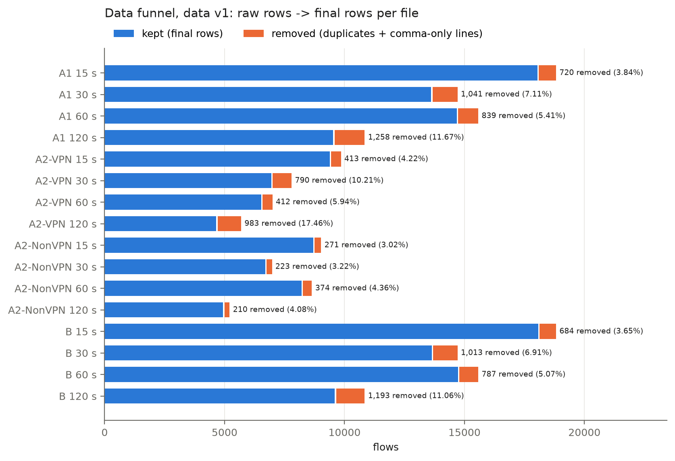
Data funnel
Removals are uneven by class, so they change the class balance.
A1
class | 15 s | 30 s | 60 s | 120 s
Non-VPN | 278 of 8,965 | 229 of 6,917 | 393 of 8,580 | 216 of 5,151
VPN | 442 of 9,793 | 812 of 7,734 | 445 of 6,935 | 1,042 of 5,631

A2-VPN
class | 15 s | 30 s | 60 s | 120 s
VPN-BROWSING | 0 of 2,500 | 0 of 2,500 | 37 of 2,500 | 256 of 2,500
VPN-CHAT | 38 of 1,196 | 38 of 780 | 36 of 514 | 39 of 349
VPN-STREAMING | 0 of 475 | 0 of 298 | 0 of 197 | 0 of 145
VPN-MAIL | 59 of 491 | 483 of 848 | 59 of 383 | 420 of 722
VPN-VOIP | 5 of 2,271 | 5 of 1,299 | 9 of 1,620 | 5 of 386
VPN-P2P | 262 of 928 | 230 of 851 | 218 of 823 | 215 of 813
VPN-FT | 49 of 1,932 | 34 of 1,158 | 53 of 898 | 48 of 716

A2-NonVPN
class | 15 s | 30 s | 60 s | 120 s
BROWSING | 0 of 2,500 | 0 of 2,500 | 0 of 2,500 | 0 of 2,500
CHAT | 3 of 890 | 7 of 595 | 24 of 778 | 3 of 242
STREAMING | 32 of 482 | 31 of 342 | 31 of 252 | 31 of 208
MAIL | 11 of 249 | 4 of 81 | 117 of 849 | 11 of 185
VOIP | 5 of 2,826 | 3 of 1,438 | 36 of 1,829 | 3 of 392
P2P | 59 of 1,000 | 7 of 1,000 | 4 of 1,000 | 2 of 1,000
FT | 161 of 1,018 | 171 of 961 | 162 of 1,372 | 160 of 624

B
class | 15 s | 30 s | 60 s | 120 s
BROWSING | 0 of 2,500 | 0 of 2,500 | 0 of 2,500 | 0 of 2,500
CHAT | 3 of 890 | 7 of 595 | 24 of 778 | 3 of 242
STREAMING | 32 of 482 | 31 of 342 | 31 of 252 | 31 of 208
MAIL | 11 of 249 | 4 of 81 | 117 of 849 | 11 of 185
VOIP | 5 of 2,826 | 3 of 1,438 | 36 of 1,829 | 3 of 392
P2P | 59 of 1,000 | 7 of 1,000 | 4 of 1,000 | 2 of 1,000
FT | 161 of 1,018 | 171 of 961 | 162 of 1,372 | 160 of 624
VPN-BROWSING | 0 of 2,500 | 0 of 2,500 | 37 of 2,500 | 256 of 2,500
VPN-CHAT | 38 of 1,196 | 38 of 780 | 36 of 514 | 39 of 349
VPN-STREAMING | 0 of 475 | 0 of 298 | 0 of 197 | 0 of 145
VPN-MAIL | 59 of 491 | 483 of 848 | 59 of 383 | 420 of 722
VPN-VOIP | 5 of 2,271 | 5 of 1,299 | 9 of 1,620 | 5 of 386
VPN-P2P | 262 of 928 | 230 of 851 | 218 of 823 | 215 of 813
VPN-FT | 49 of 1,932 | 34 of 1,158 | 53 of 898 | 48 of 716

file | groups | rows | test rows with a conflicting twin in train
A1 15 s | 23 | 46 | 4
A1 30 s | 22 | 44 | 8
A1 60 s | 47 | 94 | 9
A1 120 s | 31 | 62 | 7
A2-VPN 15 s | 24 | 53 | 9
A2-VPN 30 s | 17 | 39 | 4
A2-VPN 60 s | 28 | 61 | 6
A2-VPN 120 s | 52 | 111 | 11
A2-NonVPN 15 s | 3 | 10 | 3
A2-NonVPN 30 s | 3 | 9 | 2
A2-NonVPN 60 s | 15 | 34 | 6
A2-NonVPN 120 s | 3 | 9 | 1
B 15 s | 41 | 100 | 15
B 30 s | 33 | 83 | 15
B 60 s | 75 | 174 | 25
B 120 s | 77 | 173 | 21

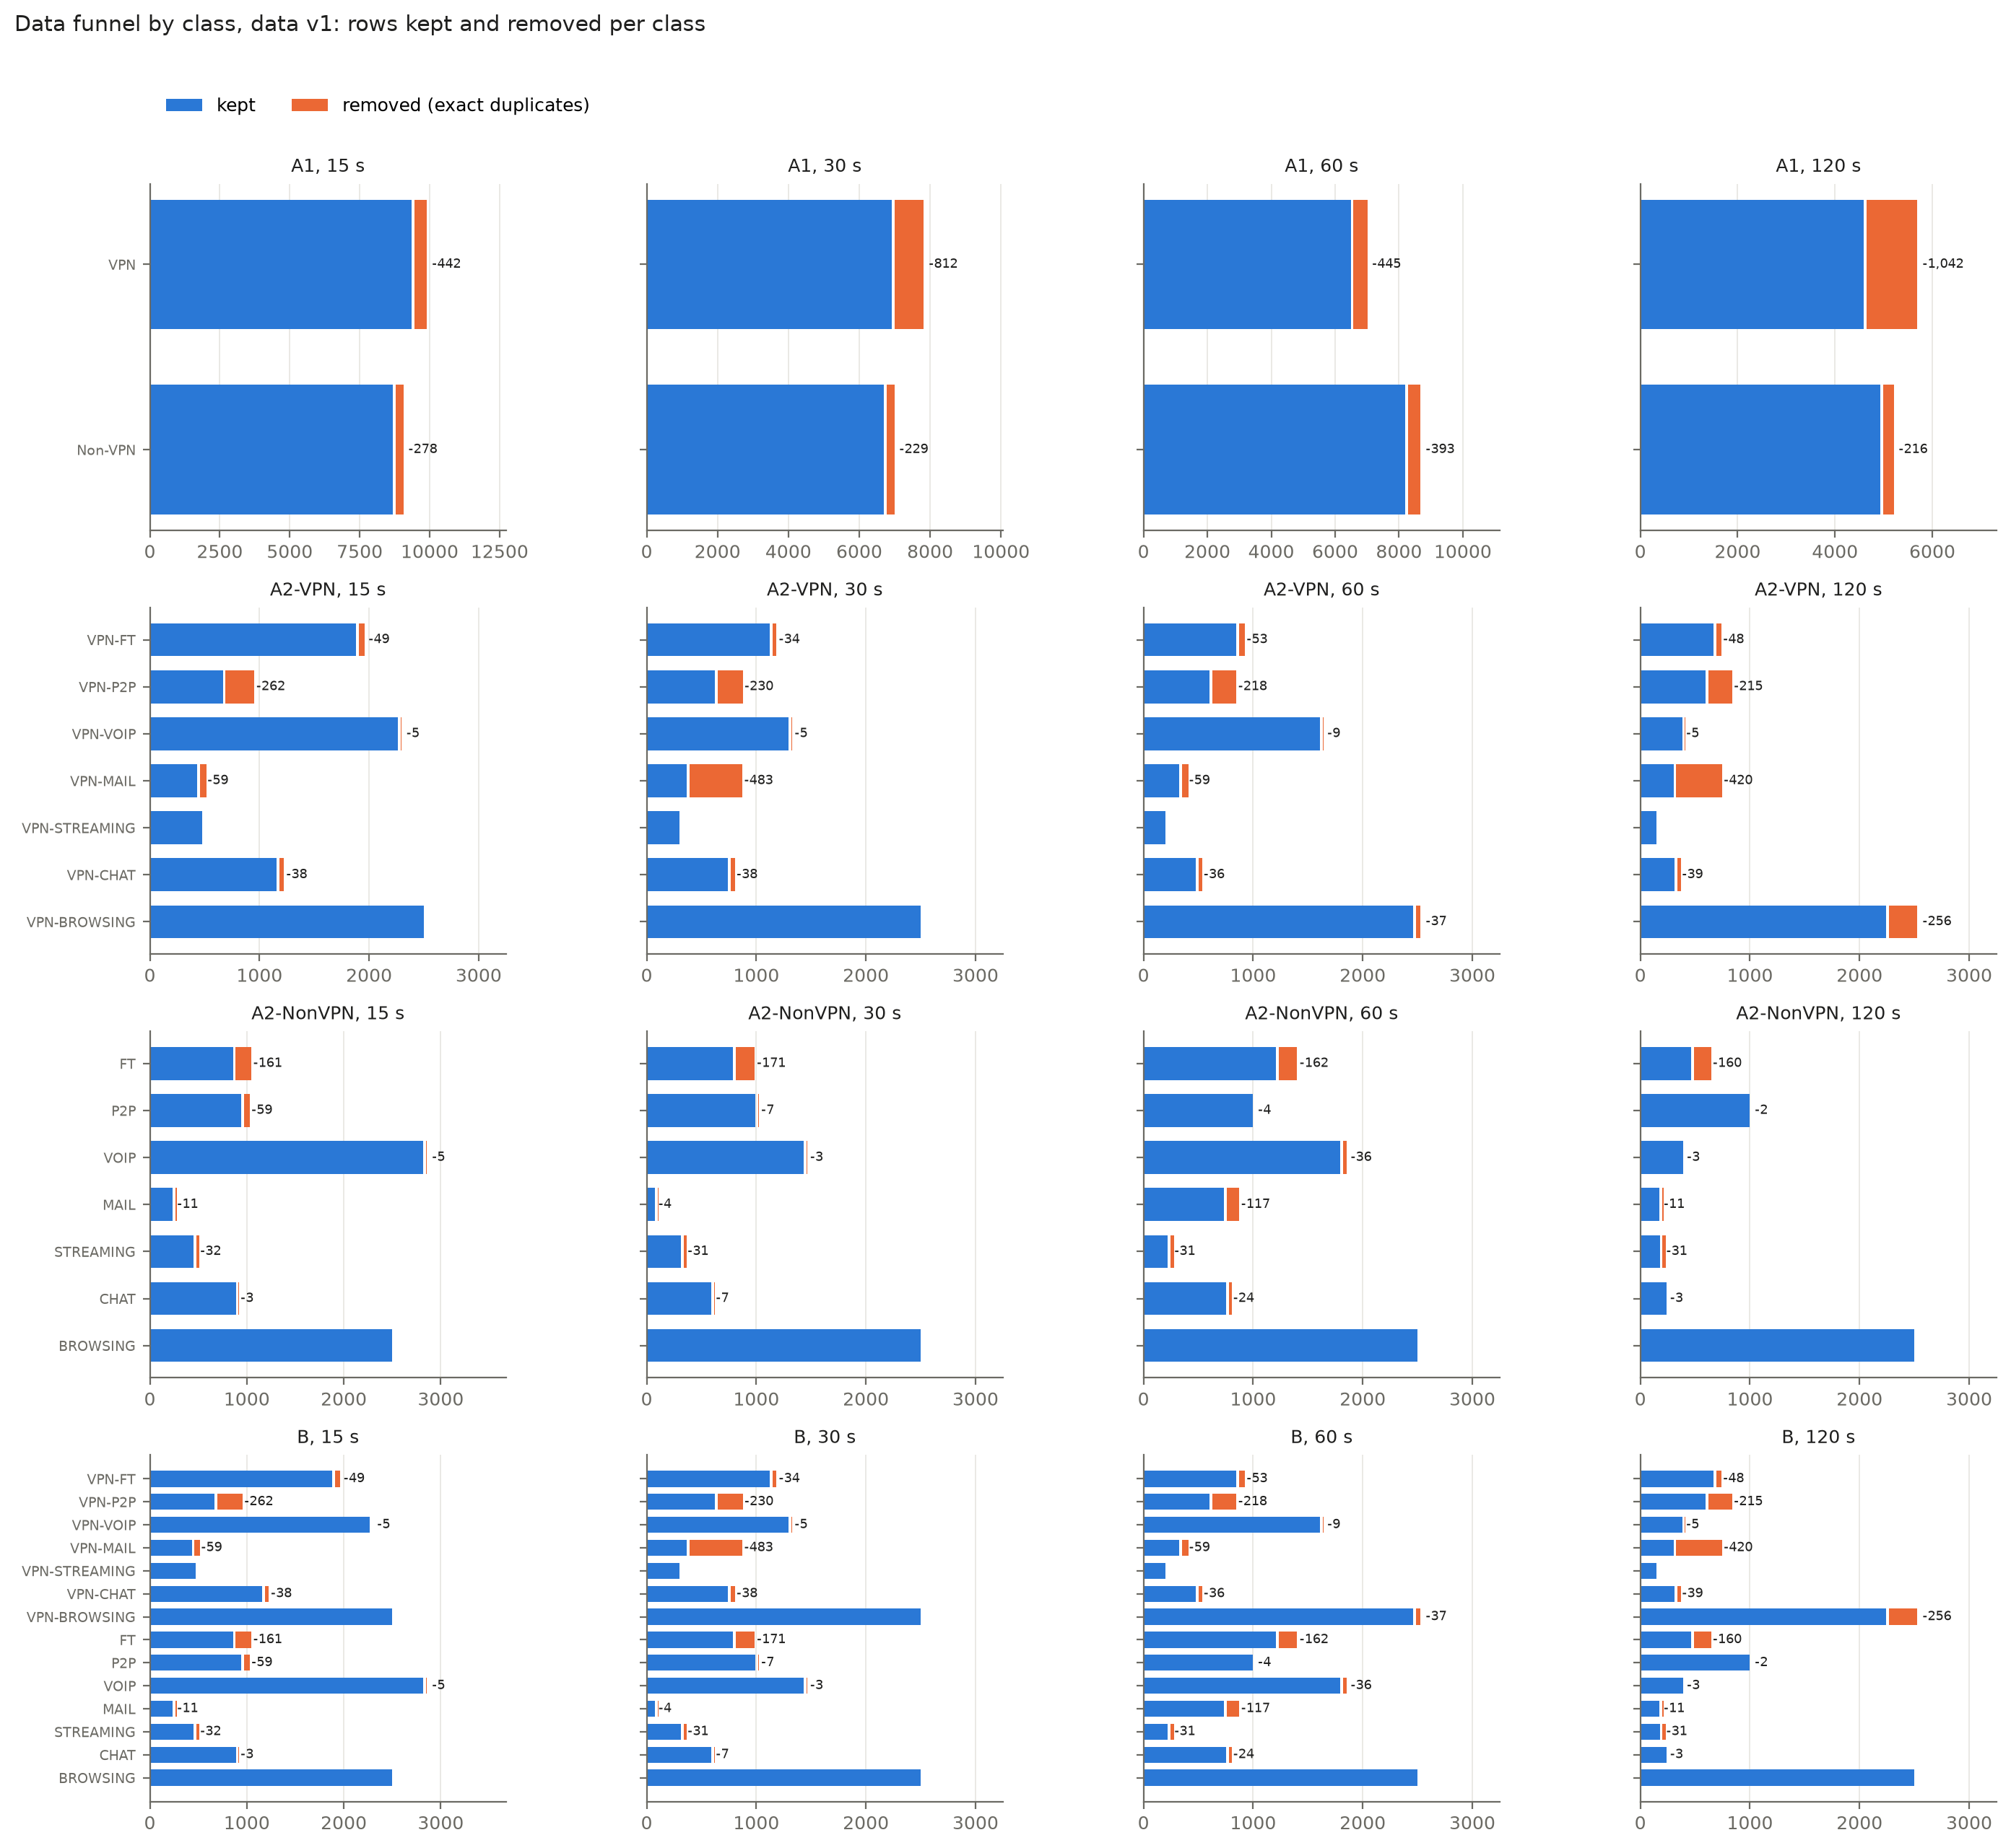
Data funnel by class
Per class, from raw rows to the final train / validation / test sets:
A1
class | timeout | raw | final | train | val | test
Non-VPN | 15 s | 8,965 | 8,687 | 6,081 | 1,303 | 1,303
VPN | 15 s | 9,793 | 9,351 | 6,545 | 1,403 | 1,403
Non-VPN | 30 s | 6,917 | 6,688 | 4,681 | 1,004 | 1,003
VPN | 30 s | 7,734 | 6,922 | 4,845 | 1,038 | 1,039
Non-VPN | 60 s | 8,580 | 8,187 | 5,731 | 1,228 | 1,228
VPN | 60 s | 6,935 | 6,490 | 4,542 | 974 | 974
Non-VPN | 120 s | 5,151 | 4,935 | 3,454 | 741 | 740
VPN | 120 s | 5,631 | 4,589 | 3,212 | 688 | 689

A2-VPN
class | timeout | raw | final | train | val | test
VPN-BROWSING | 15 s | 2,500 | 2,500 | 1,750 | 375 | 375
VPN-CHAT | 15 s | 1,196 | 1,158 | 810 | 174 | 174
VPN-STREAMING | 15 s | 475 | 475 | 333 | 71 | 71
VPN-MAIL | 15 s | 491 | 432 | 302 | 65 | 65
VPN-VOIP | 15 s | 2,271 | 2,266 | 1,586 | 340 | 340
VPN-P2P | 15 s | 928 | 666 | 466 | 100 | 100
VPN-FT | 15 s | 1,932 | 1,883 | 1,319 | 282 | 282
VPN-BROWSING | 30 s | 2,500 | 2,500 | 1,750 | 375 | 375
VPN-CHAT | 30 s | 780 | 742 | 520 | 111 | 111
VPN-STREAMING | 30 s | 298 | 298 | 208 | 45 | 45
VPN-MAIL | 30 s | 848 | 365 | 255 | 55 | 55
VPN-VOIP | 30 s | 1,299 | 1,294 | 906 | 194 | 194
VPN-P2P | 30 s | 851 | 621 | 435 | 93 | 93
VPN-FT | 30 s | 1,158 | 1,124 | 786 | 169 | 169
VPN-BROWSING | 60 s | 2,500 | 2,463 | 1,724 | 369 | 370
VPN-CHAT | 60 s | 514 | 478 | 334 | 72 | 72
VPN-STREAMING | 60 s | 197 | 197 | 139 | 29 | 29
VPN-MAIL | 60 s | 383 | 324 | 227 | 49 | 48
VPN-VOIP | 60 s | 1,620 | 1,611 | 1,127 | 242 | 242
VPN-P2P | 60 s | 823 | 605 | 423 | 91 | 91
VPN-FT | 60 s | 898 | 845 | 591 | 127 | 127
VPN-BROWSING | 120 s | 2,500 | 2,244 | 1,570 | 337 | 337
VPN-CHAT | 120 s | 349 | 310 | 216 | 47 | 47
VPN-STREAMING | 120 s | 145 | 145 | 101 | 22 | 22
VPN-MAIL | 120 s | 722 | 302 | 212 | 45 | 45
VPN-VOIP | 120 s | 386 | 381 | 267 | 57 | 57
VPN-P2P | 120 s | 813 | 598 | 418 | 90 | 90
VPN-FT | 120 s | 716 | 668 | 468 | 100 | 100

A2-NonVPN
class | timeout | raw | final | train | val | test
BROWSING | 15 s | 2,500 | 2,500 | 1,750 | 375 | 375
CHAT | 15 s | 890 | 887 | 621 | 133 | 133
STREAMING | 15 s | 482 | 450 | 315 | 67 | 68
MAIL | 15 s | 249 | 238 | 166 | 36 | 36
VOIP | 15 s | 2,826 | 2,821 | 1,975 | 423 | 423
P2P | 15 s | 1,000 | 941 | 659 | 141 | 141
FT | 15 s | 1,018 | 857 | 599 | 129 | 129
BROWSING | 30 s | 2,500 | 2,500 | 1,750 | 375 | 375
CHAT | 30 s | 595 | 588 | 412 | 88 | 88
STREAMING | 30 s | 342 | 311 | 217 | 47 | 47
MAIL | 30 s | 81 | 77 | 53 | 12 | 12
VOIP | 30 s | 1,438 | 1,435 | 1,005 | 215 | 215
P2P | 30 s | 1,000 | 993 | 695 | 149 | 149
FT | 30 s | 961 | 790 | 553 | 118 | 119
BROWSING | 60 s | 2,500 | 2,500 | 1,750 | 375 | 375
CHAT | 60 s | 778 | 754 | 528 | 113 | 113
STREAMING | 60 s | 252 | 221 | 155 | 33 | 33
MAIL | 60 s | 849 | 732 | 512 | 110 | 110
VOIP | 60 s | 1,829 | 1,793 | 1,255 | 269 | 269
P2P | 60 s | 1,000 | 996 | 697 | 150 | 149
FT | 60 s | 1,372 | 1,210 | 847 | 181 | 182
BROWSING | 120 s | 2,500 | 2,500 | 1,750 | 375 | 375
CHAT | 120 s | 242 | 239 | 167 | 36 | 36
STREAMING | 120 s | 208 | 177 | 124 | 26 | 27
MAIL | 120 s | 185 | 174 | 122 | 26 | 26
VOIP | 120 s | 392 | 389 | 273 | 58 | 58
P2P | 120 s | 1,000 | 998 | 698 | 150 | 150
FT | 120 s | 624 | 464 | 324 | 70 | 70

B
class | timeout | raw | final | train | val | test
BROWSING | 15 s | 2,500 | 2,500 | 1,750 | 375 | 375
CHAT | 15 s | 890 | 887 | 621 | 133 | 133
STREAMING | 15 s | 482 | 450 | 315 | 68 | 67
MAIL | 15 s | 249 | 238 | 166 | 36 | 36
VOIP | 15 s | 2,826 | 2,821 | 1,975 | 423 | 423
P2P | 15 s | 1,000 | 941 | 659 | 141 | 141
FT | 15 s | 1,018 | 857 | 600 | 128 | 129
VPN-BROWSING | 15 s | 2,500 | 2,500 | 1,750 | 375 | 375
VPN-CHAT | 15 s | 1,196 | 1,158 | 810 | 174 | 174
VPN-STREAMING | 15 s | 475 | 475 | 333 | 71 | 71
VPN-MAIL | 15 s | 491 | 432 | 302 | 65 | 65
VPN-VOIP | 15 s | 2,271 | 2,266 | 1,586 | 340 | 340
VPN-P2P | 15 s | 928 | 666 | 466 | 100 | 100
VPN-FT | 15 s | 1,932 | 1,883 | 1,318 | 282 | 283
BROWSING | 30 s | 2,500 | 2,500 | 1,750 | 375 | 375
CHAT | 30 s | 595 | 588 | 412 | 88 | 88
STREAMING | 30 s | 342 | 311 | 217 | 47 | 47
MAIL | 30 s | 81 | 77 | 54 | 11 | 12
VOIP | 30 s | 1,438 | 1,435 | 1,005 | 215 | 215
P2P | 30 s | 1,000 | 993 | 695 | 149 | 149
FT | 30 s | 961 | 790 | 553 | 119 | 118
VPN-BROWSING | 30 s | 2,500 | 2,500 | 1,750 | 375 | 375
VPN-CHAT | 30 s | 780 | 742 | 520 | 111 | 111
VPN-STREAMING | 30 s | 298 | 298 | 208 | 45 | 45
VPN-MAIL | 30 s | 848 | 365 | 255 | 55 | 55
VPN-VOIP | 30 s | 1,299 | 1,294 | 906 | 194 | 194
VPN-P2P | 30 s | 851 | 621 | 435 | 93 | 93
VPN-FT | 30 s | 1,158 | 1,124 | 786 | 169 | 169
BROWSING | 60 s | 2,500 | 2,500 | 1,750 | 375 | 375
CHAT | 60 s | 778 | 754 | 528 | 113 | 113
STREAMING | 60 s | 252 | 221 | 155 | 33 | 33
MAIL | 60 s | 849 | 732 | 512 | 110 | 110
VOIP | 60 s | 1,829 | 1,793 | 1,255 | 269 | 269
P2P | 60 s | 1,000 | 996 | 698 | 149 | 149
FT | 60 s | 1,372 | 1,210 | 847 | 182 | 181
VPN-BROWSING | 60 s | 2,500 | 2,463 | 1,724 | 369 | 370
VPN-CHAT | 60 s | 514 | 478 | 334 | 72 | 72
VPN-STREAMING | 60 s | 197 | 197 | 138 | 30 | 29
VPN-MAIL | 60 s | 383 | 324 | 227 | 48 | 49
VPN-VOIP | 60 s | 1,620 | 1,611 | 1,127 | 242 | 242
VPN-P2P | 60 s | 823 | 605 | 423 | 91 | 91
VPN-FT | 60 s | 898 | 845 | 591 | 127 | 127
BROWSING | 120 s | 2,500 | 2,500 | 1,750 | 375 | 375
CHAT | 120 s | 242 | 239 | 167 | 36 | 36
STREAMING | 120 s | 208 | 177 | 124 | 26 | 27
MAIL | 120 s | 185 | 174 | 122 | 26 | 26
VOIP | 120 s | 392 | 389 | 273 | 58 | 58
P2P | 120 s | 1,000 | 998 | 698 | 150 | 150
FT | 120 s | 624 | 464 | 324 | 70 | 70
VPN-BROWSING | 120 s | 2,500 | 2,244 | 1,570 | 337 | 337
VPN-CHAT | 120 s | 349 | 310 | 217 | 47 | 46
VPN-STREAMING | 120 s | 145 | 145 | 101 | 22 | 22
VPN-MAIL | 120 s | 722 | 302 | 212 | 45 | 45
VPN-VOIP | 120 s | 386 | 381 | 267 | 57 | 57
VPN-P2P | 120 s | 813 | 598 | 418 | 90 | 90
VPN-FT | 120 s | 716 | 668 | 468 | 100 | 100

In sentences. For task A1 at 15 s, 18,758 flows were parsed. After removing 720 exact duplicates (442 VPN, 278 non-VPN), 18,038 unique flows remained. All 23 features were kept without feature selection or normalization, and the flows were split 12,626 / 2,706 / 2,706 into training, validation and test sets. Duplicates are most common at the 120 s timeout: 1,258 of 10,782 A1 flows (11.67%) and 983 of 5,631 A2-VPN flows (17.46%). They hit some classes much harder than others: VPN-MAIL lost 483 of 848 flows at 30 s and 420 of 722 at 120 s, FT lost 160-171 flows at every timeout, and BROWSING lost none. A1 loses slightly more rows than B at the same timeout (720 vs 684 at 15 s) because flows that share features but differ in traffic type become exact duplicates once both are labelled with the same VPN / non-VPN label. After cleaning, no exact duplicate crosses train and test in any file; 1-25 test flows per file have a twin in training with the same features but a different label.
Deliberately not done, and why. No values were imputed (none are missing). No -1 code was replaced and nothing was set to zero, because -1 has a meaning. No flag columns were added, since the matching zero mean already marks the same rows and flags would change the paper's 23-feature set. No rows were dropped as outliers, because long, bursty or single-packet flows are real traffic. No features were scaled or selected and no classes were rebalanced at data level; all of that happens inside model pipelines, fitted on training data only (Section 3).

2.8 Timeouts
Within each task the feature names, their order and their units are the same at all four timeouts. The number of flows falls as the timeout grows (A1: 18,038 at 15 s to 9,524 at 120 s), and the class mix moves a lot. One class's share changes by up to 24.6 percentage points in A2-NonVPN (VOIP 32.5% at 15 s vs 7.9% at 120 s; BROWSING 28.8% vs 50.6%), 21.6 in A2-VPN, 12.2 in B and 7.6 in A1. A difference in scores between timeouts is therefore confounded by class mix, and we do not attribute it to the timeout alone.
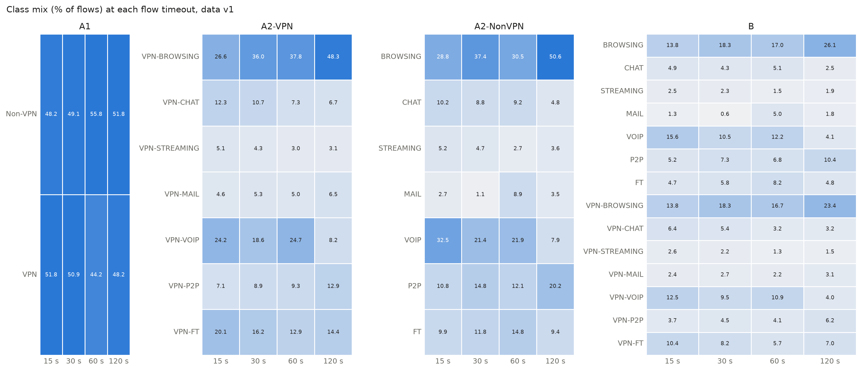
Class mix per timeout
The 60 s files differ in what some classes look like. At 15, 30 and 120 s, non-VPN VOIP flows send about 100 packets per second with a 20 ms median forward gap, and VPN-VOIP flows about 2 with a gap of about 960 ms. At 60 s the two are almost reversed (2.1 packets/s and 962 ms for VOIP, 16.5 packets/s and 18 ms for VPN-VOIP), and non-VPN FT drops from 1,237-3,739 to 56.5 packets/s. It is not a label swap. Of 7,041 flows found identically in more than one timeout file, 210 change label between timeouts; they are mostly 2-packet flows, and no VoIP pair is among them. The 60 s files are also the only ones exported with the paper-style header, so they may come from a different export run. The ARFF files can't settle the cause. Results at 60 s are therefore read with care and the issue is listed under Limitations (Section 7).
class, timeout | flows | median packets per second | median mean_fiat (us) | % mean_fiat 15-25 ms | % no active/idle period
VOIP 15s | 2,821 | 100.1 | 19994.9 | 78.1 | 99.4
VOIP 30s | 1,435 | 100.0 | 19998.1 | 77.1 | 98.9
VOIP 60s | 1,793 | 2.1 | 961624.6 | 31.2 | 51.5
VOIP 120s | 389 | 100.0 | 19999.8 | 73.5 | 95.4
FT 15s | 857 | 1236.7 | 1042.8 | 1.2 | 69.4
FT 30s | 790 | 2155.9 | 768.0 | 1.5 | 72.0
FT 60s | 1,210 | 56.5 | 34444.3 | 7.8 | 80.1
FT 120s | 464 | 3738.5 | 507.5 | 0.4 | 78.9
VPN-VOIP 15s | 2,266 | 2.2 | 960175.4 | 42.9 | 64.4
VPN-VOIP 30s | 1,294 | 2.1 | 960284.3 | 37.7 | 56.6
VPN-VOIP 60s | 1,611 | 16.5 | 18295.3 | 15.7 | 71.6
VPN-VOIP 120s | 381 | 2.1 | 960800.7 | 32.3 | 49.3
VPN-FT 15s | 1,883 | 7.1 | 192693.4 | 0.7 | 55.1
VPN-FT 30s | 1,124 | 4.0 | 416771.2 | 0.8 | 35.0
VPN-FT 60s | 845 | 6.1 | 286898.0 | 1.4 | 45.1
VPN-FT 120s | 668 | 7.5 | 187957.4 | 2.1 | 48.8

2.9 The Kaggle copy used by Isnan et al.
The Kaggle file used by Isnan et al. [13] has 59,706 rows and the A2 header. Compared as a multiset of rows, it equals the eight A2 files (VPN and non-VPN at all four timeouts) stacked: no row is left over at 12 significant digits, and the labels are the same. It has 40,987 unique rows, their count after removing 18,719 duplicates. Only 3,676 of those duplicates lie within one file; 7,093 distinct flows appear in two (2,475), three (1,286) or four (3,332) timeout files. Most of their "duplicates" are therefore the same flow built with different timeouts, and a random 80/20 split of the stacked file puts versions of one flow in both training and test sets. The file also carries the A2 feature pair (total_*), not the paper's (std_*). E16 reproduces their setup and measures the effect of keeping timeouts apart.

2.10 Data versions
Version | Date | Author | What changed | Files | Rows (raw lines -> final) | Commit
v1 | 2026-10-27 | utsav-s-r | First cleaned version | 16 core files (A1, A2-VPN, A2-NonVPN, B x 15/30/60/120 s) | 179,120 -> 167,909 | 0a36896

Figures from the exploration notebook (notebooks/01_eda.ipynb): class counts per task and timeout (class_counts_v1.png), feature distributions by class at every timeout (feature_boxes_<task>_<timeout>s.png, 16 figures) and feature correlations (correlation_<task>_15s.png, all four tasks), the data funnel by class (data_funnel_by_class_v1.png). The notebook records two findings that matter later. Classes differ by orders of magnitude on rate and gap features (VPN-STREAMING: median 202 packets/s; VPN-VOIP: 2.2). Many features are near-duplicates: 19 of 253 pairs in A1 and B (27 in A2-VPN, 20 in A2-NonVPN) have Spearman |rho| >= 0.9, mostly within the active/idle group. Feature importances will therefore be shared out among correlated features.

