Classifying Encrypted and VPN Traffic from Flow Timing Features: A Leakage-Safe Re-evaluation on ISCXVPN2016
BlindSpy team
Third-year AIML project. Code, data versions and run history: https://github.com/Varun-U-Pratap/BlindSpy
Abstract—Encryption hides packet contents, but the timing of a connection still reveals what kind of traffic it carries. We revisit the ISCXVPN2016 dataset and its three tasks: VPN against non-VPN traffic (A1), the traffic type within VPN and within non-VPN traffic (A2, two separate 7-class models), and all 14 classes at once (B), using only the 23 published flow timing features and never the payload. A check of the published files shows that 9 of the 12 A1 and B files carry column names shifted by one pair and that the A2 files hold a different pair of features; we map every column from value identities that hold on 100% of rows before any model is built. We then apply a leakage-safe protocol: exact duplicates removed before a stratified 70/15/15 split, every choice made on training and validation rows, and the test set scored once, with 10,000 stratified paired bootstrap resamples and 26 Holm-corrected tests fixed in advance. Under the original paper's protocol our C4.5 approximation and 1-NN reproduce its A1 results. Gradient-boosted trees, with the same tuning budget given to every one of seven method types, reach a test macro F1 of 0.9434 (A1), 0.8652 (A2, VPN), 0.9403 (A2, non-VPN) and 0.8480 (B). Isotonic calibration (for two of the four tasks a change made after the test set was opened) brings the test expected calibration error to 0.0090-0.0169 without changing any prediction. We also reproduce a recent 88.01% result on a stacked copy of the dataset (0.8796) and show, with a training-size control, that its gap to a single-timeout score comes from training-set size, not from mixing flow timeouts. All results come from one tracked run history of 2,015 runs.
Index Terms—encrypted traffic classification, VPN detection, flow timing features, ISCXVPN2016, gradient boosting, reproducibility, calibration, SHAP.

I. Introduction
Most network traffic is now encrypted, so deep packet inspection, which classifies traffic by reading packet contents, no longer works. Network operators still need to know what kind of traffic a connection carries, for quality of service, access control and security monitoring, and whether it passes through a VPN. Applications leave a timing pattern even when their contents are hidden: a voice call sends small packets at a steady rhythm, video streaming arrives in bursts, and a file transfer runs at full speed with almost no idle time.
Draper-Gil et al. [1] published the ISCXVPN2016 dataset [2] to study this question. Each flow is described by 23 time-related statistics and a label, and the flows are published at four flow timeouts (15, 30, 60 and 120 s). The timeout is a setting of the flow builder that closes an inactive flow; it is not the duration of a flow. The paper defines three tasks, which we follow and score separately: A1, a binary VPN / non-VPN classifier; A2, two separate 7-class classifiers, one for VPN and one for non-VPN traffic (never merged into one score); and B, one 14-class classifier over both. The seven traffic types are browsing, chat, email, file transfer (FT), P2P, streaming and VoIP. The paper used C4.5 [3] and KNN with 10-fold cross-validation.
Published scores on this dataset range from about 80% to 99%, but they are rarely comparable: studies differ in the split, the class setup, whether duplicate rows are removed and whether flows from different timeouts are mixed. This paper makes the following contributions:
- A check of the published files that finds shifted column names in 9 of the 12 A1 and B files and a different feature pair in the A2 files, decided from value identities that hold on 100% of rows (Section III).
- A reproduction of the original C4.5 and KNN results under the paper's own protocol (Section V-A).
- A leakage-safe protocol with a test set scored once, a fair comparison of seven method types with equal tuning budgets, and 26 paired tests fixed before the test set was opened (Sections IV and V).
- A reproduction of a recent 88.01% result [4] and a control experiment that separates the effect of training-set size from the effect of mixing timeouts (Section V-G).
- Analyses of calibration, stability, the amount of training data and feature use (SHAP and a feature-group ablation), and a predictor and demo that report a calibrated confidence and the features behind each prediction.

II. Related Work
Draper-Gil et al. [1] introduced the time-related features and reported, at a 15 s timeout, A1 precision of 0.89 (VPN) and 0.906 (non-VPN) with C4.5, and an average precision of 0.783 (C4.5) and 0.711 (KNN) for task B at the best timeout. Bagui et al. [5] compared several learners, including Random Forest and gradient boosting, on the same features and reported about 90%; we cite this result from the public abstract only. Jorgensen et al. [6] documented quality problems in the dataset's captures, including readable HTML in a capture that should be encrypted, VPN captures holding several connections, and ambiguous labels. Isnan et al. [4] trained a 300-tree Random Forest on a public copy of the dataset with 59,706 rows, removed 18,719 duplicates, kept 40,987 rows and reported 88.01% accuracy for 14 classes on a single 80/20 split.
We found that this copy is the eight A2 files of all four timeouts stacked together: as a multiset its 59,706 rows equal the rows of those files, and 7,093 distinct flows appear in two to four timeout files while only 3,676 rows are duplicates within one file. Most of the removed "duplicates" are therefore the same flows repeated across timeouts, and a random split of the stacked file mixes the four flow-building settings in training and test data. Section V-G measures what this does to the score.

III. Dataset
A. Source and format
ISCXVPN2016 was captured in 2016 in a lab, with and without a VPN, and turned into flows with ISCXFlowMeter [1, 2]. It is published as 20 ARFF files: tasks A1 (4 files), A2 (4 VPN and 4 non-VPN files), B (4 files) and four 7-class "AllinOne" files that are not a task. Each row is one flow with 23 numeric features (times in microseconds, rates per second) and a label; the files hold no payload, addresses, ports, timestamps or capture identifiers. A1, A2 and B hold the same flows at each timeout: every A1 row matches an A2 row on seven integer features (100%), and B is identical to A1 cell for cell except for one corrupt column.
B. Column names
The first row of the A1 15 s file has a duration of 9,368,711 µs but a "total forward gap" of 16 µs, which is impossible. The paper's feature table and the authors' poster [7] list the forward and backward inter-arrival times (fiat, biat) as min, mean, max and standard deviation, yet 17 of the 20 headers list total_fiat and total_biat and no standard deviation. We read every file under both name lists and tested identities that hold for any traffic: min <= mean <= max, 0 <= std <= max - min, and mean flow gap x (packets - 1) = duration (within 1%), allowing 0.5% for values that the files store to three significant figures.
Under the header names, min <= mean <= max holds on at most 0.02% of A1 and B rows; under names shifted by one pair (the paper's order min, max, mean, std) every identity holds on 100% of rows. The A2 files are named correctly but hold total_fiat and total_biat (the sum of the gaps) in place of std_fiat and std_biat: their totals reproduce the packet count on 100% of rows, while their std check holds on 0%. The reading of total_fiat as a packet count holds on at most 2% of rows in any file and is ruled out. Each task therefore uses its own files, with a column map that renames the 9 shifted files. One corrupt A1 120 s column (flowPktsPerSecond), which disagrees with A2 on 99.97% of matched rows, is restored from the B file that is identical in every other column; this changes 10,288 of 10,782 rows.
C. Cleaning
Every rule is applied by one script and logged per file and per class, including rules that change nothing. Exact duplicates (23 features and label) are removed within each file before splitting, so no flow can be both trained on and scored. Of 179,120 raw lines in the 16 task files, 2 comma-only lines are skipped and 11,209 duplicates removed, leaving 167,909 rows. Conflicting duplicates (same features, different label; 1,102 rows) are kept, because removing them would make the test set easier than reality. The code -1 ("not measurable": fewer than two packets in a direction, or no active or idle period), single-packet flows and negative minimum gaps (out-of-order timestamps) are kept as they are. No normalization, feature selection, outlier removal or class balancing is applied to the data itself. Table I summarizes the 15 s files used by the final models.
TABLE I
Data at the 15 s timeout after cleaning (data version v1)
Task | Raw rows | Duplicates removed | Final rows | Classes | Train / val / test
A1 | 18,758 | 720 | 18,038 | 2 | 12,626 / 2,706 / 2,706
A2-VPN | 9,793 | 413 | 9,380 | 7 | 6,566 / 1,407 / 1,407
A2-NonVPN | 8,965 | 271 | 8,694 | 7 | 6,085 / 1,304 / 1,305
B | 18,758 | 684 | 18,074 | 14 | 12,651 / 2,711 / 2,712

IV. Method
A. Protocol
For each task and timeout the cleaned data is split once into 70% training, 15% validation and 15% test rows, stratified by class, with seed 42. Hyperparameters are chosen by 5-fold stratified cross-validation inside the training rows; models are compared on validation; scaling, transforms and resampling are pipeline steps fitted on training folds only. The main metric is macro F1, which weights every class equally. The final configuration of each task is retrained on training and validation rows and scored once on its test rows. Every experiment states its hypotheses and numeric pass/fail thresholds before it runs, and changes one thing against the current best model.
B. Models
We start from a majority-class floor, a decision tree with the entropy criterion (a C4.5 approximation, since scikit-learn [8] has no C4.5 pruning), KNN, logistic regression and an RBF-kernel SVM, all at the four timeouts. Improvement experiments then add, at 15 s: a signed log, sign(x) log(1 + |x|), before scaling for the distance-based models, which keeps -1 apart from 0 and is defined for negative gaps; a 300-tree Random Forest; XGBoost [9] and LightGBM [10] with default settings; Optuna [11] tuning with the TPE sampler, 50 trials per search and the same budget for every method type; class balancing with class weights, random oversampling or SMOTE [12, 13]; and a two-step model for task B (VPN / non-VPN first, then one 7-class model per group). A model that beat the current best at 15 s by at least 0.03, above the largest cross-validation standard deviation of the baselines (0.025), was rerun at the other timeouts.
C. Final choice and comparison set
The final model of each task is the configuration with the highest validation macro F1. A rule set earlier would have broken gaps below 0.03 in favor of a simpler model, but the measured cross-validation standard deviation of the chosen models (0.0028-0.0058) is far below 0.03; the change was made before the test set was opened, and the old rule's picks were scored as well. Before the test set was opened we also fixed a comparison set: per task the best validation variant of each of seven method types (decision tree, KNN, logistic regression, SVM, Random Forest, XGBoost, LightGBM).
D. Statistics and calibration
Intervals are 95% percentile intervals from 10,000 stratified paired bootstrap resamples of the test rows [14] (rows drawn within each true class, seed 42), so they are conditional on the test set's class counts. Exactly 26 differences in macro F1 were fixed in advance: per task the final model against the six other method types, plus the old rule's pick in A1 and A2-VPN. Each is a two-sided paired bootstrap test, Holm-corrected [15] over all 26 at 0.05. With 1,000 resamples the smallest possible p-value (0.0020) would exceed Holm's first threshold (0.05 / 26 = 0.0019), so 10,000 are needed. Calibration is measured by the expected calibration error (ECE) with 15 equal-width bins [16, 17]. Isotonic calibration [18] is learned from shuffled 5-fold out-of-fold predictions on the rows the model is fitted on; the predicted class always stays the uncalibrated model's, so calibration changes only the reported confidence.
E. Reproducibility
Every run is logged to MLflow [19] with its commit, dependency lock hash, data version and hash, settings, metrics, timing and trained model, and official runs are refused unless the code is committed and pushed. A fresh clone of the repository reproduced the final scores, predictions and calibration errors exactly. Feature use is explained with SHAP [20]. A command-line predictor and a Streamlit [21] demo apply the four final models to a new flow file, report the label, its calibrated confidence and the features behind it, and reject a malformed file.

V. Results
A. Reproducing the original paper
Under the paper's protocol (10-fold cross-validation on the full files, Weka defaults [22]) our C4.5 approximation matches all 16 A1 precision and recall values of the paper within 0.05, and 1-NN matches 15 of 16. Contrary to our hypothesis, removing duplicates did not lower these scores: the removed rows are near-empty flows (median 0-2 packets), and 39-92% of them have a twin with the same features and another label, so keeping them adds errors no model can avoid.
B. Model development on validation
Table II follows the best 15 s validation macro F1 through the experiments. A 300-tree Random Forest added +0.0302 to +0.0647 over the tree; default gradient boosting added a little more. The signed log lifted KNN by 0.080-0.104 in every task, and was chosen by every logistic regression and SVM search that could use it. Equal tuning added at most +0.0151 to an ensemble but lifted the SVM by +0.3243 to +0.5277, to within 0.0017-0.0186 of each task's best. Class balancing moved macro F1 by at most 0.0064, and the two-step model for task B scored 0.8318 against 0.8428 for the direct model, with more errors across the VPN line (191 against 180). Fig. 1 shows the progress per task.
TABLE II
Best 15 s validation macro F1 after each step (majority-class floor: 0.341, 0.060, 0.070, 0.019)
Step | A1 | A2-VPN | A2-NonVPN | B
Decision tree | 0.8901 | 0.8247 | 0.8294 | 0.7585
KNN with signed log | 0.9048 | 0.8544 | 0.8670 | 0.7644
Random Forest | 0.9203 | 0.8679 | 0.8941 | 0.8147
XGBoost, default | 0.9271 | 0.8758 | 0.9015 | 0.8303
Final choice | 0.9308 | 0.8830 | 0.9075 | 0.8428

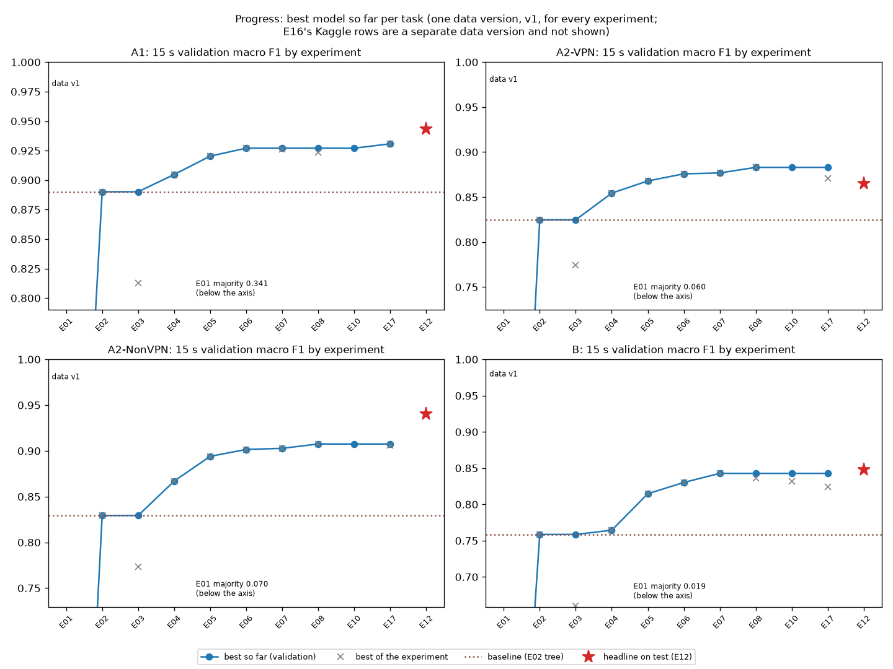
Fig. 1. Best validation macro F1 so far per task and experiment, with the final model's test score (star).
C. Final test scores
Table III gives the final models on the test rows. Three tasks score above validation and one below. One pre-stated check failed: the A2-NonVPN test score is 0.0328 above validation, more than the 0.03 we allowed. A split-seed experiment run before the test set was opened had already shown that its official validation rows are harder than any of 10 resplits (0.9075 against 0.9257-0.9468). The two other checks held: the final model scored above the old rule's pick in all four tasks, and the order of the seven method types by test score followed their order by validation score (Spearman [23] 0.9643, 0.8214, 0.9286 and 0.9643).
TABLE III
Final models on the test rows (macro F1 with 95% interval; ECE after calibration)
Task | Model | Val F1 | Test F1 | 95% interval | Accuracy | ECE
A1 | LightGBM, tuned | 0.9308 | 0.9434 | 0.9348-0.9519 | 0.9435 | 0.0090
A2-VPN | LightGBM, class weights | 0.8830 | 0.8652 | 0.8431-0.8866 | 0.8955 | 0.0169
A2-NonVPN | LightGBM, oversampling | 0.9075 | 0.9403 | 0.9216-0.9573 | 0.9609 | 0.0132
B | XGBoost, tuned | 0.8428 | 0.8480 | 0.8305-0.8651 | 0.8798 | 0.0158

The voice classes are the easiest (VPN-VOIP F1 0.9941, VOIP 0.9964 and 0.9917), and the weakest are VPN-MAIL (0.7132 in A2-VPN, 0.7259 in B) and STREAMING in A2-NonVPN (0.8955). In task B the largest confusion is BROWSING predicted as VPN-BROWSING (28 flows) and the reverse (17), and 55.05% of the direct model's validation errors cross the VPN line: separating VPN from non-VPN is the hard part of B.
D. Comparison of method types
Table IV and Fig. 2 give every member of the comparison set on the same test rows. Of the 26 pre-stated tests, 14 are clear after Holm correction. The final model is clearly better than logistic regression in every task and than the decision tree in A1, A2-NonVPN and B, but it is not clearly different from the tuned SVM in any task, nor from XGBoost or LightGBM except A1 against XGBoost. Two comparison models scored slightly higher on test, neither clearly: the A2-VPN SVM (0.8670) and the B LightGBM (0.8567); nothing was swapped after the test set was seen. Two tests sit on the Holm line (Holm p 0.0504, Monte Carlo band about 0.03-0.07) and count as not clear. The old rule's picks scored 0.0322 (A1, clear), 0.0211, 0.0242 (clear) and 0.0069 below the final models.
TABLE IV
Test macro F1 of the seven method types (bold: final model)
Task | Tree | KNN | LogReg | SVM | RF | XGB | LGBM
A1 | 0.8982 | 0.9208 | 0.6804 | 0.9311 | 0.9289 | 0.9304 | 0.9434
A2-VPN | 0.8308 | 0.8431 | 0.7179 | 0.8670 | 0.8594 | 0.8577 | 0.8652
A2-NonVPN | 0.8825 | 0.9160 | 0.8053 | 0.9244 | 0.9067 | 0.9346 | 0.9403
B | 0.7886 | 0.8253 | 0.6089 | 0.8411 | 0.8403 | 0.8480 | 0.8567

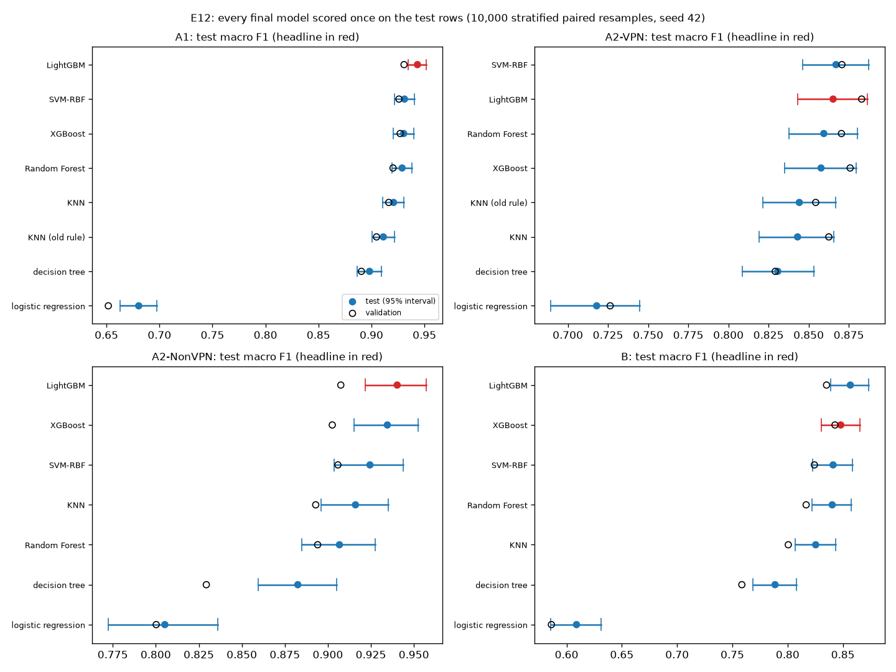
Fig. 2. Test macro F1 with 95% intervals (filled) and validation macro F1 (open) of every final model; the final model of each task is in red.
E. Calibration, stability and training size
All four final models were overconfident on validation. A rule fixed before the test set adopted isotonic calibration where the uncalibrated validation ECE exceeded 0.05 (A1 and A2-VPN). After the test set had been opened, the team calibrated A2-NonVPN and B in the same way as well; this is a post-hoc change, it changed no label or score, and the raw values stay reported (Table V). Across 10 resplits of training and validation rows the validation macro F1 of the final configurations varies with a standard deviation of 0.0042-0.0114. The learning curve still rises between 80% and 100% of the training rows in every task, most in B (0.8297 to 0.8428), so more data would probably help.
TABLE V
Expected calibration error, uncalibrated and isotonic
Task | Val ECE raw | Val ECE isotonic | Test ECE raw | Test ECE used | Decided
A1 | 0.0552 | 0.0140 | 0.0442 | 0.0090 | before test
A2-VPN | 0.0714 | 0.0168 | 0.0709 | 0.0169 | before test
A2-NonVPN | 0.0444 | 0.0152 | 0.0339 | 0.0132 | after test
B | 0.0350 | 0.0099 | 0.0420 | 0.0158 | after test

F. What the models use
SHAP values of the final models on the test rows and a feature-group ablation on validation answer two different questions: which features a model uses, and which it cannot do without (Fig. 3). The byte rate is the most used feature in A2-VPN, A2-NonVPN and B, and the smallest gaps between packets are in the top five of every task. Rates and duration hold 21.4-26.9% of mean |SHAP|, and dropping them costs the most in A2-VPN, A2-NonVPN and B (0.0395, 0.0301 and 0.0549); in A1 dropping the backward gaps costs more (0.0155 against 0.0122). Active and idle times matter least (3.1-5.7% of mean |SHAP|; dropping either group changes macro F1 by -0.0036 to +0.0051). A timing-only model without the byte rate loses 0.015-0.044, so the models read no payload but do use the amount of data per second.
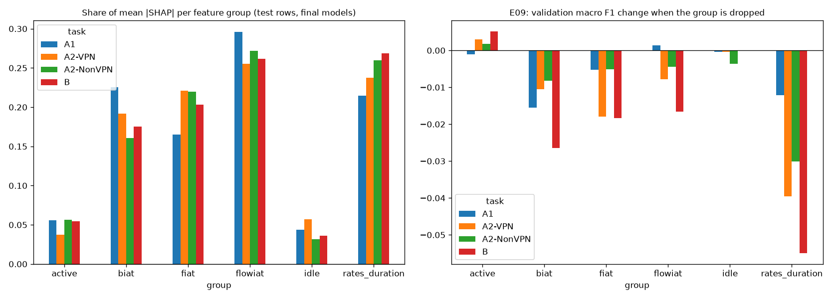
Fig. 3. Share of mean |SHAP| per feature group on the test rows (left) and the change in validation macro F1 when the group is dropped (right).
G. Reproducing and correcting a published result
On the stacked copy used by Isnan et al. [4], with their deduplication, 80/20 split and grid search, a Random Forest reaches 0.8796 accuracy against their 0.8801 (Table VI). Keeping the timeouts apart lowers the same method to 0.8206-0.8658 (mean 0.8430). Stacking the four files gives 2.3-4.3 times as many training rows, so we trained the mixed-timeout forest on training sets cut to each per-timeout size: it then scores 0.8395 on average, no higher than the per-timeout models. The gap therefore comes from training-set size, not from the mixing itself; the result is still not comparable with a single-timeout score. Our tuned task-B XGBoost beats the forest at every timeout (mean 0.8647).
TABLE VI
Reproduction of Isnan et al. on the stacked copy (test accuracy, 14 classes)
Setup | Training rows | Accuracy
Isnan et al., published | 32,789 | 0.8801
Their setup, our run | 32,789 | 0.8796
Same forest, per timeout (mean) | 7,671-14,459 | 0.8430
Mixed, cut to per-timeout size (mean) | 7,671-14,459 | 0.8395
Our XGBoost, per timeout (mean) | 7,671-14,459 | 0.8647

VI. Discussion
Most of the gain over the paper's algorithms comes from ensembles and boosting, while tuning mattered mainly for the SVM, which went from one of the weakest models to one of the strongest. Choosing by the highest validation score instead of a fixed tie margin did not cost anything on the test rows and gained a clear margin in two tasks. Class balancing and a two-step task-B model did not help: the weak classes appear weak not because they are small but because their flows look like those of other classes, and the two-step model inherits the hardest decision, VPN or not, as its first step. The most confident errors come from a byte rate typical of another class (for example a VPN-P2P flow predicted as VPN-FT with confidence 0.9916), so a calibrated confidence is useful on average but does not prove an individual prediction right.

VII. Limitations
The data were captured in a lab in 2016 with specific applications and one VPN setup, and the captures have documented quality problems [6]; label errors in the source are errors in our training and test rows alike. The files carry no session or capture identifiers, so a session-aware split was impossible. Holding out contiguous blocks of the file-ordered training rows instead of shuffled rows lowers out-of-fold accuracy by 0.07-0.26, which suggests that neighboring flows, probably from the same capture, resemble each other; random-split scores may therefore be optimistic for traffic from new captures. The 60 s files hold different VoIP and file-transfer flows from the other timeouts, and the class mix changes with the timeout, so score differences between timeouts are not read as a timeout effect. The tree is only an approximation of C4.5. Two deviations from rules set in advance are reported as such: the final choice by the highest validation score, made before the test set was opened, and the post-hoc calibration of A2-NonVPN and B, which used their test rows a second time for confidence only. Every interval is conditional on the test set's class counts, two of the 26 tests are borderline, and one test set is one sample.

VIII. Conclusion
Using only 23 timing statistics per flow, gradient-boosted trees classify ISCXVPN2016 traffic with test macro F1 of 0.9434 (VPN or not), 0.8652 and 0.9403 (traffic type within VPN and non-VPN traffic) and 0.8480 (14 classes), each with a 95% interval, on a protocol that removes duplicates before splitting and scores the test set once. Getting there required fixing the column names of most published files, and comparing with earlier work required reproducing it under its own protocol. These results hold for this dataset only: a session-aware split on data with capture identifiers, and a test on traffic captured independently of ISCXVPN2016, are the next steps before any of these models is used on a real network. The code, the data versions, every run and every decision are kept in the project repository.
References
[1] G. Draper-Gil, A. H. Lashkari, M. S. I. Mamun, and A. A. Ghorbani, "Characterization of Encrypted and VPN Traffic using Time-related Features," in Proc. 2nd Int. Conf. on Information Systems Security and Privacy (ICISSP), 2016, pp. 407–414.
[2] Canadian Institute for Cybersecurity, University of New Brunswick, "VPN-nonVPN dataset (ISCXVPN2016)." [Online]. Available: https://www.unb.ca/cic/datasets/vpn.html
[3] J. R. Quinlan, C4.5: Programs for Machine Learning. Morgan Kaufmann, 1993.
[4] W. Isnan, Y. Fatmi, R. Darni, and V. Aulia, "Flow-Based Encrypted Network Traffic Classification Using Random Forest for Network Access Control," Intechno Journal: Information Technology Journal, vol. 8, no. 1, 2026, doi: 10.24076/intechnojournal.2026v8i1.2922.
[5] S. Bagui, X. Fang, E. Kalaimannan, S. C. Bagui, and J. Sheehan, "Comparison of machine-learning algorithms for classification of VPN network traffic flow using time-related features," Journal of Cyber Security Technology, vol. 1, no. 2, pp. 108–126, 2017, doi: 10.1080/23742917.2017.1321891.
[6] S. Jorgensen et al., "Extensible Machine Learning for Encrypted Network Traffic Application Labeling via Uncertainty Quantification," IEEE Transactions on Artificial Intelligence, 2023, doi: 10.1109/TAI.2023.3244168 (arXiv:2205.05628).
[7] G. Draper-Gil, A. H. Lashkari, M. S. I. Mamun, and A. A. Ghorbani, "Characterization of Encrypted and VPN Traffic Using Time-Related Features" (poster), UNB Research Expo, 2016. [Online]. Available: https://www.cs.unb.ca/research-expo/expos/2016/
[8] F. Pedregosa et al., "Scikit-learn: Machine Learning in Python," Journal of Machine Learning Research, vol. 12, pp. 2825–2830, 2011.
[9] T. Chen and C. Guestrin, "XGBoost: A Scalable Tree Boosting System," in Proc. 22nd ACM SIGKDD Int. Conf. on Knowledge Discovery and Data Mining, 2016, pp. 785–794.
[10] G. Ke et al., "LightGBM: A Highly Efficient Gradient Boosting Decision Tree," in Advances in Neural Information Processing Systems 30, 2017.
[11] T. Akiba, S. Sano, T. Yanase, T. Ohta, and M. Koyama, "Optuna: A Next-generation Hyperparameter Optimization Framework," in Proc. 25th ACM SIGKDD, 2019, pp. 2623–2631.
[12] G. Lemaître, F. Nogueira, and C. K. Aridas, "Imbalanced-learn: A Python Toolbox to Tackle the Curse of Imbalanced Datasets in Machine Learning," JMLR, vol. 18, no. 17, pp. 1–5, 2017.
[13] N. V. Chawla, K. W. Bowyer, L. O. Hall, and W. P. Kegelmeyer, "SMOTE: Synthetic Minority Over-sampling Technique," Journal of Artificial Intelligence Research, vol. 16, pp. 321–357, 2002.
[14] B. Efron and R. J. Tibshirani, An Introduction to the Bootstrap. New York: Chapman & Hall, 1993.
[15] S. Holm, "A Simple Sequentially Rejective Multiple Test Procedure," Scandinavian Journal of Statistics, vol. 6, no. 2, pp. 65–70, 1979.
[16] M. P. Naeini, G. F. Cooper, and M. Hauskrecht, "Obtaining Well Calibrated Probabilities Using Bayesian Binning," in Proc. 29th AAAI Conf. on Artificial Intelligence, 2015, pp. 2901–2907.
[17] C. Guo, G. Pleiss, Y. Sun, and K. Q. Weinberger, "On Calibration of Modern Neural Networks," in Proc. 34th Int. Conf. on Machine Learning (ICML), PMLR 70, 2017, pp. 1321–1330.
[18] B. Zadrozny and C. Elkan, "Transforming Classifier Scores into Accurate Multiclass Probability Estimates," in Proc. 8th ACM SIGKDD Int. Conf. on Knowledge Discovery and Data Mining (KDD), 2002.
[19] M. Zaharia et al., "Accelerating the Machine Learning Lifecycle with MLflow," IEEE Data Engineering Bulletin, vol. 41, no. 4, pp. 39–45, 2018.
[20] S. M. Lundberg and S.-I. Lee, "A Unified Approach to Interpreting Model Predictions," in Advances in Neural Information Processing Systems 30, 2017.
[21] Snowflake Inc., "Streamlit: a faster way to build and share data apps" (open-source Python library, Apache 2.0 licence). [Online]. Available: https://streamlit.io
[22] University of Waikato, "Weka 3 API documentation (stable)": classes weka.classifiers.trees.J48, weka.classifiers.lazy.IBk, weka.core.EuclideanDistance and weka.core.NormalizableDistance. [Online]. Available: https://weka.sourceforge.io/doc.stable/ (accessed 28 Oct 2026).
[23] C. Spearman, "The Proof and Measurement of Association between Two Things," American Journal of Psychology, vol. 15, no. 1, pp. 72–101, 1904.

