BlindSpy
Classifying encrypted traffic (ISCXVPN2016) from 23 flow timing features
Report at milestone v1.0-final
Built 2026-10-31 from the report drafts at commit 249afad

1 Introduction

1.1 Problem
Most network traffic is now encrypted. Deep packet inspection, which classifies traffic by reading packet contents, no longer works when the contents are hidden. Network operators still need to know what kind of traffic a connection carries (for quality of service, access control and security monitoring) and whether it is routed through a VPN.
Applications leave a timing pattern even when their contents are encrypted. A voice call sends small packets at a steady rhythm, video streaming arrives in bursts, and a file transfer runs at full speed with almost no idle time. BlindSpy trains classifiers on these patterns only: 23 flow timing statistics per connection, never the payload.
We use the ISCXVPN2016 dataset [2] published with Draper-Gil et al. [1]. Each row is one flow described by 23 time-related features and a label. The dataset is provided in four versions, built with flow timeouts of 15, 30, 60 and 120 seconds. The timeout is a setting of the flow builder (it decides when an inactive flow is closed); it is not the duration of each flow.

1.2 Tasks
We follow the three tasks of the original paper [1], each scored on its own:
Task | Description | Scored by
A1 | One binary classifier: VPN vs non-VPN | Precision and recall per class, macro F1, ROC-AUC
A2 | Two separate 7-class classifiers, one trained on VPN flows and one on non-VPN flows | Each model scored separately; never merged into one score
B | One 14-class classifier over VPN and non-VPN traffic together | Macro F1 and per-class scores over all 14 labels

The seven traffic types are browsing, email, chat, streaming, file transfer, VoIP and P2P; task B uses each type twice (VPN and non-VPN).

1.3 What BlindSpy can and cannot claim
- It predicts the traffic type from aggregate timing statistics and never reads packet contents.
- It does not prove that traffic is encrypted.
- The data was captured in 2016, in a lab, with specific applications and one VPN setup. Results may not hold for current applications, VPN providers or networks. The conclusion repeats this.

1.4 Related work
Study | Data and setup | Models | Reported result
Draper-Gil et al. 2016 [1] | ISCXVPN2016 ARFF files, tasks A1, A2, B, each timeout separately; Weka, 10-fold cross-validation | C4.5, KNN | A1 at 15 s, C4.5: precision 0.89 (VPN) and 0.906 (non-VPN); KNN: 0.848 and 0.846. A2 at 15 s, C4.5: average precision 0.84 (VPN model), 0.89 (non-VPN model). B, best timeout: average precision 0.783 (C4.5), 0.711 (KNN)
Bagui et al. 2017 [12] | Same time-related features | Random Forest, gradient boosting and others | About 90% (cited from the public abstract only; the full paper was not available to us, so no further detail is claimed)
Jorgensen et al. 2023 [14] | ISCXVPN2016 captures | Uncertainty-aware traffic labelling | Documents quality problems in the dataset's captures (see Section 7)
Isnan et al. 2026 [13] | Kaggle copy of the dataset, 59,706 rows; 18,719 duplicates removed, leaving 40,987; 14 classes; 80/20 split | Random Forest, 300 trees | 88.01% accuracy

Paper values are taken from reports/paper_baseline.csv, which records each number's page and whether it is stated in the text or read from a figure.
Why published scores (80–99%) are not directly comparable. Studies on this dataset differ in the split (k-fold vs a single hold-out), the class setup (binary, 7-class or 14-class), whether duplicates are removed, and whether flows from different timeout versions are mixed. Each of these can move accuracy by several points, so we compare only under matched protocols.
The Isnan et al. data. The Kaggle file used by Isnan et al. is the eight A2 files (VPN and non-VPN at all four timeouts) stacked together: compared as a multiset, its 59,706 rows equal the rows of those files (5,151 + 5,631 + 8,965 + 9,793 + 6,917 + 7,734 + 8,580 + 6,935), with no row left over and the same labels. It has 40,987 unique rows, exactly their count. 7,093 distinct flows appear in two to four timeout files, while only 3,676 rows are duplicates within one file (E00). So most of their 18,719 "duplicates" are the same flows repeated across timeout versions, and a random 80/20 split of the stacked file mixes the four flow-building settings in both training and test data. E16 reproduces their 88.01% (0.8796 on the same split) and shows that with the timeouts kept apart the same method scores 0.82-0.87 (mean 0.8430). A size control in E16 attributes that drop to training-set size, not to the mixing itself: stacking the four files gives 2.3-4.3 times as many training rows, and at equal size the mixed setup scores no higher (0.8395). Their score is therefore not comparable with a single-timeout score. The file also uses the A2 feature set (total_fiat and total_biat in place of the paper's std_fiat and std_biat; Section 2).

1.5 Contributions
- A reproduction of the paper's C4.5 and KNN results under its own 10-fold protocol, compared precision with precision and recall with recall. [E02, E03, paper benchmark]
- A leakage-safe protocol (stratified 70/15/15 split, cross-validation inside the training set only, test set scored once) applied to all three tasks and all four timeouts.
- Stronger models (Random Forest, XGBoost, LightGBM) and a fair comparison of seven method types: every type tuned with the same search budget, plus class balancing and a two-step model for task B. [E04–E08, E10, E17]
- A reproduction of a recent published result on a copy of this dataset (Isnan et al.), then a corrected version that keeps the timeout files apart, with a control that separates the effect of training-set size from the effect of mixing timeouts. [E16]
- A check of the dataset itself: whether the ARFF column names match the data, duplicates, odd values and the class mix across timeouts, recorded as versioned data with a step-by-step cleaning log. [E00]
- Analyses of what the models learned and how far the results can be trusted: feature-group ablation, SHAP, learning curve, split-seed stability and calibration. [E09, E13–E15]
- A full history: every run, data version and experiment, traceable to a commit.

2 Dataset

2.1 Source and format
We use ISCXVPN2016 [2], published with Draper-Gil et al. [1] by the Canadian Institute for Cybersecurity, University of New Brunswick. The traffic was captured in 2016 in a lab, with and without a VPN, for seven traffic types: browsing, chat, streaming, mail, VoIP, P2P and file transfer. The authors turned the captures into flows with ISCXFlowMeter and published the flows as 20 ARFF files (Weka's text format). Each row is one flow: 23 numeric time-related features (times in microseconds, rates per second) and a label. We use only these files. They hold no payload, addresses, ports or timestamps. The SHA-256 hash of every file is recorded in data/arff_sha256.txt.
Each scenario is published at four flow timeouts (15, 30, 60 and 120 s). The timeout is a setting of the flow builder, not a flow duration. Flows longer than the timeout exist (up to 646 s) because the timeout closes a flow only after it has been inactive for that long.

2.2 Tasks and files
Task | Files | Labels
A1 | Scenario A1-ARFF, 4 files | VPN, Non-VPN
A2-VPN | Scenario A2-ARFF, 4 -VPN files | 7 VPN traffic types
A2-NonVPN | Scenario A2-ARFF, 4 -NO-VPN files | 7 traffic types
B | Scenario B-ARFF, 4 files | 14 classes (7 types x VPN / non-VPN)
(B-AllinOne) | Scenario B-ARFF, 4 -AllinOne files | 7 types, VPN and non-VPN merged; inventoried, not a task

file | task | timeout | header | rows | classes | core_task
Scenario A1-ARFF/TimeBasedFeatures-Dataset-15s-VPN.arff | A1 | 15 | T | 18,758 | 2 | 1
Scenario A1-ARFF/TimeBasedFeatures-Dataset-30s-VPN.arff | A1 | 30 | T | 14,651 | 2 | 1
Scenario A1-ARFF/TimeBasedFeatures-Dataset-60s-VPN.arff | A1 | 60 | S | 15,515 | 2 | 1
Scenario A1-ARFF/TimeBasedFeatures-Dataset-120s-VPN.arff | A1 | 120 | T | 10,782 | 2 | 1
Scenario A2-ARFF/TimeBasedFeatures-Dataset-15s-VPN.arff | A2-VPN | 15 | T | 9,793 | 7 | 1
Scenario A2-ARFF/TimeBasedFeatures-Dataset-30s-VPN.arff | A2-VPN | 30 | T | 7,734 | 7 | 1
Scenario A2-ARFF/TimeBasedFeatures-Dataset-60s-VPN.arff | A2-VPN | 60 | T | 6,935 | 7 | 1
Scenario A2-ARFF/TimeBasedFeatures-Dataset-120s-VPN.arff | A2-VPN | 120 | T | 5,631 | 7 | 1
Scenario A2-ARFF/TimeBasedFeatures-Dataset-15s-NO-VPN.arff | A2-NonVPN | 15 | T | 8,965 | 7 | 1
Scenario A2-ARFF/TimeBasedFeatures-Dataset-30s-NO-VPN.arff | A2-NonVPN | 30 | T | 6,917 | 7 | 1
Scenario A2-ARFF/TimeBasedFeatures-Dataset-60s-NO-VPN.arff | A2-NonVPN | 60 | T | 8,580 | 7 | 1
Scenario A2-ARFF/TimeBasedFeatures-Dataset-120s-NO-VPN.arff | A2-NonVPN | 120 | T | 5,151 | 7 | 1
Scenario B-ARFF/TimeBasedFeatures-Dataset-15s.arff | B | 15 | T | 18,758 | 14 | 1
Scenario B-ARFF/TimeBasedFeatures-Dataset-30s.arff | B | 30 | T | 14,651 | 14 | 1
Scenario B-ARFF/TimeBasedFeatures-Dataset-60s.arff | B | 60 | S | 15,515 | 14 | 1
Scenario B-ARFF/TimeBasedFeatures-Dataset-120s.arff | B | 120 | T | 10,782 | 14 | 1
Scenario B-ARFF/TimeBasedFeatures-Dataset-15s-AllinOne.arff | B-AllinOne | 15 | T | 18,758 | 7 | 0
Scenario B-ARFF/TimeBasedFeatures-Dataset-30s-AllinOne.arff | B-AllinOne | 30 | T | 14,651 | 7 | 0
Scenario B-ARFF/TimeBasedFeatures-Dataset-60s-AllinOne.arff | B-AllinOne | 60 | S | 15,515 | 7 | 0
Scenario B-ARFF/TimeBasedFeatures-Dataset-120s-AllinOne.arff | B-AllinOne | 120 | T | 10,782 | 7 | 0

Two features of the raw files matter for everything below. A1, A2 and B hold the same flows at each timeout: every A1 row matches an A2 row on seven integer features at all four timeouts (100%), and the labels agree key by key (0 disagreements). B and A1 are identical cell for cell except for one corrupt column (Section 2.4). BROWSING and VPN-BROWSING hold exactly 2,500 flows in every raw A2 file, which suggests the dataset authors capped those classes.

2.3 Column-name check
Problem. The first row of A1 15 s has duration = 9,368,711 us (9.4 s) but total_fiat = 16 and total_biat = 4. A total forward gap of 16 us in a 9-second flow is impossible. The paper's Table 2 [1] and the authors' 2016 poster [15] describe the forward and backward inter-arrival features as min, mean, max and std, with no totals. Yet 17 of the 20 headers list total_fiat and total_biat and no std. The three 60 s files of A1 and B have a second header that matches the paper.
Method. We read every file under both name lists. On every row we tested identities that hold whatever the traffic: min <= mean <= max for each gap statistic, 0 <= std <= max - min, mean flow gap x (packets - 1) = duration, and, for totals, total / mean + 1 per direction = packet count. Means of 10^7 or more are stored to 3 significant figures in the files, so a tolerance of 0.5% is allowed. We also tested the reading that total_fiat is a forward packet count.
check | A1 15 s (T) | A1 15 s (S) | A2-VPN 15 s (T) | A2-VPN 15 s (S) | A2-NonVPN 15 s (T) | A2-NonVPN 15 s (S) | B 15 s (T) | B 15 s (S)
fiat: min <= mean <= max | 0.0 | 100.0 | 100.0 | 18.8 | 100.0 | 5.24 | 0.0 | 100.0
biat: min <= mean <= max | 0.01 | 100.0 | 100.0 | 14.07 | 100.0 | 4.06 | 0.01 | 100.0
flowiat: min <= mean <= max | 100.0 | 100.0 | 100.0 | 100.0 | 100.0 | 100.0 | 100.0 | 100.0
active: min <= mean <= max | 100.0 | 100.0 | 100.0 | 100.0 | 100.0 | 100.0 | 100.0 | 100.0
idle: min <= mean <= max | 100.0 | 100.0 | 100.0 | 100.0 | 100.0 | 100.0 | 100.0 | 100.0
mean_flowiat x (packets - 1) = duration (+-1%) | 100.0 | 100.0 | 100.0 | 100.0 | 100.0 | 100.0 | 100.0 | 100.0
bytes per packet in 40-1500 | 97.72 | 97.72 | 99.26 | 99.26 | 96.06 | 96.06 | 97.72 | 97.72
min_flowiat <= min(min_fiat, min_biat) | 100.0 | 100.0 | 100.0 | 80.98 | 100.0 | 83.1 | 100.0 | 100.0
total_fiat <= duration | 100.0 | - | 100.0 | - | 100.0 | - | 100.0 | -
total/mean + 1, fwd + bwd = packets (+-2%) | 0.0 | - | 100.0 | - | 100.0 | - | 0.0 | -
total_fiat as packet count (+-10%) | 1.98 | - | 0.0 | - | 0.04 | - | 1.98 | -
0 <= std_fiat <= max - min | - | 100.0 | - | 0.0 | - | 0.0 | - | 100.0
0 <= std_biat <= max - min | - | 100.0 | - | 0.0 | - | 0.0 | - | 100.0

The same pattern holds at every timeout (column_name_check in the manifest has all 16 files).
Result. The headers are wrong for 9 of the 12 A1/B files, and the fault is a shift, not a shuffle. These files hold the paper's features in the order min, max, mean, std for fiat and biat, but their header names them total, min, max, mean. Under the corrected names every identity passes on 100% of rows; under the header names, min <= mean <= max passes on at most 0.02%. A2 files are named correctly and hold a different pair of features: total_fiat and total_biat (the sum of the forward and backward gaps) instead of std_fiat and std_biat. The packet-count reading passes on at most 2% of rows in any file, so it is ruled out. COLUMN_MAP in src/blindspy/data.py renames the 9 shifted files. It maps total_fiat->min_fiat, total_biat->min_biat, min_fiat->max_fiat, min_biat->max_biat, max_fiat->mean_fiat, max_biat->mean_biat, mean_fiat->std_fiat, mean_biat->std_biat; the other 15 names are unchanged. All feature names in this report (importances, SHAP, ablation) are the corrected ones.
Units and value ranges. Table 2 gives no units. The data does: with packets = flow packets per second x duration / 10^6, the mean flow gap x (packets - 1) equals the duration within 1% on 100% of rows in all 16 files, which holds only if times are in microseconds and rates per second. Every measured gap, active or idle value is at most the flow's duration (100% of values), as Table 2's definitions require. Under the corrected names the A1/B feature list is exactly Table 2's 23 features; the A2 list differs only in total_fiat and total_biat (reports/data_checks_v1.json).
feature | min | median | p99 | max | exactly_-1 | other_negative | % <= duration
duration | 0 | 14,422,310 | 119,998,194 | 646,565,983 | 0 | 0 | -
min_fiat | -1 | 112 | 45,211,908 | 119,999,708 | 6,308 | 0 | 100.0
min_biat | -1 | 45 | 45,213,098 | 119,999,620 | 10,522 | 0 | 100.0
max_fiat | -1 | 1,650,890 | 104,244,407 | 646,287,731 | 6,308 | 0 | 100.0
max_biat | -1 | 2,294,484 | 63,987,999 | 600,109,667 | 10,522 | 0 | 100.0
mean_fiat | 0 | 158,066 | 45,200,000 | 152,000,000 | 0 | 0 | 100.0
mean_biat | 0 | 83,359 | 45,200,000 | 120,000,000 | 0 | 0 | 100.0
std_fiat | 0 | 27,808 | 34,000,000 | 264,000,000 | 0 | 0 | -
std_biat | 0 | 24,804 | 25,700,000 | 98,000,000 | 0 | 0 | -
flowPktsPerSecond | 0 | 8.96615 | 57,143 | 2,000,000 | 0 | 0 | -
flowBytesPerSecond | 0 | 1,695 | 6,140,974 | 617,000,000 | 0 | 0 | -
min_flowiat | -1,247 | 21 | 1,076,195 | 59,947,704 | 224 | 405 | 100.0
max_flowiat | -1 | 962,728 | 109,547,639 | 646,287,731 | 45 | 0 | 100.0
mean_flowiat | 0 | 144,230 | 19,900,000 | 64,700,000 | 0 | 0 | 100.0
std_flowiat | 0 | 192,278 | 33,700,000 | 204,000,000 | 0 | 0 | -
min_active | -1 | 5,949,131 | 120,988,572 | 646,565,983 | 28,663 | 0 | 100.0
mean_active | 0 | 0 | 110,000,000 | 647,000,000 | 0 | 0 | 100.0
max_active | -1 | 10,316,202 | 122,147,146 | 646,565,983 | 28,663 | 0 | 100.0
std_active | 0 | 0 | 23,200,000 | 184,000,000 | 0 | 0 | -
min_idle | -1 | 4,993,314 | 120,661,941 | 646,287,731 | 28,663 | 0 | 100.0
mean_idle | 0 | 0 | 109,000,000 | 646,000,000 | 0 | 0 | 100.0
max_idle | -1 | 10,000,610 | 121,615,880 | 646,287,731 | 28,663 | 0 | 100.0
std_idle | 0 | 0 | 23,100,000 | 185,000,000 | 0 | 0 | -

This also explains the earlier puzzle that A1 and A2 rows never match. As published (names ignored), 0 A1 rows equal an A2 row in all 23 values at any timeout, and only 2,364 of 18,758 at 15 s (1,501, 2,190 and 494 at 30, 60 and 120 s) contain the same set of values in another order. Two of the 23 values mean different things in the two families, and 9 of the 12 A1/B headers shift the names.

2.4 File-family decision
Because A1/B and A2 hold the same flows with two different feature pairs, we had three options: use each task's own files, rebuild A1 and B from the A2 files, or merge both into 25 features. We use each task's own files: A1 and B with the paper's 23 features, A2 with its 23. These are the files the paper trained on for each scenario, so our comparison with it stays matched. A rebuild would have replaced two of the paper's features, and a merge is ambiguous wherever a key repeats. For the two-step classifier in E10, both steps use the A1/B layout: the 7-class step is trained on B rows split by VPN (the same flows as A2).
One column needed repair. In A1 120 s, flowPktsPerSecond disagrees with A2 on 99.97% of matched rows, while B 120 s, identical to A1 120 s in the other 22 columns of every row, agrees with A2 on 100%. We restore the column from B 120 s, which changes 10,288 of 10,782 rows.

2.5 Cleaning rules
Every rule is in configs/base.yaml and is applied by scripts/prepare_data.py in this order. Each file gets one line per rule in the cleaning log, including rules that change nothing.
# | Step | Rule | Reason
1 | parse | Strip trailing commas from header lines; skip comma-only data lines | Export glitch; a comma-only line (one in each 60 s file of A1 and B) is not a flow
2 | column map | Rename with COLUMN_MAP | Section 2.3
3 | restore | A1 120 s flowPktsPerSecond from B 120 s | Section 2.4
4-5 | missing, infinite | Count; none found | No imputation needed
6-9 | -1 codes | Keep | -1 means "not measurable": fewer than 2 packets in a direction, a single-packet flow, or no active/idle period. The matching mean or total is 0 on the same rows
10 | single-packet flows | Keep duration = 0 flows | Real flows; dropping them would bias the data toward long flows
11 | negative min_flowiat | Keep (down to -1,247 us) | Out-of-order capture timestamps
12 | rounding | Keep means, stds and rates >= 10^7 as stored | Already rounded to 3 significant figures in the source; can't be undone
13 | packet size | Keep flows outside 40-1,500 B per packet | Header-only packets (down to 30 B) and segments merged at capture (up to about 7 kB) are real
14 | exact duplicates | Drop within each file before splitting, keep the first copy | A copy in both train and test would score the model on rows it trained on
15 | conflicting duplicates | Keep (one row per label) | Real ambiguity; removing it would make the test set easier than reality
16-19 | not done | No normalization, no feature selection, no outlier removal, no class balancing | Scaling and resampling run inside the model pipeline on training folds only; all 23 features are kept

Rows each kept-as-is rule applies to:
rule | A1 | A2-VPN | A2-NonVPN | B
fiat_not_measurable | 8,846 | 5,120 | 3,726 | 8,846
biat_not_measurable | 13,857 | 8,056 | 5,801 | 13,857
flowiat_not_measurable | 2,108 | 1,205 | 903 | 2,108
active_idle_not_measurable | 32,228 | 15,753 | 16,475 | 32,228
single_packet | 2,110 | 1,207 | 903 | 2,110
negative_flowiat | 586 | 300 | 286 | 586
rounding | 15,217 | 7,979 | 7,234 | 15,217
packet_size | 1,380 | 397 | 983 | 1,380

2.6 Dataset summary
file | initial_rows | comma_only_lines_skipped | exact_duplicates_removed | conflicting_rows_kept | conflicting_groups | final_rows | missing_values | features | classes | largest_to_smallest_class | train | val | test
A1 15 s | 18,758 | 0 | 720 | 46 | 23 | 18,038 | 0 | 23 | 2 | 1.08:1 | 12,626 | 2,706 | 2,706
A1 30 s | 14,651 | 0 | 1,041 | 44 | 22 | 13,610 | 0 | 23 | 2 | 1.03:1 | 9,526 | 2,042 | 2,042
A1 60 s | 15,516 | 1 | 838 | 94 | 47 | 14,677 | 0 | 23 | 2 | 1.26:1 | 10,273 | 2,202 | 2,202
A1 120 s | 10,782 | 0 | 1,258 | 62 | 31 | 9,524 | 0 | 23 | 2 | 1.08:1 | 6,666 | 1,429 | 1,429
A2-VPN 15 s | 9,793 | 0 | 413 | 53 | 24 | 9,380 | 0 | 23 | 7 | 5.79:1 | 6,566 | 1,407 | 1,407
A2-VPN 30 s | 7,734 | 0 | 790 | 39 | 17 | 6,944 | 0 | 23 | 7 | 8.39:1 | 4,860 | 1,042 | 1,042
A2-VPN 60 s | 6,935 | 0 | 412 | 61 | 28 | 6,523 | 0 | 23 | 7 | 12.50:1 | 4,565 | 979 | 979
A2-VPN 120 s | 5,631 | 0 | 983 | 111 | 52 | 4,648 | 0 | 23 | 7 | 15.48:1 | 3,252 | 698 | 698
A2-NonVPN 15 s | 8,965 | 0 | 271 | 10 | 3 | 8,694 | 0 | 23 | 7 | 11.85:1 | 6,085 | 1,304 | 1,305
A2-NonVPN 30 s | 6,917 | 0 | 223 | 9 | 3 | 6,694 | 0 | 23 | 7 | 32.47:1 | 4,685 | 1,004 | 1,005
A2-NonVPN 60 s | 8,580 | 0 | 374 | 34 | 15 | 8,206 | 0 | 23 | 7 | 11.31:1 | 5,744 | 1,231 | 1,231
A2-NonVPN 120 s | 5,151 | 0 | 210 | 9 | 3 | 4,941 | 0 | 23 | 7 | 14.37:1 | 3,458 | 741 | 742
B 15 s | 18,758 | 0 | 684 | 100 | 41 | 18,074 | 0 | 23 | 14 | 11.85:1 | 12,651 | 2,711 | 2,712
B 30 s | 14,651 | 0 | 1,013 | 83 | 33 | 13,638 | 0 | 23 | 14 | 32.47:1 | 9,546 | 2,046 | 2,046
B 60 s | 15,516 | 1 | 786 | 174 | 75 | 14,729 | 0 | 23 | 14 | 12.69:1 | 10,309 | 2,210 | 2,210
B 120 s | 10,782 | 0 | 1,193 | 173 | 77 | 9,589 | 0 | 23 | 14 | 17.24:1 | 6,711 | 1,439 | 1,439

2.7 Data funnel (data v1)
Only two steps remove rows: the parser (two comma-only lines in total) and exact de-duplication (11,209 rows). Over the 16 core files, 179,120 raw data lines become 167,909 cleaned flows; no value is changed except the restored A1 120 s column.
file | raw data lines | parsed | after duplicates | final | train | val | test
A1 15 s | 18,758 | 18,758 | 18,038 | 18,038 | 12,626 | 2,706 | 2,706
A1 30 s | 14,651 | 14,651 | 13,610 | 13,610 | 9,526 | 2,042 | 2,042
A1 60 s | 15,516 | 15,515 | 14,677 | 14,677 | 10,273 | 2,202 | 2,202
A1 120 s | 10,782 | 10,782 | 9,524 | 9,524 | 6,666 | 1,429 | 1,429
A2-VPN 15 s | 9,793 | 9,793 | 9,380 | 9,380 | 6,566 | 1,407 | 1,407
A2-VPN 30 s | 7,734 | 7,734 | 6,944 | 6,944 | 4,860 | 1,042 | 1,042
A2-VPN 60 s | 6,935 | 6,935 | 6,523 | 6,523 | 4,565 | 979 | 979
A2-VPN 120 s | 5,631 | 5,631 | 4,648 | 4,648 | 3,252 | 698 | 698
A2-NonVPN 15 s | 8,965 | 8,965 | 8,694 | 8,694 | 6,085 | 1,304 | 1,305
A2-NonVPN 30 s | 6,917 | 6,917 | 6,694 | 6,694 | 4,685 | 1,004 | 1,005
A2-NonVPN 60 s | 8,580 | 8,580 | 8,206 | 8,206 | 5,744 | 1,231 | 1,231
A2-NonVPN 120 s | 5,151 | 5,151 | 4,941 | 4,941 | 3,458 | 741 | 742
B 15 s | 18,758 | 18,758 | 18,074 | 18,074 | 12,651 | 2,711 | 2,712
B 30 s | 14,651 | 14,651 | 13,638 | 13,638 | 9,546 | 2,046 | 2,046
B 60 s | 15,516 | 15,515 | 14,729 | 14,729 | 10,309 | 2,210 | 2,210
B 120 s | 10,782 | 10,782 | 9,589 | 9,589 | 6,711 | 1,439 | 1,439
All 16 files | 179,120 | 179,118 | 167,909 | 167,909 | 117,523 | 25,191 | 25,195

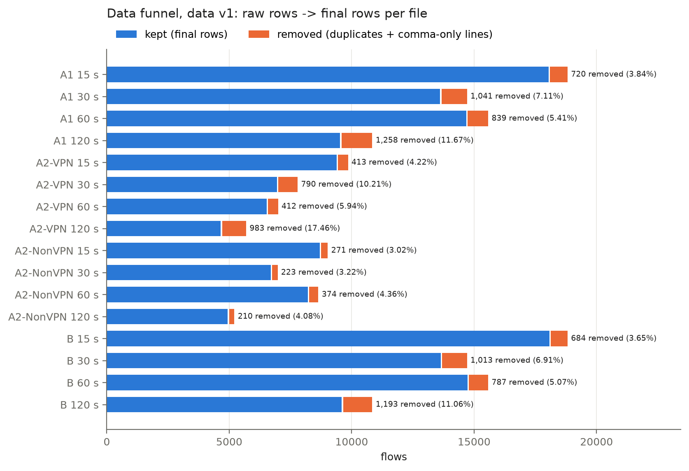
Figure 1. Data funnel
Removals are uneven by class, so they change the class balance.
A1
class | 15 s | 30 s | 60 s | 120 s
Non-VPN | 278 of 8,965 | 229 of 6,917 | 393 of 8,580 | 216 of 5,151
VPN | 442 of 9,793 | 812 of 7,734 | 445 of 6,935 | 1,042 of 5,631

A2-VPN
class | 15 s | 30 s | 60 s | 120 s
VPN-BROWSING | 0 of 2,500 | 0 of 2,500 | 37 of 2,500 | 256 of 2,500
VPN-CHAT | 38 of 1,196 | 38 of 780 | 36 of 514 | 39 of 349
VPN-STREAMING | 0 of 475 | 0 of 298 | 0 of 197 | 0 of 145
VPN-MAIL | 59 of 491 | 483 of 848 | 59 of 383 | 420 of 722
VPN-VOIP | 5 of 2,271 | 5 of 1,299 | 9 of 1,620 | 5 of 386
VPN-P2P | 262 of 928 | 230 of 851 | 218 of 823 | 215 of 813
VPN-FT | 49 of 1,932 | 34 of 1,158 | 53 of 898 | 48 of 716

A2-NonVPN
class | 15 s | 30 s | 60 s | 120 s
BROWSING | 0 of 2,500 | 0 of 2,500 | 0 of 2,500 | 0 of 2,500
CHAT | 3 of 890 | 7 of 595 | 24 of 778 | 3 of 242
STREAMING | 32 of 482 | 31 of 342 | 31 of 252 | 31 of 208
MAIL | 11 of 249 | 4 of 81 | 117 of 849 | 11 of 185
VOIP | 5 of 2,826 | 3 of 1,438 | 36 of 1,829 | 3 of 392
P2P | 59 of 1,000 | 7 of 1,000 | 4 of 1,000 | 2 of 1,000
FT | 161 of 1,018 | 171 of 961 | 162 of 1,372 | 160 of 624

B
class | 15 s | 30 s | 60 s | 120 s
BROWSING | 0 of 2,500 | 0 of 2,500 | 0 of 2,500 | 0 of 2,500
CHAT | 3 of 890 | 7 of 595 | 24 of 778 | 3 of 242
STREAMING | 32 of 482 | 31 of 342 | 31 of 252 | 31 of 208
MAIL | 11 of 249 | 4 of 81 | 117 of 849 | 11 of 185
VOIP | 5 of 2,826 | 3 of 1,438 | 36 of 1,829 | 3 of 392
P2P | 59 of 1,000 | 7 of 1,000 | 4 of 1,000 | 2 of 1,000
FT | 161 of 1,018 | 171 of 961 | 162 of 1,372 | 160 of 624
VPN-BROWSING | 0 of 2,500 | 0 of 2,500 | 37 of 2,500 | 256 of 2,500
VPN-CHAT | 38 of 1,196 | 38 of 780 | 36 of 514 | 39 of 349
VPN-STREAMING | 0 of 475 | 0 of 298 | 0 of 197 | 0 of 145
VPN-MAIL | 59 of 491 | 483 of 848 | 59 of 383 | 420 of 722
VPN-VOIP | 5 of 2,271 | 5 of 1,299 | 9 of 1,620 | 5 of 386
VPN-P2P | 262 of 928 | 230 of 851 | 218 of 823 | 215 of 813
VPN-FT | 49 of 1,932 | 34 of 1,158 | 53 of 898 | 48 of 716

file | groups | rows | test rows with a conflicting twin in train
A1 15 s | 23 | 46 | 4
A1 30 s | 22 | 44 | 8
A1 60 s | 47 | 94 | 9
A1 120 s | 31 | 62 | 7
A2-VPN 15 s | 24 | 53 | 9
A2-VPN 30 s | 17 | 39 | 4
A2-VPN 60 s | 28 | 61 | 6
A2-VPN 120 s | 52 | 111 | 11
A2-NonVPN 15 s | 3 | 10 | 3
A2-NonVPN 30 s | 3 | 9 | 2
A2-NonVPN 60 s | 15 | 34 | 6
A2-NonVPN 120 s | 3 | 9 | 1
B 15 s | 41 | 100 | 15
B 30 s | 33 | 83 | 15
B 60 s | 75 | 174 | 25
B 120 s | 77 | 173 | 21

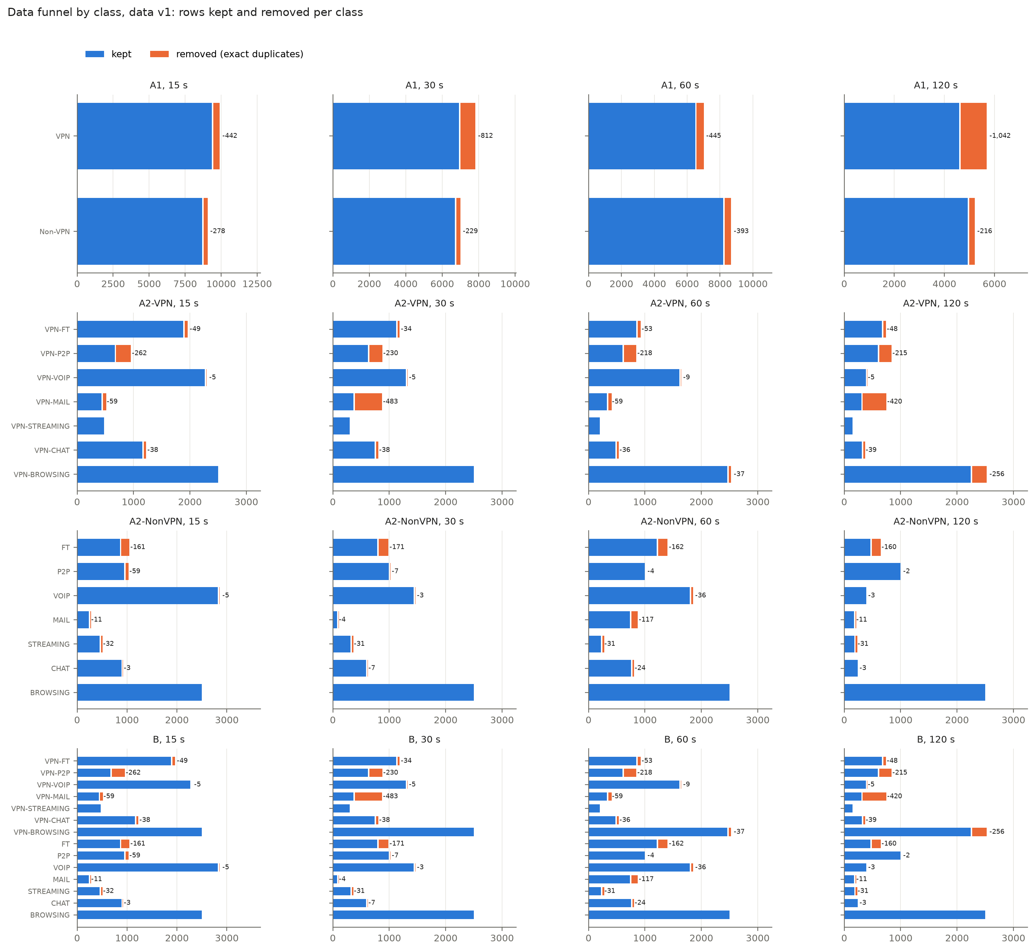
Figure 2. Data funnel by class
Per class, from raw rows to the final train / validation / test sets:
A1
class | timeout | raw | final | train | val | test
Non-VPN | 15 s | 8,965 | 8,687 | 6,081 | 1,303 | 1,303
VPN | 15 s | 9,793 | 9,351 | 6,545 | 1,403 | 1,403
Non-VPN | 30 s | 6,917 | 6,688 | 4,681 | 1,004 | 1,003
VPN | 30 s | 7,734 | 6,922 | 4,845 | 1,038 | 1,039
Non-VPN | 60 s | 8,580 | 8,187 | 5,731 | 1,228 | 1,228
VPN | 60 s | 6,935 | 6,490 | 4,542 | 974 | 974
Non-VPN | 120 s | 5,151 | 4,935 | 3,454 | 741 | 740
VPN | 120 s | 5,631 | 4,589 | 3,212 | 688 | 689

A2-VPN
class | timeout | raw | final | train | val | test
VPN-BROWSING | 15 s | 2,500 | 2,500 | 1,750 | 375 | 375
VPN-CHAT | 15 s | 1,196 | 1,158 | 810 | 174 | 174
VPN-STREAMING | 15 s | 475 | 475 | 333 | 71 | 71
VPN-MAIL | 15 s | 491 | 432 | 302 | 65 | 65
VPN-VOIP | 15 s | 2,271 | 2,266 | 1,586 | 340 | 340
VPN-P2P | 15 s | 928 | 666 | 466 | 100 | 100
VPN-FT | 15 s | 1,932 | 1,883 | 1,319 | 282 | 282
VPN-BROWSING | 30 s | 2,500 | 2,500 | 1,750 | 375 | 375
VPN-CHAT | 30 s | 780 | 742 | 520 | 111 | 111
VPN-STREAMING | 30 s | 298 | 298 | 208 | 45 | 45
VPN-MAIL | 30 s | 848 | 365 | 255 | 55 | 55
VPN-VOIP | 30 s | 1,299 | 1,294 | 906 | 194 | 194
VPN-P2P | 30 s | 851 | 621 | 435 | 93 | 93
VPN-FT | 30 s | 1,158 | 1,124 | 786 | 169 | 169
VPN-BROWSING | 60 s | 2,500 | 2,463 | 1,724 | 369 | 370
VPN-CHAT | 60 s | 514 | 478 | 334 | 72 | 72
VPN-STREAMING | 60 s | 197 | 197 | 139 | 29 | 29
VPN-MAIL | 60 s | 383 | 324 | 227 | 49 | 48
VPN-VOIP | 60 s | 1,620 | 1,611 | 1,127 | 242 | 242
VPN-P2P | 60 s | 823 | 605 | 423 | 91 | 91
VPN-FT | 60 s | 898 | 845 | 591 | 127 | 127
VPN-BROWSING | 120 s | 2,500 | 2,244 | 1,570 | 337 | 337
VPN-CHAT | 120 s | 349 | 310 | 216 | 47 | 47
VPN-STREAMING | 120 s | 145 | 145 | 101 | 22 | 22
VPN-MAIL | 120 s | 722 | 302 | 212 | 45 | 45
VPN-VOIP | 120 s | 386 | 381 | 267 | 57 | 57
VPN-P2P | 120 s | 813 | 598 | 418 | 90 | 90
VPN-FT | 120 s | 716 | 668 | 468 | 100 | 100

A2-NonVPN
class | timeout | raw | final | train | val | test
BROWSING | 15 s | 2,500 | 2,500 | 1,750 | 375 | 375
CHAT | 15 s | 890 | 887 | 621 | 133 | 133
STREAMING | 15 s | 482 | 450 | 315 | 67 | 68
MAIL | 15 s | 249 | 238 | 166 | 36 | 36
VOIP | 15 s | 2,826 | 2,821 | 1,975 | 423 | 423
P2P | 15 s | 1,000 | 941 | 659 | 141 | 141
FT | 15 s | 1,018 | 857 | 599 | 129 | 129
BROWSING | 30 s | 2,500 | 2,500 | 1,750 | 375 | 375
CHAT | 30 s | 595 | 588 | 412 | 88 | 88
STREAMING | 30 s | 342 | 311 | 217 | 47 | 47
MAIL | 30 s | 81 | 77 | 53 | 12 | 12
VOIP | 30 s | 1,438 | 1,435 | 1,005 | 215 | 215
P2P | 30 s | 1,000 | 993 | 695 | 149 | 149
FT | 30 s | 961 | 790 | 553 | 118 | 119
BROWSING | 60 s | 2,500 | 2,500 | 1,750 | 375 | 375
CHAT | 60 s | 778 | 754 | 528 | 113 | 113
STREAMING | 60 s | 252 | 221 | 155 | 33 | 33
MAIL | 60 s | 849 | 732 | 512 | 110 | 110
VOIP | 60 s | 1,829 | 1,793 | 1,255 | 269 | 269
P2P | 60 s | 1,000 | 996 | 697 | 150 | 149
FT | 60 s | 1,372 | 1,210 | 847 | 181 | 182
BROWSING | 120 s | 2,500 | 2,500 | 1,750 | 375 | 375
CHAT | 120 s | 242 | 239 | 167 | 36 | 36
STREAMING | 120 s | 208 | 177 | 124 | 26 | 27
MAIL | 120 s | 185 | 174 | 122 | 26 | 26
VOIP | 120 s | 392 | 389 | 273 | 58 | 58
P2P | 120 s | 1,000 | 998 | 698 | 150 | 150
FT | 120 s | 624 | 464 | 324 | 70 | 70

B
class | timeout | raw | final | train | val | test
BROWSING | 15 s | 2,500 | 2,500 | 1,750 | 375 | 375
CHAT | 15 s | 890 | 887 | 621 | 133 | 133
STREAMING | 15 s | 482 | 450 | 315 | 68 | 67
MAIL | 15 s | 249 | 238 | 166 | 36 | 36
VOIP | 15 s | 2,826 | 2,821 | 1,975 | 423 | 423
P2P | 15 s | 1,000 | 941 | 659 | 141 | 141
FT | 15 s | 1,018 | 857 | 600 | 128 | 129
VPN-BROWSING | 15 s | 2,500 | 2,500 | 1,750 | 375 | 375
VPN-CHAT | 15 s | 1,196 | 1,158 | 810 | 174 | 174
VPN-STREAMING | 15 s | 475 | 475 | 333 | 71 | 71
VPN-MAIL | 15 s | 491 | 432 | 302 | 65 | 65
VPN-VOIP | 15 s | 2,271 | 2,266 | 1,586 | 340 | 340
VPN-P2P | 15 s | 928 | 666 | 466 | 100 | 100
VPN-FT | 15 s | 1,932 | 1,883 | 1,318 | 282 | 283
BROWSING | 30 s | 2,500 | 2,500 | 1,750 | 375 | 375
CHAT | 30 s | 595 | 588 | 412 | 88 | 88
STREAMING | 30 s | 342 | 311 | 217 | 47 | 47
MAIL | 30 s | 81 | 77 | 54 | 11 | 12
VOIP | 30 s | 1,438 | 1,435 | 1,005 | 215 | 215
P2P | 30 s | 1,000 | 993 | 695 | 149 | 149
FT | 30 s | 961 | 790 | 553 | 119 | 118
VPN-BROWSING | 30 s | 2,500 | 2,500 | 1,750 | 375 | 375
VPN-CHAT | 30 s | 780 | 742 | 520 | 111 | 111
VPN-STREAMING | 30 s | 298 | 298 | 208 | 45 | 45
VPN-MAIL | 30 s | 848 | 365 | 255 | 55 | 55
VPN-VOIP | 30 s | 1,299 | 1,294 | 906 | 194 | 194
VPN-P2P | 30 s | 851 | 621 | 435 | 93 | 93
VPN-FT | 30 s | 1,158 | 1,124 | 786 | 169 | 169
BROWSING | 60 s | 2,500 | 2,500 | 1,750 | 375 | 375
CHAT | 60 s | 778 | 754 | 528 | 113 | 113
STREAMING | 60 s | 252 | 221 | 155 | 33 | 33
MAIL | 60 s | 849 | 732 | 512 | 110 | 110
VOIP | 60 s | 1,829 | 1,793 | 1,255 | 269 | 269
P2P | 60 s | 1,000 | 996 | 698 | 149 | 149
FT | 60 s | 1,372 | 1,210 | 847 | 182 | 181
VPN-BROWSING | 60 s | 2,500 | 2,463 | 1,724 | 369 | 370
VPN-CHAT | 60 s | 514 | 478 | 334 | 72 | 72
VPN-STREAMING | 60 s | 197 | 197 | 138 | 30 | 29
VPN-MAIL | 60 s | 383 | 324 | 227 | 48 | 49
VPN-VOIP | 60 s | 1,620 | 1,611 | 1,127 | 242 | 242
VPN-P2P | 60 s | 823 | 605 | 423 | 91 | 91
VPN-FT | 60 s | 898 | 845 | 591 | 127 | 127
BROWSING | 120 s | 2,500 | 2,500 | 1,750 | 375 | 375
CHAT | 120 s | 242 | 239 | 167 | 36 | 36
STREAMING | 120 s | 208 | 177 | 124 | 26 | 27
MAIL | 120 s | 185 | 174 | 122 | 26 | 26
VOIP | 120 s | 392 | 389 | 273 | 58 | 58
P2P | 120 s | 1,000 | 998 | 698 | 150 | 150
FT | 120 s | 624 | 464 | 324 | 70 | 70
VPN-BROWSING | 120 s | 2,500 | 2,244 | 1,570 | 337 | 337
VPN-CHAT | 120 s | 349 | 310 | 217 | 47 | 46
VPN-STREAMING | 120 s | 145 | 145 | 101 | 22 | 22
VPN-MAIL | 120 s | 722 | 302 | 212 | 45 | 45
VPN-VOIP | 120 s | 386 | 381 | 267 | 57 | 57
VPN-P2P | 120 s | 813 | 598 | 418 | 90 | 90
VPN-FT | 120 s | 716 | 668 | 468 | 100 | 100

In sentences. For task A1 at 15 s, 18,758 flows were parsed. After removing 720 exact duplicates (442 VPN, 278 non-VPN), 18,038 unique flows remained. All 23 features were kept without feature selection or normalization, and the flows were split 12,626 / 2,706 / 2,706 into training, validation and test sets. Duplicates are most common at the 120 s timeout: 1,258 of 10,782 A1 flows (11.67%) and 983 of 5,631 A2-VPN flows (17.46%). They hit some classes much harder than others: VPN-MAIL lost 483 of 848 flows at 30 s and 420 of 722 at 120 s, FT lost 160-171 flows at every timeout, and BROWSING lost none. A1 loses slightly more rows than B at the same timeout (720 vs 684 at 15 s) because flows that share features but differ in traffic type become exact duplicates once both are labelled with the same VPN / non-VPN label. After cleaning, no exact duplicate crosses train and test in any file; 1-25 test flows per file have a twin in training with the same features but a different label.
Deliberately not done, and why. No values were imputed (none are missing). No -1 code was replaced and nothing was set to zero, because -1 has a meaning. No flag columns were added, since the matching zero mean already marks the same rows and flags would change the paper's 23-feature set. No rows were dropped as outliers, because long, bursty or single-packet flows are real traffic. No features were scaled or selected and no classes were rebalanced at data level; all of that happens inside model pipelines, fitted on training data only (Section 3).

2.8 Timeouts
Within each task the feature names, their order and their units are the same at all four timeouts. The number of flows falls as the timeout grows (A1: 18,038 at 15 s to 9,524 at 120 s), and the class mix moves a lot. One class's share changes by up to 24.6 percentage points in A2-NonVPN (VOIP 32.5% at 15 s vs 7.9% at 120 s; BROWSING 28.8% vs 50.6%), 21.6 in A2-VPN, 12.2 in B and 7.6 in A1. A difference in scores between timeouts is therefore confounded by class mix, and we do not attribute it to the timeout alone.
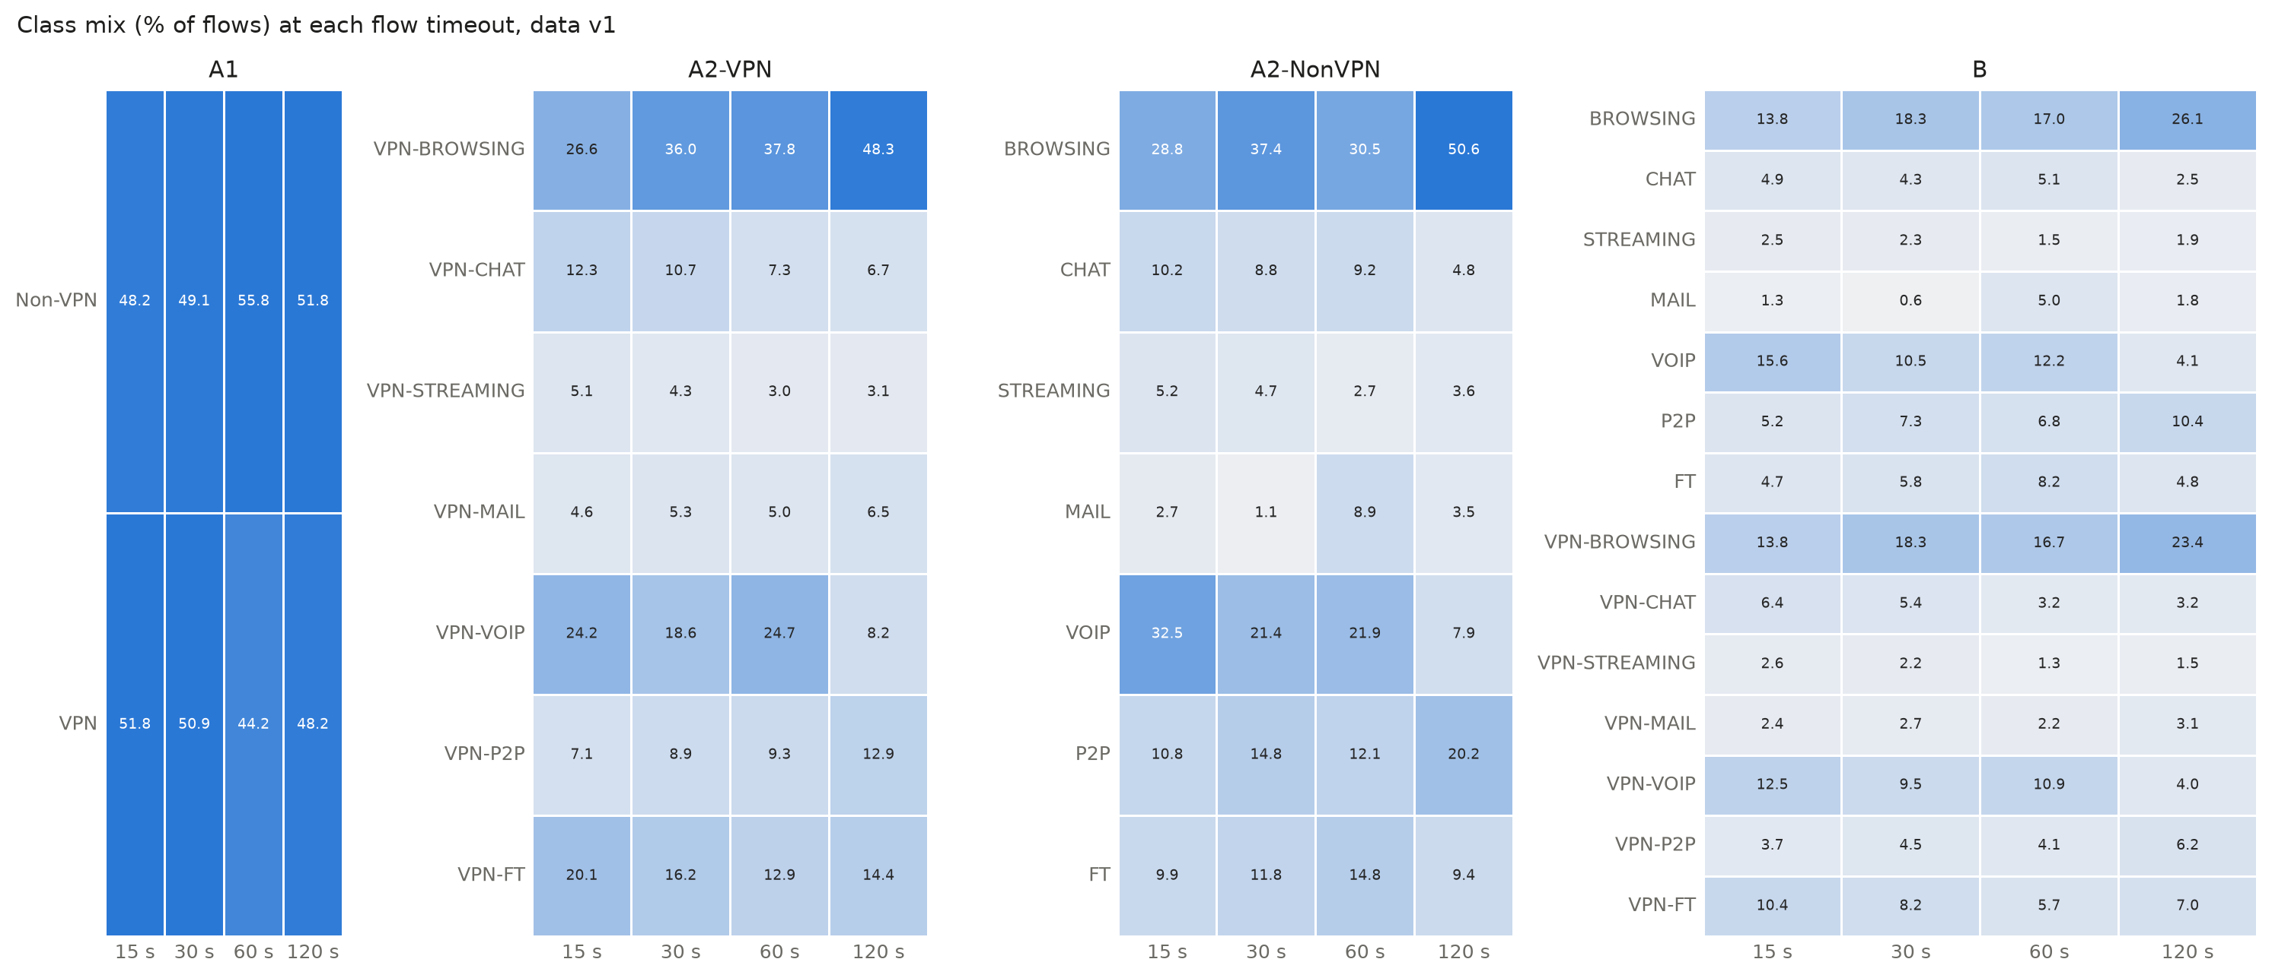
Figure 3. Class mix per timeout
The 60 s files differ in what some classes look like. At 15, 30 and 120 s, non-VPN VOIP flows send about 100 packets per second with a 20 ms median forward gap, and VPN-VOIP flows about 2 with a gap of about 960 ms. At 60 s the two are almost reversed (2.1 packets/s and 962 ms for VOIP, 16.5 packets/s and 18 ms for VPN-VOIP), and non-VPN FT drops from 1,237-3,739 to 56.5 packets/s. It is not a label swap. Of 7,041 flows found identically in more than one timeout file, 210 change label between timeouts; they are mostly 2-packet flows, and no VoIP pair is among them. The 60 s files are also the only ones exported with the paper-style header, so they may come from a different export run. The ARFF files can't settle the cause. Results at 60 s are therefore read with care and the issue is listed under Limitations (Section 7).
class, timeout | flows | median packets per second | median mean_fiat (us) | % mean_fiat 15-25 ms | % no active/idle period
VOIP 15s | 2,821 | 100.1 | 19994.9 | 78.1 | 99.4
VOIP 30s | 1,435 | 100.0 | 19998.1 | 77.1 | 98.9
VOIP 60s | 1,793 | 2.1 | 961624.6 | 31.2 | 51.5
VOIP 120s | 389 | 100.0 | 19999.8 | 73.5 | 95.4
FT 15s | 857 | 1236.7 | 1042.8 | 1.2 | 69.4
FT 30s | 790 | 2155.9 | 768.0 | 1.5 | 72.0
FT 60s | 1,210 | 56.5 | 34444.3 | 7.8 | 80.1
FT 120s | 464 | 3738.5 | 507.5 | 0.4 | 78.9
VPN-VOIP 15s | 2,266 | 2.2 | 960175.4 | 42.9 | 64.4
VPN-VOIP 30s | 1,294 | 2.1 | 960284.3 | 37.7 | 56.6
VPN-VOIP 60s | 1,611 | 16.5 | 18295.3 | 15.7 | 71.6
VPN-VOIP 120s | 381 | 2.1 | 960800.7 | 32.3 | 49.3
VPN-FT 15s | 1,883 | 7.1 | 192693.4 | 0.7 | 55.1
VPN-FT 30s | 1,124 | 4.0 | 416771.2 | 0.8 | 35.0
VPN-FT 60s | 845 | 6.1 | 286898.0 | 1.4 | 45.1
VPN-FT 120s | 668 | 7.5 | 187957.4 | 2.1 | 48.8

2.9 The Kaggle copy used by Isnan et al.
The Kaggle file used by Isnan et al. [13] has 59,706 rows and the A2 header. Compared as a multiset of rows, it equals the eight A2 files (VPN and non-VPN at all four timeouts) stacked: no row is left over at 12 significant digits, and the labels are the same. It has 40,987 unique rows, their count after removing 18,719 duplicates. Only 3,676 of those duplicates lie within one file; 7,093 distinct flows appear in two (2,475), three (1,286) or four (3,332) timeout files. Most of their "duplicates" are therefore the same flow built with different timeouts, and a random 80/20 split of the stacked file mixes all four timeout settings in training and test. The file also carries the A2 feature pair (total_*), not the paper's (std_*). E16 reproduces their setup and measures the effect of keeping timeouts apart (Section 4): the drop it finds is explained by training-set size, not by the mixing itself.

2.10 Data versions
Version | Date | Author | What changed | Files | Rows (raw lines -> final) | Commit
v1 | 2026-10-27 | utsav-s-r | First cleaned version | 16 core files (A1, A2-VPN, A2-NonVPN, B x 15/30/60/120 s) | 179,120 -> 167,909 | 0a36896

Figures from the exploration notebook (notebooks/01_eda.ipynb): class counts per task and timeout (class_counts_v1.png), feature distributions by class at every timeout (feature_boxes_<task>_<timeout>s.png, 16 figures) and feature correlations (correlation_<task>_15s.png, all four tasks), the data funnel by class (data_funnel_by_class_v1.png). The notebook records two findings that matter later. Classes differ by orders of magnitude on rate and gap features (VPN-STREAMING: median 202 packets/s; VPN-VOIP: 2.2). Many features are near-duplicates: 19 of 253 pairs in A1 and B (27 in A2-VPN, 20 in A2-NonVPN) have Spearman |rho| >= 0.9, mostly within the active/idle group. Feature importances will therefore be shared out among correlated features.

3 Method

3.1 Pipeline overview
All code is in the project repository (Python 3.12). Dependencies are managed with uv; exact package versions are fixed in uv.lock, so every team member and every rerun uses identical library versions. The main libraries are pandas and NumPy (data), liac-arff and pyarrow (reading ARFF, writing Parquet), scikit-learn [3] (models, pipelines, metrics), MLflow [8] (run tracking), matplotlib and seaborn (figures) and SHAP [6] (explanations). XGBoost [4], LightGBM [5], Optuna [7] and imbalanced-learn [9] were added together in one commit before the first Phase 3 run, so every Phase 3 run uses the same locked library versions.
The flow of data and results is:
- Raw data. The 20 ARFF files of ISCXVPN2016 [2] are kept unchanged; their SHA-256 hashes are recorded in data/arff_sha256.txt and checked on every machine.
- Preparation. scripts/prepare_data.py parses the files, applies the verified column-name map and the cleaning rules, and writes one Parquet file per task and timeout to a versioned folder data/processed/vN/. [Column-name check and cleaning rules: E00.]
- Training. scripts/run_experiment.py reads one YAML configuration file, builds a scikit-learn Pipeline (preprocessing + model), runs 5-fold cross-validation on the training set, fits on the training set and scores the validation set.
- Tracking. Every run is logged to MLflow (Section 3.6).
- Reporting. scripts/export_history.py exports every run to reports/history.csv; scripts/results_tables.py builds every result table from it, and the notebooks (written for Phase 3 by scripts/make_notebooks.py) draw the figures from it, so no number in this report is copied by hand.

3.2 Data versions
Any change that alters the cleaned data (a cleaning rule, the column map, the parser, row filtering or the split seed) creates a new data version (v1, v2, …) in its own folder, which is never overwritten. Each version has a manifest (file hashes, row and label counts, column map, cleaning rules) and a step-by-step cleaning log listing, for every step, the rows before and after, rows removed or changed (overall and per class), the rule and its reason. Steps that change nothing and decisions not to do something are logged too. Every run records the data version and its hash. After a version change, the current best model is rerun as its own experiment so the effect of the change is measured. [Data versions: see Section 2 and the data changelog.]

3.3 Splits and evaluation protocol
For each task and timeout the cleaned data is split once into 70% training, 15% validation and 15% test sets, stratified by class, with random seed 42. The row indices are saved inside the data version, so every run on that version uses exactly the same rows.
- Hyperparameters are chosen by 5-fold stratified cross-validation inside the training set only.
- Candidate models are compared on the validation set.
- The chosen configuration is retrained on training + validation data and scored once on the test set, at the final milestone, with 95% percentile intervals from 10,000 stratified bootstrap resamples (rows drawn with replacement within each true class, so every resample keeps the test set's class counts; seed 42). A comparison set (the best validation variant of each method type per task, Section 3.8) is fixed before the test set is opened and scored the same way, once; it never changes the chosen configuration. 26 differences are tested, fixed before the test set is opened (E12): per task the chosen model against each of the other six method types, and against the old-rule pick (Section 3.8) in A1 and A2-VPN. Each test is a two-sided paired bootstrap on macro F1 (the same resampled rows for both models), Holm-corrected over all 26 at alpha 0.05; other differences and metrics are only described. 10,000 resamples are needed because with 1,000 the smallest possible p-value (0.0020) is above Holm's first threshold (0.05 / 26 = 0.0019).
- Calibration (E15) is decided on the validation set before the test set is opened; it changes only the reported confidence, never the predicted class. The isotonic calibrator learns from 5-fold out-of-fold predictions on the training rows, with the same shuffled folds (seed 42) as every other cross-validation here: unshuffled folds over the file-ordered rows hold out whole blocks of the files and give far too poor out-of-fold predictions (E15).
- Scaling, transforms and resampling are steps inside the pipeline, so they are fitted on training folds only and never see validation or test rows.
- Every random step (split, models, tuning sampler, oversampling, bootstrap) uses seed 42. Only the learning-curve and seed-stability experiments (E13, E14) use seeds 42–51, on purpose.
Paper benchmark. To compare with Draper-Gil et al. [1], the decision tree and KNN are also run with the paper's own protocol: 10-fold cross-validation on the full file with Weka's default settings (KNN with k = 1; C4.5 with pruning confidence 0.25 and at least 2 samples per leaf). These results are reported in their own table. scikit-learn's decision tree with the entropy criterion is a close substitute for C4.5 [11], not an exact copy, and is called a C4.5 approximation.
Session-aware check. Flows from one recording session may fall on both sides of a random split and inflate scores. A group-aware split would keep each session on one side, but the ARFF files hold only the 23 timing features and the label: no capture-file name, address, port or timestamp identifies a session (E00). E11 therefore cannot run, and this is listed as a limitation (Section 7).

3.4 Models
Model | Settings | Experiment
Majority class | Always predicts the most frequent class (the floor) | E01
Decision tree | Entropy criterion (C4.5 approximation); then tuned | E02, E17
KNN | k = 5, standard scaling; signed log + standard or robust scaling; then tuned | E03, E04, E07
Logistic Regression | Standard scaling; then tuned, signed log optional | E03, E17
SVM, RBF kernel | Standard scaling; then tuned, signed log optional | E03, E17
Random Forest | 300 trees, default settings; then tuned | E05, E07, E17
XGBoost, LightGBM | Default settings; then tuned | E06, E07, E17
Class balancing | Class weights, random oversampling, SMOTE (inside the pipeline) | E08
Two-step model (task B) | VPN / non-VPN model, then one 7-class model per group | E10

Every baseline is run on all tasks (A1; A2-VPN and A2-NonVPN as separate models; B) at all four timeouts. Improvement experiments change one thing at a time against the current best model: preprocessing for KNN (E04), tuning with Optuna, 50 trials per model with the same budget for the best baseline (E07), class imbalance handling (E08: none, class weights, random oversampling, SMOTE [10]), feature-group ablation (E09), direct vs two-step classification for task B (E10), and the same 50-trial tuning budget for every remaining method type (E17). The chosen models are then described by a learning curve (E13) and a split-seed stability check (E14), and a published result on a copy of this dataset is reproduced and corrected (E16). Each experiment states its hypothesis and a numeric pass/fail threshold before it is run.

3.5 Metrics
The main metric is macro F1, which weights every class equally, so small classes count as much as large ones. We also report per-class precision, recall and F1; weighted F1; accuracy; balanced accuracy; confusion matrices and the five most frequent confusion pairs; ROC-AUC (task A1); cross-validation mean and standard deviation; the gap between cross-validation and held-out scores; training time, prediction time per 1,000 flows, model size and peak memory; and, for the final models, Expected Calibration Error with a reliability diagram (E15). Comparisons with the paper use precision against precision and recall against recall.

3.6 Tracking and reproducibility
Every run is logged automatically to MLflow with: the experiment ID, the person and machine that ran it (operating system, CPU, memory), the git commit, whether there were uncommitted changes, the hash of the dependency lock file, the configuration file, the data version and hash, all settings, all metrics, timing, model size and memory, plots, and the trained model file (every official run except individual tuning trials). Official runs are made on one machine, so timings are comparable, and only from code that is committed and pushed to the shared repository; the run script refuses otherwise. Each experiment also has a written entry (hypothesis, threshold, change, result, verdict, decision), and milestones are marked with git tags (v0.1-baseline, v0.2-tuned, v1.0-final).

3.7 Preprocessing for distance-based models: the signed log
KNN, logistic regression and the RBF-kernel SVM depend on distances or linear scales, and the raw timing features span six or more orders of magnitude (microseconds up to about 1.2e8), so a few very large values dominate. A log compresses them, but plain log1p is not usable here: the features hold -1 codes meaning "not measurable" (log1p(-1) is minus infinity) and 586 negative minimum inter-arrival times (E00). We therefore apply the signed log sign(x)·log1p(|x|) as a step inside the pipeline, before scaling. It is defined for every value, keeps the order of values, keeps -1 apart from 0, and is a fixed formula: nothing is learned from data, so it cannot leak information from validation or test rows. Data v1 is not changed. Alternatives not chosen: shifting each column so its minimum is 0 before the log (a shift learned from the training data, different per column, and -1 merges into small values); logging only the non-negative columns (inconsistent, and large values stay uncompressed); replacing -1 by 0 plus indicator columns (changes the feature set, so E04 would change two things at once). E04 compares the signed log with StandardScaler and with RobustScaler; in E17 logistic regression and the SVM choose it inside their search (both chose it in every task). Tree models are not affected by any order-keeping transform, so they get none.

3.8 Phase 3 rules and decisions
These rules were fixed before the Phase 3 runs (28 Oct) unless stated otherwise; each experiment entry repeats the ones it uses before it runs.
- One change at a time. Each experiment changes one thing against the current best model of each task: the highest 15 s validation macro F1 so far, whatever the margin.
- Winner rule. Every experiment runs first at 15 s for all four tasks. A model whose 15 s validation macro F1 beats the task's current best by at least 0.03 is rerun at 30, 60 and 120 s with its 15 s settings (nothing is re-tuned per timeout). Why 0.03: it is above the largest Phase 2 cross-validation standard deviation (0.025), so a smaller gain could be noise from the split; a fixed number set before running keeps the choice honest. Not chosen: rerunning the top two per task, or running everything at every timeout (about four times the runs, and no screen-then-confirm design).
- Tuning (E07, E17). Optuna with the TPE sampler (seed 42), 50 trials per search, trials run one after another (parallel trials are not reproducible). Each trial is scored by 5-fold cross-validation macro F1 on the training rows only. E07 tunes, per task, the best two of Random Forest, XGBoost and LightGBM plus KNN with the same budget, so no model wins only because it was tuned more. E17 (added 28 Oct after E10) gives the same budget to every other method type, so the comparison of method types is between tuned models. Search ranges were written into the configurations before running. The best trial is retrained and scored like any other run; trials keep their settings and scores only.
- Balancing (E08). Inside the pipeline (imbalanced-learn), so only training folds are resampled. XGBoost has no class-weight option, so its "balanced" step uses per-row sample weights. SMOTE uses 5 neighbours; the smallest training class in any task file has 53 rows (MAIL, A2-NonVPN 30 s), about 42 per cross-validation fold, so it is always possible.
- Two-step model (E10). Both steps train on task B's training rows only; the VPN / non-VPN label comes from the B label. The A1 split is never used, because A1 and B hold the same flows split differently, so an A1-trained model would have seen B validation flows.
- Analysis experiments (E09, E13, E14) describe the chosen models and change nothing. If a feature set in E09 had scored at least 0.03 above all 23 features, the work would have stopped for a decision, because choosing features on validation scores risks overfitting the choice. E13 and E14 use other seeds on purpose and never touch the seed-42 test rows.
- Reproducing Isnan et al. (E16) uses its own data version (kaggle-k1, built by a committed script with its own manifest and hashes); data v1 is untouched, and no E16 result feeds model selection.
- Cost and resources. Every model runs on one thread (XGBoost and LightGBM included), with the five cross-validation folds in parallel. This keeps results deterministic and timings comparable with Phase 2. Peak memory is measured twice: with Python's tracemalloc (comparable with Phase 2) and as the peak memory of a fresh process doing the fit, which also sees the native memory of XGBoost and LightGBM. Every model is saved with joblib compression level 3. This is lossless and cuts a 300-tree Random Forest from 171.9 MiB to 22.4 MiB. Both the compressed and the uncompressed size are logged.
- Final choice (decided 28 Oct after E10, a deviation from the rule set before Phase 3). The rule fixed before Phase 3 treated any gap below 0.03 as a tie, broken in favour of the simpler model. Applied as written, it would have chosen KNN or the SVM at 0.0146-0.0286 below the best model. The cross-validation standard deviations of the chosen models (0.0028-0.0058) are far below 0.03, and the goal is the best score on unseen traffic. The final configuration per task is therefore the highest validation macro F1 among all model-selection runs (any experiment, any timeout). The only fallback is a saved model file above 50 MB (GitHub's warning size), which none of the chosen models reaches. The old rule's picks were scored on the test set too (E12), so the cost of either rule is visible (Section 5.3).
- Comparison set. Fixed in configs/final/compare/ before the test set is opened: per task, the best 15 s validation variant of each of 7 method types (decision tree, KNN, logistic regression, SVM-RBF, Random Forest, XGBoost, LightGBM), 28 models. A type's variants are its default, tuned and balanced runs; KNN includes the E03 and E04 preprocessings; the E10 two-step model counts as XGBoost; the majority baseline is a reference, not a member. Only the four headline models are saved in the repository (models/final/); the others stay in the run store.

4 Experiments
Each experiment states a hypothesis and a numeric pass/fail threshold before it runs, changes one thing, and ends with a verdict (supported / not supported). Unless stated otherwise, scores are on the validation set of the fixed 70/15/15 split (seed 42); models are chosen with 5-fold cross-validation on the training set; the test set is not used until the final experiment (E12).

4.0 E00: data findings and data version v1
E00 checked the dataset before any model was trained: the corrected column names, the file-family decision, the odd-value and duplicate rules, the session question and the Kaggle finding. It produced data version v1 (167,909 flows in 16 task files). Section 2 reports it in full.

4.1 E01: majority-class baseline
What. A model that always predicts the largest training class (DummyClassifier), for every task and timeout (16 runs). Why. It is the floor every model must beat, and its scores are known in advance, so it also tests the metrics code: accuracy must equal the largest class's share p of the validation set, and macro F1 must equal 2p / ((1 + p) k) for k classes. Result. Supported: all 16 runs match both values to 4 decimals (threshold 0.001). The floor in macro F1 is 0.34-0.36 for A1, 0.06-0.10 for A2 and 0.02-0.03 for B. Accuracy alone would look much better (up to 0.56 for A1 and 0.51 for A2-NonVPN 120 s), which is why macro F1 is the main score.
task | timeout | classes | largest_class | p | val_accuracy | expected_macro_f1 | val_macro_f1 | ok
A1 | 15 s | 2 | VPN | 0.5185 | 0.5185 | 0.3414 | 0.3414 | yes
A1 | 30 s | 2 | VPN | 0.5083 | 0.5083 | 0.337 | 0.337 | yes
A1 | 60 s | 2 | Non-VPN | 0.5577 | 0.5577 | 0.358 | 0.358 | yes
A1 | 120 s | 2 | Non-VPN | 0.5185 | 0.5185 | 0.3415 | 0.3415 | yes
A2-VPN | 15 s | 7 | VPN-BROWSING | 0.2665 | 0.2665 | 0.0601 | 0.0601 | yes
A2-VPN | 30 s | 7 | VPN-BROWSING | 0.3599 | 0.3599 | 0.0756 | 0.0756 | yes
A2-VPN | 60 s | 7 | VPN-BROWSING | 0.3769 | 0.3769 | 0.0782 | 0.0782 | yes
A2-VPN | 120 s | 7 | VPN-BROWSING | 0.4828 | 0.4828 | 0.093 | 0.093 | yes
A2-NonVPN | 15 s | 7 | VOIP | 0.3244 | 0.3244 | 0.07 | 0.07 | yes
A2-NonVPN | 30 s | 7 | BROWSING | 0.3735 | 0.3735 | 0.0777 | 0.0777 | yes
A2-NonVPN | 60 s | 7 | BROWSING | 0.3046 | 0.3046 | 0.0667 | 0.0667 | yes
A2-NonVPN | 120 s | 7 | BROWSING | 0.5061 | 0.5061 | 0.096 | 0.096 | yes
B | 15 s | 14 | VOIP | 0.156 | 0.156 | 0.0193 | 0.0193 | yes
B | 30 s | 14 | BROWSING | 0.1833 | 0.1833 | 0.0221 | 0.0221 | yes
B | 60 s | 14 | BROWSING | 0.1697 | 0.1697 | 0.0207 | 0.0207 | yes
B | 120 s | 14 | BROWSING | 0.2606 | 0.2606 | 0.0295 | 0.0295 | yes

4.2 E02 and E03: decision tree, KNN, Logistic Regression and SVM-RBF
What. Four baselines, each a scikit-learn pipeline, run on all 16 task/timeout files (64 runs): an unpruned entropy decision tree (E02; the closest scikit-learn model to C4.5, so a "C4.5 approximation"), KNN with k = 5 and standard scaling, Logistic Regression and an RBF-kernel SVM, both with standard scaling (E03). Scaling is a pipeline step, fitted on training rows only. Why. The tree and KNN are the paper's two algorithms. Logistic Regression and SVM-RBF match the baselines of Isnan et al. [13]. Together they set the bar for the improvements in Phase 3. Hypotheses and thresholds (written before running). E02: the tree beats the floor by at least 0.30 in every config and reaches at least 0.80 on A1 at every timeout. E03: all three beat the floor by at least 0.10; KNN is within 0.10 of the tree in at least 12 of 16 configs; Logistic Regression and SVM-RBF score below the tree in at least 12 of 16 configs, because the features are heavy-tailed (microsecond times up to about 10^8 next to -1 and 0 codes). Result. All supported. The tree is the best baseline in all 16 configs (macro F1 0.706-0.890), 0.499-0.765 above the floor. KNN is second everywhere, 0.039-0.101 below the tree (within 0.10 in 15 of 16). Logistic Regression (0.270-0.598) and SVM-RBF (0.274-0.621) are below the tree in all 16.
Validation macro F1 (E01-E03):
task | timeout | majority | tree | knn | logreg | svm_rbf
A1 | 15 s | 0.341 | 0.890 | 0.813 | 0.585 | 0.602
A1 | 30 s | 0.337 | 0.864 | 0.825 | 0.598 | 0.610
A1 | 60 s | 0.358 | 0.857 | 0.813 | 0.541 | 0.545
A1 | 120 s | 0.341 | 0.857 | 0.807 | 0.576 | 0.621
A2-VPN | 15 s | 0.060 | 0.825 | 0.774 | 0.432 | 0.468
A2-VPN | 30 s | 0.076 | 0.828 | 0.788 | 0.536 | 0.542
A2-VPN | 60 s | 0.078 | 0.775 | 0.730 | 0.339 | 0.330
A2-VPN | 120 s | 0.093 | 0.780 | 0.727 | 0.332 | 0.332
A2-NonVPN | 15 s | 0.070 | 0.829 | 0.773 | 0.449 | 0.487
A2-NonVPN | 30 s | 0.078 | 0.828 | 0.783 | 0.486 | 0.468
A2-NonVPN | 60 s | 0.067 | 0.825 | 0.750 | 0.447 | 0.441
A2-NonVPN | 120 s | 0.096 | 0.839 | 0.769 | 0.482 | 0.471
B | 15 s | 0.019 | 0.759 | 0.660 | 0.307 | 0.296
B | 30 s | 0.022 | 0.748 | 0.647 | 0.320 | 0.311
B | 60 s | 0.021 | 0.706 | 0.617 | 0.271 | 0.278
B | 120 s | 0.030 | 0.716 | 0.637 | 0.270 | 0.274

5-fold cross-validation on the training set, mean +- standard deviation:
task | timeout | majority | tree | knn | logreg | svm_rbf
A1 | 15 s | 0.341 +- 0.000 | 0.888 +- 0.005 | 0.821 +- 0.002 | 0.600 +- 0.011 | 0.608 +- 0.005
A1 | 30 s | 0.337 +- 0.000 | 0.873 +- 0.006 | 0.814 +- 0.010 | 0.600 +- 0.012 | 0.619 +- 0.023
A1 | 60 s | 0.358 +- 0.000 | 0.852 +- 0.010 | 0.808 +- 0.009 | 0.551 +- 0.008 | 0.552 +- 0.006
A1 | 120 s | 0.341 +- 0.000 | 0.857 +- 0.009 | 0.803 +- 0.002 | 0.569 +- 0.008 | 0.608 +- 0.011
A2-VPN | 15 s | 0.060 +- 0.000 | 0.810 +- 0.007 | 0.767 +- 0.008 | 0.410 +- 0.014 | 0.448 +- 0.024
A2-VPN | 30 s | 0.076 +- 0.000 | 0.796 +- 0.009 | 0.769 +- 0.025 | 0.495 +- 0.016 | 0.507 +- 0.021
A2-VPN | 60 s | 0.078 +- 0.000 | 0.760 +- 0.016 | 0.708 +- 0.019 | 0.334 +- 0.022 | 0.331 +- 0.021
A2-VPN | 120 s | 0.093 +- 0.000 | 0.725 +- 0.023 | 0.692 +- 0.016 | 0.343 +- 0.019 | 0.317 +- 0.021
A2-NonVPN | 15 s | 0.070 +- 0.000 | 0.862 +- 0.009 | 0.792 +- 0.010 | 0.459 +- 0.013 | 0.479 +- 0.018
A2-NonVPN | 30 s | 0.078 +- 0.000 | 0.817 +- 0.015 | 0.783 +- 0.017 | 0.459 +- 0.007 | 0.426 +- 0.008
A2-NonVPN | 60 s | 0.067 +- 0.000 | 0.829 +- 0.016 | 0.740 +- 0.013 | 0.454 +- 0.015 | 0.432 +- 0.022
A2-NonVPN | 120 s | 0.096 +- 0.000 | 0.807 +- 0.015 | 0.731 +- 0.013 | 0.472 +- 0.016 | 0.441 +- 0.023
B | 15 s | 0.019 +- 0.000 | 0.757 +- 0.013 | 0.663 +- 0.008 | 0.299 +- 0.010 | 0.278 +- 0.008
B | 30 s | 0.022 +- 0.000 | 0.733 +- 0.008 | 0.654 +- 0.016 | 0.323 +- 0.009 | 0.292 +- 0.008
B | 60 s | 0.021 +- 0.000 | 0.703 +- 0.013 | 0.607 +- 0.010 | 0.275 +- 0.002 | 0.261 +- 0.009
B | 120 s | 0.030 +- 0.000 | 0.684 +- 0.020 | 0.607 +- 0.015 | 0.250 +- 0.005 | 0.251 +- 0.017

What the tables show:
- Cross-validation predicts validation. For every run, |CV mean - validation| is at most 0.054, and CV standard deviations are at most 0.025. A gap of several points between two models is therefore larger than fold-to-fold noise.
- Small classes. Logistic Regression and SVM-RBF score F1 = 0.00 on MAIL / VPN-MAIL in most A2 and B configs. So their macro F1 is far below their weighted F1 (gap up to 0.225); the tree's gap is 0.000-0.069. The SVM keeps 55-88% of the training rows as support vectors, a sign that the RBF kernel separates the standard-scaled features poorly. A log transform or a robust scaler is tested in E04.
- Easiest and hardest classes. VoIP is the easiest type (tree F1 0.92-0.99 for VOIP and VPN-VOIP). The weakest are CHAT, VPN-CHAT, STREAMING, MAIL and VPN-MAIL (tree F1 0.42-0.71).
- Most frequent confusion. In task B the largest confusion for the tree and KNN, at every timeout, is BROWSING vs VPN-BROWSING in both directions (tree: 29-45 validation flows each way). The model recognises browsing, but not whether it went through the VPN.
- Timeouts. B and A2-VPN score lower at 60 s and 120 s. The class mix differs between timeouts (Section 2.8), and the 60 s files hold differently shaped VOIP and FT flows (E00 addendum), so this is not read as an effect of the timeout.
- Cost. All baselines train in under 3 s. To predict 1,000 flows, the tree needs 0.30 ms (median), KNN 8.0 ms and the SVM 210 ms. Model files range from 1.4 KB (majority) and 4-5 KB (Logistic Regression) to 4.2 MB (SVM).
Per-class extremes for the tree (E02): macro vs weighted F1, their gap, the generalisation gap, and the best and worst class by F1 and by recall:
task | timeout | macro F1 | weighted F1 | gap | CV - val | best F1 | worst F1 | best recall | worst recall
A1 | 15 s | 0.89 | 0.89 | 0.0 | -0.002 | VPN 0.89 | Non-VPN 0.89 | Non-VPN 0.89 | VPN 0.89
A1 | 30 s | 0.864 | 0.864 | 0.0 | 0.009 | VPN 0.87 | Non-VPN 0.86 | VPN 0.87 | Non-VPN 0.86
A1 | 60 s | 0.857 | 0.859 | 0.002 | -0.005 | Non-VPN 0.87 | VPN 0.84 | Non-VPN 0.87 | VPN 0.85
A1 | 120 s | 0.857 | 0.857 | 0.0 | 0.0 | Non-VPN 0.86 | VPN 0.85 | Non-VPN 0.86 | VPN 0.85
A2-VPN | 15 s | 0.825 | 0.849 | 0.024 | -0.014 | VPN-VOIP 0.99 | VPN-CHAT 0.65 | VPN-VOIP 0.98 | VPN-CHAT 0.66
A2-VPN | 30 s | 0.828 | 0.847 | 0.02 | -0.031 | VPN-VOIP 0.98 | VPN-CHAT 0.67 | VPN-STREAMING 0.98 | VPN-CHAT 0.70
A2-VPN | 60 s | 0.775 | 0.831 | 0.056 | -0.014 | VPN-VOIP 0.92 | VPN-CHAT 0.63 | VPN-VOIP 0.92 | VPN-FT 0.65
A2-VPN | 120 s | 0.78 | 0.825 | 0.045 | -0.054 | VPN-VOIP 0.98 | VPN-CHAT 0.61 | VPN-VOIP 0.98 | VPN-CHAT 0.57
A2-NonVPN | 15 s | 0.829 | 0.891 | 0.061 | 0.033 | VOIP 0.99 | STREAMING 0.71 | VOIP 0.99 | STREAMING 0.70
A2-NonVPN | 30 s | 0.828 | 0.889 | 0.061 | -0.011 | VOIP 0.98 | STREAMING 0.68 | VOIP 0.98 | STREAMING 0.57
A2-NonVPN | 60 s | 0.825 | 0.878 | 0.053 | 0.004 | VOIP 0.97 | STREAMING 0.58 | VOIP 0.97 | STREAMING 0.55
A2-NonVPN | 120 s | 0.839 | 0.893 | 0.054 | -0.033 | VOIP 0.95 | CHAT 0.56 | BROWSING 0.95 | CHAT 0.56
B | 15 s | 0.759 | 0.81 | 0.051 | -0.001 | VOIP 0.98 | VPN-MAIL 0.55 | VOIP 0.99 | VPN-MAIL 0.52
B | 30 s | 0.748 | 0.8 | 0.053 | -0.014 | VPN-VOIP 0.98 | MAIL 0.55 | VPN-VOIP 0.99 | MAIL 0.55
B | 60 s | 0.706 | 0.775 | 0.069 | -0.002 | VOIP 0.92 | VPN-CHAT 0.42 | VOIP 0.92 | VPN-CHAT 0.42
B | 120 s | 0.716 | 0.767 | 0.051 | -0.031 | VOIP 0.97 | STREAMING 0.47 | VOIP 1.00 | CHAT 0.42

Top 5 confusion pairs of the tree on the validation set (E02):
task | timeout | top 5 confusion pairs (true -> predicted: flows)
A1 | 15 s | VPN -> Non-VPN: 158; Non-VPN -> VPN: 139
A1 | 30 s | Non-VPN -> VPN: 142; VPN -> Non-VPN: 135
A1 | 60 s | Non-VPN -> VPN: 161; VPN -> Non-VPN: 150
A1 | 120 s | Non-VPN -> VPN: 104; VPN -> Non-VPN: 100
A2-VPN | 15 s | VPN-FT -> VPN-CHAT: 28; VPN-CHAT -> VPN-BROWSING: 26; VPN-BROWSING -> VPN-CHAT: 25; VPN-CHAT -> VPN-FT: 20; VPN-FT -> VPN-BROWSING: 19
A2-VPN | 30 s | VPN-BROWSING -> VPN-CHAT: 26; VPN-FT -> VPN-BROWSING: 22; VPN-BROWSING -> VPN-FT: 15; VPN-CHAT -> VPN-BROWSING: 12; VPN-CHAT -> VPN-FT: 12
A2-VPN | 60 s | VPN-FT -> VPN-BROWSING: 17; VPN-BROWSING -> VPN-FT: 16; VPN-FT -> VPN-CHAT: 14; VPN-BROWSING -> VPN-VOIP: 13; VPN-CHAT -> VPN-FT: 12
A2-VPN | 120 s | VPN-FT -> VPN-BROWSING: 18; VPN-BROWSING -> VPN-FT: 16; VPN-CHAT -> VPN-BROWSING: 11; VPN-FT -> VPN-P2P: 9; VPN-P2P -> VPN-BROWSING: 9
A2-NonVPN | 15 s | BROWSING -> CHAT: 18; CHAT -> BROWSING: 15; BROWSING -> STREAMING: 12; FT -> BROWSING: 12; FT -> CHAT: 11
A2-NonVPN | 30 s | CHAT -> BROWSING: 12; STREAMING -> BROWSING: 11; BROWSING -> CHAT: 10; BROWSING -> FT: 10; FT -> CHAT: 9
A2-NonVPN | 60 s | CHAT -> BROWSING: 20; BROWSING -> CHAT: 19; MAIL -> FT: 8; FT -> BROWSING: 7; BROWSING -> MAIL: 6
A2-NonVPN | 120 s | CHAT -> BROWSING: 12; P2P -> BROWSING: 8; FT -> BROWSING: 7; BROWSING -> P2P: 6; BROWSING -> CHAT: 5
B | 15 s | VPN-BROWSING -> BROWSING: 41; BROWSING -> VPN-BROWSING: 39; VPN-CHAT -> VPN-FT: 25; VPN-FT -> VPN-CHAT: 24; VPN-BROWSING -> VPN-CHAT: 18
B | 30 s | VPN-BROWSING -> BROWSING: 44; BROWSING -> VPN-BROWSING: 36; VPN-BROWSING -> VPN-CHAT: 13; VPN-FT -> VPN-CHAT: 12; VPN-CHAT -> VPN-BROWSING: 11
B | 60 s | BROWSING -> VPN-BROWSING: 37; VPN-BROWSING -> BROWSING: 29; VPN-MAIL -> MAIL: 15; VPN-P2P -> P2P: 14; VPN-VOIP -> VOIP: 14
B | 120 s | BROWSING -> VPN-BROWSING: 45; VPN-BROWSING -> BROWSING: 32; VPN-BROWSING -> VPN-FT: 17; VPN-FT -> VPN-BROWSING: 12; VPN-BROWSING -> VPN-P2P: 10

Model complexity (E02 tree, E03 SVM):
task | timeout | n_train | tree depth | tree nodes | tree leaves | SVM support vectors
A1 | 15 s | 12,626 | 27 | 1,789 | 895 | 10,292
A1 | 30 s | 9,526 | 35 | 1,601 | 801 | 7,976
A1 | 60 s | 10,273 | 27 | 1,917 | 959 | 7,882
A1 | 120 s | 6,666 | 25 | 1,243 | 622 | 5,501
A2-VPN | 15 s | 6,566 | 23 | 1,407 | 704 | 4,497
A2-VPN | 30 s | 4,860 | 20 | 1,067 | 534 | 3,108
A2-VPN | 60 s | 4,565 | 24 | 1,249 | 625 | 3,265
A2-VPN | 120 s | 3,252 | 21 | 985 | 493 | 2,368
A2-NonVPN | 15 s | 6,085 | 16 | 743 | 372 | 3,329
A2-NonVPN | 30 s | 4,685 | 19 | 751 | 376 | 2,751
A2-NonVPN | 60 s | 5,744 | 24 | 1,001 | 501 | 3,803
A2-NonVPN | 120 s | 3,458 | 18 | 591 | 296 | 1,907
B | 15 s | 12,651 | 30 | 3,409 | 1,705 | 11,076
B | 30 s | 9,546 | 23 | 2,901 | 1,451 | 8,368
B | 60 s | 10,309 | 26 | 3,437 | 1,719 | 8,796
B | 120 s | 6,711 | 22 | 2,481 | 1,241 | 5,813

Cost per model over the 16 configs:
model | train time (s) median | train time (s) max | 5-fold CV time (s) median | 5-fold CV time (s) max | predict ms / 1,000 flows median | predict ms / 1,000 flows max | model file (KB) median | model file (KB) max | peak fit memory (MB) median | peak fit memory (MB) max
majority | 0.004 | 0.008 | 0.157 | 2.854 | 0.091 | 0.18 | 1.414 | 1.523 | 0.623 | 1.182
tree | 0.112 | 0.304 | 0.293 | 0.652 | 0.298 | 0.531 | 134.49 | 592.916 | 1.257 | 2.392
knn | 0.01 | 0.021 | 0.182 | 0.281 | 8.031 | 13.338 | 1242.967 | 2374.631 | 2.999 | 5.722
logreg | 0.084 | 0.428 | 0.212 | 0.603 | 0.378 | 0.69 | 3.829 | 5.196 | 3.433 | 8.144
svm_rbf | 0.626 | 2.913 | 1.61 | 3.784 | 209.808 | 596.678 | 1175.091 | 4288.896 | 3.552 | 7.781

Peak fit memory is measured with Python's tracemalloc, which counts NumPy arrays but not memory allocated inside compiled libraries (for example libsvm), so SVM memory is a lower bound. Training time comes from a fit without tracemalloc and peak memory from a separate fit of a clone. The first Phase 2 runs (commits 1817c5a and 36c56a1) timed the fit with tracemalloc on, which slowed it (x1.05 tree, x1.00 SVM, x1.19 Logistic Regression, x2.3 KNN in a recheck); all 144 configs were rerun from the fixed code (commit c450c3e) with identical scores, and these tables use the rerun. The first runs also logged process_max_rss_mb, a high-water mark of the whole batch process rather than a per-run figure; it is not used.
The same tables for KNN, Logistic Regression and SVM-RBF, plus accuracy, balanced accuracy, weighted F1 and A1 ROC-AUC for every run, are in reports/baseline_tables.md (Appendix).
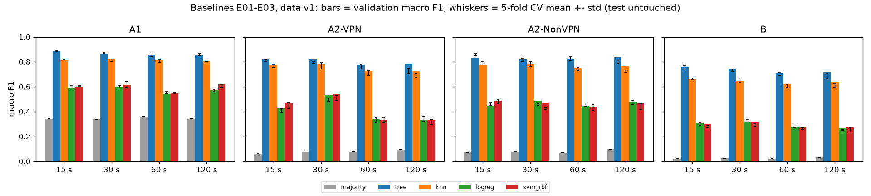
Figure 4. Baselines E01-E03

4.3 Paper benchmark (part of E02 and E03)
What. The paper's own protocol [1]: 10-fold stratified cross-validation on the whole file, with predictions pooled over the folds as Weka reports them, for its two algorithms with Weka's default settings. J48 (C4.5) defaults are a pruning confidence of 0.25 and at least 2 instances per leaf; scikit-learn has no C4.5 pruning, so our stand-in is an unpruned entropy tree with at least 2 rows per leaf. IBk (KNN) defaults are k = 1 with a Euclidean distance that normalises each attribute to its range; our stand-in is min-max scaling followed by 1-NN. The defaults were checked in the Weka documentation [16] (also cited in notebooks/02_baselines.ipynb). Each algorithm ran on two row sources per file (64 runs): every row as published (duplicates kept, values untouched), which is closest to the paper's input, and data v1 (deduplicated). Why. It tests whether we reproduce the paper's results before we try to improve on them. We compare precision with precision and recall with recall, never the paper's precision with our F1. These scores are never used to choose a model. Hypotheses and thresholds. On the published rows, at least 12 of the 16 A1 values of the paper's Figure 2 are matched within +-0.05, for each algorithm. Because duplicates can put a copy of a flow in the training folds, removing them lowers 10-fold macro F1 in at least 12 of 16 files. Result. Reproduction supported: our C4.5 approximation matches all 16 A1 values (largest difference 0.021, close to the +-0.01 reading error of the chart), and 1-NN matches 15 of 16 (the miss is VPN recall at 120 s: 0.803 vs 0.860). The duplicate hypothesis is not supported (6 of 16 files lower for the tree, 2 of 16 for 1-NN).
A1, paper (Figure 2, read to +-0.01) vs ours (diff = ours - paper):
algorithm | class | timeout | metric | paper | paper_source | ours_published | ours_v1 | diff_published | diff_v1
C4.5 | Non-VPN | 15 | precision | 0.906 | chart +-0.01 and text | 0.886 | 0.882 | -0.02 | -0.024
C4.5 | Non-VPN | 30 | precision | 0.885 | chart +-0.01 | 0.866 | 0.866 | -0.019 | -0.019
C4.5 | Non-VPN | 60 | precision | 0.864 | chart +-0.01 | 0.86 | 0.876 | -0.004 | 0.012
C4.5 | Non-VPN | 120 | precision | 0.887 | chart +-0.01 and text | 0.87 | 0.863 | -0.017 | -0.024
C4.5 | Non-VPN | 15 | recall | 0.877 | chart +-0.01 | 0.882 | 0.903 | 0.005 | 0.026
C4.5 | Non-VPN | 30 | recall | 0.846 | chart +-0.01 | 0.857 | 0.886 | 0.011 | 0.04
C4.5 | Non-VPN | 60 | recall | 0.888 | chart +-0.01 | 0.889 | 0.898 | 0.001 | 0.01
C4.5 | Non-VPN | 120 | recall | 0.843 | chart +-0.01 | 0.853 | 0.89 | 0.01 | 0.047
C4.5 | VPN | 15 | precision | 0.89 | chart +-0.01 and text | 0.892 | 0.908 | 0.002 | 0.018
C4.5 | VPN | 30 | precision | 0.868 | chart +-0.01 | 0.874 | 0.888 | 0.006 | 0.02
C4.5 | VPN | 60 | precision | 0.856 | chart +-0.01 | 0.857 | 0.867 | 0.001 | 0.011
C4.5 | VPN | 120 | precision | 0.863 | chart +-0.01 and text | 0.868 | 0.877 | 0.005 | 0.014
C4.5 | VPN | 15 | recall | 0.917 | chart +-0.01 | 0.896 | 0.888 | -0.021 | -0.029
C4.5 | VPN | 30 | recall | 0.901 | chart +-0.01 | 0.881 | 0.867 | -0.02 | -0.034
C4.5 | VPN | 60 | recall | 0.827 | chart +-0.01 | 0.821 | 0.84 | -0.006 | 0.013
C4.5 | VPN | 120 | recall | 0.902 | chart +-0.01 | 0.884 | 0.849 | -0.018 | -0.053
KNN | Non-VPN | 15 | precision | 0.846 | chart +-0.01 and text | 0.821 | 0.846 | -0.025 | 0.0
KNN | Non-VPN | 30 | precision | 0.84 | chart +-0.01 | 0.805 | 0.83 | -0.035 | -0.01
KNN | Non-VPN | 60 | precision | 0.838 | chart +-0.01 | 0.831 | 0.854 | -0.007 | 0.016
KNN | Non-VPN | 120 | precision | 0.837 | chart +-0.01 and text | 0.794 | 0.83 | -0.043 | -0.007
KNN | Non-VPN | 15 | recall | 0.832 | chart +-0.01 | 0.857 | 0.848 | 0.025 | 0.016
KNN | Non-VPN | 30 | recall | 0.808 | chart +-0.01 | 0.839 | 0.831 | 0.031 | 0.023
KNN | Non-VPN | 60 | recall | 0.851 | chart +-0.01 | 0.857 | 0.849 | 0.006 | -0.002
KNN | Non-VPN | 120 | recall | 0.787 | chart +-0.01 | 0.827 | 0.825 | 0.04 | 0.038
KNN | VPN | 15 | precision | 0.848 | chart +-0.01 and text | 0.863 | 0.859 | 0.015 | 0.011
KNN | VPN | 30 | precision | 0.835 | chart +-0.01 | 0.85 | 0.836 | 0.015 | 0.001
KNN | VPN | 60 | precision | 0.812 | chart +-0.01 | 0.816 | 0.811 | 0.004 | -0.001
KNN | VPN | 120 | precision | 0.815 | chart +-0.01 and text | 0.836 | 0.813 | 0.021 | -0.002
KNN | VPN | 15 | recall | 0.861 | chart +-0.01 | 0.83 | 0.857 | -0.031 | -0.004
KNN | VPN | 30 | recall | 0.862 | chart +-0.01 | 0.818 | 0.835 | -0.044 | -0.027
KNN | VPN | 60 | recall | 0.795 | chart +-0.01 | 0.784 | 0.817 | -0.011 | 0.022
KNN | VPN | 120 | recall | 0.86 | chart +-0.01 | 0.803 | 0.818 | -0.057 | -0.042

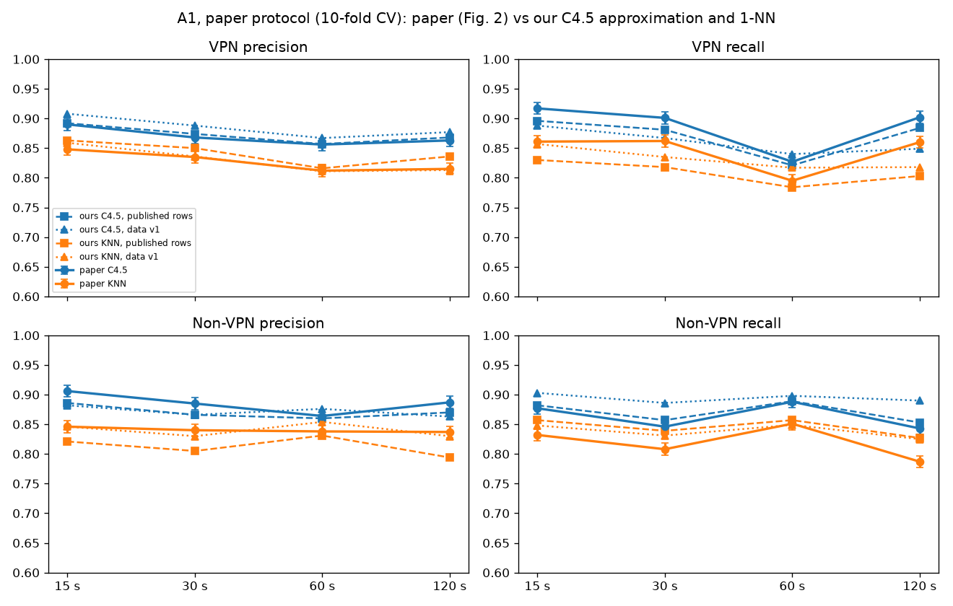
Figure 5. Paper vs ours, A1
The plan asks for the comparison as one table per task. The tables below give our 10-fold precision and recall for every class, both algorithms and all timeouts, on the published rows (closest to the paper's input), with the paper's value in brackets wherever the paper gives one (C = read from its chart, +-0.01; T = stated in its text). The same tables on data v1 are in reports/baseline_tables.md.
A2-VPN:
class | metric | C4.5 15 s | C4.5 30 s | C4.5 60 s | C4.5 120 s | KNN 15 s | KNN 30 s | KNN 60 s | KNN 120 s
VPN-BROWSING | precision | 0.872 | 0.878 | 0.873 | 0.878 | 0.830 | 0.874 | 0.881 | 0.795
VPN-BROWSING | recall | 0.884 | 0.916 | 0.918 | 0.906 | 0.846 | 0.893 | 0.902 | 0.888
VPN-CHAT | precision | 0.661 | 0.647 | 0.568 | 0.532 | 0.511 | 0.490 | 0.427 | 0.576
VPN-CHAT | recall | 0.687 | 0.628 | 0.562 | 0.473 | 0.651 | 0.667 | 0.658 | 0.562
VPN-FT | precision | 0.792 | 0.744 | 0.676 | 0.649 | 0.773 | 0.764 | 0.714 | 0.674
VPN-FT | recall | 0.770 | 0.690 | 0.610 | 0.605 | 0.735 | 0.689 | 0.648 | 0.595
VPN-MAIL | precision | 0.808 | 0.891 | 0.778 | 0.864 | 0.766 | 0.912 | 0.753 | 0.859
VPN-MAIL | recall | 0.762 | 0.887 | 0.715 | 0.852 | 0.766 | 0.947 | 0.734 | 0.904
VPN-P2P | precision | 0.827 | 0.831 | 0.793 | 0.810 | 0.736 | 0.806 | 0.727 | 0.771
VPN-P2P | recall | 0.863 | 0.870 | 0.848 | 0.862 | 0.517 | 0.585 | 0.527 | 0.567
VPN-STREAMING | precision | 0.922 | 0.926 | 0.875 | 0.838 | 0.906 | 0.876 | 0.838 | 0.815
VPN-STREAMING | recall | 0.891 | 0.876 | 0.782 | 0.752 | 0.914 | 0.856 | 0.787 | 0.759
VPN-VOIP | precision | 0.990 | 0.992 | 0.939 | 0.973 | 0.990 | 0.993 | 0.911 | 0.984
VPN-VOIP | recall | 0.979 | 0.975 | 0.914 | 0.925 | 0.987 | 0.981 | 0.907 | 0.951
AVERAGE (macro) | precision | 0.839 (paper 0.840 T) | 0.844 | 0.786 | 0.792 | 0.788 | 0.816 | 0.750 | 0.782
AVERAGE (macro) | recall | 0.834 | 0.835 | 0.764 | 0.768 | 0.774 | 0.803 | 0.738 | 0.747

A2-NonVPN:
class | metric | C4.5 15 s | C4.5 30 s | C4.5 60 s | C4.5 120 s | KNN 15 s | KNN 30 s | KNN 60 s | KNN 120 s
BROWSING | precision | 0.904 | 0.915 | 0.897 | 0.928 | 0.866 | 0.883 | 0.865 | 0.922
BROWSING | recall | 0.930 | 0.934 | 0.922 | 0.948 | 0.880 | 0.912 | 0.872 | 0.932
CHAT | precision | 0.813 | 0.769 | 0.738 | 0.656 | 0.558 | 0.508 | 0.483 | 0.331
CHAT | recall | 0.798 | 0.793 | 0.753 | 0.694 | 0.692 | 0.662 | 0.661 | 0.599
FT | precision | 0.810 | 0.794 | 0.793 | 0.796 | 0.812 | 0.769 | 0.847 | 0.791
FT | recall | 0.853 | 0.824 | 0.873 | 0.851 | 0.670 | 0.629 | 0.734 | 0.571
MAIL | precision | 0.849 | 0.754 | 0.866 | 0.859 | 0.709 | 0.734 | 0.762 | 0.709
MAIL | recall | 0.835 | 0.605 | 0.786 | 0.789 | 0.735 | 0.716 | 0.723 | 0.697
P2P | precision | 0.971 | 0.943 | 0.948 | 0.946 | 0.907 | 0.897 | 0.893 | 0.914
P2P | recall | 0.955 | 0.916 | 0.919 | 0.929 | 0.890 | 0.883 | 0.897 | 0.911
STREAMING | precision | 0.837 | 0.769 | 0.757 | 0.768 | 0.782 | 0.759 | 0.655 | 0.657
STREAMING | recall | 0.701 | 0.664 | 0.567 | 0.558 | 0.685 | 0.617 | 0.504 | 0.524
VOIP | precision | 0.992 | 0.990 | 0.973 | 0.989 | 0.990 | 0.980 | 0.968 | 0.931
VOIP | recall | 0.988 | 0.979 | 0.946 | 0.941 | 0.987 | 0.977 | 0.954 | 0.929
AVERAGE (macro) | precision | 0.882 (paper 0.890 T) | 0.848 | 0.853 | 0.849 | 0.803 | 0.790 | 0.782 | 0.751
AVERAGE (macro) | recall | 0.866 | 0.817 | 0.824 | 0.816 | 0.791 | 0.771 | 0.764 | 0.738

B:
class | metric | C4.5 15 s | C4.5 30 s | C4.5 60 s | C4.5 120 s | KNN 15 s | KNN 30 s | KNN 60 s | KNN 120 s
BROWSING | precision | 0.771 | 0.790 | 0.779 | 0.800 | 0.690 | 0.748 | 0.746 | 0.807
BROWSING | recall | 0.820 | 0.831 | 0.827 | 0.847 | 0.700 | 0.758 | 0.741 | 0.794
CHAT | precision | 0.677 | 0.620 | 0.631 | 0.510 | 0.349 | 0.292 | 0.336 | 0.164
CHAT | recall | 0.727 | 0.667 | 0.667 | 0.554 | 0.567 | 0.536 | 0.586 | 0.488
FT | precision | 0.717 | 0.666 | 0.807 | 0.687 | 0.744 | 0.685 | 0.809 | 0.683
FT | recall | 0.653 | 0.614 | 0.743 | 0.535 | 0.622 | 0.552 | 0.717 | 0.487
MAIL | precision | 0.633 (paper 0.671 T) | 0.617 | 0.741 | 0.680 (paper 0.790 T) | 0.618 | 0.712 | 0.674 | 0.548
MAIL | recall | 0.651 | 0.617 | 0.727 | 0.665 | 0.643 | 0.642 | 0.645 | 0.616
P2P | precision | 0.880 | 0.851 | 0.842 | 0.874 | 0.749 | 0.743 | 0.760 | 0.818
P2P | recall | 0.893 | 0.845 | 0.863 | 0.891 | 0.732 | 0.724 | 0.752 | 0.804
STREAMING | precision | 0.713 | 0.657 | 0.496 | 0.510 | 0.679 | 0.630 | 0.536 | 0.477
STREAMING | recall | 0.670 | 0.623 | 0.472 | 0.495 | 0.629 | 0.532 | 0.440 | 0.394
VOIP | precision | 0.983 | 0.976 | 0.912 | 0.934 | 0.980 | 0.974 | 0.923 | 0.895
VOIP | recall | 0.981 | 0.971 | 0.905 | 0.903 | 0.983 | 0.972 | 0.903 | 0.895
VPN-BROWSING | precision | 0.773 (paper 0.771 T) | 0.800 | 0.797 | 0.807 (paper 0.809 T) | 0.689 (paper 0.691 T) | 0.738 | 0.760 | 0.742 (paper 0.743 T)
VPN-BROWSING | recall | 0.768 | 0.778 | 0.802 | 0.799 | 0.711 | 0.759 | 0.780 | 0.703
VPN-CHAT | precision | 0.616 | 0.607 | 0.557 | 0.534 | 0.510 (paper 0.501 T) | 0.503 | 0.460 | 0.466 (paper 0.501 T)
VPN-CHAT | recall | 0.571 | 0.560 | 0.477 | 0.444 | 0.507 | 0.471 | 0.442 | 0.476
VPN-FT | precision | 0.759 | 0.717 | 0.639 | 0.661 | 0.693 | 0.664 | 0.584 | 0.549
VPN-FT | recall | 0.712 | 0.661 | 0.532 | 0.539 | 0.637 | 0.593 | 0.528 | 0.580
VPN-MAIL | precision | 0.770 (paper 0.739 T) | 0.828 | 0.702 | 0.804 (paper 0.786 T) | 0.687 (paper 0.688 T) | 0.843 | 0.599 | 0.820 (paper 0.688 T)
VPN-MAIL | recall | 0.670 | 0.808 | 0.608 | 0.802 | 0.644 | 0.902 | 0.554 | 0.878
VPN-P2P | precision | 0.615 | 0.620 | 0.547 | 0.629 | 0.591 | 0.666 | 0.593 | 0.669
VPN-P2P | recall | 0.767 | 0.771 | 0.745 | 0.806 | 0.428 | 0.498 | 0.441 | 0.514
VPN-STREAMING | precision | 0.885 | 0.871 | 0.863 | 0.875 | 0.836 | 0.774 | 0.774 | 0.713
VPN-STREAMING | recall | 0.823 | 0.812 | 0.766 | 0.772 | 0.848 | 0.772 | 0.782 | 0.703
VPN-VOIP | precision | 0.986 | 0.980 | 0.893 | 0.942 | 0.978 | 0.963 | 0.807 | 0.921
VPN-VOIP | recall | 0.973 | 0.968 | 0.845 | 0.889 | 0.972 | 0.965 | 0.809 | 0.912
AVERAGE (macro) | precision | 0.770 | 0.757 | 0.729 | 0.732 | 0.700 | 0.710 | 0.669 | 0.662
AVERAGE (macro) | recall | 0.763 | 0.752 | 0.713 | 0.710 | 0.687 | 0.691 | 0.651 | 0.660

For A2 and B the paper's Figure 3 draws two unlabelled lines per timeout, which can't be assigned to C4.5 or KNN. So only the values the paper states in its text are compared. The paper doesn't say whether its "average" is a plain or a class-weighted mean, so both are shown. On the published rows the plain (macro) mean matches it within 0.013 in every case, which suggests the paper used the plain mean.
For averages the paper does not say whether it is a plain or a class-weighted mean (Weka prints the weighted one), so both are shown.
task | algorithm | class | timeout | metric | paper | rows | ours | ours_kind | diff
A2-VPN | C4.5 | AVERAGE | 15 | precision | 0.84 | published | 0.839 | macro | -0.001
A2-VPN | C4.5 | AVERAGE | 15 | precision | 0.84 | published | 0.853 | weighted | 0.013
A2-VPN | C4.5 | AVERAGE | 15 | precision | 0.84 | v1 | 0.827 | macro | -0.013
A2-VPN | C4.5 | AVERAGE | 15 | precision | 0.84 | v1 | 0.846 | weighted | 0.006
A2-NonVPN | C4.5 | AVERAGE | 15 | precision | 0.89 | published | 0.882 | macro | -0.008
A2-NonVPN | C4.5 | AVERAGE | 15 | precision | 0.89 | published | 0.914 | weighted | 0.024
A2-NonVPN | C4.5 | AVERAGE | 15 | precision | 0.89 | v1 | 0.886 | macro | -0.004
A2-NonVPN | C4.5 | AVERAGE | 15 | precision | 0.89 | v1 | 0.92 | weighted | 0.03
B | C4.5 | VPN-BROWSING | 15 | precision | 0.771 | published | 0.773 | class | 0.002
B | C4.5 | VPN-BROWSING | 15 | precision | 0.771 | v1 | 0.76 | class | -0.011
B | C4.5 | VPN-BROWSING | 120 | precision | 0.809 | published | 0.807 | class | -0.002
B | C4.5 | VPN-BROWSING | 120 | precision | 0.809 | v1 | 0.76 | class | -0.049
B | C4.5 | VPN-MAIL | 15 | precision | 0.739 | published | 0.77 | class | 0.031
B | C4.5 | VPN-MAIL | 15 | precision | 0.739 | v1 | 0.718 | class | -0.021
B | C4.5 | VPN-MAIL | 120 | precision | 0.786 | published | 0.804 | class | 0.018
B | C4.5 | VPN-MAIL | 120 | precision | 0.786 | v1 | 0.682 | class | -0.104
B | C4.5 | MAIL | 15 | precision | 0.671 | published | 0.633 | class | -0.038
B | C4.5 | MAIL | 15 | precision | 0.671 | v1 | 0.625 | class | -0.046
B | C4.5 | MAIL | 120 | precision | 0.79 | published | 0.68 | class | -0.11
B | C4.5 | MAIL | 120 | precision | 0.79 | v1 | 0.613 | class | -0.177
B | KNN | VPN-BROWSING | 15 | precision | 0.691 | published | 0.689 | class | -0.002
B | KNN | VPN-BROWSING | 15 | precision | 0.691 | v1 | 0.695 | class | 0.004
B | KNN | VPN-BROWSING | 120 | precision | 0.743 | published | 0.742 | class | -0.001
B | KNN | VPN-BROWSING | 120 | precision | 0.743 | v1 | 0.7 | class | -0.043
B | KNN | VPN-CHAT | 15 | precision | 0.501 | published | 0.51 | class | 0.009
B | KNN | VPN-CHAT | 15 | precision | 0.501 | v1 | 0.509 | class | 0.008
B | KNN | VPN-CHAT | 120 | precision | 0.501 | published | 0.466 | class | -0.035
B | KNN | VPN-CHAT | 120 | precision | 0.501 | v1 | 0.494 | class | -0.007
B | KNN | VPN-MAIL | 15 | precision | 0.688 | published | 0.687 | class | -0.001
B | KNN | VPN-MAIL | 15 | precision | 0.688 | v1 | 0.633 | class | -0.055
B | KNN | VPN-MAIL | 120 | precision | 0.688 | published | 0.82 | class | 0.132
B | KNN | VPN-MAIL | 120 | precision | 0.688 | v1 | 0.521 | class | -0.167
B | C4.5 | AVERAGE_BEST_TIMEOUT | best | precision | 0.783 | published | 0.77 | macro | -0.013
B | C4.5 | AVERAGE_BEST_TIMEOUT | best | precision | 0.783 | published | 0.808 | weighted | 0.025
B | C4.5 | AVERAGE_BEST_TIMEOUT | best | precision | 0.783 | v1 | 0.774 | macro | -0.009
B | C4.5 | AVERAGE_BEST_TIMEOUT | best | precision | 0.783 | v1 | 0.815 | weighted | 0.032
B | KNN | AVERAGE_BEST_TIMEOUT | best | precision | 0.711 | published | 0.71 | macro | -0.001
B | KNN | AVERAGE_BEST_TIMEOUT | best | precision | 0.711 | published | 0.745 | weighted | 0.034
B | KNN | AVERAGE_BEST_TIMEOUT | best | precision | 0.711 | v1 | 0.707 | macro | -0.004
B | KNN | AVERAGE_BEST_TIMEOUT | best | precision | 0.711 | v1 | 0.755 | weighted | 0.044

Duplicates. Removing the exact duplicates changed the 10-fold macro F1 by -0.018 to +0.014 for the tree (mean +0.001) and by -0.017 to +0.040 for 1-NN (mean +0.012):
algo | task | timeout | rows_published | rows_v1 | f1_published | f1_v1 | v1_minus_published
j48 | A1 | 15 | 18,758 | 18,038 | 0.8888 | 0.8954 | 0.0067
j48 | A1 | 30 | 14,651 | 13,610 | 0.8696 | 0.8766 | 0.0069
j48 | A1 | 60 | 15,515 | 14,677 | 0.8562 | 0.8702 | 0.014
j48 | A1 | 120 | 10,782 | 9,524 | 0.8688 | 0.8694 | 0.0007
j48 | A2-VPN | 15 | 9,793 | 9,380 | 0.836 | 0.8197 | -0.0162
j48 | A2-VPN | 30 | 7,734 | 6,944 | 0.8389 | 0.821 | -0.0179
j48 | A2-VPN | 60 | 6,935 | 6,523 | 0.7741 | 0.7702 | -0.0039
j48 | A2-VPN | 120 | 5,631 | 4,648 | 0.779 | 0.7719 | -0.0071
j48 | A2-NonVPN | 15 | 8,965 | 8,694 | 0.8731 | 0.8768 | 0.0037
j48 | A2-NonVPN | 30 | 6,917 | 6,694 | 0.8303 | 0.8359 | 0.0055
j48 | A2-NonVPN | 60 | 8,580 | 8,206 | 0.8359 | 0.8483 | 0.0123
j48 | A2-NonVPN | 120 | 5,151 | 4,941 | 0.8294 | 0.8346 | 0.0052
j48 | B | 15 | 18,758 | 18,074 | 0.765 | 0.7707 | 0.0057
j48 | B | 30 | 14,651 | 13,638 | 0.7535 | 0.7488 | -0.0047
j48 | B | 60 | 15,515 | 14,729 | 0.7185 | 0.7293 | 0.0107
j48 | B | 120 | 10,782 | 9,589 | 0.7183 | 0.718 | -0.0003
ibk | A1 | 15 | 18,758 | 18,038 | 0.8424 | 0.8524 | 0.01
ibk | A1 | 30 | 14,651 | 13,610 | 0.8276 | 0.8331 | 0.0055
ibk | A1 | 60 | 15,515 | 14,677 | 0.8217 | 0.8326 | 0.0109
ibk | A1 | 120 | 10,782 | 9,524 | 0.8146 | 0.8218 | 0.0072
ibk | A2-VPN | 15 | 9,793 | 9,380 | 0.7766 | 0.793 | 0.0164
ibk | A2-VPN | 30 | 7,734 | 6,944 | 0.8047 | 0.81 | 0.0054
ibk | A2-VPN | 60 | 6,935 | 6,523 | 0.7377 | 0.7552 | 0.0175
ibk | A2-VPN | 120 | 5,631 | 4,648 | 0.7611 | 0.7441 | -0.017
ibk | A2-NonVPN | 15 | 8,965 | 8,694 | 0.7949 | 0.8118 | 0.0169
ibk | A2-NonVPN | 30 | 6,917 | 6,694 | 0.7769 | 0.7989 | 0.022
ibk | A2-NonVPN | 60 | 8,580 | 8,206 | 0.7687 | 0.7899 | 0.0213
ibk | A2-NonVPN | 120 | 5,151 | 4,941 | 0.7349 | 0.7751 | 0.0402
ibk | B | 15 | 18,758 | 18,074 | 0.69 | 0.7071 | 0.0171
ibk | B | 30 | 14,651 | 13,638 | 0.6958 | 0.6931 | -0.0027
ibk | B | 60 | 15,515 | 14,729 | 0.6561 | 0.6697 | 0.0137
ibk | B | 120 | 10,782 | 9,589 | 0.6531 | 0.661 | 0.0079

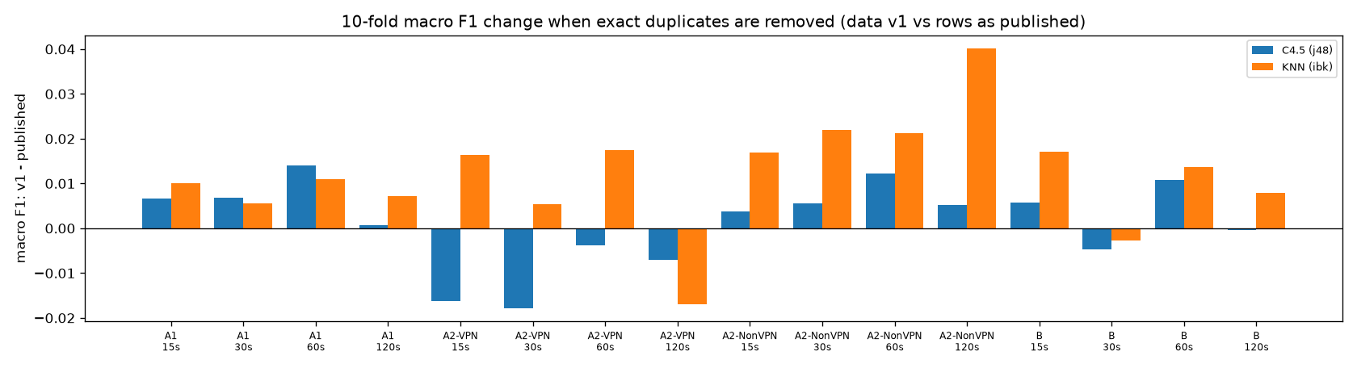
Figure 6. Duplicate effect
The reason the hypothesis failed is in the rows themselves. The removed duplicates are not copies of ordinary flows. Between 39% and 92% of them have an identical twin with a different label, against 2-10% of all rows, and their median flow has 0-2 packets (all flows: 8-43). They are near-empty flows that timing features can't tell apart. Keeping every copy multiplies errors that no model can avoid, which outweighs the advantage of having a test flow's copy in the training data:
Share of removed rows whose features also occur with another label, and packets per flow. A1 120 s packet counts use its published (corrupt) flowPktsPerSecond.
task | timeout | duplicates removed | removed with other-label twin | all rows with other-label twin | median packets, removed | median packets, all
A1 | 15 | 720 | 0.761 | 0.032 | 0.0 | 32.0
A1 | 30 | 1,041 | 0.51 | 0.039 | 2.0 | 22.0
A1 | 60 | 838 | 0.766 | 0.047 | 0.0 | 16.0
A1 | 120 | 1,257 | 0.434 | 0.056 | 0.0 | 0.0
A2-VPN | 15 | 413 | 0.823 | 0.04 | 0.0 | 27.0
A2-VPN | 30 | 790 | 0.395 | 0.045 | 2.0 | 17.0
A2-VPN | 60 | 412 | 0.748 | 0.053 | 0.0 | 8.0
A2-VPN | 120 | 983 | 0.45 | 0.098 | 2.0 | 8.0
A2-NonVPN | 15 | 271 | 0.742 | 0.024 | 0.0 | 43.0
A2-NonVPN | 30 | 223 | 0.897 | 0.03 | 0.0 | 26.0
A2-NonVPN | 60 | 374 | 0.805 | 0.039 | 0.0 | 23.0
A2-NonVPN | 120 | 210 | 0.919 | 0.039 | 0.0 | 17.0
B | 15 | 684 | 0.804 | 0.035 | 0.0 | 32.0
B | 30 | 1,013 | 0.529 | 0.042 | 2.0 | 22.0
B | 60 | 786 | 0.818 | 0.053 | 0.0 | 16.0
B | 120 | 1,193 | 0.562 | 0.078 | 2.0 | 12.0

The duplicate rule of data v1 stays: in our own split it guarantees that no flow is scored after being trained on, and this benchmark shows it changes 10-fold scores by only about +-0.02.

4.4 Storage after the baselines
Every official run saves its trained model (the plan's rule). After the first 147 runs (80 baselines, 64 benchmark, 2 pilot, 1 setup check), the MLflow store held 137.8 MB of artifacts and a 5.8 MB database (275.2 MB and 10.4 MB after the timing rerun of all 144 configs); the largest single run is 4.3 MB (SVM). Per model type:
kind | runs | total_MB | per_run_max_MB | model_file_max_MB
knn (holdout) | 16 | 23.075 | 2.475 | 2.319
knn_minmax (paper_10fold) | 32 | 66.742 | 3.596 | 3.438
logreg (holdout) | 16 | 1.64 | 0.167 | 0.005
majority (holdout) | 16 | 1.395 | 0.118 | 0.001
svm_rbf (holdout) | 16 | 27.418 | 4.345 | 4.188
tree (holdout) | 16 | 5.457 | 0.764 | 0.579
tree (paper_10fold) | 32 | 11.674 | 0.817 | 0.629

Whole store now (after the rerun): artifacts 275.2 MB, mlflow.db 10.4 MB.
Tree ensembles in Phase 3 will be much larger: a 300-tree Random Forest, measured on the largest training set (B, 15 s), is a 171.9 MB file (22.4 MB with joblib compression level 3) [E03].

4.5 Phase 3: how the improvement experiments were run
Phase 3 (E04-E17) starts from the Phase 2 baselines and changes one thing at a time against the current best model of each task: the highest 15 s validation macro F1 so far, whatever the margin. Every experiment runs first at 15 s for all four tasks. A model is a winner, and is rerun at 30, 60 and 120 s with its 15 s settings, only if it beats the task's current best by at least 0.03; 0.03 is above the largest Phase 2 cross-validation standard deviation (0.025), so a smaller gain could be noise from the split. The rule was fixed on 28 Oct, before any Phase 3 run, and written into every experiment entry before it ran. All Phase 3 runs use data v1, the same dependency lock file and one thread per model; every model is saved with joblib compression level 3. Every table below is copied unchanged from reports/phase3_tables.md, generated by scripts/results_tables.py --phase 3 from reports/history.csv; the figures come from notebooks 03 and 04 (scripts/make_notebooks.py). Scores are validation scores of the fixed 70/15/15 split (seed 42); the test set is not used in Phase 3.

4.6 E04: KNN with a signed log transform
What. KNN (k = 5, as in E03) with a signed log, sign(x)·log1p(|x|), applied inside the pipeline before scaling, once with StandardScaler and once with RobustScaler (Section 3.7). Why. KNN compares flows by distance, and a few very large timing values (up to about 1.2e8 microseconds) dominate every distance on the raw features. Threshold (pre-stated). (a) the better variant beats the E03 KNN by at least 0.02 in at least 3 of 4 tasks; (b) the two scalers are within 0.02 of each other in at least 3 of 4 tasks.
task | model | val macro F1 | CV macro F1 | best before | best before F1 | gain | winner (gain >= 0.03)
A1 | E04-knn_log_robust | 0.8929 | 0.8874 +- 0.0042 | E02-tree | 0.8901 | 0.0028 | no
A1 | E04-knn_log_standard | 0.9048 | 0.9033 +- 0.0046 | E02-tree | 0.8901 | 0.0146 | no
A2-VPN | E04-knn_log_robust | 0.8372 | 0.8185 +- 0.0080 | E02-tree | 0.8247 | 0.0125 | no
A2-VPN | E04-knn_log_standard | 0.8544 | 0.8336 +- 0.0103 | E02-tree | 0.8247 | 0.0296 | no
A2-NonVPN | E04-knn_log_robust | 0.854 | 0.8688 +- 0.0050 | E02-tree | 0.8294 | 0.0247 | no
A2-NonVPN | E04-knn_log_standard | 0.867 | 0.8861 +- 0.0068 | E02-tree | 0.8294 | 0.0376 | yes
B | E04-knn_log_robust | 0.742 | 0.7555 +- 0.0094 | E02-tree | 0.7585 | -0.0166 | no
B | E04-knn_log_standard | 0.7644 | 0.7798 +- 0.0078 | E02-tree | 0.7585 | 0.0059 | no

Result. The signed log lifts KNN by 0.080-0.104 in every task, and StandardScaler beats RobustScaler in every task (by 0.0118-0.0224). The signed-log KNN also passes the E02 tree in all four tasks and becomes the current best; only A2-NonVPN (+0.0376) is a winner (A2-VPN misses the margin by 0.0004). Rerun at the other timeouts, it stays the best A2-NonVPN run at each:
task | timeout | model | val macro F1 | CV macro F1 | best other run | its F1 | difference
A2-NonVPN | 15 s | E04-knn_log_standard | 0.867 | 0.8861 +- 0.0068 | E04-knn_log_robust | 0.854 | 0.0129
A2-NonVPN | 30 s | E04-knn_log_standard | 0.8523 | 0.8487 +- 0.0067 | E02-tree | 0.8283 | 0.024
A2-NonVPN | 60 s | E04-knn_log_standard | 0.859 | 0.8638 +- 0.0108 | E02-tree | 0.8246 | 0.0344
A2-NonVPN | 120 s | E04-knn_log_standard | 0.8491 | 0.8243 +- 0.0252 | E02-tree | 0.8393 | 0.0098

Verdict. (a) supported, (b) supported. [E04]

4.7 E05: Random Forest
What. A 300-tree Random Forest with default settings. Why. The E02 tree is unpruned (depth 16-35) and fits noise; averaging 300 trees grown on bootstrap samples lowers that variance. Threshold. (a) the forest beats the E02 tree by at least 0.03 in at least 3 of 4 tasks; (b) it beats the current best (the E04 KNN) in at least 2 of 4 tasks.
task | model | val macro F1 | CV macro F1 | best before | best before F1 | gain | winner (gain >= 0.03)
A1 | E05-rf | 0.9203 | 0.9172 +- 0.0050 | E04-knn_log_standard | 0.9048 | 0.0156 | no
A2-VPN | E05-rf | 0.8679 | 0.8637 +- 0.0066 | E04-knn_log_standard | 0.8544 | 0.0135 | no
A2-NonVPN | E05-rf | 0.8941 | 0.9048 +- 0.0049 | E04-knn_log_standard | 0.867 | 0.0271 | no
B | E05-rf | 0.8147 | 0.8102 +- 0.0090 | E04-knn_log_standard | 0.7644 | 0.0503 | yes

Result. The forest is the current best in all four tasks (+0.0135 to +0.0503 over the E04 KNN; +0.0302 to +0.0647 over the tree). Only B is a winner; its reruns:
task | timeout | model | val macro F1 | CV macro F1 | best other run | its F1 | difference
B | 15 s | E05-rf | 0.8147 | 0.8102 +- 0.0090 | E04-knn_log_standard | 0.7644 | 0.0503
B | 30 s | E05-rf | 0.8114 | 0.7979 +- 0.0119 | E02-tree | 0.7476 | 0.0638
B | 60 s | E05-rf | 0.7771 | 0.7656 +- 0.0136 | E02-tree | 0.7058 | 0.0713
B | 120 s | E05-rf | 0.7835 | 0.7562 +- 0.0083 | E02-tree | 0.7158 | 0.0677

Verdict. (a) and (b) supported. The forest is the largest model so far: 171.9 MiB uncompressed for B at 15 s, 22.4 MiB as a compressed file. [E05]

4.8 E06: gradient boosting (XGBoost and LightGBM)
What. XGBoost and LightGBM with default settings. Why. Boosted trees correct the errors of earlier trees, which should help the classes the forest still confuses. Threshold. (a) the better booster beats the forest in at least 2 of 4 tasks; (b) the two are within 0.02 of each other in at least 3 of 4 tasks.
task | model | val macro F1 | CV macro F1 | best before | best before F1 | gain | winner (gain >= 0.03)
A1 | E06-lgbm | 0.9181 | 0.9175 +- 0.0042 | E05-rf | 0.9203 | -0.0022 | no
A1 | E06-xgb | 0.9271 | 0.9251 +- 0.0046 | E05-rf | 0.9203 | 0.0067 | no
A2-VPN | E06-lgbm | 0.8694 | 0.8827 +- 0.0080 | E05-rf | 0.8679 | 0.0015 | no
A2-VPN | E06-xgb | 0.8758 | 0.8799 +- 0.0025 | E05-rf | 0.8679 | 0.0079 | no
A2-NonVPN | E06-lgbm | 0.8983 | 0.9224 +- 0.0097 | E05-rf | 0.8941 | 0.0042 | no
A2-NonVPN | E06-xgb | 0.9015 | 0.9237 +- 0.0117 | E05-rf | 0.8941 | 0.0075 | no
B | E06-lgbm | 0.8201 | 0.8305 +- 0.0088 | E05-rf | 0.8147 | 0.0054 | no
B | E06-xgb | 0.8303 | 0.8334 +- 0.0053 | E05-rf | 0.8147 | 0.0156 | no

Result. Default XGBoost is the current best in all four tasks (+0.0067 to +0.0156 over the forest); LightGBM is 0.0032-0.0102 below it. No winner. Verdict. (a) and (b) supported. Default XGBoost is also one of the cheapest models to run: 1.13-11.76 ms per 1,000 flows, against 21.91-27.28 ms for the forest. The figures show validation macro F1 with cross-validation mean +- std for every E02-E06 model at 15 s, the F1 of every class, and macro F1 against training and prediction time. [E06]
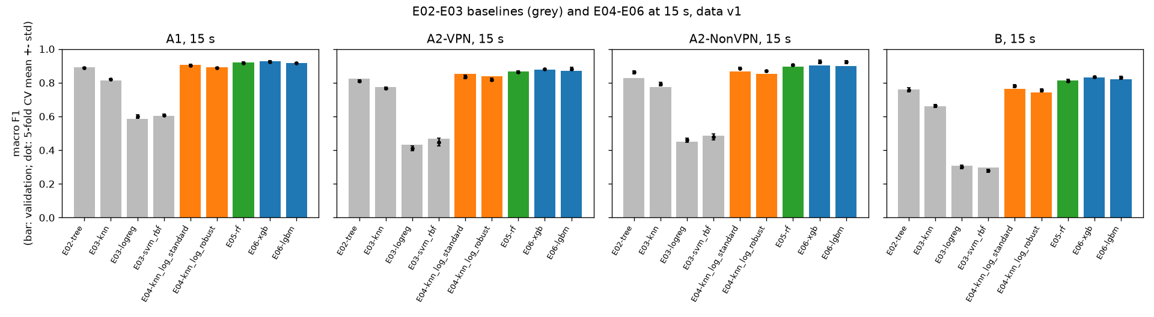
Figure 7. E02-E06 at 15 s
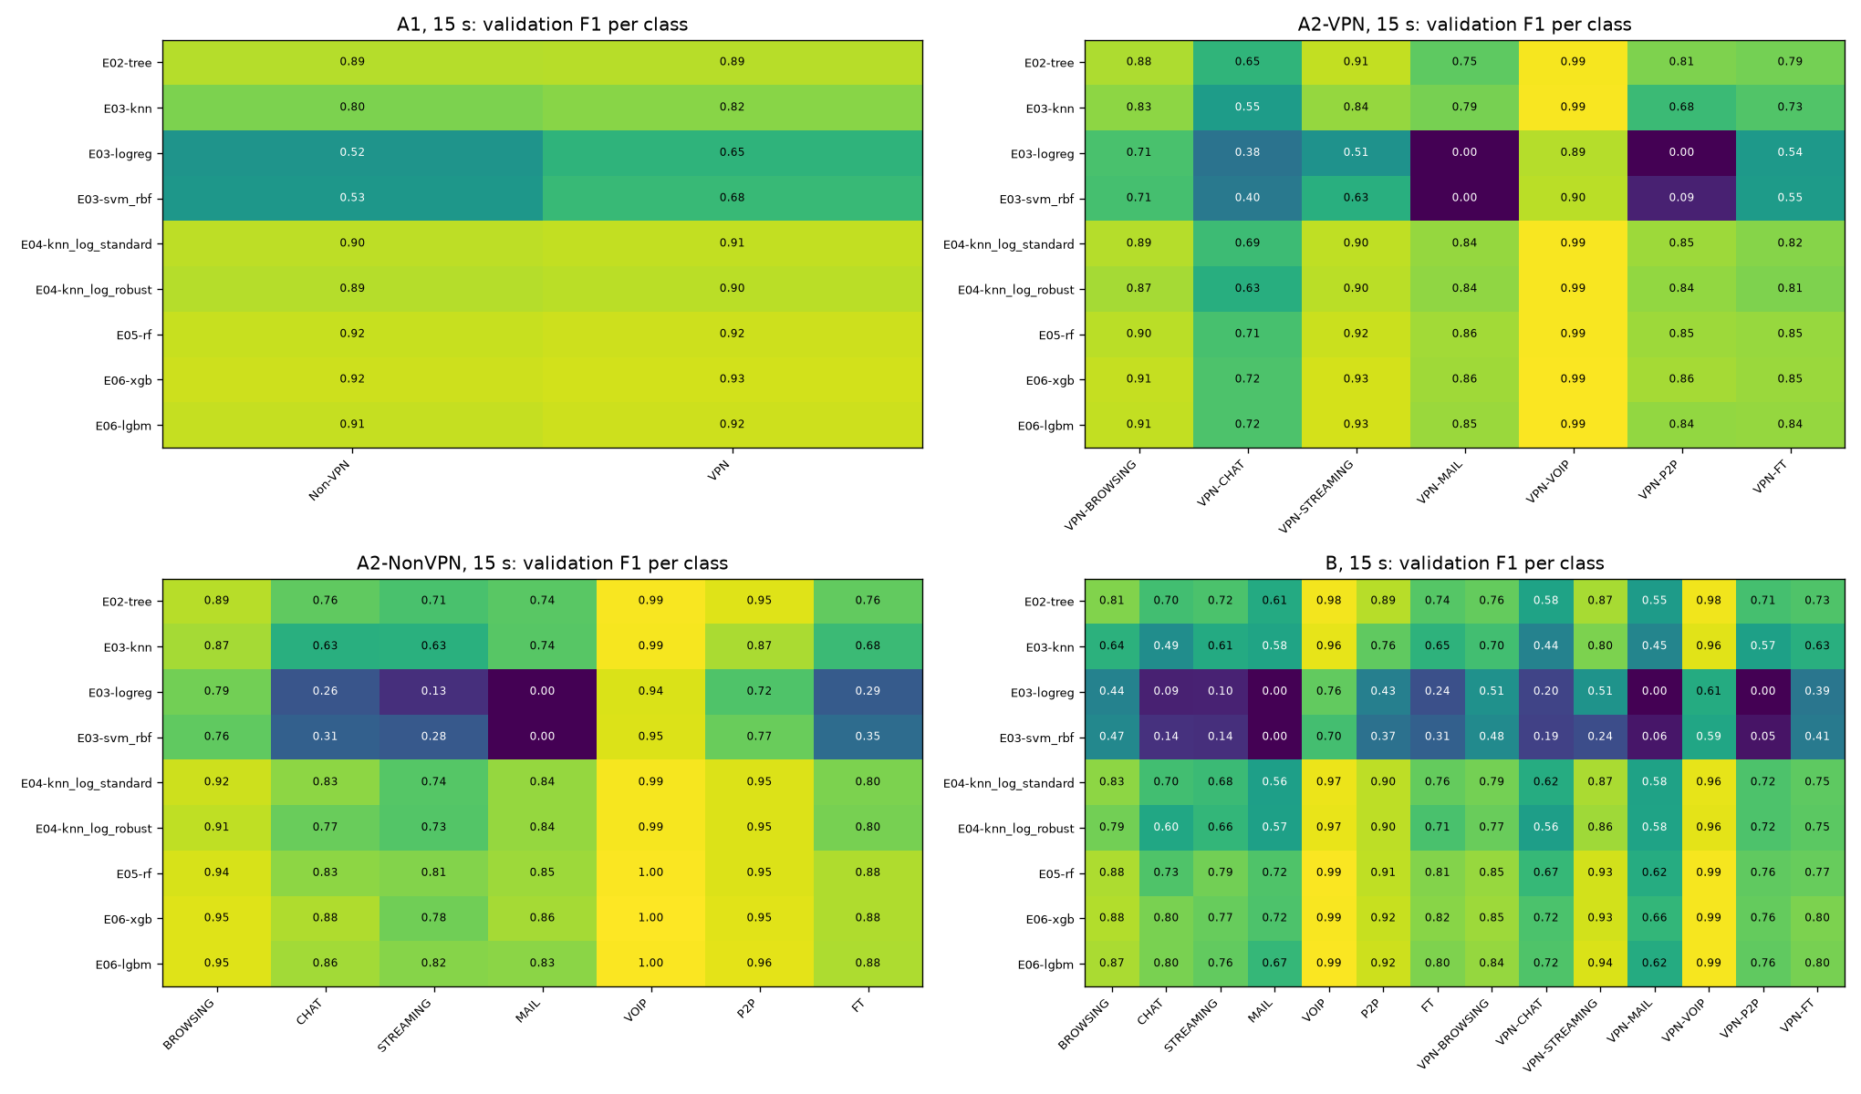
Figure 8. Per-class F1, E02-E06
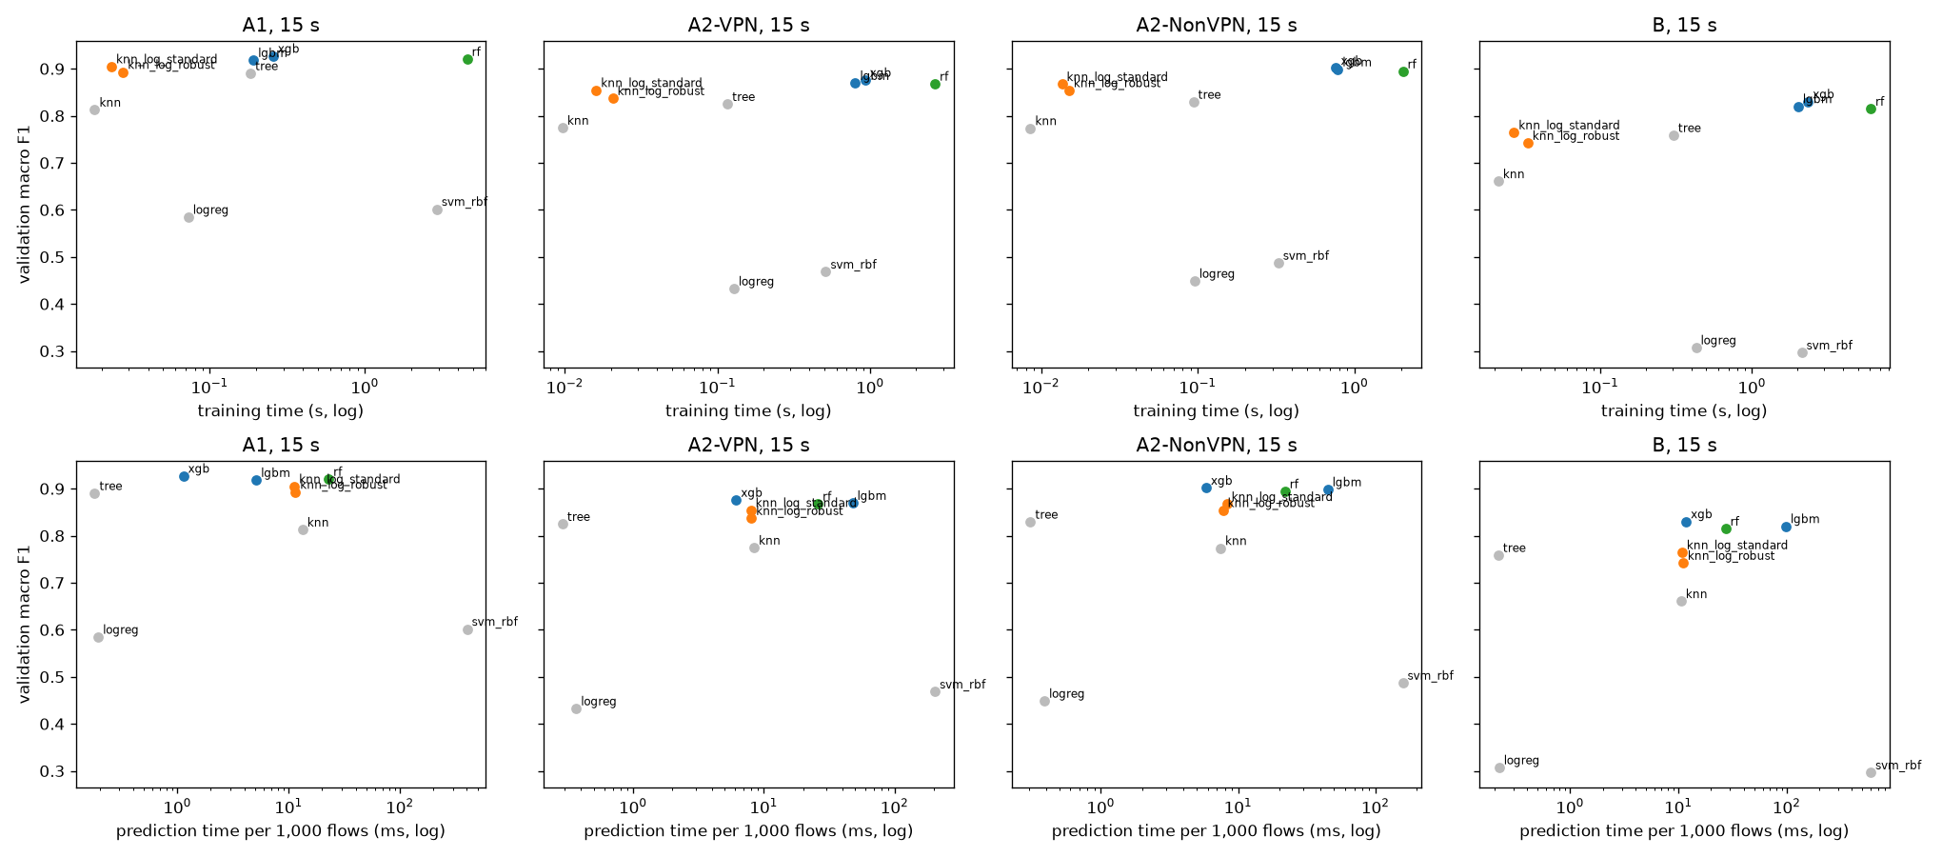
Figure 9. Macro F1 against cost, E02-E06

4.9 E07: hyperparameter tuning with Optuna
What. For each task the best 2 of Random Forest, XGBoost and LightGBM, plus the signed-log KNN, each tuned with the same budget: 50 Optuna trials (TPE sampler, seed 42), each trial scored by 5-fold cross-validation macro F1 on the training rows only. The search ranges were fixed in the plan before running. The best trial is retrained and scored on validation like any other run. Why. Defaults are general-purpose; giving every candidate the same budget means no model wins only because it was tuned more. Threshold. (a) tuned above untuned in at least 8 of 12 searches; (b) the best E07 model beats the current best (default XGBoost) by at least 0.01 in at least 2 of 4 tasks; (c) the tuned KNN stays below the best tuned tree ensemble in all four tasks.
task | ranking (15 s val macro F1) | tuned in E07 | KNN preprocessing for E07
A1 | xgb 0.9271, rf 0.9203, lgbm 0.9181 | xgb, rf | knn_log_standard 0.9048
A2-VPN | xgb 0.8758, lgbm 0.8694, rf 0.8679 | xgb, lgbm | knn_log_standard 0.8544
A2-NonVPN | xgb 0.9015, lgbm 0.8983, rf 0.8941 | xgb, lgbm | knn_log_standard 0.8670
B | xgb 0.8303, lgbm 0.8201, rf 0.8147 | xgb, lgbm | knn_log_standard 0.7644

task | model | val macro F1 | CV macro F1 | best before | best before F1 | gain | winner (gain >= 0.03)
A1 | E07-knn_log_standard | 0.9163 | 0.9122 +- 0.0047 | E06-xgb | 0.9271 | -0.0108 | no
A1 | E07-rf | 0.9181 | 0.9209 +- 0.0025 | E06-xgb | 0.9271 | -0.009 | no
A1 | E07-xgb | 0.9259 | 0.9293 +- 0.0065 | E06-xgb | 0.9271 | -0.0011 | no
A2-VPN | E07-knn_log_standard | 0.8625 | 0.8575 +- 0.0048 | E06-xgb | 0.8758 | -0.0133 | no
A2-VPN | E07-lgbm | 0.8768 | 0.8902 +- 0.0023 | E06-xgb | 0.8758 | 0.001 | no
A2-VPN | E07-xgb | 0.8661 | 0.8838 +- 0.0011 | E06-xgb | 0.8758 | -0.0097 | no
A2-NonVPN | E07-knn_log_standard | 0.8929 | 0.9060 +- 0.0071 | E06-xgb | 0.9015 | -0.0086 | no
A2-NonVPN | E07-lgbm | 0.9028 | 0.9329 +- 0.0072 | E06-xgb | 0.9015 | 0.0013 | no
A2-NonVPN | E07-xgb | 0.9025 | 0.9294 +- 0.0067 | E06-xgb | 0.9015 | 0.001 | no
B | E07-knn_log_standard | 0.8006 | 0.8044 +- 0.0111 | E06-xgb | 0.8303 | -0.0297 | no
B | E07-lgbm | 0.8352 | 0.8447 +- 0.0058 | E06-xgb | 0.8303 | 0.0049 | no
B | E07-xgb | 0.8428 | 0.8405 +- 0.0056 | E06-xgb | 0.8303 | 0.0125 | no

Result. Tuning raised the cross-validation score in all 12 searches but the validation score in only 9: the best of 50 cross-validation scores is optimistic. The largest gains are for KNN (B +0.0361, A2-NonVPN +0.0260); the ensembles gain at most +0.0151. Only B improves by more than 0.01 (tuned XGBoost 0.8428, +0.0125). No winner. In every search the retrained model's cross-validation score equals its best trial's exactly. Verdict. (a) supported (9 of 12), (b) not supported (1 of 4 tasks), (c) supported. [E07]
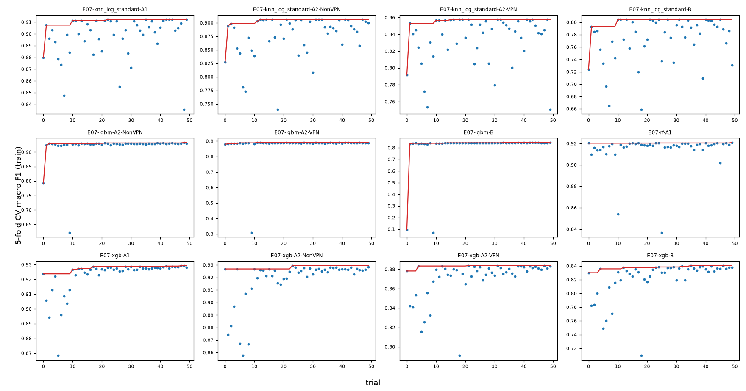
Figure 10. E07 Optuna histories

4.10 E08: class balancing
What. On the current best model per task, a ladder: none, then class weights, then random oversampling, then SMOTE (inside the pipeline, so only training folds are resampled); a step runs only if every earlier step helped. Why. Three tasks are imbalanced (largest to smallest class 5.79:1 in A2-VPN, 11.85:1 in A2-NonVPN and B), and macro F1 weights every class equally. Threshold. (a) the best step beats "none" by at least 0.01 in at least 2 of the 3 imbalanced tasks; (b) in A1 no step moves macro F1 by more than 0.01; (c) the best step raises the F1 of the weakest class in at least 2 of the 3 imbalanced tasks.
task | step | run | val macro F1 | change vs none | F1 of weakest class without balancing | helped | next
A1 | none | E06-xgb | 0.9271 | 0.0 | Non-VPN 0.9240
A1 | class_weight | E08-xgb_class_weight | 0.9237 | -0.0034 | Non-VPN 0.9202 | no | stop: this step did not help
A2-VPN | none | E07-lgbm | 0.8768 | 0.0 | VPN-CHAT 0.7343
A2-VPN | class_weight | E08-lgbm_class_weight | 0.883 | 0.0062 | VPN-CHAT 0.7463 | yes
A2-VPN | oversample | E08-lgbm_oversample | 0.883 | 0.0062 | VPN-CHAT 0.7477 | no | stop: this step did not help
A2-NonVPN | none | E07-lgbm | 0.9028 | 0.0 | STREAMING 0.8095
A2-NonVPN | class_weight | E08-lgbm_class_weight | 0.9049 | 0.0022 | STREAMING 0.8189 | yes
A2-NonVPN | oversample | E08-lgbm_oversample | 0.9075 | 0.0047 | STREAMING 0.8372 | yes
A2-NonVPN | smote | E08-lgbm_smote | 0.9046 | 0.0019 | STREAMING 0.8217 | no | stop: this step did not help
B | none | E07-xgb | 0.8428 | 0.0 | VPN-MAIL 0.6496
B | class_weight | E08-xgb_class_weight | 0.8364 | -0.0064 | VPN-MAIL 0.6290 | no | stop: this step did not help

Result. Every change is within +-0.0064. Balancing helps a little in A2-VPN (class weights +0.0062) and A2-NonVPN (random oversampling +0.0047) and hurts in A1 and B. Verdict. (a) not supported, (b) supported, (c) supported. The weak classes (VPN-CHAT, STREAMING, VPN-MAIL) seem to fail because their flows look like those of other classes, not because there are too few of them; E08 does not test this directly. [E08]
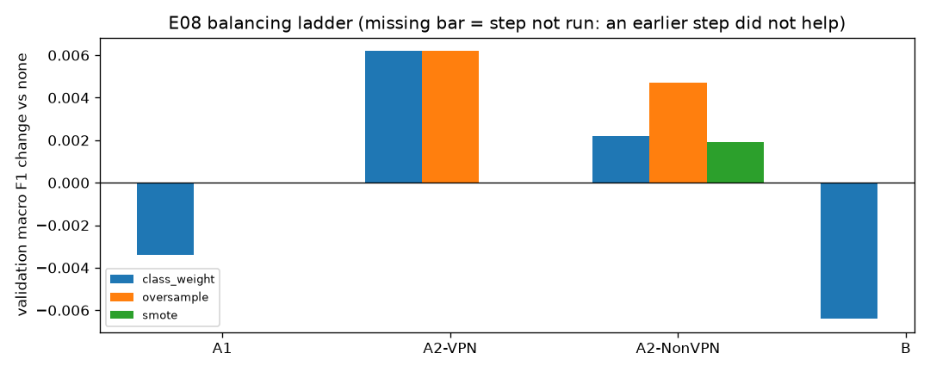
Figure 11. E08 balancing ladder

4.11 E10: task B as one 14-class model or two steps
What. A two-step model for task B: a VPN / non-VPN model routes each flow to one of two 7-class models. All three models use the current best B model type and settings (tuned XGBoost), and all are trained on B's training rows only. They are never trained on the A1 split, because A1 and B hold the same flows split differently. Why. Task B mixes two questions; separating them could help. Threshold. (a) the two-step score is within 0.01 of the direct model; (b) its first step makes fewer VPN / non-VPN errors than the direct model (180); (c) more than half of its errors come from a wrong first step.
structure | run | val macro F1 | CV macro F1 | val accuracy | rows | errors | group errors (VPN / non-VPN wrong) | type errors (right group, wrong type) | group accuracy | share of errors from the group
direct 14-class | E07-xgb | 0.8428 | 0.8405 +- 0.0056 | 0.8794 | 2,711 | 327 | 180 | 147 | 0.9336 | 0.5505
two-step | E10-xgb_two_step | 0.8318 | 0.8274 +- 0.0083 | 0.8727 | 2,711 | 345 | 191 | 154 | 0.9295 | 0.5536

Result. The two-step model scores 0.0110 lower, makes more group errors (191 vs 180), and 55.36% of its errors come from the first step. The direct model also makes 55.05% of its errors across the VPN / non-VPN line: telling VPN from non-VPN is the hard part either way. Verdict. (a) not supported, (b) not supported, (c) supported. Task B stays a direct 14-class model. [E10]

4.12 E17: the same tuning budget for every method type
What. The same 50-trial search as E07 for every method type not yet tuned: decision tree, logistic regression and SVM-RBF in all four tasks, Random Forest in A2-VPN, A2-NonVPN and B, and LightGBM in A1 (16 searches). Logistic regression and SVM may choose the signed log inside the search. Why. Without it, a comparison of method types would mix tuned and untuned models, the weakness we point out in earlier studies. Added on 28 Oct after E10, with the ranges agreed before running. Threshold. (a) tuned above untuned in at least 12 of 16 searches; (b) the best run per task is still XGBoost or LightGBM in at least 3 of 4 tasks; (c) the signed log is chosen in at least 6 of the 8 logistic-regression and SVM searches.
task | model | val macro F1 | CV macro F1 | best before | best before F1 | gain | winner (gain >= 0.03)
A1 | E17-lgbm | 0.9308 | 0.9320 +- 0.0028 | E06-xgb | 0.9271 | 0.0037 | no
A1 | E17-logreg | 0.6517 | 0.6762 +- 0.0051 | E06-xgb | 0.9271 | -0.2754 | no
A1 | E17-svm_rbf | 0.9259 | 0.9187 +- 0.0044 | E06-xgb | 0.9271 | -0.0011 | no
A1 | E17-tree | 0.8905 | 0.8915 +- 0.0043 | E06-xgb | 0.9271 | -0.0366 | no
A2-VPN | E17-logreg | 0.7263 | 0.7344 +- 0.0074 | E08-lgbm_class_weight | 0.883 | -0.1566 | no
A2-VPN | E17-rf | 0.8704 | 0.8707 +- 0.0069 | E08-lgbm_class_weight | 0.883 | -0.0126 | no
A2-VPN | E17-svm_rbf | 0.8707 | 0.8668 +- 0.0074 | E08-lgbm_class_weight | 0.883 | -0.0123 | no
A2-VPN | E17-tree | 0.8292 | 0.8129 +- 0.0071 | E08-lgbm_class_weight | 0.883 | -0.0538 | no
A2-NonVPN | E17-logreg | 0.8002 | 0.8138 +- 0.0120 | E08-lgbm_oversample | 0.9075 | -0.1073 | no
A2-NonVPN | E17-rf | 0.8829 | 0.9063 +- 0.0050 | E08-lgbm_oversample | 0.9075 | -0.0246 | no
A2-NonVPN | E17-svm_rbf | 0.9058 | 0.9256 +- 0.0042 | E08-lgbm_oversample | 0.9075 | -0.0017 | no
A2-NonVPN | E17-tree | 0.8294 | 0.8619 +- 0.0086 | E08-lgbm_oversample | 0.9075 | -0.0781 | no
B | E17-logreg | 0.5862 | 0.5909 +- 0.0067 | E07-xgb | 0.8428 | -0.2566 | no
B | E17-rf | 0.8167 | 0.8270 +- 0.0092 | E07-xgb | 0.8428 | -0.0261 | no
B | E17-svm_rbf | 0.8242 | 0.8228 +- 0.0059 | E07-xgb | 0.8428 | -0.0186 | no
B | E17-tree | 0.7585 | 0.7575 +- 0.0132 | E07-xgb | 0.8428 | -0.0843 | no

Result. SVM-RBF gains the most (+0.3243 to +0.5277), and every logistic-regression and SVM search chose the signed log. The tuned SVM ends 0.0017-0.0186 below each task's best. Logistic regression gains +0.0670 to +0.3515 but stays at 0.5862-0.8002. The tree (0.0000 to +0.0044) and the forest (-0.0111 to +0.0025) barely change. Tuned LightGBM is the new A1 best (0.9308). No winner. Verdict. (a) supported (13 of 16), (b) supported (4 of 4), (c) supported (8 of 8). The A2-NonVPN logistic regression stops at its fixed 1,000 iterations before converging (chosen C = 985); this is recorded as a limitation and was not changed after the run. [E17]
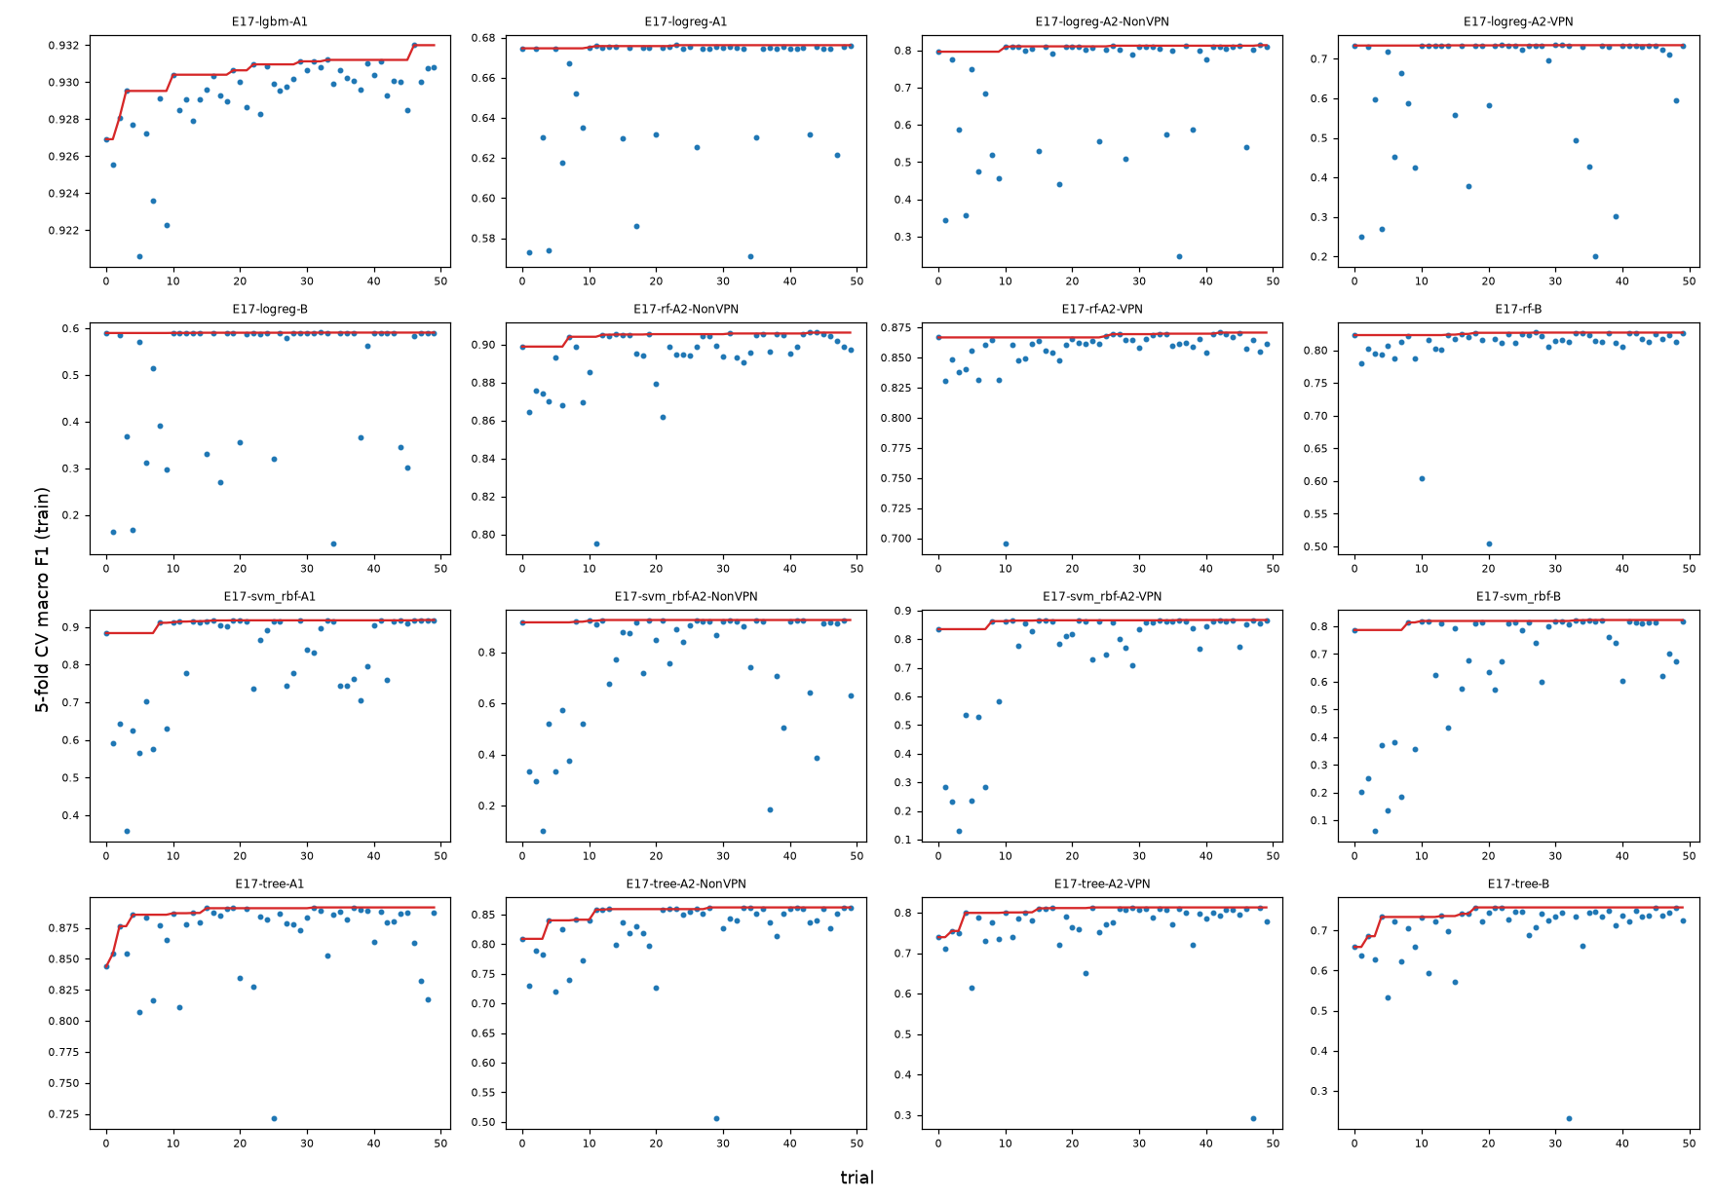
Figure 12. E17 Optuna histories
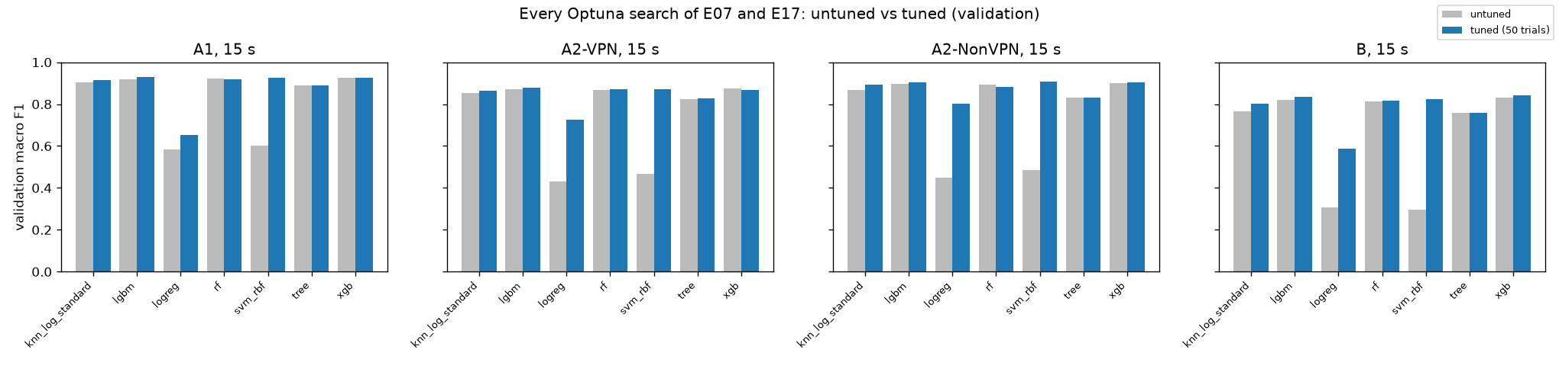
Figure 13. Untuned vs tuned, E07 and E17

4.13 Final choice per task and the comparison set
The final configuration per task is the run with the highest validation macro F1 among all model-selection runs (E02-E17, any timeout), decided on 28 Oct after E10. This replaces the rule set before Phase 3, under which any gap below 0.03 was a tie broken in favour of the simpler model. The cross-validation standard deviations of the headline models (0.0028-0.0058) are far below 0.03, and under the old rule KNN or the SVM would have been chosen at 0.0146-0.0286 below the best. This is a deviation from the pre-set rule and is reported as one (Section 3.8). The models the old rule would pick were also scored on the test set (E12), so the cost of either rule is visible (Section 5.3). The only fallback is a saved model file above 50 MB; none of the four is.
task | run | method type | timeout | val macro F1 | next best | next best F1 | model file MiB | skipped for file size
A1 | E17-lgbm-A1-15s | LightGBM | 15 | 0.9308 | E06-xgb-A1-15s | 0.9271 | 7.09 | none
A2-VPN | E08-lgbm_class_weight-A2-VPN-15s | LightGBM | 15 | 0.883 | E08-lgbm_oversample-A2-VPN-15s | 0.883 | 25.12 | none
A2-NonVPN | E08-lgbm_oversample-A2-NonVPN-15s | LightGBM | 15 | 0.9075 | E17-svm_rbf-A2-NonVPN-15s | 0.9058 | 4.32 | none
B | E07-xgb-B-15s | XGBoost | 15 | 0.8428 | E08-xgb_class_weight-B-15s | 0.8364 | 4.31 | none

task | run | method type | val macro F1 | below the best by | runs within 0.03 | in comparison set
A1 | E04-knn_log_standard-A1-15s | KNN | 0.9048 | 0.026 | 10 | no
A2-VPN | E04-knn_log_standard-A2-VPN-15s | KNN | 0.8544 | 0.0286 | 11 | no
A2-NonVPN | E07-knn_log_standard-A2-NonVPN-15s | KNN | 0.8929 | 0.0146 | 11 | yes
B | E17-svm_rbf-B-15s | SVM-RBF | 0.8242 | 0.0186 | 9 | yes

The comparison set holds, per task, the best 15 s validation variant of each of the 7 method types, 28 models in all. It was fixed in configs/final/compare/ before the test set was opened. In Phase 4 each was retrained on training + validation data and scored once on the test set, with 26 paired bootstrap tests on macro F1 (Holm correction), fixed before the test set was opened (Section 3.3, E12; results in Section 5.3).
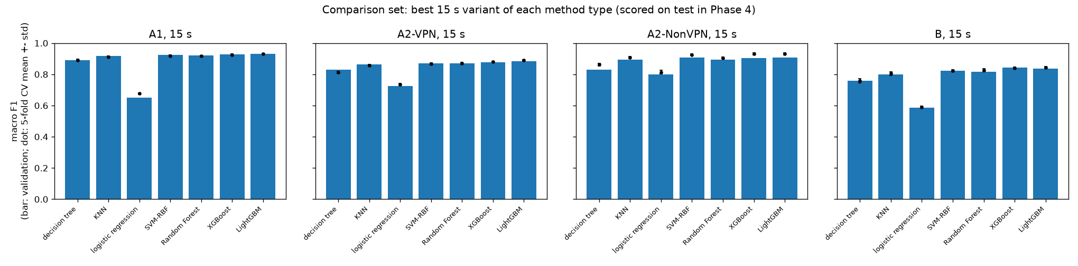
Figure 14. Comparison set at 15 s
task | method type | run | val macro F1 | variants compared
A1 | decision tree | E17-tree-A1-15s | 0.8905 | 2
A1 | KNN | E07-knn_log_standard-A1-15s | 0.9163 | 4
A1 | logistic regression | E17-logreg-A1-15s | 0.6517 | 2
A1 | SVM-RBF | E17-svm_rbf-A1-15s | 0.9259 | 2
A1 | Random Forest | E05-rf-A1-15s | 0.9203 | 2
A1 | XGBoost | E06-xgb-A1-15s | 0.9271 | 3
A1 | LightGBM | E17-lgbm-A1-15s | 0.9308 | 2
A2-VPN | decision tree | E17-tree-A2-VPN-15s | 0.8292 | 2
A2-VPN | KNN | E07-knn_log_standard-A2-VPN-15s | 0.8625 | 4
A2-VPN | logistic regression | E17-logreg-A2-VPN-15s | 0.7263 | 2
A2-VPN | SVM-RBF | E17-svm_rbf-A2-VPN-15s | 0.8707 | 2
A2-VPN | Random Forest | E17-rf-A2-VPN-15s | 0.8704 | 2
A2-VPN | XGBoost | E06-xgb-A2-VPN-15s | 0.8758 | 2
A2-VPN | LightGBM | E08-lgbm_class_weight-A2-VPN-15s | 0.883 | 4
A2-NonVPN | decision tree | E02-tree-A2-NonVPN-15s | 0.8294 | 2
A2-NonVPN | KNN | E07-knn_log_standard-A2-NonVPN-15s | 0.8929 | 4
A2-NonVPN | logistic regression | E17-logreg-A2-NonVPN-15s | 0.8002 | 2
A2-NonVPN | SVM-RBF | E17-svm_rbf-A2-NonVPN-15s | 0.9058 | 2
A2-NonVPN | Random Forest | E05-rf-A2-NonVPN-15s | 0.8941 | 2
A2-NonVPN | XGBoost | E07-xgb-A2-NonVPN-15s | 0.9025 | 2
A2-NonVPN | LightGBM | E08-lgbm_oversample-A2-NonVPN-15s | 0.9075 | 5
B | decision tree | E02-tree-B-15s | 0.7585 | 2
B | KNN | E07-knn_log_standard-B-15s | 0.8006 | 4
B | logistic regression | E17-logreg-B-15s | 0.5862 | 2
B | SVM-RBF | E17-svm_rbf-B-15s | 0.8242 | 2
B | Random Forest | E17-rf-B-15s | 0.8167 | 2
B | XGBoost | E07-xgb-B-15s | 0.8428 | 4
B | LightGBM | E07-lgbm-B-15s | 0.8352 | 2

4.14 E09: feature-group ablation (analysis only)
What. The four headline models retrained with one feature group only, with one group removed, and with the timing-only set (all but flowBytesPerSecond, the only size-based feature). Threshold. (a) every group alone scores below all 23 features in all four tasks; (b) dropping any one group costs at most 0.02 in at least 3 of 4 tasks; (c) the timing-only set is within 0.01 of all 23 features in at least 3 of 4 tasks. If any set scored at least 0.03 above all 23, the work would stop and the user would be asked (it did not happen).
task | feature set | features | val macro F1 | change vs all | CV macro F1
A1 | all | 23 | 0.9308 | 0.0 | 0.9320 +- 0.0028
A1 | only_fiat | 4 | 0.8078 | -0.1229 | 0.8111 +- 0.0059
A1 | only_biat | 4 | 0.8243 | -0.1064 | 0.8136 +- 0.0100
A1 | only_flowiat | 4 | 0.8507 | -0.08 | 0.8456 +- 0.0043
A1 | only_active | 4 | 0.5489 | -0.3819 | 0.5618 +- 0.0124
A1 | only_idle | 4 | 0.5505 | -0.3803 | 0.5614 +- 0.0107
A1 | only_rates_duration | 3 | 0.8392 | -0.0915 | 0.8363 +- 0.0063
A1 | no_fiat | 19 | 0.9256 | -0.0052 | 0.9187 +- 0.0050
A1 | no_biat | 19 | 0.9152 | -0.0155 | 0.9161 +- 0.0050
A1 | no_flowiat | 19 | 0.9322 | 0.0014 | 0.9222 +- 0.0019
A1 | no_active | 19 | 0.9296 | -0.0011 | 0.9300 +- 0.0024
A1 | no_idle | 19 | 0.9304 | -0.0004 | 0.9302 +- 0.0031
A1 | no_rates_duration | 20 | 0.9185 | -0.0122 | 0.9133 +- 0.0054
A1 | timing_only | 22 | 0.9159 | -0.0148 | 0.9140 +- 0.0031
A2-VPN | all | 23 | 0.883 | 0.0 | 0.8893 +- 0.0044
A2-VPN | only_fiat | 4 | 0.7593 | -0.1237 | 0.7326 +- 0.0146
A2-VPN | only_biat | 4 | 0.7199 | -0.1631 | 0.6958 +- 0.0108
A2-VPN | only_flowiat | 4 | 0.7861 | -0.0969 | 0.7690 +- 0.0107
A2-VPN | only_active | 4 | 0.3252 | -0.5578 | 0.3222 +- 0.0193
A2-VPN | only_idle | 4 | 0.3067 | -0.5763 | 0.3208 +- 0.0145
A2-VPN | only_rates_duration | 3 | 0.779 | -0.104 | 0.7661 +- 0.0082
A2-VPN | no_fiat | 19 | 0.8651 | -0.0179 | 0.8723 +- 0.0037
A2-VPN | no_biat | 19 | 0.8724 | -0.0105 | 0.8760 +- 0.0037
A2-VPN | no_flowiat | 19 | 0.8752 | -0.0078 | 0.8833 +- 0.0054
A2-VPN | no_active | 19 | 0.886 | 0.003 | 0.8895 +- 0.0041
A2-VPN | no_idle | 19 | 0.8826 | -0.0004 | 0.8893 +- 0.0054
A2-VPN | no_rates_duration | 20 | 0.8435 | -0.0395 | 0.8449 +- 0.0083
A2-VPN | timing_only | 22 | 0.849 | -0.034 | 0.8410 +- 0.0095
A2-NonVPN | all | 23 | 0.9075 | 0.0 | 0.9310 +- 0.0058
A2-NonVPN | only_fiat | 4 | 0.7535 | -0.154 | 0.7720 +- 0.0087
A2-NonVPN | only_biat | 4 | 0.7271 | -0.1804 | 0.7407 +- 0.0140
A2-NonVPN | only_flowiat | 4 | 0.8165 | -0.091 | 0.8288 +- 0.0095
A2-NonVPN | only_active | 4 | 0.3355 | -0.572 | 0.3208 +- 0.0128
A2-NonVPN | only_idle | 4 | 0.3038 | -0.6037 | 0.3225 +- 0.0177
A2-NonVPN | only_rates_duration | 3 | 0.8471 | -0.0604 | 0.8396 +- 0.0110
A2-NonVPN | no_fiat | 19 | 0.9024 | -0.0051 | 0.9260 +- 0.0087
A2-NonVPN | no_biat | 19 | 0.8993 | -0.0082 | 0.9240 +- 0.0087
A2-NonVPN | no_flowiat | 19 | 0.903 | -0.0045 | 0.9189 +- 0.0065
A2-NonVPN | no_active | 19 | 0.9093 | 0.0018 | 0.9283 +- 0.0066
A2-NonVPN | no_idle | 19 | 0.9039 | -0.0036 | 0.9300 +- 0.0045
A2-NonVPN | no_rates_duration | 20 | 0.8774 | -0.0301 | 0.8980 +- 0.0037
A2-NonVPN | timing_only | 22 | 0.8744 | -0.0331 | 0.9000 +- 0.0060
B | all | 23 | 0.8428 | 0.0 | 0.8405 +- 0.0056
B | only_fiat | 4 | 0.64 | -0.2028 | 0.6399 +- 0.0089
B | only_biat | 4 | 0.6098 | -0.233 | 0.6147 +- 0.0121
B | only_flowiat | 4 | 0.6716 | -0.1712 | 0.6926 +- 0.0102
B | only_active | 4 | 0.2138 | -0.629 | 0.2262 +- 0.0072
B | only_idle | 4 | 0.2083 | -0.6345 | 0.2118 +- 0.0092
B | only_rates_duration | 3 | 0.7043 | -0.1385 | 0.6886 +- 0.0091
B | no_fiat | 19 | 0.8244 | -0.0184 | 0.8266 +- 0.0072
B | no_biat | 19 | 0.8163 | -0.0265 | 0.8189 +- 0.0067
B | no_flowiat | 19 | 0.8262 | -0.0166 | 0.8284 +- 0.0052
B | no_active | 19 | 0.8479 | 0.0051 | 0.8400 +- 0.0071
B | no_idle | 19 | 0.8428 | 0.0 | 0.8405 +- 0.0058
B | no_rates_duration | 20 | 0.7879 | -0.0549 | 0.7936 +- 0.0076
B | timing_only | 22 | 0.7987 | -0.0441 | 0.7949 +- 0.0062

Result. No single group comes close to all 23 features (the best single group is 0.0604-0.1385 below). Removing rates + duration costs the most in A2-VPN, A2-NonVPN and B (0.0395, 0.0301, 0.0549); in A1 removing the backward gaps costs more (0.0155 against 0.0122). Active or idle features can be removed with almost no effect (at most +-0.0051). The timing-only set loses 0.0148-0.0441, so packet sizes carry information here. Verdict. (a) supported, (b) not supported, (c) not supported. Nothing changes in the final configurations. [E09]
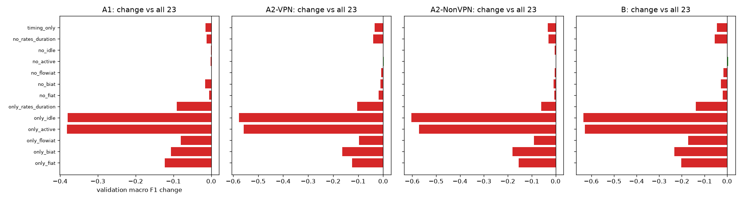
Figure 15. E09 feature-group ablation

4.15 E13: learning curve (analysis only)
What. The headline models trained on 10%, 20%, 40%, 60% and 80% of the training rows (stratified samples, 5 seeds each) and scored on the full validation set; 100% is the headline run. Threshold. (a) 100% scores above 10% in all four tasks; (b) the gain from 80% to 100% is below 0.01 in at least 3 of 4 tasks; (c) the spread over seeds is larger at 10% than at 80% in at least 3 of 4 tasks.
task | train fraction | runs | training rows | val macro F1 mean | val macro F1 std
A1 | 0.1 | 5 | 1,262 | 0.8724 | 0.0062
A1 | 0.2 | 5 | 2,525 | 0.8952 | 0.0041
A1 | 0.4 | 5 | 5,050 | 0.9106 | 0.0066
A1 | 0.6 | 5 | 7,575 | 0.9213 | 0.0039
A1 | 0.8 | 5 | 10,100 | 0.927 | 0.0029
A1 | 1.0 | 1 | 12,626 | 0.9308
A2-VPN | 0.1 | 5 | 656 | 0.7793 | 0.0052
A2-VPN | 0.2 | 5 | 1,313 | 0.826 | 0.0101
A2-VPN | 0.4 | 5 | 2,626 | 0.8582 | 0.0041
A2-VPN | 0.6 | 5 | 3,939 | 0.8721 | 0.0053
A2-VPN | 0.8 | 5 | 5,252 | 0.8804 | 0.0036
A2-VPN | 1.0 | 1 | 6,566 | 0.883
A2-NonVPN | 0.1 | 5 | 608 | 0.8176 | 0.0093
A2-NonVPN | 0.2 | 5 | 1,217 | 0.8585 | 0.0118
A2-NonVPN | 0.4 | 5 | 2,434 | 0.8806 | 0.0057
A2-NonVPN | 0.6 | 5 | 3,651 | 0.8934 | 0.0045
A2-NonVPN | 0.8 | 5 | 4,868 | 0.9005 | 0.0033
A2-NonVPN | 1.0 | 1 | 6,085 | 0.9075
B | 0.1 | 5 | 1,265 | 0.6969 | 0.0097
B | 0.2 | 5 | 2,530 | 0.7468 | 0.0138
B | 0.4 | 5 | 5,060 | 0.7975 | 0.0036
B | 0.6 | 5 | 7,590 | 0.8156 | 0.0016
B | 0.8 | 5 | 10,120 | 0.8297 | 0.0029
B | 1.0 | 1 | 12,651 | 0.8428

Result. Every task gains with more data (10% to 100%: +0.0584 to +0.1459). A1 and both A2 tasks are near their plateau (80% to 100%: +0.0026 to +0.0070), but the 14-class task B still gains +0.0131. Verdict. (a), (b) and (c) supported. [E13]
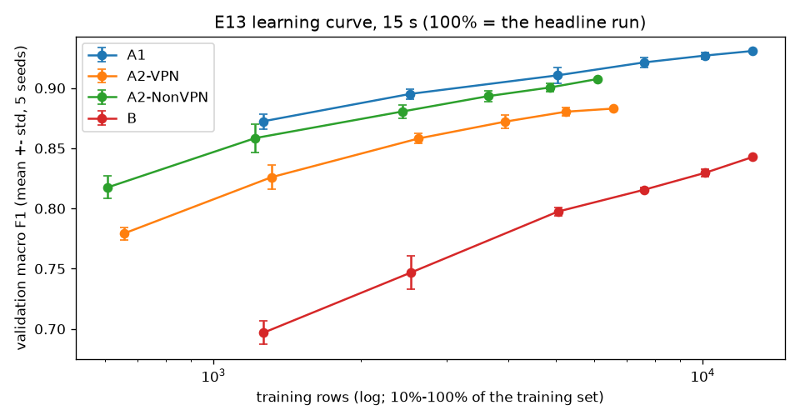
Figure 16. E13 learning curve

4.16 E14: split-seed stability (analysis only)
What. The headline models retrained on 10 new stratified splits of training + validation (seeds 42-51, same sizes). The seed-42 test rows are never pooled or looked at. Seed 42 here is a resplit, not the official split. Threshold. (a) the standard deviation is below 0.01 in at least 3 of 4 tasks; (b) mean cross-validation minus mean validation is within 0.01 in at least 3 of 4 tasks; (c) the official validation score lies inside the range of the 10 resplits in all four tasks.
task | seeds | val macro F1 mean | val macro F1 std | val macro F1 min | val macro F1 max | val accuracy mean | val accuracy std | CV macro F1 mean | CV - val mean | official split (seed 42) val macro F1
A1 | 10 | 0.9338 | 0.0042 | 0.9275 | 0.9397 | 0.9339 | 0.0042 | 0.9306 | -0.0032 | 0.9308
A2-VPN | 10 | 0.8862 | 0.0114 | 0.8689 | 0.902 | 0.9037 | 0.0066 | 0.8805 | -0.0057 | 0.883
A2-NonVPN | 10 | 0.9324 | 0.0071 | 0.9257 | 0.9468 | 0.9589 | 0.0044 | 0.9283 | -0.0041 | 0.9075
B | 10 | 0.8476 | 0.0084 | 0.8344 | 0.8636 | 0.8819 | 0.0074 | 0.8358 | -0.0119 | 0.8428

Result. Scores move with the split by a standard deviation of 0.0042-0.0114. In A2-NonVPN the official validation score (0.9075) is below all 10 resplits (0.9257-0.9468): its validation rows are unusually hard, mostly for MAIL and P2P. This also explains the large cross-validation minus validation gaps seen for A2-NonVPN in E04-E17. Verdict. (a) supported, (b) supported, (c) not supported. [E14]
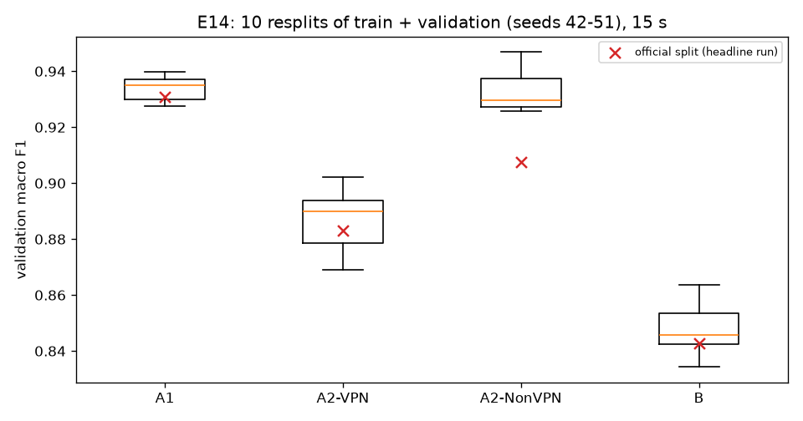
Figure 17. E14 seed stability
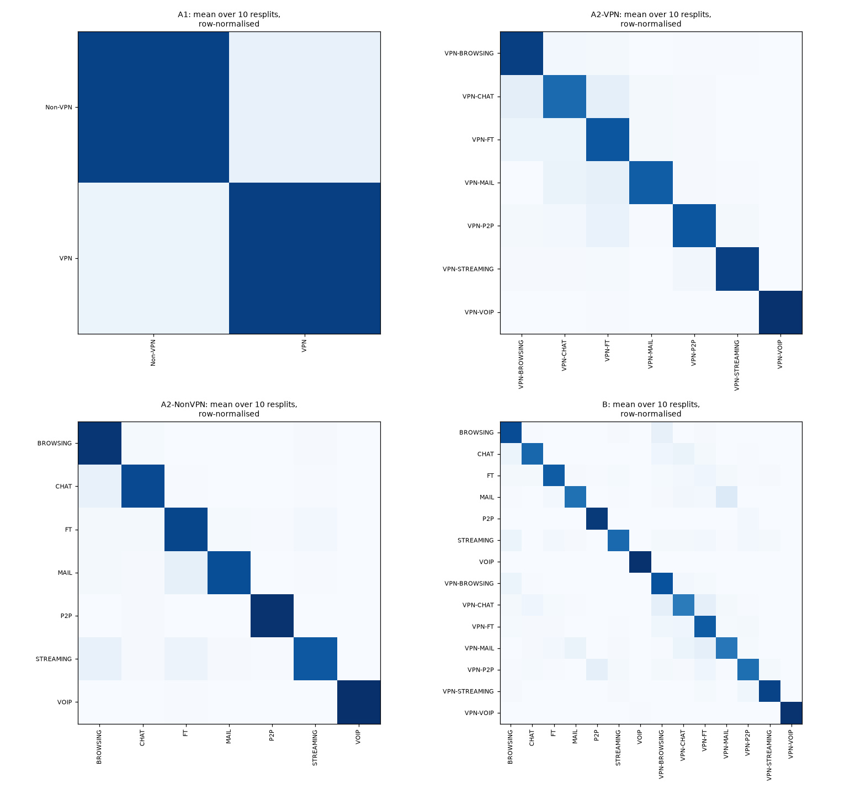
Figure 18. E14 mean confusion matrices

4.17 E11: session-aware split (not run)
The ARFF files hold only the 23 features and the label, with no flow IDs, addresses, ports, timestamps or capture-file names, so flows cannot be grouped by recording session (E00). E11 therefore does not run. Exact duplicates were removed before the split (E00), and E14 and E16(b) measure related effects. The missing session split is a limitation (Section 7). [E11]

4.18 E16: reproducing Isnan et al. (2026), then correcting it
What. Isnan et al. report 88.01% accuracy for a 300-tree Random Forest on the Kaggle copy of the dataset, which is the eight A2 files from all four timeouts stacked (Section 2.9). E16 used its own data version (kaggle-k1) and ran four parts:
- (a) their exact setup: duplicates dropped over the whole file, a stratified 80/20 split with seed 42, and their grid search with accuracy as the score;
- (b) the same method with each timeout kept apart;
- (c) our tuned task-B XGBoost under (b);
- (d), added in a recheck: (a)'s forest trained on mixed-timeout rows cut to each per-timeout training size.
Threshold. (a) accuracy and weighted F1 within 0.01 of theirs; (b) the per-timeout mean is at least 0.01 below (a); (c) our model's per-timeout mean is at least the forest's; (d) at equal training size, mixing timeouts adds less than 0.01 over (b).
run | split | train / test rows | grid pick | grid best CV accuracy | test accuracy | test weighted F1 | test macro F1
E16-isnan-rf | isnan | 32,789 / 8,198 | {"max_depth": null, "min_samples_leaf": 1, "min_samples_split": 2, "n_estimators": 200} | 0.8742 | 0.8796 | 0.8792 | 0.8407
E16-per_timeout-rf-120s | per_timeout_120s | 7,671 / 1,918 | {"max_depth": null, "min_samples_leaf": 1, "min_samples_split": 5, "n_estimators": 300} | 0.8178 | 0.8206 | 0.817 | 0.7724
E16-per_timeout-rf-15s | per_timeout_15s | 14,459 / 3,615 | {"max_depth": 30, "min_samples_leaf": 1, "min_samples_split": 2, "n_estimators": 300} | 0.8578 | 0.8658 | 0.8652 | 0.8323
E16-per_timeout-rf-30s | per_timeout_30s | 10,910 / 2,728 | {"max_depth": 30, "min_samples_leaf": 1, "min_samples_split": 2, "n_estimators": 300} | 0.8457 | 0.8537 | 0.8527 | 0.815
E16-per_timeout-rf-60s | per_timeout_60s | 11,783 / 2,946 | {"max_depth": 30, "min_samples_leaf": 1, "min_samples_split": 2, "n_estimators": 300} | 0.8307 | 0.8316 | 0.8308 | 0.7873
E16-per_timeout-xgb-120s | per_timeout_120s | 7,671 / 1,918 | fixed (configs/final/B.yaml) |  | 0.8384 | 0.8346 | 0.7881
E16-per_timeout-xgb-15s | per_timeout_15s | 14,459 / 3,615 | fixed (configs/final/B.yaml) |  | 0.8924 | 0.8919 | 0.8637
E16-per_timeout-xgb-30s | per_timeout_30s | 10,910 / 2,728 | fixed (configs/final/B.yaml) |  | 0.8728 | 0.872 | 0.8327
E16-per_timeout-xgb-60s | per_timeout_60s | 11,783 / 2,946 | fixed (configs/final/B.yaml) |  | 0.8551 | 0.8544 | 0.8076

training rows (timeouts mixed) | runs | test accuracy mean | std | min - max | 15s test rows | 30s test rows | 60s test rows | 120s test rows | (b) same rows, one timeout
32,789 | 1 | 0.8796 |  |  | 0.8913 | 0.9038 | 0.8982 | 0.8222
14,459 | 5 | 0.8504 | 0.0021 | 0.8470 - 0.8529 | 0.8643 | 0.8798 | 0.8655 | 0.7887 | 15s: 0.8658
11,783 | 5 | 0.8435 | 0.0028 | 0.8401 - 0.8464 | 0.8592 | 0.8742 | 0.8558 | 0.7809 | 60s: 0.8316
10,910 | 5 | 0.8396 | 0.0024 | 0.8367 - 0.8430 | 0.8559 | 0.8708 | 0.8517 | 0.7755 | 30s: 0.8537
7,671 | 5 | 0.8243 | 0.0038 | 0.8202 - 0.8302 | 0.8402 | 0.8576 | 0.8372 | 0.7583 | 120s: 0.8206

Result.
- (a) Their result is reproduced: 0.8796 accuracy and 0.8792 weighted F1, against their 0.8801 and 0.8797, on the same split. Their accuracy hides weaker small classes (macro F1 0.8407).
- (b) With the timeouts kept apart, the same method scores 0.8206-0.8658 (mean 0.8430).
- (d) That drop is explained by training-set size, not by the mixing. Stacking the four files gives 2.3-4.3 times as many training rows. At equal size the mixed setup scores 0.8395 on average, slightly below (b).
- (c) Our tuned XGBoost beats their forest at every timeout (mean 0.8647; 0.8924 at 15 s).
The Kaggle rows use the A2 column layout and an 80/20 split, so these scores are not comparable with our validation scores. Verdict. (a), (b), (c) and (d) supported. E16 feeds no model selection. [E16]
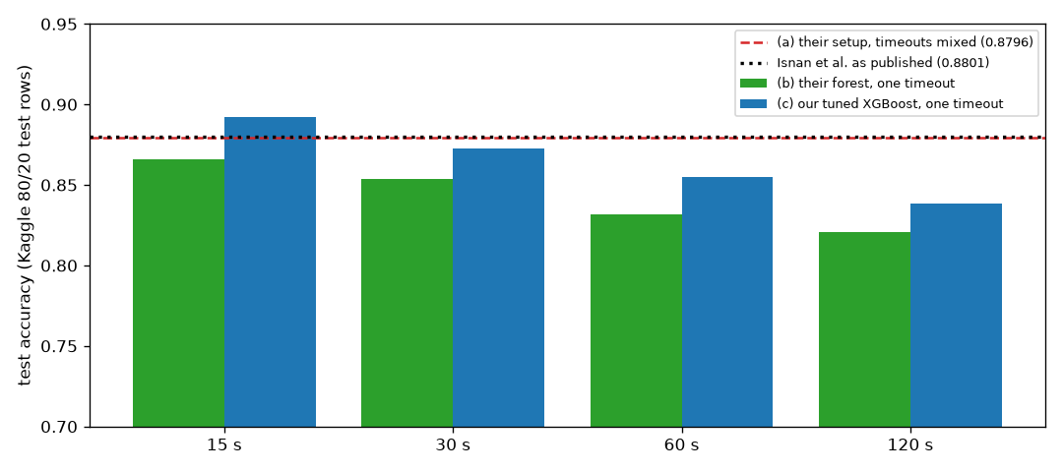
Figure 19. E16 Isnan et al. reproduced and corrected

4.19 Storage after Phase 3
Every official run saves its model (compressed, level 3). Per experiment and model type:
kind | runs | total_MB | per_run_max_MB | model_file_max_MB
E04 knn_log_robust | 4 | 4.678 | 1.577 | 1.435
E04 knn_log_standard | 7 | 6.54 | 1.579 | 1.437
E05 rf | 7 | 102.403 | 22.6 | 22.436
E06 lgbm | 4 | 4.56 | 2.168 | 2.014
E06 xgb | 4 | 2.522 | 1.226 | 1.064
E07 knn_log_standard | 4 | 4.78 | 1.604 | 1.437
E07 lgbm | 3 | 92.646 | 62.694 | 62.51
E07 rf | 1 | 3.835 | 3.835 | 3.72
E07 xgb | 4 | 9.238 | 4.508 | 4.315
E08 lgbm | 5 | 67.775 | 27.135 | 27.033
E08 xgb | 2 | 4.724 | 4.511 | 4.348
E09 lgbm | 39 | 482.749 | 27.644 | 27.549
E09 xgb | 13 | 61.881 | 5.261 | 5.092
E10 xgb_two_step | 1 | 3.856 | 3.856 | 3.728
E13 lgbm | 75 | 474.7 | 21.265 | 21.163
E13 xgb | 25 | 73.528 | 4.188 | 4.025
E14 lgbm | 30 | 372.146 | 25.859 | 25.759
E14 xgb | 10 | 44.771 | 4.494 | 4.336
E16 rf | 26 | 453.605 | 35.049 | 34.902
E16 xgb | 4 | 17.765 | 4.829 | 4.697
E17 lgbm | 1 | 7.215 | 7.215 | 7.092
E17 logreg | 4 | 0.515 | 0.199 | 0.004
E17 rf | 3 | 68.011 | 45.962 | 45.773
E17 svm_rbf | 4 | 2.944 | 1.479 | 1.306
E17 tree | 4 | 0.732 | 0.275 | 0.07

Whole store at this point: artifacts 2645.3 MiB, mlflow.db 35.8 MiB. This is far below the plan's 20 GB limit. The four headline model files are 4.31-25.12 MiB, all below GitHub's 50 MB warning size.

4.20 E15: calibration of the headline models (on validation, before the test set)
What. The Expected Calibration Error (15 equal-width bins; confidence = the probability of the predicted class) and a reliability diagram for each headline model, fitted on the training rows and measured on the validation rows; then isotonic calibration (CalibratedClassifierCV, one base model, mapping learned from 5-fold out-of-fold predictions on the training rows with shuffled folds, seed 42). Why. predict.py and the demo report a confidence for every prediction, so it must be trustworthy. Rule and thresholds, fixed before running. Calibration is adopted for a task if the uncalibrated validation ECE is above 0.05 and isotonic calibration lowers it; it changes only the reported confidence, never the predicted class. (a) uncalibrated ECE above 0.05 in at least 2 of 4 tasks; (b) isotonic ECE lower in all 4; (c) the predicted class unchanged on every row and validation macro F1 equal to the source run. Correction before the counted runs. The first pilot used cv=5, which means unshuffled folds; the training rows are stored in file order, so each fold held out a block of the file and the out-of-fold predictions were far too poor (A1 out-of-fold accuracy 0.6701 unshuffled against 0.9321 shuffled). The folds were changed to the project's shuffled folds before any counted E15 run; the pilot run is kept and superseded.
task | run | headline | val accuracy | mean confidence, uncalibrated | mean confidence, isotonic | ECE uncalibrated | ECE isotonic | adopted | same predicted class (share of rows) | calibrated argmax would differ (share, unused) | val macro F1 = source run
A1 | E15-A1-15s | E17-lgbm-A1-15s | 0.9309 | 0.9861 | 0.9356 | 0.0552 | 0.014 | yes | 1.0 | 0.0007 | yes
A2-VPN | E15-A2-VPN-15s | E08-lgbm_class_weight-A2-VPN-15s | 0.8984 | 0.9692 | 0.9004 | 0.0714 | 0.0168 | yes | 1.0 | 0.0078 | yes
A2-NonVPN | E15-A2-NonVPN-15s | E08-lgbm_oversample-A2-NonVPN-15s | 0.9479 | 0.991 | 0.9469 | 0.0444 | 0.0152 | no | 1.0 | 0.0084 | yes
B | E15-B-15s | E07-xgb-B-15s | 0.8794 | 0.9144 | 0.8787 | 0.035 | 0.0099 | no | 1.0 | 0.0077 | yes

Result. All four models are overconfident on validation. (a), (b) and (c) are supported: calibration was adopted for A1 (ECE 0.0552 to 0.0140) and A2-VPN (0.0714 to 0.0168), and not for A2-NonVPN (0.0444) or B (0.0350), whose uncalibrated ECE is not above 0.05. The test-set ECE, measured once, is in Section 5.4.

4.21 E12: final results on the test set
What. Each of the 30 final models (the 28 comparison-set members, which include the 4 headline models, and the 2 old-rule picks that are not members) was retrained on training + validation data and scored once on the test rows. The models, the 26 paired tests, the 10,000-resample stratified bootstrap and the calibration rule were all fixed before the test set was opened; a rehearsal of the same runs on the validation rows (fitted on the training rows, in a separate run store) passed every check first, and the official runs went in one batch from commit 87181d2, with no crash and no rerun. Why. A score on rows that no choice has seen is the honest estimate of performance on new flows from the same captures. Hypotheses, fixed in Phase 3. (a) every headline model within 0.03 of its validation score; (b) the headline model above the old rule's pick in at least 3 of 4 tasks; (c) Spearman >= 0.8 between the validation and test order of the 7 method types in at least 3 of 4 tasks.
task | role | method type | run | source run | val macro F1 | test macro F1 | 95% interval | test - val | test accuracy | accuracy 95% interval | test weighted F1 | test balanced accuracy | CV macro F1 (fit rows) | CV - test | calibration
A1 | headline | LightGBM | E12-final-A1 | E17-lgbm-A1-15s | 0.9308 | 0.9434 | 0.9348-0.9519 | 0.0126 | 0.9435 | 0.9350-0.9520 | 0.9435 | 0.9433 | 0.9322 | -0.0111 | isotonic
A2-VPN | headline | LightGBM | E12-final-A2-VPN | E08-lgbm_class_weight-A2-VPN-15s | 0.883 | 0.8652 | 0.8431-0.8866 | -0.0178 | 0.8955 | 0.8799-0.9112 | 0.896 | 0.8682 | 0.8827 | 0.0175 | isotonic
A2-NonVPN | headline | LightGBM | E12-final-A2-NonVPN | E08-lgbm_oversample-A2-NonVPN-15s | 0.9075 | 0.9403 | 0.9216-0.9573 | 0.0328 | 0.9609 | 0.9510-0.9709 | 0.9607 | 0.9343 | 0.9347 | -0.0055 | none
B | headline | XGBoost | E12-final-B | E07-xgb-B-15s | 0.8428 | 0.848 | 0.8305-0.8651 | 0.0052 | 0.8798 | 0.8684-0.8916 | 0.8797 | 0.8439 | 0.8473 | -0.0007 | none

Result. (a) is not supported (A2-NonVPN is 0.0328 above its validation score; E14 had already shown its validation rows to be unusually hard), (b) and (c) are supported. 14 of the 26 paired differences are clear after Holm; two more sit on the Holm line and are borderline. All results are in Section 5.

5 Results
This section reports the final models on the test rows: 15% of each task's 15 s file (A1 2,706 flows, A2-VPN 1,407, A2-NonVPN 1,305, B 2,712), held out by the seed-42 split and used by no earlier experiment. Each model was retrained on training + validation data with the settings fixed in configs/final/ before the test set was opened (Section 3.3, Section 4.13). Every interval is a 95% percentile interval from 10,000 stratified paired bootstrap resamples (seed 42), so it is conditional on the test set's class counts.

5.1 Final test scores
task | role | method type | run | source run | val macro F1 | test macro F1 | 95% interval | test - val | test accuracy | accuracy 95% interval | test weighted F1 | test balanced accuracy | CV macro F1 (fit rows) | CV - test | calibration
A1 | headline | LightGBM | E12-final-A1 | E17-lgbm-A1-15s | 0.9308 | 0.9434 | 0.9348-0.9519 | 0.0126 | 0.9435 | 0.9350-0.9520 | 0.9435 | 0.9433 | 0.9322 | -0.0111 | isotonic
A2-VPN | headline | LightGBM | E12-final-A2-VPN | E08-lgbm_class_weight-A2-VPN-15s | 0.883 | 0.8652 | 0.8431-0.8866 | -0.0178 | 0.8955 | 0.8799-0.9112 | 0.896 | 0.8682 | 0.8827 | 0.0175 | isotonic
A2-NonVPN | headline | LightGBM | E12-final-A2-NonVPN | E08-lgbm_oversample-A2-NonVPN-15s | 0.9075 | 0.9403 | 0.9216-0.9573 | 0.0328 | 0.9609 | 0.9510-0.9709 | 0.9607 | 0.9343 | 0.9347 | -0.0055 | none
B | headline | XGBoost | E12-final-B | E07-xgb-B-15s | 0.8428 | 0.848 | 0.8305-0.8651 | 0.0052 | 0.8798 | 0.8684-0.8916 | 0.8797 | 0.8439 | 0.8473 | -0.0007 | none

- Test macro F1: A1 0.9434 (0.9348-0.9519), A2-VPN 0.8652 (0.8431-0.8866), A2-NonVPN 0.9403 (0.9216-0.9573), B 0.8480 (0.8305-0.8651). The two A2 models are scored separately and never merged into one score.
- Against validation, three scores are higher and one lower: +0.0126 (A1), -0.0178 (A2-VPN), +0.0328 (A2-NonVPN), +0.0052 (B). E14 had already shown that the official A2-NonVPN validation rows are unusually hard: its validation macro F1 (0.9075) lies below all 10 resplits of training + validation (0.9257-0.9468), and the test score lies inside that range (Section 5.5).
- Weighted and macro F1 differ most where the classes are unequal in size: weighted minus macro F1 is 0.0001 (A1), 0.0308 (A2-VPN), 0.0204 (A2-NonVPN) and 0.0317 (B).
- Cross-validation on the fitting rows agrees with the test score to within 0.0175 (CV - test: -0.0111, 0.0175, -0.0055, -0.0007).
Hypotheses fixed before the test set was opened (E12, Section 4.21):
- (a) every headline model within 0.03 of its validation score: not supported, because A2-NonVPN is 0.0328 higher. The failure is reported as it is; nothing was changed because of it.
- (b) the headline model above the old tie rule's pick in at least 3 of 4 tasks: supported (4 of 4; the paired test finds the difference clear in A1 and A2-NonVPN).
- (c) the order of the 7 method types by test score agrees with their order by validation score (Spearman >= 0.8) in at least 3 of 4 tasks: supported (0.9643, 0.8214, 0.9286, 0.9643).
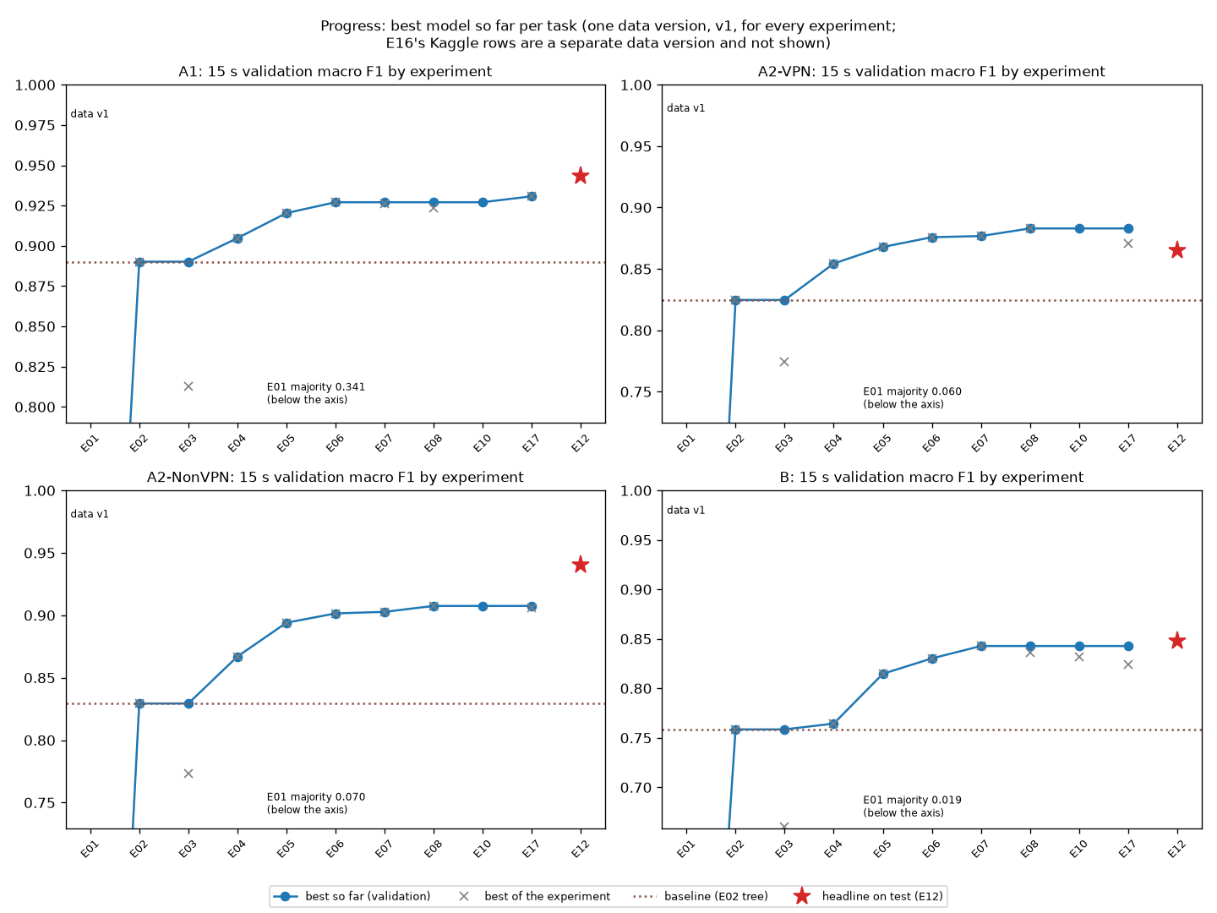
Figure 20. Progress over the experiments

5.2 Per class
class | test rows | precision | recall | F1
Non-VPN | 1,303 | 0.9444 | 0.9378 | 0.9411
VPN | 1,403 | 0.9426 | 0.9487 | 0.9456

class | test rows | precision | recall | F1
VPN-BROWSING | 375 | 0.9305 | 0.928 | 0.9292
VPN-CHAT | 174 | 0.7663 | 0.8103 | 0.7877
VPN-FT | 282 | 0.8672 | 0.8333 | 0.8499
VPN-MAIL | 65 | 0.7188 | 0.7077 | 0.7132
VPN-P2P | 100 | 0.8148 | 0.88 | 0.8462
VPN-STREAMING | 71 | 0.9429 | 0.9296 | 0.9362
VPN-VOIP | 340 | 1.0 | 0.9882 | 0.9941

class | test rows | precision | recall | F1
BROWSING | 375 | 0.9365 | 0.984 | 0.9597
CHAT | 133 | 0.9219 | 0.8872 | 0.9042
FT | 129 | 0.9504 | 0.8915 | 0.92
MAIL | 36 | 0.9167 | 0.9167 | 0.9167
P2P | 141 | 0.9929 | 0.9858 | 0.9893
STREAMING | 68 | 0.9091 | 0.8824 | 0.8955
VOIP | 423 | 1.0 | 0.9929 | 0.9964

class | test rows | precision | recall | F1
BROWSING | 375 | 0.8865 | 0.896 | 0.8912
CHAT | 133 | 0.7698 | 0.8045 | 0.7868
FT | 129 | 0.8992 | 0.8295 | 0.8629
MAIL | 36 | 0.8182 | 0.75 | 0.7826
P2P | 141 | 0.9214 | 0.9149 | 0.9181
STREAMING | 67 | 0.8833 | 0.791 | 0.8346
VOIP | 423 | 0.9929 | 0.9905 | 0.9917
VPN-BROWSING | 375 | 0.827 | 0.8667 | 0.8464
VPN-CHAT | 174 | 0.7607 | 0.7126 | 0.7359
VPN-FT | 283 | 0.8027 | 0.8481 | 0.8247
VPN-MAIL | 65 | 0.7 | 0.7538 | 0.7259
VPN-P2P | 100 | 0.814 | 0.7 | 0.7527
VPN-STREAMING | 71 | 0.8861 | 0.9859 | 0.9333
VPN-VOIP | 340 | 1.0 | 0.9706 | 0.9851

Best and worst classes, calibration on the test rows and cost of the four headline models:
task | run | calibration | test ECE (probabilities used) | test ECE uncalibrated | mean confidence | test accuracy | weighted - macro F1 gap | best class F1 | worst class F1 | best class recall | worst class recall | top-5 confusion pairs (true -> predicted: flows) | model file MiB | train time s | predict ms per 1,000 flows
A1 | E12-final-A1 | isotonic | 0.009 | 0.0442 | 0.9376 | 0.9435 | 0.0001 | VPN 0.9456 | Non-VPN 0.9411 | VPN 0.9487 | Non-VPN 0.9378 | Non-VPN -> VPN: 81; VPN -> Non-VPN: 72 | 7.63 | 4.31 | 192.9
A2-VPN | E12-final-A2-VPN | isotonic | 0.0169 | 0.0709 | 0.889 | 0.8955 | 0.0308 | VPN-VOIP 0.9941 | VPN-MAIL 0.7132 | VPN-VOIP 0.9882 | VPN-MAIL 0.7077 | VPN-FT -> VPN-CHAT: 19; VPN-BROWSING -> VPN-CHAT: 16; VPN-CHAT -> VPN-FT: 15; VPN-CHAT -> VPN-BROWSING: 11; VPN-FT -> VPN-BROWSING: 10 | 28.14 | 14.79 | 1372.9
A2-NonVPN | E12-final-A2-NonVPN | none | 0.0339 | 0.0339 | 0.9942 | 0.9609 | 0.0204 | VOIP 0.9964 | STREAMING 0.8955 | VOIP 0.9929 | STREAMING 0.8824 | CHAT -> BROWSING: 14; STREAMING -> BROWSING: 7; BROWSING -> CHAT: 4; FT -> BROWSING: 4; FT -> STREAMING: 4 | 4.92 | 6.24 | 325.6
B | E12-final-B | none | 0.042 | 0.042 | 0.9213 | 0.8798 | 0.0317 | VOIP 0.9917 | VPN-MAIL 0.7259 | VOIP 0.9905 | VPN-P2P 0.7000 | BROWSING -> VPN-BROWSING: 28; VPN-BROWSING -> BROWSING: 17; VPN-CHAT -> VPN-FT: 16; VPN-BROWSING -> VPN-CHAT: 13; VPN-CHAT -> VPN-BROWSING: 13 | 4.6 | 10.56 | 58.8

The best class in each multi-class task is the voice class (VPN-VOIP 0.9941 in A2-VPN, VOIP 0.9964 in A2-NonVPN and 0.9917 in B); the weakest are VPN-MAIL (0.7132 in A2-VPN, 0.7259 in B) and STREAMING in A2-NonVPN (0.8955), and VPN-P2P has B's lowest recall (0.7000). In A1 both classes are close (VPN 0.9456, Non-VPN 0.9411).
The five largest confusions per task:
task | run | rank | true | predicted | flows | share of true class
A1 | E12-final-A1 | 1 | Non-VPN | VPN | 81 | 0.0622
A1 | E12-final-A1 | 2 | VPN | Non-VPN | 72 | 0.0513
A2-VPN | E12-final-A2-VPN | 1 | VPN-FT | VPN-CHAT | 19 | 0.0674
A2-VPN | E12-final-A2-VPN | 2 | VPN-BROWSING | VPN-CHAT | 16 | 0.0427
A2-VPN | E12-final-A2-VPN | 3 | VPN-CHAT | VPN-FT | 15 | 0.0862
A2-VPN | E12-final-A2-VPN | 4 | VPN-CHAT | VPN-BROWSING | 11 | 0.0632
A2-VPN | E12-final-A2-VPN | 5 | VPN-FT | VPN-BROWSING | 10 | 0.0355
A2-NonVPN | E12-final-A2-NonVPN | 1 | CHAT | BROWSING | 14 | 0.1053
A2-NonVPN | E12-final-A2-NonVPN | 2 | STREAMING | BROWSING | 7 | 0.1029
A2-NonVPN | E12-final-A2-NonVPN | 3 | BROWSING | CHAT | 4 | 0.0107
A2-NonVPN | E12-final-A2-NonVPN | 4 | FT | BROWSING | 4 | 0.031
A2-NonVPN | E12-final-A2-NonVPN | 5 | FT | STREAMING | 4 | 0.031
B | E12-final-B | 1 | BROWSING | VPN-BROWSING | 28 | 0.0747
B | E12-final-B | 2 | VPN-BROWSING | BROWSING | 17 | 0.0453
B | E12-final-B | 3 | VPN-CHAT | VPN-FT | 16 | 0.092
B | E12-final-B | 4 | VPN-BROWSING | VPN-CHAT | 13 | 0.0347
B | E12-final-B | 5 | VPN-CHAT | VPN-BROWSING | 13 | 0.0747

In B the largest confusion is between a non-VPN class and its VPN counterpart: BROWSING predicted as VPN-BROWSING (28 flows) and the reverse (17). Within the VPN classes, CHAT, FT and BROWSING are mixed up with each other in both A2-VPN and B.
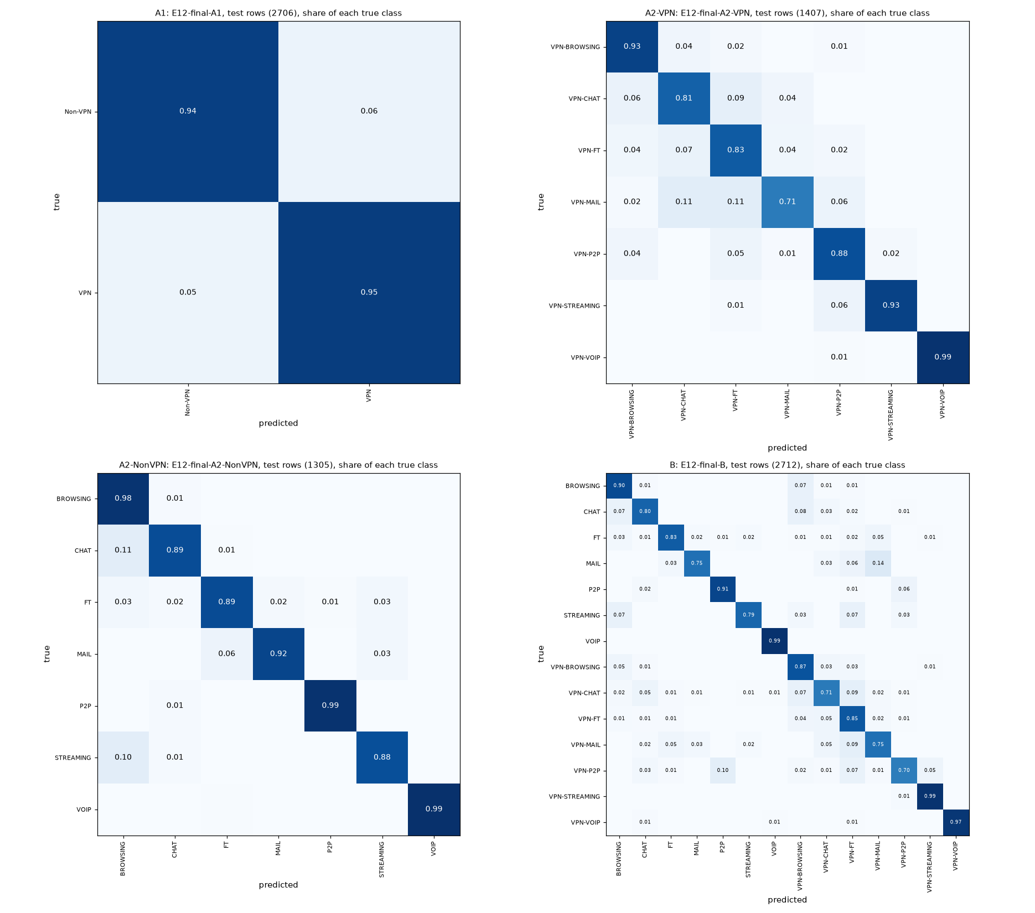
Figure 21. Normalised confusion matrices of the final models

5.3 Comparison of the seven method types
Every model of the comparison set (the best validation variant of each method type, fixed before the test set was opened) and the two old-rule picks that are not members, scored once on the same test rows:
task | role | method type | run | source run | val macro F1 | test macro F1 | 95% interval | test - val | test accuracy | accuracy 95% interval | test weighted F1 | test balanced accuracy | CV macro F1 (fit rows) | CV - test | calibration
A1 | headline | LightGBM | E12-final-A1 | E17-lgbm-A1-15s | 0.9308 | 0.9434 | 0.9348-0.9519 | 0.0126 | 0.9435 | 0.9350-0.9520 | 0.9435 | 0.9433 | 0.9322 | -0.0111 | isotonic
A1 | comparison | KNN | E12-compare-knn-A1 | E07-knn_log_standard-A1-15s | 0.9163 | 0.9208 | 0.9108-0.9308 | 0.0045 | 0.9209 | 0.9109-0.9309 | 0.9209 | 0.9209 | 0.9174 | -0.0034 | none
A1 | comparison | Random Forest | E12-compare-random_forest-A1 | E05-rf-A1-15s | 0.9203 | 0.9289 | 0.9192-0.9382 | 0.0085 | 0.929 | 0.9194-0.9383 | 0.929 | 0.9286 | 0.9199 | -0.009 | none
A1 | comparison | SVM-RBF | E12-compare-svm_rbf-A1 | E17-svm_rbf-A1-15s | 0.9259 | 0.9311 | 0.9215-0.9404 | 0.0052 | 0.9313 | 0.9217-0.9405 | 0.9312 | 0.9309 | 0.9222 | -0.0089 | none
A1 | comparison | XGBoost | E12-compare-xgboost-A1 | E06-xgb-A1-15s | 0.9271 | 0.9304 | 0.9207-0.9397 | 0.0033 | 0.9305 | 0.9209-0.9398 | 0.9305 | 0.9301 | 0.929 | -0.0014 | none
A1 | comparison | decision tree | E12-compare-decision_tree-A1 | E17-tree-A1-15s | 0.8905 | 0.8982 | 0.8866-0.9093 | 0.0077 | 0.8984 | 0.8869-0.9095 | 0.8983 | 0.8979 | 0.8983 | 0.0001 | none
A1 | comparison | logistic regression | E12-compare-logistic_regression-A1 | E17-logreg-A1-15s | 0.6517 | 0.6804 | 0.6628-0.6976 | 0.0287 | 0.6811 | 0.6633-0.6984 | 0.6809 | 0.6803 | 0.673 | -0.0074 | none
A1 | old_rule | KNN | E12-old_rule-A1 | E04-knn_log_standard-A1-15s | 0.9048 | 0.9112 | 0.9004-0.9216 | 0.0064 | 0.9113 | 0.9006-0.9217 | 0.9113 | 0.9111 | 0.9078 | -0.0034 | none
A2-VPN | headline | LightGBM | E12-final-A2-VPN | E08-lgbm_class_weight-A2-VPN-15s | 0.883 | 0.8652 | 0.8431-0.8866 | -0.0178 | 0.8955 | 0.8799-0.9112 | 0.896 | 0.8682 | 0.8827 | 0.0175 | isotonic
A2-VPN | comparison | KNN | E12-compare-knn-A2-VPN | E07-knn_log_standard-A2-VPN-15s | 0.8625 | 0.8431 | 0.8190-0.8655 | -0.0195 | 0.8735 | 0.8564-0.8898 | 0.8731 | 0.8441 | 0.8577 | 0.0146 | none
A2-VPN | comparison | Random Forest | E12-compare-random_forest-A2-VPN | E17-rf-A2-VPN-15s | 0.8704 | 0.8594 | 0.8379-0.8804 | -0.011 | 0.8827 | 0.8664-0.8984 | 0.8823 | 0.8646 | 0.8688 | 0.0093 | none
A2-VPN | comparison | SVM-RBF | E12-compare-svm_rbf-A2-VPN | E17-svm_rbf-A2-VPN-15s | 0.8707 | 0.867 | 0.8464-0.8875 | -0.0037 | 0.8863 | 0.8699-0.9019 | 0.8869 | 0.8732 | 0.8672 | 0.0002 | none
A2-VPN | comparison | XGBoost | E12-compare-xgboost-A2-VPN | E06-xgb-A2-VPN-15s | 0.8758 | 0.8577 | 0.8349-0.8796 | -0.0181 | 0.8891 | 0.8728-0.9048 | 0.8896 | 0.8606 | 0.882 | 0.0243 | none
A2-VPN | comparison | decision tree | E12-compare-decision_tree-A2-VPN | E17-tree-A2-VPN-15s | 0.8292 | 0.8308 | 0.8085-0.8534 | 0.0016 | 0.8557 | 0.8380-0.8735 | 0.8568 | 0.8383 | 0.8219 | -0.0089 | none
A2-VPN | comparison | logistic regression | E12-compare-logistic_regression-A2-VPN | E17-logreg-A2-VPN-15s | 0.7263 | 0.7179 | 0.6893-0.7446 | -0.0084 | 0.7633 | 0.7434-0.7832 | 0.7584 | 0.7093 | 0.7275 | 0.0096 | none
A2-VPN | old_rule | KNN | E12-old_rule-A2-VPN | E04-knn_log_standard-A2-VPN-15s | 0.8544 | 0.8442 | 0.8216-0.8667 | -0.0102 | 0.8685 | 0.8515-0.8856 | 0.8679 | 0.8538 | 0.8444 | 0.0003 | none
A2-NonVPN | headline | LightGBM | E12-final-A2-NonVPN | E08-lgbm_oversample-A2-NonVPN-15s | 0.9075 | 0.9403 | 0.9216-0.9573 | 0.0328 | 0.9609 | 0.9510-0.9709 | 0.9607 | 0.9343 | 0.9347 | -0.0055 | none
A2-NonVPN | comparison | KNN | E12-compare-knn-A2-NonVPN | E07-knn_log_standard-A2-NonVPN-15s | 0.8929 | 0.916 | 0.8960-0.9351 | 0.0231 | 0.9425 | 0.9303-0.9540 | 0.9423 | 0.9126 | 0.9091 | -0.007 | none
A2-NonVPN | comparison | Random Forest | E12-compare-random_forest-A2-NonVPN | E05-rf-A2-NonVPN-15s | 0.8941 | 0.9067 | 0.8848-0.9276 | 0.0127 | 0.9379 | 0.9249-0.9502 | 0.9373 | 0.897 | 0.908 | 0.0012 | none
A2-NonVPN | comparison | SVM-RBF | E12-compare-svm_rbf-A2-NonVPN | E17-svm_rbf-A2-NonVPN-15s | 0.9058 | 0.9244 | 0.9036-0.9438 | 0.0186 | 0.9525 | 0.9410-0.9632 | 0.9521 | 0.9202 | 0.923 | -0.0014 | none
A2-NonVPN | comparison | XGBoost | E12-compare-xgboost-A2-NonVPN | E07-xgb-A2-NonVPN-15s | 0.9025 | 0.9346 | 0.9151-0.9523 | 0.032 | 0.9579 | 0.9471-0.9678 | 0.9576 | 0.9268 | 0.9293 | -0.0053 | none
A2-NonVPN | comparison | decision tree | E12-compare-decision_tree-A2-NonVPN | E02-tree-A2-NonVPN-15s | 0.8294 | 0.8825 | 0.8596-0.9051 | 0.0532 | 0.9203 | 0.9057-0.9341 | 0.9204 | 0.8841 | 0.8686 | -0.0139 | none
A2-NonVPN | comparison | logistic regression | E12-compare-logistic_regression-A2-NonVPN | E17-logreg-A2-NonVPN-15s | 0.8002 | 0.8053 | 0.7724-0.8360 | 0.005 | 0.8828 | 0.8674-0.8981 | 0.8789 | 0.7814 | 0.7992 | -0.0061 | none
B | headline | XGBoost | E12-final-B | E07-xgb-B-15s | 0.8428 | 0.848 | 0.8305-0.8651 | 0.0052 | 0.8798 | 0.8684-0.8916 | 0.8797 | 0.8439 | 0.8473 | -0.0007 | none
B | comparison | KNN | E12-compare-knn-B | E07-knn_log_standard-B-15s | 0.8006 | 0.8253 | 0.8068-0.8432 | 0.0248 | 0.861 | 0.8488-0.8732 | 0.8607 | 0.825 | 0.811 | -0.0144 | none
B | comparison | LightGBM | E12-compare-lightgbm-B | E07-lgbm-B-15s | 0.8352 | 0.8567 | 0.8389-0.8735 | 0.0215 | 0.885 | 0.8732-0.8964 | 0.8846 | 0.8468 | 0.8501 | -0.0066 | none
B | comparison | Random Forest | E12-compare-random_forest-B | E17-rf-B-15s | 0.8167 | 0.8403 | 0.8222-0.8576 | 0.0236 | 0.8721 | 0.8603-0.8838 | 0.8713 | 0.8339 | 0.8359 | -0.0044 | none
B | comparison | SVM-RBF | E12-compare-svm_rbf-B | E17-svm_rbf-B-15s | 0.8242 | 0.8411 | 0.8224-0.8584 | 0.0169 | 0.8728 | 0.8610-0.8850 | 0.872 | 0.8342 | 0.8248 | -0.0163 | none
B | comparison | decision tree | E12-compare-decision_tree-B | E02-tree-B-15s | 0.7585 | 0.7886 | 0.7687-0.8081 | 0.03 | 0.8278 | 0.8145-0.8414 | 0.8279 | 0.7892 | 0.7574 | -0.0312 | none
B | comparison | logistic regression | E12-compare-logistic_regression-B | E17-logreg-B-15s | 0.5862 | 0.6089 | 0.5856-0.6313 | 0.0227 | 0.6574 | 0.6412-0.6737 | 0.6505 | 0.595 | 0.5885 | -0.0204 | none

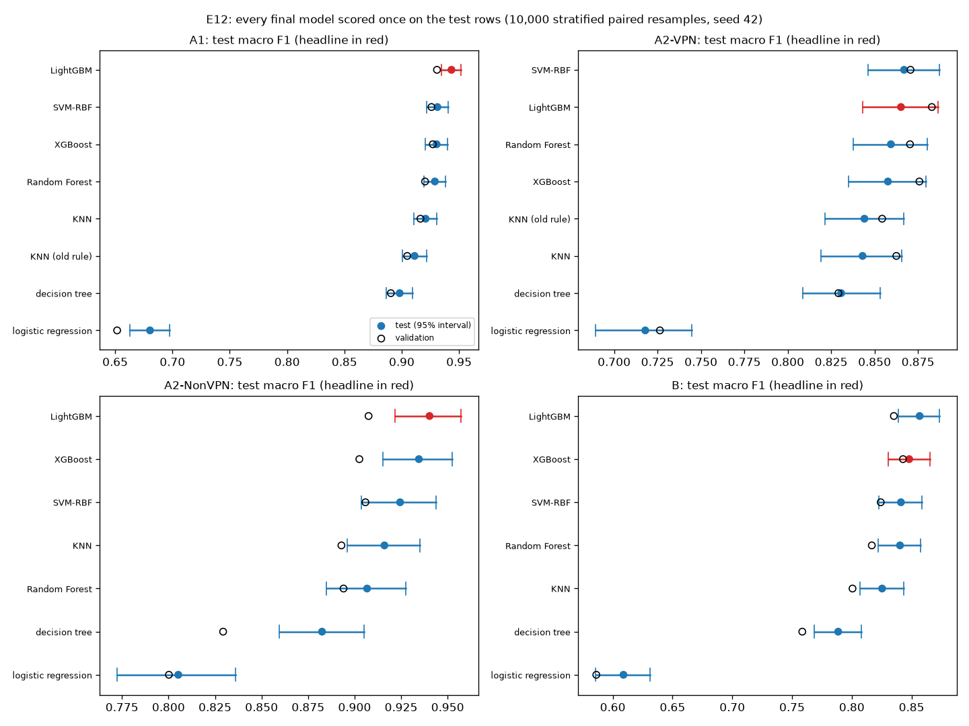
Figure 22. Every final model on the test rows
The 26 paired tests fixed before the test set was opened (headline model minus the other model on the same resampled rows; Holm correction over all 26 at 0.05):
task | headline | other | other role | other type | d (headline - other) | d 95% interval | p | Holm p | different (Holm, 0.05)
A1 | E12-final-A1 | E12-compare-knn-A1 | comparison | KNN | 0.0226 | 0.0140-0.0314 | 0.0002 | 0.0052 | yes
A1 | E12-final-A1 | E12-compare-random_forest-A1 | comparison | Random Forest | 0.0145 | 0.0071-0.0219 | 0.0004 | 0.0064 | yes
A1 | E12-final-A1 | E12-compare-svm_rbf-A1 | comparison | SVM-RBF | 0.0122 | 0.0038-0.0207 | 0.0042 | 0.0504 | no
A1 | E12-final-A1 | E12-compare-xgboost-A1 | comparison | XGBoost | 0.013 | 0.0056-0.0204 | 0.0004 | 0.0064 | yes
A1 | E12-final-A1 | E12-compare-decision_tree-A1 | comparison | decision tree | 0.0452 | 0.0352-0.0559 | 0.0002 | 0.0052 | yes
A1 | E12-final-A1 | E12-compare-logistic_regression-A1 | comparison | logistic regression | 0.263 | 0.2446-0.2817 | 0.0002 | 0.0052 | yes
A1 | E12-final-A1 | E12-old_rule-A1 | old_rule | KNN | 0.0322 | 0.0226-0.0422 | 0.0002 | 0.0052 | yes
A2-VPN | E12-final-A2-VPN | E12-compare-knn-A2-VPN | comparison | KNN | 0.0221 | 0.0052-0.0390 | 0.0132 | 0.1320 | no
A2-VPN | E12-final-A2-VPN | E12-compare-random_forest-A2-VPN | comparison | Random Forest | 0.0058 | -0.0117-0.0234 | 0.5123 | 1.0000 | no
A2-VPN | E12-final-A2-VPN | E12-compare-svm_rbf-A2-VPN | comparison | SVM-RBF | -0.0018 | -0.0224-0.0186 | 0.8525 | 1.0000 | no
A2-VPN | E12-final-A2-VPN | E12-compare-xgboost-A2-VPN | comparison | XGBoost | 0.0075 | -0.0062-0.0214 | 0.2918 | 1.0000 | no
A2-VPN | E12-final-A2-VPN | E12-compare-decision_tree-A2-VPN | comparison | decision tree | 0.0345 | 0.0115-0.0577 | 0.0042 | 0.0504 | no
A2-VPN | E12-final-A2-VPN | E12-compare-logistic_regression-A2-VPN | comparison | logistic regression | 0.1473 | 0.1173-0.1777 | 0.0002 | 0.0052 | yes
A2-VPN | E12-final-A2-VPN | E12-old_rule-A2-VPN | old_rule | KNN | 0.0211 | -0.0005-0.0426 | 0.0566 | 0.4752 | no
A2-NonVPN | E12-final-A2-NonVPN | E12-compare-knn-A2-NonVPN | comparison | KNN | 0.0242 | 0.0106-0.0387 | 0.0004 | 0.0064 | yes
A2-NonVPN | E12-final-A2-NonVPN | E12-compare-random_forest-A2-NonVPN | comparison | Random Forest | 0.0336 | 0.0181-0.0506 | 0.0002 | 0.0052 | yes
A2-NonVPN | E12-final-A2-NonVPN | E12-compare-svm_rbf-A2-NonVPN | comparison | SVM-RBF | 0.0158 | -0.0001-0.0327 | 0.0528 | 0.4752 | no
A2-NonVPN | E12-final-A2-NonVPN | E12-compare-xgboost-A2-NonVPN | comparison | XGBoost | 0.0057 | -0.0059-0.0181 | 0.3406 | 1.0000 | no
A2-NonVPN | E12-final-A2-NonVPN | E12-compare-decision_tree-A2-NonVPN | comparison | decision tree | 0.0578 | 0.0402-0.0763 | 0.0002 | 0.0052 | yes
A2-NonVPN | E12-final-A2-NonVPN | E12-compare-logistic_regression-A2-NonVPN | comparison | logistic regression | 0.135 | 0.1033-0.1687 | 0.0002 | 0.0052 | yes
B | E12-final-B | E12-compare-knn-B | comparison | KNN | 0.0227 | 0.0090-0.0364 | 0.0020 | 0.0260 | yes
B | E12-final-B | E12-compare-lightgbm-B | comparison | LightGBM | -0.0087 | -0.0197-0.0028 | 0.1368 | 0.9575 | no
B | E12-final-B | E12-compare-random_forest-B | comparison | Random Forest | 0.0077 | -0.0040-0.0196 | 0.1952 | 1.0000 | no
B | E12-final-B | E12-compare-svm_rbf-B | comparison | SVM-RBF | 0.0069 | -0.0093-0.0235 | 0.4078 | 1.0000 | no
B | E12-final-B | E12-compare-decision_tree-B | comparison | decision tree | 0.0594 | 0.0435-0.0762 | 0.0002 | 0.0052 | yes
B | E12-final-B | E12-compare-logistic_regression-B | comparison | logistic regression | 0.2391 | 0.2147-0.2648 | 0.0002 | 0.0052 | yes

- 14 of the 26 differences are clear after Holm (A1 6 of 7, A2-VPN 1 of 7, A2-NonVPN 4 of 6, B 3 of 6). The headline model is clearly better than logistic regression in every task and than the decision tree in A1, A2-NonVPN and B.
- It is not clearly different from the SVM in any task, nor from XGBoost or LightGBM except A1 against XGBoost. Two comparison models scored slightly higher on the test rows, neither clearly: the A2-VPN SVM (0.8670 against 0.8652) and the B LightGBM (0.8567 against 0.8480).
Two of the 26 tests sit on the Holm line. The p-value of each test comes from the same 10,000 resamples, so it carries Monte Carlo error; the band below is 2 x the tail share plus or minus two standard errors, times the test's Holm multiplier:
task | other | smaller tail count | p | Holm p | Holm p band (+-2 SE) | different (Holm, 0.05) | settled by B resamples
A1 | E12-compare-knn-A1 | 0 | 0.0002 | 0.0052 | 0.0000-0.0156 | yes | yes
A1 | E12-compare-decision_tree-A1 | 0 | 0.0002 | 0.0052 | 0.0000-0.0150 | yes | yes
A1 | E12-compare-logistic_regression-A1 | 0 | 0.0002 | 0.0052 | 0.0000-0.0144 | yes | yes
A1 | E12-old_rule-A1 | 0 | 0.0002 | 0.0052 | 0.0000-0.0138 | yes | yes
A2-VPN | E12-compare-logistic_regression-A2-VPN | 0 | 0.0002 | 0.0052 | 0.0000-0.0132 | yes | yes
A2-NonVPN | E12-compare-random_forest-A2-NonVPN | 0 | 0.0002 | 0.0052 | 0.0000-0.0126 | yes | yes
A2-NonVPN | E12-compare-decision_tree-A2-NonVPN | 0 | 0.0002 | 0.0052 | 0.0000-0.0120 | yes | yes
A2-NonVPN | E12-compare-logistic_regression-A2-NonVPN | 0 | 0.0002 | 0.0052 | 0.0000-0.0114 | yes | yes
B | E12-compare-decision_tree-B | 0 | 0.0002 | 0.0052 | 0.0000-0.0108 | yes | yes
B | E12-compare-logistic_regression-B | 0 | 0.0002 | 0.0052 | 0.0000-0.0102 | yes | yes
A1 | E12-compare-random_forest-A1 | 1 | 0.0004 | 0.0064 | 0.0000-0.0154 | yes | yes
A1 | E12-compare-xgboost-A1 | 1 | 0.0004 | 0.0064 | 0.0000-0.0145 | yes | yes
A2-NonVPN | E12-compare-knn-A2-NonVPN | 1 | 0.0004 | 0.0064 | 0.0000-0.0135 | yes | yes
B | E12-compare-knn-B | 9 | 0.0020 | 0.0260 | 0.0096-0.0424 | yes | yes
A1 | E12-compare-svm_rbf-A1 | 20 | 0.0042 | 0.0504 | 0.0284-0.0724 | no | no
A2-VPN | E12-compare-decision_tree-A2-VPN | 20 | 0.0042 | 0.0504 | 0.0261-0.0663 | no | no
A2-VPN | E12-compare-knn-A2-VPN | 65 | 0.0132 | 0.1320 | 0.0996-0.1644 | no | yes
A2-NonVPN | E12-compare-svm_rbf-A2-NonVPN | 263 | 0.0528 | 0.4752 | 0.4174-0.5329 | no | yes
A2-VPN | E12-old_rule-A2-VPN | 282 | 0.0566 | 0.4752 | 0.3997-0.5058 | no | yes
B | E12-compare-lightgbm-B | 683 | 0.1368 | 0.9575 | 0.8868-1.0000 | no | yes
B | E12-compare-random_forest-B | 975 | 0.1952 | 1.0000 | 1.0000-1.0000 | no | yes
A2-VPN | E12-compare-xgboost-A2-VPN | 1,458 | 0.2918 | 1.0000 | 1.0000-1.0000 | no | yes
A2-NonVPN | E12-compare-xgboost-A2-NonVPN | 1,702 | 0.3406 | 1.0000 | 1.0000-1.0000 | no | yes
B | E12-compare-svm_rbf-B | 2,038 | 0.4078 | 1.0000 | 1.0000-1.0000 | no | yes
A2-VPN | E12-compare-random_forest-A2-VPN | 2,561 | 0.5123 | 1.0000 | 0.9898-1.0000 | no | yes
A2-VPN | E12-compare-svm_rbf-A2-VPN | 4,262 | 0.8525 | 1.0000 | 0.8327-0.8723 | no | yes

A1 against the SVM and A2-VPN against the decision tree (Holm p 0.0504) have bands of about 0.03-0.07, so 10,000 resamples cannot settle whether they fall below 0.05. Under the rule fixed in advance both count as not clear; they are reported as borderline. No verdict depends on them, and the other 24 tests are settled either way. An independent recomputation from the saved predictions (scripts/check_e12_independent.py) reproduced every interval, p-value and Holm p.
The deviation from the pre-set tie rule, and what it cost. The rule set before Phase 3 would have chosen a simpler model whenever the gap was below 0.03 (Section 3.8). Its picks were scored on the test set too: the headline model scored higher in all four tasks, by 0.0322 in A1 (against the E04 KNN, clear), 0.0211 in A2-VPN (E04 KNN, not clear), 0.0242 in A2-NonVPN (E07 KNN, clear) and 0.0069 in B (E17 SVM, not clear). Choosing by the highest validation score therefore did not cost anything on the test rows, and in two tasks it gained a clear margin.

5.4 Calibration (E15)
task | run | headline | val accuracy | mean confidence, uncalibrated | mean confidence, isotonic | ECE uncalibrated | ECE isotonic | adopted | same predicted class (share of rows) | calibrated argmax would differ (share, unused) | val macro F1 = source run
A1 | E15-A1-15s | E17-lgbm-A1-15s | 0.9309 | 0.9861 | 0.9356 | 0.0552 | 0.014 | yes | 1.0 | 0.0007 | yes
A2-VPN | E15-A2-VPN-15s | E08-lgbm_class_weight-A2-VPN-15s | 0.8984 | 0.9692 | 0.9004 | 0.0714 | 0.0168 | yes | 1.0 | 0.0078 | yes
A2-NonVPN | E15-A2-NonVPN-15s | E08-lgbm_oversample-A2-NonVPN-15s | 0.9479 | 0.991 | 0.9469 | 0.0444 | 0.0152 | no | 1.0 | 0.0084 | yes
B | E15-B-15s | E07-xgb-B-15s | 0.8794 | 0.9144 | 0.8787 | 0.035 | 0.0099 | no | 1.0 | 0.0077 | yes

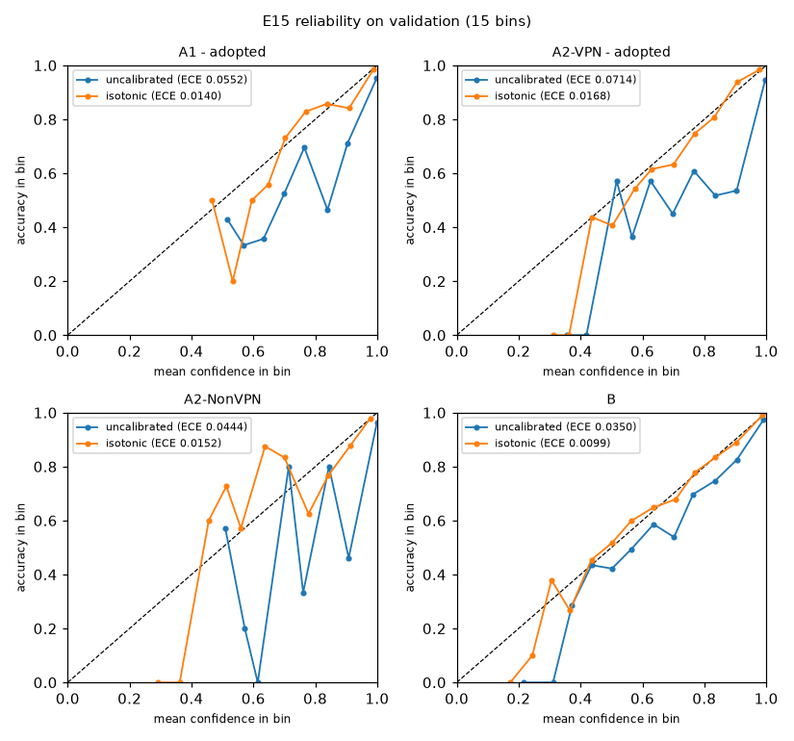
Figure 23. Reliability diagrams (validation)
All four headline models were overconfident on validation (mean confidence above accuracy). By the rule fixed before the test set (calibrate where the uncalibrated validation ECE is above 0.05 and isotonic calibration lowers it), calibration was adopted for A1 and A2-VPN. On the test rows, measured once, it lowers the expected calibration error from 0.0442 to 0.0090 (A1) and from 0.0709 to 0.0169 (A2-VPN); the uncalibrated A2-NonVPN and B models have 0.0339 and 0.0420. Calibration changes only the reported confidence; the predicted class, and so every test score above, is the uncalibrated model's.

5.5 Stability and amount of training data (E14, E13)
Split-seed stability on validation, 10 resplits of training + validation (E14, Section 4.16):
task | seeds | val macro F1 mean | val macro F1 std | val macro F1 min | val macro F1 max | val accuracy mean | val accuracy std | CV macro F1 mean | CV - val mean | official split (seed 42) val macro F1
A1 | 10 | 0.9338 | 0.0042 | 0.9275 | 0.9397 | 0.9339 | 0.0042 | 0.9306 | -0.0032 | 0.9308
A2-VPN | 10 | 0.8862 | 0.0114 | 0.8689 | 0.902 | 0.9037 | 0.0066 | 0.8805 | -0.0057 | 0.883
A2-NonVPN | 10 | 0.9324 | 0.0071 | 0.9257 | 0.9468 | 0.9589 | 0.0044 | 0.9283 | -0.0041 | 0.9075
B | 10 | 0.8476 | 0.0084 | 0.8344 | 0.8636 | 0.8819 | 0.0074 | 0.8358 | -0.0119 | 0.8428

The validation macro F1 of the headline models varies by 0.0042-0.0114 (standard deviation) across resplits. The test scores are inside the resplit range for A2-NonVPN (0.9403 in 0.9257-0.9468) and B (0.8480 in 0.8344-0.8636), above it for A1 (0.9434 against at most 0.9397) and below it for A2-VPN (0.8652 against at least 0.8689). The resplit models are trained on the training share of each resplit only, while the final models also use the validation rows, so the two are not the same model; a single 15% test set can also land outside a 10-resplit range by chance.
Learning curve on validation (E13, Section 4.15):
task | train fraction | runs | training rows | val macro F1 mean | val macro F1 std
A1 | 0.1 | 5 | 1,262 | 0.8724 | 0.0062
A1 | 0.2 | 5 | 2,525 | 0.8952 | 0.0041
A1 | 0.4 | 5 | 5,050 | 0.9106 | 0.0066
A1 | 0.6 | 5 | 7,575 | 0.9213 | 0.0039
A1 | 0.8 | 5 | 10,100 | 0.927 | 0.0029
A1 | 1.0 | 1 | 12,626 | 0.9308
A2-VPN | 0.1 | 5 | 656 | 0.7793 | 0.0052
A2-VPN | 0.2 | 5 | 1,313 | 0.826 | 0.0101
A2-VPN | 0.4 | 5 | 2,626 | 0.8582 | 0.0041
A2-VPN | 0.6 | 5 | 3,939 | 0.8721 | 0.0053
A2-VPN | 0.8 | 5 | 5,252 | 0.8804 | 0.0036
A2-VPN | 1.0 | 1 | 6,566 | 0.883
A2-NonVPN | 0.1 | 5 | 608 | 0.8176 | 0.0093
A2-NonVPN | 0.2 | 5 | 1,217 | 0.8585 | 0.0118
A2-NonVPN | 0.4 | 5 | 2,434 | 0.8806 | 0.0057
A2-NonVPN | 0.6 | 5 | 3,651 | 0.8934 | 0.0045
A2-NonVPN | 0.8 | 5 | 4,868 | 0.9005 | 0.0033
A2-NonVPN | 1.0 | 1 | 6,085 | 0.9075
B | 0.1 | 5 | 1,265 | 0.6969 | 0.0097
B | 0.2 | 5 | 2,530 | 0.7468 | 0.0138
B | 0.4 | 5 | 5,060 | 0.7975 | 0.0036
B | 0.6 | 5 | 7,590 | 0.8156 | 0.0016
B | 0.8 | 5 | 10,120 | 0.8297 | 0.0029
B | 1.0 | 1 | 12,651 | 0.8428

Macro F1 still rises between 80% and 100% of the training rows in every task (A1 0.927 to 0.9308, A2-VPN 0.8804 to 0.883, A2-NonVPN 0.9005 to 0.9075, B 0.8297 to 0.8428), most in B, the task with the most classes. Retraining on training + validation for the final models adds 15 percentage points of the file to the 70% used here.

5.6 What the models use (SHAP and E09)
SHAP values of the four final models on the test rows (scripts/explain_final.py, notebook 05_explain); no score is computed from them.
rank | A1 | A2-VPN | A2-NonVPN | B
1 | min_flowiat (2.224) | flowBytesPerSecond (1.062) | flowBytesPerSecond (1.409) | flowBytesPerSecond (0.989)
2 | min_biat (2.192) | min_flowiat (0.776) | min_flowiat (1.326) | min_flowiat (0.828)
3 | flowBytesPerSecond (1.905) | min_fiat (0.688) | min_fiat (0.756) | duration (0.687)
4 | min_fiat (1.535) | min_biat (0.537) | flowPktsPerSecond (0.685) | min_fiat (0.589)
5 | max_flowiat (1.320) | duration (0.448) | mean_flowiat (0.663) | min_biat (0.495)

task | group | features | mean | SHAP | (sum) | SHAP share | E09 drop this group (val change) | E09 this group alone (val change)
A1 | fiat | 4 | 2.9511 | 0.1654 | -0.0052 | -0.1229
A1 | biat | 4 | 4.0202 | 0.2253 | -0.0155 | -0.1064
A1 | flowiat | 4 | 5.2763 | 0.2957 | 0.0014 | -0.08
A1 | active | 4 | 0.9953 | 0.0558 | -0.0011 | -0.3819
A1 | idle | 4 | 0.7757 | 0.0435 | -0.0004 | -0.3803
A1 | rates_duration | 3 | 3.8264 | 0.2144 | -0.0122 | -0.0915
A2-VPN | fiat | 4 | 1.6589 | 0.2212 | -0.0179 | -0.1237
A2-VPN | biat | 4 | 1.4386 | 0.1918 | -0.0105 | -0.1631
A2-VPN | flowiat | 4 | 1.9133 | 0.2551 | -0.0078 | -0.0969
A2-VPN | active | 4 | 0.2794 | 0.0373 | 0.003 | -0.5578
A2-VPN | idle | 4 | 0.4264 | 0.0569 | -0.0004 | -0.5763
A2-VPN | rates_duration | 3 | 1.7828 | 0.2377 | -0.0395 | -0.104
A2-NonVPN | fiat | 4 | 2.3124 | 0.2197 | -0.0051 | -0.154
A2-NonVPN | biat | 4 | 1.694 | 0.1609 | -0.0082 | -0.1804
A2-NonVPN | flowiat | 4 | 2.8594 | 0.2716 | -0.0045 | -0.091
A2-NonVPN | active | 4 | 0.593 | 0.0563 | 0.0018 | -0.572
A2-NonVPN | idle | 4 | 0.3305 | 0.0314 | -0.0036 | -0.6037
A2-NonVPN | rates_duration | 3 | 2.7372 | 0.26 | -0.0301 | -0.0604
B | fiat | 4 | 1.5248 | 0.2032 | -0.0184 | -0.2028
B | biat | 4 | 1.3158 | 0.1754 | -0.0265 | -0.233
B | flowiat | 4 | 1.9626 | 0.2616 | -0.0166 | -0.1712
B | active | 4 | 0.4103 | 0.0547 | 0.0051 | -0.629
B | idle | 4 | 0.2732 | 0.0364 | 0.0 | -0.6345
B | rates_duration | 3 | 2.0161 | 0.2687 | -0.0549 | -0.1385

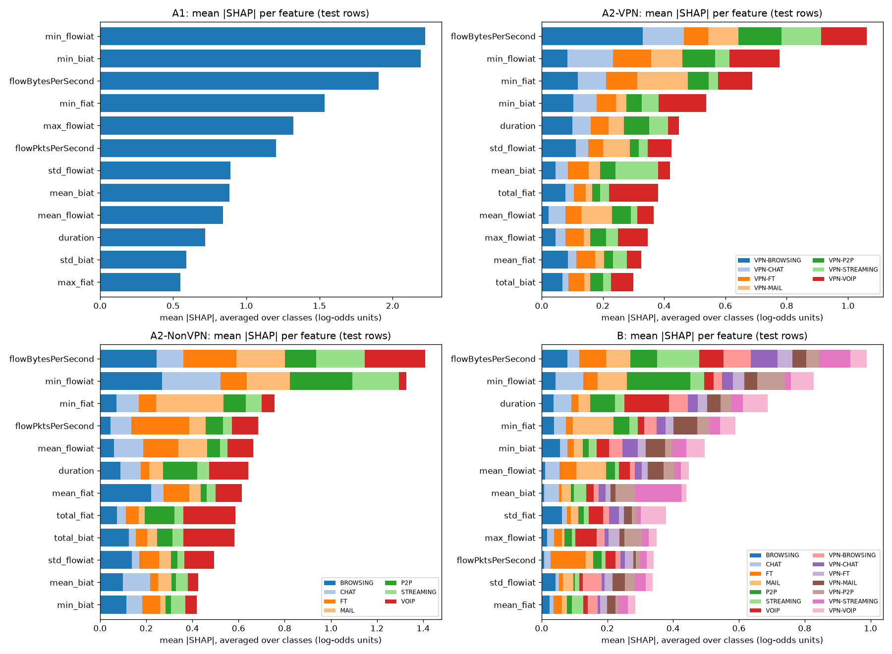
Figure 24. SHAP summary per task
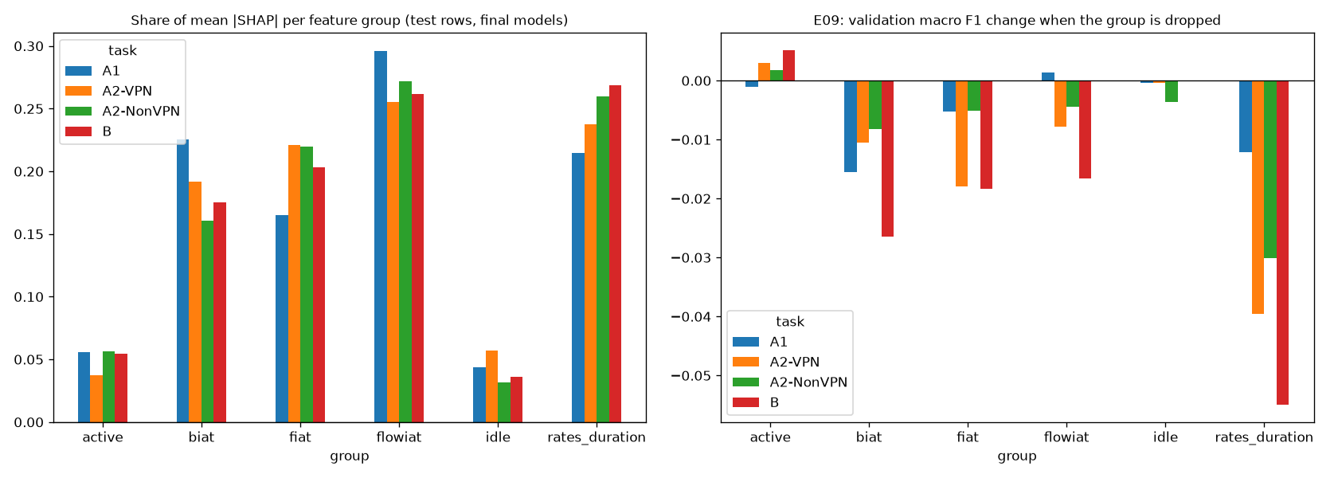
Figure 25. SHAP feature groups next to the E09 ablation
- The byte rate (flowBytesPerSecond) is the most used feature in A2-VPN, A2-NonVPN and B, and the smallest gaps between packets (min_flowiat, min_fiat, min_biat) are in the top 5 of every task.
- SHAP and the ablation (E09) agree that the active and idle groups matter least (3.1-5.7% of mean |SHAP|; dropping either changes validation macro F1 by -0.0036 to +0.0051). Rates + duration hold 21.4-26.9% of mean |SHAP| (the largest group share in B), and dropping them costs the most in A2-VPN, A2-NonVPN and B (0.0395, 0.0301, 0.0549); in A1 dropping the backward gaps costs more (0.0155 against 0.0122).
- They differ on the flow gaps (flowiat): the largest SHAP share in A1, A2-VPN and A2-NonVPN (25.5-29.6%), yet dropping the group costs at most 0.0166, because the correlated forward and backward gaps carry much the same timing. SHAP shows what a model uses; the ablation shows what it cannot do without. Because the features are correlated, neither describes what causes the traffic patterns.
Worked examples (one flow each; picked by a rule fixed before looking at them):
task | example | raw_row | true | predicted | confidence | rank | feature | value | SHAP
A1 | most confident correct | 797 | Non-VPN | Non-VPN | 1.0 | 1 | max_flowiat | 55123.0 | 4.2942
A1 | most confident correct | 797 | Non-VPN | Non-VPN | 1.0 | 2 | min_flowiat | 55123.0 | 3.4935
A1 | most confident correct | 797 | Non-VPN | Non-VPN | 1.0 | 3 | flowPktsPerSecond | 36.2825 | 3.1267
A1 | least confident correct | 5,497 | VPN | VPN | 0.4519 | 1 | flowBytesPerSecond | 240.3304 | 2.6886
A1 | least confident correct | 5,497 | VPN | VPN | 0.4519 | 2 | flowPktsPerSecond | 1.6321 | 1.3703
A1 | least confident correct | 5,497 | VPN | VPN | 0.4519 | 3 | mean_active | 4695071.0 | 0.7458
A1 | most confident error | 2,218 | Non-VPN | VPN | 0.9956 | 1 | flowBytesPerSecond | 130.9021 | 4.5879
A1 | most confident error | 2,218 | Non-VPN | VPN | 0.9956 | 2 | min_fiat | 794487.0 | 2.3452
A1 | most confident error | 2,218 | Non-VPN | VPN | 0.9956 | 3 | max_flowiat | 794487.0 | 1.9669
A1 | weakest class, median confidence | 2,896 | Non-VPN | Non-VPN | 0.9946 | 1 | min_flowiat | 559.0 | 6.0851
A1 | weakest class, median confidence | 2,896 | Non-VPN | Non-VPN | 0.9946 | 2 | max_flowiat | 969065.0 | 1.6854
A1 | weakest class, median confidence | 2,896 | Non-VPN | Non-VPN | 0.9946 | 3 | min_biat | 959994.0 | 1.3987
A2-VPN | most confident correct | 9,144 | VPN-VOIP | VPN-VOIP | 0.9994 | 1 | min_biat | 10038206.0 | 3.9411
A2-VPN | most confident correct | 9,144 | VPN-VOIP | VPN-VOIP | 0.9994 | 2 | flowBytesPerSecond | 21.4332 | 3.4869
A2-VPN | most confident correct | 9,144 | VPN-VOIP | VPN-VOIP | 0.9994 | 3 | min_flowiat | 38775.0 | 3.2343
A2-VPN | least confident correct | 4,435 | VPN-FT | VPN-FT | 0.2259 | 1 | min_flowiat | 52.0 | 1.8895
A2-VPN | least confident correct | 4,435 | VPN-FT | VPN-FT | 0.2259 | 2 | min_fiat | 52.0 | 1.016
A2-VPN | least confident correct | 4,435 | VPN-FT | VPN-FT | 0.2259 | 3 | min_biat | 60.0 | 0.5417
A2-VPN | most confident error | 1 | VPN-BROWSING | VPN-STREAMING | 0.9788 | 1 | flowBytesPerSecond | 1322206.4391 | 4.4567
A2-VPN | most confident error | 1 | VPN-BROWSING | VPN-STREAMING | 0.9788 | 2 | mean_biat | 998.9129 | 3.3432
A2-VPN | most confident error | 1 | VPN-BROWSING | VPN-STREAMING | 0.9788 | 3 | max_flowiat | 217299.0 | 2.3032
A2-VPN | weakest class, median confidence | 5,962 | VPN-MAIL | VPN-MAIL | 0.877 | 1 | duration | 192.0 | 3.2163
A2-VPN | weakest class, median confidence | 5,962 | VPN-MAIL | VPN-MAIL | 0.877 | 2 | min_flowiat | 192.0 | 3.0667
A2-VPN | weakest class, median confidence | 5,962 | VPN-MAIL | VPN-MAIL | 0.877 | 3 | max_fiat | 192.0 | 1.4462
A2-NonVPN | most confident correct | 1,570 | BROWSING | BROWSING | 1.0 | 1 | min_flowiat | 2.0 | 2.7472
A2-NonVPN | most confident correct | 1,570 | BROWSING | BROWSING | 1.0 | 2 | std_flowiat | 2354206.5587 | 2.6679
A2-NonVPN | most confident correct | 1,570 | BROWSING | BROWSING | 1.0 | 3 | mean_flowiat | 567400.6667 | 1.7755
A2-NonVPN | least confident correct | 4,393 | FT | FT | 0.4821 | 1 | min_flowiat | 961.0 | 2.639
A2-NonVPN | least confident correct | 4,393 | FT | FT | 0.4821 | 2 | std_flowiat | 139858.6502 | 1.0974
A2-NonVPN | least confident correct | 4,393 | FT | FT | 0.4821 | 3 | max_flowiat | 198751.0 | 0.6833
A2-NonVPN | most confident error | 4,356 | FT | MAIL | 1.0 | 1 | duration | 79.0 | 4.2734
A2-NonVPN | most confident error | 4,356 | FT | MAIL | 1.0 | 2 | min_fiat | 79.0 | 4.1959
A2-NonVPN | most confident error | 4,356 | FT | MAIL | 1.0 | 3 | mean_fiat | 79.0 | 2.9155
A2-NonVPN | weakest class, median confidence | 5,721 | STREAMING | STREAMING | 1.0 | 1 | flowBytesPerSecond | 180014.1793 | 4.7998
A2-NonVPN | weakest class, median confidence | 5,721 | STREAMING | STREAMING | 1.0 | 2 | min_flowiat | 0.0 | 1.7719
A2-NonVPN | weakest class, median confidence | 5,721 | STREAMING | STREAMING | 1.0 | 3 | min_fiat | 5.0 | 1.6621
B | most confident correct | 3,045 | VOIP | VOIP | 1.0 | 1 | duration | 14991066.0 | 3.8544
B | most confident correct | 3,045 | VOIP | VOIP | 1.0 | 2 | std_biat | 3595.304 | 1.1211
B | most confident correct | 3,045 | VOIP | VOIP | 1.0 | 3 | max_flowiat | 30384.0 | 0.8372
B | least confident correct | 2,091 | MAIL | MAIL | 0.2948 | 1 | min_fiat | 96.0 | 1.3413
B | least confident correct | 2,091 | MAIL | MAIL | 0.2948 | 2 | duration | 96.0 | 1.3326
B | least confident correct | 2,091 | MAIL | MAIL | 0.2948 | 3 | mean_flowiat | 96.0 | 0.825
B | most confident error | 7,408 | VPN-P2P | VPN-FT | 0.9986 | 1 | flowBytesPerSecond | 365.1224 | 2.4335
B | most confident error | 7,408 | VPN-P2P | VPN-FT | 0.9986 | 2 | max_flowiat | 284836.0 | 0.5198
B | most confident error | 7,408 | VPN-P2P | VPN-FT | 0.9986 | 3 | min_fiat | -1.0 | 0.4553
B | weakest class, median confidence | 9,737 | VPN-MAIL | VPN-MAIL | 0.9845 | 1 | duration | 11544.0 | 1.7503
B | weakest class, median confidence | 9,737 | VPN-MAIL | VPN-MAIL | 0.9845 | 2 | min_fiat | 27.0 | 1.2891
B | weakest class, median confidence | 9,737 | VPN-MAIL | VPN-MAIL | 0.9845 | 3 | min_flowiat | 27.0 | 0.6031

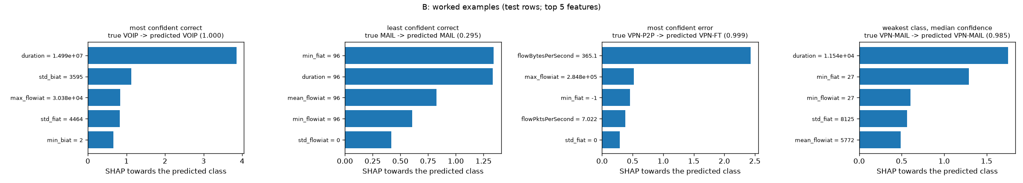
Figure 26. Worked examples, task B
The most confident errors come from a byte rate typical of another class (for example a B VPN-P2P flow at 365.1 bytes per second predicted as VPN-FT with confidence 0.9986), so a high confidence alone does not show that a prediction is right.

5.7 Comparison with the paper
The paper's own protocol (10-fold cross-validation on the full file) is reproduced in Section 4.3: on the published rows our C4.5 approximation matches all 16 A1 values of the paper's Figure 2 within 0.05 and 1-NN matches 15 of 16. The scores in this section come from a different protocol (a held-out test set after deduplication, models chosen on validation) and are not compared with the paper's figures value for value.
Figure 27. Paper vs ours, A1

5.8 Cost and timeout
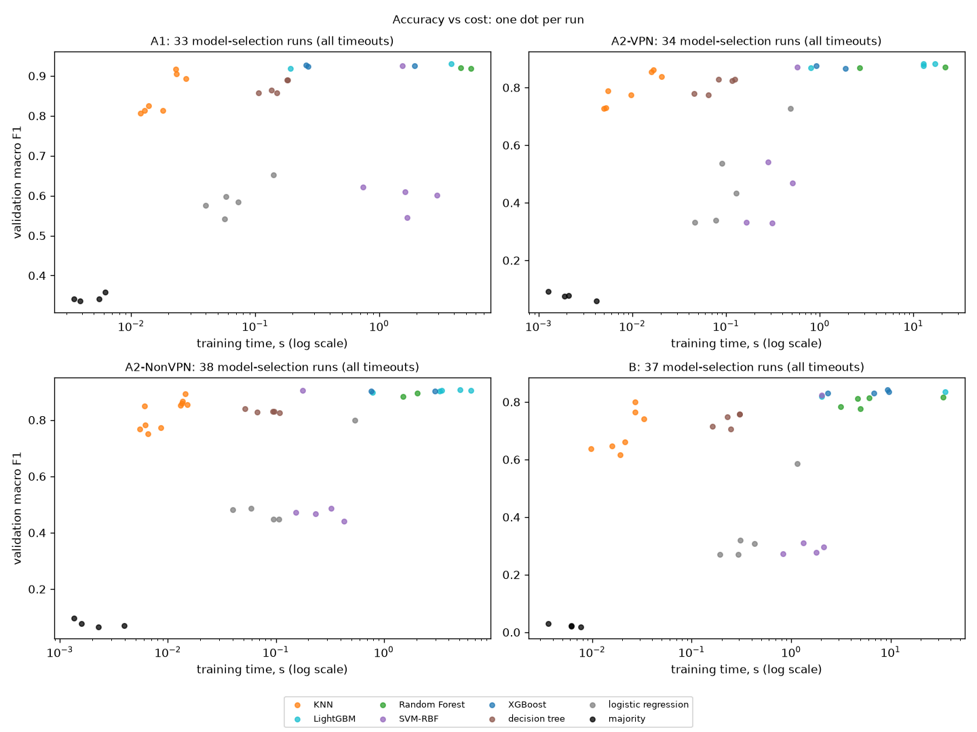
Figure 28. Accuracy against training time, one dot per model-selection run
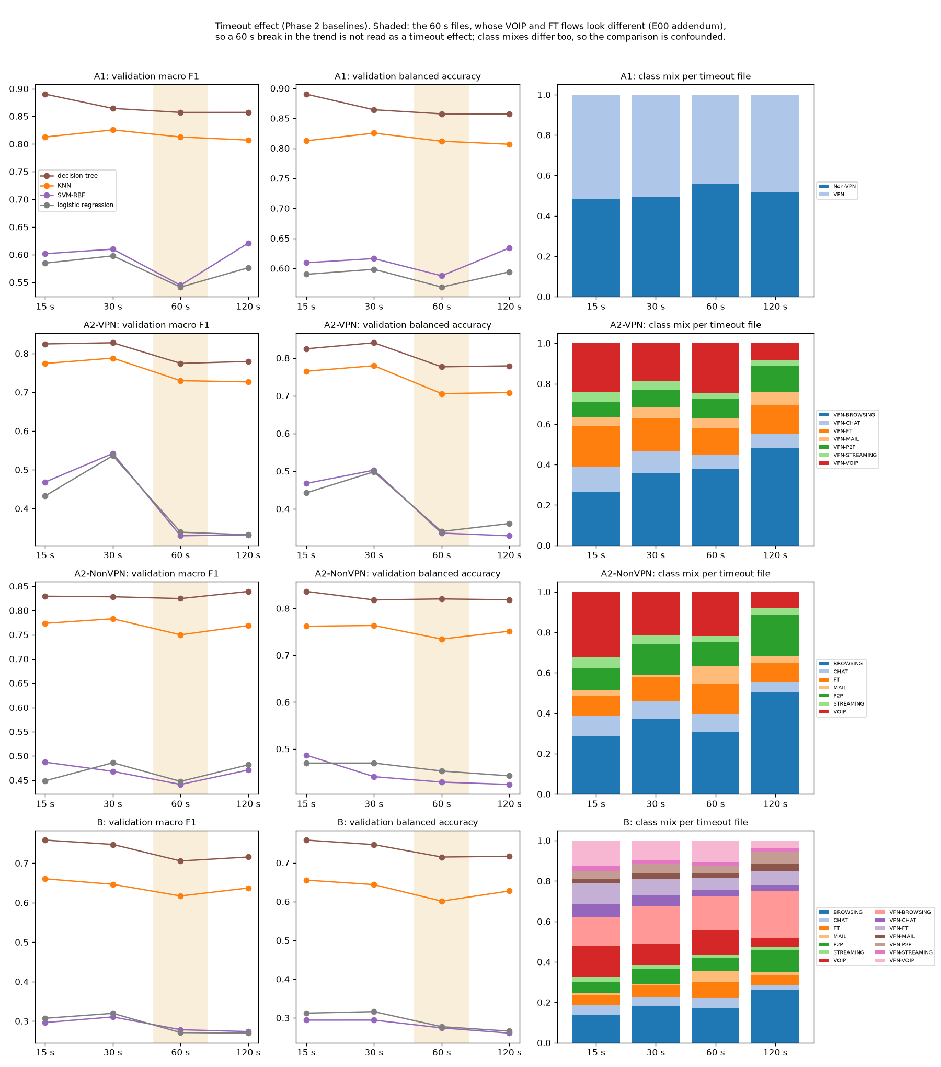
Figure 29. Timeout effect of the Phase 2 baselines with the class mix of each file
The best scores come from the boosted trees, Random Forest and the tuned SVM, which take longer to train than KNN and the decision tree (figure above); prediction with the headline models costs 58.8-1,372.9 ms per 1,000 flows (B and A2-VPN). The timeout comparison uses the Phase 2 baselines, the only models run at all four timeouts. The class mix changes with the timeout and the 60 s files hold different VOIP and FT flows (Section 2), so the comparison is confounded and is not read as a timeout effect.

5.9 Every pre-stated hypothesis
Each experiment stated its hypotheses and numeric thresholds before it ran; the verdicts, read from the generated threshold checks:
experiment | supported | not supported
E01 | single check | none
E02 | a, b, c | d
E03 | a_knn, a_logreg, a_svm_rbf, b, c_logreg, c_svm_rbf, d | e
E04 | a, b | none
E05 | a, b | none
E06 | a, b | none
E07 | a, c | b
E08 | b, c | a
E09 | a | b, c
E10 | c | a, b
E12 | b, c | a
E13 | a, b, c | none
E14 | a, b | c
E15 | a, b, c | none
E16 | a, b, c, d | none
E17 | a, b, c | none

5.10 Using a final model
scripts/predict.py checks a flow file against the model's feature list (names, order, numeric and finite values) and writes, per flow, the predicted label, its confidence and the three features that pushed the model most towards that label. A malformed file stops with an error and exit code 2. The first 8 rows of its output for the task B sample file, from uv run python scripts/predict.py --task B --input app/samples/B_test_sample.csv --output predictions.csv:
row | label | true_label | confidence | top_feature_1 | top_feature_2 | top_feature_3
1 | MAIL | MAIL | 0.9879 | flowBytesPerSecond (+3.048) | max_biat (+1.391) | min_flowiat (+1.088)
2 | VOIP | VOIP | 0.9998 | duration (+3.221) | min_biat (+0.953) | flowBytesPerSecond (+0.756)
3 | VOIP | VOIP | 0.9998 | duration (+3.220) | min_biat (+0.989) | flowBytesPerSecond (+0.760)
4 | VOIP | VOIP | 1.0 | duration (+3.751) | std_biat (+1.102) | max_flowiat (+0.877)
5 | VOIP | VOIP | 0.9995 | duration (+3.618) | mean_flowiat (+0.849) | max_flowiat (+0.743)
6 | VOIP | VOIP | 1.0 | duration (+3.528) | std_biat (+1.169) | std_fiat (+0.747)
7 | VPN-FT | VPN-CHAT | 0.7308 | flowPktsPerSecond (+0.375) | mean_fiat (+0.346) | flowBytesPerSecond (+0.306)
8 | VPN-FT | VPN-FT | 0.7385 | max_flowiat (+0.977) | min_flowiat (+0.556) | min_fiat (+0.353)

References
- G. Draper-Gil, A. H. Lashkari, M. S. I. Mamun, and A. A. Ghorbani, "Characterization of Encrypted and VPN Traffic using Time-related Features," in Proc. 2nd Int. Conf. on Information Systems Security and Privacy (ICISSP), 2016, pp. 407–414.
- Canadian Institute for Cybersecurity, University of New Brunswick, "VPN-nonVPN dataset (ISCXVPN2016)." [Online]. Available: https://www.unb.ca/cic/datasets/vpn.html
- F. Pedregosa et al., "Scikit-learn: Machine Learning in Python," Journal of Machine Learning Research, vol. 12, pp. 2825–2830, 2011.
- T. Chen and C. Guestrin, "XGBoost: A Scalable Tree Boosting System," in Proc. 22nd ACM SIGKDD Int. Conf. on Knowledge Discovery and Data Mining, 2016, pp. 785–794.
- G. Ke et al., "LightGBM: A Highly Efficient Gradient Boosting Decision Tree," in Advances in Neural Information Processing Systems 30, 2017.
- S. M. Lundberg and S.-I. Lee, "A Unified Approach to Interpreting Model Predictions," in Advances in Neural Information Processing Systems 30, 2017.
- T. Akiba, S. Sano, T. Yanase, T. Ohta, and M. Koyama, "Optuna: A Next-generation Hyperparameter Optimization Framework," in Proc. 25th ACM SIGKDD, 2019, pp. 2623–2631.
- M. Zaharia et al., "Accelerating the Machine Learning Lifecycle with MLflow," IEEE Data Engineering Bulletin, vol. 41, no. 4, pp. 39–45, 2018.
- G. Lemaître, F. Nogueira, and C. K. Aridas, "Imbalanced-learn: A Python Toolbox to Tackle the Curse of Imbalanced Datasets in Machine Learning," JMLR, vol. 18, no. 17, pp. 1–5, 2017.
- N. V. Chawla, K. W. Bowyer, L. O. Hall, and W. P. Kegelmeyer, "SMOTE: Synthetic Minority Over-sampling Technique," Journal of Artificial Intelligence Research, vol. 16, pp. 321–357, 2002.
- J. R. Quinlan, C4.5: Programs for Machine Learning. Morgan Kaufmann, 1993.
- S. Bagui, X. Fang, E. Kalaimannan, S. C. Bagui, and J. Sheehan, "Comparison of machine-learning algorithms for classification of VPN network traffic flow using time-related features," Journal of Cyber Security Technology, vol. 1, no. 2, pp. 108–126, 2017, doi: 10.1080/23742917.2017.1321891.
- W. Isnan, Y. Fatmi, R. Darni, and V. Aulia, "Flow-Based Encrypted Network Traffic Classification Using Random Forest for Network Access Control," Intechno Journal: Information Technology Journal, vol. 8, no. 1, 2026, doi: 10.24076/intechnojournal.2026v8i1.2922.
- S. Jorgensen et al., "Extensible Machine Learning for Encrypted Network Traffic Application Labeling via Uncertainty Quantification," IEEE Transactions on Artificial Intelligence, 2023, doi: 10.1109/TAI.2023.3244168 (arXiv:2205.05628).
- G. Draper-Gil, A. H. Lashkari, M. S. I. Mamun, and A. A. Ghorbani, "Characterization of Encrypted and VPN Traffic Using Time-Related Features" (poster), UNB Research Expo, 2016. [Online]. Available: https://www.cs.unb.ca/research-expo/expos/2016/
- University of Waikato, "Weka 3 API documentation (stable)": classes weka.classifiers.trees.J48, weka.classifiers.lazy.IBk, weka.core.EuclideanDistance and weka.core.NormalizableDistance. [Online]. Available: https://weka.sourceforge.io/doc.stable/ (accessed 28 Oct 2026).

