**Input data for inserting into the table**

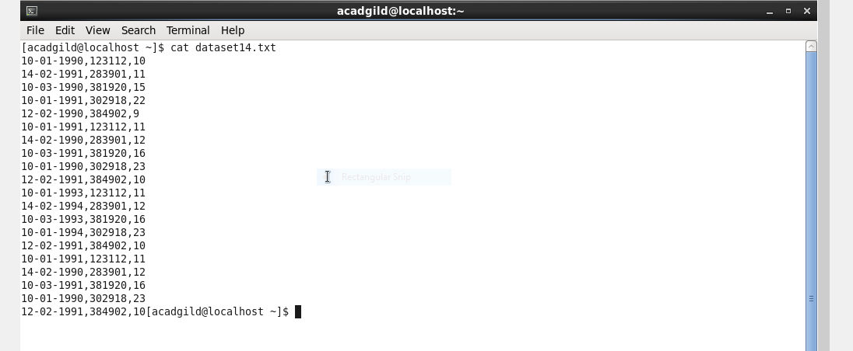

**Creat database**

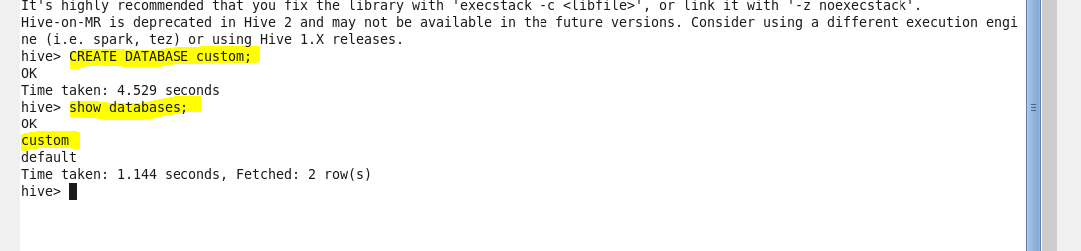

**use database custom**



**Create table temperature_data with comma delimited**

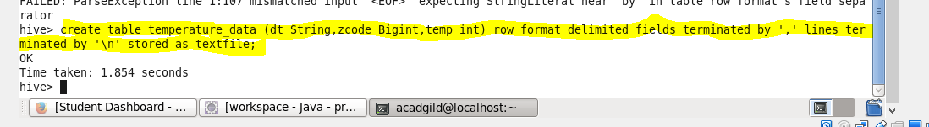

**Show table**

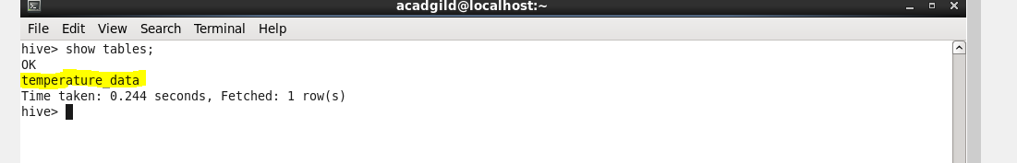

**Load tha data into the table**

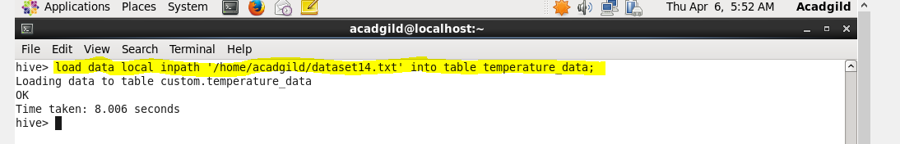

**Display the content of the table**

