**Calculate the number of employees corresponding to each skill from the table 'employee' which is loaded in the Demo.**

Create table employee

Show tables

Load data into table emplyee

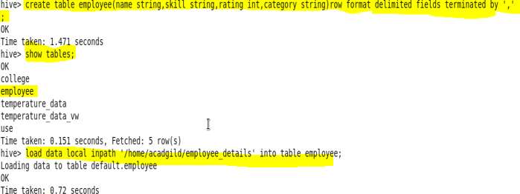

Show data of the table

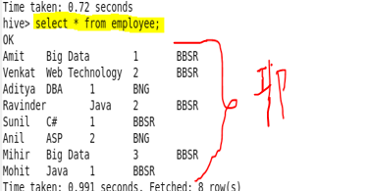

Solution

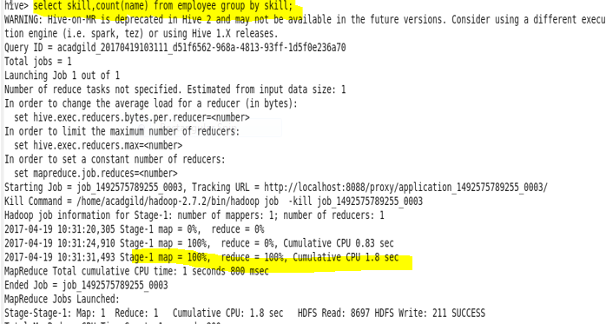

Output

