**Cteate table titanic_tragedy**

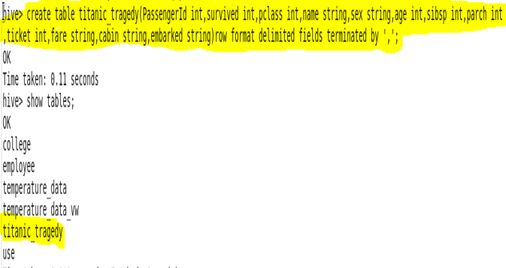

**Load data into table**

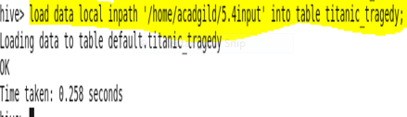

**Write a hive query find the average age of male and female persons died in the titanic tragedy**

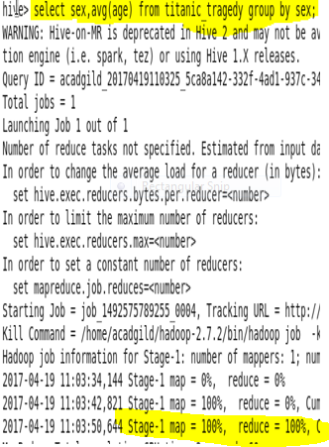

**Output**

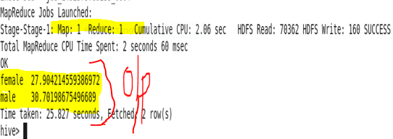

**Write a hive query to find the number of people died and survived in each class**

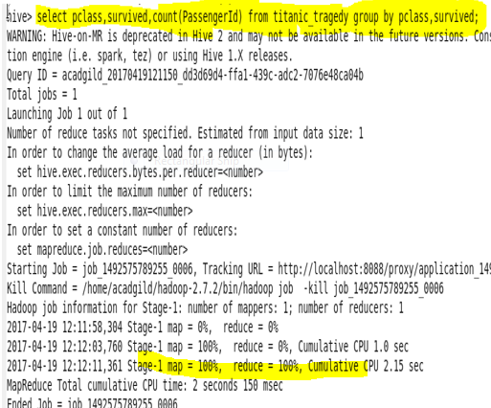

**Output**

