**Create table**

**Load data into table**

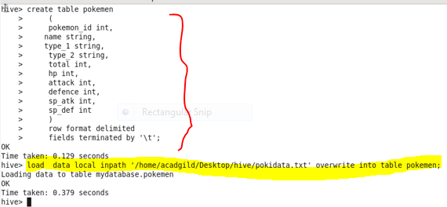

**1. Find out the average HP (Hit points) of all the Pokémons**

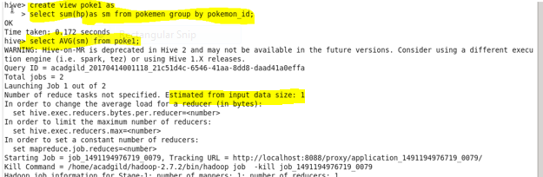

**Output**

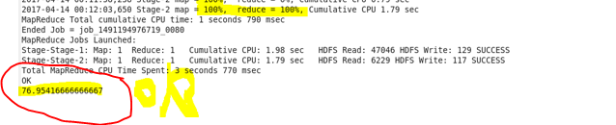

**2. Find out the average Defense of all the pokemon**

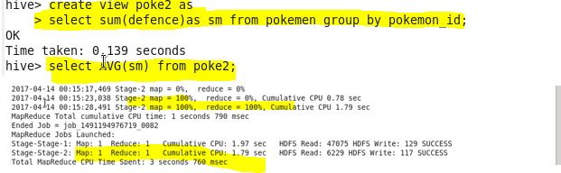

**Output**

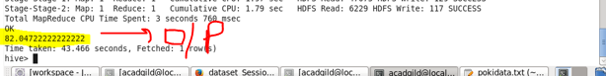

**3. Find out the average Sp.Atk of all the pokemons**

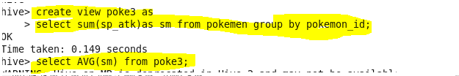

**Output**

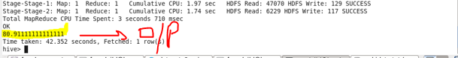

**4. Find out the average sp.Def of all the pokemons**

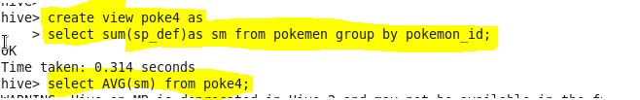

**Output**

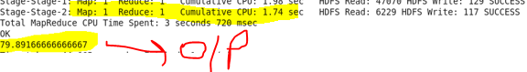

**5. Find out the average Speed of all the pokemons**

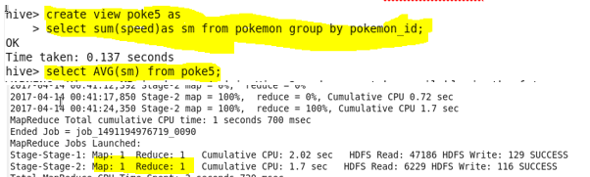

**Output**

