**Create table**

**Show table**

**Load data into table**

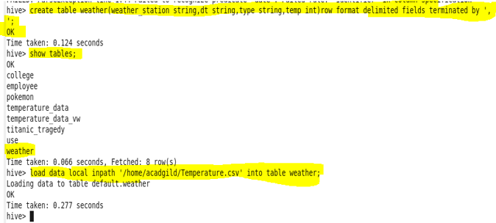

**1.Write a hive query to find the minimum temperature observed in a given weather station in a particular year.**

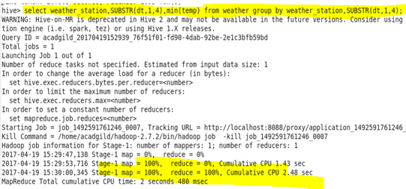

**Output**

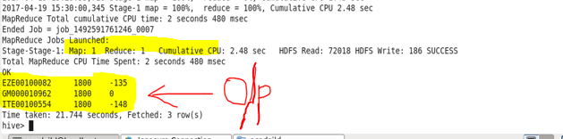

**2. Write a hive query to find the maximum temperature observed in a given weather station in a particular year.**

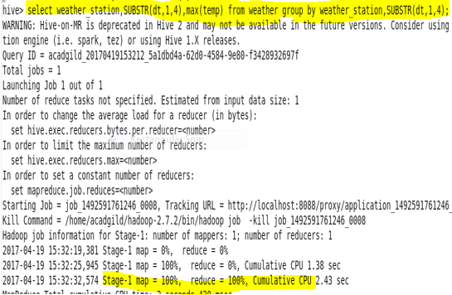

**Output**

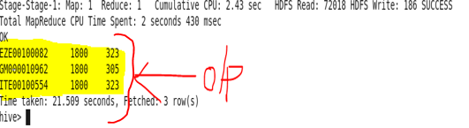

**3. Write a hive query to find the number of readings given by each weather station according to the dataset.**

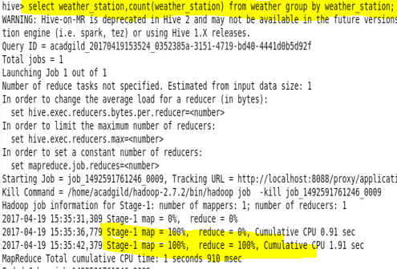

**Output**

