**Perform word count in Hive for above given dataset.**

**Input file**

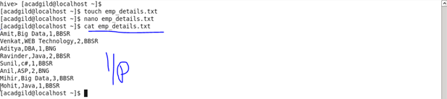

**Creating table and loading data**

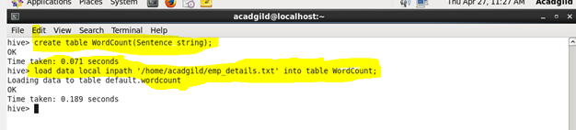

Split command

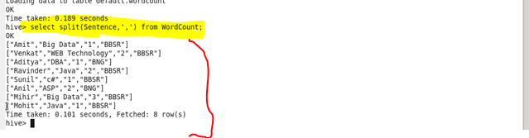

Explode command

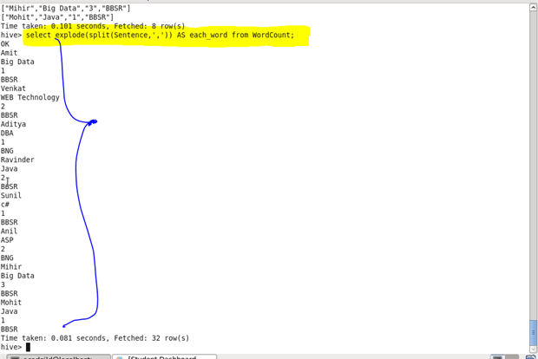

Counting each word

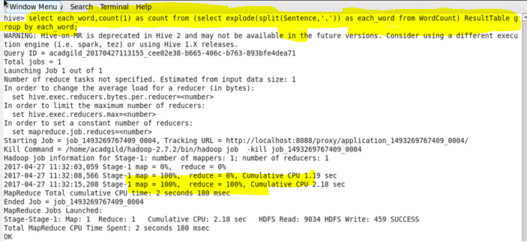

Output

