Implement view in hive by following the steps in the below blog

Input file 1

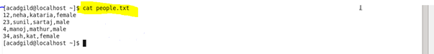

Input file 2

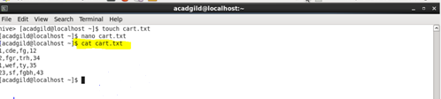

Create table and load data

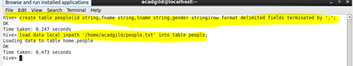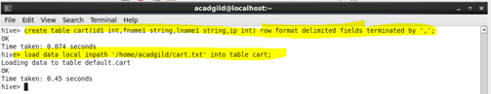

Create view

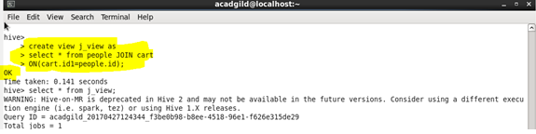

Output

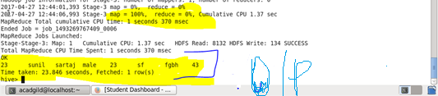

Query

