Java program to list down all the files inside a directory and its sub-directories who have last modified timestamp between the start_ts and end_ts passed as an argument.

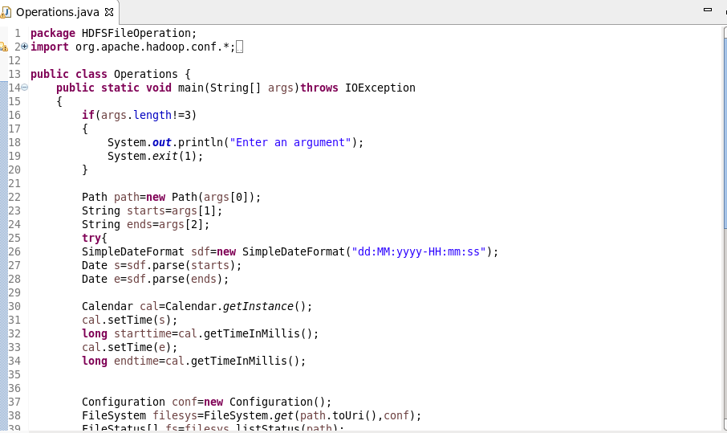

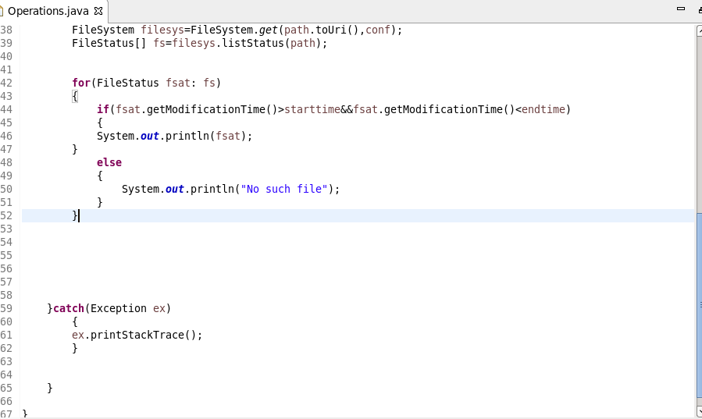

Output:

