**Find the number of GoogleKnowlege_Occupation people who were guests in the show, in a particular time period. Take the time period as 1/11/99 to 6/11/99 i.e., 6 months**

**Driver**

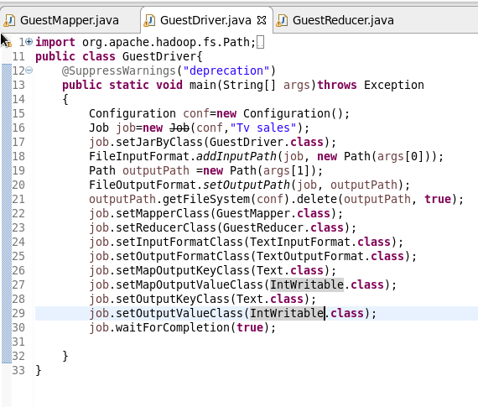

**Mapper**

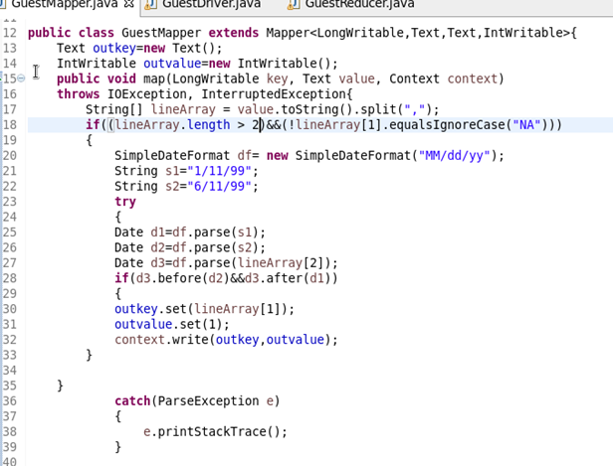

**Reducer**

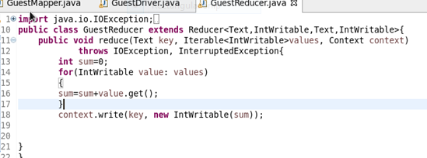

**Output**

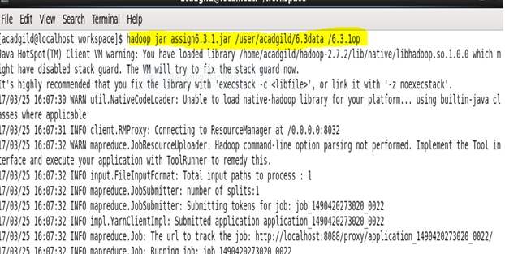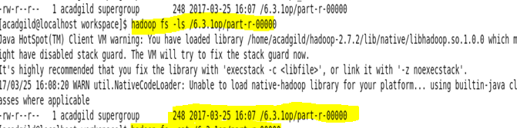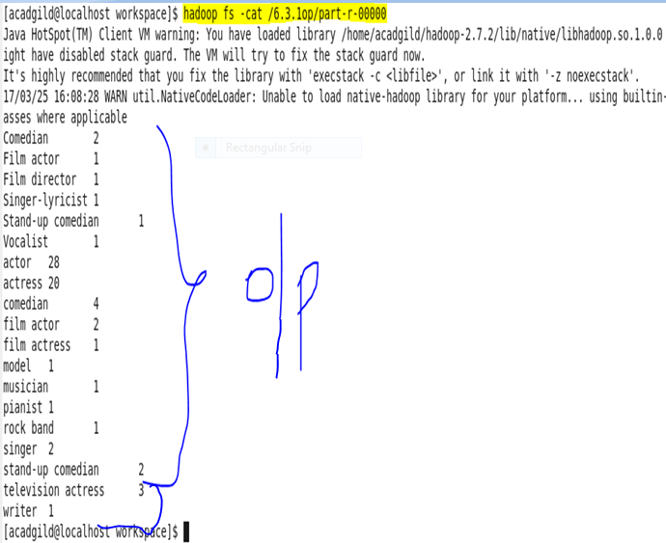

**Find the number of GoogleKnowledge occupation types in each group, who have been guests on the show.**

**Driver**

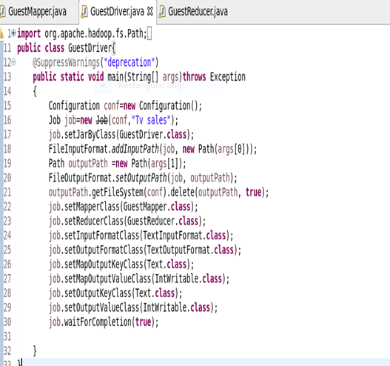

**Mapper**

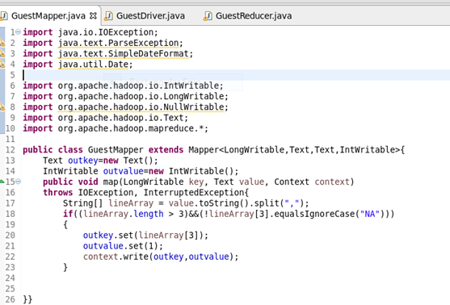

**Reducer**

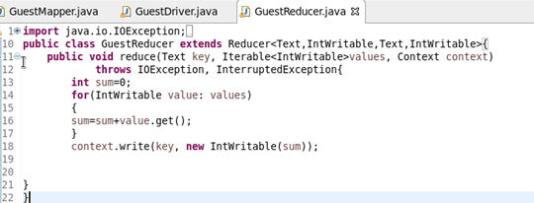

**Output**

