**Input file**

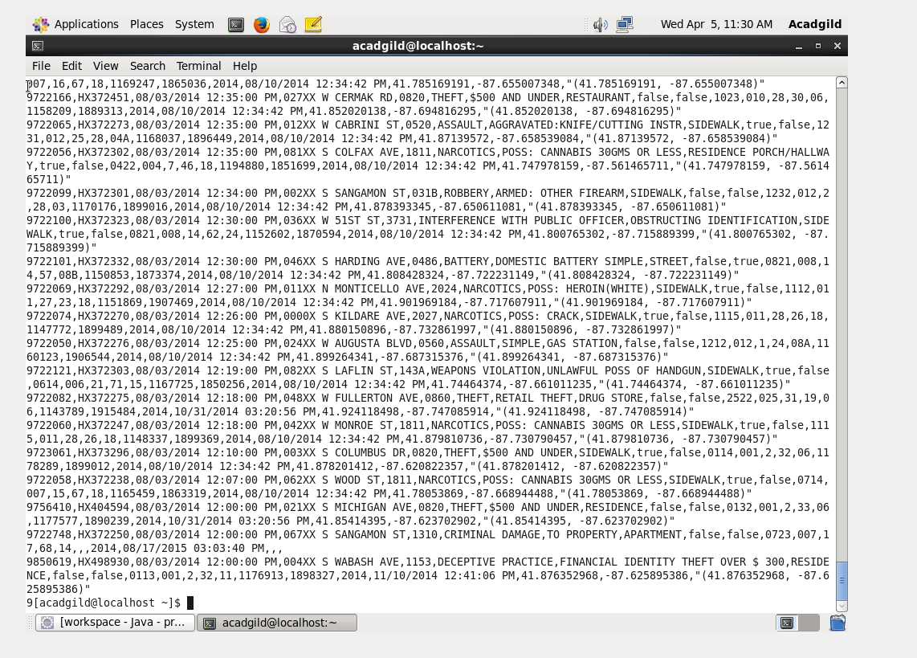

**Solution by pig**

**1.Write a mapreduce and pig program to calculate the number of cases investigated under each FBI code**

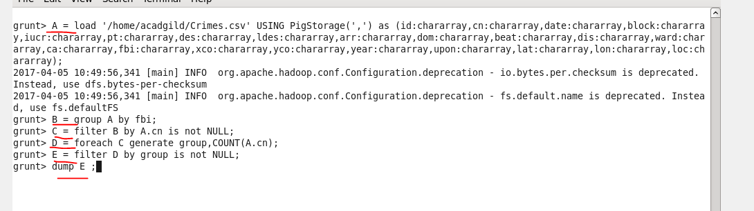

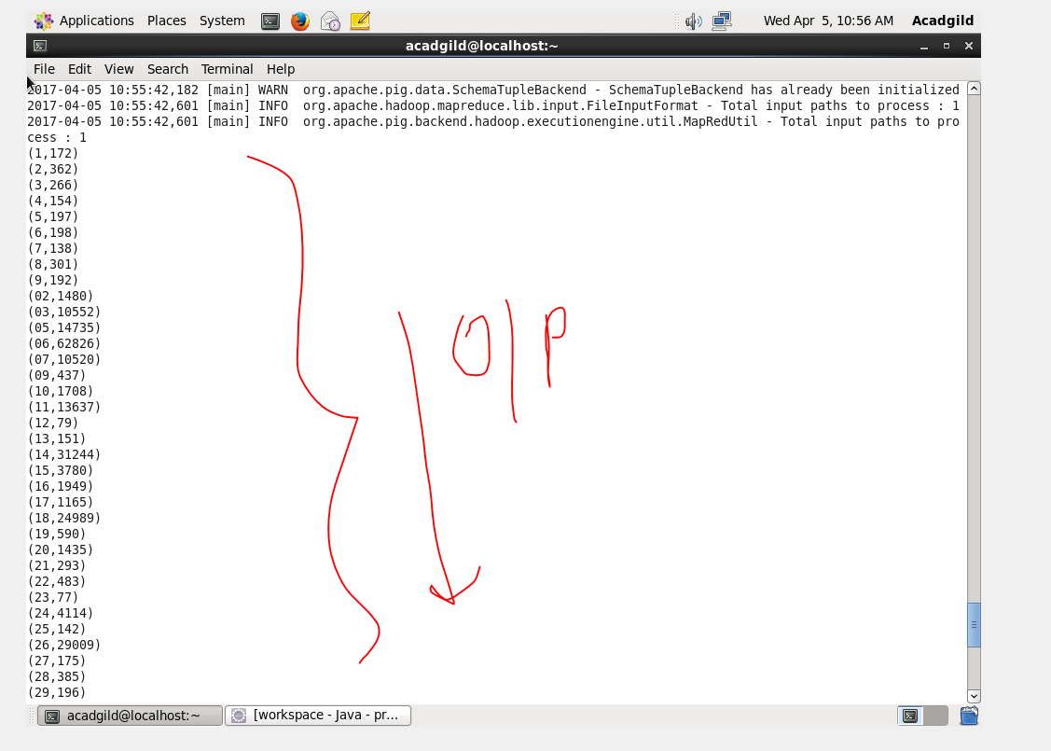

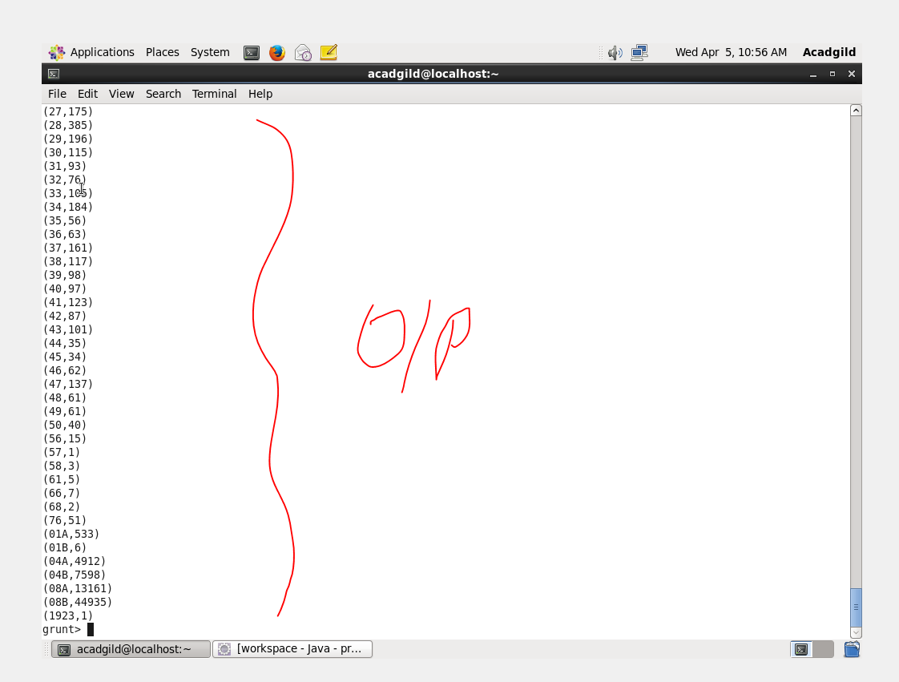

**2. Write a mapreduce and pig program to calculate the number of cases investigated under FBI code 32.**

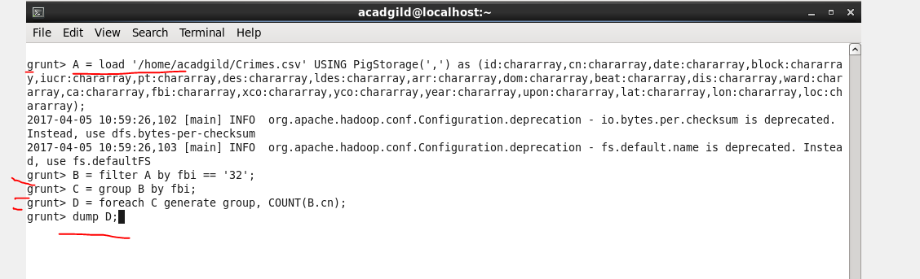

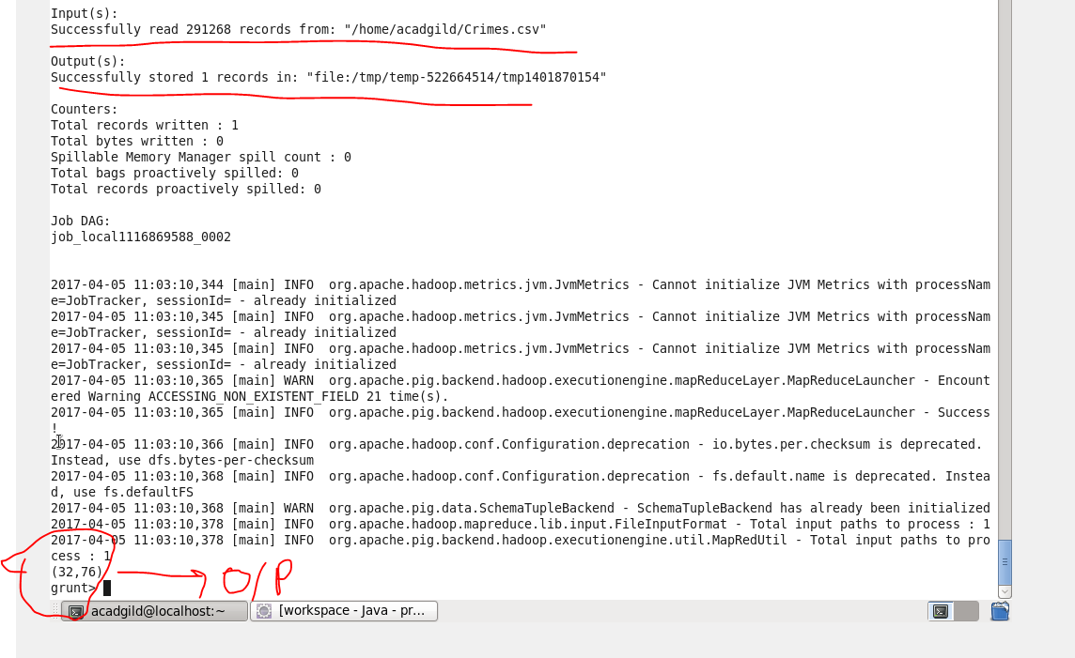

**3. Write a mapreduce and pig program to calculate the number of arrests in theft district wise.**

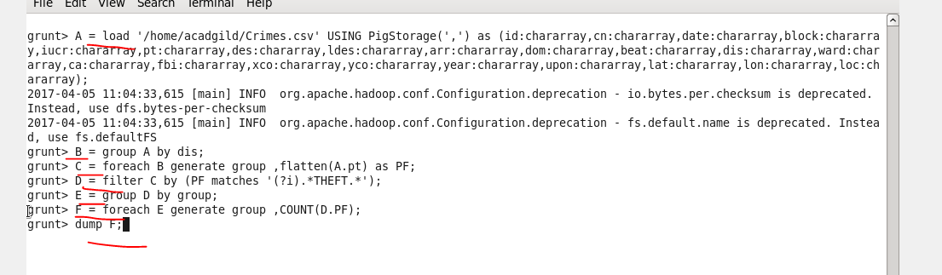

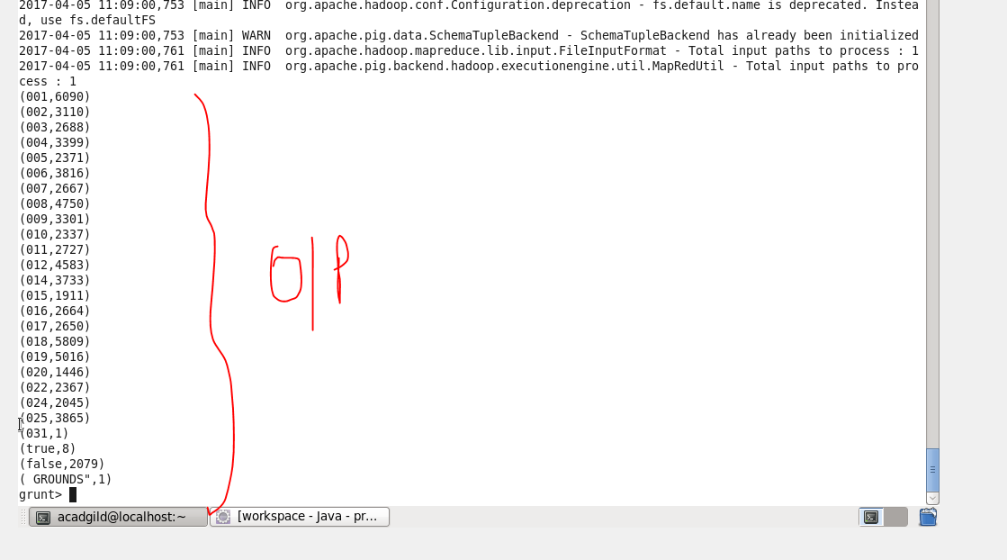

**4. Write a mapreduce and pig program to calculate the number of arrests done between October 2014 and October 2015.**

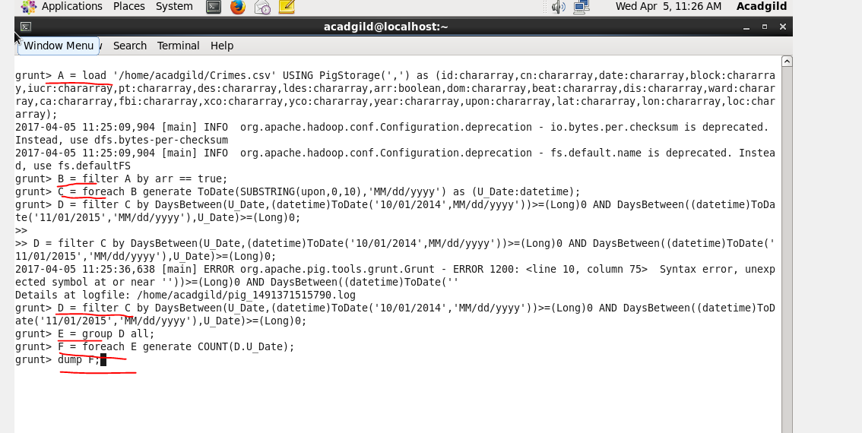

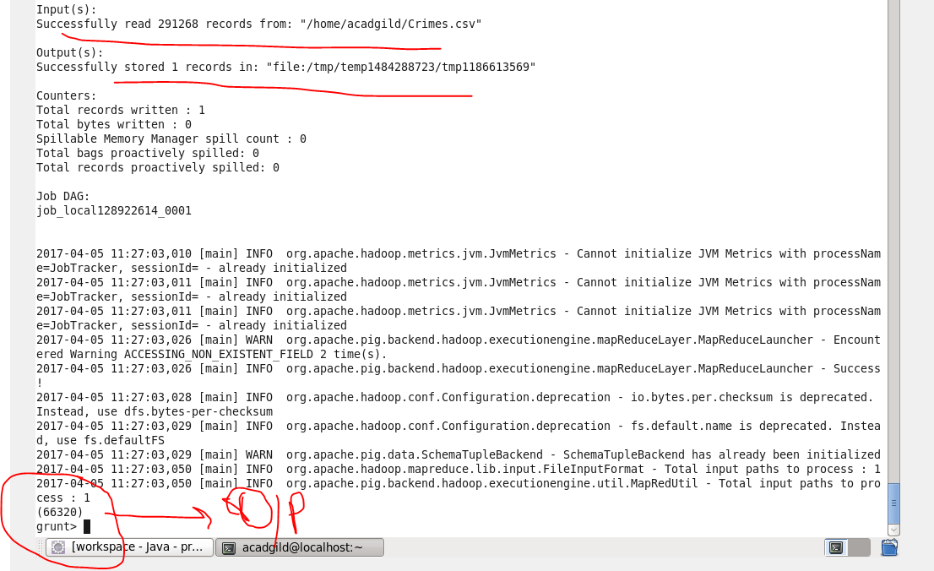

**Solution by map reduce**

Driver and Reducer are same for all the questions

**Driver**

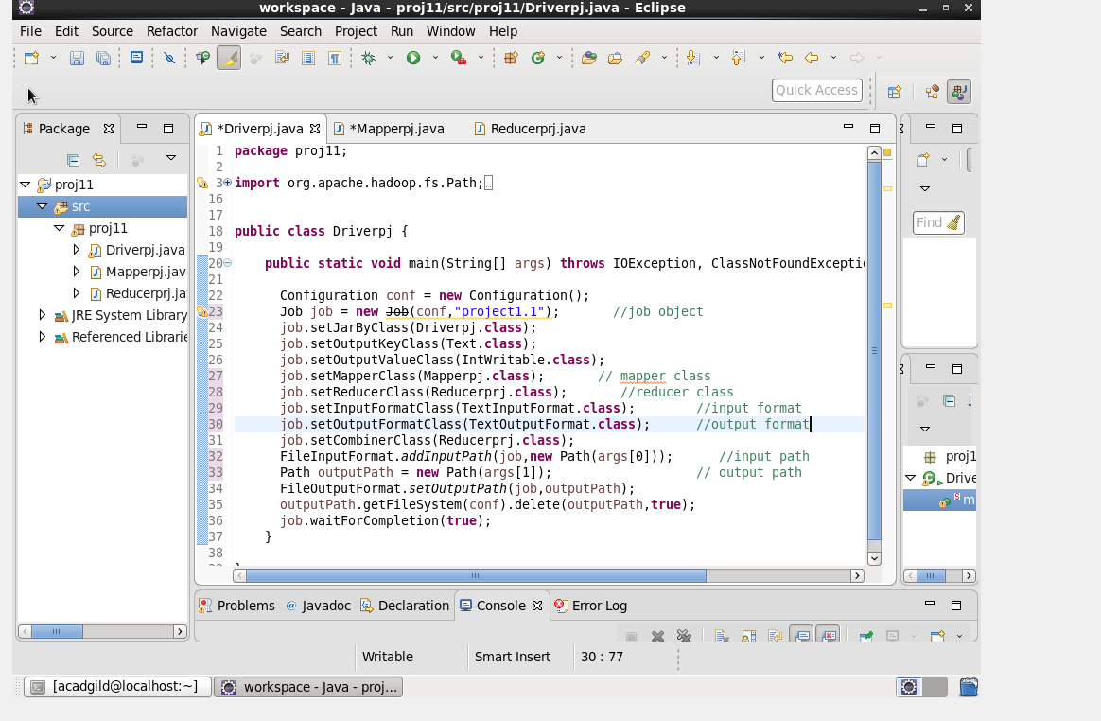

**Reducer**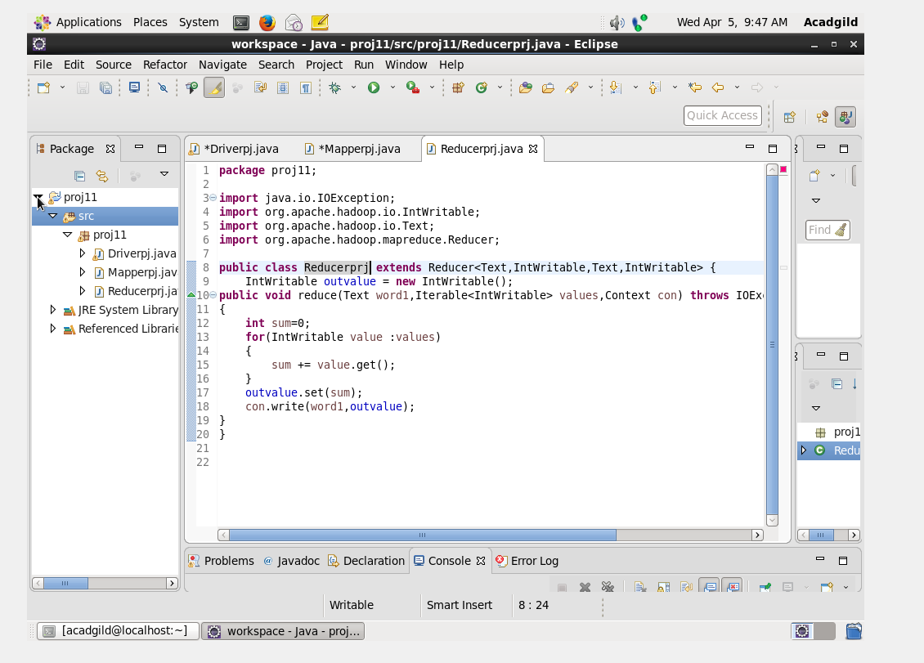

**Mapper and output for each question**

**1.Write a mapreduce and pig program to calculate the number of cases investigated under each FBI code**

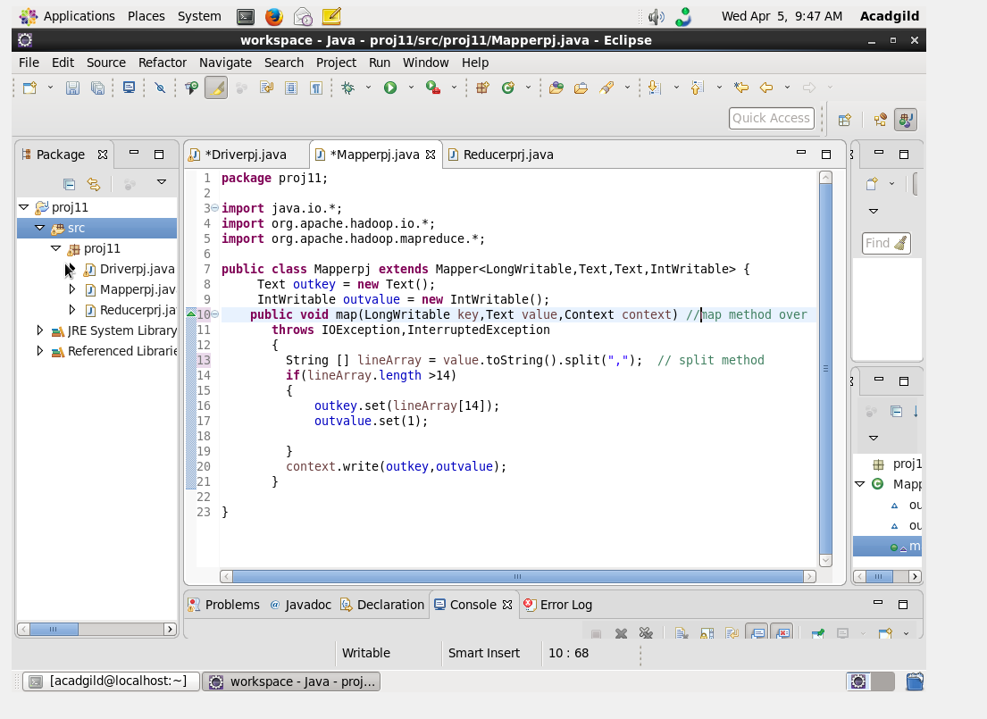

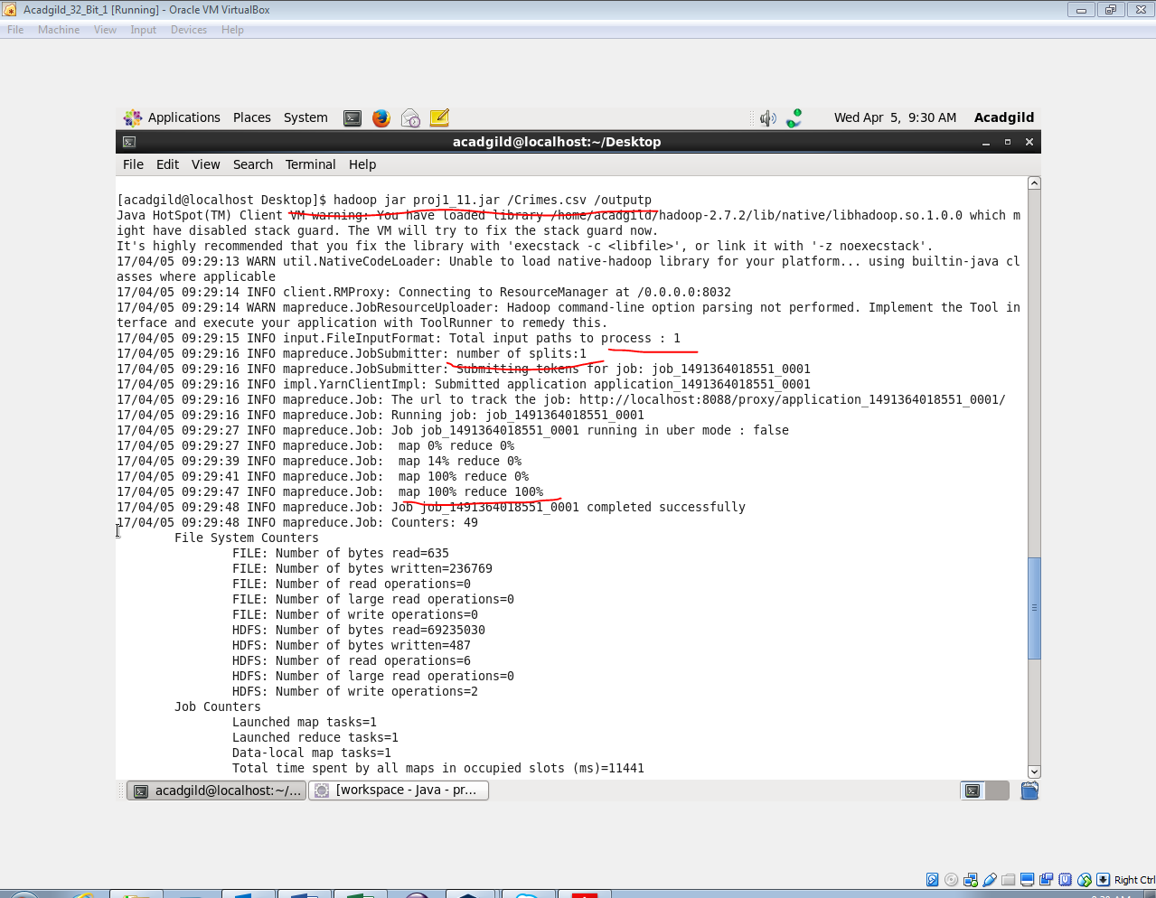

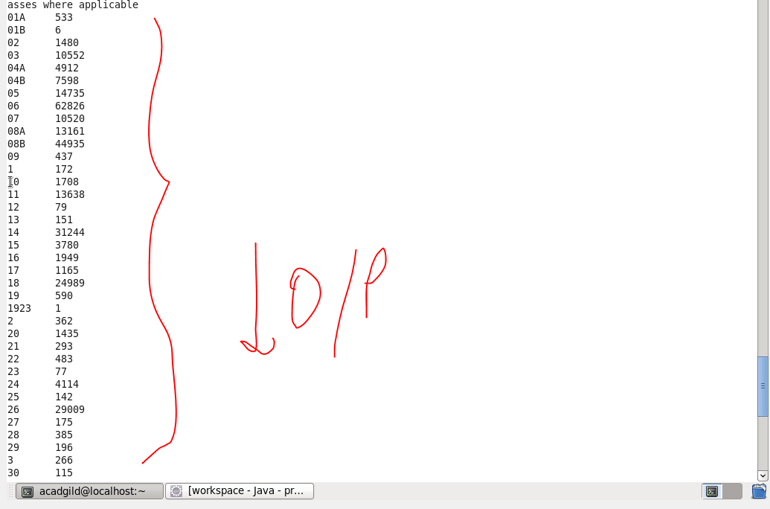

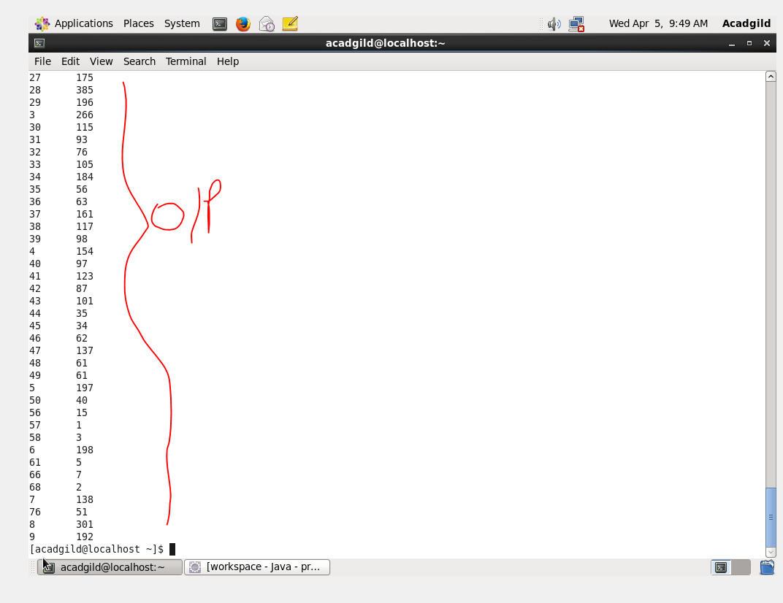

**2.Write a mapreduce and pig program to calculate the number of cases investigated under FBI code 32.**

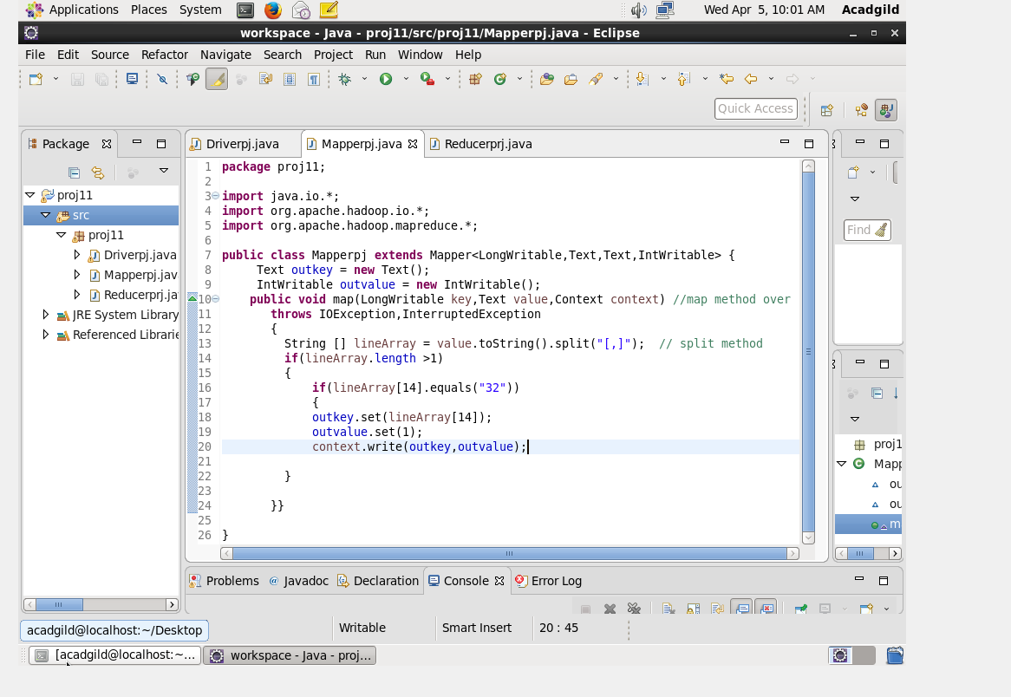

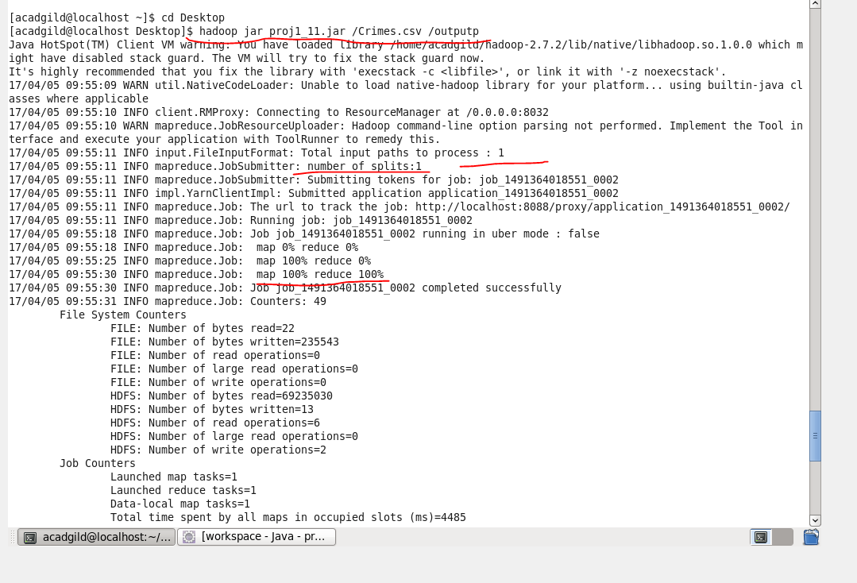

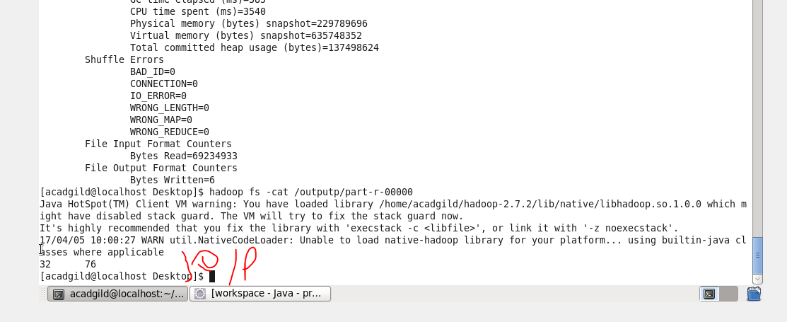

**3.Write a mapreduce and pig program to calculate the number of arrests in theft district wise.**

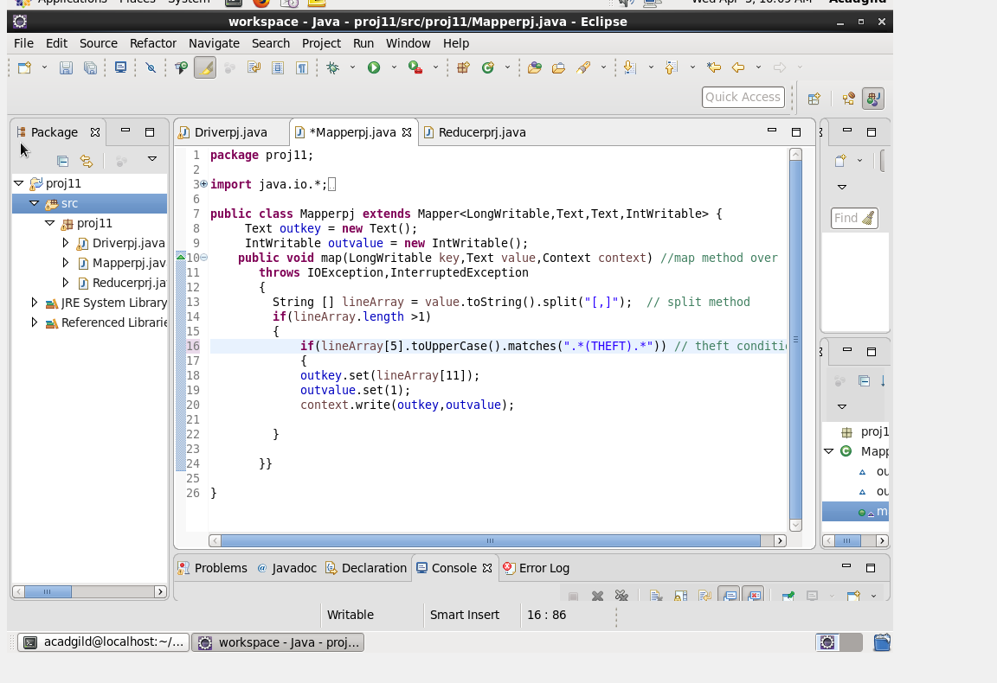

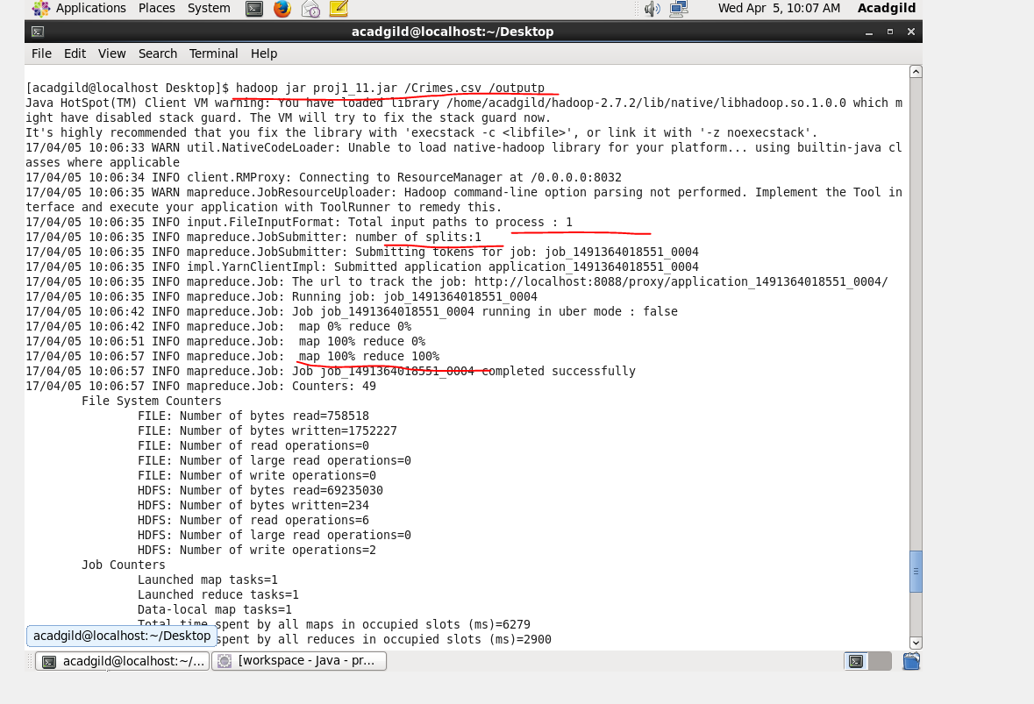

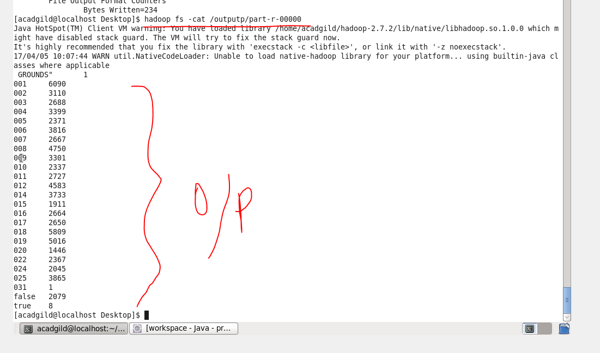

**4.Write a mapreduce and pig program to calculate the number of arrests done between October 2014 and October 2015.**

