**Write a mapreduce program to remove commas present inside the double quotes.**

**Driver class**

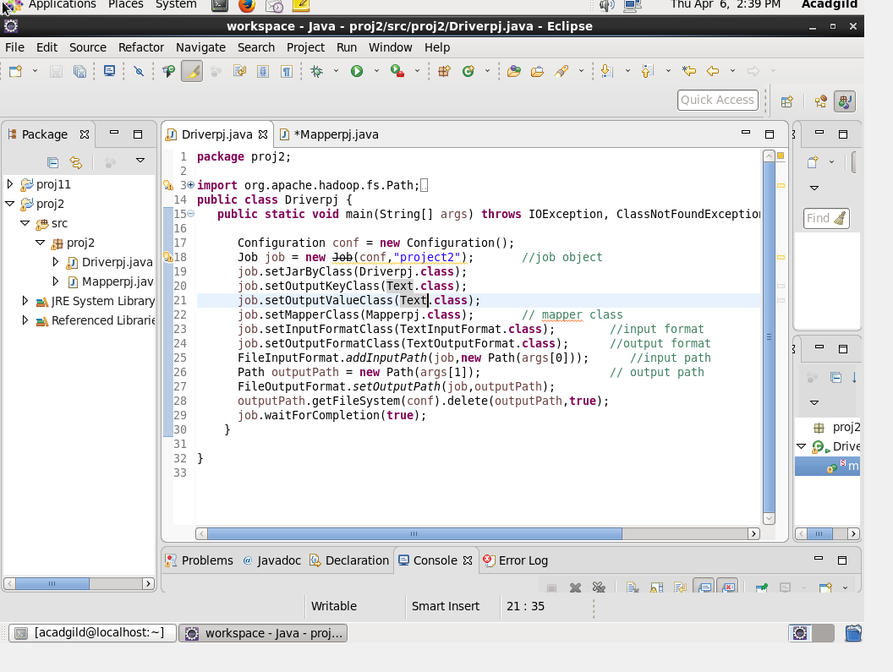

**Mapper class**

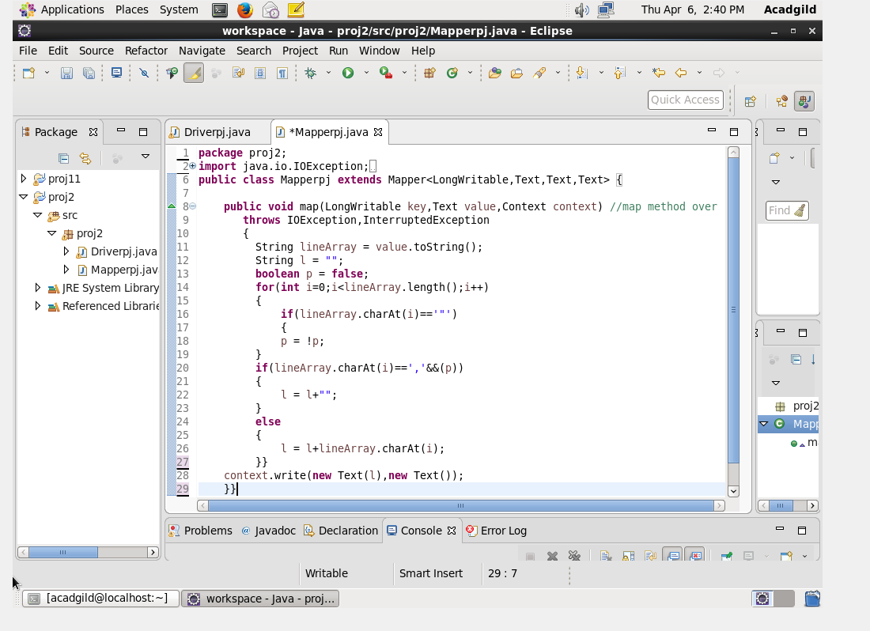

**Running jar file**

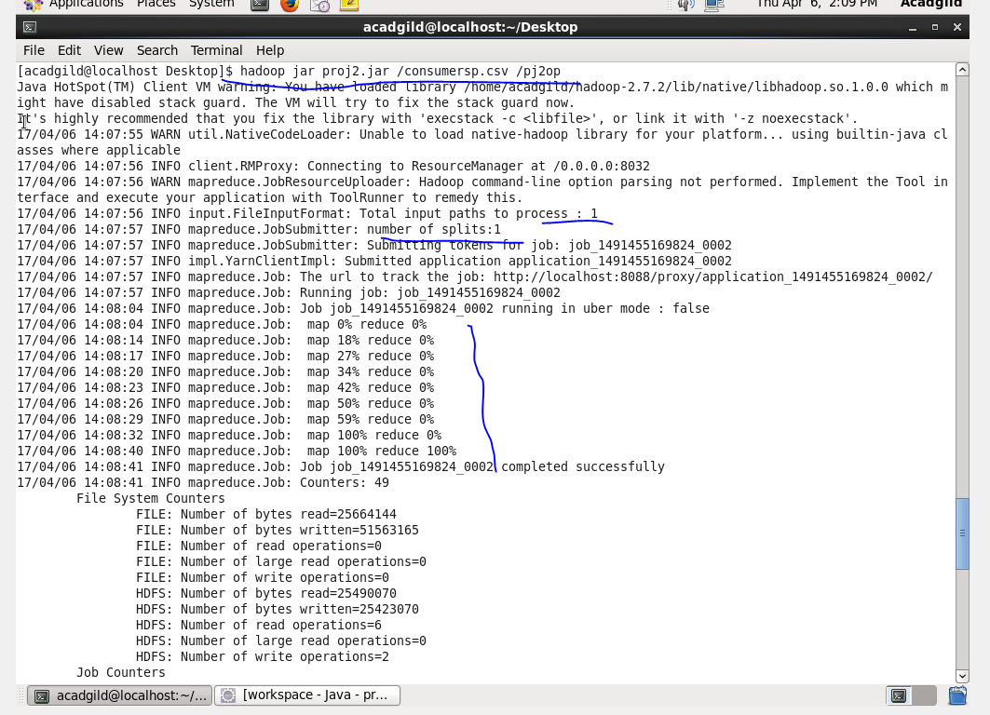

**Output**

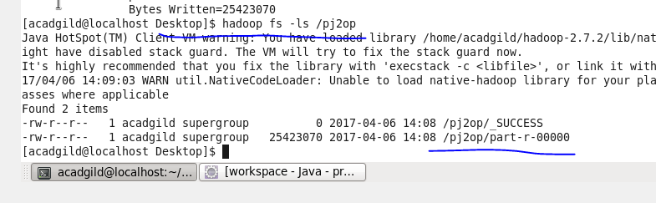

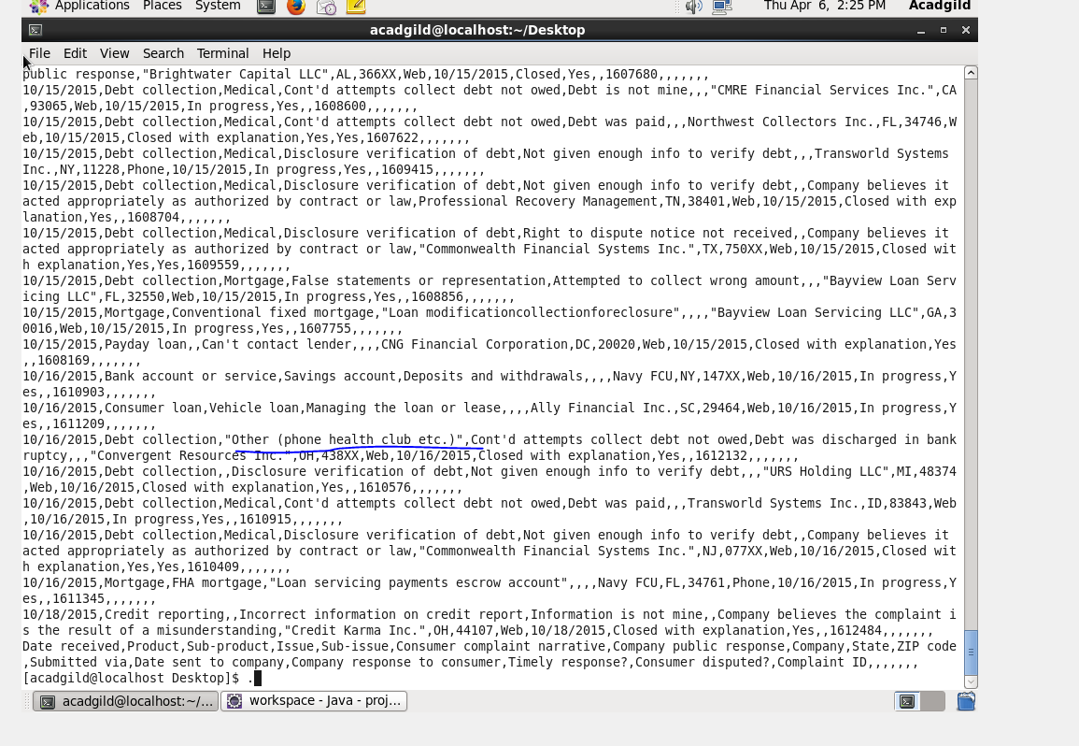

**Transfer the output file from hdfs to local system by get command**

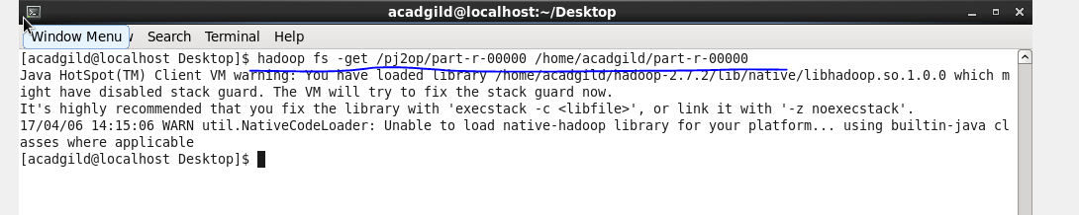

**Apply the pig commands on the output file , now output of the map reduce program acts as input file for pig commands**

1. **Write a pig script to find no of complaints which got timely response**

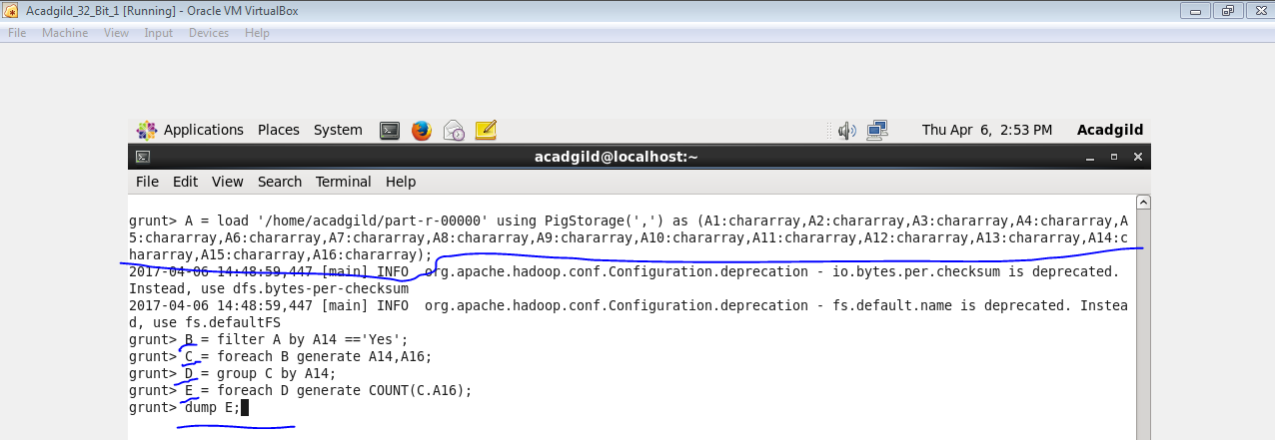

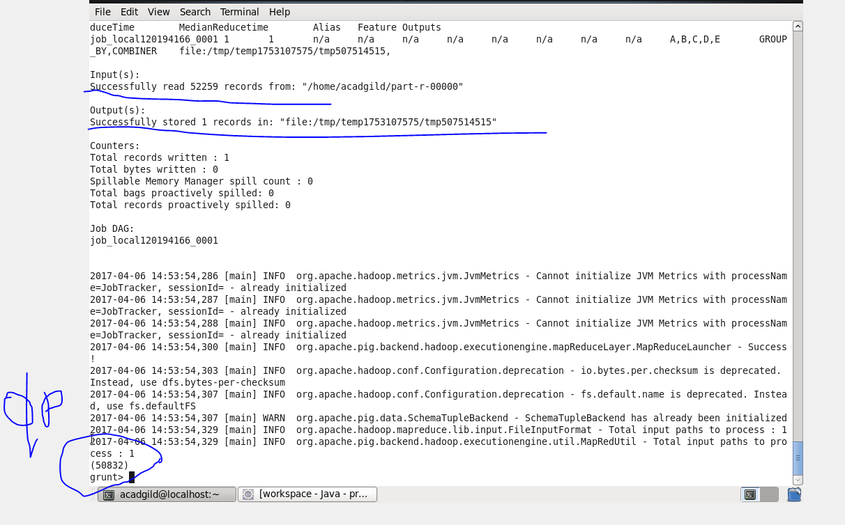

1. **Write a pig script to find no of complaints where consumer forum forwarded the complaint same day they received to respective company**

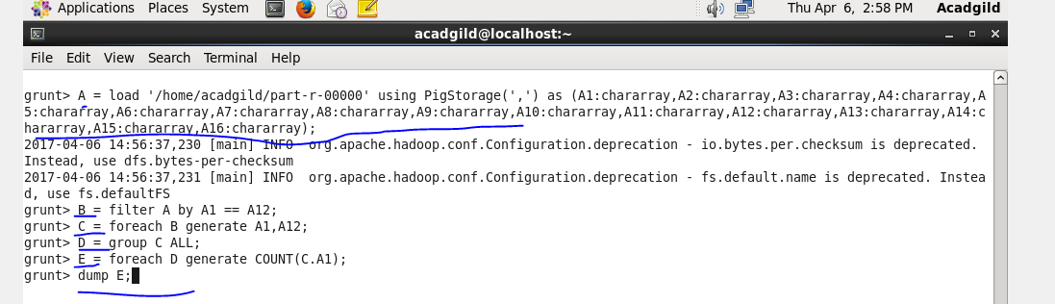

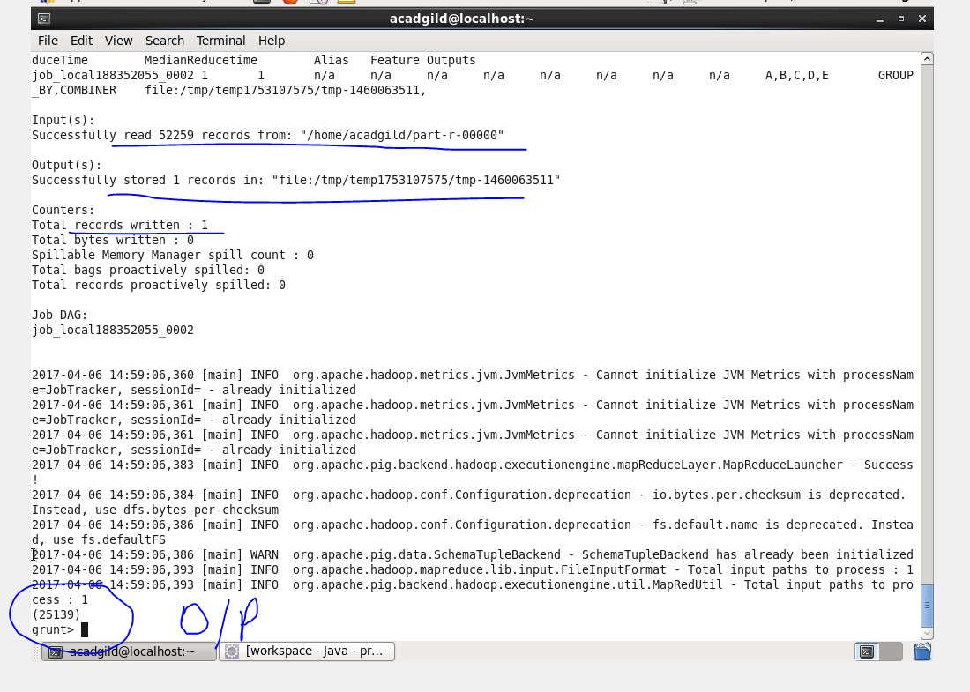

1. **Write a pig script to find list of companies topping in complaint chart (companies with maximum number of complaints)**

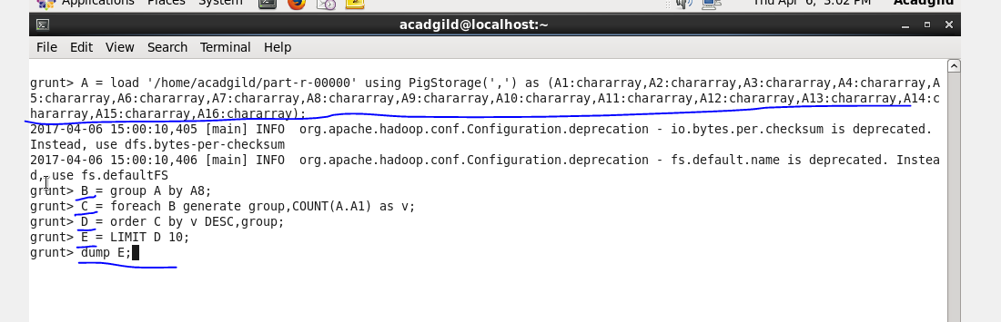

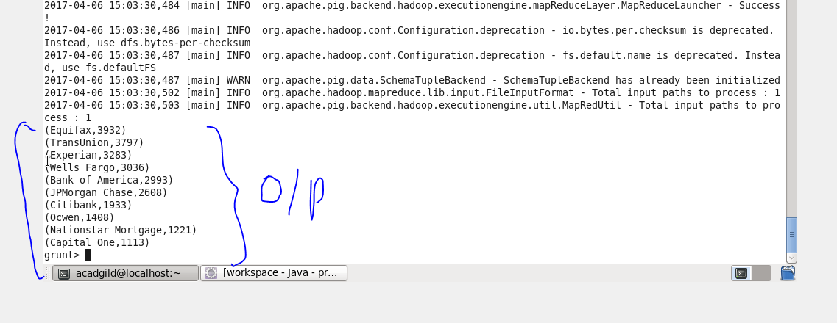

1. **Write a pig script to find no of complaints filed with product type has "Debt collection" for the year 2015**

