Report
Online Exam System Project

Objective

Conducting a paperless examination is made available by using the concept of web based online examination, which includes automated processing system for all the works which was previously done by using human work power. This online examination system will able to work as two way road just by single system. Through this web application, it can be possible to conduct examination through internet or to a particular geographical region using the concept of LAN or through intranet for particular organization.

Tools Used
- Operating System : Linux mint 19.04
- Back End :Mysql
- IDE : eclipse
- Front End : JAVA using SERVLETS
- Database Connectivity: JDBC

Online Examination System Snapshots

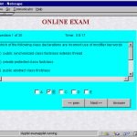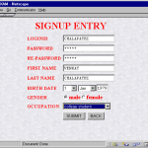

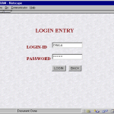

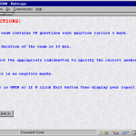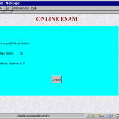

Class diagram

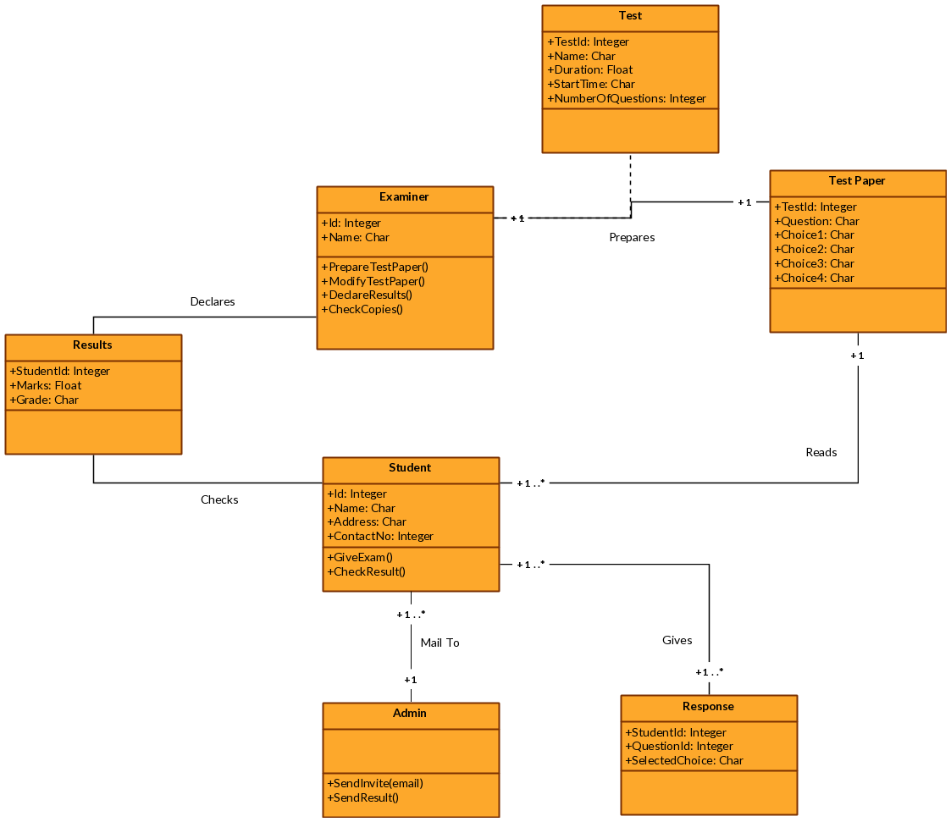

Dataflow diagram
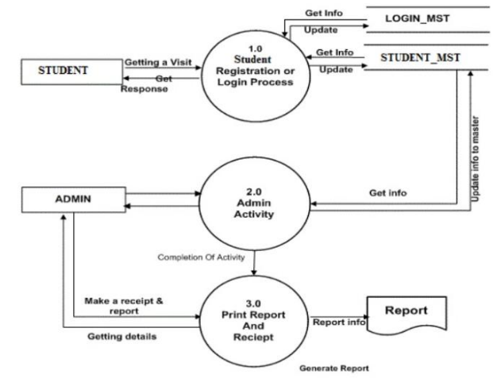
Activity diagram
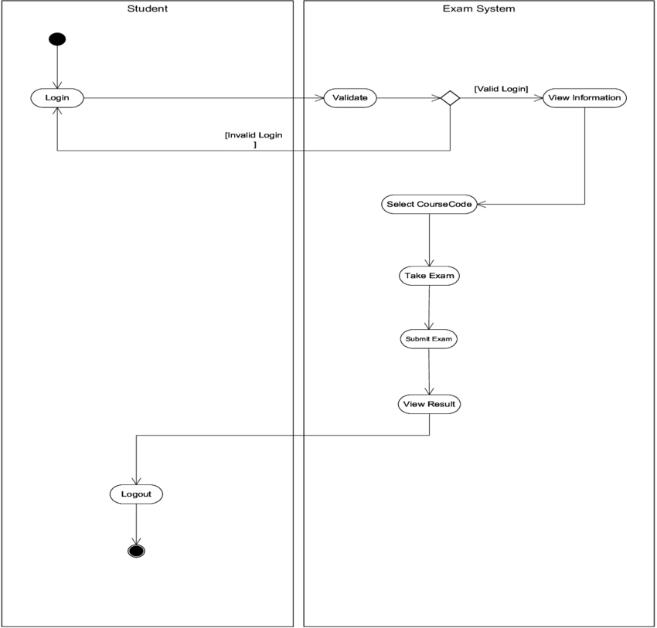

Er diagram
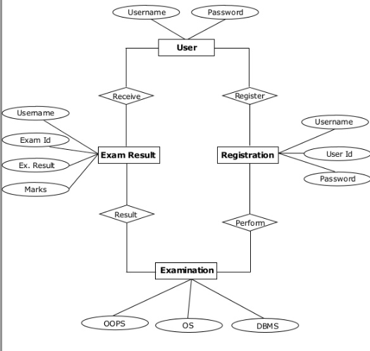

Sequential diagram

