Screenshots of the website

Login Page:

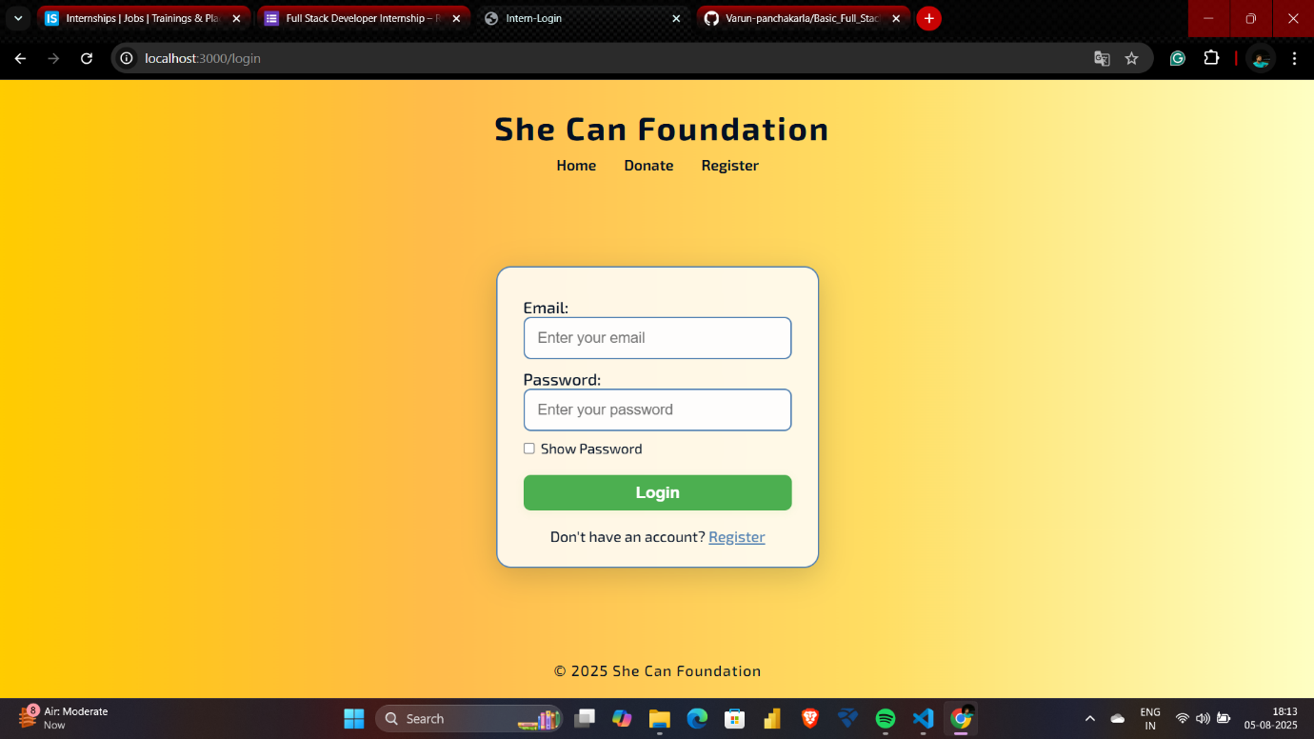

Register Page:

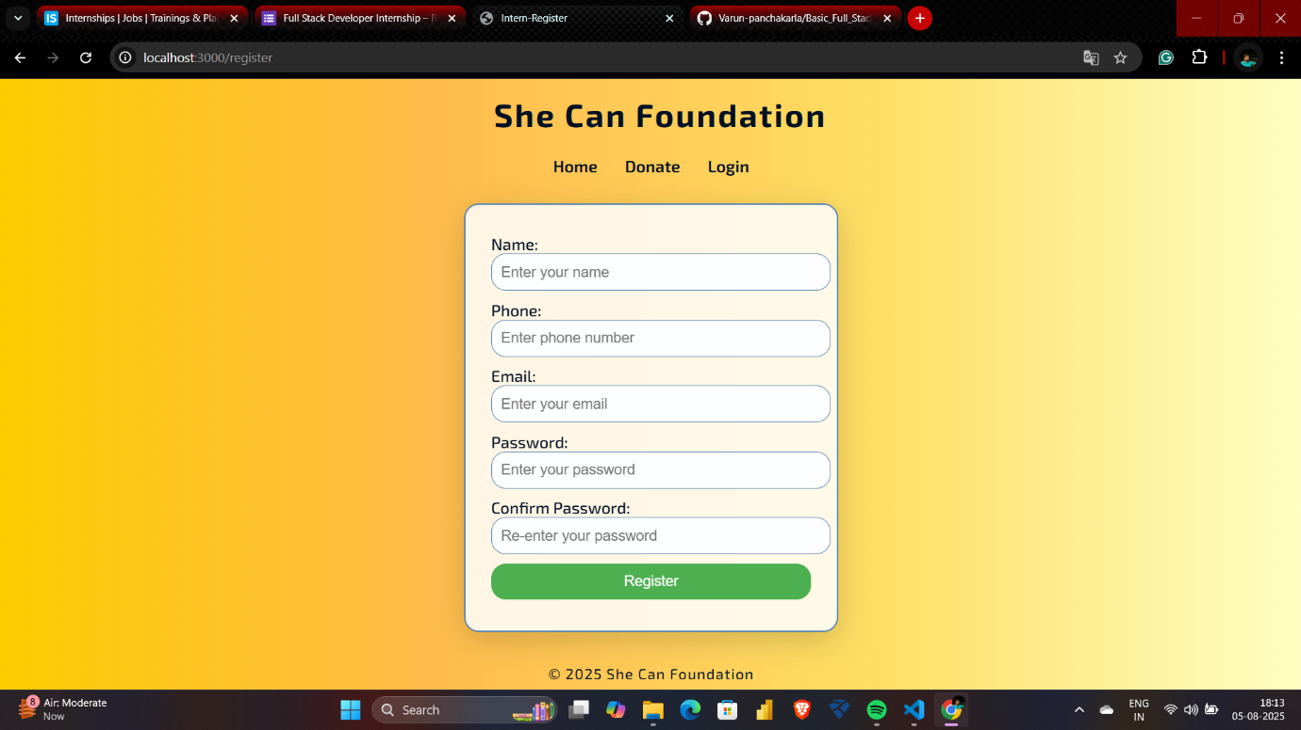

Donation Page:

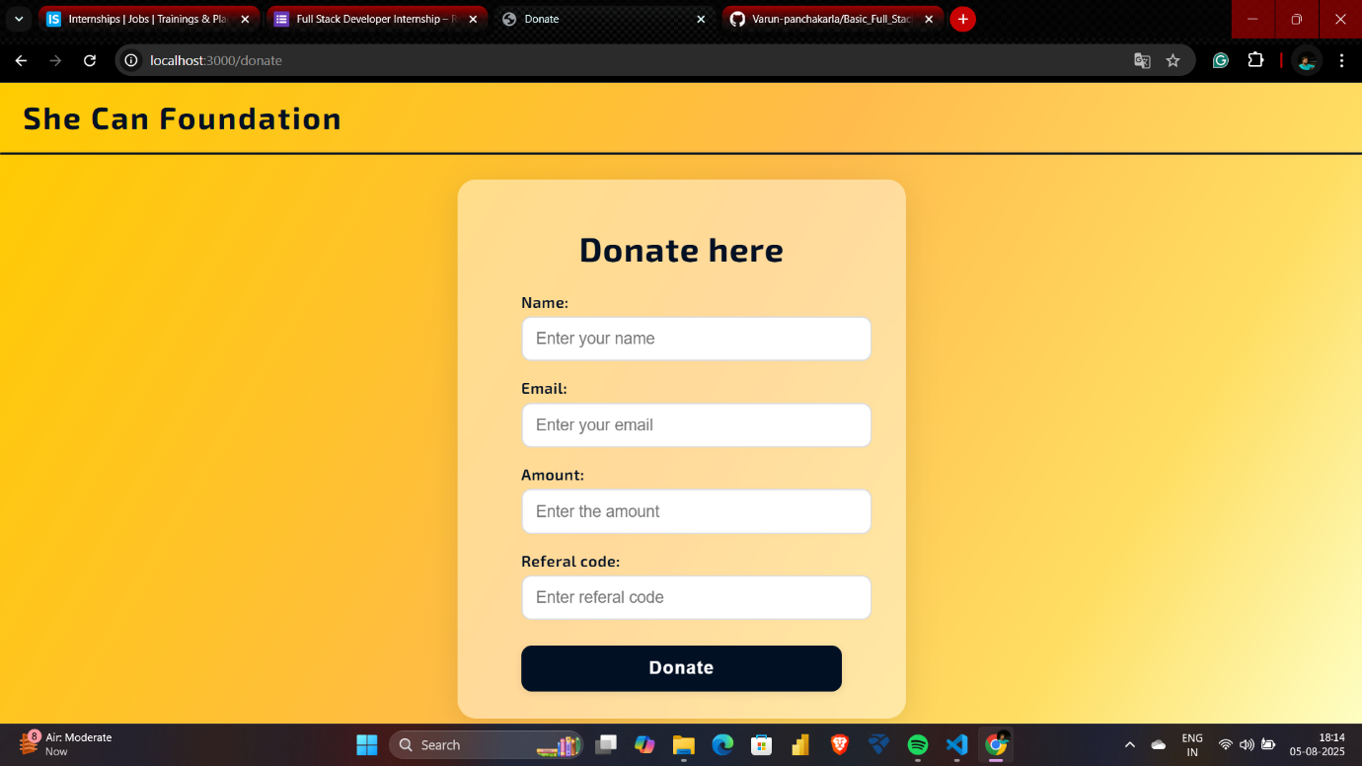

Dashboard:

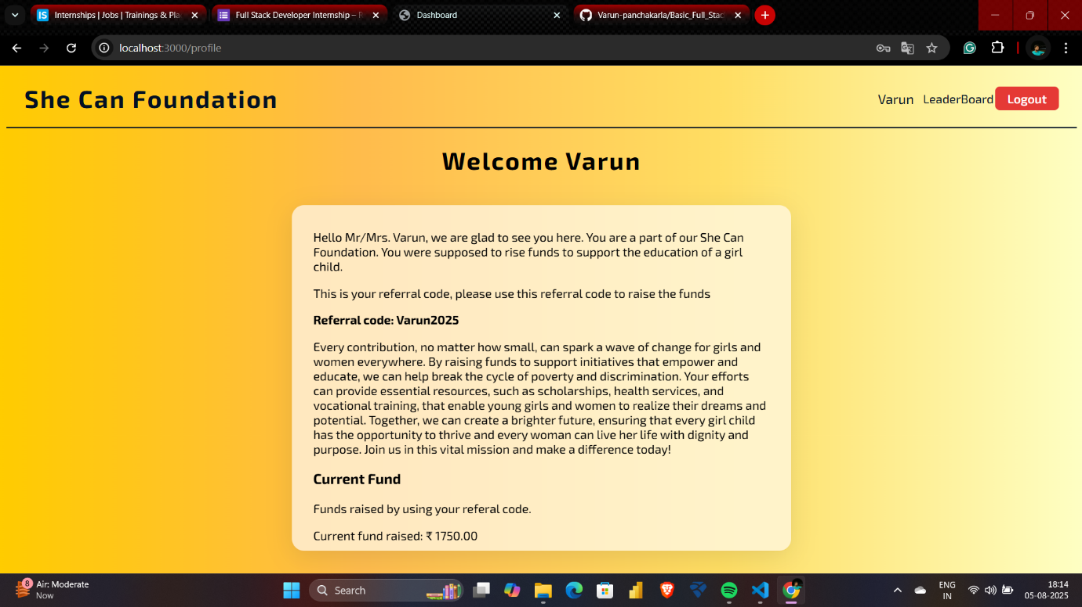

LeaderBoard:

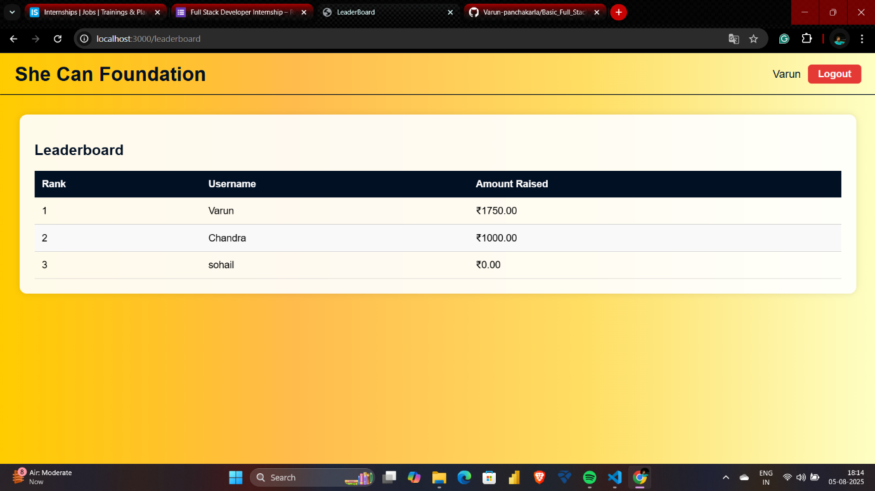

Demo Video link:

https://drive.google.com/file/d/1BcHs_U6F2iZ5p-NBFTgcKLklELkLnrzv/view?usp=drive_link