Detection of Phishing Website using SVM & Light GBM

In this project we are implementing SVM and Light GBM machine learning algorithms o detect phishing website URLS. We are training all this algorithms with normal and phishing URLS and build a trained model and this train model will be applied on new TEST URL to detect whether its normal or phishing URL.

In this project you asked to use UCI machine learning phishing dataset but this dataset contains only 0’s and 1’s values like below screen

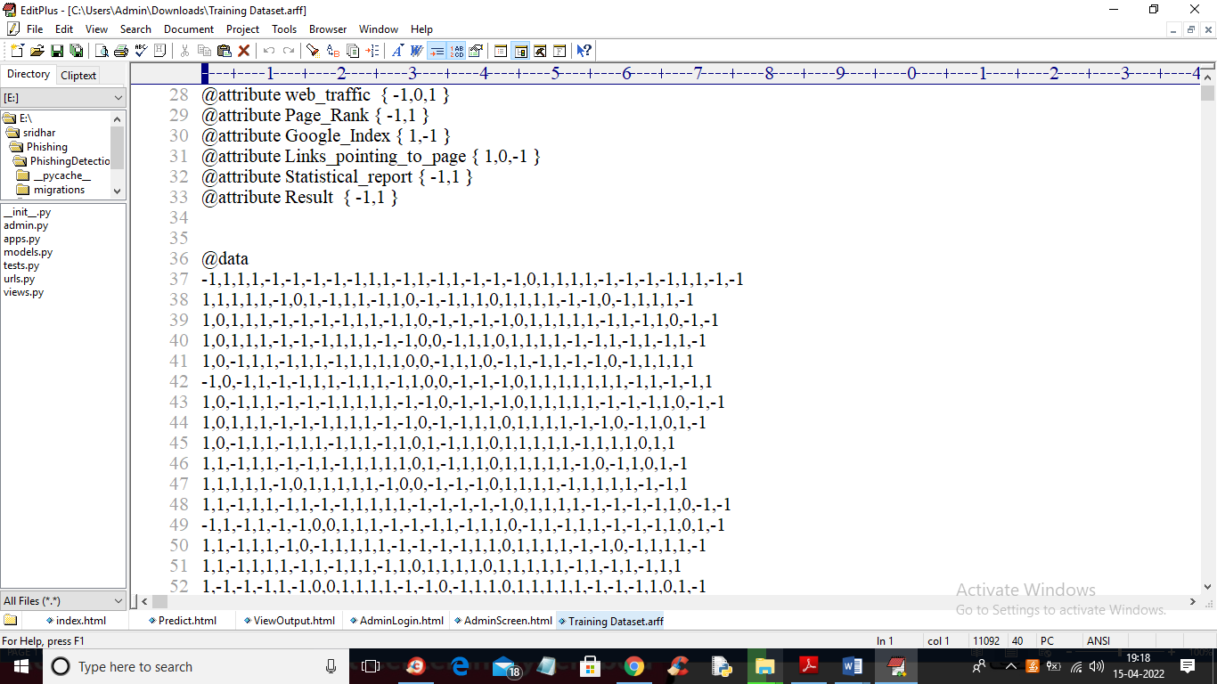

From above dataset ML algorithms can get trained but we can’t understand anything so I am using REAL WORLD URL dataset which contains normal and phishing URLS like below screen

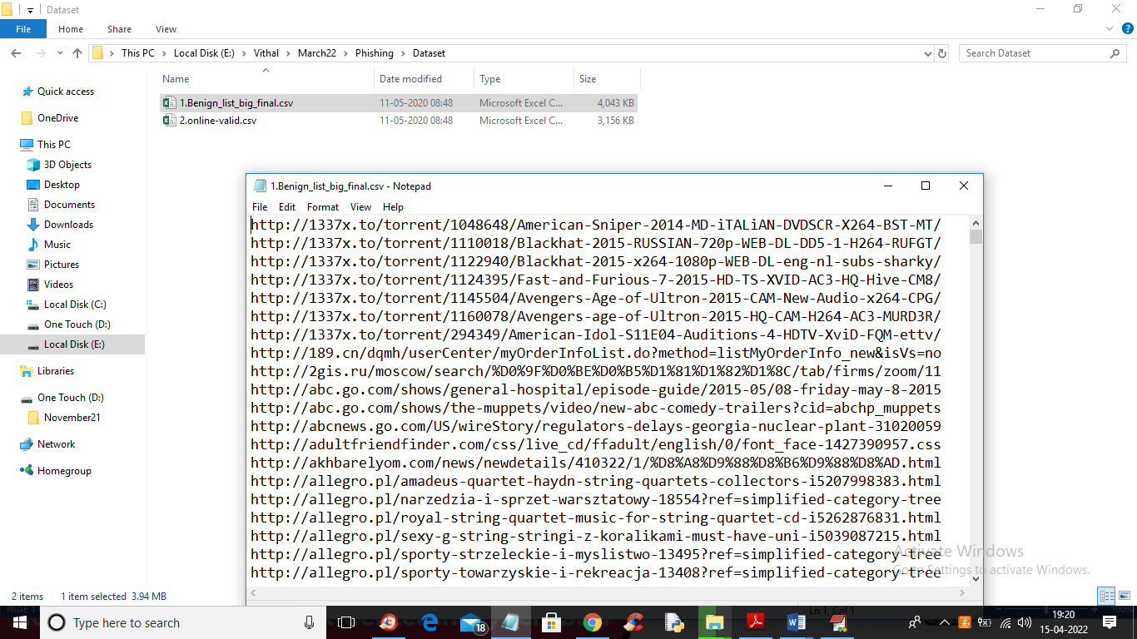

In above screen you can see our dataset contains 2 folders called benign (phishing URLS) and valid (normal URL) and this are real world URLS and we will train all algorithms with above dataset and then when we input any test URL then ML model will predict as normal or phishing

To run this project double click on ‘run.bat’ file to start python DJANO server like below screen

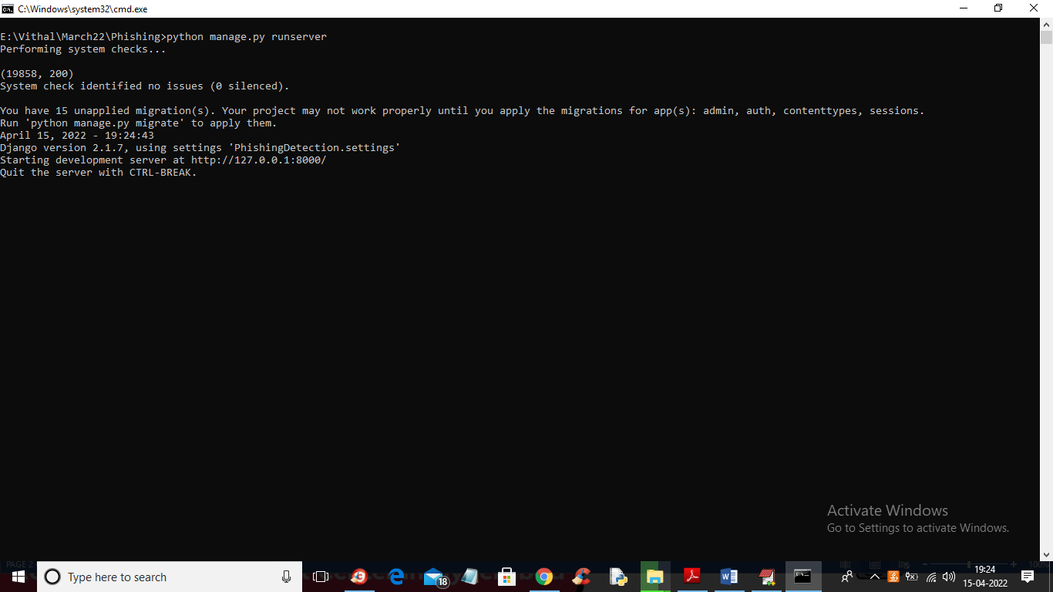

In above screen DJANGO webserver started and now open browser and enter URL <http://127.0.0.1:8000/index.html> and press enter key to get below output

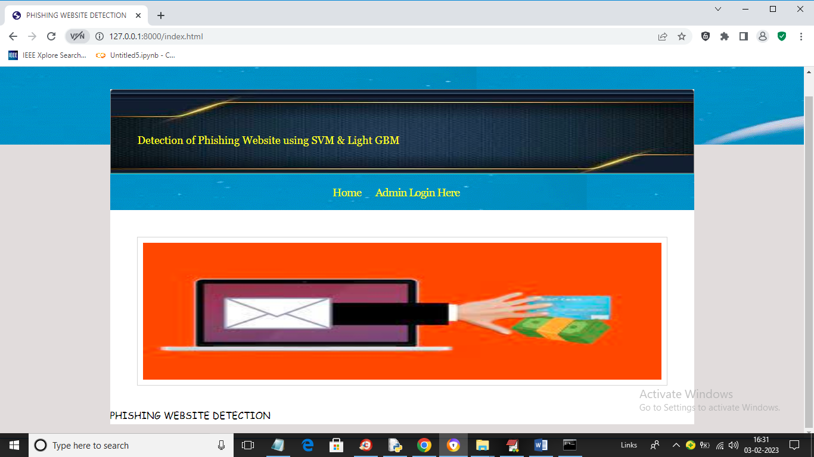

In above screen click on ‘Admin Login Here’ link to get below login screen

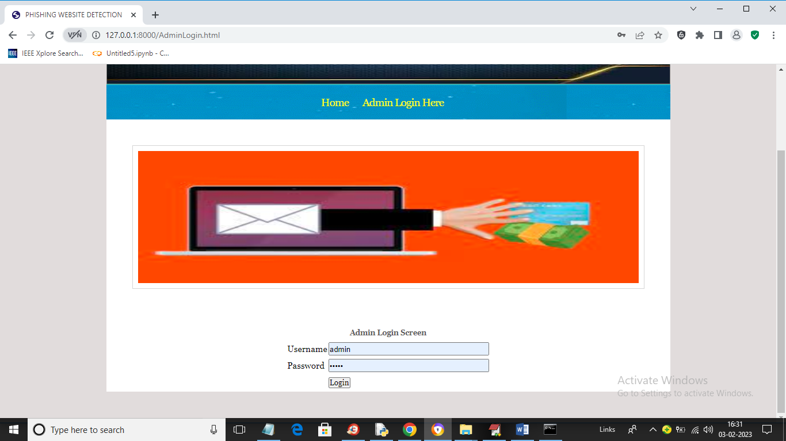

In above screen enter username and password as ‘admin’ and ‘admin’ and then press button to get below output

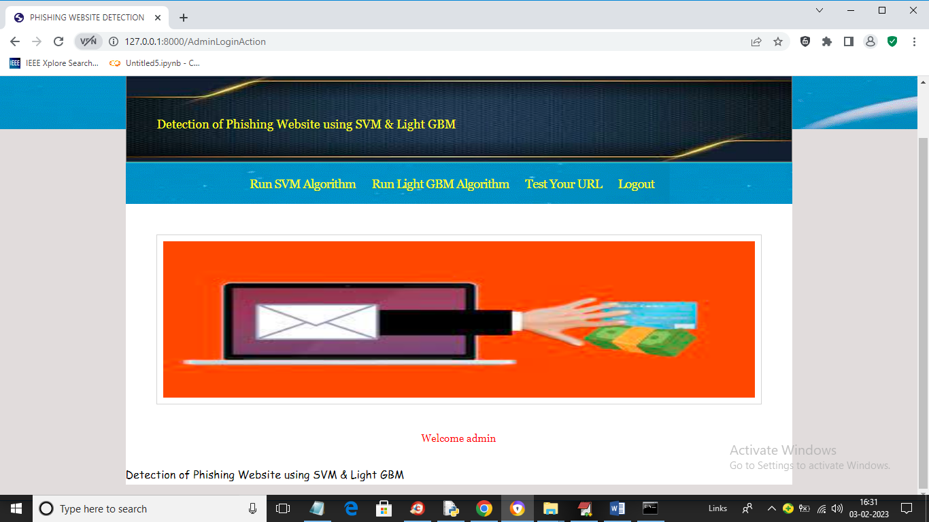

In above screen click on ‘Run SVM Algorithm’ link to train SVM algorithm and get below output

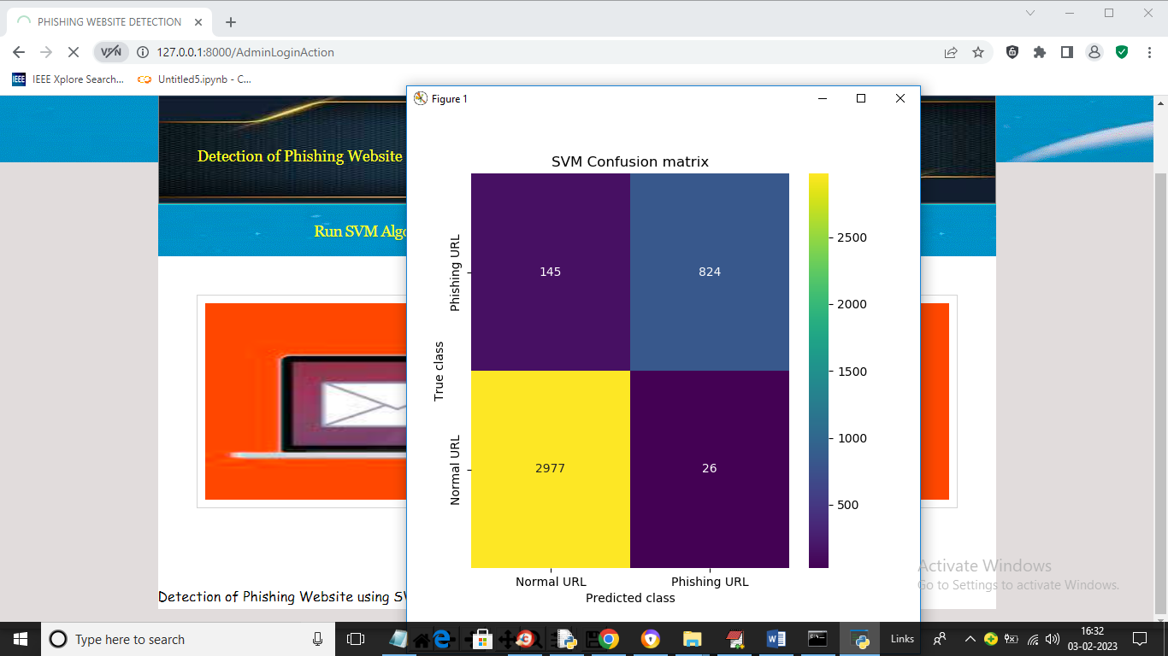

In above screen we can see SVM confusion matrix where x-axis represents predicted class and y-axis represents TRUE class and we can see SVM predict 2977 records correctly as NORMAL and only 145 are incorrect prediction and it predict 824 records as PHISHING URL and only 26 are incorrect prediction and now close above graph to get below output

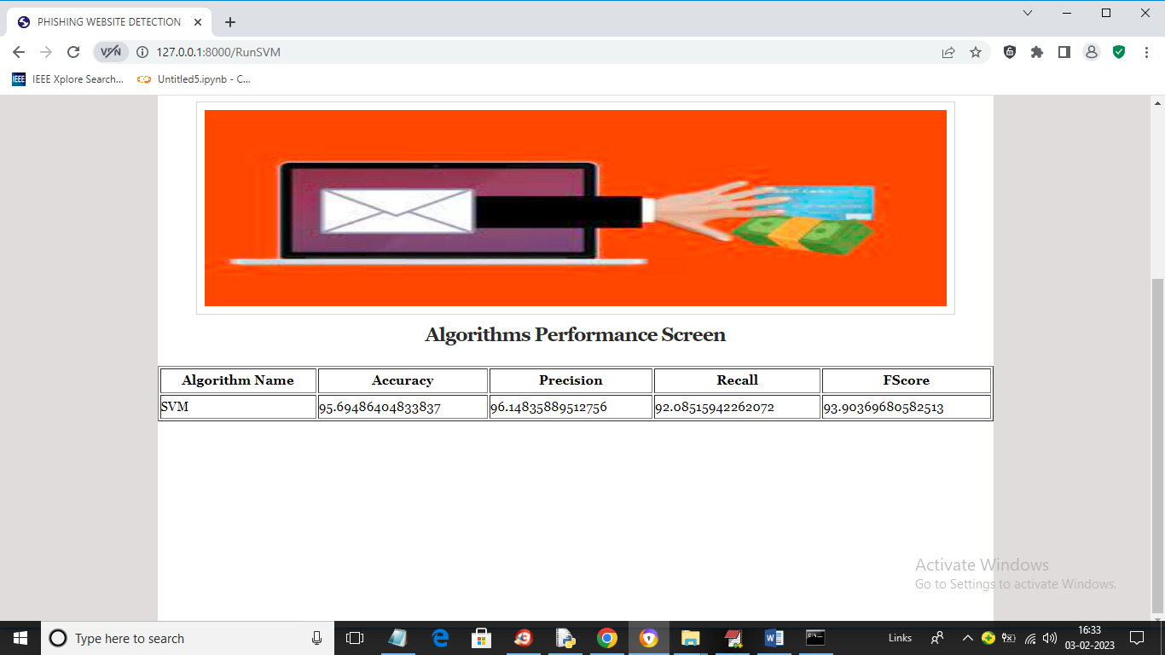

In above screen with SVM we got 95% accuracy and now click on ‘Run Light GBM Algorithm’ link to get below output

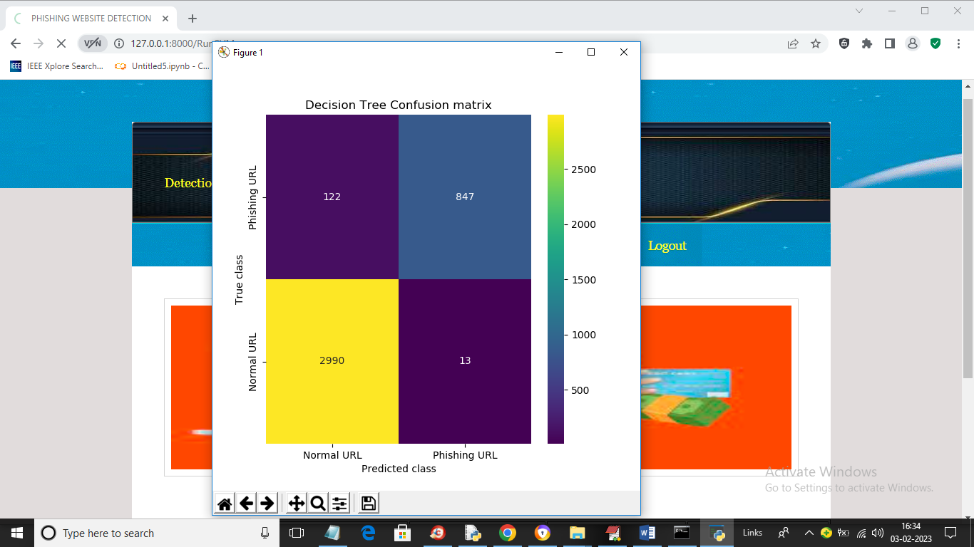

In above screen we can see Decision Tree confusion matrix graph and now close above graph to get below output

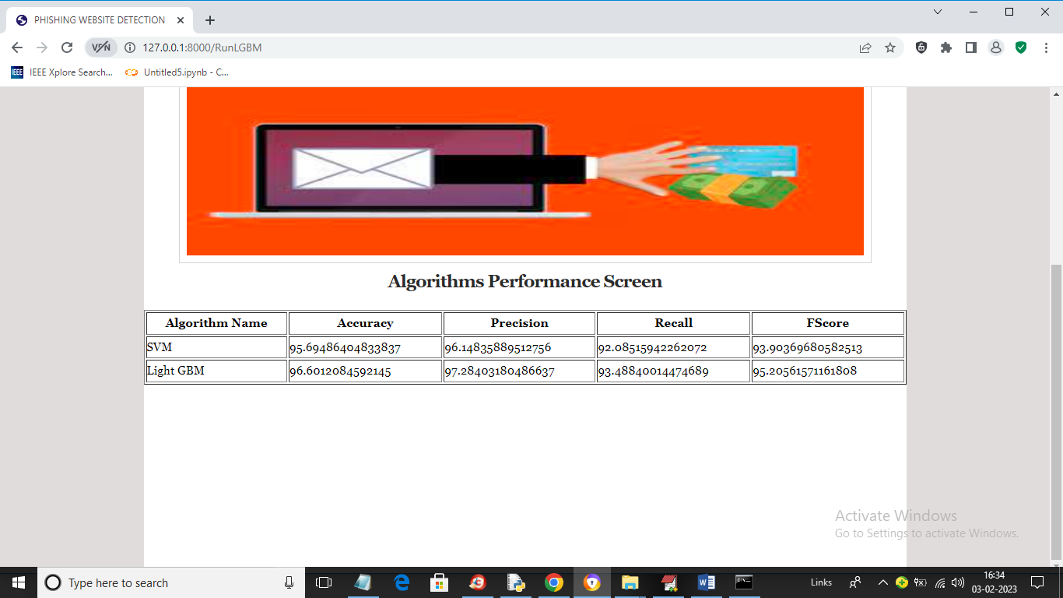

In above screen with Light GBM also we got 96% accuracy and now click on ‘Test Your URL’ link to get below screen

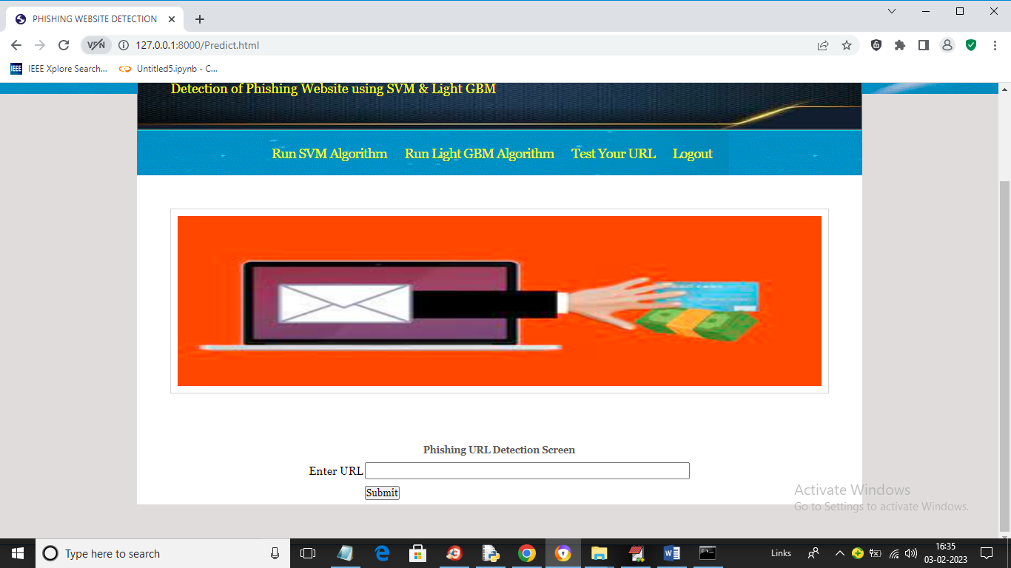

In above screen enter any URL and then press button and then Light GBM will predict whether that URL IS normal or phishing

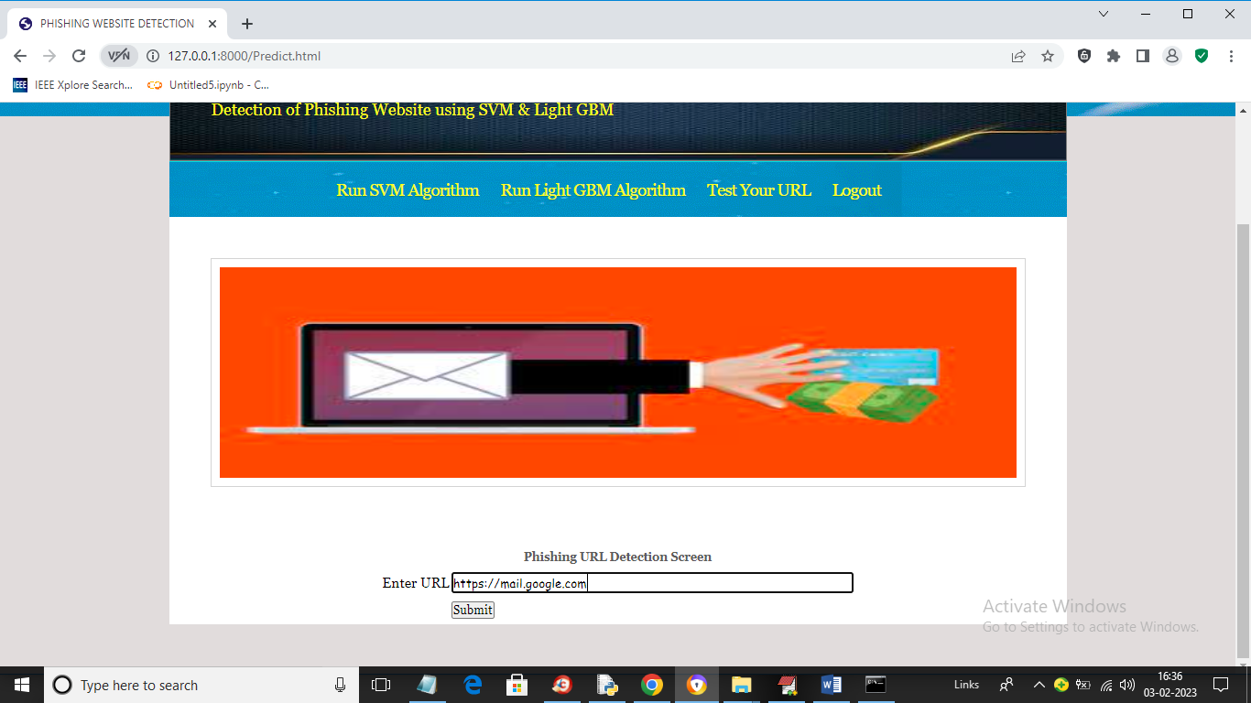

In above screen I entered URL as <https://mail.google.com> and then press button to get below output

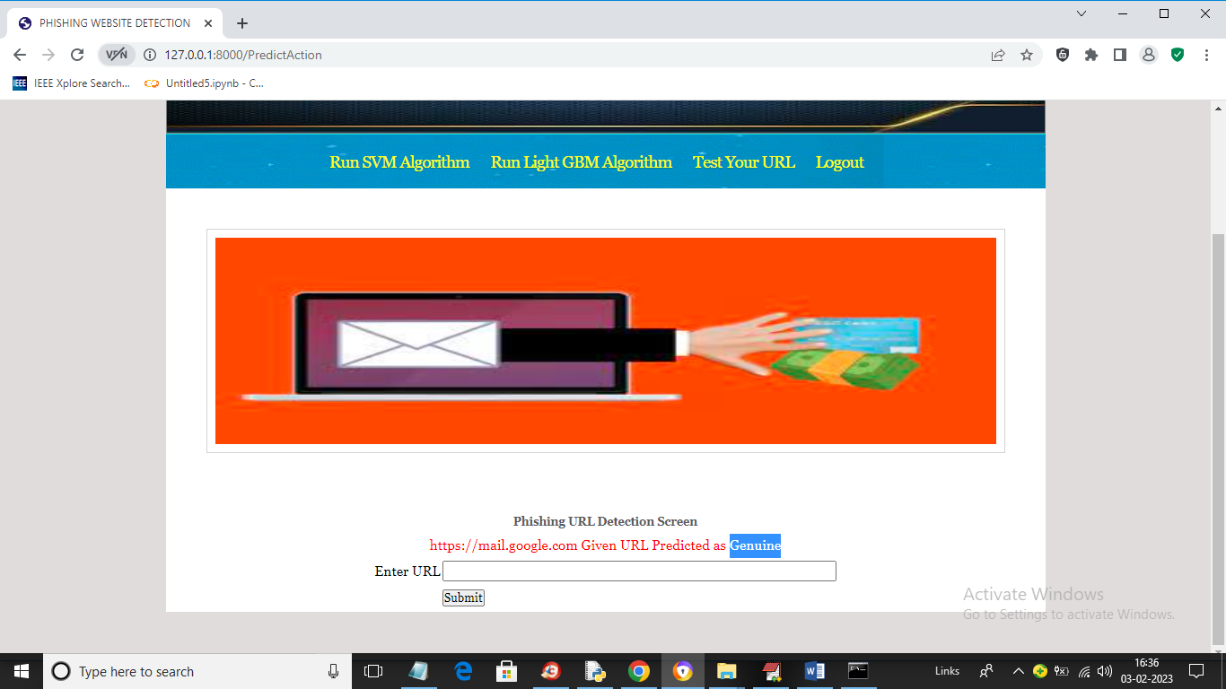

In above screen in blue colour text we can see given URL predicted as GENUINE (normal) and now test other URL. Similarly now I will enter Google.com in below screen

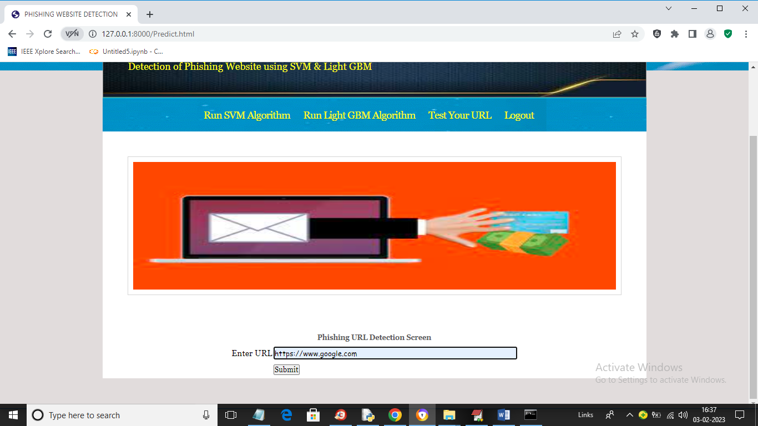

In above screen I gave URL as Google.com and below is the output

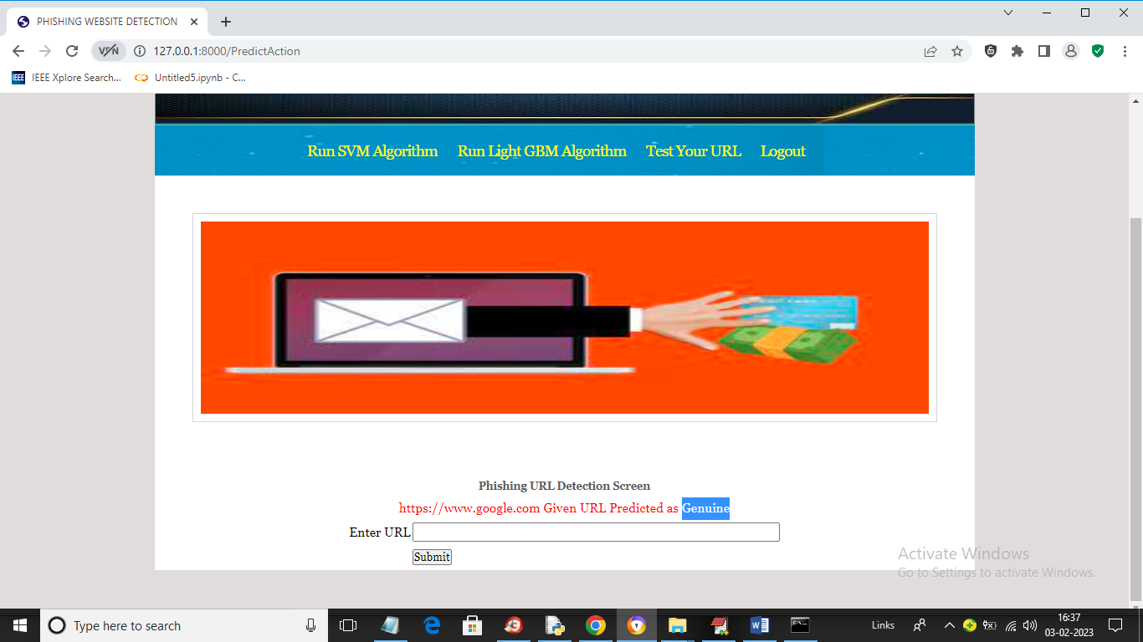

In above screen Google.com also predicted as Genuine. Now in below screen from internet I am taking one phishing URL and then input to my application to get prediction

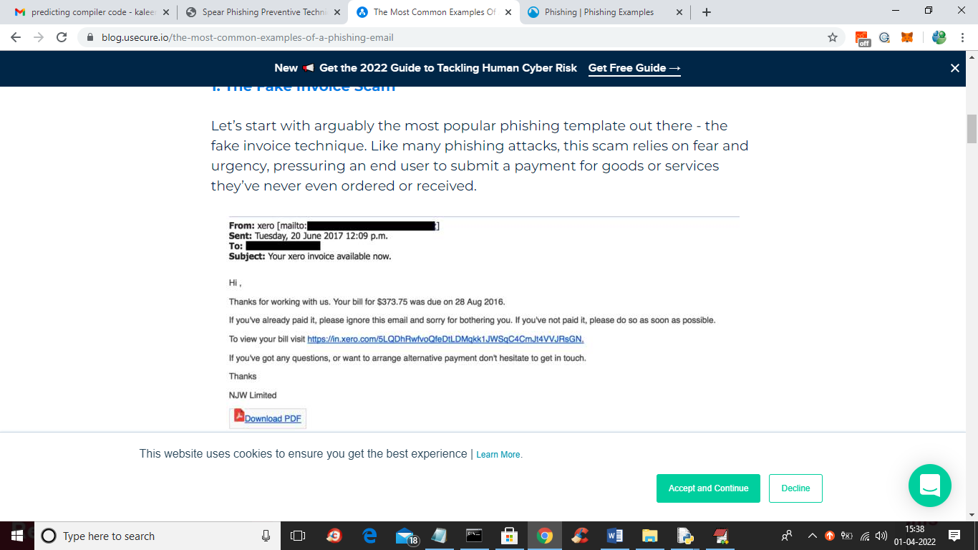

In above screen blue colour URL is the phishing URL and I will input that to my application in below screen and below is the phishing URL from internet

‘https://in.xero.com/3LQDhRwfvoQfeDtlDMqkk1JWSqC4CMJt4VVJRsGN’

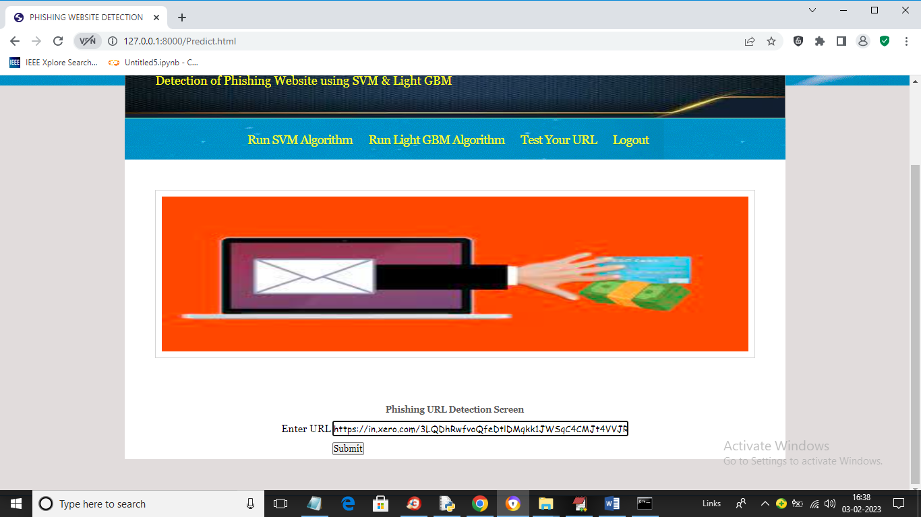

In above screen I entered same URL and press button to get below output

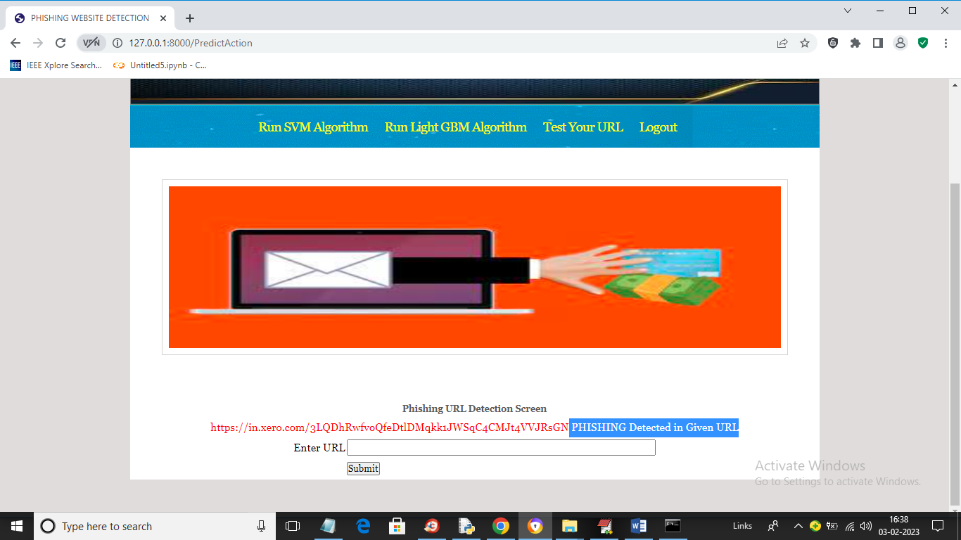

In above screen in blue colour text we can see application detected PHISHING in given URL and similarly you can enter any URL and detect it as NORMAL or phishing