LAB 16
Database Design and Queries
Schema Design and SQL Generation
Student Name: Varun Reddy
Database platform: MySQL 8.0

Lab Objectives
- Understand schema design principles for relational databases.
- Use AI-assisted tools to generate SQL schema definitions.
- Write and refine SQL queries for CRUD and aggregate operations.
- Explore query optimization and database normalization.

How to Use This Lab
Each task includes an AI prompt, SQL schema, query examples, and an illustrative Visual Studio Code-style screenshot of the schema. The screenshots are generated editor mockups for documentation; they are not captures from a live VS Code session. Run the SQL in MySQL Workbench or the SQL extension in VS Code, then replace the illustrations with your own screenshots if your instructor requires actual execution evidence.

Task 1 – Employee Management Database

1. AI Prompt
Create a relational database for employee management with Employees, Departments, and Salaries tables. Add primary keys, foreign keys, NOT NULL, UNIQUE, and salary validation constraints. Write queries to list employees by department, retrieve salary details, and find the highest-paid employee in each department.

2. Input Code – Create Database
CREATE DATABASE EmployeeDB;
USE EmployeeDB;

3. Output Code – Table Schema
CREATE DATABASE EmployeeDB;
USE EmployeeDB;
CREATE TABLE Departments (
department_id INT PRIMARY KEY AUTO_INCREMENT,
department_name VARCHAR(100) NOT NULL UNIQUE
);
CREATE TABLE Employees (
employee_id INT PRIMARY KEY AUTO_INCREMENT,
employee_name VARCHAR(100) NOT NULL,
email VARCHAR(100) NOT NULL UNIQUE,
department_id INT NOT NULL,
FOREIGN KEY (department_id) REFERENCES Departments(department_id)
);
CREATE TABLE Salaries (
salary_id INT PRIMARY KEY AUTO_INCREMENT,
employee_id INT NOT NULL,
salary DECIMAL(10,2) NOT NULL CHECK (salary >= 0),
effective_date DATE NOT NULL,
FOREIGN KEY (employee_id) REFERENCES Employees(employee_id)
);

4. SQL Queries

List employees in a specific department
SELECT e.employee_id, e.employee_name, d.department_name
FROM Employees e
JOIN Departments d ON e.department_id = d.department_id
WHERE d.department_name = 'IT';

Retrieve salary details for an employee
SELECT e.employee_name, s.salary, s.effective_date
FROM Employees e
JOIN Salaries s ON e.employee_id = s.employee_id
WHERE e.employee_id = 1
ORDER BY s.effective_date DESC;

Highest-paid employee in each department
WITH RankedSalaries AS (
SELECT e.employee_name, d.department_name, s.salary,
ROW_NUMBER() OVER (
PARTITION BY e.department_id
ORDER BY s.salary DESC, s.effective_date DESC, e.employee_id
) AS rn
FROM Employees e
JOIN Departments d ON e.department_id = d.department_id
JOIN Salaries s ON e.employee_id = s.employee_id
)
SELECT employee_name, department_name, salary
FROM RankedSalaries
WHERE rn = 1;

5. VS Code Screenshot
Illustrative Visual Studio Code-style editor view of the table schema:
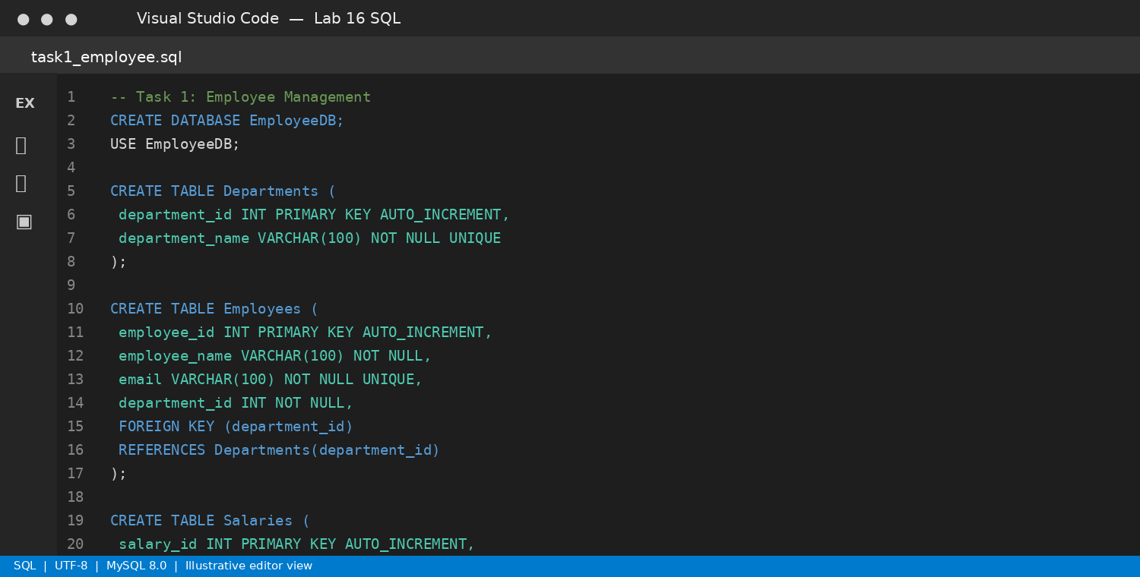
Screenshot note: This is a generated illustration, not a live application capture.

Expected Output
A normalized employee database with department relationships, salary records, constraints, and join/ranking queries.

Task 2 – Online Course Platform Database

1. AI Prompt
Design an online learning database with Users, Courses, Lessons, and Enrollments. Define primary keys, foreign keys, unique constraints, and relationships. Write queries to list courses enrolled by a user, count learners per course, and retrieve lessons for a course.

2. Input Code – Create Database
CREATE DATABASE CourseDB;
USE CourseDB;

3. Output Code – Table Schema
CREATE DATABASE CourseDB;
USE CourseDB;
CREATE TABLE Users (
user_id INT PRIMARY KEY AUTO_INCREMENT,
user_name VARCHAR(100) NOT NULL,
email VARCHAR(150) NOT NULL UNIQUE
);
CREATE TABLE Courses (
course_id INT PRIMARY KEY AUTO_INCREMENT,
course_name VARCHAR(150) NOT NULL,
description TEXT
);
CREATE TABLE Lessons (
lesson_id INT PRIMARY KEY AUTO_INCREMENT,
course_id INT NOT NULL,
lesson_title VARCHAR(150) NOT NULL,
lesson_order INT NOT NULL,
FOREIGN KEY (course_id) REFERENCES Courses(course_id),
UNIQUE (course_id, lesson_order)
);
CREATE TABLE Enrollments (
enrollment_id INT PRIMARY KEY AUTO_INCREMENT,
user_id INT NOT NULL,
course_id INT NOT NULL,
enrollment_date DATE NOT NULL,
FOREIGN KEY (user_id) REFERENCES Users(user_id),
FOREIGN KEY (course_id) REFERENCES Courses(course_id),
UNIQUE (user_id, course_id)
);

4. SQL Queries

List all courses enrolled by a user
SELECT u.user_name, c.course_name, en.enrollment_date
FROM Enrollments en
JOIN Users u ON en.user_id = u.user_id
JOIN Courses c ON en.course_id = c.course_id
WHERE u.user_id = 1;

Count learners per course
SELECT c.course_name, COUNT(en.user_id) AS total_learners
FROM Courses c
LEFT JOIN Enrollments en ON c.course_id = en.course_id
GROUP BY c.course_id, c.course_name;

Retrieve lessons for a course
SELECT c.course_name, l.lesson_title, l.lesson_order
FROM Courses c
JOIN Lessons l ON c.course_id = l.course_id
WHERE c.course_id = 1
ORDER BY l.lesson_order;

5. VS Code Screenshot
Illustrative Visual Studio Code-style editor view of the table schema:
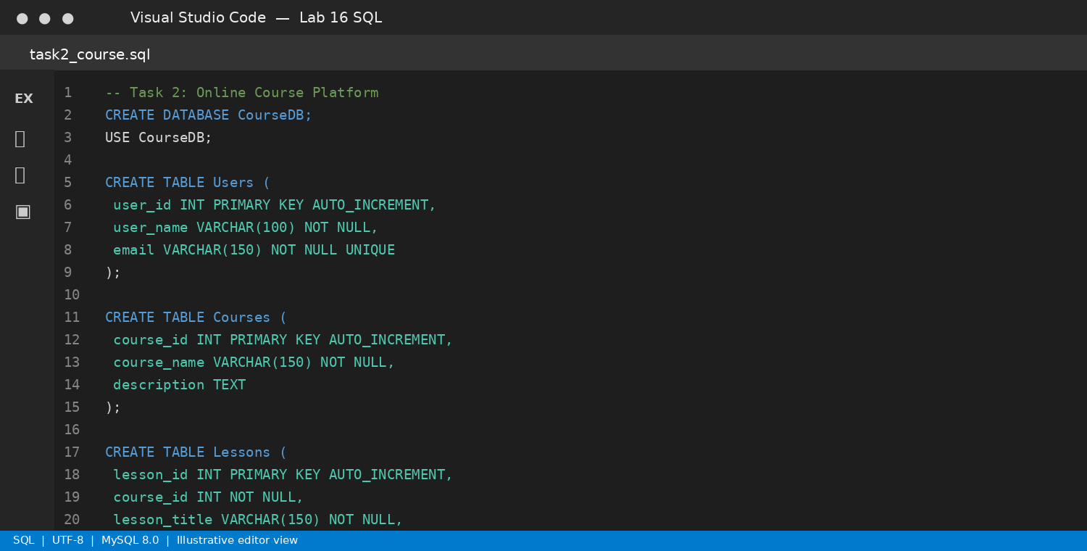
Screenshot note: This is a generated illustration, not a live application capture.

Expected Output
A relational learning platform supporting enrollments, lesson ordering, and course-level learner counts.

Task 3 – Banking Transaction Database

1. AI Prompt
Create a banking transaction database with Customers, Accounts, and Transactions. Use primary keys, foreign keys, balance constraints, and transaction validation. Write queries for account transaction history, total deposits and withdrawals, and accounts below a balance threshold.

2. Input Code – Create Database
CREATE DATABASE BankingDB;
USE BankingDB;

3. Output Code – Table Schema
CREATE DATABASE BankingDB;
USE BankingDB;
CREATE TABLE Customers (
customer_id INT PRIMARY KEY AUTO_INCREMENT,
customer_name VARCHAR(100) NOT NULL,
email VARCHAR(150) NOT NULL UNIQUE
);
CREATE TABLE Accounts (
account_id INT PRIMARY KEY AUTO_INCREMENT,
customer_id INT NOT NULL,
account_number VARCHAR(20) NOT NULL UNIQUE,
balance DECIMAL(12,2) NOT NULL DEFAULT 0,
CHECK (balance >= 0),
FOREIGN KEY (customer_id) REFERENCES Customers(customer_id)
);
CREATE TABLE Transactions (
transaction_id INT PRIMARY KEY AUTO_INCREMENT,
account_id INT NOT NULL,
transaction_type ENUM('Deposit', 'Withdrawal') NOT NULL,
amount DECIMAL(12,2) NOT NULL CHECK (amount > 0),
transaction_date DATETIME NOT NULL DEFAULT CURRENT_TIMESTAMP,
FOREIGN KEY (account_id) REFERENCES Accounts(account_id)
);

4. SQL Queries

Retrieve transaction history for an account
SELECT a.account_number, t.transaction_type, t.amount, t.transaction_date
FROM Transactions t
JOIN Accounts a ON t.account_id = a.account_id
WHERE a.account_id = 1
ORDER BY t.transaction_date DESC;

Calculate total deposits and withdrawals
SELECT account_id,
SUM(CASE WHEN transaction_type = 'Deposit' THEN amount ELSE 0 END) AS total_deposits,
SUM(CASE WHEN transaction_type = 'Withdrawal' THEN amount ELSE 0 END) AS total_withdrawals
FROM Transactions
GROUP BY account_id;

Find accounts below a threshold
SELECT account_number, balance
FROM Accounts
WHERE balance < 1000;

5. VS Code Screenshot
Illustrative Visual Studio Code-style editor view of the table schema:
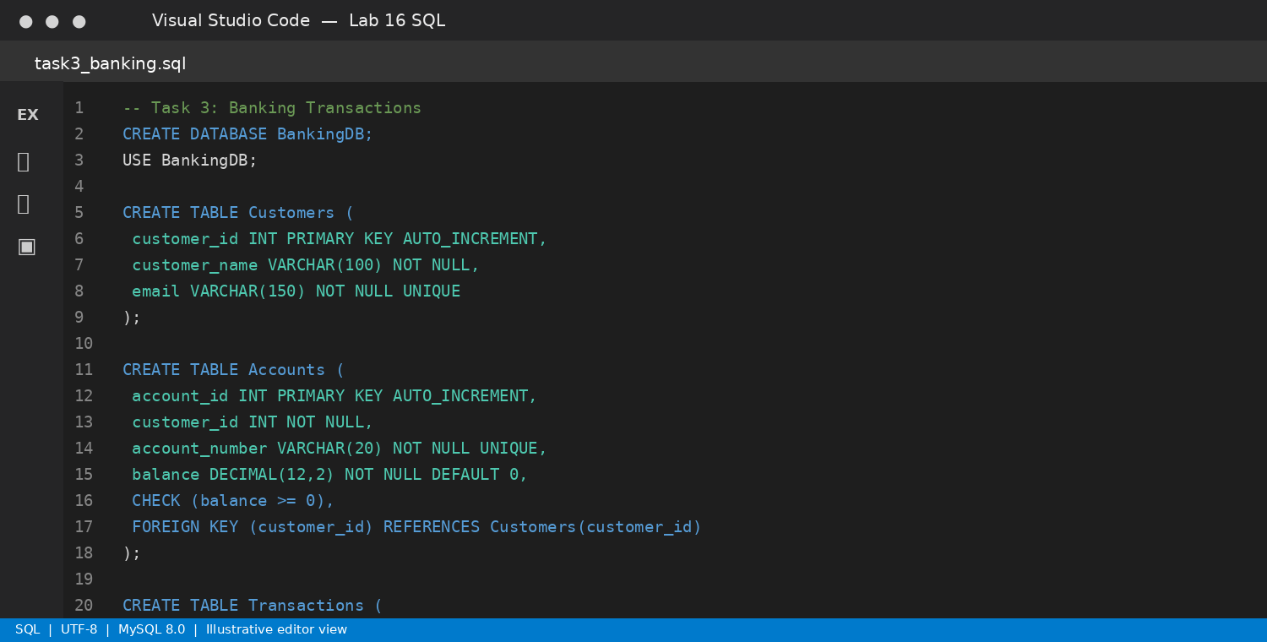
Screenshot note: This is a generated illustration, not a live application capture.

Expected Output
A banking schema with valid transaction amounts and analytical queries. Production withdrawals also need transactional balance checks and concurrency control.

Task 4 – Airline Reservation Database

1. AI Prompt
Design an airline reservation database using Flights, Passengers, Tickets, and Bookings. Define relationships and prevent duplicate seat allocation on the same flight. Write queries to list passengers on a flight, find available seats, and count bookings per flight.

2. Input Code – Create Database
CREATE DATABASE AirlineDB;
USE AirlineDB;

3. Output Code – Table Schema
CREATE DATABASE AirlineDB;
USE AirlineDB;
CREATE TABLE Flights (
flight_id INT PRIMARY KEY AUTO_INCREMENT,
flight_number VARCHAR(20) NOT NULL UNIQUE,
origin VARCHAR(100) NOT NULL,
destination VARCHAR(100) NOT NULL,
departure_time DATETIME NOT NULL,
total_seats INT NOT NULL CHECK (total_seats > 0)
);
CREATE TABLE Passengers (
passenger_id INT PRIMARY KEY AUTO_INCREMENT,
passenger_name VARCHAR(100) NOT NULL,
email VARCHAR(150) NOT NULL UNIQUE
);
CREATE TABLE Bookings (
booking_id INT PRIMARY KEY AUTO_INCREMENT,
passenger_id INT NOT NULL,
flight_id INT NOT NULL,
booking_date DATETIME NOT NULL DEFAULT CURRENT_TIMESTAMP,
status ENUM('Booked', 'Cancelled') NOT NULL DEFAULT 'Booked',
FOREIGN KEY (passenger_id) REFERENCES Passengers(passenger_id),
FOREIGN KEY (flight_id) REFERENCES Flights(flight_id)
);
CREATE TABLE Tickets (
ticket_id INT PRIMARY KEY AUTO_INCREMENT,
booking_id INT NOT NULL UNIQUE,
flight_id INT NOT NULL,
seat_number VARCHAR(10) NOT NULL,
UNIQUE (flight_id, seat_number),
FOREIGN KEY (booking_id) REFERENCES Bookings(booking_id),
FOREIGN KEY (flight_id) REFERENCES Flights(flight_id)
);

4. SQL Queries

List passengers on a specific flight
SELECT f.flight_number, p.passenger_name, t.seat_number
FROM Flights f
JOIN Bookings b ON f.flight_id = b.flight_id
JOIN Passengers p ON b.passenger_id = p.passenger_id
JOIN Tickets t ON b.booking_id = t.booking_id
WHERE f.flight_id = 1 AND b.status = 'Booked';

Find available numeric seats (1 to total_seats)
WITH RECURSIVE SeatNumbers AS (
SELECT 1 AS seat_no
UNION ALL
SELECT seat_no + 1
FROM SeatNumbers
WHERE seat_no < (SELECT total_seats FROM Flights WHERE flight_id = 1)
)
SELECT sn.seat_no AS available_seat
FROM SeatNumbers sn
WHERE NOT EXISTS (
SELECT 1
FROM Tickets t
JOIN Bookings b ON t.booking_id = b.booking_id
WHERE t.flight_id = 1
AND t.seat_number = CAST(sn.seat_no AS CHAR)
AND b.status = 'Booked'
);

Count bookings per flight
SELECT f.flight_number, COUNT(b.booking_id) AS total_bookings
FROM Flights f
LEFT JOIN Bookings b
ON f.flight_id = b.flight_id AND b.status = 'Booked'
GROUP BY f.flight_id, f.flight_number;

5. VS Code Screenshot
Illustrative Visual Studio Code-style editor view of the table schema:
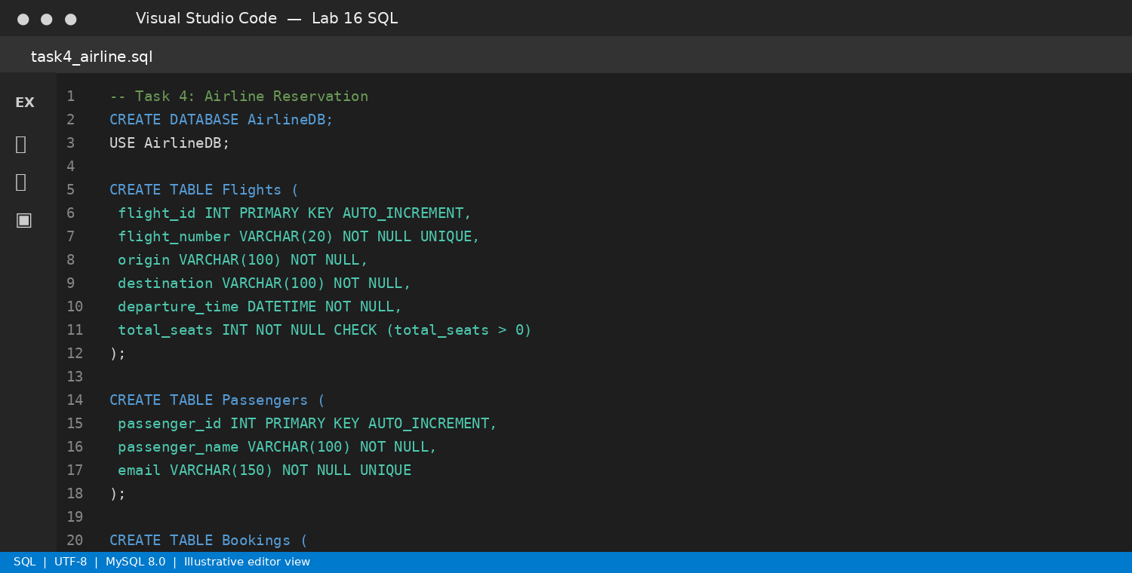
Screenshot note: This is a generated illustration, not a live application capture.

Expected Output
An airline schema with flight bookings and unique seat allocation. The seat query assumes seats are numbered sequentially; production booking should also handle concurrent requests.

Task 5 – Transport Management Database

1. AI Prompt
Create a transport management database with Vehicles, Routes, Drivers, and Assignments. Define keys, suggest useful indexes, and write queries to list vehicles assigned to a route, retrieve driver details for a vehicle, and count trips per route.

2. Input Code – Create Database
CREATE DATABASE TransportDB;
USE TransportDB;

3. Output Code – Table Schema
CREATE DATABASE TransportDB;
USE TransportDB;
CREATE TABLE Vehicles (
vehicle_id INT PRIMARY KEY AUTO_INCREMENT,
registration_number VARCHAR(20) NOT NULL UNIQUE,
vehicle_type VARCHAR(50) NOT NULL
);
CREATE TABLE Routes (
route_id INT PRIMARY KEY AUTO_INCREMENT,
route_name VARCHAR(100) NOT NULL UNIQUE,
start_location VARCHAR(100) NOT NULL,
end_location VARCHAR(100) NOT NULL
);
CREATE TABLE Drivers (
driver_id INT PRIMARY KEY AUTO_INCREMENT,
driver_name VARCHAR(100) NOT NULL,
license_number VARCHAR(50) NOT NULL UNIQUE
);
CREATE TABLE Assignments (
assignment_id INT PRIMARY KEY AUTO_INCREMENT,
vehicle_id INT NOT NULL,
route_id INT NOT NULL,
driver_id INT NOT NULL,
trip_date DATE NOT NULL,
FOREIGN KEY (vehicle_id) REFERENCES Vehicles(vehicle_id),
FOREIGN KEY (route_id) REFERENCES Routes(route_id),
FOREIGN KEY (driver_id) REFERENCES Drivers(driver_id)
);
CREATE INDEX idx_assignments_route ON Assignments(route_id);
CREATE INDEX idx_assignments_vehicle ON Assignments(vehicle_id);
CREATE INDEX idx_assignments_driver ON Assignments(driver_id);
CREATE INDEX idx_assignments_trip_date ON Assignments(trip_date);

4. SQL Queries

List vehicles assigned to a route
SELECT r.route_name, v.registration_number, v.vehicle_type
FROM Assignments a
JOIN Routes r ON a.route_id = r.route_id
JOIN Vehicles v ON a.vehicle_id = v.vehicle_id
WHERE r.route_id = 1;

Retrieve driver details for a vehicle
SELECT v.registration_number, d.driver_name, d.license_number, a.trip_date
FROM Assignments a
JOIN Vehicles v ON a.vehicle_id = v.vehicle_id
JOIN Drivers d ON a.driver_id = d.driver_id
WHERE v.vehicle_id = 1
ORDER BY a.trip_date DESC;

Count trips per route
SELECT r.route_name, COUNT(a.assignment_id) AS total_trips
FROM Routes r
LEFT JOIN Assignments a ON r.route_id = a.route_id
GROUP BY r.route_id, r.route_name;

5. VS Code Screenshot
Illustrative Visual Studio Code-style editor view of the table schema:
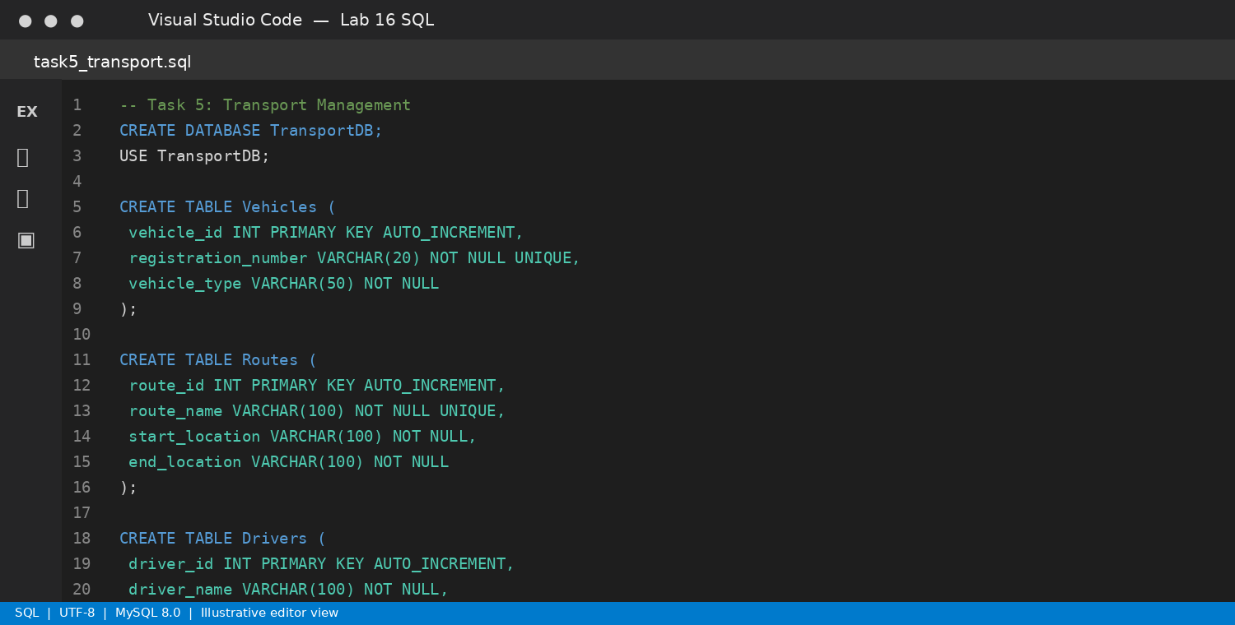
Screenshot note: This is a generated illustration, not a live application capture.

Expected Output
A transport database with indexed assignment relationships and route-level trip reports.

Task 6 – Hotel Reservation Database

1. AI Prompt
Create a hotel reservation database with Hotels, Rooms, Guests, and Reservations. Define primary keys, foreign keys, unique room numbers per hotel, and date constraints. Write queries to list reservations for a guest, find available rooms for a date range, and calculate occupancy rate per hotel.

2. Input Code – Create Database
CREATE DATABASE HotelDB;
USE HotelDB;

3. Output Code – Table Schema
CREATE DATABASE HotelDB;
USE HotelDB;
CREATE TABLE Hotels (
hotel_id INT PRIMARY KEY AUTO_INCREMENT,
hotel_name VARCHAR(150) NOT NULL,
city VARCHAR(100) NOT NULL
);
CREATE TABLE Rooms (
room_id INT PRIMARY KEY AUTO_INCREMENT,
hotel_id INT NOT NULL,
room_number VARCHAR(10) NOT NULL,
room_type VARCHAR(50) NOT NULL,
price_per_night DECIMAL(10,2) NOT NULL CHECK (price_per_night >= 0),
FOREIGN KEY (hotel_id) REFERENCES Hotels(hotel_id),
UNIQUE (hotel_id, room_number)
);
CREATE TABLE Guests (
guest_id INT PRIMARY KEY AUTO_INCREMENT,
guest_name VARCHAR(100) NOT NULL,
email VARCHAR(150) NOT NULL UNIQUE
);
CREATE TABLE Reservations (
reservation_id INT PRIMARY KEY AUTO_INCREMENT,
room_id INT NOT NULL,
guest_id INT NOT NULL,
check_in DATE NOT NULL,
check_out DATE NOT NULL,
status ENUM('Booked', 'Cancelled') NOT NULL DEFAULT 'Booked',
CHECK (check_out > check_in),
FOREIGN KEY (room_id) REFERENCES Rooms(room_id),
FOREIGN KEY (guest_id) REFERENCES Guests(guest_id)
);

4. SQL Queries

List all reservations for a guest
SELECT g.guest_name, h.hotel_name, r.room_number,
rs.check_in, rs.check_out, rs.status
FROM Reservations rs
JOIN Guests g ON rs.guest_id = g.guest_id
JOIN Rooms r ON rs.room_id = r.room_id
JOIN Hotels h ON r.hotel_id = h.hotel_id
WHERE g.guest_id = 1
ORDER BY rs.check_in;

Find rooms available for a date range
SELECT h.hotel_name, r.room_number, r.room_type, r.price_per_night
FROM Rooms r
JOIN Hotels h ON r.hotel_id = h.hotel_id
WHERE NOT EXISTS (
SELECT 1
FROM Reservations rs
WHERE rs.room_id = r.room_id
AND rs.status = 'Booked'
AND rs.check_in < '2026-11-10'
AND rs.check_out > '2026-11-05'
);

Calculate occupancy rate per hotel for a date
SELECT h.hotel_name,
ROUND(
100.0 * COUNT(DISTINCT CASE
WHEN rs.reservation_id IS NOT NULL THEN r.room_id
END) / NULLIF(COUNT(DISTINCT r.room_id), 0), 2
) AS occupancy_rate_percent
FROM Hotels h
JOIN Rooms r ON h.hotel_id = r.hotel_id
LEFT JOIN Reservations rs
ON r.room_id = rs.room_id
AND rs.status = 'Booked'
AND rs.check_in <= '2026-11-05'
AND rs.check_out > '2026-11-05'
GROUP BY h.hotel_id, h.hotel_name;

5. VS Code Screenshot
Illustrative Visual Studio Code-style editor view of the table schema:
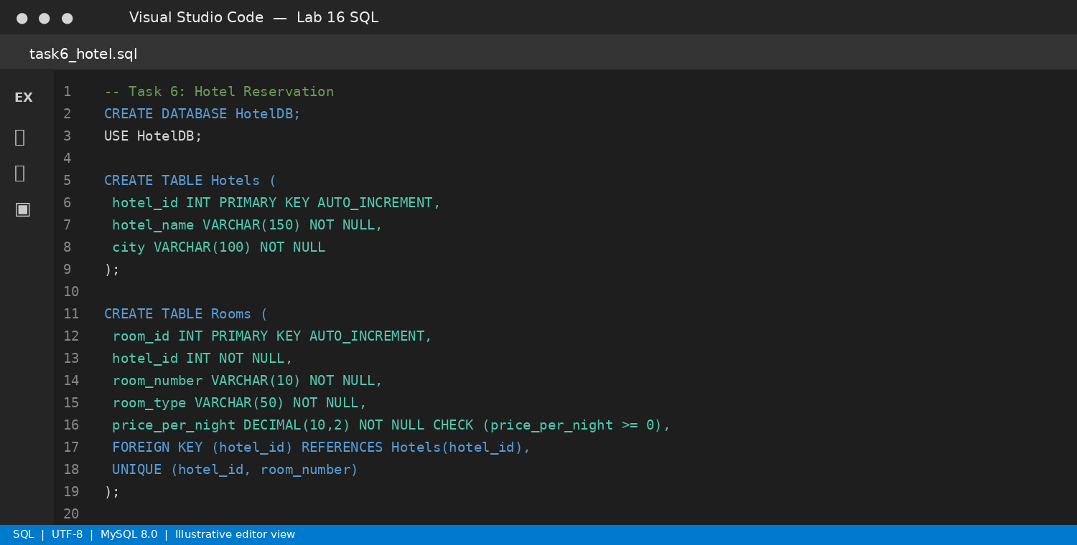
Screenshot note: This is a generated illustration, not a live application capture.

Expected Output
A hotel reservation schema with date validation, room availability checking, and occupancy reporting. Preventing overlapping bookings reliably also requires transaction logic or triggers.

Conclusion
This lab demonstrates relational schema design for six practical systems. Primary keys uniquely identify records, foreign keys enforce relationships, NOT NULL and UNIQUE constraints improve data quality, and CHECK constraints validate selected values. JOIN queries combine related tables, while GROUP BY, COUNT, SUM, and window functions support reporting. Indexes should be added to frequently filtered or joined columns and validated with EXPLAIN. In production systems, business rules such as bank withdrawal validation, seat allocation, and non-overlapping hotel reservations require additional transaction-safe application logic.

