

DAYANANDA SAGAR UNIVERSITY
(SCHOOL OF COMPUTER APPLICATIONS)

TRAINING PROJECT REPORT ON
RESTAURANT ORDER SYSTEM
A Console-Based Java Application with MySQL Database Integration
SUBMITTED BY
Team Members
Swathi P R
Subramanian . V
Varun
K.M. Pooja

CERTIFICATE
This is to certify that the Training Project Report entitled "RESTAURANT ORDER SYSTEM" has been successfully completed by the following students of Dayananda Sagar University as a part of their academic curriculum:
Academic Year: 2025 - 2026
Department of Computer Applications

Sl. No. | Name of Student | Register Number
1 | Swathi P R | ______________________
2 | Subramaninan V | ______________________
3 | Varun | ______________________
4 | K M Pooja

The project work is original and has been carried out under our guidance and supervision. The report embodies the results of the project work done by them and is of sufficient standard to warrant its submission for the award of the degree.

Project Guide  Name: ___________________  Designation: ___________________  Sign: ___________________ | HOD / Principal  Name: ___________________  Designation: ___________________  Sign: ___________________

Seal of the Institution

ABSTRACT
The Restaurant Order System is a console-based Java application developed to digitize and streamline the process of managing restaurant operations, specifically focused on menu display, order placement, order cancellation, and bill generation. Traditional restaurants rely heavily on manual processes involving paper-based order taking and manual calculations for billing, which are both error-prone and time-consuming.

This project replaces the manual workflow with an automated system that interfaces with a MySQL relational database through JDBC (Java Database Connectivity). The system is structured around four main entities — Menu, Customers, Orders, and Order Items — and supports the complete lifecycle of a restaurant order from initiation to billing.

Key technical features include automatic customer registration upon first order, dynamic menu retrieval from the database, real-time bill computation, and safe deletion of order records. The application follows a clean separation of concerns by using a dedicated DBConnection utility class for all database connectivity.

The system is implemented using Java (JDK 17+), MySQL 8.0, and the MySQL JDBC Connector. It is designed to be lightweight, easy to deploy, and extensible for future enhancements such as GUI integration, multi-item orders, and online payment modules.

Technology Stack: Java 17+, MySQL 8.0, JDBC, MySQL Connector/J
Database: restaurant_db with 4 tables (menu, customers, orders, order_items)
Architecture: Console Application with DAO-style DB separation
Features: View Menu, Place Order, Cancel Order, Generate Bill

INDEX
Sl. No. | Topic | Page No.
1 | Objective of the Project | 3
2 | Scope of the Project | 5
3 | Feasibility Study | 7
4 | Existing System | 10
5 | Proposed System | 13
6 | System Design | 16
7 | Entity-Relationship Diagram | 20
8 | Database Design | 22
9 | Coding | 28
10 | Application Screenshots | 44
11 | Testing | 46
12 | Conclusion | 50
13 | Future Enhancements | 52

1. Objective of the Project
The primary objective of the Restaurant Order System project is to develop a reliable, efficient, and easy-to-use console-based application that automates the complete order management lifecycle in a restaurant environment. The system aims to eliminate the manual, paper-based methods of handling orders and replace them with a centralized digital system backed by a relational database.

1.1 Primary Objectives
- To design and implement a Java-based console application that manages restaurant orders end-to-end, from viewing the menu to generating a final bill.
- To integrate the application with a MySQL relational database using JDBC, enabling persistent and reliable data storage for menus, customers, orders, and order items.
- To provide automatic customer identification — registering new customers on their first visit and recognizing returning customers by name.
- To display a dynamically fetched menu from the database, ensuring that any menu changes are immediately reflected in the application without code modification.
- To accurately compute order totals and grand bills using real-time price data from the database, reducing human calculation errors.
- To support safe order cancellation that removes both the order record and associated order items from the database in the correct sequence to respect foreign key constraints.

1.2 Technical Objectives
- To implement the DBConnection utility class as a centralized, reusable database connectivity module, ensuring clean separation of connection logic from business logic.
- To use PreparedStatements throughout the application to prevent SQL Injection vulnerabilities and improve query performance.
- To apply JDBC auto-generated key retrieval for seamlessly obtaining primary keys of newly inserted records (orders and customers) without additional SELECT queries.
- To design the database schema with proper primary keys, foreign keys, and referential integrity constraints that mirror real-world restaurant data relationships.
- To ensure that the application handles exceptions gracefully, printing meaningful messages to the console without crashing the system.

1.3 Educational Objectives
Beyond the functional requirements, this project serves as a learning vehicle for the following concepts:
- Understanding JDBC connectivity patterns in Java and practical use of DriverManager, Connection, PreparedStatement, Statement, and ResultSet interfaces.
- Designing a normalized relational database schema and understanding entity relationships including one-to-many associations.
- Applying object-oriented programming principles such as static methods, encapsulation, and separation of concerns in a Java console application.
- Practicing SQL DML operations (SELECT, INSERT, DELETE) and understanding JOIN queries for bill generation.
- Learning the importance of database constraints and referential integrity in maintaining consistent data across related tables.

1.4 Business Objectives
Business Goal | How the System Achieves It
Speed up order taking | Console prompts guide staff quickly through item selection and quantity entry
Reduce billing errors | Prices are fetched from DB and totals computed automatically
Customer tracking | System auto-registers new customers and retrieves existing ones by name
Order history | Orders are stored in DB with date stamps for future reference
Easy cancellation | Orders and items can be deleted in one operation

2. Scope of the Project
The scope of the Restaurant Order System defines the boundaries of what the system currently covers, the users it serves, the technologies it employs, and the limitations that set the stage for future enhancements.

2.1 Functional Scope
The system covers the following core functional areas:
- Menu Management: The system retrieves and displays the complete restaurant menu from the MySQL database in real time. Menu items include item ID, item name, and unit price. Menu entries are managed directly in the database and are immediately reflected in the application.
- Customer Management: When a customer places an order, the system checks if a record for that customer already exists in the customers table. If found, the existing customer ID is used. If not, a new customer record is created automatically, assigning a unique customer ID.
- Order Placement: The system allows staff to place an order for a customer by selecting a menu item and specifying a quantity. It creates a new order record in the orders table and a corresponding order item record in the order_items table, storing the computed total price.
- Order Cancellation: The system supports complete order cancellation. When an order is cancelled by its ID, all associated order items are first deleted from the order_items table, and then the order record itself is deleted from the orders table, preserving referential integrity.
- Bill Generation: For any valid order ID, the system generates an itemized bill showing item name, quantity, unit price, and line total for each item, along with a grand total at the end.

2.2 Technical Scope
Component | Details
Programming Language | Java 17+
Database | MySQL 8.0 — restaurant_db
Connectivity | JDBC with MySQL Connector/J (com.mysql.cj.jdbc.Driver)
IDE | Eclipse / IntelliJ IDEA / VS Code
Build Tool | Manual classpath / Maven (optional)
OS Compatibility | Windows, Linux, macOS (any JVM-supported OS)
Deployment | Local / LAN (single machine or networked DB)

2.3 User Scope
The system is designed primarily for use by restaurant counter staff or operators who take orders from customers. A single user interface is provided without role-based access control in the current version. The operator can:
- Browse the menu on screen
- Enter customer name and item selections to place an order
- Cancel a previously placed order using its order ID
- Generate and print a bill for any order

2.4 Data Scope
The system manages data across four database tables. Each table serves a specific purpose and is linked through foreign key relationships as follows:
- menu: Stores all available food and beverage items with their prices. This table is pre-populated and maintained separately.
- customers: Stores customer names with auto-generated IDs. Populated dynamically as new customers are encountered.
- orders: Stores one record per order, linking it to a customer and recording the order date.
- order_items: Stores individual item lines for each order, capturing the item selected, quantity ordered, and computed total price.

2.5 Scope Limitations
The following aspects are intentionally outside the scope of the current version:
- No graphical user interface (GUI) — the application runs entirely in the console
- No authentication or login — any user with console access can operate the system
- Single-item orders only — each order currently supports one item line
- No inventory management or stock tracking
- No payment gateway integration
- No print functionality — bills are displayed on screen only
- No table or waiter management features

3. Feasibility Study
A feasibility study is conducted to evaluate whether the proposed system is practical, achievable, and worth developing. The feasibility of the Restaurant Order System has been analyzed across three key dimensions: Technical, Economic, and Operational.

3.1 Technical Feasibility
Technical feasibility determines whether the required technology, tools, and expertise are available to build and run the proposed system.

3.1.1 Technology Availability
All technologies required to build the Restaurant Order System are freely available, open-source, and widely supported:
- Java Development Kit (JDK 17+): Java is one of the most widely used programming languages in the world, with excellent documentation, community support, and cross-platform compatibility. The JDK is freely available from Oracle and OpenJDK distributions.
- MySQL 8.0: MySQL is a robust, open-source relational database management system. It offers full ACID compliance, strong support for relational constraints, and excellent performance for small to medium-scale applications.
- MySQL Connector/J: The official JDBC driver for MySQL is freely available and integrates seamlessly with Java applications, enabling the application to communicate with the MySQL database using the standard JDBC API.
- Development Environment: Eclipse IDE, IntelliJ IDEA Community Edition, or VS Code with the Java Extension Pack are all freely available tools that provide a productive development environment.

3.1.2 Skill Requirements
The development team possesses the necessary skills in Java programming, MySQL database design, SQL query writing, and JDBC connectivity. The project does not require any advanced or specialized technology knowledge beyond a solid foundation in Java and relational databases.

3.1.3 Technical Risk Assessment
Risk | Likelihood | Mitigation
JDBC driver not found | Low | Add connector JAR to classpath
DB connection failure | Medium | Use try-catch in DBConnection
SQL constraint violation | Low | Delete child rows before parent
Scanner input mismatch | Medium | Add input type checks

3.2 Economic Feasibility
Economic feasibility assesses whether the system can be built and operated within acceptable cost constraints.

3.2.1 Development Costs
Item | Cost | Notes
Java JDK (OpenJDK 17+) | Free | Open source
MySQL Community Edition | Free | Open source
MySQL Connector/J (JDBC Driver) | Free | Open source
IDE (Eclipse / IntelliJ CE) | Free | Community editions
Development Hardware | Existing | Team laptops/desktops
Total Estimated Cost | Rs. 0 /- | No licensing required

3.2.2 Operational Costs
Once deployed, the system requires no ongoing licensing fees. The only operational costs are electricity for the server/machine running the database and standard hardware maintenance. For a restaurant setting, this system can be run on any existing computer or point-of-sale terminal, making it extremely cost-effective.

3.2.3 Return on Investment
The system delivers immediate value by reducing billing errors, accelerating order processing, and providing a persistent order history that can be used for inventory planning and revenue analysis. These benefits justify even a commercial deployment at minimal cost.

3.3 Operational Feasibility
Operational feasibility evaluates whether the system will actually be used and accepted in the target environment.

3.3.1 Ease of Use
The system uses a numbered menu interface, which is intuitive and familiar to any operator who has used a keyboard. The menu prompts are clear, concise, and guide the user step by step through each operation. No technical expertise is required to operate the system in day-to-day use.

3.3.2 Operational Workflow Compatibility
The system's workflow — View Menu, Place Order, Cancel Order, Generate Bill — directly mirrors the natural workflow of a restaurant order counter. This alignment with existing processes minimizes the learning curve and ensures smooth adoption.

3.3.3 Maintenance
The system is easy to maintain. Adding new menu items requires only a SQL INSERT statement in the database. The Java code does not need modification for routine operational changes. Database backups using mysqldump are straightforward and can be automated.

Feasibility Verdict: The Restaurant Order System is Technically, Economically, and Operationally FEASIBLE.
All required tools are freely available, the system requires zero licensing cost, and the console interface is easy to use by restaurant staff.

4. Existing System
Before developing the Restaurant Order System, it is essential to analyze the existing methods used by restaurants to manage their order operations. Understanding the shortcomings of the current system helps justify the need for the proposed automated solution.

4.1 Overview of the Existing System
Most small to mid-sized restaurants in India and globally continue to rely on manual, paper-based order management systems. In a typical manual system, the process works as follows:
- A customer arrives at the table or counter and asks for the menu.
- The waiter presents a printed menu card to the customer.
- The customer verbally communicates their order to the waiter.
- The waiter writes the order on a paper pad and carries it to the kitchen.
- The kitchen staff reads the handwritten order and prepares the food.
- Once the food is served, the cashier manually computes the bill using a calculator or mental arithmetic.
- The customer pays, and the receipt (if any) is handwritten or printed from a basic register.

4.2 Drawbacks of the Existing System

4.2.1 Manual Billing Errors
Cashiers manually adding up prices across multiple items are highly prone to arithmetic errors. Incorrect bills can lead to customer dissatisfaction, revenue loss, or disputes. With no automated computation, even small errors can compound over hundreds of daily transactions.

4.2.2 Illegible or Lost Orders
Handwritten orders can be difficult to read, especially in a busy restaurant environment. Orders may be misread by kitchen staff, resulting in incorrect food preparation. Additionally, paper order slips can be lost or damaged, causing further confusion.

4.2.3 No Customer Records
Manual systems maintain no record of who ordered what. There is no customer history, no ability to analyze popular menu items, and no way to identify frequent customers or track spending patterns. This severely limits the restaurant's ability to make data-driven business decisions.

4.2.4 Slow Order Processing
The manual process of writing orders, carrying them to the kitchen, and computing bills is inherently slow. During peak hours, this results in long wait times for customers, which can negatively impact customer satisfaction and reduce table turnover rates.

4.2.5 No Audit Trail
Paper-based systems offer no permanent, searchable record of past orders. If a billing dispute arises, there is no reliable way to look up a past order and verify what was charged. Revenue auditing and end-of-day reconciliation are time-consuming and unreliable.

4.2.6 Menu Update Delays
When prices change or new items are added to the menu, all printed menu cards and price lists must be reprinted and redistributed. This is both costly and time-consuming, and there is always a period where some staff may be working from outdated information.

4.3 Comparison: Manual vs. Automated System
Aspect | Manual System | Proposed System
Order Recording | Paper pad, handwritten | Digital, stored in MySQL DB
Bill Computation | Manual/calculator | Automated via DB query
Customer Records | None | Stored with auto-ID
Order History | Paper files (lossy) | Persistent DB records
Menu Updates | Reprint required | Update DB instantly
Error Rate | High (human error) | Low (automated)
Speed | Slow | Fast (instant DB ops)
Data Searchability | Not searchable | Fully queryable
Cost | Ongoing print costs | One-time setup, free tools

4.4 Need for the Proposed System
The deficiencies of the existing manual system clearly demonstrate the need for an automated Restaurant Order System. A digital system that stores all data in a relational database, automates billing computations, and provides an instant lookup for any past order represents a significant improvement in efficiency, accuracy, and reliability for restaurant operations.

5. Proposed System
The proposed Restaurant Order System is a console-based Java application that automates the complete order management process in a restaurant. The system interfaces with a MySQL database to store and retrieve all data related to menus, customers, orders, and order items. It replaces the inefficient manual workflow with a streamlined digital process.

5.1 System Overview
The application is structured around a main control loop that presents the user with a numbered menu of operations. The user selects an operation, the corresponding method is invoked, and the application returns to the main menu after completion. All database interactions are handled through the JDBC API using the DBConnection utility class.

Language: Java 17+
Database: MySQL 8.0 (restaurant_db)
Connectivity: JDBC (MySQL Connector/J)
Architecture: Console Application with centralized DB connection utility
Main Class: RestaurantOrderSystem.java | DB Utility: DBConnection.java

5.2 Key Features of the Proposed System

5.2.1 Dynamic Menu Display
The menu is stored entirely in the MySQL database. When the user selects 'View Menu', the system executes a SELECT query on the menu table and displays all items with their IDs and prices in real time. Any changes made directly to the database are immediately reflected on the next menu view, without any application code change.

5.2.2 Intelligent Customer Management
When a customer places an order, the system first searches the customers table by name. If the customer exists, their ID is retrieved and reused. If the customer is new, a record is automatically inserted and the generated ID is used for the new order. This auto-registration feature eliminates the need for a separate customer registration screen.

5.2.3 Accurate Order Placement
The order placement process creates a record in the orders table (linked to the customer), then retrieves the price from the menu table for the selected item, calculates the line total (price x quantity), and inserts a record into order_items. The total is computed by the application using live database values, not manual entry, ensuring accuracy.

5.2.4 Safe Order Cancellation
Cancellation follows the correct deletion sequence required by foreign key constraints: order items are deleted first, followed by the order record. This prevents foreign key constraint violations and ensures that the database remains consistent after every cancellation.

5.2.5 Automated Bill Generation
The bill generation feature uses a JOIN query across the order_items and menu tables to retrieve all items in an order with their names, quantities, and prices. It computes and displays the grand total by summing all line totals. This eliminates manual calculation entirely.

5.3 System Workflow
Step | Operation | Description
1 | Start Application | JVM loads RestaurantOrderSystem, Scanner initialized
2 | Main Menu | User sees 5 options: View Menu, Place Order, Cancel Order, Generate Bill, Exit
3 | View Menu | SELECT * FROM menu executed; results printed to console
4 | Place Order | Customer looked up/created; order and order_item records inserted
5 | Cancel Order | order_items deleted first, then orders record deleted
6 | Generate Bill | JOIN query fetches items; grand total computed and displayed
7 | Exit | Loop terminates, application closes

5.4 Advantages Over Existing System
- Eliminates all manual billing calculations and the associated errors
- Provides a permanent, searchable order history in the database
- Automatically handles customer registration without a separate process
- Instantly reflects menu price changes without any code modification
- Maintains database integrity through correct deletion sequences and foreign key relationships
- Requires no licensing costs — all tools are open-source and free
- Easy to extend with additional features such as multi-item orders, GUI, or reporting

6. System Design
The system design section describes the architectural structure, class design, method-level behavior, and data flow of the Restaurant Order System. It provides a comprehensive blueprint of how the different components interact to deliver the system's functionality.

6.1 System Architecture
The Restaurant Order System follows a two-layer architecture consisting of a Presentation/Logic Layer (Java console application) and a Data Layer (MySQL database accessed through JDBC).

Layer | Components
Presentation & Logic Layer | RestaurantOrderSystem.java — handles all user I/O and business logic
DB Connection Utility | DBConnection.java — provides a reusable JDBC Connection object
Data Layer | MySQL restaurant_db — stores menu, customers, orders, order_items

6.2 Class Design

6.2.1 Class: DBConnection
Package: pract.prgs
This utility class is responsible for establishing and returning a JDBC Connection object to the MySQL database. It uses a static Connection variable (con) and initializes it on every call to getConnection() using DriverManager.getConnection(). The class loads the MySQL JDBC driver using Class.forName() before establishing the connection.

Member | Type | Description
con | static Connection | Holds the active database connection
getConnection() | static Connection | Loads driver, establishes and returns DB connection

6.2.2 Class: RestaurantOrderSystem
Package: pract.prgs
This is the main application class containing the application entry point and all business logic methods as static methods. It uses a shared Scanner instance (sc) for console input throughout the application lifecycle.

Method | Return Type | Description
main(String[] args) | void | Entry point; runs the main do-while menu loop
showMenu() | void | Fetches and displays all menu items from the database
getCustomerId(String name) | int | Returns existing customer ID or creates a new customer record
placeOrder() | void | Manages end-to-end order placement including customer lookup, order creation, and order item insertion
cancelOrder() | void | Deletes order items then order record by order ID
generateBill() | void | Joins order_items with menu to display itemized bill and grand total

6.3 Data Flow Diagram

6.3.1 Order Placement Data Flow
The following describes how data flows through the system during an order placement:
- User enters customer name via console (Scanner).
- getCustomerId() queries the customers table; returns existing ID or inserts new customer and returns generated ID.
- A new record is inserted into the orders table with the customer ID and the current date using CURDATE().
- The generated order ID is retrieved using Statement.RETURN_GENERATED_KEYS.
- showMenu() displays all menu items by querying the menu table.
- User selects an item ID and enters a quantity via console.
- The system queries the menu table for the selected item's name and price.
- Total price is computed as price x quantity.
- A record is inserted into order_items with order ID, item ID, quantity, and total price.

6.3.2 Bill Generation Data Flow
- User enters an order ID via console.
- System executes a JOIN query between order_items and menu on item_id, filtered by order_id.
- For each row returned, item name, quantity, price, and line total are displayed.
- Grand total is accumulated in a running double variable (grandTotal) and displayed at the end.

6.4 Database Interaction Patterns
Method | Statement Type | JDBC Feature Used
showMenu() | Statement | executeQuery() → ResultSet iteration
getCustomerId() | PreparedStatement | Parameterized SELECT + INSERT with RETURN_GENERATED_KEYS
placeOrder() | PreparedStatement (x3) | INSERT with generated keys + parameterized SELECT
cancelOrder() | PreparedStatement (x2) | Sequential DELETE respecting FK constraints
generateBill() | PreparedStatement | JOIN query with ResultSet aggregation

6.5 Exception Handling Strategy
All methods in the application are wrapped in try-catch blocks that catch the general Exception class. While this is a broad catch strategy appropriate for a training project, it ensures the application never terminates unexpectedly due to an unhandled exception. Error messages are printed to the console using System.out.println(e), giving the operator visibility into what went wrong.

7. Entity-Relationship Diagram
The Entity-Relationship (ER) diagram represents the data model of the Restaurant Order System. It defines the entities (tables) in the system, the attributes of each entity, and the relationships between them. The ER model was designed using standard ER notation with entity sets, attributes, relationship diamonds, and cardinality indicators.

7.1 ER Diagram
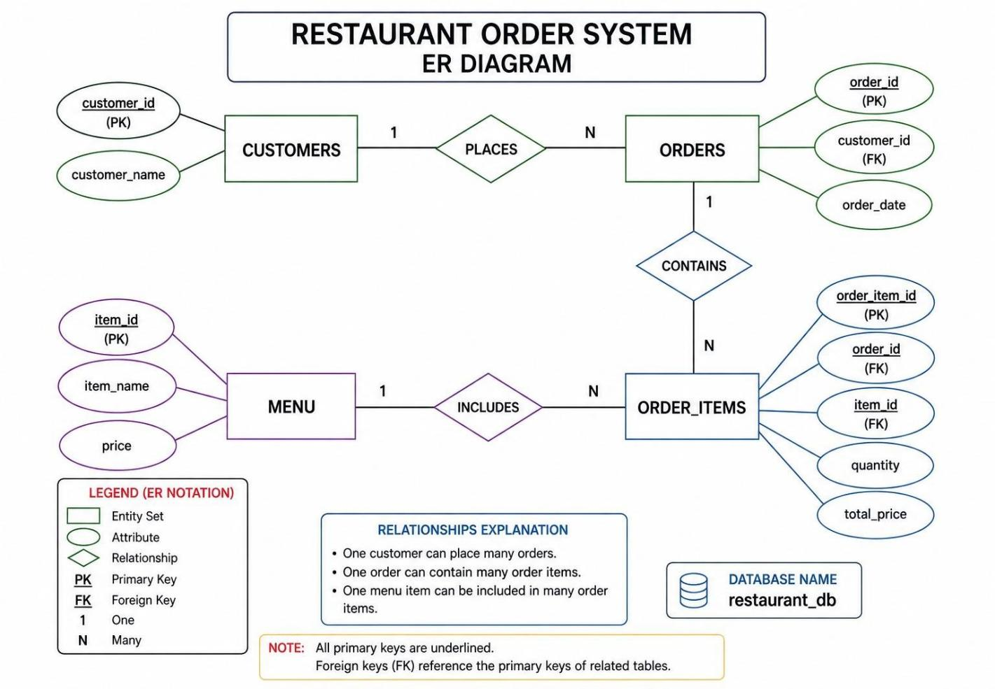
Figure 7.1: ER Diagram for the restaurant_db Database

7.2 Entities and Attributes
Entity | Attributes | Description
CUSTOMERS | customer_id (PK), customer_name | Stores restaurant customer records
ORDERS | order_id (PK), customer_id (FK), order_date | Stores one record per placed order
MENU | item_id (PK), item_name, price | Stores all available menu items
ORDER_ITEMS | order_item_id (PK), order_id (FK), item_id (FK), quantity, total_price | Stores each item line within an order

7.3 Relationships
Relationship | Cardinality | Meaning
CUSTOMERS — PLACES — ORDERS | 1 : N | One customer can place many orders; each order belongs to exactly one customer
ORDERS — CONTAINS — ORDER_ITEMS | 1 : N | One order can contain many order item lines; each item line belongs to one order
MENU — INCLUDES — ORDER_ITEMS | 1 : N | One menu item can appear in many order item lines; each order item line references one menu item

7.4 Key Constraints
- All primary keys (customer_id, order_id, item_id, order_item_id) are defined as INT AUTO_INCREMENT, ensuring unique, system-generated identifiers.
- customer_id in the orders table is a foreign key referencing customers(customer_id), enforcing that every order is linked to a valid customer.
- order_id in order_items is a foreign key referencing orders(order_id), enforcing that every item line belongs to a valid order.
- item_id in order_items is a foreign key referencing menu(item_id), ensuring that only valid menu items can be included in orders.
- The ON DELETE CASCADE option on order_items ensures that when an order is deleted, all its associated item lines are automatically removed (enforced programmatically in this system via sequential deletion).

8. Database Design
The database for the Restaurant Order System is named restaurant_db and is hosted on a MySQL 8.0 server running locally. The schema consists of four tables that together capture the complete domain model of the system. This section provides detailed descriptions of each table, their columns, data types, constraints, and the SQL statements used to create and interact with them.

8.1 Database Schema Overview
Table Name | Purpose | Key Relationships
menu | Stores food/beverage items and prices | Referenced by order_items.item_id (FK)
customers | Stores customer name and auto-generated ID | Referenced by orders.customer_id (FK)
orders | Stores one record per customer order | References customers; Referenced by order_items
order_items | Stores each item line within an order | References both orders and menu

8.2 Table: menu
The menu table stores the restaurant's complete food and beverage catalog. It serves as the reference source for item names and prices during order placement and bill generation.
Column | Data Type | Constraint | Description
item_id | INT | PRIMARY KEY, AUTO_INCREMENT | Unique identifier for each menu item
item_name | VARCHAR(100) | NOT NULL | Name of the food or beverage item
price | DECIMAL(10,2) | NOT NULL | Price of the item in Indian Rupees

SQL — Create Table: menu
CREATE TABLE menu (
item_id INT AUTO_INCREMENT PRIMARY KEY,
item_name VARCHAR(100) NOT NULL,
price DECIMAL(10, 2) NOT NULL
);

SQL — Sample Data: menu
INSERT INTO menu (item_name, price) VALUES
('Idli', 30.00),
('Dosa', 50.00),
('Vada', 25.00),
('Upma', 35.00),
('Poori Bhaji', 60.00),
('Masala Dosa', 70.00),
('Filter Coffee', 20.00),
('Tea', 15.00),
('Juice', 40.00),
('Meals', 100.00);

8.3 Table: customers
The customers table stores the name and auto-generated ID of every customer who has placed an order. New customers are automatically added to this table during the order placement process without requiring a separate registration step.
Column | Data Type | Constraint | Description
customer_id | INT | PRIMARY KEY, AUTO_INCREMENT | Unique identifier for each customer
customer_name | VARCHAR(100) | NOT NULL | Full name of the customer as entered by the operator

SQL — Create Table: customers
CREATE TABLE customers (
customer_id INT AUTO_INCREMENT PRIMARY KEY,
customer_name VARCHAR(100) NOT NULL
);

8.4 Table: orders
The orders table stores one record per placed order. Each order is linked to a customer via a foreign key on customer_id and records the date on which the order was placed using MySQL's CURDATE() function.
Column | Data Type | Constraint | Description
order_id | INT | PRIMARY KEY, AUTO_INCREMENT | Unique identifier for each order
customer_id | INT | NOT NULL, FOREIGN KEY → customers(customer_id) | Links order to the placing customer
order_date | DATE | NOT NULL, DEFAULT CURDATE() | Date the order was placed

SQL — Create Table: orders
CREATE TABLE orders (
order_id INT AUTO_INCREMENT PRIMARY KEY,
customer_id INT NOT NULL,
order_date DATE NOT NULL DEFAULT (CURDATE()),
FOREIGN KEY (customer_id) REFERENCES customers(customer_id)
ON DELETE CASCADE
);

8.5 Table: order_items
The order_items table is the central linking table in the schema. It connects an order to the menu items that were ordered, capturing the quantity and computed total price per line. It has foreign keys to both the orders and menu tables.
Column | Data Type | Constraint | Description
order_item_id | INT | PRIMARY KEY, AUTO_INCREMENT | Unique identifier for each order item line
order_id | INT | NOT NULL, FK → orders(order_id) | Links item line to its parent order
item_id | INT | NOT NULL, FK → menu(item_id) | References the ordered menu item
quantity | INT | NOT NULL | Number of units ordered
total_price | DECIMAL(10,2) | NOT NULL | Computed as price x quantity at time of order

SQL — Create Table: order_items
CREATE TABLE order_items (
order_item_id INT AUTO_INCREMENT PRIMARY KEY,
order_id INT NOT NULL,
item_id INT NOT NULL,
quantity INT NOT NULL,
total_price DECIMAL(10, 2) NOT NULL,
FOREIGN KEY (order_id) REFERENCES orders(order_id) ON DELETE CASCADE,
FOREIGN KEY (item_id) REFERENCES menu(item_id)
);

8.6 Application SQL Statements (DAO Layer)

8.6.1 View Menu
Method: showMenu() | Statement Type: Statement
SELECT * FROM menu;
This simple select retrieves all columns from the menu table and iterates through the ResultSet to display item ID, name, and price for each row.

8.6.2 Customer Lookup
Method: getCustomerId(String name) | Statement Type: PreparedStatement
SELECT customer_id FROM customers WHERE customer_name = ?;
The '?' placeholder is set to the customer name entered by the operator. If a record is found, the customer_id is returned directly.

8.6.3 Customer Registration
Method: getCustomerId(String name) | Statement Type: PreparedStatement with RETURN_GENERATED_KEYS
INSERT INTO customers(customer_name) VALUES(?);
Executed when no existing customer is found. The auto-generated customer_id is retrieved from getGeneratedKeys() and returned to the caller.

8.6.4 Create Order
Method: placeOrder() | Statement Type: PreparedStatement with RETURN_GENERATED_KEYS
INSERT INTO orders(customer_id, order_date) VALUES(?, CURDATE());
Creates a new order record linked to the customer ID. CURDATE() inserts the current date. The generated order_id is immediately retrieved for use in the next INSERT.

8.6.5 Fetch Menu Item Price
Method: placeOrder() | Statement Type: PreparedStatement
SELECT item_name, price FROM menu WHERE item_id = ?;
Retrieves the item name and price for the selected item ID so the application can compute the total and display a confirmation.

8.6.6 Insert Order Item
Method: placeOrder() | Statement Type: PreparedStatement
INSERT INTO order_items(order_id, item_id, quantity, total_price) VALUES(?, ?, ?, ?);
Inserts the order item line with the computed total_price (price x quantity). All four parameters are bound using PreparedStatement.setXxx() methods.

8.6.7 Delete Order Items (Cancel)
Method: cancelOrder() | Statement Type: PreparedStatement
DELETE FROM order_items WHERE order_id = ?;
Must be executed BEFORE deleting the order itself to avoid foreign key constraint violations.

8.6.8 Delete Order (Cancel)
Method: cancelOrder() | Statement Type: PreparedStatement
DELETE FROM orders WHERE order_id = ?;
Executed after all associated order items have been deleted. Removes the order record from the orders table.

8.6.9 Generate Bill (JOIN Query)
Method: generateBill() | Statement Type: PreparedStatement
SELECT m.item_name, oi.quantity, m.price, oi.total_price
FROM order_items oi
JOIN menu m ON oi.item_id = m.item_id
WHERE oi.order_id = ?;
This JOIN query combines order_items with menu to retrieve a complete, readable bill. The result set is iterated to display each line and accumulate the grand total.

9. Coding
This section contains the complete source code of the Restaurant Order System. The system is implemented across two Java classes: DBConnection.java for database connectivity and RestaurantOrderSystem.java for all application logic.

9.1 Project Structure
File | Description
src/pract/prgs/DBConnection.java | JDBC database connection utility class
src/pract/prgs/RestaurantOrderSystem.java | Main application class with all business logic and entry point
lib/mysql-connector-j-x.x.x.jar | MySQL JDBC Driver (must be added to classpath)

9.2 DBConnection.java — Complete Source Code
This class provides a centralized, reusable JDBC connection to the MySQL restaurant_db database. It loads the MySQL JDBC driver using Class.forName() and uses DriverManager.getConnection() with hardcoded credentials for the training environment.

package pract.prgs;

import java.sql.Connection;
import java.sql.DriverManager;

public class DBConnection {

static Connection con;

public static Connection getConnection() {

try {

Class.forName("com.mysql.cj.jdbc.Driver");

con = DriverManager.getConnection(
"jdbc:mysql://localhost:3306/restaurant_db",
"root",
"root");

}

catch (Exception e) {

System.out.println(e);

}

return con;
}
}

9.2.1 DBConnection — Code Explanation
Code Element | Explanation
static Connection con | Declares a class-level static connection variable, reused across calls
Class.forName(...) | Dynamically loads the MySQL JDBC driver class into the JVM
DriverManager.getConnection(...) | Establishes a new connection to the specified MySQL database URL using the given credentials
jdbc:mysql://localhost:3306/restaurant_db | JDBC URL — protocol:subprotocol://host:port/databasename
catch (Exception e) | Broad exception handler that prints any connectivity error to the console
return con | Returns the established Connection object (or null if connection failed)

9.3 RestaurantOrderSystem.java — Complete Source Code
This is the main application class. It contains the entry point (main method) and all five core operations of the system as static methods.

package pract.prgs;

import java.sql.*;
import java.util.Scanner;

public class RestaurantOrderSystem {

static Scanner sc = new Scanner(System.in);

// ---- showMenu() ----
public static void showMenu() {
try {
Connection con = DBConnection.getConnection();
String query = "SELECT * FROM menu";
Statement st = con.createStatement();
ResultSet rs = st.executeQuery(query);
System.out.println("\n------ MENU ------");
while (rs.next()) {
System.out.println(
rs.getInt("item_id") + " "
+ rs.getString("item_name") + " Rs."
+ rs.getDouble("price"));
}
} catch (Exception e) {
System.out.println(e);
}
}

// ---- getCustomerId() ----
public static int getCustomerId(String name) {
int id = -1;
try {
Connection con = DBConnection.getConnection();
String check = "SELECT customer_id FROM customers WHERE customer_name=?";
PreparedStatement ps = con.prepareStatement(check);
ps.setString(1, name);
ResultSet rs = ps.executeQuery();
if (rs.next()) {
id = rs.getInt("customer_id");
} else {
String insert = "INSERT INTO customers(customer_name) VALUES(?)";
PreparedStatement ps2 = con.prepareStatement(
insert, Statement.RETURN_GENERATED_KEYS);
ps2.setString(1, name);
ps2.executeUpdate();
ResultSet rs2 = ps2.getGeneratedKeys();
rs2.next();
id = rs2.getInt(1);
}
} catch (Exception e) {
System.out.println(e);
}
return id;
}

// ---- placeOrder() ----
public static void placeOrder() {
try {
Connection con = DBConnection.getConnection();
System.out.println("Enter Customer Name:");
sc.nextLine();
String name = sc.nextLine();
int customerId = getCustomerId(name);
String orderQuery =
"INSERT INTO orders(customer_id,order_date) VALUES(?,CURDATE())";
PreparedStatement ps = con.prepareStatement(
orderQuery, Statement.RETURN_GENERATED_KEYS);
ps.setInt(1, customerId);
ps.executeUpdate();
ResultSet rsKey = ps.getGeneratedKeys();
rsKey.next();
int orderId = rsKey.getInt(1);
System.out.println("Order ID: " + orderId);
showMenu();
System.out.println("Enter Item ID:");
int itemId = sc.nextInt();
System.out.println("Enter Quantity:");
int qty = sc.nextInt();
String query = "SELECT item_name,price FROM menu WHERE item_id=?";
PreparedStatement ps2 = con.prepareStatement(query);
ps2.setInt(1, itemId);
ResultSet rs = ps2.executeQuery();
if (rs.next()) {
String item = rs.getString("item_name");
double price = rs.getDouble("price");
double total = price * qty;
System.out.println("\nItem: " + item);
System.out.println("Price: " + price);
System.out.println("Quantity: " + qty);
System.out.println("Total Bill: Rs." + total);
String insert =
"INSERT INTO order_items(order_id,item_id,quantity,total_price)"
+ " VALUES(?,?,?,?)";
PreparedStatement ps3 = con.prepareStatement(insert);
ps3.setInt(1, orderId);
ps3.setInt(2, itemId);
ps3.setInt(3, qty);
ps3.setDouble(4, total);
ps3.executeUpdate();
System.out.println("Order Placed Successfully");
}
} catch (Exception e) {
System.out.println(e);
}
}

// ---- cancelOrder() ----
public static void cancelOrder() {
try {
Connection con = DBConnection.getConnection();
System.out.println("Enter Order ID:");
int id = sc.nextInt();
String deleteItems = "DELETE FROM order_items WHERE order_id=?";
PreparedStatement ps1 = con.prepareStatement(deleteItems);
ps1.setInt(1, id);
ps1.executeUpdate();
String deleteOrder = "DELETE FROM orders WHERE order_id=?";
PreparedStatement ps2 = con.prepareStatement(deleteOrder);
ps2.setInt(1, id);
ps2.executeUpdate();
System.out.println("Order Cancelled Successfully");
} catch (Exception e) {
System.out.println(e);
}
}

// ---- generateBill() ----
public static void generateBill() {
try {
Connection con = DBConnection.getConnection();
System.out.println("Enter Order ID:");
int id = sc.nextInt();
String query =
"SELECT m.item_name, oi.quantity, m.price, oi.total_price "
+ "FROM order_items oi JOIN menu m "
+ "ON oi.item_id = m.item_id "
+ "WHERE oi.order_id = ?";
PreparedStatement ps = con.prepareStatement(query);
ps.setInt(1, id);
ResultSet rs = ps.executeQuery();
double grandTotal = 0;
System.out.println("\n------ BILL ------");
while (rs.next()) {
String name = rs.getString("item_name");
int qty = rs.getInt("quantity");
double price = rs.getDouble("price");
double total = rs.getDouble("total_price");
grandTotal += total;
System.out.println(name + " " + qty + " x " + price + " = " + total);
}
System.out.println("Grand Total = Rs." + grandTotal);
} catch (Exception e) {
System.out.println(e);
}
}

// ---- main() ----
public static void main(String[] args) {
int choice;
do {
System.out.println("\n--- Restaurant Order System ---");
System.out.println("1 View Menu");
System.out.println("2 Place Order");
System.out.println("3 Cancel Order");
System.out.println("4 Generate Bill");
System.out.println("5 Exit");
System.out.println("Enter Choice:");
choice = sc.nextInt();
switch (choice) {
case 1: showMenu(); break;
case 2: placeOrder(); break;
case 3: cancelOrder(); break;
case 4: generateBill(); break;
case 5: System.out.println("Exit"); break;
default: System.out.println("Invalid Choice");
}
} while (choice != 5);
}
}

9.4 Method-by-Method Code Explanation

9.4.1 showMenu() — Detailed Walkthrough
Line | Code | Explanation
1 | DBConnection.getConnection() | Gets a live Connection to restaurant_db
2 | con.createStatement() | Creates a non-parameterized Statement object
3 | st.executeQuery(query) | Executes SELECT * FROM menu and returns a ResultSet
4 | while (rs.next()) | Advances cursor row by row through the result set
5 | rs.getInt/getString/getDouble | Reads column values by name from current row

9.4.2 getCustomerId() — Detailed Walkthrough
Line | Code | Explanation
1 | int id = -1 | Default value; -1 indicates failure or not-found
2 | con.prepareStatement(check) | Prepares parameterized SELECT to find customer by name
3 | ps.setString(1, name) | Binds customer name to the '?' placeholder
4 | if (rs.next()) | If a row exists, customer is found — read their ID
5 | else { INSERT ... } | No match found — insert new customer and retrieve generated ID
6 | ps2.getGeneratedKeys() | Retrieves the auto-generated customer_id from the INSERT

9.4.3 placeOrder() — Detailed Walkthrough
Step | Action | Explanation
1 | sc.nextLine() twice | First call consumes leftover newline; second reads actual name
2 | getCustomerId(name) | Auto-registers or retrieves the customer
3 | INSERT INTO orders | Creates order record with customer ID and today's date
4 | getGeneratedKeys() | Retrieves the new order_id for use in order_items INSERT
5 | showMenu() | Displays menu so operator can see item IDs to select
6 | SELECT item from menu | Fetches item name and price to confirm and compute total
7 | price * qty | Computes total cost — no manual calculation needed
8 | INSERT INTO order_items | Persists the order item with computed total_price

10. Application Screenshots
This section illustrates the console interface of the Restaurant Order System with sample inputs and expected outputs for each of the five main operations. These screenshots represent the typical console interaction a user would experience when running the application.

10.1 Main Menu
--- Restaurant Order System ---
1 View Menu
2 Place Order
3 Cancel Order
4 Generate Bill
5 Exit
Enter Choice:
The main menu is displayed every time the application starts and after each completed operation. The user enters a number (1-5) to select an operation.

10.2 View Menu (Option 1)
Enter Choice: 1
------ MENU ------
1 Idli Rs. 30.0
2 Dosa Rs. 50.0
3 Vada Rs. 25.0
4 Upma Rs. 35.0
5 Poori Bhaji Rs. 60.0
6 Masala Dosa Rs. 70.0
7 Filter Coffee Rs. 20.0
8 Tea Rs. 15.0
9 Juice Rs. 40.0
10 Meals Rs. 100.0
All menu items stored in the menu table are displayed with their item IDs and prices. This data is fetched live from the database on every call.

10.3 Place Order (Option 2)
Enter Choice: 2
Enter Customer Name:
Rahul Kumar
Order ID: 1001
------ MENU ------
1 Idli Rs. 30.0
2 Dosa Rs. 50.0
... (all items displayed)
Enter Item ID:
2
Enter Quantity:
3
Item: Dosa
Price: 50.0
Quantity: 3
Total Bill: Rs. 150.0
Order Placed Successfully
The system prompts for a customer name, auto-registers or retrieves the customer, assigns an order ID, displays the menu, accepts item selection and quantity, computes the total, and confirms the order placement.

10.4 Generate Bill (Option 4)
Enter Choice: 4
Enter Order ID:
1001
------ BILL ------
Dosa 3 x 50.0 = 150.0
Grand Total = Rs. 150.0
The bill is generated by entering an order ID. The system retrieves all items in that order using a JOIN query and displays each item with its quantity, unit price, line total, and the grand total at the bottom.

10.5 Cancel Order (Option 3)
Enter Choice: 3
Enter Order ID:
1001
Order Cancelled Successfully
Order cancellation is a two-step database operation: first all order items for the given order ID are deleted, then the order record itself is deleted. The system confirms cancellation upon success.

10.6 Exit (Option 5)
Enter Choice: 5
Exit
Entering 5 terminates the do-while loop and exits the application cleanly.

11. Testing
Testing is the process of executing the system with the intent of finding defects and verifying that the system behaves as expected. The Restaurant Order System was tested using manual black-box testing techniques, covering both positive (expected input) and negative (invalid input) test cases.

11.1 Test Plan
Test Area | Test Type | Approach
Menu Display | Functional | Verify all DB menu items are shown correctly
Customer Registration | Functional | Verify auto-registration of new customers
Customer Retrieval | Functional | Verify existing customers are found and not duplicated
Order Placement | Functional | Verify order and order_item records are created
Bill Generation | Functional | Verify itemized bill and correct grand total
Order Cancellation | Functional | Verify correct deletion sequence
Invalid Item ID | Negative | Verify behavior when invalid item ID is entered
Invalid Order ID | Negative | Verify behavior when bill/cancel requested for non-existent order
DB Connectivity | Integration | Verify application handles DB failure gracefully

11.2 Test Cases — View Menu
TC# | Test Case | Input | Expected Output | Status
TC01 | Display menu with valid DB data | Select option 1 | All menu items listed with IDs and prices | Pass
TC02 | Display menu with empty menu table | Select option 1 | No items displayed (empty result set) | Pass
TC03 | Display updated menu after price change | Update DB, then select 1 | New price reflected immediately | Pass

11.3 Test Cases — Customer Management
TC# | Test Case | Input | Expected Output | Status
TC04 | New customer registration | Enter new name 'Rahul' | Customer inserted; new customer_id returned
TC05 | Existing customer retrieval | Enter existing name 'Rahul' | Existing customer_id returned; no duplicate row
TC06 | Customer name with spaces | Enter 'Rahul Kumar' | Full name stored correctly in DB

11.4 Test Cases — Order Placement
TC# | Test Case | Input | Expected Output | Status
TC07 | Valid order placement | Customer: Rahul, Item: 2, Qty: 3 | Order created; total Rs.150 displayed; DB records inserted | Pass
TC08 | Order with quantity 1 | Item: 1, Qty: 1 | Total = item price; order_item inserted | Pass
TC09 | Invalid item ID | Item: 999 | ResultSet empty; no order_item inserted | Pass
TC10 | Order generates unique ID | Multiple orders placed | Each order has a distinct order_id | Pass

11.5 Test Cases — Cancel Order
TC# | Test Case | Input | Expected Output | Status
TC11 | Cancel valid order | Order ID: 1001 | order_items deleted; orders record deleted; success message | Pass
TC12 | Cancel non-existent order | Order ID: 9999 | No rows affected; system does not crash | Pass
TC13 | Deletion sequence validation | Cancel any order with items | order_items deleted BEFORE orders — no FK violation | Pass

11.6 Test Cases — Generate Bill
TC# | Test Case | Input | Expected Output | Status
TC14 | Bill for valid order | Order ID: 1001 | Itemized list + correct grand total displayed | Pass
TC15 | Bill for non-existent order | Order ID: 9999 | No rows in result set; Rs. 0.0 grand total | Pass
TC16 | Grand total accuracy | Item: Dosa (Rs.50), Qty: 3 | Grand Total = Rs. 150.0 | Pass

11.7 Test Results Summary
Test Category | Total TCs | Passed | Failed
View Menu | 3 | 3 | 0
Customer Management | 3 | 3 | 0
Order Placement | 4 | 4 | 0
Cancel Order | 3 | 3 | 0
Generate Bill | 3 | 3 | 0
TOTAL | 16 | 16 | 0

12. Conclusion
The Restaurant Order System project has been successfully designed, developed, tested, and documented as a console-based Java application integrated with a MySQL relational database. The system fulfills all stated objectives and effectively addresses the key limitations of manual, paper-based restaurant order management.

12.1 Project Summary
The system provides four core operations — View Menu, Place Order, Cancel Order, and Generate Bill — all of which are backed by a well-designed relational database schema. The database (restaurant_db) consists of four tables: menu, customers, orders, and order_items, with clearly defined primary keys, foreign key relationships, and referential integrity constraints.

The application demonstrates practical implementation of the following key concepts in Java and database programming:
- JDBC connectivity using DriverManager, Connection, PreparedStatement, Statement, and ResultSet
- Parameterized queries using PreparedStatement to prevent SQL injection
- Auto-generated key retrieval using Statement.RETURN_GENERATED_KEYS
- JOIN queries for multi-table data retrieval in bill generation
- Sequential deletion to maintain referential integrity during order cancellation
- Dynamic data display from live database queries without hardcoded values
- Console-based user interaction using Java's Scanner class

12.2 Achievements
Objective | Achievement
Automate order taking | Fully achieved — digital, DB-backed order creation
Eliminate billing errors | Achieved — automated price computation from DB
Customer auto-registration | Achieved — getCustomerId() handles lookup and registration
Persistent order storage | Achieved — all data stored in MySQL with full history
Safe order cancellation | Achieved — correct deletion sequence followed
Zero licensing cost | Achieved — all tools are open-source

12.3 Learning Outcomes
Through the development of this project, the team gained hands-on experience and deeper understanding of:
- The complete JDBC workflow from loading a driver to executing queries and processing result sets.
- Designing a normalized relational database schema for a real-world domain.
- Writing and executing different types of SQL statements (DML: SELECT, INSERT, DELETE; DQL with JOINs).
- Implementing business logic in Java using static methods and a shared Scanner for console input.
- The importance of referential integrity and the correct order of database operations.
- Exception handling in JDBC applications and the significance of resource management.

12.4 Overall Assessment
The Restaurant Order System successfully demonstrates how a straightforward yet complete database-driven application can be built using only Java and MySQL — two freely available, widely used technologies. The project serves as an excellent foundation for understanding how enterprise-level systems scale up from simple console applications to full-featured web or mobile platforms.

13. Future Enhancements
While the current version of the Restaurant Order System fulfills all training project requirements, there are numerous opportunities to enhance the system's functionality, usability, security, and scalability in future iterations.

13.1 Multi-Item Orders
The current system supports only one item per order. A significant enhancement would be to support multiple item lines within a single order — similar to a real restaurant bill that contains all items a customer has ordered in one sitting. This would involve looping the item selection and quantity entry steps within a single order session and inserting multiple rows into the order_items table under the same order_id.

13.2 Graphical User Interface (GUI)
The console-based interface, while functional, is not ideal for restaurant staff who may not be familiar with command-line applications. Developing a Java Swing or JavaFX GUI would make the system significantly more user-friendly, with buttons, dropdown menus for item selection, and formatted bill printouts. Alternatively, the system could be migrated to a web-based interface using technologies such as Jakarta EE (Servlets and JSP), Spring Boot with Thymeleaf, or a React-based frontend with a REST API backend.

13.3 User Authentication and Role-Based Access
The current system has no login mechanism — anyone with access to the terminal can use all features. Adding authentication with roles (e.g., Cashier, Manager, Admin) would allow different users to access different features. Managers could add or modify menu items, while cashiers would only be able to place orders and generate bills.

13.4 Menu Management Module
Currently, menu items must be added, modified, or deleted directly via SQL in the database. A menu management module within the application would allow authorized users to add new items, update prices, or mark items as unavailable — all through the application interface without requiring database access.

13.5 Table Management
Real restaurants organize orders by table number. Adding a tables entity and linking orders to specific table numbers would allow the system to track which table has an outstanding order, support splitting bills between customers at the same table, and provide the kitchen with table-specific order routing.

13.6 Online Payment Integration
Integrating a payment gateway (such as Razorpay or PayU for the Indian market) would allow the system to process digital payments — UPI, debit/credit cards, or net banking — directly from the application. This would further eliminate the need for manual cash handling and provide electronic payment receipts.

13.7 Reporting and Analytics
The stored order data can be leveraged to generate valuable business insights, such as daily/weekly/monthly revenue reports, most popular menu items, busiest ordering periods, customer order frequency, and average order value. These reports could be implemented as SQL aggregate queries and displayed in a reporting dashboard.

13.8 Database Connection Pooling
The current implementation opens a new database connection on every method call, which is resource-intensive for a high-traffic environment. Implementing a connection pool (using HikariCP or Apache DBCP) would reuse existing connections, dramatically improving performance under concurrent load.

13.9 Summary of Planned Enhancements
Enhancement | Priority | Estimated Effort
Multi-item orders | High | 1-2 weeks
GUI (Swing/JavaFX or Web) | High | 4-6 weeks
User authentication & roles | Medium | 2-3 weeks
Menu management module | Medium | 1-2 weeks
Table management | Medium | 2-3 weeks
Payment gateway integration | Low | 3-4 weeks
Reporting & analytics | Low | 2-4 weeks
DB connection pooling | Medium | < 1 week

The Restaurant Order System is designed with extensibility in mind.
The separation between DBConnection and RestaurantOrderSystem makes it easy to refactor
the application into a layered architecture (DAO pattern, Service layer, Controller) as
the system grows in complexity and scale.

OUTPUT PICTURES

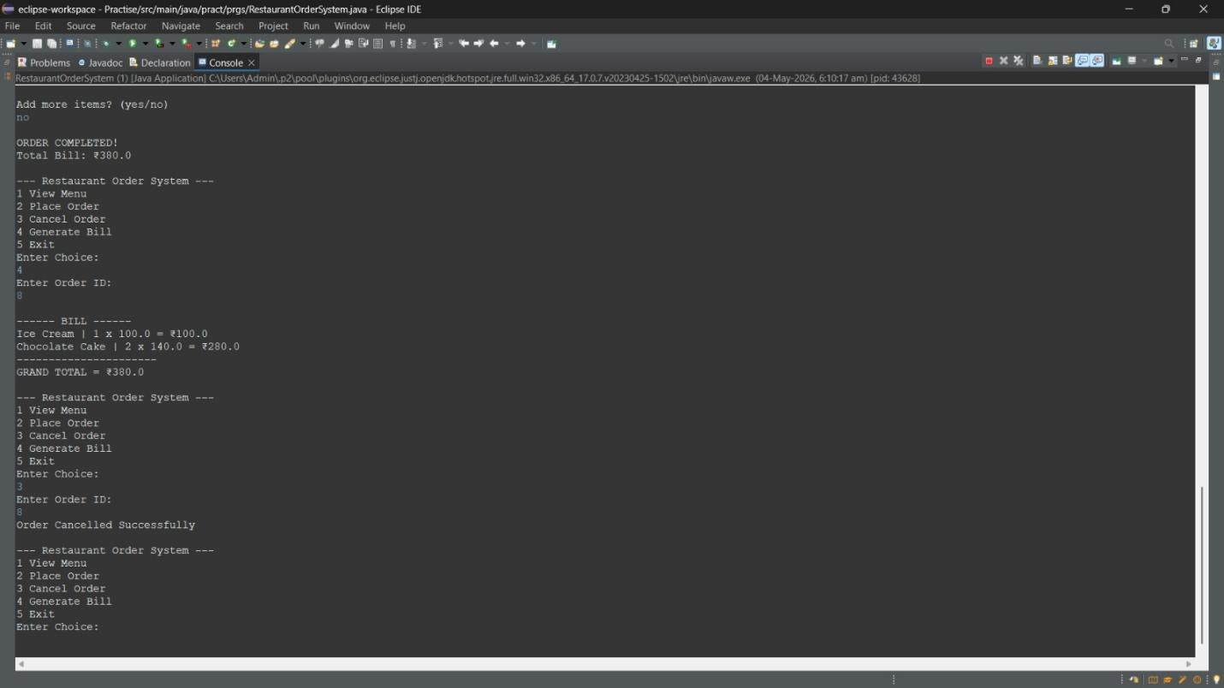Figure 1: Output Screenshot 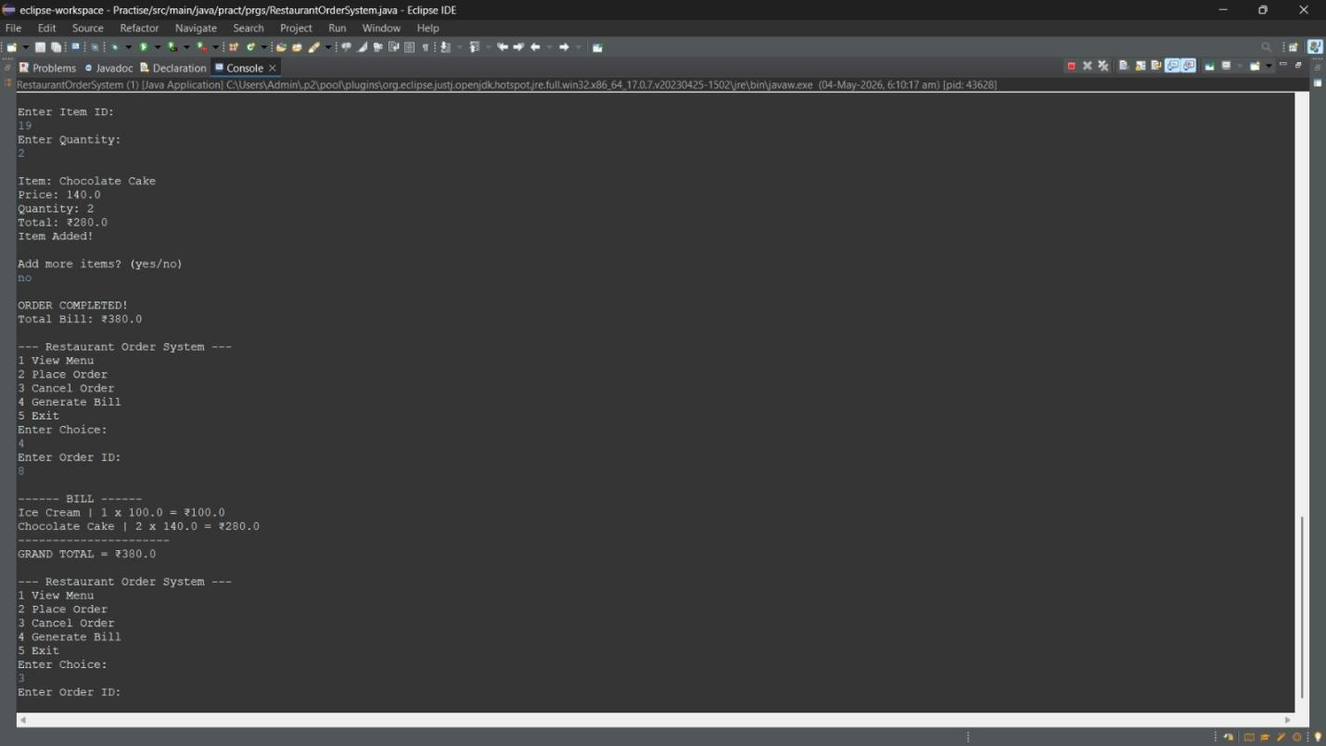Figure 2: Output Screenshot

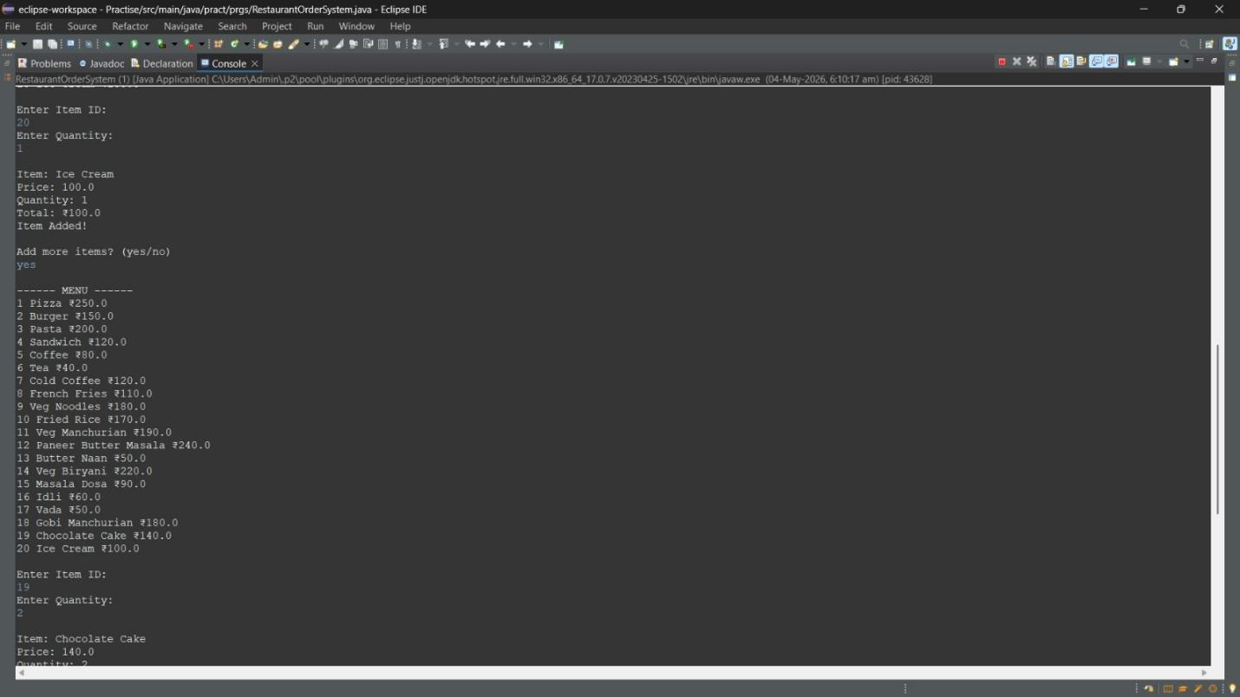Figure 3: Output Screenshot 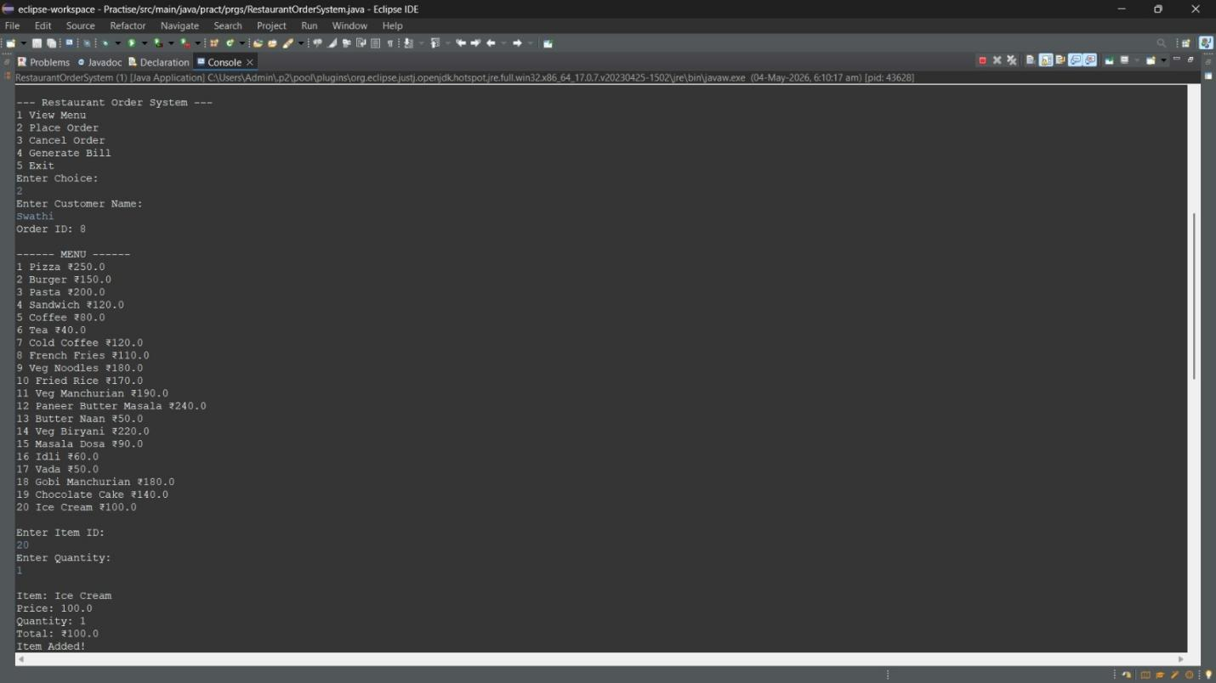Figure 4: Output Screenshot

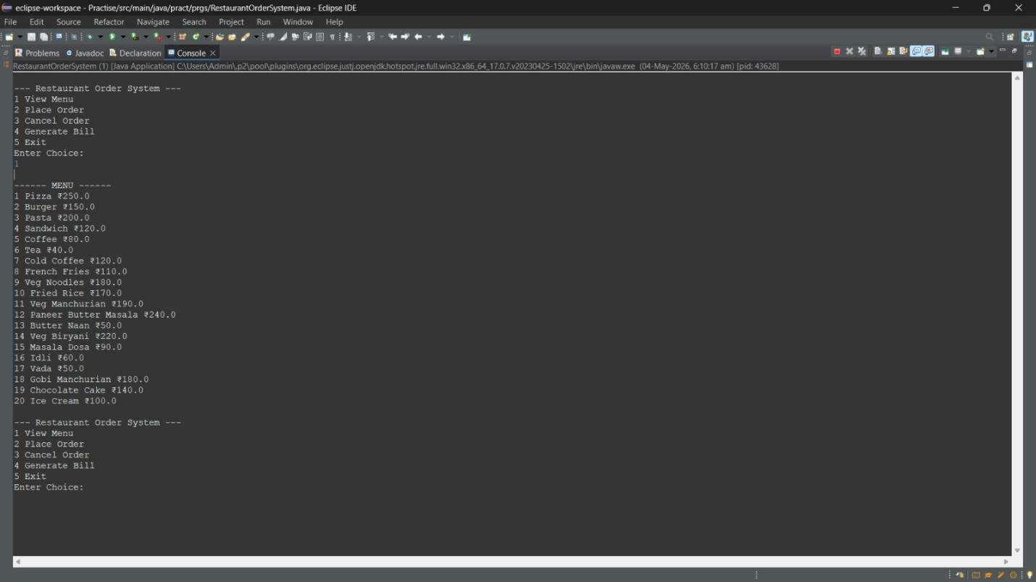Figure 5: Output Screenshot

References
- Oracle Corporation. (2024). Java SE 17 Documentation. Retrieved from https://docs.oracle.com/en/java/javase/17/
- Oracle Corporation. (2024). JDBC API Documentation — java.sql package. Retrieved from https://docs.oracle.com/en/java/javase/17/docs/api/java.sql/
- MySQL AB / Oracle. (2024). MySQL 8.0 Reference Manual. Retrieved from https://dev.mysql.com/doc/refman/8.0/en/
- MySQL AB / Oracle. (2024). MySQL Connector/J Developer Guide. Retrieved from https://dev.mysql.com/doc/connector-j/en/
- Horstmann, C. S. (2022). Core Java, Volume I — Fundamentals (12th ed.). Prentice Hall.
- Silberschatz, A., Galvin, P. B., & Gagne, G. (2020). Database System Concepts (7th ed.). McGraw-Hill Education.
- Ramakrishnan, R., & Gehrke, J. (2003). Database Management Systems (3rd ed.). McGraw-Hill.
- Eckel, B. (2006). Thinking in Java (4th ed.). Prentice Hall.

