**CAPSTONE PROJECT REPORT**

**TITLE: ONLINE RECRUITMENT SYSTEM**

SHAIK RIZWAN (192110730)

COURSE CODE/NAME: CSA0934/ JAVA PROGRAMMING

**OBJECTIVE:**

The objective of the online recruitment system is to streamline and enhance the hiring process by leveraging digital tools and technologies. It aims to simplify candidate sourcing, improve application management, and expedite the overall recruitment cycle, ensuring efficient and effective talent acquisition for the organization.

**INTRODUCTION:**

Online Recruitment System – a cutting-edge platform designed to revolutionize the way we identify, attract, and hire top talent. In today's dynamic and competitive job market, our online recruitment solution serves as a strategic tool, seamlessly connecting employers with potential candidates. By harnessing the power of technology, we aim to streamline the hiring process, enhance collaboration, and ultimately build high-performing teams that drive success for our organization. Embrace the future of recruitment with us, where efficiency meets innovation.

In the fast-paced landscape of contemporary hiring, our Online Recruitment System stands at the forefront of innovation, reshaping the traditional approach to talent acquisition. This advanced platform is meticulously crafted to address the evolving needs of our organization in the pursuit of exceptional candidates. In an era dominated by digital connectivity, our system offers a transformative solution to identify and engage with top-tier talent. Through a seamless and user-friendly interface, both employers and prospective candidates navigate a streamlined process that optimizes every stage of recruitment. Our platform empowers recruiters by leveraging the latest technologies for candidate sourcing, application management, and collaboration. By centralizing and automating these processes, we aim to significantly reduce time-to-hire and resource investments while maintaining the highest standards of quality in candidate selection. In essence, our Online Recruitment System is more than just a tool; it is a strategic gateway to a more efficient, effective, and tech-driven hiring process. By embracing this solution, we are not just adapting to the future of recruitment; we are actively shaping it. Join us on this journey, where innovation and efficiency converge to build the workforce that propels our organization towards sustained success.

**LITERATURE SURVEY:**

A literature survey on online recruitment systems reveals a wealth of research and insights into the evolution, challenges, and benefits of leveraging digital platforms for talent acquisition. Key themes and findings from existing literature include:

**Evolution of Recruitment Technologies:** Scholars have traced the historical development of recruitment technologies, highlighting the shift from traditional methods to online platforms. The advent of the internet has fundamentally transformed how organizations identify and engage with potential candidates.

**Advantages of Online Recruitment Systems:** Researchers emphasize the efficiency gains associated with online recruitment systems, citing improved speed in the hiring process, wider reach for job postings, and enhanced candidate experience. The ability to automate certain tasks streamlines workflows and allows recruiters to focus on strategic aspects of talent acquisition.

**Challenges and Criticisms:** Literature acknowledges challenges in online recruitment, including concerns about the reliability of digital assessments, potential biases in algorithms, and the need for effective cybersecurity measures. Ethical considerations in the use of technology in hiring are also explored.

**Candidate Experience and Employer Branding:** Studies emphasize the importance of a positive candidate experience in the online recruitment process. A user-friendly interface, prompt communication, and transparency contribute to a favorable perception of the employer brand, influencing a candidate's decision to apply and accept an offer.

**Social Media and Recruitment**: Scholars have delved into the impact of social media on recruitment strategies. The integration of platforms like LinkedIn, Twitter, and Facebook into online recruitment systems has emerged as a powerful tool for talent identification, engagement, and employer branding.

**Big Data and Analytics in Recruitment:** The use of big data and analytics in recruitment is explored, with researchers investigating how organizations can leverage data-driven insights to make informed decisions about sourcing, screening, and selecting candidates.

**Globalization and Cross-Border Recruitment:** As organizations increasingly operate on a global scale, literature examines the challenges and opportunities associated with cross-border recruitment. Online systems play a crucial role in facilitating international talent acquisition and addressing the complexities of diverse labor markets.

**Future Trends and Emerging Technologies:** Research speculates on the future trends in online recruitment, including the integration of artificial intelligence (AI), machine learning, and chatbots. The potential impact of these technologies on the efficiency and effectiveness of recruitment processes is a subject of ongoing exploration.

**Modules:**

**Day 1: Job Posting Module 1.**

**Module 1:**

Job Posting This module allows recruiters to create and post job listings. Key features include: User-friendly interface for job creation, with fields for job title, description, and requirements. Option to specify the application deadline. Attachment feature for supporting documents, such as detailed job descriptions or additional information.

**Day 2: Application Submission Module 2.**

**Module 2:**

Application Submission Candidates use this module to submit their applications. Features include: Online application form with fields capturing necessary details. Resume and cover letter upload functionality. Basic application tracking system for candidates to monitor their submission status.

**Day 3: Application Review Module 3.**

**Module 3:**

Application Review Recruiters use this module to review received applications. Features include: Application sorting and filtering options based on key criteria. Access to candidate profiles, resumes, and detailed application information. Preliminary evaluation tools for initial screening.

**Project Scope:**

The project scope for the Online Recruitment System aims to develop a user-friendly platform with a focus on enhancing the efficiency of recruitment processes. The objectives encompass the streamlined creation and posting of job listings, along with specified deadlines and attachment options. The application submission module emphasizes the design of an intuitive online form and the facilitation of resume and cover letter uploads. The application review module introduces sorting, filtering, and preliminary evaluation tools for recruiters. Exclusions in this phase involve advanced shortlisting and interview modules, as well as a basic communication tool implementation. The project operates within specified constraints of time, budget, and a predefined technology stack, with assumptions including user training and data security measures. Success is contingent on seamless integration with existing systems, and potential risks include technology-related challenges and user adoption concerns.

**Functionality:**

* Job Posting: Create and post job vacancies with detailed descriptions.
* Application Management: Allow candidates to submit applications online. Store and manage candidate resumes and application materials.
* Candidate Database: Enable searching and filtering based on skills, experience, education, etc.

**Candidate Class:**

Purpose: The Candidate class represents an individual who is interested in applying for a job within the organization.

**Attributes:**

* name: Holds the candidate's name.
* resume: Stores the candidate's resume or application materials.
* email: Contains the candidate's email address.

**Methods**:

* displayInfo(): Displays essential information about the candidate, such as name and email.

**JobPosting Class:**

Purpose: The JobPosting class represents a job opportunity within the organization that candidates can apply for.

Attributes:

* title: Holds the job title.
* description: Contains a brief description of the job.
* requirements: Specifies the educational or experiential requirements for the job.

**Methods:**

displayInfo(): Displays essential information about the job, such as title and description.

**RecruitmentSystem Class:**

Purpose: The RecruitmentSystem class serves as the central component managing job postings and candidate applications.

**Attributes:**

* jobPostings: A vector storing instances of JobPosting representing available job opportunities.

Methods:

* postJob(const JobPosting& job): Adds a new job posting to the system.
* displayJobPostings(): Displays information about all available job postings.
* applyForJob(const Candidate& candidate, const JobPosting& job): Simulates a candidate applying for a job, with potential additional logic for handling applications.

**CODE:**

import java.util.ArrayList;

import java.util.List;

class Candidate {

private String name;

private String resume;

private String email;

public Candidate(String name, String resume, String email) {

this.name = name;

this.resume = resume;

this.email = email;

}

public void displayInfo() {

System.out.println("Candidate: " + name + "\nEmail: " + email);

}

}

class JobPosting {

private String title;

private String description;

private String requirements;

public JobPosting(String title, String description, String requirements) {

this.title = title;

this.description = description;

this.requirements = requirements;

}

public void displayInfo() {

System.out.println("Job Title: " + title + "\nDescription: " + description);

}

}

class RecruitmentSystem {

private List<JobPosting> jobPostings;

public RecruitmentSystem() {

jobPostings = new ArrayList<>();

}

public void postJob(JobPosting job) {

jobPostings.add(job);

}

public void displayJobPostings() {

System.out.println("Available Job Postings:");

for (JobPosting job : jobPostings) {

job.displayInfo();

System.out.println("-------------------------");

}

}

public void applyForJob(Candidate candidate, JobPosting job) {

candidate.displayInfo();

System.out.println(" applied for the job: ");

job.displayInfo();

}

}

public class Main {

public static void main(String[] args) {

RecruitmentSystem recruitmentSystem = new RecruitmentSystem();

// Example: Posting a job

JobPosting softwareEngineer = new JobPosting("Software Engineer", "Developing cutting-edge software", "Bachelor's in Computer Science");

recruitmentSystem.postJob(softwareEngineer);

// Example: Displaying job postings

recruitmentSystem.displayJobPostings();

// Example: Candidate applying for a jobd

Candidate johnDoe = new Candidate("John Doe", "Resume content...", "john.doe@example.com");

recruitmentSystem.applyForJob(johnDoe, softwareEngineer);

}

}

OUTPUT

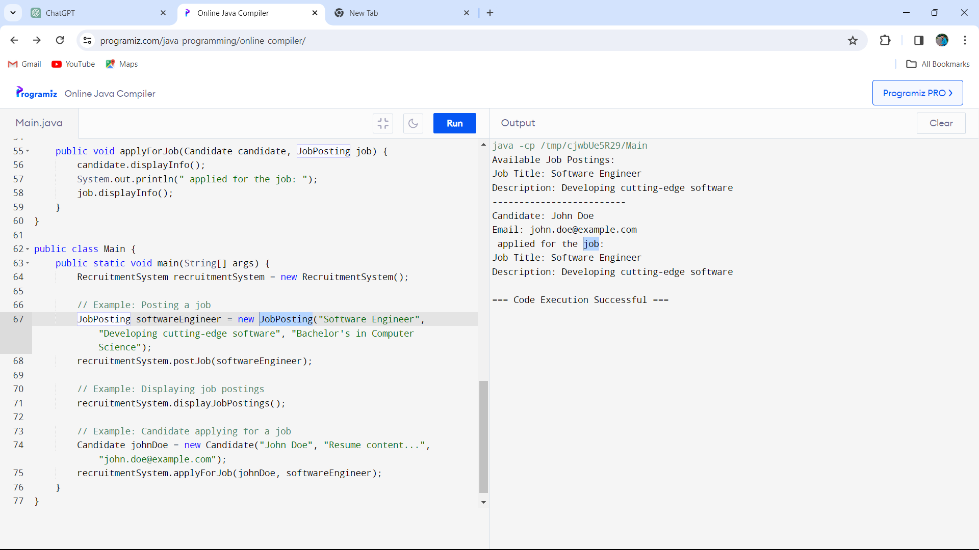**CONCLUSION:**

In conclusion, the provided Java code outlines a basic structure for a recruitment system with three essential classes: Candidate, JobPosting, and RecruitmentSystem. The code demonstrates the posting of job opportunities, displaying available job postings, and simulating a candidate applying for a job. This serves as a foundation that can be expanded and customized to meet the specific needs and complexities of a real-world recruitment system. The modular design of the code promotes scalability and maintainability. Additional features and functionalities can be introduced by extending the existing classes or introducing new ones, such as classes for interviews, assessments, and feedback collection.