Ab Initio Business Documentation: simple_graph

This document provides a business‑level and technical overview of the Ab Initio graph, including component roles, parameters, and end‑to‑end data flow.

# Components

## input_table (input_table)

Reads structured data from a flat or delimited file.

Parameters:

* • filename: /data/input/data.txt
* • record_format: record

## reformat1 (reformat)

Transforms each input record to a new format or structure.

Parameters:

* • transform: output :: record

## output_table (output_table)

Writes structured data to a flat or delimited file.

Parameters:

* • filename: /data/output/data_out.txt

# Data Flow Diagram

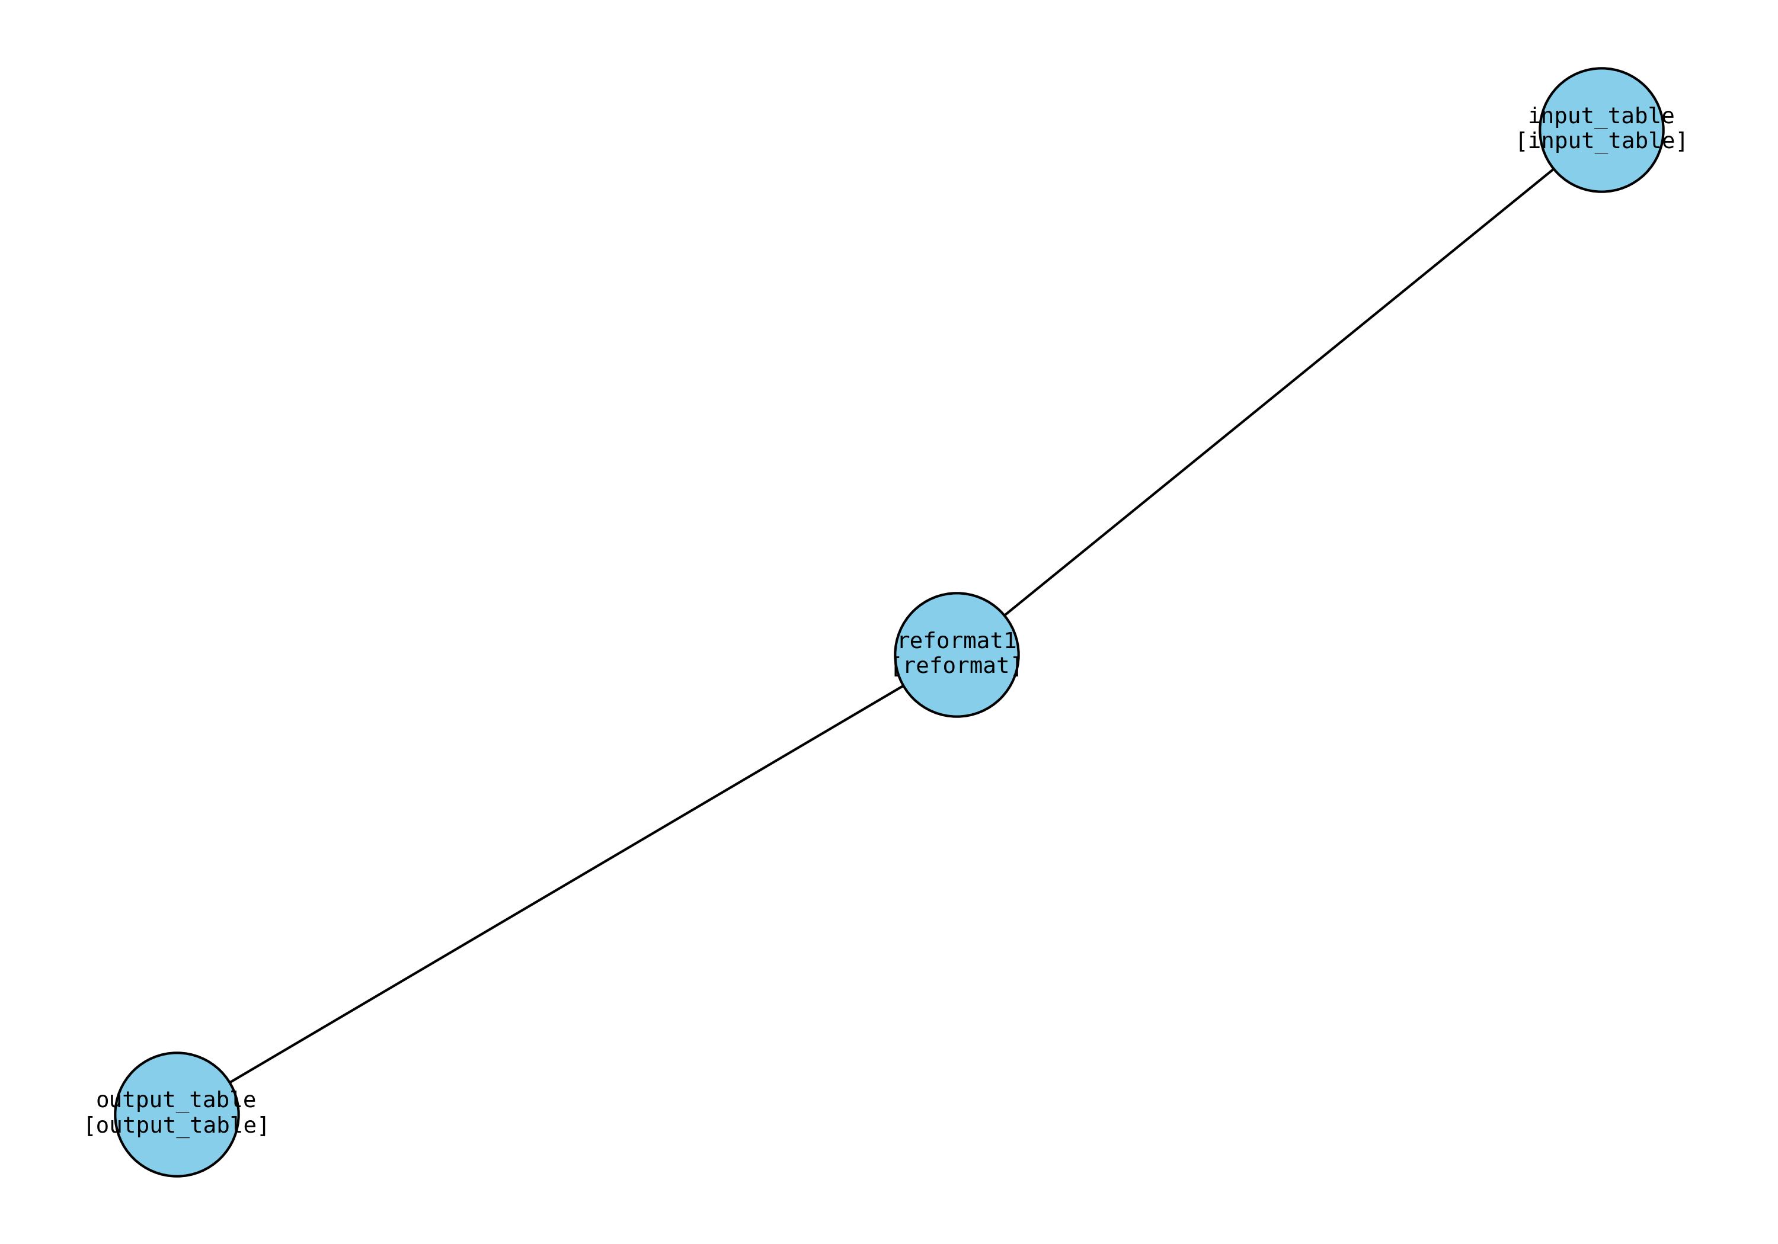

## Detailed Connections

* • Data flows from input_table → reformat1
* • Data flows from reformat1 → output_table