Business Requirements Document
Retail Personal Loan Origination — Process Redesign
Meridian Bank (fictional) · Banking Loan Process — As-Is / To-Be project
Item | Detail
Document | 10_BRD — Business Requirements Document
Version | 0.2 (draft for review)
Date | 27 September 2026
Prepared by | Varun (Business Analyst)
Sponsor | Head of Retail Lending
Basis | Reconstruction from public sources (07_source_log). All figures are estimates (assumption_register.xlsx).

1. Purpose
This document states what Meridian Bank's personal loan origination process must improve after the redesign, so that the business, IT and testing teams share one agreed description of the change. It describes business needs and system behaviour, not technical design.

2. Background and problem
Meridian Bank takes an estimated 11.5 days (expected, calendar time) to turn a personal loan application into money in the customer's account. Competitors advertise approval in 24–72 hours (Kotak, S05) or 48 hours once documents are complete (ICICI, S03).
Analysis of the current process (08_as_is_narrative, process_metrics.xlsx) found that an application is actively worked on for only about 6 hours; about 98% of the elapsed time is waiting. The waiting is concentrated in two stages:
- Close & Disburse (48% of waiting): the customer must reply to the sanction letter, visit the branch to sign on paper, and then wait for mandate registration.
- Verify (39% of waiting): files found incomplete after the handoff to Credit Operations are sent back through the branch (the document chase), and employers are verified by email.
Root-cause analysis (09_root_cause) traced these to two design problems: completeness is checked too late and owned by a team that never meets the customer, and closing is designed around paper documents and sequential handoffs.
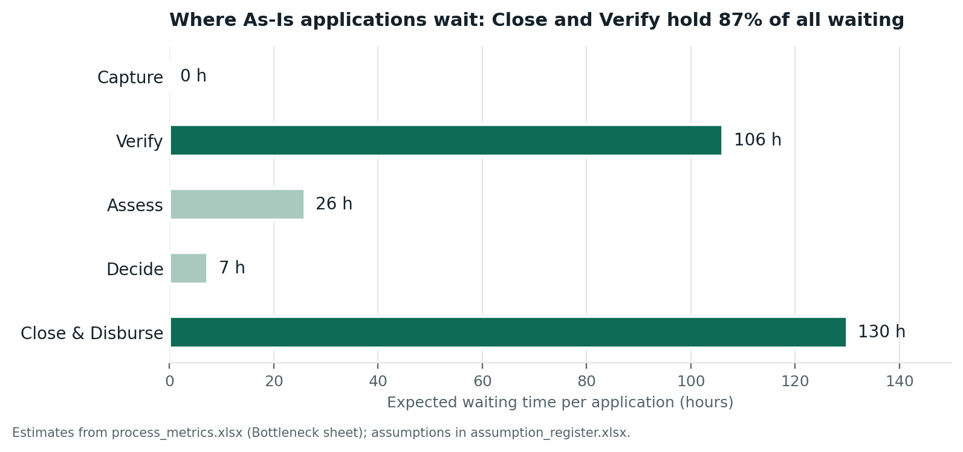
Figure 1 — Expected waiting time by stage, As-Is (process_metrics.xlsx, Bottleneck sheet)

3. Scope
In scope: retail unsecured personal loan origination, from loan application submitted to funds credited and welcome pack issued (full scope in 02_process_scope).
Out of scope: loan servicing, collections, secured lending (home and vehicle loans), marketing and lead generation, and replacement of the core banking system (charter constraint 3).

4. Business objectives
ID | Objective | As-Is | Target
OBJ-1 | Reduce expected turnaround time | 11.5 days | 2 days or less
OBJ-2 | Reduce document-chase rework | 0.5 rounds per application | 0.1 or less
OBJ-3 | Remove re-keying of customer data | 5 re-keying points | 0
OBJ-4 | Reduce staff time per application | 5.8 hours | Under 1 hour
OBJ-5 | Keep every regulatory control | All controls present | No control removed
Targets come from the To-Be estimate in process_metrics.xlsx (Comparison sheet): 1.8 days, 0.1 rounds, 0 re-keying, 0.5 staff hours.

5. Stakeholders
Role | Interest in this change | Involvement
Head of Retail Lending (sponsor) | Faster turnaround, lower cost per loan, competitiveness | Approves this BRD
Customer | Fast, certain decision; apply once; no branch visit | Represented through journey tests (UAT)
Branch Sales Officer / RM | Less chasing; assisted digital applications | Reviews FR-01 to FR-08
Credit Operations Analyst | Handle exceptions instead of routine checks | Reviews FR-09 to FR-13
Underwriter / Credit Manager | Only referred cases; deviations in the system | Reviews FR-14 to FR-18
Risk & Compliance Officer | Every control kept and evidenced | Reviews all Must requirements; signs off
Disbursement Officer | No re-keying; complete files | Reviews FR-20 to FR-24
IT / LOS Application Owner | Clear, testable system requirements | Estimates and builds

6. Current process (As-Is)
The current process has 26 activities across five bank roles plus the customer, 10 handoffs on the main path, 5 points where data is re-keyed, and 4 systems connected only by manual bridges.
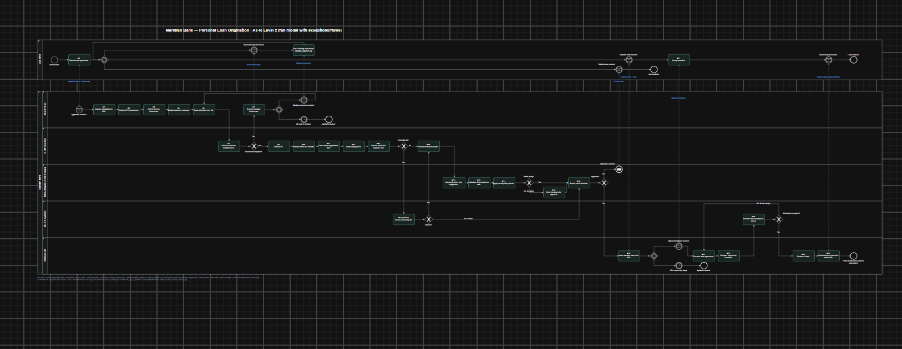
Figure 2 — As-Is Level 2 model (models/as-is/loan_origination_as_is.drawio)

7. Future process (To-Be)
In the To-Be, the customer applies once online (or with branch help on a tablet). The loan system checks completeness at submission and runs identity, PAN, bureau, employment and screening checks automatically. Applications that meet policy are decided automatically; others go to an underwriter. The customer accepts the offer, e-signs and sets up an e-mandate in one session after seeing the KFS. Staff work only on exceptions, the final compliance check and disbursal.

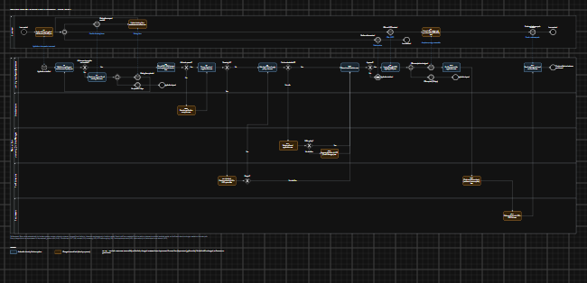
Figure 3 — To-Be Level 2 model (models/to-be/loan_origination_to_be.drawio). Blue = automatic, orange = changed manual task.
Metric | As-Is | To-Be (estimate)
Expected turnaround time | 11.5 days | 1.8 days
Staff time per application | 5.8 hours | 0.5 hours
Handoffs on the main path | 10 | 6
Re-keying points | 5 | 0
Manual staff tasks on the happy path | 22 | 2

8. Business requirements
Priority uses MoSCoW: Must (required for go-live), Should (important, can follow shortly), Could (desirable). Every requirement in sections 8–11 has an ID and at least one linked gap from gap_analysis.xlsx (G01–G17).
ID | Business requirement | Why | Gaps | Priority
BR-01 | Customers must be able to apply and submit all required documents in one digital journey, entering each piece of information only once. | Removes branch re-keying and the paper hand-over (PP-04). | G01 | Must
BR-02 | An application must not enter credit processing until every mandatory document is present and readable. | Removes the main cause of the document chase (PP-01, root cause 1). | G02, G03 | Must
BR-03 | When something is missing, the customer must receive one request listing everything missing and be able to respond digitally. | Ends piecemeal chasing through the branch (PP-01). | G04 | Must
BR-04 | Identity, PAN, credit bureau, employment and screening checks must run automatically at submission, keeping every KYC, consent and screening control. | Removes manual portals and email checks; brings the bureau check forward (PP-04, PP-05, PP-06, PP-07). | G05, G06, G07, G16 | Must
BR-05 | Applications that meet credit policy must be decided without manual underwriting; all others must be referred to an underwriter with the reasons shown. | Underwriters focus on the cases that need judgement (PP-04, PP-08). | G08, G09 | Should
BR-06 | Referrals, deviation approvals, screening hits and compliance evidence must be handled inside the loan system, with visible status and time limits. | Ends email handoffs and late discovery of missing evidence (PP-07, PP-09, PP-10). | G10, G12, G14, G17 | Must
BR-07 | After seeing the Key Fact Statement, customers must be able to accept the offer, sign the agreement and set up repayment in one digital step. | Removes the branch visit and separate mandate step (PP-02, PP-03, root cause 2). | G11 | Must
BR-08 | The loan account must be created and funds disbursed without re-entering data, only into the borrower's own account. | Removes the last manual bridge (PP-04) and keeps the disbursal control (S02). | G13 | Must
BR-09 | Roles and responsibilities must be updated: completeness owned at capture, Credit Operations handling exceptions, underwriters reviewing referred cases. | Process change needs people change (G03, G15). Delivered by training and procedures, not by the system. | G03, G15 | Must

9. Functional requirements
ID | Functional requirement | BR | Gap | Priority
FR-01 | The system shall provide a digital application form (web and mobile) capturing personal, employment, income and loan details, with a staff-assisted mode for branch walk-ins. | BR-01 | G01 | Must
FR-02 | The system shall pre-fill identity details from the CKYC registry or Aadhaar e-KYC after the customer gives consent. | BR-01, BR-04 | G01, G05 | Should
FR-03 | The system shall show the mandatory document checklist for the applicant's type (salaried or self-employed). | BR-02 | G02 | Must
FR-04 | The system shall not allow an application to be submitted until every mandatory document on the checklist is uploaded. | BR-02 | G02 | Must
FR-05 | The system shall reject unreadable, password-protected or wrong-type files at upload and tell the customer why. | BR-02 | G02 | Must
FR-06 | The system shall record the customer's explicit consent for the credit bureau check, KYC and data use, with date and time. | BR-04 | G01 | Must
FR-07 | When items are missing or defective, the system shall send the customer one request listing every item, with a secure upload link. | BR-03 | G04 | Must
FR-08 | The system shall mark an application as lapsed and notify the customer if no response is received within 7 days of a missing-item request. | BR-03 | G04 | Should
FR-09 | The system shall verify identity automatically through the CKYC registry or e-KYC, and route the application to video KYC or manual review when no match is found. | BR-04 | G05 | Must
FR-10 | The system shall validate the PAN and check that name and date of birth match across the PAN, KYC record and application. | BR-04 | G05 | Must
FR-11 | The system shall pull the credit bureau report at submission and store it with the application. | BR-04 | G06 | Must
FR-12 | The system shall verify the applicant's employment electronically, without staff contacting the employer by email or phone (for example, official-email OTP or an employer database). | BR-04 | G07 | Should
FR-13 | The system shall screen every applicant against negative and AML lists and send any hit to the Risk & Compliance queue. | BR-04, BR-06 | G10, G16 | Must
FR-14 | The system shall calculate net monthly income and the debt-to-income ratio from bureau and bank-statement data. | BR-05 | G08 | Should
FR-15 | The system shall apply configurable credit-policy rules and give each application an outcome of auto-approve, auto-decline or refer, recording the reasons. | BR-05 | G09 | Should
FR-16 | The system shall place referred applications in the underwriting queue with the referral reasons displayed. | BR-05 | G09 | Should
FR-17 | The system shall route deviation requests to an approver with the required authority and record the approver, decision and time. | BR-06 | G10 | Must
FR-18 | The system shall show a time-limit (SLA) timer on every queue item and escalate items that breach it. | BR-06 | G10 | Should
FR-19 | The system shall notify the customer and branch by SMS or email at each status change. | BR-06 | G14 | Could
FR-20 | The system shall generate the sanction letter and Key Fact Statement and require the customer to view the KFS before accepting. | BR-07 | G11 | Must
FR-21 | The system shall let the customer accept the offer, sign the agreement electronically (for example, Aadhaar OTP e-sign) and register a repayment e-mandate in one session. | BR-07 | G11 | Must
FR-22 | The system shall send copies of all signed documents and the welcome pack to the customer automatically, and archive the complete file. | BR-07 | G11, G17 | Must
FR-23 | The system shall compile a compliance evidence checklist as the process runs and block disbursal until every mandatory item is present. | BR-06 | G12 | Must
FR-24 | The system shall create the loan account in the core banking system through an integration and disburse only to the borrower's own verified account. | BR-08 | G13 | Must
BR-09 (roles and responsibilities) has no functional requirement. It is delivered through updated procedures, the revised RACI and staff training.

10. Non-functional requirements
ID | Area | Requirement | Gaps
NFR-01 | Availability | The customer application journey shall be available 99.5% of the time each month. | G01, G11
NFR-02 | Performance | Automated checks (N4, N5, N7) shall complete within 2 minutes for 95% of applications. | G05, G06, G07, G08, G16
NFR-03 | Audit trail | Every decision, override, approval and data change shall be logged with user, date and time, and kept for the period required by regulation. | G09, G10, G12
NFR-04 | Data privacy | Customer data shall be collected only with explicit consent, encrypted in transit and at rest, and the app shall not access phone contacts, call logs or media (S02). | G01, G05
NFR-05 | Usability | The journey shall work on a mobile phone and be available in English and Hindi. | G01, G11

11. Key business rules
ID | Rule | Source | Gaps
RULE-01 | Mandatory documents (salaried): PAN, one identity and address proof, last 3 months' bank statement, latest salary slip. | S03 (ICICI checklist) — Meridian to confirm | G02
RULE-02 | Debt-to-income limit: total EMIs must not exceed 65% of net monthly income. | Modelled on S04 (SBI), AS-33 — credit policy to confirm | G09
RULE-03 | The customer must view the KFS before the offer can be accepted. | S02 | G11
RULE-04 | Funds are disbursed only to a bank account in the borrower's own name. | S02 | G13
RULE-05 | A missing-item request lapses after 7 days; an offer lapses after 30 days. | Meridian policy (assumed) | G04, G11

12. Assumptions, constraints and dependencies
- Assumptions: all time figures are estimates listed in assumption_register.xlsx (AS-01 to AS-35); no Meridian Bank data was available.
- Constraints: no regulatory control may be removed; the core banking system is not replaced; KYC must follow the RBI KYC Directions 2025 (S01) and lending the RBI Digital Lending Directions 2025 (S02).
- Dependencies: access to the CKYC registry, e-KYC and PAN services, a credit bureau API, an e-sign provider, an e-mandate (NACH) provider and an LOS–CBS interface; credit-policy approval of auto-decision rules (G09).

13. Traceability
Every requirement in this document traces backwards to a gap (gap_analysis.xlsx) and a pain point (pain_point_log.xlsx), and forwards to a user story (11_user_stories) and a test case (uat_test_cases.xlsx). The full chain is in traceability_matrix.xlsx.

14. Sign-off
Role | Name | Decision | Date
Head of Retail Lending (sponsor)
Risk & Compliance
IT / LOS Application Owner

