Process Mining

- [Stages Extraction]

This document outlines an n8n workflow designed to process video files, extract stages using Google Cloud's Vertex AI, and generate both an HTML display of markdown content and a Mermaid.js diagram representing those stages.

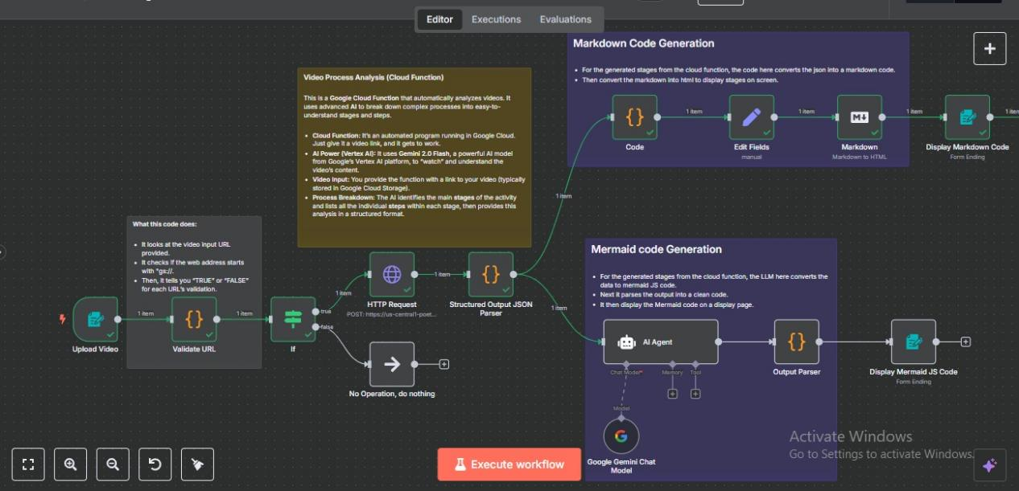

## Workflow Overview

## The workflow automates the following steps:

### Video Upload & URI Validation (User Input & Data Integrity):

* A user initiates the workflow by uploading a video through a form.
* The video is provided as a Google Cloud Storage (GCS) URI (e.g., gs://your-bucket/your-video.mp4).
* Validation: The workflow immediately validates the provided URI to ensure it begins with gs://. This prevents processing of invalid inputs.

### Conditional Processing (Flow Control):

* TRUE Condition: If the URI is valid (starts with gs://), the workflow proceeds to the next steps.
* FALSE Condition: If the URI is invalid, the workflow stops, preventing unnecessary processing or errors.

### Vertex AI Integration via Google Cloud Function (AI-Powered Video Analysis):

* An HTTP Request node is triggered.
* This node calls a pre-configured Google Cloud Function.
* Function's Role: The Google Cloud Function serves as an intermediary, securely invoking the Vertex AI Gemini 2.5 model.
* AI Processing: The Gemini 2.5 model analyzes the provided video (from the GCS URI) based on a detailed prompt. The prompt instructs the model to identify and generate distinct "stages" or key events within the video content.

### Structured Output Parsing (Data Transformation):

* The raw output received from the Vertex AI model (via the Google Cloud Function) is often unstructured.
* A Structured Output Parser node cleanses and transforms this raw output into a consistent, easily consumable JSON response. This standardization is crucial for subsequent operations.

### Parallel Output Generation (Dual Display & Diagramming):

* After the HTTP call response is fetched and parsed into a structured JSON, the workflow branches into two parallel paths to generate different types of output:

#### 5.1 Markdown to HTML Conversion for Form Display:

* + A Javascript Code node takes the structured JSON output.
  + It converts this JSON into Markdown formatted text.
  + Subsequently, it converts the Markdown text into HTML code.
  + **Purpose**: This HTML content is then displayed directly within the n8n form, providing a human-readable summary or details about the extracted video stages.

#### 5.2 Mermaid.js Code Generation (AI Agent for Diagrams):

* + An **AI Agent** node processes the same structured JSON output.
  + **Custom Prompt**: This agent uses a custom prompt specifically designed to instruct an LLM (likely another call to Gemini or a similar model) to convert the JSON data into valid **Mermaid.js** **code**. Mermaid.js is a JavaScript-based diagramming tool that renders diagrams from text.

### Mermaid.js Code Cleaning & Validation (Ensuring Functionality):

* A dedicated Parser node is used after the AI Agent.
* Purpose: This parser's role is critical for cleaning and validating the Mermaid.js code generated by the AI agent. LLM outputs can sometimes have minor syntax errors or formatting issues. This step ensures the generated Mermaid.js code is syntactically correct and will render properly.

### Result (Mermaid.js Diagram Code):

* The final output of the workflow is a text format containing the cleaned and validated Mermaid.js code representing the identified video stages. This code can then be used in a Mermaid.js viewer or integrated into documentation to visualize the workflow.

### Prompts:

#### Stages Extraction

Role: You are an expert Process Analyst and Workflow Designer. Your task is to meticulously observe and deconstruct processes from raw input, transforming complex activities into clear, actionable, and sequential stages and steps.

Objective: Analyze the provided video content to identify the complete "as-is" workflow. Your output must clearly delineate the main stages of the process, and for each stage, enumerate the distinct, chronological steps performed within it.

Output Format: Provide the analysis in a structured JSON format, ensuring it is syntactically correct and easily parseable. Always provide theoutput in a JSON format.

example:

{

"process_title": "A concise, descriptive title for the overall process observed in the video.",

"video_analysis_summary": "A brief overview (1-2 sentences) of the entire process shown in the video.",

"stages": [

{

"stage_number": 1,

"stage_name": "Clear, action-oriented name for Stage 1 (e.g., 'Initial Setup', 'Data Input', 'Execution Phase').",

"stage_description": "A brief description of the primary activity or goal of this stage.",

"steps": [

"Step 1.1: Detailed and precise description of the first action.",

"Step 1.2: Detailed and precise description of the second action.",

"...",

"Step 1.N: Last action in this stage."

]

},

{

"stage_number": 2,

"stage_name": "Clear, action-oriented name for Stage 2.",

"stage_description": "A brief description of the primary activity or goal of this stage.",

"steps": [

"Step 2.1: Detailed and precise description of the first action in Stage 2.",

"...",

"Step 2.M: Last action in this stage."

]

}

// ... Continue adding stages until the entire video's process is covered.

],

"completeness_check": "Confirm that all visible actions and the entire duration of the video's process have been analyzed and broken down into stages and steps. (e.g., 'The analysis covers the entire video content provided.')"

}

1. Mermaid Code Generation:

You are an expert in process visualization and Mermaid.js syntax. Your task is to convert the provided JSON process analysis into a Mermaid.js flowchart.

Instructions:

Analyze the JSON: Carefully read the stages and steps within each stage.

Generate a Flowchart: Create a Mermaid.js flowchart using graph TD (top-down) for clear sequential flow.

Represent Stages as Nodes:

Each stage should have a short, simple, alphanumeric ID (e.g., S1, S2, S3).

The visible label for each node must be enclosed in square brackets and double quotes, allowing for multi-line content (e.g., NodeID["Visible Name<br>Key Step 1<br>Key Step 2"]).

Represent Flow with Arrows: Use --> to show the sequential flow from one node to the next.

Include Key Steps in Node Descriptions: For clarity, include the stage_name on the first line, followed by the first 1-2 key steps from each stage's steps list on subsequent lines within the node's label. Use <br> for line breaks within the quoted node label.

Start and End Nodes: Add a clear "Start" and "End" node to delineate the process boundaries. These should also follow the NodeID["Label"] format (e.g., Start["Start"]).

Output Format: Provide only the Mermaid.js code block, enclosed in markdown code fences (```mermaid ... ```). Do not include any additional text or explanations outside of the Mermaid code block.

JSON is : {{$json.stages.map(stage => `${stage.stage_name}:\n - ${stage.steps.slice(0, 2).join('\n - ')}${stage.steps.length > 2 ? '\n ...' : ''}`).join('\n\n') }}

#### Markdown code Generation:

**Process: Shopping on Amazon**

**Stages and Steps Overview**

**1. Account Setup/Login**

Description: The initial stage focuses on accessing Amazon by either logging into an existing account or creating a new one if necessary.

Step 1.1: Navigate to the Amazon homepage.

Step 1.2: Click on the 'Sign In' button.

Step 1.3: If an account exists, enter the email/mobile number and password, then click 'Login'.

Step 1.4: If a new account is required, click 'I am a new customer'.

Step 1.5: Fill in the required details like name, email, password, and retype password.

Step 1.6: Click 'Create your Amazon account'.

Step 1.7: Return to the 'Sign In' page and log in with the new credentials.

**2. Product Search and Selection**

Description: Involves finding the desired product using the category browser or the search bar, then reviewing details and ratings.

Step 2.1: Search for a product using the category browsing feature, selecting 'Shop by Category'.

Step 2.2: Alternatively, use the search bar at the top of the page, entering the product name or category and clicking 'Search'.

Step 2.3: Review the search results and filter as needed.

Step 2.4: Check product rating to assess seller trustworthiness.

Step 2.5: Click on the desired product to view its individual page.

Step 2.6: Review the product pictures, details, description, specifications, and customer reviews.

**3. Adding to Cart or Buying Directly**

Description: This stage adds selected product to the shopping cart or allows an immediate purchase.

Step 3.1: To add the product to the shopping cart for purchasing with other items, click 'Add to Cart'.

Step 3.2: To directly purchase the product, click 'Buy Now'.

**4. Shopping Cart Review and Checkout**

Description: Reviewing added items, selecting delivery address, and proceeding with payment.

Step 4.1: Click on the 'Cart' icon to review the selected items.

Step 4.2: Adjust quantities or remove items if needed.

Step 4.3: Click 'Proceed to checkout'.

Step 4.4: Select or add a delivery address.

Step 4.5: Click 'Deliver to this address'.

Step 4.6: Review the delivery options and click 'Continue'.

**5. Payment Process**

Description: Selecting a payment method, entering payment details, and completing the order.

Step 5.1: Choose a payment method: credit card, debit card, net banking.

Step 5.2: If using Net Banking, choose your bank.

Step 5.3: Click 'Continue'.

Step 5.4: Enter any gift cards or promotional codes.

Step 5.5: Click on 'Place your order and Pay'.

Step 5.6: Log in to the Net Banking account.

Step 5.7: Verify the details and click 'Continue'.

Step 5.8: Enter the transaction password and click 'Submit'.

Step 5.9: Enter the One-Time Password (OTP) received on your phone and click 'Submit'.

**6. Order Confirmation and Tracking**

Description: Confirmation of a successful purchase and tracking of the order's delivery status.

Step 6.1: Confirm that the 'Thank you, your order has been placed' message is displayed.

Step 6.2: To track the order, click on 'Your Orders'.

Step 6.3: Select 'Track Package' to view the order status.

**Completeness Check**

The analysis covers the entire video content provided, detailing all actions from account login/creation to order confirmation and tracking.

### 