**VIVEKANANDA COLLEGE OF ENGINEERING & TECHNOLOGY**

[A Unit of Vivekananda VidyavardhakaSangha, Puttur (R)]

Affiliated to Visvesvaraya Technological University and Approved by AICTE New Delhi & Govt. of Karnataka

Nehru Nagara, Puttur – 574 203, DK, Karnataka, India

**DEPARTMENT OF MASTER OF COMPUTER APPLICATIONS**

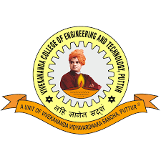

**CERTIFICATE**

Certified that the internship titled “**Internship Title**” at **Company Name** was successfully completed by **Name**, bearing USN **4VP23MC0XX**, a bonafide student of **Vivekananda College of Engineering & Technology, Puttur**, in partial fulfillment of the requirements for the award of the **Master of Computer Applications** degree under **Visvesvaraya Technological University, Belagavi** for the academic year 2024 – 25.

It is hereby confirmed that all corrections and suggestions recommended during the Internal Assessment have been duly incorporated into the report, which has been deposited in the departmental library. The internship report meets the academic standards and requirements for the Internship/Professional Practice component prescribed for this degree.

|  |  |  |  |
| --- | --- | --- | --- |
| **Supervisor**  **Name** | **Internal Guide**  **Name** | **Director – MCA**  **Dr. Jothimani K** | **Principal**  **Dr. Mahesh Prasanna K** |

**EXTERNAL VIVA**

Name of the ExaminersSignature with date

1…………………………….............. ....................................

2…………………………….............. ....................................