|  |  |
| --- | --- |
| **Exp No: 6**  **Date: 07.04.25** | **HTTP SESSION** |

**AIM:**

To  Write a Servlet to demonstrate session tracking using HTTP Session.Implement a simple login system where the user's session is tracked.

**PROGRAM:**

**httpsessionhandle.java**

package com.gunal.servlet;

import java.io.IOException;

import java.io.PrintWriter;

import javax.servlet.ServletException;

import javax.servlet.annotation.WebServlet;

import javax.servlet.http.HttpServlet;

import javax.servlet.http.HttpServletRequest;

import javax.servlet.http.HttpServletResponse;

import javax.servlet.http.HttpSession;

/**

* Servlet implementation class HttpSessionHandle

*/

@WebServlet("/HttpSessionHandle")

public class HttpSessionHandle extends HttpServlet {

private static final long serialVersionUID = 1L;

protected void doPost(HttpServletRequest request, HttpServletResponse response) throws ServletException, IOException {

String username = "WTMA";

String password = "WTMA";

PrintWriter p = response.getWriter();

String user = request.getParameter("username");

String pass = request.getParameter("password");

if(user.equals(username) && pass.equals(password))

{

HttpSession session = request.getSession(true);

session. setAttribute("username", user);

response.sendRedirect(request.getContextPath() + "/HttpSessionHandleDisplay");

}

else

{

p.println("fail");

}

}

}

**HttpSessionHandleDisply.java**

package com.rohit.servlet;

import java.io.IOException;

import java.io.PrintWriter;

import javax.servlet.ServletException;

import javax.servlet.annotation.WebServlet;

import javax.servlet.http.HttpServlet;

import javax.servlet.http.HttpServletRequest;

import javax.servlet.http.HttpServletResponse;

import javax.servlet.http.HttpSession;

/**

* Servlet implementation class HttpSessionHandleDisplay

*/

@WebServlet("/HttpSessionHandleDisplay")

public class HttpSessionHandleDisplay extends HttpServlet {

private static final long serialVersionUID = 1L;

/**

* @see HttpServlet#doGet(HttpServletRequest request, HttpServletResponse response)

*/

protected void doGet(HttpServletRequest request, HttpServletResponse response) throws ServletException, IOException {

PrintWriter p = response.getWriter();

HttpSession session = request.getSession(true);

String user_name = (String)session.getAttribute("username");

p.println("Usernmae is " + user_name);

}

}

INDEX.HTML

<!DOCTYPE html>

<html>

<head>

<meta charset="ISO-8859-1">

<title>HTTP Session</title>

</head>

<body>

<h1>Form Handle By HTTP Session</h1>

<form action="/ROHIT_191/HttpSessionHandle" method="POST" style="margin-left: 50px">

<label>Username: </label><input type="text" name="username"/><br><br>

<label>Password: </label><input type="password" name="password"/><br><br>

<input type="submit" value="Login" style="margin-left: 130px"/>

</form>

</body>

</html>

**OUTPUT:**

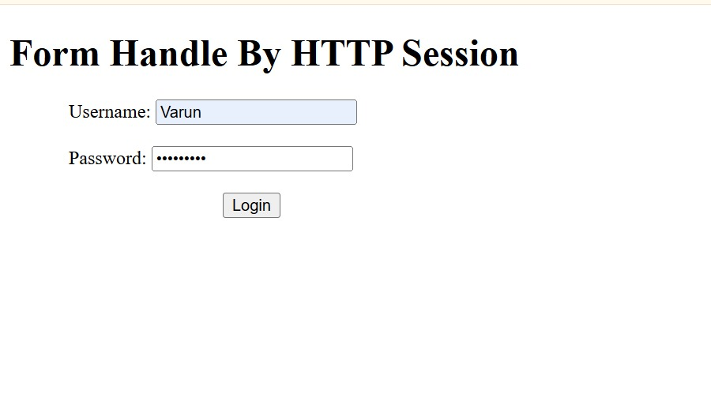

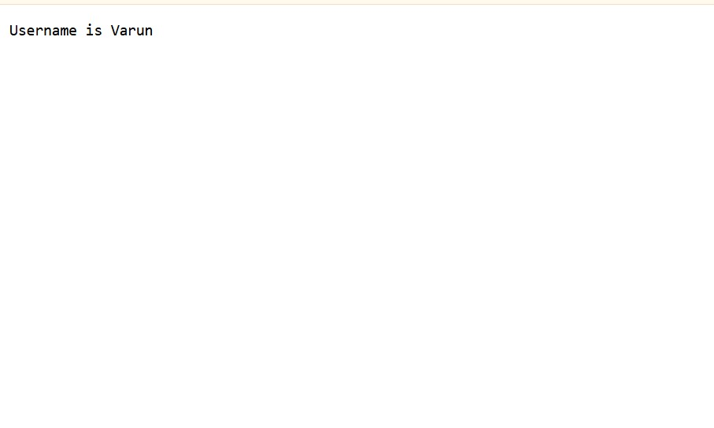

**RESULT :**Thus the To  Write a Servlet to demonstrate session tracking using HTTP Session.Implement a simple login system where the user's session is tracked. has been implemented and verified successfully