ONLINE AUCTION

MINI PROJECT REPORT

1.1 ABOUT THE PROJECT

"U Auction" is an online auction web site aimed at taking the auction to the finger tips of aspiring bidders there by opening up the doors of the "OPEN Auction House' to a wider cross section of Art Lovers and Antique Collectors. This site also acts as an open forum where buyers and sellers can come together and exchange their products. The site makes sure that the sellers get a fair deal and buyers get a genuine product.

Home Page - The site opens up door to aspiring web users through the Home page. The Home page is designed in such way that the layout is as user friendly as possible. There is a navigational menu at the top of the page which links to various inner pages. There is a category drop down on the left side for easy manipulation. The center area is for displaying latest products in the chorological order.

Login/User Registration - Those who wish to take part in bidding or sell products at the site have to register at the site as seller or buyer. Only authenticated users can take part in selling or in bidding. The system automatically rejects un-authenticated users who try to bid or sell at the site.

Register Products - This module is for presenting items for bidding. Only those who have registered and authenticated as sellers can place their articles for bidding. The Module collects information like Product Name, Product Details, Starting Bid amount, Incremental value etc. The system automatically inputs the closing date.

Bidding Module - The module is for bidding on any selected item. The bidder has to authenticate before participating in bidding. The system checks whether the incremental amount entered by the bidder is equal or more than the incremental minimum set during the product registration time. The system places the record in the bid history against the bidder account.
My Auction - This page is an interface for both buyer and seller. Buyer can see the profile of the bidding history of items which are still open on which he/she has already bided. Similarly the seller can see the progress of bidding on articles he/she has placed for bidding.

Feedback - The purpose of the page is to send messages/comments to the web administrator.

FAQ - This page is meant for first time users of the site. The page provided answers to questions which are common and frequently asked.

WebAdmin - This link opens to the administration module which is open to web administrator only. Here site administrator can add product categories and can edit product information like closing date. Also there is an option for administering the closed bids. This module is for contacting the bidder and seller by email instructing them to settle the transaction within a time frame.
CHAPTER 2

PROBLEM DEFINITION
The problem with public auction is that the participation of the general public is very limited. The aim of the project is to socialize the auction so that people from far & wide and even across the continent can participate in it. The "U Auction" site is developed with a vision to wipe out the inherent problems of "Conventional Auction House". The salient features of the site are as follows:
- Paperless Auction System
- It's accessible to everyone, at any time no matter where they are
- Reliable user validation & checking.
- Easy online settlement.

"U Auction" is designed in such a way that it is as user friendly as possible. So any aspiring bidder or seller can visit the site and engage in bidding with least effort.

2.1 EXISTING SYSTEM

The existing "OPEN Auction House" is managed manually. Prior to each auction, the day of auction, the venue and the items on auction are announced through news media. Those who wish to take part in the auction have to arrive at the venue on that day on time. This conventional method most of the times prevent aspiring bidders from participating in the bidding process. Another headache of the old system is to track each bidding process and to make it culminate in financial settlement. So the system has to keep records of both buyers and sellers until the end of settlement. The process is very cumbersome and time consuming.

2.2 PROPOSED SYSTEM

The slogan of the new site is AAA, 'Anyone, Anytime, Anywhere'. That what it really is? The "U Auction" is online auction house so the seller or bidder doesn't need to go anywhere, instead they can take part in the auction just sitting in the comfort of their living room, be it during the day or night.

The proposed computerized "U Auction" site has made auction process simple. The only
5 pre-condition is that the user must register and authenticate before he/she can take part in the bidding process. The system uses HTTP forms authentication which creates a session cookie for any signed in user. Through out the span of the session the cookie remains valid until the user logs out.

An auction house needs to have products to auction, so in the proposed system this is done using product registration module. The module is open to user who is registered sellers and they need to authenticate before they register any product. The system controls the closing date by adding 14 days to the submitting date there by restricting the bidding process to go on indefinitely.

Another important module in the proposed project is the "Bidding module ". Here one can see the details of any particular product and also the bidding history. The user can bid on that item by entering any amount greater than or equal to the incremental bid amount. Here also system checks to see whether the user has his credential verified otherwise he/she will be directed to the login/registration page.

The last but the least module is the "Web Administration" module. The module is only open to the web administrator due to security reasons. In this module the administrator can add product categories; this is to avoid rampant creation of categories. The 2nd thing is the option to edit any given product. This will be necessary when some of the details of the product need to be edited for one reason or other. The 3rd and last the closed bid manager where the administrator notifies both the seller and buyer the need to complete the transaction.

There is another module which runs more or less like background process. The function of the module is to close bid of those products whose closing date is less than the current date. The process is automatic and hidden from the web users.
CHAPTER 3 SYSTEM STUDY

The system study phase involves the investigation of the structure of current system, with the objective of identifying the problem and difficulties with the existing system. The major steps involved in this phase included defining the user requirements and studying the present system to verify the problem. The performance expected by the new system was also defined in this phase in order to meet the user requirements. The information gathered from various documents were analyzed and evaluated and the findings reviewed in order to establish specific system objectives.

3.1 SYSTEM ANALYSIS

System Analysis is an investigation into a problem and how a new system will solve it. It is the most essential part of the development of a project of a system analysis. System analysis consists of system element, process and technology.

To analyze a system, has to study the systems in details. The analyst has to understand the functioning and concept of the system in detail, before design the appropriate computer based system that will meet all the requirements of the existing system. The system analyst has to carry out a customary approach to use the computer for problem solving.

System analysis includes the following basic concepts
- Preliminary investigation
- Requirements specification
- Feasibility study
- Detailed investigation
- Drawing up of strategies
- Design and coding
- Testing and training
- Implementation

The above steps constitute the logical framework for the system analysis. After the preliminary investigation and feasibility study, the scope of the defined and comparable items are set forth and hence detailed investigation is executed. This allows the system analyst to comprehend the full scope of the project. Soon after the implementation of the newly developed system, followed by the training of the users, the system analysis is included.
CHAPTER 4
PRELIMINARY INVESTIGATION

A request to receive assistance from information system can be made for many reasons, but in case a manager, employee or system specialist initiates the request. When that request is made, the first system activity preliminary investigation begins. The activity has three parts
- Request clarification: the request from employee may not be well stated. Sometimes the request may not be well defined. Therefore before any system investigation can be considered, the project request must be examined to determine precisely the actual requirements of the organization.
- Feasibility study: the basic idea behind feasibility study is to determine whether the project is feasible or not.
- Request approval: all projects that are requested are not desirable or feasible .some organization receive so many projects requests from employee that only a few of them can be pursued. However those projects that are feasible and desirable should put into a schedule. The management decides request that are most important. After a project request is approved the cost priority, the completion time and the personal required are estimated. Once the request is approved, the collection of data and determination of requirements can be started.
CHAPTER 5 REQUIREMENT SPECIFICATION

The primary goal of the system analyst is to understand the requirements of the new system that is to be developed. For that the study of specification of the requirements is very essential. For the development of the new system, a preliminary survey of the existing system will be conducted. Investigation is done whether the upgradation of the system into an application program could solve the problems and eradicate the inefficiency of the existing system.

5.1 FEASIBILITY STUDY

The basic idea behind feasibility study is to determine whether the project is feasible or not. A feasibility is conducted to identify a best system that meets all the requirements. This includes an identification ,description, an evaluation of the proposed systems and selection of the best system for the job .

The requirements of the system are specified with a set of constraints such as system objectives and the description of the out puts. It is then duty of the analyst to evaluate the feasibility of the proposed system to generate the above results. Three key factors are to be considered during the feasibility study.

5.1.1 Operation Feasibility

An estimate should be made to determine how much effort and care will go into the developing of the system including the training to be given to the user. Usually, people are reluctant to changes that come in their progression. The computer initialization will certainly affected the turn over, transfer and employee job status. Hence an additional effort is to be made to train and educate the users on the new way of the system.
5.1.2 Technical Feasibility

The main consideration is to be given to the study of available resources of the organization where the software is to be implemented. Here the system analyst evaluates the technical merits of the system giving emphasis on the performance, reliability, maintainability and productivity.

By taking the consideration before developing the proposed system, the resources availability of the organization was studied. The organization was immense computer facilities equipped with sophisticated machines and the software hence this technically feasible.

5.1.3 Economic Feasibility

Economic feasibility is the most important and frequently used method for evaluating the effectiveness of the proposed system. It is very essential because the main goal of the proposed system is to have economically better result along with increased efficiency. Cost benefit analysis is usually performed for this purpose. It is the comparative study of the cost verses the benefit and savings that are expected from the proposed system. Since the organization is well equipped with the required hard ware, the project was found to be economically.

5.2 HARDWARE REQUIREMENTS

PROCESSOR | : PENTIUM III or Above
CLOCK SPEED | : 800 MHZ
SYSTEM BUS | : 32 BIT
RAM | : 256MB or more
HDD | : 40GB
MONITOR | : SVGA COLOR
KEY BOARD | : 101 KEYS
MODEM | : 56 KBPS/ADSL Broadband
MOUSE | : PS2/ Serial
FDD | : 1.44 MB

5.3 SOFTWARE REQUIREMENTS

OPERATING SYSTEM
: WINDOWS 2000/XP/2003 server

BROWSER
: INTERNET EXPLORER 5.5 OR ANY HTTP BROWSER

DATABASE LAYER
: MS SQL 2000

WEB SERVER
: IIS 5 or above

SERVER SIDE SCRIPTING
: ASP.NET & VB.NET

CLIENT SIDE SCRIPTING
: JAVA SCRIPT

CONNECTION
: ADO.NET

PROTOCOL
: HTTP, SMTP

5.4 TECHNOLOGY SPECIFICATION

> Client-Server Architecture
Typical client-server systems are based on the 2-tiered architecture, whereby there is a clear separation between the data and the presentation/business logic. These are generally data driven, with the application existing entirely on the client machine while the database server is deployed somewhere in the organization.
> 2-Tier Architecture
In a traditional 2- Tiered application, the processing load is given to the client PC while the server simply acts as a traffic controller between the application and data. As a result, not only does the application performance suffer due to the limited resources of the PC, but the network traffic tends to increase as well.
> 3- Tier Architecture
In 3- Tier architecture an application is broken into three separate logical layers, each with a well - defined set of interfaces. The first tier is referred to as the presentation layer and typically consists of graphical user interface of some kind. The middle tier, or business layer, consists of application or business layer and the third layer- the data layer contains the data that is needed for the application. The middle tier is basically the code that the user calls upon to retrieve the desired data. The presentation layer then receives the data and formats it for display. This separation of application logic from the user interface adds enormous flexibility to the design of application. The third tier contains the data that is needed for the application.

> n- Tier Architecture

In an n - tier architecture the application logic is divided by function rather than physically. N - Tier architecture then breaks down like this:
- A user interface that handle the user's interaction with the application; this can be web browser running through a firewall, a heavier desktop application or even a wireless device
- Presentation logic that defines what the user interface displays and how a user's requests are handled- depending on what user interfaces are supported we need to have slightly different versions of the presentation logic to handle the client appropriately.
- Business logic that models the application's business rules, often through the interaction with the application's data.
- Interface services that provide additional functionality required by the application components, such as messaging, transactional support etc.
- The Data layer where the enterprise's data resides.
CHAPTER 6
SYSTEM DESIGN

The basic goal of system design is to plan a solution for the problem. This phase is composed of several systems. This phase focuses on the detailed implementation of the feasible system. It emphasis on translating design specifications to performance specification. System design has two phases of development logical and physical design.

During logical design phase the analyst describes inputs (sources), outputs (destinations), databases (data stores) and procedures (data flows) all in a format that meets the user requirements. The analyst also specifies the user needs and at a level that virtually determines the information flow into and out of the system and the data resources. Here the logical design is done through data flow diagrams and database design.

The logical design is followed by physical design or coding. Physical design produces the working system by defining the design specifications, which tell the programmers exactly what the candidate system must do. The programmers write the necessary programs that accept input from the user, perform necessary processing on accepted data through call and produce the required report on a hard copy or display it on the screen.

6.1 LOGICAL DESIGN

Logical design of an information system shows the major features and also how they are related to one another. The first step of the system design is to design logical design elements. This is the most creative and challenging phase and important too. Design of proposed system produces the details of the state how the system will meet the requirements identified during the system analysis that is, in the design phase we have to find how to solve the difficulties faced by the existing system. The logical design of the proposed system should include the details that contain how the solutions can be implemented. It also specifies how the database is to be built for storing and retrieving data, what kind of reports are to be created and what are the inputs to be given to the system. The logical design includes input design, output design, and database design and physical design
6.2 INPUT DESIGN

The input design is the link between the information system and the user. It comprises the developing specification and procedures for data preparation and those steps are necessary to put transaction data into a usable form for processing data entry. The activity of putting data into the computer for processing can be achieved by inspecting the computer to read data from a written or printed document or it can occur by having people keying the data directly into the system. The design of input focuses on controlling the amount of input required, controlling errors, avoiding delay, avoiding extra steps and keeping the process simple.

The system needs the data regarding the asset items, depreciation rates, asset transfer, physical verification for various validation, checking, calculation and report generation.. The error raising method is also included in the software, which helps to raise error message while wrong entry of input is done. So in input design the following things are considered.

What data should be given as input?
- How the data should be arranged or coded?
- The dialogue to guide the operating personnel in providing input.
- Methods for preparing input validations and steps to follow when error occur
- The samples of screen layout are given in the appendix.

6.3 OUTPUT DESIGN

Computer output is the most important and direct information source to the user. Output design is a process that involves designing necessary outputs in the form of reports that should be given to the users according to the requirements. Efficient, intelligible output design should improve the system's relationship with the user and help in decision making. Since the reports are directing referred by the management for taking decisions and to draw conclusions they must be designed with almost care and the details in the reports must be simple, descriptive and clear to the user. So while designing output the following things are to be considered.
- Determine what information to present
- Arrange the presentation of information in an acceptable format
- Decide how to distribute the output to intended receipts

Depending on the nature and future use of output required, they can be displayed on the monitor for immediate need and for obtaining the hardcopy. The options for the output reports are given in the appendix.

6.4 PHYSICAL DESIGN
The process of developing the program software is referred to as physical design. We have to design the process by identifying reports and the other outputs the system will produce. Coding the program for each module with its logic is performed in this step. Proper software specification is also done in this step.

6.5 MODULAR DESIGN

A software system is always divided into several sub systems that makes it easier for the development. A software system that is structured into several subsystems makes it easy for the development and testing. The different subsystems are known as the modules and the process of dividing an entire system into subsystems is known as modularization or decomposition.

A system cannot be decomposed into several subsystems in any way. There must some logical barrier, which facilitates the separation of each module. The separation must be simple but yet must be effective so that the development is not affected.

The system under consideration has been divided into several modules taking in consideration

the above-mentioned criteria. The different modules are
- User Registration Module
- Product Registration Module.
- Bidding Module
- Closed Bid Manager Module
- My Auction Module

CHAPTER 7

DATABASE DESIGN

The overall objective in the development of database technology has been to treat data as an organizational resource and as an integrated whole. DBMS allow data to be protected and organized separately from other resources. Database is an integrated collection of data. The most significant form of data as seen by the programmers is data as stored on the direct access storage devices. This is the difference between logical and physical data.

Database files are the key source of information into the system. It is the process of designing database files, which are the key source of information to the system. The files should be properly designed and planned for collection, accumulation, editing and retrieving the required information.

The organization of data in database aims to achieve three major objectives: -
- Data integration.
- Data integrity.
- Data independence.

The proposed system stores the information relevant for processing in the MS SQL SERVER 2000 database. This database contains tables, where each table corresponds to one particular type of information. Each piece of information in table is called a field or column. A table also contains records, which is a set of fields. All records in a table have the same set of fields with different information. There are primary key fields that uniquely identify a record in a table. There are also fields that contain primary key from another table called foreign keys.
7.1 NORMALIZATION

Normalization is a refinement process to resolve the issues like inconsistency, ambiguity and redundancy. It is also used to avoid insertion, deletion and updating anomalies. All the tables have been normalized up to the third normal form. In short the rules for each of the three normal forms are as below.

• First normal form
A relation is said to be in 1NF if and only if all the attributes of the relation are atomic in nature.

• Second normal form

The 2NF is based on the concept of full functional dependency. A relation said to be in 2NF if and only if it is in 1NF and no partial dependency exists between non-key attributes and key attributes.

• Third normal form

The 3NF is based on the concept of transitive dependency. A relation in 2NF is said to be in 3NF if no transitive dependency exists between non-key attributes and key attributes.
CHAPTER 8 SYSTEM IMPLEMENTATION

Implementation includes all those activities that take place to convert from the old system to the new. The old system consists of manual operations, which is operated in a very different manner from the proposed new system. A proper implementation is essential to provide a reliable system to meet the requirements of the organizations. An improper installation may affect the success of the computerized system.

8.1 IMPLEMENTATION METHODS:

There are several methods for handling the implementation and the consequent conversion from the old to the new computerized system.

The most secure method for conversion from the old system to the new system is to run the old and new system in parallel. In this approach, a person may operate in the manual older processing system as well as start operating the new computerized system. This method offers high security, because even if there is a flaw in the computerized system, we can depend upon the manual system. However, the cost for maintaining two systems in parallel is very high. This outweighs its benefits.

Another commonly method is a direct cut over from the existing manual system to the computerized system. The change may be with in a week or with in a day. There are no parallel activities. However, there is no remedy in case of a problem. This strategy requires careful planning.

A working version of the system can also be implemented in one part of the organization and the personnel will be piloting the system and changes can be made as and when required. But this method is less preferable due to the loss of entirety of the system.
8.2 IMPLEMENTATION PLAN:

The implementation plan includes a description of all the activities that must occur to implement the new system and to put it into operation. It identifies the personnel responsible for the activities and prepares a time chart for implementing the system. The implementation plan consists of the following steps.
o List all files required for implementation.
o Identify all data required to build new files during the implementation. o List all new documents and procedures that go into the new system.

The implementation plan should anticipate possible problems and must be able to deal with them. The usual problems may be missing documents; mixed data formats between current and files, errors in data translation, missing data etc.

CHAPTER 9 SYSTEM ORIENTATION AND TRAINING

The implementation of the proposed system includes the training of system operators. Training the system operators includes not only instructions in how to use the equipment, but also in how to diagnose malfunctions and in what steps to take when they occur. So proper training should be provided to the system operators. No training is complete without familiarizing users with simple system maintenance activities. Since the proposed system is developed in a GUI, training will be comparatively easy than systems developed in a non-GUI. There are different types of training. We can select off-site to give depth knowledge to the system operators.

Success of the system depends on the way in which it is operated and used. Therefore the quality of training given to the operating person affects the successful implementation of the system. The training must ensure that the person can handle all the possible operations.

Training must also include data entry personnel. They must also be given training for the installation of new hardware, terminals, how to power the system, how to power it down, how to detect the malfunctions, how to solve the problems etc. the operators must also be provided with the knowledge of trouble shooting which involves the determination of the cause of the problem.

The proposed system requires trained personnel for operating the system. Data entry jobs must be done utmost carefully to avoid errors. This will reduce the data entry errors considerably. It is preferable to provide the person with some kind of operating manuals that will explain all the details of the system.

9.1 POST IMPLEMENTATION REVIEW

After the system is implemented, a review should be conducted to determine whether the system is meeting expectations and where improvements are needed. System quality , user confidence and operating systems statistics are accessed through such technique event logging , impact evaluation and attitude surveys. The review not only assesses how well the proposed system is designed and implemented, but also is a valuable source of information that can be applied to a critical evaluation of the system.
22
The reviews are conducted by the operating personals as well as the software developers in order to determine how well the system is working, how it has been accepted and whether adjustments are needed. The review of the system is highly essential to determine the future enhancements required by the system. The system can be considered successful only if information system has met its objectives. The review analyses the opinion of the employees and identifies the attitudes towards the new computerized system. Only when the merits and demerits of the implemented system are known, one can determine what all additional features it requires are.
CHAPTER 10
SYSTEM TESTING

System testing is a critical aspect of Software Quality Assurance and represents the ultimate review of specification, design and coding. Testing is a process of executing a program with the intent of finding an error. A good test is one that has a probability of finding an as yet undiscovered error. The purpose of testing is to identify and correct bugs in the developed system. Nothing is complete without testing. Testing is the vital to the success of the system.

In the code testing the logic of the developed system is tested. For this every module of the program is executed to find an error. To perform specification test, the examination of the specifications stating what the program should do and how it should perform under various conditions.

Unit testing focuses first on the modules in the proposed system to locate errors. This enables to detect errors in the coding and logic that are contained within that module alone. Those resulting from the interaction between modules are initially avoided. In unit testing step each module has to be checked separately.

System testing does not test the software as a whole, but rather than integration of each module in the system. The primary concern is the compatibility of individual modules. One has to find areas where modules have been designed with different specifications of data lengths, type and data element name.

Testing and validation are the most important steps after the implementation of the developed system. The system testing is performed to ensure that there are no errors in the implemented system. The software must be executed several times in order to find out the errors in the different modules of the system.

Validation refers to the process of using the new software for the developed system in a live environment i.e., new software inside the organization, in order to find out the errors. The validation phase reveals the failures and the bugs in the developed system. It will be come to know about the practical difficulties the system faces when operated in the true environment.
By testing the code of the implemented software, the logic of the program can be examined. A specification test is conducted to check whether the specifications stating the program are performing under various conditions. Apart from these tests, there are some special tests conducted which are given below:

Peak Load Tests: This determines whether the new system will handle the volume of activities when the system is at the peak of its processing demand. The test has revealed that the new software for the agency is capable of handling the demands at the peak time.

Storage Testing: This determines the capacity of the new system to store transaction data on a disk or on other files. The proposed software has the required storage space available, because of the use of a number of hard disks.

Performance Time Testing: This test determines the length of the time used by the system to process transaction data.

In this phase the software developed Testing is exercising the software to uncover errors and ensure the system meets defined requirements. Testing may be done at 4 levels
- Unit Level
- Module Level
- Integration & System
- Regression

10.1 UNIT TESTING

A Unit corresponds to a screen /form in the package. Unit testing focuses on verification of the corresponding class or Screen. This testing includes testing of control paths, interfaces, local data structures, logical decisions, boundary conditions, and error handling. Unit testing may use Test Drivers, which are control programs to co-ordinate test case inputs and outputs, and Test stubs, which replace low-level modules. A stub is a dummy subprogram.
10.2 MODULE LEVEL TESTING

Module Testing is done using the test cases prepared earlier. Module is defined during the time of design.

10.3 INTEGRATION & SYSTEM TESTING

Integration testing is used to verify the combining of the software modules. Integration testing addresses the issues associated with the dual problems of verification and program construction. System testing is used to verify, whether the developed system meets the requirements.

10.4 REGRESSION TESTING

Each modification in software impacts unmodified areas, which results serious injuries to that software. So the process of re-testing for rectification of errors due to modification is known as regression testing.

Installation and Delivery
Installation and Delivery is the process of delivering the developed and tested software to the customer. Refer the support procedures

Acceptance and Project Closure
Acceptance is the part of the project by which the customer accepts the product. This will be done as per the Project Closure, once the customer accepts the product; closure of the project is started. This includes metrics collection, PCD, etc.
CHAPTER 11
MAINTENANCE

Maintenance is making adaptation of the software for external changes (requirements changes or enhancements) and internal changes (fixing bugs). When changes are made during the maintenance phase all preceding steps of the model must be revisited.

There are three types of maintenance:
- Corrective (Fixing bugs/errors)
- Adaptive (Updates due to environment changes)
- Perfective (Enhancements, requirements changes.
CHAPTER 12 TABLES

Table 12.1 USERINFO

Field | ^{Type} | Constraints
User Id | Number | Primary key
LoginName | Varchar
Passwd | Varchar
FirstName | Varchar
LastName | Varchar
Role | SmallInt
RegDate | DateTime
Address | Varchar
Email | Varchar

The above table stores the user details of those who register at the site.

The above table stores details of Products available for bidding. Table 12.4 BIDTRANSACTION
FieldConstraintsCatIdNumberPrimary KeyCatNameVarcharCatDescVarcharThe above table stores Product Category Name and DescriptionTable 12.3 PRODUCTFieldConstraintsProdIdNumberPrimary KeyProductNameVarcharNot NullProductDetailsTextImgVarcharUserIdNumberForeign KeyMinBidAmtMoneyMinIncValueMoneyClosingDateDateTimeLastBidValueMoneyCatIdNumberForeign KeyDateCreatedDateTimeStatusBitHotProductBit
Table 12.2 CATEGORY

Field | ^{Type} | Constraints
TransId | Number | Primary Key
UserId | Number | Foreign Key
ProdId | Number | Foreign Key
IncAmt | Money
BidAmt | Money
DateCreated | DateTime
Field^{Type}ConstraintsClosedBidIdNumberPrimary KeyProdIdNumberForeign KeySellerIdNumberForeign KeySellerIdNumberForeign KeyFinalAmtMoneyClosedDateDateTimeSellerNotifyBitBidderNotifyBitTransNotifyBit
The above table stores the Closed Bid details
The above table stores the details of Bidding Transaction. Table 12.5 CLOSEDBIDS

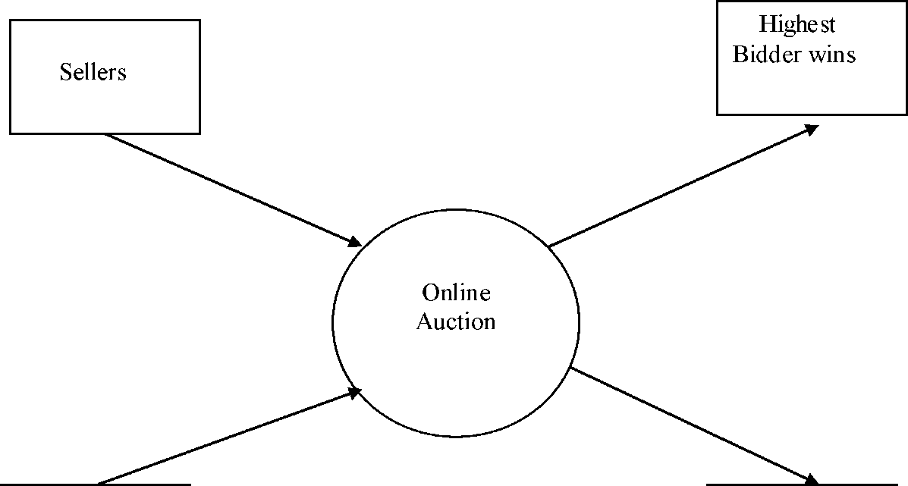
CHAPTER 13
Bidders
FIGURES

Fig 13.1 LOW LEVEL0 DFD
Seller Collects Bid Amt

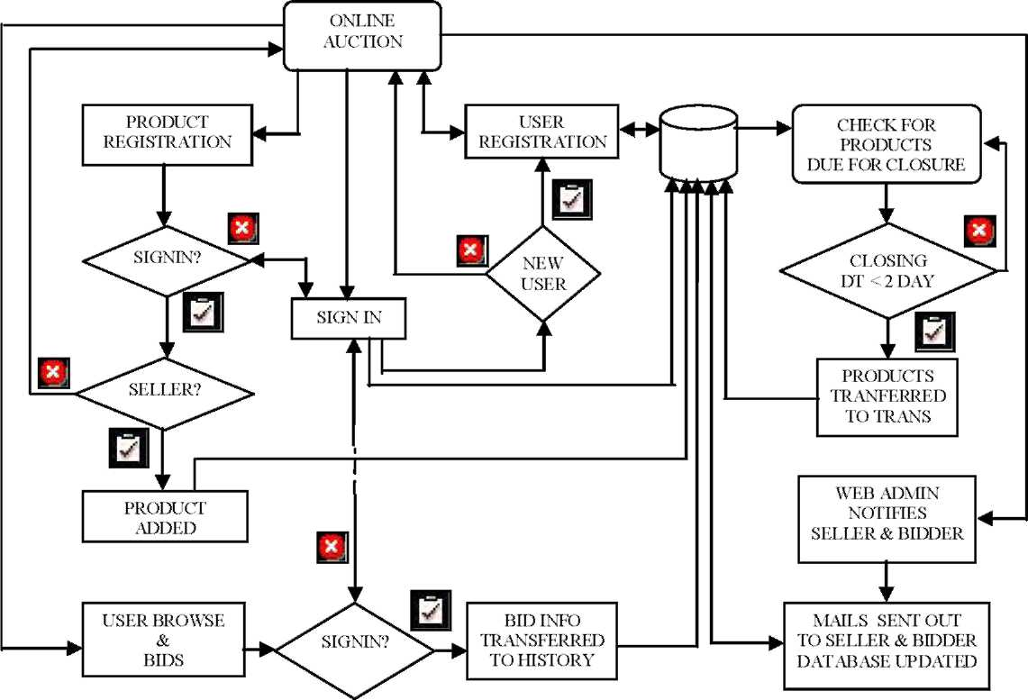

Fig13.2 HIGH LEVEL DFD
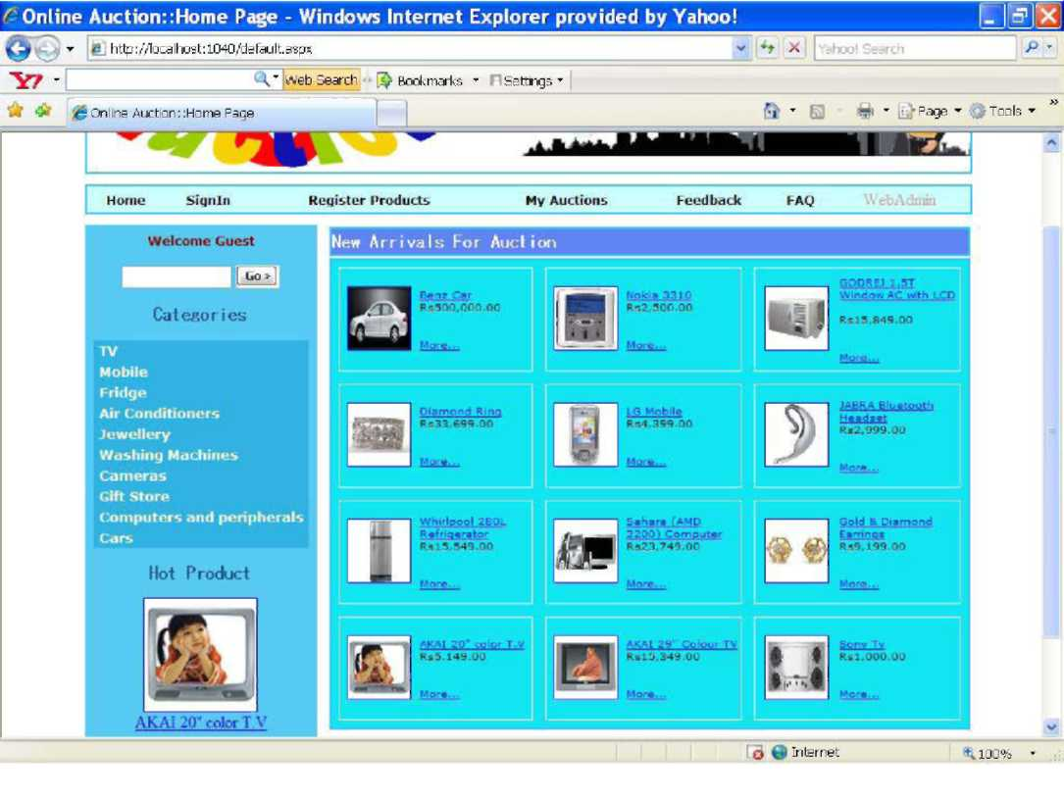

Fig 13.3 HOME PAGE
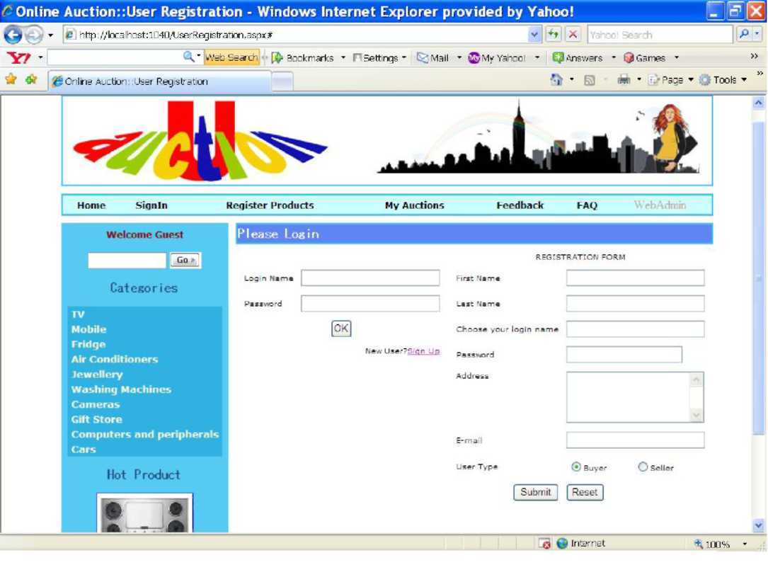
Fig 13.4 USER LOGIN AND REGISTRATION FORM
Users can login and New user can register through this form.

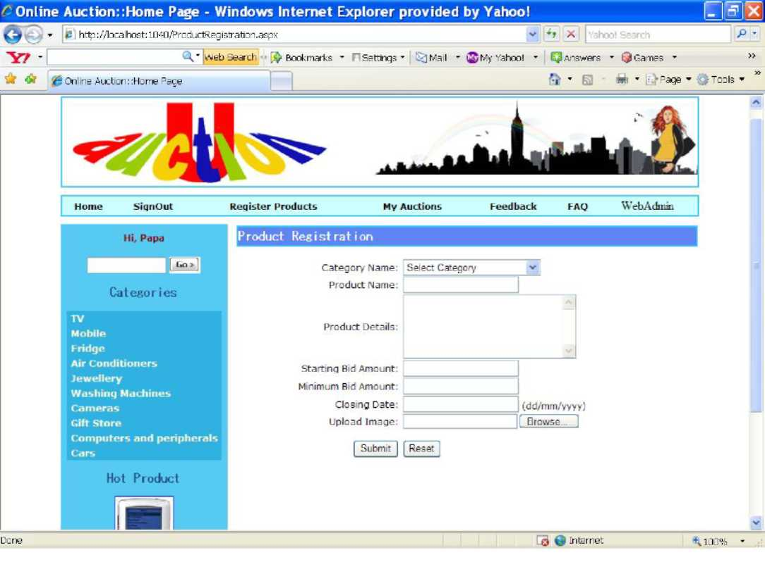
Fig 13.5 PRODUCT REGISTRATION FORM
Seller have to register his products before placing it for bidding.

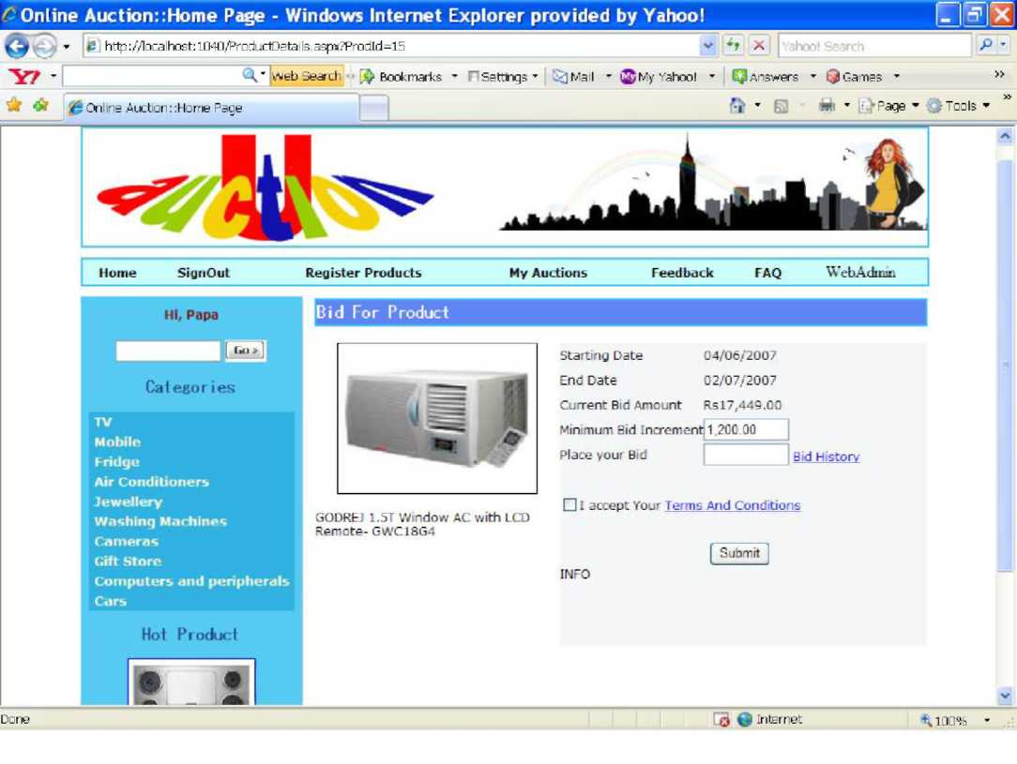
Fig 13.6 BIDDING FORM
Bidders can place bid value for their favourite products through this form.
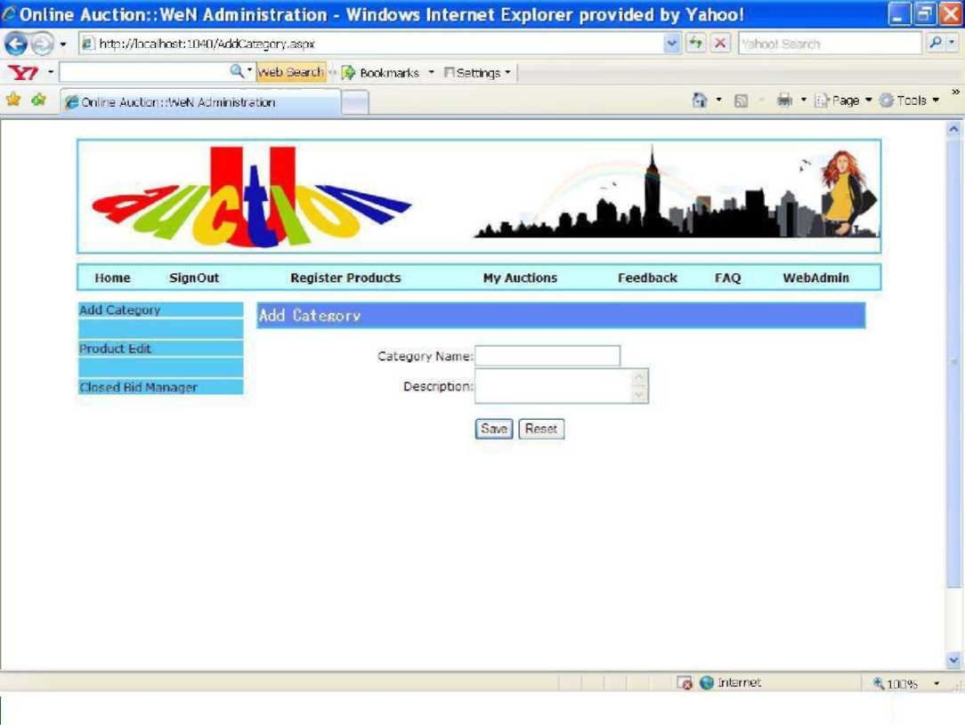
Fig 13.7 CATEGORY ADDITION FORM
WebAdministrator can add categories through this form.
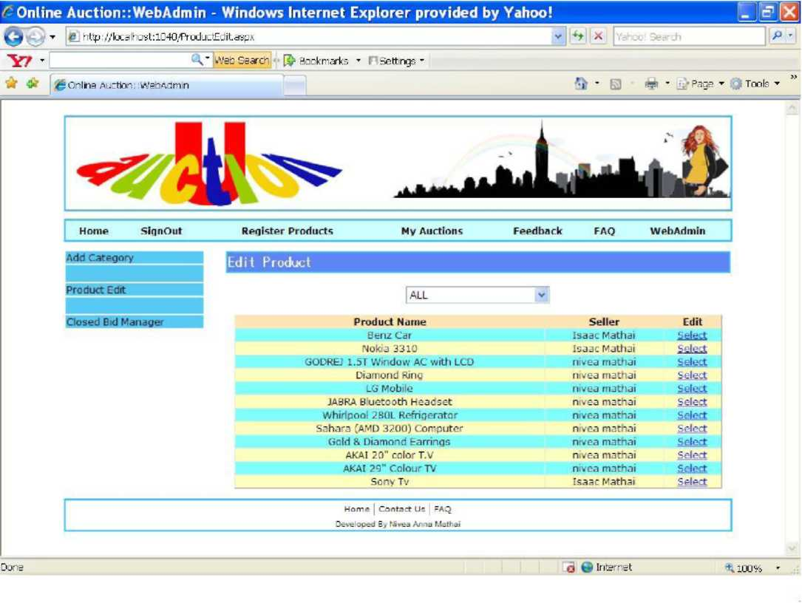
Fig 13.8 PRODUCT EDITING FORM 1
WebAdministrator can select the product he want to edit by category through this form.
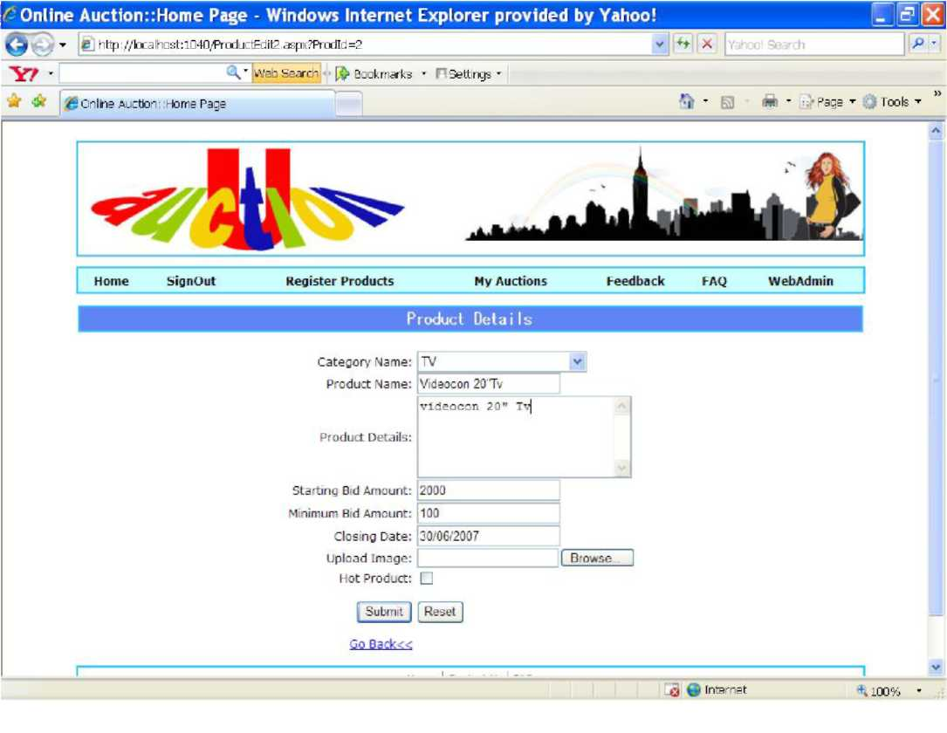
Fig 13.9 PRODUCT EDITING FORM 2
WebAdministrator can edit productdetails through this form.

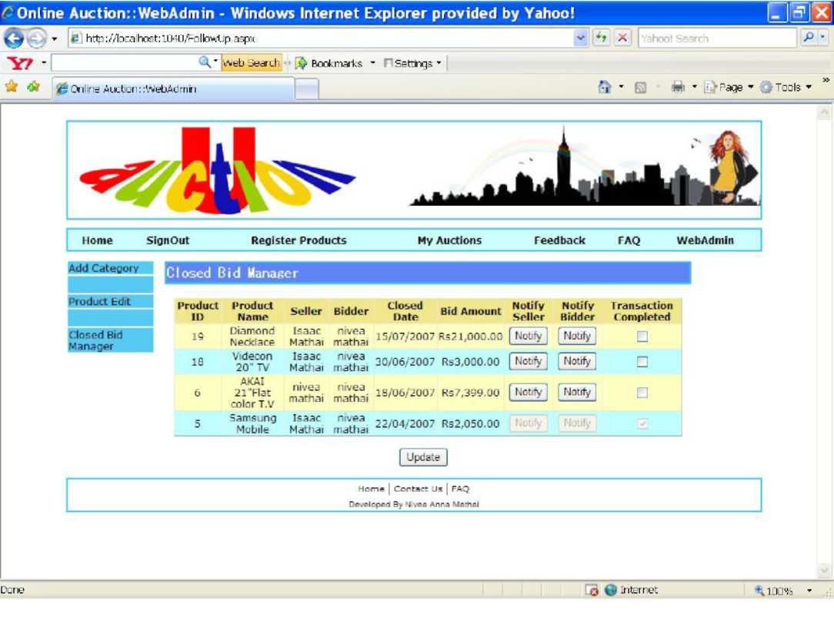
Fig 13.10 CLOSED BID MANAGER
WebAdministrator can notify both seller and buyer and can perform updation operation through this form.

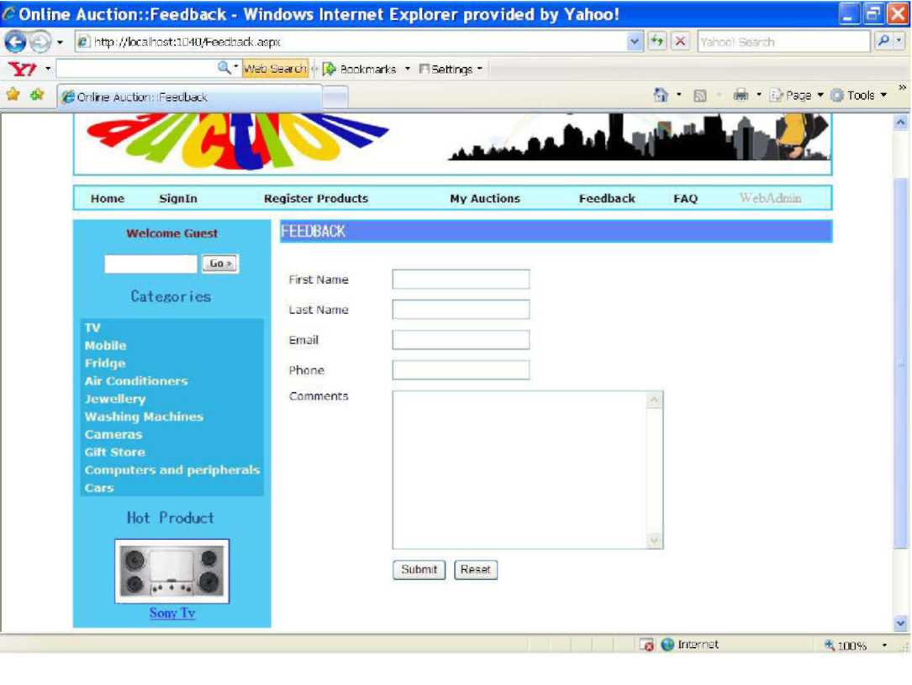
Fig 13.11 FEEDBACK
Users can send their feedback through this form.
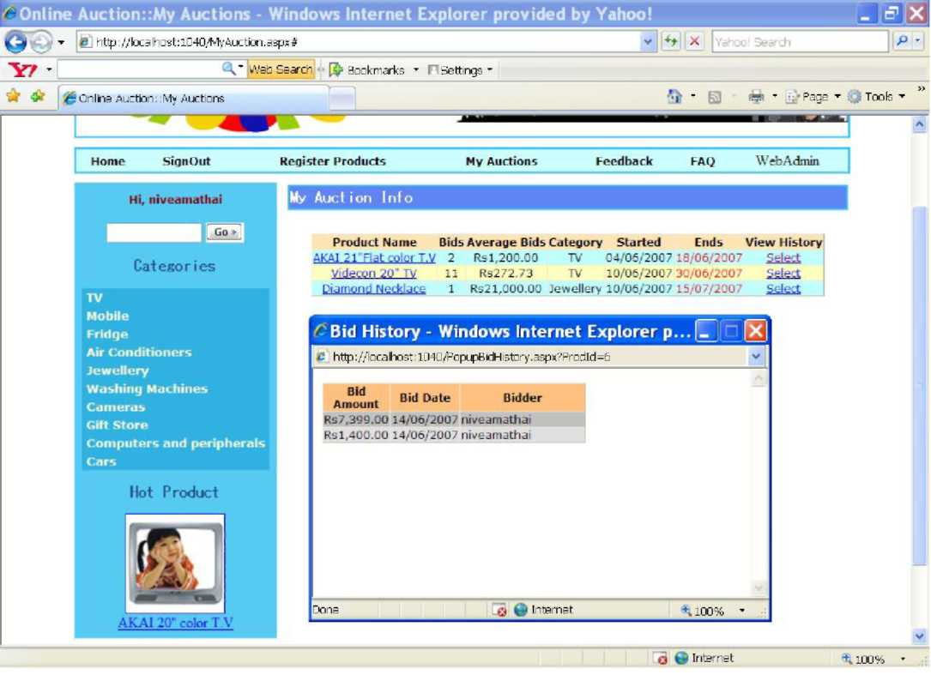
Fig 13.12 MY AUCTION FORM
Both seller and bidder can view his/ her status.
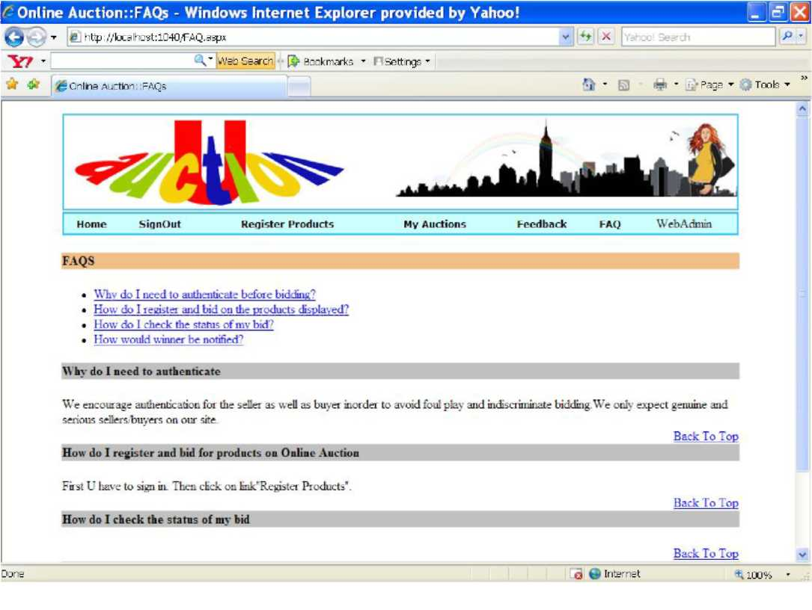
Fig 13.13 FAQ FORM
This page contains frequently asked questions.

CHAPTER 14 CONCLUSION

The project report entitled "ONLINE AUCTION" has come to its conclusion. The new system has been developed with so much care that it is free of errors and at the same time efficient and less time consuming. System is robust. Also provision is provided for future developments in the system.

APPENDICES

OVERVIEW OF MICROSOFT.NET

.NET represents Microsoft's vision of the future of applications in the Internet age. .NET provides enhanced interoperability features based upon open Internet standards. Microsoft .NET represents a great improvement. .

Microsoft .NET provides the following:
- A robust runtime platform, the CLR
- Multiple language development
- An extensible programming model, the .NET Framework, which provides a large class library of reusable code available from multiple languages
- A networking infrastructure built on top of Internet standards that supports a high level of communication among applications
- A new mechanism of application delivery, the Web service, that supports the concept of an application as a service
- Powerful development tools

.NET Framework Overview

The .NET Framework consists of the CLR, the .NET Framework Class Library, the Common Language Specification (CLS), a number of .NET languages, and Visual Studio .NET.

Common Language Runtime
The runtime environment provided by .NET, the CLR, manages the execution of code and provides useful services. The services of the CLR are exposed through programming languages. The syntax for these services varies from language to language, but the underlying execution engine providing the services is the same.
Not all languages expose all the features of the CLR. The language with the best mapping
45 to the CLR is the new language C#. VB.NET, however, does an admirable job of exposing the functionality.

.NET Framework Class Library

The .NET Framework class library is huge, comprising more than 2,500 classes. All this functionality is available to all the .NET languages. The library consists of four main parts:
1. Base class library (which includes networking, security, diagnostics, I/O, and other
types of operating system services)
- Data and XML classes
- Windows UI
- Web services and Web UI

Common Language Specification

The CLS is an agreement among language designers and class library designers about those features and usage conventions that can be relied upon. CLS rules apply to public features that are visible outside the assembly where they are defined.

Languages in .NET

Microsoft itself is providing four CLS-compliant languages. VB.NET, C#, and C++ with managed extensions are extenders. Jscript .NET is a consumer.

Visual Studio .NET 2003
Visual Studio .NET 2003 includes a range of new features and enhancements for every type of developer, and offers key improvements directed at mobile device developers and enterprise developers.
Base classes provide standard functionality such as input/output, string manipulation, security management, network communications, thread management, text management, and user interface design features.
The ADO.NET classes enable developers to interact with data accessed in the form of XML through the OLE DB, ODBC, Oracle, and SQL Server interfaces. The ASP.NET classes
support the development of Web-based applications and Web services. The Windows Forms classes support the development of desktop-based smart client applications.

ASP.NET

ASP.NET is a programming framework built on the common language runtime that can be used on a server to build powerful Web applications. ASP.NET offers several important advantages over previous Web development models:

Enhanced Performance
ASP.NET is compiled common language runtime code running on the server. Unlike its interpreted predecessors, ASP.NET can take advantage of early binding, just-in-time compilation, native optimization, and caching services right out of the box. This amounts to dramatically better performance before you ever write a line of code

World-Class Tool Support
The ASP.NET framework is complemented by a rich toolbox and designer in the Visual Studio integrated development environment. WYSIWYG editing, drag-and-drop server controls, and automatic deployment are just a few of the features this powerful tool provides.

Power and Flexibility.
Because ASP.NET is based on the common language runtime, the power and flexibility of that entire platform is available to Web application developers. The .NET Framework class library, Messaging, and Data Access solutions are all seamlessly accessible from the Web. ASP.NET is also language-independent, so you can choose the language that best applies to your application or partition your application across many languages.

Simplicity
ASP.NET makes it easy to perform common tasks, from simple form submission and client authentication to deployment and site configuration. For example, the ASP.NET page framework allows you to build user interfaces that cleanly separate application logic from presentation code and to handle events in a simple, Visual Basic - like forms processing model. Additionally, the common language runtime simplifies development, with managed code services such as automatic reference counting and garbage collection

Manageability
ASP.NET employs a text-based, hierarchical configuration system, which simplifies applying settings to your server environment and Web applications. Because configuration information is stored as plain text, new settings may be applied without the aid of local administration tools. This "zero local administration" philosophy extends to deploying ASP.NET Framework applications as well. An ASP.NET Framework application is deployed to a server simply by copying the necessary files to the server.

Scalability and Availability
ASP.NET has been designed with scalability in mind, with features specifically tailored to improve performance in clustered and multiprocessor environments. Further, processes are closely monitored and managed by the ASP.NET runtime, so that if one misbehaves (leaks, deadlocks), a new process can be created in its place, which helps keep your applications constantly available to handle requests

Customizability and Extensibility
ASP.NET delivers a well-factored architecture that allows developers to "plug in" their code at the appropriate level. In fact, it is possible to extend or replace any subcomponent of the ASP.NET runtime with your own custom-written component.

Security
With built in Windows authentication and per-application configuration, you can be assured that your applications are secure.

Language Support
The Microsoft .NET Platform currently offers built-in support for three languages: C#, Visual Basic, and JScript.

Language Compatibility
The differences between the VBScript used in ASP and the Visual Basic .NET language used in ASP.NET are by far the most extensive of all the potential migration issues. Not only has ASP.NET departed from the VBScript language to "true" Visual Basic, but the Visual Basic language itself has undergone significant changes in this release.

TOOL SELECTED: VB. NET

Visual Basic.Net is designed to be a fast and easy way to create .NET applications, including Web services and ASP.NET Web applications. Applications written in Visual Basic are built on the services of the common language runtime and take full advantage of the .NET Framework.

Visual Basic .NET (VB.NET) is an object-oriented computer language that can be viewed as an evolution of Microsoft's Visual Basic (VB) implemented on the Microsoft .NET framework. Its introduction has been controversial, as significant changes were made that broke backward compatibility with VB and caused a rift within the developer community.

It is fully integrated with the .NET Framework and the common language runtime,1 which together provide language interoperability, garbage collection, enhanced security, and improved versioning support.

MICROSOFT SQL SERVER 2000

SQL Server 2000 exceeds dependability requirements and provides innovative capabilities that increase employee effectiveness, integrate heterogeneous IT ecosystems, and maximize capital and operating budgets. SQL Server 2000 provides the enterprise data management platform your organization needs to adapt quickly in a fast-changing environment. With the lowest implementation and maintenance costs in the industry, SQL Server 2000 delivers rapid return on your data management investment. SQL Server 2000 supports the rapid development of enterprise-class business applications that can give your company a critical competitive advantage.

Easy-to-Use Business Intelligence
These tools through rich data analysis and data mining capabilities that integrate with familiar applications such as Microsoft Office, SQL Server 2000 enables you to provide all of your employees with critical, timely business information tailored to their specific information needs. Every copy of SQL Server 2000 ships with a suite of BI services.

Self-Tuning and Management Capabilities
Revolutionary self-tuning and dynamic self-configuring features optimize database performance, while management tools automate standard activities. Graphical tools and wizards simplify setup, database design, and performance monitoring, allowing database administrators to focus on meeting strategic business needs.

Data Management Applications and Services
Unlike its competitors, SQL Server 2000 provides a powerful and comprehensive data management platform. Every software license includes extensive management and development tools, a powerful extraction, transformation, and loading (ETL) tool, business intelligence and analysis services, and new capabilities such as Notification Services. The result is the best overall business value available.

SQL Server 2000 Enterprise Edition

Enterprise Edition includes the complete set of SQL Server data management and analysis features and is uniquely characterized by several features that make it the most scalable and available edition of SQL Server 2000. It scales to the performance levels required to support the largest Web sites, Enterprise Online Transaction Processing (OLTP) systems and Data Warehousing systems. Its support for failover clustering also makes it ideal for any mission critical line-of-business application.
RESUME

The developed system is flexible and changes can be made easily. The system is developed with an insight into the necessary modification that may be required in the future. Hence the system can be maintained successfully without much rework.

One of the main future enhancements of our system is to enhance the system security by adding the option of Blacklisting defaulting bidders. There also can be option for rating sellers. Online payment settlement can be incorporated into the system.
REFERENCES
- Fred Barwell,Richard Blair,..(2004)'Professional VB.NET 2nd Edition',Wrox Press Ltd.
- www.auction.indiatimes.com
- www.ebay.com
- www.msdn. com

