Create a knowledge base using propositional logic and show that the given query entails the knowledge base or not

i)((not q) or (not p) or r) and ((not q) and p)and q

def evaluate_expression(q, p, r):

expression_result = ((not q) or (not p) or r) and ((not q) and p)and q

return expression_result

def generate_truth_table():

print("\tExpression (KB)")

print("---|---|---|-----------------|------------")

for q in [True, False]:

for p in [True, False]:

for r in [True, False]:

expression_result = evaluate_expression(q, p, r)

query_result = r

print(f"{expression_result}| {query_result}")

def query_entails_knowledge():

for q in [True, False]:

for p in [True, False]:

for r in [True, False]:

expression_result = evaluate_expression(q, p, r)

query_result =r

if expression_result and not query_result:

return False

return True

def main():

generate_truth_table()

if query_entails_knowledge():

print("\nQuery entails the knowledge.")

else:

print("\nQuery does not entail the knowledge.")

if __name__ == "__main__":

main()

OUTPUT:

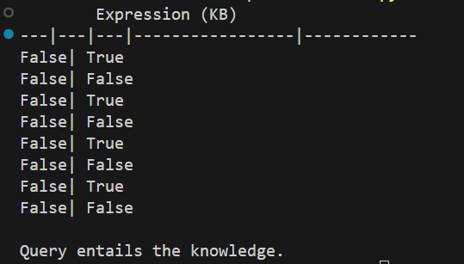

ii)(p or q) and (not r or p)

def evaluate_expression(q, p, r):

expression_result = (p or q) and (not r or p)

return expression_result

def generate_truth_table():

print("\tExpression (KB)")

print("---|---|---|-----------------|------------")

for q in [True, False]:

for p in [True, False]:

for r in [True, False]:

expression_result = evaluate_expression(q, p, r)

query_result = p and r

print(f"{expression_result}| {query_result}")

def query_entails_knowledge():

for q in [True, False]:

for p in [True, False]:

for r in [True, False]:

expression_result = evaluate_expression(q, p, r)

query_result = p and r

if expression_result and not query_result:

return False

return True

def main():

generate_truth_table()

if query_entails_knowledge():

print("\nQuery entails the knowledge.")

else:

print("\nQuery does not entail the knowledge.")

if __name__ == "__main__":

main()

OUTPUT:

