I. Perform the following DB operations using MongoDB.

1. Create a database “Student” with the following attributes Rollno, Age, ContactNo, Email-Id.



2. Insert appropriate values

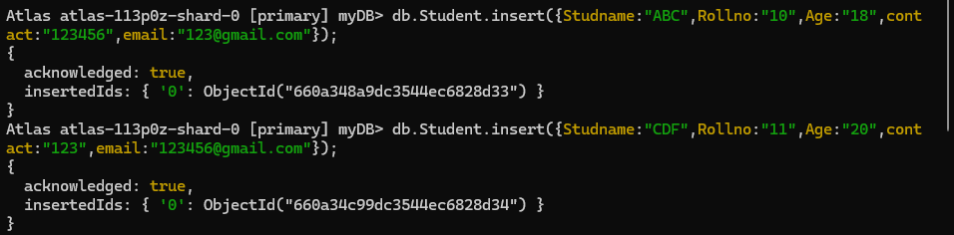

3. Write query to update Email-Id of a student with rollno 10.

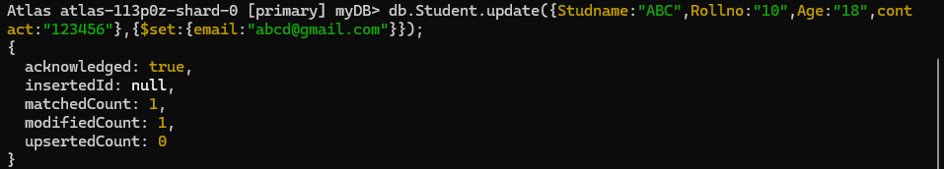

4. . Replace the student name from “ABC” to “FEM” of rollno 11

