BUSINESS REQUIREMENTS DOCUMENT
Carbon Emission Tracking Dashboard
TMS Integration | Shipment-based Emission Monitoring
Document Version | Status | Prepared By | Date
1.0 | Draft | Vaishnavi Singh( Business Analyst) | April 23, 2026

Project | System
Carbon Emission Dashboard | TMS – Shipment Module

1. Executive Summary
This document defines the business requirements for the Carbon Emission Tracking Dashboard, a web-based analytical tool that enables the organization to monitor, measure, and report on carbon emissions generated across its logistics operations. The dashboard aggregates carbonEmissionValue data from completed shipments in the Transport Management System (TMS) and presents it through interactive charts and KPI tiles.

This BRD covers two scopes:
- Scope 1 – Carbon Emission vs Time: Time-based emission tracking with bar charts filtered by year, quarter, month, and week.
- Scope 2 – Carbon Emission vs Customer: Customer-wise emission dashboard with drill-down shipment reports and an integrated emission certificate mailing feature.

2. Business Objectives
- Provide a single source of truth for carbon emissions generated by the company’s shipments.
- Enable time-period based analysis (annual, quarterly, monthly, weekly) of total CO₂ emissions.
- Correlate shipment volume with emission data to derive per-shipment emission averages.
- Support ESG reporting, regulatory compliance, and sustainability target monitoring.
- Empower logistics managers to identify high-emission periods and take corrective action.
- Enable customer-wise emission tracking and drill-down reporting for transparency and accountability.
- Automate the generation and delivery of emission certificates to customers via email, eliminating the need for manual certificate dispatch by the IT team.

3. Scope

3.1 In Scope – Scope 1: Carbon Emission vs Time
- Carbon emission data aggregation from TMS Shipment Module via REST API.
- Time-period filtering: Year, Quarter, Month, Week, Custom Date Range.
- Bar chart visualization of emissions grouped by selected time period.
- KPI summary tiles: Total Emissions, Total Shipments, Avg Emission/Shipment.
- Shipment count display for the selected time period.
- Reading and summing the carbonEmissionValue custom field from all completed shipments.

3.2 In Scope – Scope 2: Carbon Emission vs Customer
- A dropdown selector to switch between two dashboard views:
- Carbon Emission vs Time (Scope 1)
- Carbon Emission vs Customer (Scope 2)
- Customer-wise bar chart showing total carbon emissions per customer for the selected time period.
- Time period filter and customer filter for the customer emission view.
- Drill-down shipment report (road + rail) on bar click, covering all 13 required data fields.
- Download option for the drill-down shipment report.
- Email / Certificate dispatch feature: compose and send emission certificate to customer with CC, Subject, and Body options.

3.3 Out of Scope
- Manual data entry of emission values.
- Emissions from non-shipment sources (offices, warehouses, etc.).
- Predictive or AI-based emission forecasting.
- Integration with external carbon offset or trading platforms.

Scope 1: Carbon Emission vs Time

4. What the Dashboard Does
The dashboard will:
- Connect to the TMS Shipment Module and read completed shipments
- Add up all the carbon emission values from those shipments
- Display the total emissions on a chart, broken down by the time period you choose
- Let you filter by different time periods — from a few days up to years
- Show the emissions for both road shipments and the potential savings if rail was used instead

5. Time Period Filter
You will be able to choose how much data to view at once. The available time period options are:

Option | What it shows | How the chart is grouped
3 Days | Last 3 days of shipments | One bar per day
4 Days | Last 4 days of shipments | One bar per day
1 Week | Last 7 days of shipments | One bar per day
1 Month | Last 30 days of shipments | One bar per week
2 Months | Last 2 months of shipments | One bar per week
5 Months | Last 5 months of shipments | One bar per month
1 Year | Last 12 months of shipments | One bar per month
2 Years | Last 24 months of shipments | One bar per quarter

When you change the time period, the chart and all the summary numbers will automatically refresh — no need to reload the page.

6. Emission Data Fields
Every shipment in the TMS has two custom fields that this dashboard will use:

Field Name | Shipment Type | What it means
carbonEmissionValue | Road Shipment & Rail Shipment | The actual CO₂ emitted (in kg) for this shipment travelling by road or rail
aversionValue_rail | Rail (Comparison) | The CO₂ that would have been emitted if this shipment had gone by rail instead — used to show potential savings

The dashboard will sum up all carbonEmissionValue figures for road shipments in the chosen period. It will also sum up all aversionValue_rail figures so you can compare road vs rail emissions side by side.
Note: If a shipment is missing either value, it will still be counted in the total number of shipments, but left out of the emission totals.

7. What Will Be Displayed

7.1 Summary Tiles (top of dashboard)
Four summary boxes will appear at the top of the dashboard showing:

Summary Box | How it's calculated | Unit
Total Road Emissions | Sum of all carbonEmissionValue in the period | kg CO₂
Total Rail Comparison | Sum of all aversionValue_rail in the period | kg CO₂
Total Shipments | Count of shipments in the selected period | Shipments
Avg Road Emission per Shipment | Total Road Emissions ÷ Total Shipments | kg CO₂ / shipment

7.2 Emission Chart
A bar chart will show the carbon emissions across time. Each bar represents one sub-period (e.g. one day, one week, one month) within your chosen filter. The chart will show:
- Blue bars for road emissions (carbonEmissionValue)
- Green bars for rail comparison (aversionValue_rail)
- A tooltip when you hover over a bar showing: the period, total road emissions, total rail comparison, and shipment count for that sub-period

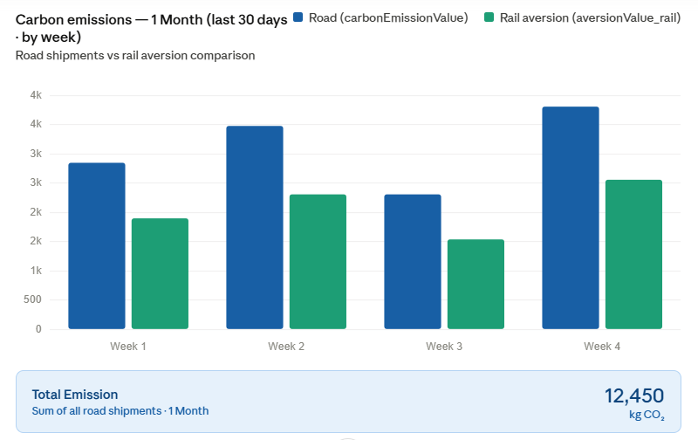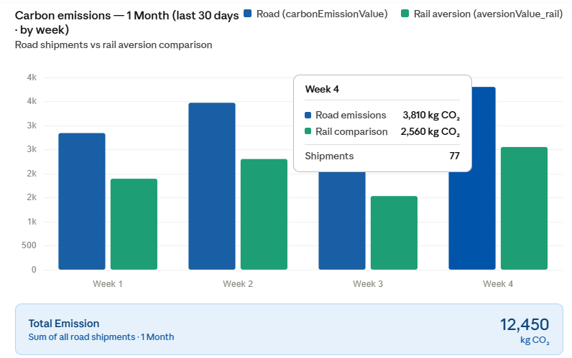

7.3 Total Emission Display
Directly below the chart, a clearly labeled field called Total Emission will show the combined sum of all road carbon emissions for the selected time period as a single number.

Example — if you select 1 Month:
- The chart will show 4 bars, one per week
- Below the chart, the Total Emission field will display the overall total for all 4 weeks combined, e.g.:

Total Emission (Last 30 Days) | 12,450 kg CO₂

This field updates automatically whenever you change the time period filter. It always reflects the sum of all carbonEmissionValue figures for every shipment in the chosen window — giving you one clear number at a glance, without needing to add up the individual bars.

7.4 Shipment Count
The total number of shipments completed in the selected period will be displayed both in the summary tiles and as a secondary detail in the chart tool-tip.

8. Where the Data Comes From
The dashboard can use two TMS REST API calls to fetch all the data it needs. Both APIs are read-only — the dashboard never writes anything back to TMS.

8.1 Step 1 — Get the List of Completed Shipments
This API returns a list of shipments filtered by status and time period. The dashboard calls this first to find all shipments in the selected date range.

Endpoint:
https://tmsapis.cjdarcl.com/shipment-view/shipments/v1

Method: GET

The filters are sent as a URL-encoded JSON object in the query string. The decoded filter structure is:

{
"_shipmentStatus_": {
"shipmentStatus": ["Completed"]
},
"__version": 2,
"completionTime": {
"isTillExpression": false,
"isFromExpression": false,
"from": 1775027820000,
"till": 1777274258000
}
}

8.2 Step 2 — Get Emission Values for Each Shipment
The shipment list API does not return carbon emission values directly. For each shipment ID returned in Step 1, the dashboard calls this second API to read the individual shipment detail and extract the emission fields.

Endpoint:
https://tmsapis.cjdarcl.com/shipment/v1/shipment/{shipmentId}?skipCn=true

Method: GET

Replace {shipmentId} with each shipment's unique ID from Step 1. The skipCn=true parameter skips non-essential data to speed up the response.

Custom fields read from each shipment response:

Custom Field | Data Type | Used For
carbonEmissionValue | Number (kg CO₂) | Actual CO₂ emitted by this road shipment. Summed to produce Total Road Emissions.
aversionValue_rail | Number (kg CO₂) | CO₂ that would have been emitted if this shipment went by rail. Summed to produce Rail Comparison Total.

If either field is missing or null for a shipment, that shipment is still counted in the total shipment count but excluded from the emission sums.

8.3 How the Two API Calls Work Together
Every time the user selects or changes a time period, the dashboard runs this sequence:

Step | Action | Detail
1 | Call the shipment list API | Pass completionTime.from and .till for the chosen period, with shipmentStatus = Completed and __version = 2. Collect all shipment IDs across all pages.
2 | Call the individual API per shipment | For each shipment ID, call the detail endpoint with skipCn=true and read carbonEmissionValue and aversionValue_rail.
3 | Calculate totals | Sum all carbonEmissionValue values for Total Road Emissions. Sum all aversionValue_rail values for Rail Comparison Total.
4 | Render the dashboard | Update KPI tiles, bar chart, and Total Emission field with the results.

9. What's Not Included
To keep the scope clear, the following are not part of this dashboard:
- Manually entering emission values
- Emissions from non-shipment sources (offices, warehouses, etc.)
- Predicting future emissions
- Writing any data back into the TMS

10. Key Assumptions
- The TMS API is available and accessible from the environment where the dashboard is hosted
- The carbonEmissionValue and aversionValue_rail fields are filled in for most shipments
- Both emission values are stored in kilograms (kg CO₂)
- The API returns paginated results and the dashboard will handle all pages to ensure accurate totals.

11. Acceptance Checklist
The dashboard will be considered complete and ready when:
- It loads data within 3 seconds for up to 10,000 shipments
- Changing the time period filter immediately updates all numbers and the chart
- The total road emissions equal the sum of all carbonEmissionValue values from the API for that period
- The total rail comparison equals the sum of all aversionValue_rail values from the API for that period
- The shipment count matches the number of records returned by the API
- Shipments with missing emission values are counted in shipment totals but not in emission sums
- A clear message is shown if no shipments exist in the selected period

12. Dashboard UI Design
This section describes how the dashboard should look and behave. It is intended as a guide for the development team and for sign-off by stakeholders.

12.1 Overall Layout
The dashboard is a single page with four zones arranged top to bottom:

Zone | Component | Description
1 — Top bar | Title + date stamp | Dashboard name on the left, last-updated date on the right
2 — Filter bar | Calendar date picker button | Opens the time period selector dropdown (see Section 10.2)
3 — KPI tiles | Four summary cards | Total Road Emissions, Rail Comparison, Total Shipments, Avg Emission per Shipment
4 — Chart area | Bar chart + Total Emission field | Grouped bar chart with the Total Emission box directly below it

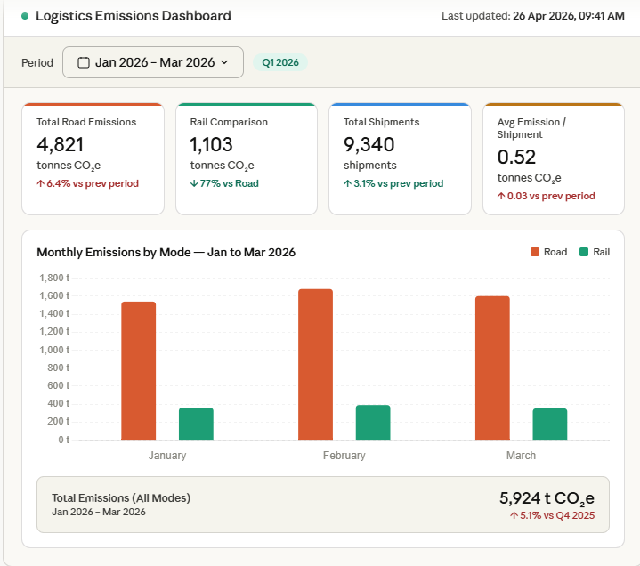

12.2 Time Period Filter — Calendar Dropdown
Instead of simple buttons, the time period filter opens as a dropdown panel that looks and works exactly like a date picker. When the user clicks the filter button, a panel appears with two parts side by side:

Left side — Preset options list:
A list of named time periods the user can click to instantly select a range. The active selection is highlighted in blue. The preset options are:

Preset Label | Date Range it Covers | How Chart is Grouped
Today | Current day only | By hour
Yesterday | Previous day only | By hour
This Week | Monday to today | By day
Previous Week | Last full Mon–Sun week | By day
Last 7 Days | Rolling last 7 days | By day
This Month | 1st of month to today | By week
Previous Month | Last full calendar month | By week
Last 30 Days | Rolling last 30 days | By week
Last 2 Months | Rolling last 2 months | By week
Last 5 Months | Rolling last 5 months | By month
Last 1 Year | Rolling last 12 months | By month
Last 2 Years | Rolling last 24 months | By quarter
Custom Range | User picks start and end date | Auto — based on range length
Reset | Clears the current selection | —

Right side — Calendar panel:
A monthly calendar grid is shown next to the presets. The user can navigate forward and backward through months using arrow buttons. Clicking a date sets the From date; clicking a second date sets the To date. The selected range is highlighted in blue across the calendar. Two fields at the bottom of the panel show the chosen From and To dates as text. An Apply button confirms the selection and refreshes the dashboard.

Behaviour rules for the calendar picker:
- Clicking a preset automatically fills the From and To date fields and highlights the range on the calendar — the user can apply straight away or adjust the dates manually
- Selecting Custom Range clears the current selection so the user can pick freely on the calendar
- The Apply button closes the dropdown and triggers a data refresh
- Clicking anywhere outside the dropdown also closes it without applying changes
- The filter button label always shows the currently active preset name or Custom Range
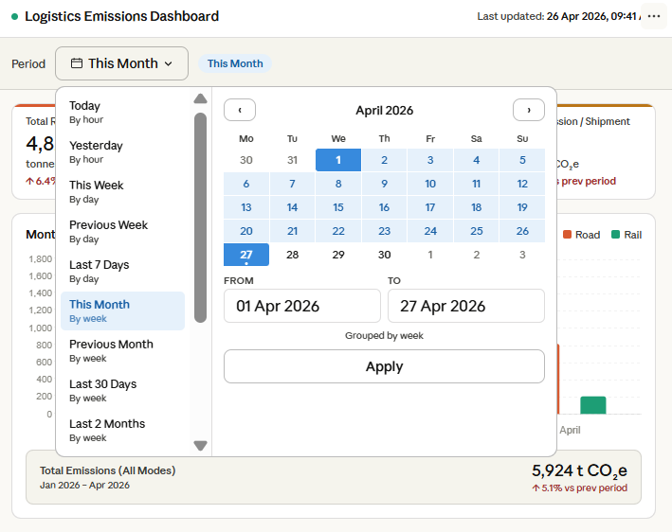

12.3 KPI Summary Tiles
Four cards sit in a row below the filter bar. Each card shows a short label and a large number:

Card | Value colour | Label | Unit shown
Total Road Emissions | Blue | Total road emissions | kg CO₂
Rail Comparison | Green | Rail comparison (aversion) | kg CO₂
Total Shipments | Default | Total shipments | shipments
Avg Emission/Shipment | Default | Avg emission / shipment | kg CO₂ / shipment
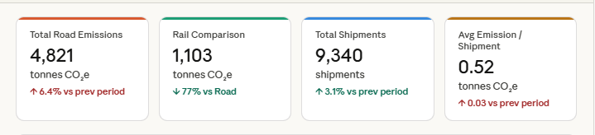

12.4 Emission Bar Chart
The main chart area shows a grouped bar chart. For each sub-period (e.g. each week within a month), two bars are shown side by side — one blue bar for road emissions and one green bar for the rail aversion comparison. A legend in the top-right of the chart identifies the two colours. The Y-axis shows kg CO₂ values. The X-axis shows period labels (e.g. Week 1, Week 2).

Hovering over a bar shows a tooltip with: the period label, total road emissions for that period, rail aversion total for that period, and shipment count for that period.

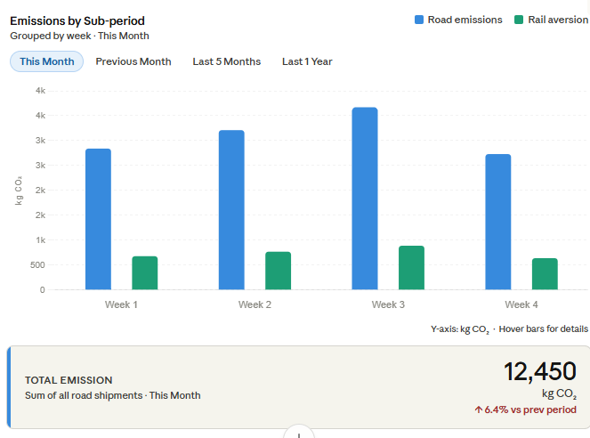

12.5 Total Emission Field
Immediately below the chart, a highlighted panel labeled Total Emission displays the single combined road emission total for the entire selected time period. It shows:
- A title: Total Emission
- A subtitle describing the period, e.g. Sum of all road shipments · This Month
- A large number showing the total value, e.g. 12,450
- A unit label: kg CO₂


This field updates automatically every time the user changes the time period filter. Its purpose is to give an immediate at-a-glance total without the user needing to add up the individual chart bars.

Scope 2: Carbon Emission vs Customer

What the Dashboard Does

The dashboard will:

• Connect to the TMS Shipment Module and read completed shipments
• Add up all the carbon emission values for each customer
• Display the total emissions on a chart, grouped by customer
• Let you filter by different time periods — from a few days up to years
• Let you filter and select specific customers
• Show emissions for both road shipments and rail comparison values
• Allow users to hover over a bar to view emission details for that customer
• Allow users to click on a customer bar to view a detailed shipment-level report
• Display all shipment details (road and rail) for the selected customer and time period
• Provide an option to download the shipment-level report
• Provide an option to send emission certificates directly to customers via email

13.1 Dashboard View Toggle (Dropdown)
The dashboard shall provide a drop-down selector at the top of the page allowing users to switch between two views:
Dropdown Option | View Description
Carbon Emission vs Time | Scope 1 – Emission trends over time periods (existing)
Carbon Emission vs Customer | Scope 2 – Emission breakdown by customer (new)

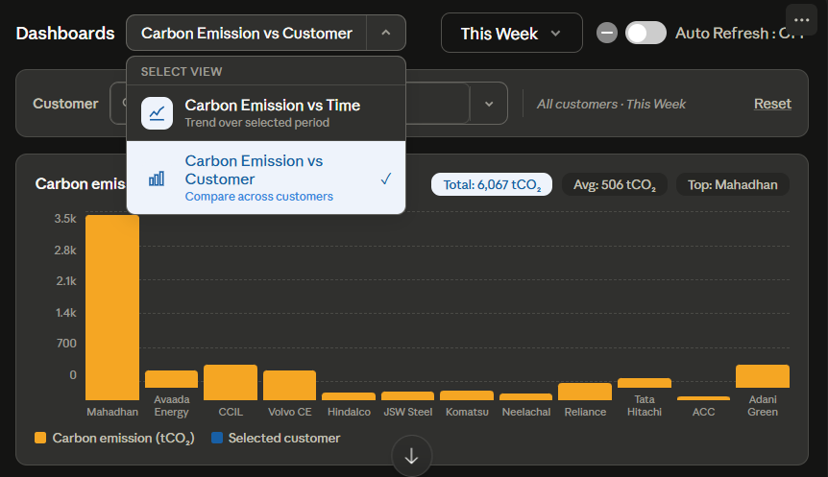
Switching views shall preserve the currently selected time period where applicable.

13.2 Filters
The Carbon Emission vs Customer view shall provide the following filters, consistent with the TMS UI design pattern:
- Time Period Filter: Year, Quarter, Month, Week, Custom Date Range.
- Customer Filter: A searchable dropdown to select a specific customer. When a customer is selected, the chart shows only that customer’s data. When no customer is selected, all customers are shown as individual bars.
Both filters shall update the chart and all metrics dynamically without page reload.

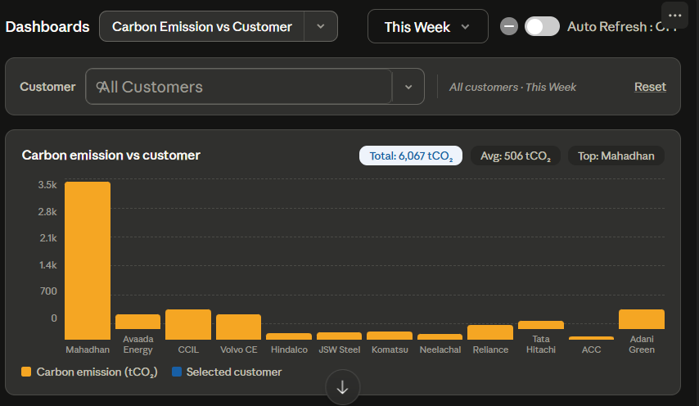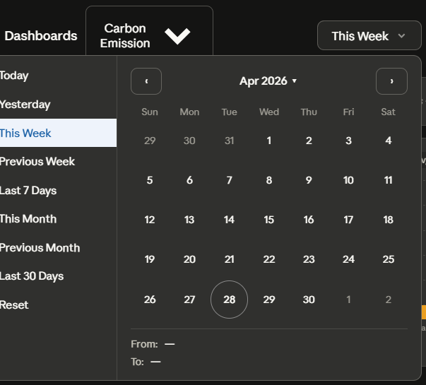
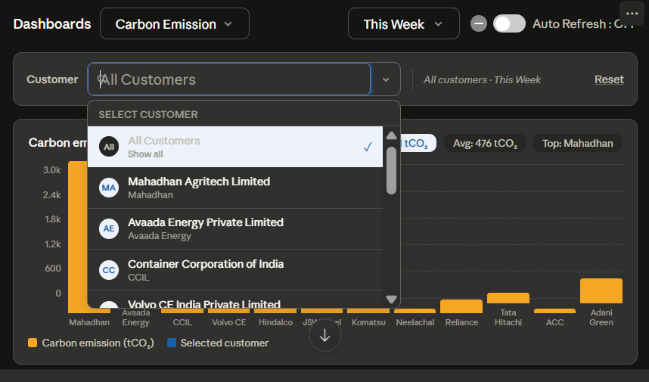

13.3 Customer-wise Bar Chart
The Customer Emission view shall render a bar chart where:
- Each bar represents a single customer’s total carbon emissions for the selected time period.
- The X-axis displays customer names or codes.
- The Y-axis displays total CO₂ emissions in kg CO₂e.
- Hovering over a bar shall show a tooltip: Customer Name, Total Emissions, Total Shipments.
- Clicking on a bar shall open the Drill-Down Shipment Detail Report for that customer (see Section 6.4).

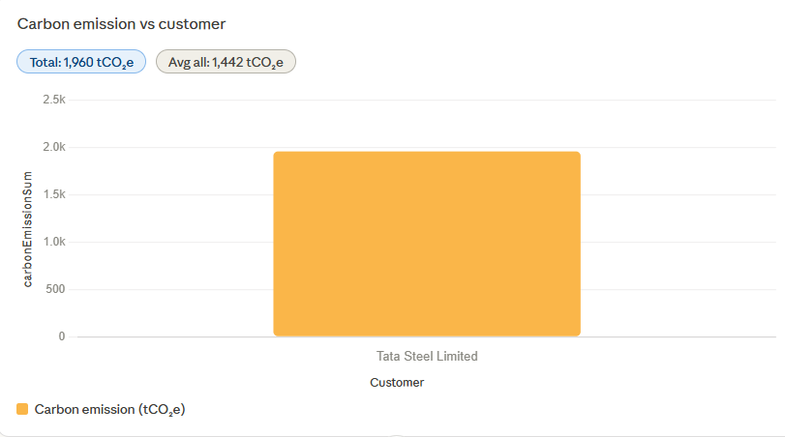

13.4 Drill-Down Shipment Detail Report
Clicking a customer bar shall display a detailed shipment report (modal or expanded panel) showing all shipments for that customer within the selected time period. This report shall cover both road and rail shipments.

13.4.1 Report Fields
Field Name | Description | Transport Mode
Shipment No. | Unique shipment identifier | Road + Rail
Consignment Number | Consignment reference number | Road + Rail
Vehicle Type | Type of vehicle used | Road
Source | Origin location of the shipment | Road + Rail
Destination | Destination location of the shipment | Road + Rail
Transportation Mode | Road / Rail / Multimodal | Road + Rail
carbonEmissionValue | CO₂ emitted for this shipment (kg CO₂e) | Road + Rail
TotalDistance | Total distance covered (km) | Road + Rail
fuelUsed | Fuel consumed (litres) | Road + Rail
aversionValue_lng | Aversion value for LNG alternative | Road + Rail
aversionValue_electric | Aversion value for electric alternative | Road + Rail
aversionValue_hydrogen | Aversion value for hydrogen alternative | Road + Rail
aversionValue_rail | Aversion value for rail alternative | Road
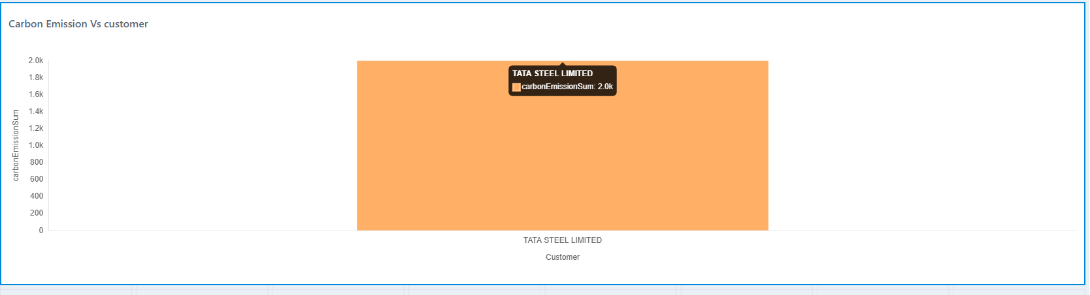
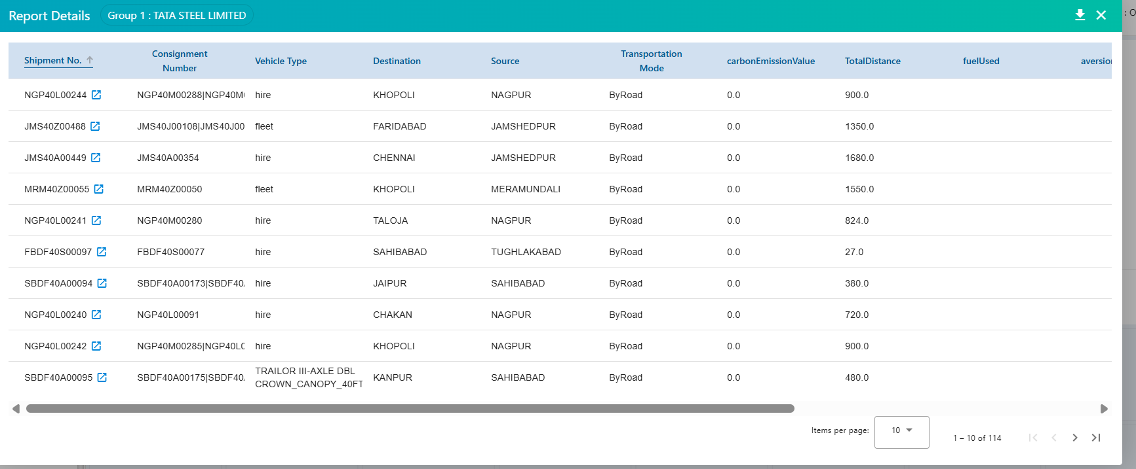
13.4.2 Report Behaviour
- The report is triggered by clicking any customer bar in the chart.
- All matching shipments for the selected customer and time period are displayed, covering both road and rail transport modes.
- Rows shall be sort-able by any column.
- A record count (total shipments shown) shall be displayed at the top of the report.

13.5 Download Option
A Download button shall be available in the top-right corner of the drill-down shipment report.
- Clicking Download shall export the currently displayed shipment report to Excel (.xlsx).
- The exported file shall include all columns listed in Section 6.4.1.
- The filename shall follow the format: CustomerName_EmissionReport_[Period].xlsx

13.6 Emission Certificate Email Feature
13.6.1 Overview
The dashboard shall provide an integrated email dispatch feature allowing authorized users to send an emission certificate directly to a customer’s email address. This replaces the current manual certificate-sending process handled by the IT team.

13.6.2 Access
A Mail / Send Certificate button shall be available in the top-right area of the Customer Emission view, alongside the Download button. It shall be accessible once a customer and time period are selected and report data is visible.

13.6.4 Email Compose Modal
Clicking the Mail button shall open an email compose modal with the following fields:
Field | Description | Required
To | Primary recipient email address (customer email) | Yes
CC | One or more CC email addresses | No
Subject | Email subject line (pre-filled, editable). Default: Carbon Emission Certificate – [Customer Name] – [Period] | Yes
Body | Email body text (pre-filled with standard template, editable) | Yes
Attachment | Emission certificate (auto-attached in the agreed certificate format) | Auto

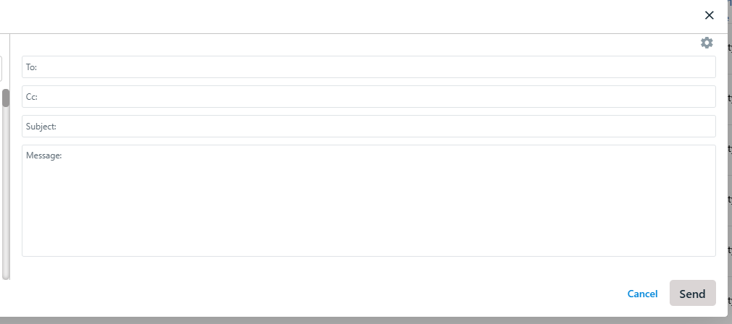
13.6.5 Certificate Format
The emission certificate attached to the email shall follow the format defined in the certificate template uploaded alongside this BRD. The certificate shall include:
- Customer name and details
- Time period covered
- Total carbon emissions (kg CO₂e)
- Total shipments (road + rail)
- Breakdown by transportation mode
- Company branding, authorised signatory, and date of issue
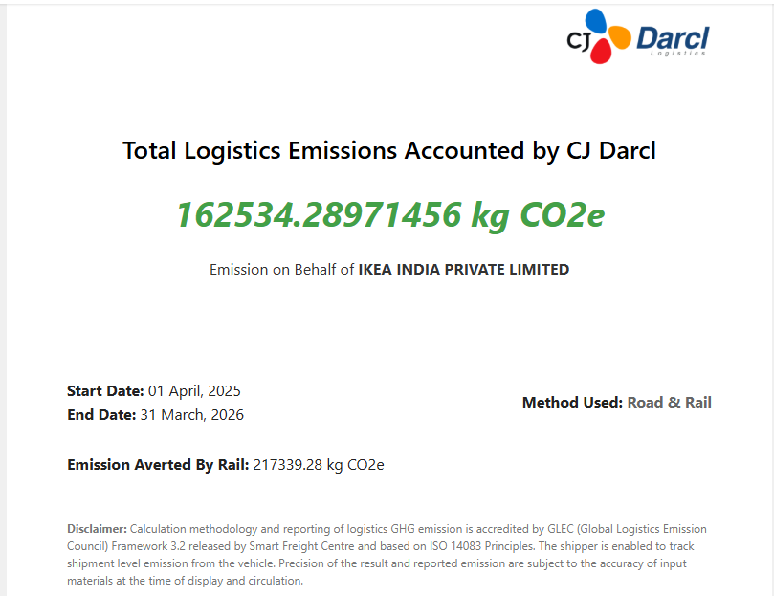
13.6.6 Email Dispatch
Upon clicking Send in the compose modal:
- The system shall validate all required fields (To, Subject, Body).
- The emission certificate shall be generated dynamically based on the selected customer, period, and shipment data.
- The email shall be dispatched to the recipient(s) with the certificate as an attachment.
- A success or failure notification shall be displayed to the user.
- A log of sent certificates (customer, period, sent by, sent at) shall be maintained for audit purposes.

14. Non-Functional Requirements
Requirement | Detail
Performance | Dashboard shall load initial data within 3 seconds for up to 10,000 shipments.
Availability | 99.5% uptime during business hours (06:00–22:00 IST).
Security | API calls shall use authenticated tokens; emission data is read-only.
Scalability | Architecture shall support up to 100,000 shipments per query without redesign.
Usability | Responsive design supporting desktop and tablet; WCAG 2.1 AA compliant.
Data Accuracy | Displayed totals shall match API source data with zero rounding error.
Email Delivery | Certificate emails shall be dispatched within 30 seconds of user action; delivery failures shall be surfaced immediately.
Audit Trail | All certificate email dispatch events shall be logged with user, customer, period, and timestamp.

Carbon Emission Dashboard – BRD v1.0 | Confidential | April 2026

