**PROFESSIONAL TRAINING REPORT**

**at**

**SATHYABAMA INSTITUITE OF SCIENCE AND TECHNOLOGY**

**(DEEMED TO BE UNIVERSITY)**

Submitted in partial fulfillment of the requirements for the award of Bachelor of Engineering Degree in Computer Science and Engineering

by

**VARUN DAS.G**

**(39111063)**



**DEPARTMENT OF COMPUTER SCIENCE AND ENGINEERING**

**SCHOOL OF COMPUTING**

**SATHYABAMA INSTITUTE OF SCIENCE AND TECHNOLOGY**

**JEPPIAAR NAGAR, RAJIV GANDHI SALAI,**

**CHENNAI - 600 119, TAMIL NADU**

**April 2022**

|  |  |  |
| --- | --- | --- |
|  | **SATHYABAMA**  **INSTITUTE OF SCIENCE AND TECHNOLOGY**  **(DEEMED TO BE UNIVERSITY)**  **Accredited with Grade “A” by NAAC**  (Established under Section 3 of UGC Act, 1956)  JEPPIAAR NAGAR, RAJIV GANDHI SALAI  CHENNAI– 600119  [**www.sathyabama.ac.in**](http://www.sathyabama.ac.in) |  |

**DEPARTMENT OF COMPUTER SCIENCE AND ENGINEERING**

**BONAFIDE CERTIFICATE**

This is to certify that this Professional Training Report is the bonafide work of **VARUN DAS. G** (**39111063)** who carried out the project entitled “**VIDEO STREAMER-HUMAN LIBRARY**” under my supervision from December 2021 to April 2022.

**Internal Guide**

**Ms.R.Aishwarya,M.E.,**

**Head of the Department**



**Submitted for Viva Voce Examination held on**

**Internal Examiner External Examiner**

**DECLARATION**

I, **VARUN DAS. G** hereby declare that the project report entitled **VIDEO STREAMER-HUMAN LIBRARY** done by me under the guidance of Ms.R.Aishwarya,M.E., is submitted in partial fulfillment of the requirements for the award of Bachelor of Engineering Degree in Computer Science and Engineering.

**DATE:**

**PLACE: SIGNATURE OF THE CANDIDATE**

**ACKNOWLEDGEMENT**

I am pleased to acknowledge my sincere thanks to **Board of Management** of **SATHYABAMA** for their kind encouragement in doing this project and for completing it successfully. I am grateful to them.

I convey my thanks to **Dr. T. Sasikala M.E., Ph.D.**, **Dean**, School of Computing, **Dr. S. Vigneshwari, M.E., Ph.D. and Dr. L. Lakshmanan, M.E., Ph.D., Heads of the Department** of **Computer Science and Engineering** for providing me necessary support and details at the right time during the progressive reviews.

I would like to express my sincere and deep sense of gratitude to my Project Guide **Ms.R.Aishwarya,M.E.,** for her valuable guidance, suggestions and constant encouragement paved way for the successful completion of my project work.

I wish to express my thanks to all Teaching and Non-teaching staff members of the **Department of Computer Science and Engineering** who were helpful in many ways for the completion of the project.

**TRAINING CERTIFICATE**

**Table of Contents**

|  |  |  |
| --- | --- | --- |
| **CHAPTER NO.** | **TITLE** | **PAGE NO.** |
|  | ABSTRACT  LIST OF FIGURES | i  ii |
| **1.** | **INTRODUCTION**  1.1 HUMAN BOOK LIBRARY  1.2 NEED FOR VIRTUAL HUMAN LIBRARY | 1  1  1 |
| **2.** | **AIM AND SCOPE OF PRESENT INVESTIGATION**  2.1 GOAL AND OBJECTIVE  2.2 SCOPE | 2  2  2 |
| **3.** | **SOFTWARE AND HARDWARE REQUIREMENTS**  3.1 MATERIALS USED (HARDWARE)  3.2 MATERIALS USED (SOFTWARE)  3.3 WORKFLOW DIAGRAM | 3  3  3  4 |
|  |
|  |
|  |
| **4.** | **SUMMARY AND CONCLUSIONS**  5.1 SUMMARY  5.2 CONCLUSION | 5  5  5 |
|  | **REFERENCES**  **APPENDIX**   1. SCREENSHOTS 2. GITHUB LINK | 6  7  8  12 |

# ABSTRACT

**The Human Library** is an international organization and movement that first started in [Copenhagen](https://en.wikipedia.org/wiki/Copenhagen), [Denmark](https://en.wikipedia.org/wiki/Denmark), in 2000. It aims to address people's [prejudices](https://en.wikipedia.org/wiki/Prejudice) by helping them to talk to those they would not normally meet. The organization uses a [library](https://en.wikipedia.org/wiki/Library) analogy of lending people rather than books. These people have "experienced prejudice, [social exclusion](https://en.wikipedia.org/wiki/Social_exclusion) or stigma," and participants can ask them questions so as to "learn about the other person and also challenge their own prejudices." The Human Library Organization is active in over 80 countries, in which there are a few permanent Human Libraries but most happen as events.

In this project, the concept of human library has been implemented virtually as video streamer. This video streamer consists of “virtual book” that are human in video format. Each of these books volunteer to take part in the library by uploading their videos and share their story .The virtual human library has bookstacks with different books(videos).Readers can also schedule appointment with any specific book if interested.

**LIST OF FIGURES**

1. FIG: 1.1: WORK FLOW DIAGRAM HUMAN LIBRARY VIDEO STREAMER
2. FIG: 1.2: LOGIN PAGE
3. FIG: 1.3: HOME PAGE
4. FIG: 1.4: OPTIONS PAGE
5. FIG: 1.5: VIDEO STREAMING PAGE
6. FIG: 1.6: NEW VIDEO UPLOAD PAGE
7. FIG: 1.7: CONTACT US PAGE

Chapter-1

**INTRODUCTION**

**1.1 HUMAN BOOK LIBRARY**

Human Library is very much like a regular library, where the books are all human volunteers who have opted to speak about their experiences openly to an interested audience and answer any questions they are asked.

The main goal of the Human Library consisted of three main objectives; to bring different social and ethnical groups of society together, to challenge (and overcome) prejudice, stereotypes, and discrimination in society, and to learn, educate, and change attitudes.

**1.2 NEED FOR HUMAN BOOK LIBRARY**

There are many stories waiting to be shared, but not in the conventional way that humans are used to. There are books, e-books then there are audio books but ever heard of books you can have a conversation with? What if, instead of interpreting someone's story from the printed text, you could hear it directly from them in video format? For instance, what if you one could ask a Holocaust survivor about their experience or challenge your own notions of eating disorders by speaking to someone who has one by scheduling appointments with them?

Human libraries provide readers with access to the knowledge and personal experiences of their fellow community members. Human books stand to benefit from participation as well, in various ways ranging from altruistic to self-focused.

Human library events depend on the services of the “human books” who volunteer to participate, though recruitment of these volunteers remains one of the most challenging aspects of hosting the events. Making this concept virtual can bring more books to volunteer and experience sharing could be done efficiently.

The Covid-19 pandemic has also underlined the need of the Human Library. According to a Pew Research Center report, more than 60% of individuals believe that national divides have increased since the pandemic began. This demonstrates how there has never been a better time to bring people together.

Chapter-2

**AIM AND SCOPE OF THE PRESENT INVESTIGATION**

**2.1 GOAL AND OBJECTIVE**

* The main goal of this project is to bring people from different communities together to share their life experiences in a video streaming platform.
* The primary objective is to develop a video streaming website which acts as a human library.
* To bring human books from different locations in a common platform for sharing their life experiences.
* Readers can also schedule appointment with the human books if they are interested to know more about the specific book they have read.

**2.2 SCOPE**

* The concept is basic and intuitive, and it is centered on the idea that one-on-one conversations can provide a personal experience of sharing, questioning, and reflection that can significantly alter perceptions. The goal is to challenge stereotypes and discrimination through dialogue.
* Each "human" book writes a summary of their experiences, describing their daily activities, what they do in their spare time, one thing that may surprise people, an example of discrimination they have faced, and their values; they also choose a title for their story, which can help to facilitate the discussion.
* The video streaming Human Library is a safe space where we can challenge our unconscious biases, explore diversity, learn about how we're different from one another, and interact with people we'd never meet otherwise.

Chapter-3

**SOFTWARE AND HARDWARE REQUIREMENTS**

**3.1 MATERIALS USED (HARDWARE)**

* 4GB RAM or above
* Any Operating System

**3.2 MATERIALS USED (SOFTWARE)**

* HTML
* CSS
* BOOTSTRAP
* JAVASCRIPT
* DJANGO
* VISUAL STUDIO

**3.3 WORKFLOW DIAGRAM**

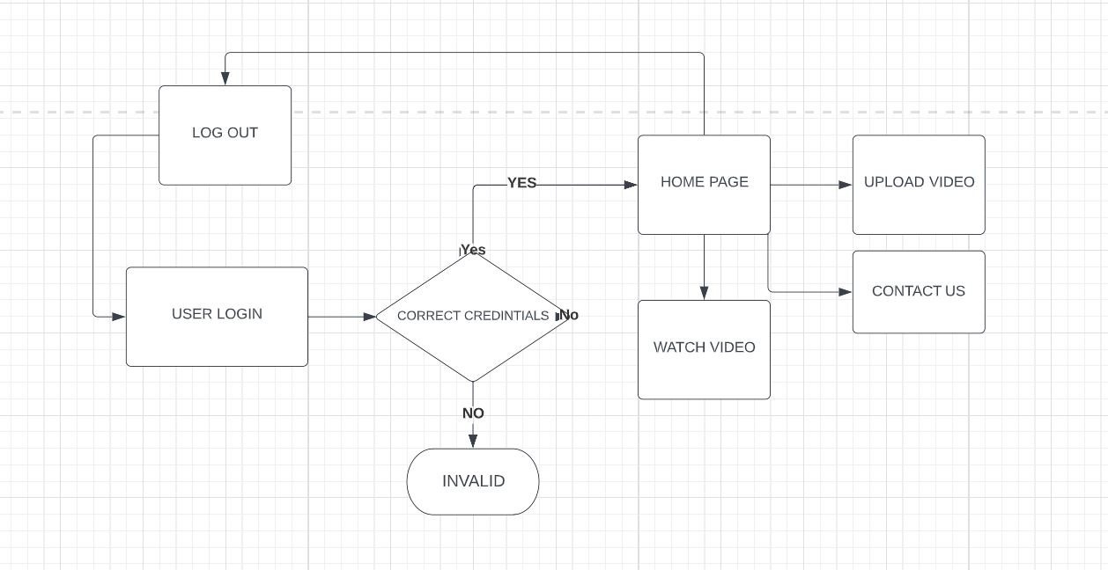

**FIG: 1.1: WORK FLOW DIAGRAM -HUMAN LIBRARY VIDEO STREAMER**

**CHAPTER-4**

**SUMMARY AND CONCLUSION**

**4.1 SUMMARY**

In this project we have designed a video streaming website in which people act as human books and share their life experiences with people all around the world. Readers of the book can select any book and watch it in video format. We have also provided login page for the readers and for people who volunteer themselves as human books. If the reader is interested to know more about any specific human book, there is an option to schedule an appointment and get it in touch with them.

**4.2 CONCLUSIONS**

* Every person in this world has a story to share with. The concept of video streaming human library can be very efficient in bringing people from different parts of the world together and also to get to know about their life experience.
* This video streaming human book library will definitely help people to share their stories and also for people to get to know about different lifestyles.

**REFERENCES:**

1. <https://getbootstrap.com/>
2. https://fontawesome.com/
3. <https://www.w3schools.com/>
4. https://www.djangoproject.com/
5. https://www.pexels.com/

**APPENDIX**

1. **SCREENSHOTS**

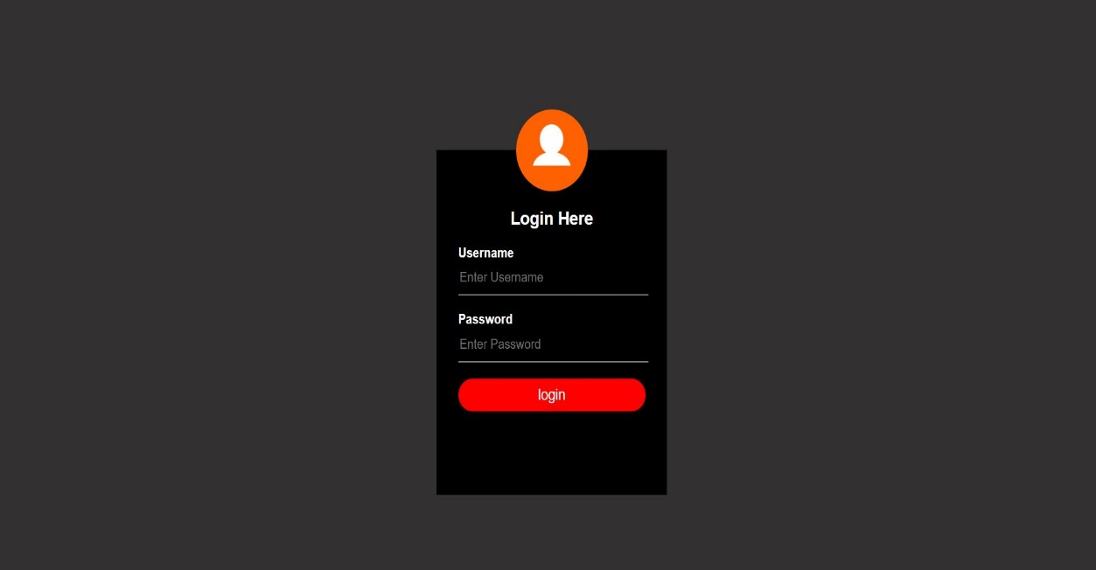

**FIG: 1.2: LOGIN PAGE**

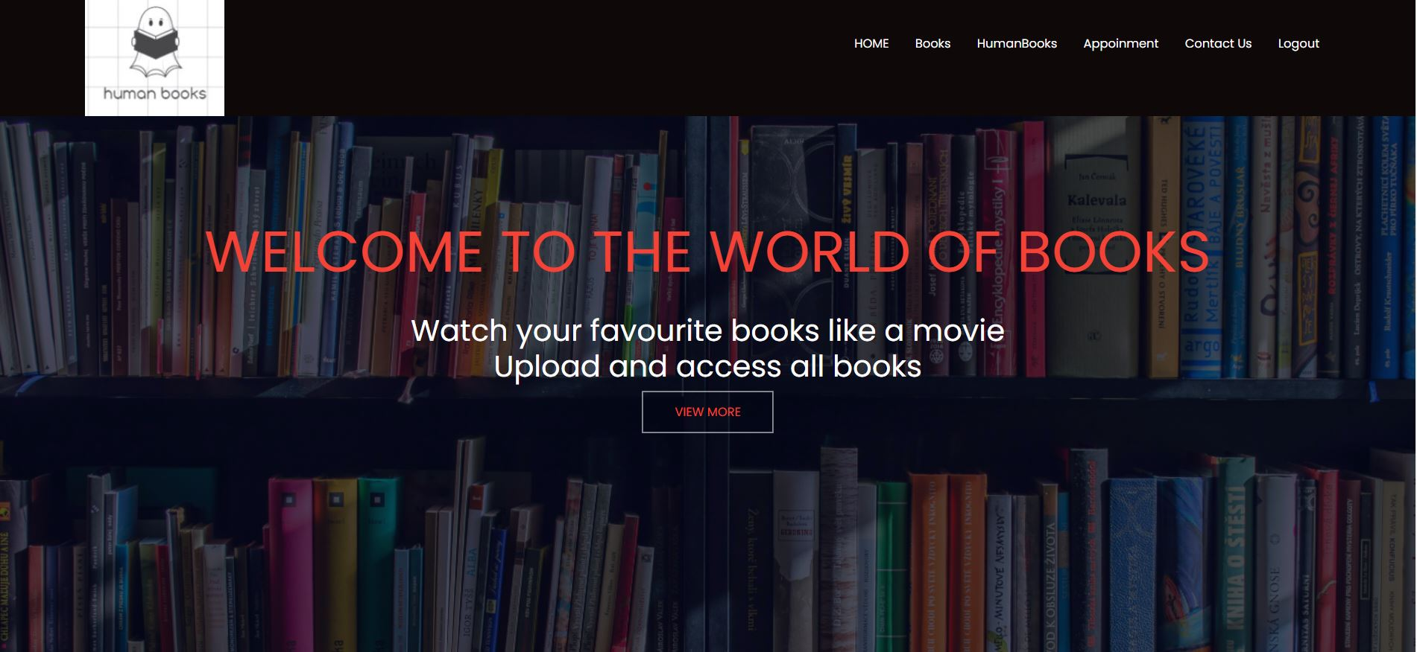

**FIG: 1.3: HOME PAGE**

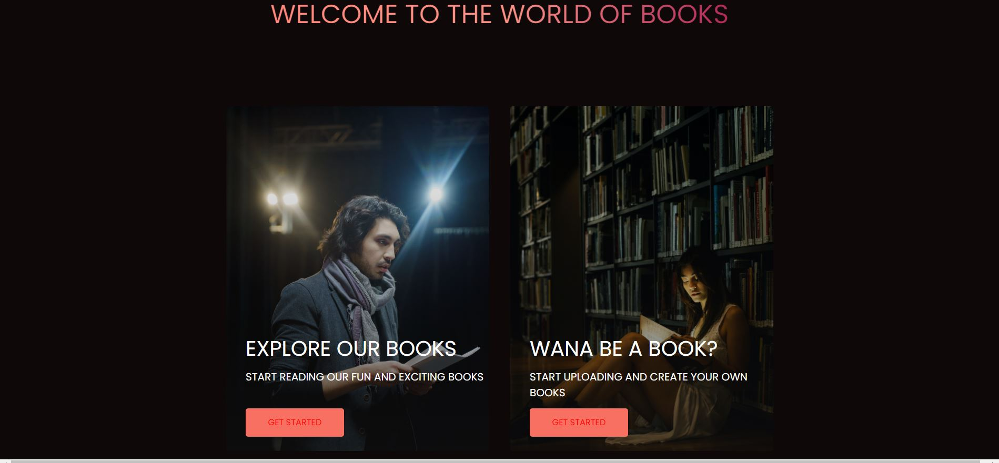

**FIG: 1.4: OPTIONS PAGE**

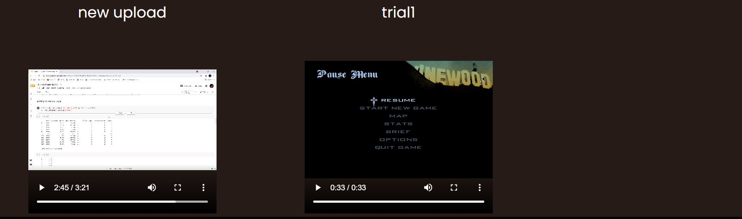

**FIG: 1.5: VIDEO STREAMING PAGE**

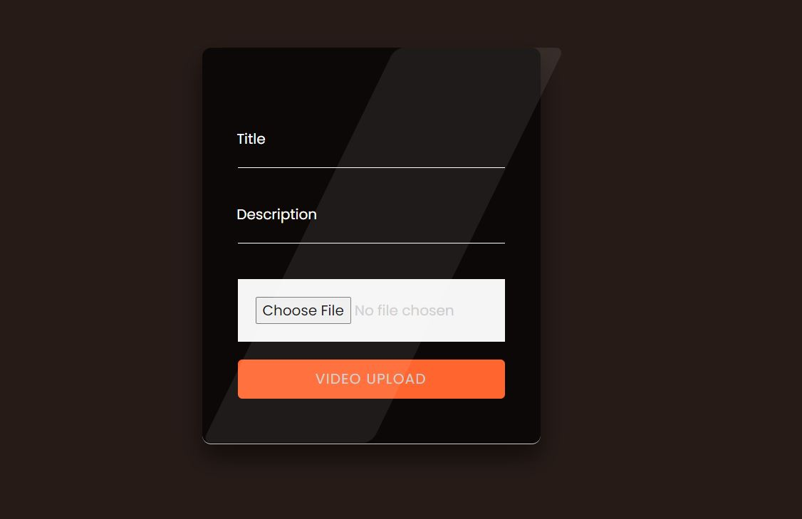

**FIG: 1.6: NEW VIDEO UPLOAD PAGE**

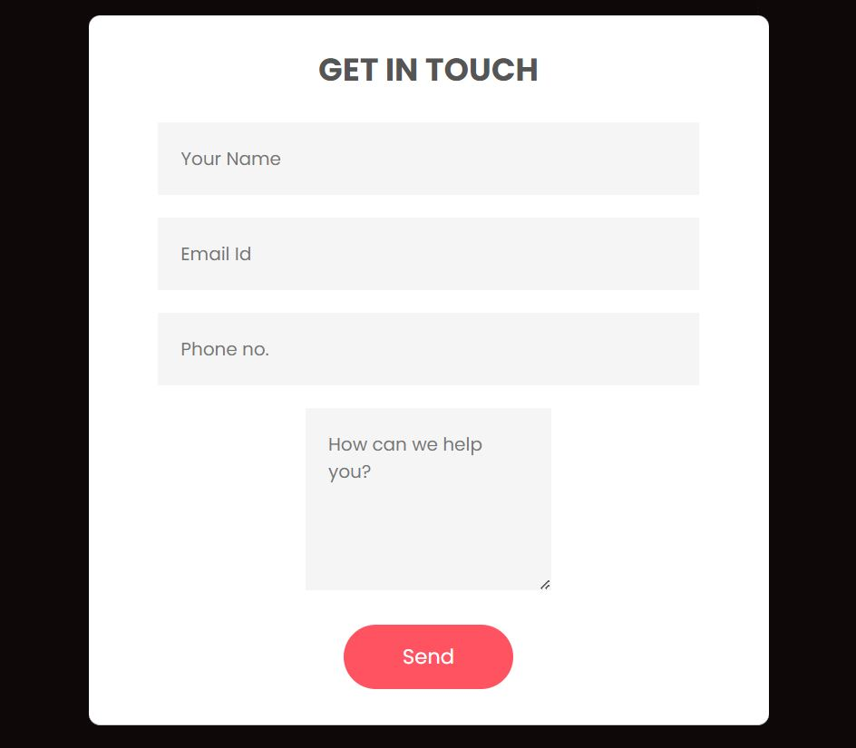

**FIG: 1.7: CONTACT US PAGE**

**GITHUB LINK-** **https://github.com/VarunDas11901/video-streamer-hcl-internship-**