***SoulPass - Soulbound NFT Based Certification System***

**Project Synopsis**

Of Major Project

***Submitted to***

***G H Raisoni College of Engineering & Management Nagpur,***

***In partial fulfillment of the requirement for the award of degree of***

**Bachelor of Technology**

**In**

**Computer Science & Engineering (Cyber Security)**

*Submitted by*

|  |  |
| --- | --- |
|  |  |
|  |  |
|  |  |

*Under the guidance of*

Prof. Shalini Kumari

(Guide)



**Department of Computer Science & Engineering (Cyber Security)**

**G H Raisoni College of Engineering & Management Nagpur**

(Formerly Known as G H Raisoni Institute of Engineering & Technology, Nagpur)

(Approved by AICTE, New Delhi and Recognized by DTE, Maharashtra)

An Autonomous Institute Affiliated to Rashtrasant Tukadoji Maharaj Nagpur University, Nagpur

**Accredited by NAAC with A+ Grade**

**Session: 2025-2026**

**G H Raisoni College of Engineering & Management Nagpur**

(Formerly Known as G H Raisoni Institute of Engineering & Technology, Nagpur)

(Approved by AICTE, New Delhi and Recognized by DTE, Maharashtra)

An Autonomous Institute Affiliated to Rashtrasant Tukadoji Maharaj Nagpur University, Nagpur

**Accredited by NAAC with A+ Grade**

We, the above-mentioned students of Final year Computer Science & Engineering (Cyber Security)Department, wish to undergo the projecttitled **‘Title of Project** under the guidance of **Prof.** **XYZ (Guide) and Prof.** **XYZ (Co-Guide)** for the **session 2025-26.**



|  |  |  |
| --- | --- | --- |
| **Roll No.** | **Name of Student** | **Signature** |
| **55** | Varun Gotmare |  |
| **51** | Tejashwini Battinwar |  |
| **43** | Shruti Singh Thakur |  |
| **47** | Siddhanth Sakhare |  |
| **53** | Vaishnavi Lepande |  |

Prof. Shalini Kumari

(Guide)

**Assistant Professor**

**Department of Computer Science & Engineering (Cyber Security)**

Prof. XYZ

Project In charge

**Assistant Professor**

**Department of Computer Science & Engineering (Cyber Security)**

Dr. Tejpal C. Parshiwanikar

**HOD**

**Department of Computer Science & Engineering (Cyber Security)**

**Index**

|  |  |  |
| --- | --- | --- |
| **Sr. No.** | **Topic** | **Page No.** |
| 1. | Introduction | 1 |
| 2. | Literature Survey | 2-3 |
| 3. | Problem Statement | 4 |
| 4. | Objective of Project | 5 |
| 5. | Design/Block Diagram | 6 |
| 6. | Expected Results & Discussion | 7 |
| 7. | Work plan |  |
| 8. | References |  |

**Introduction**

The shift toward digital transformation in education has created a need for secure, verifiable, and tamper-proof credential systems. Traditional methods—whether paper-based or centralized—are prone to forgery, loss, and slow verification, and often lack interoperability, transparency, and lifetime accessibility.

**SoulPass** is a decentralized credential verification system that uses **Soul bound NFTs (SBTs)** to permanently bind credentials to an individual’s blockchain wallet. These non-transferable, immutable tokens ensure authenticity for achievements such as event participation, academic accomplishments, and institutional recognition. Metadata is stored via **IPFS**, making credentials publicly verifiable without reliance on centralized authorities.

The system enables event organizers and institutions to issue credentials seamlessly. Students can scan a **QR code** during events, triggering instant minting of a Soul bound NFT tied to their identity. This eliminates manual attendance tracking, prevents duplication, and builds a lifelong, verifiable academic portfolio. Institutions can verify credentials directly via blockchain or the SoulPass portal, improving trust and reducing administrative effort.

Incorporating principles from **rejectable soul bound tokens (RejSBTs)**, SoulPass supports **selective reception**, ensuring only rightful recipients can accept credentials. It aligns with **self-sovereign identity (SSI)** principles, empowering individuals to control their own verifiable achievements.

While initially focused on academic events, SoulPass can extend to **digital transcripts, online course completions, professional certifications, and job fair participation**, creating a scalable, secure, and transparent ecosystem for digital credential management.

**Literature Survey**

Existing research highlights multiple approaches to designing decentralized credential systems, with a focus on non-transferability, user control, interoperability, and trust.

1. **Digital Credentials Management System using Rejectable Soul bound Tokens (RejSBTs) — Rosa Pericàs-Gornals et al. (Springer, 2024)**

Enhances SBTs by allowing users to accept or reject credentials, implements non-repudiation, and manages privacy-aware metadata.

1. **Soul bound Token Framework for Privacy-Preserving Verification — Reddy & Kushwaha (ICDSAC, 2023)**

Proposes non-transferrable SBTs with selective disclosure and key recovery mechanisms for users.

1. **Web 3.0 and a Decentralized Approach to Education — Flanery et al. (arXiv, 2023)**

Implements DIDs and DID-based access control to attach credentials directly to users over a secure, decentralized Web3 ecosystem.

1. **Blockchain-Enabled Micro-Credentialing for Lifelong Learning — University of Ljubljana (EDULEARN25, 2025)**

Uses blockchain to enhance trust, mobility, and interoperability of micro-credentials in lifelong learning systems.

1. **ZKBAR-V: Zero-Knowledge Academic Record Verification System — Berrios Moya et al. (Sensors, 2025)**

Leverages zk-proofs, dual-blockchain architecture, DIDs, and IPFS to enable privacy-preserving credential verification without exposing user data.

1. **BACIP: Blockchain Academic Credential Interoperability Protocol — Berrios Moya (arXiv, 2024)**

Introduces a zero-knowledge and interoperability protocol to prevent academic fraud and support global credential verification.

1. **Cerberus: Blockchain-Based Degree Verification System — Tariq et al. (arXiv, 2019)**

Provides smart contract-based revocation, selective disclosure, and audit mechanisms for academic credentials.

1. **NFTCert: NFT-Based Certificates with Payment Integration — Zhao & Si (arXiv, 2022)**

A practical NFT-based certificate system featuring minting, verification, and a payment gateway—with an emphasis on usability.

1. **SBTCert: Soul bound Token Certificate Verification System — Tumati, Jiang & Tian (IEEE CCNC, 2024)**

Presents a non-transferable credential issuance system suitable for academic degree verification with on-chain validation.

Collectively, these studies illustrate a progressive movement toward **self-sovereign, blockchain-based credential systems** that prioritize **security, authenticity, privacy, and user control**. They establish a strong foundation for the development of **SoulPass**, which integrates RejSBT principles, lifelong academic record management, and user-centric verification processes to create a scalable, verifiable, and tamper-proof credentialing platform for educational institutions and beyond.

**Problem Statement**

Traditional and existing digital certificate systems used by event organizers and educational institutions suffer from inefficiencies, vulnerabilities, and a lack of standardization. Paper-based certificates are highly susceptible to loss, damage, and duplication, while many digital alternatives still depend on centralized databases that can be hacked, altered, or deleted. The absence of a globally accepted verification mechanism forces institutions to rely on slow, manual validation processes, creating bottlenecks in confirming authenticity. This lack of permanent ownership, transparency, and tamper-proofing erodes trust in issued credentials. Consequently, students are deprived of a secure, verifiable academic record, and administrators face difficulty in maintaining and verifying genuine credentials.

**Challenges:**

**🔹 For Admins:**

* **Risk of forgery and fraud:** Certificates can be replicated or manipulated without detection, leading to false claims of participation or achievement.
* **No secure verification mechanism:** Institutions must manually validate certificates, often by contacting the issuing authority, which is time-consuming, error-prone, and not scalable for large events or multiple verifications.

**🔹 For Students:**

* **Loss or damage of certificates:** Physical certificates can be misplaced, stolen, or destroyed over time, while some digital versions may become inaccessible due to server failures or expired storage links.
* **No authenticity proof:** Students lack an independent, verifiable proof of their achievements, making it difficult to present credentials confidently to employers, institutions, or professional bodies.

**Objectives of the Project**

The primary objective of the **SoulPass** project is to design and develop a secure, transparent, and tamper-proof **Attendance and Event Credential Verification System** using **Soul bound NFTs**. This system leverages blockchain technology to provide immutable proof of participation while offering a seamless, modern, and student-friendly user experience.

The specific objectives of the project are:

1. **Implement a Soul bound NFT Credential System**
   * To design and deploy **non-transferable ERC-721 tokens** (Soul bound NFTs) that represent unique attendance or event participation credentials.
   * Ensure that each credential is permanently bound to the student’s blockchain wallet, preventing resale or unauthorized transfer.
2. **Enable Secure and Instant NFT Claiming via QR Codes**
   * To develop a **QR code-based claim mechanism** where participants can instantly claim their event credentials by scanning a code during the event.
   * Integrate hybrid claiming modes (live scan and manual code entry) to cater to various real-world event scenarios.
3. **Provide a Transparent and Immutable Record of Participation**
   * To store attendance records on the blockchain, ensuring **tamper-proof verification** for academic and extracurricular activities.
   * Allow third parties, such as recruiters or institutions, to verify a participant’s credentials without relying on centralized databases.
4. **Design an Intuitive and Responsive Web Interface**
   * To build a **Next.js + Tailwind CSS** based frontend that is mobile-friendly, visually appealing, and simple for both administrators and students to use.
   * Include dedicated interfaces for event creation, NFT claiming, and profile views that display all owned credentials.
5. **Automate Event Credential Management for Organizers**
   * To enable administrators to create events that automatically generate unique claim codes and corresponding NFT metadata.
   * Reduce manual workload while ensuring a consistent and secure process for issuing participation credentials.
6. **Promote Adoption of Blockchain in Academic and Event Management**
   * To demonstrate the **practical use of blockchain technology** beyond cryptocurrency, fostering trust and transparency in academic and event environments.
   * Encourage institutions to adopt decentralized credential verification systems for improved record-keeping and recognition.

**Design / Block Diagram**

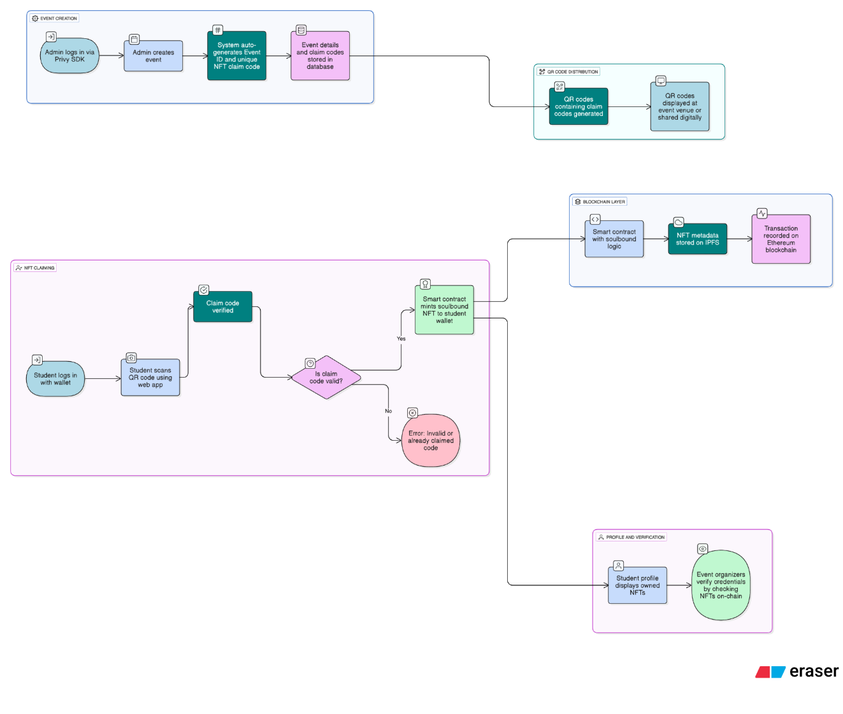

**Work plan**

|  |  |  |  |  |  |
| --- | --- | --- | --- | --- | --- |
| **Months Activities** | **JUN’25** | **JULY’25** | **AUG’25** | **SEPT’25** | **OCT’25** |
| **Literature Reviews** | **√** | **√** |  |  |  |
| **Component Identification**  **& Selection** |  | **√** |  |  |  |
| **Designing** |  | **√** | **√** |  |  |
| **Fabrication** |  | **√** | **√** |  |  |
| **Experimental Analysis** |  | **√** | **√** | **√** |  |
| **Testing and debugging** |  | **√** | **√** | **√** |  |
| **Preparation of Project Report** |  |  | **√** | **√** |  |
| **Thesis and Poster Submission** |  |  |  |  | **√** |

**References**

**Journals:**

1. Prakash, K. (2011). Feedback and optimal sensitivity: Model reference transformations, multiplicative semi norms, and approximate inverses. IEEE Transactions on Automatic Control, 26(2): 301–320.

**Textbooks:**

1. Myers, D. G. (2007). Psychology (1st Canadian ed.). Worth: New York.

**Conference proceedings:**

1. Payne, D.B. and Gunhold, H.G. (1986). Digital sundials and broadband technology, In Proc. IOOC-ECOC, 1986, pp. 557-998.

**Reports:**

1. Milton, M and Robert, L. (2004). Atmospheric carbon emission through genetic algorithm, Environment and Technical Report No.3., Indian Meteorological Department., New Delhi.

**Online journals with a DOI (Digital Object Identifier):**

1. Krebs, D.L. and Denton, K. (2006). Explanatory limitations of cognitive developmental approaches to morality. Psychological Review, 113(3): 672- 675. Doi: 10.1037/0033-295X.113.3.672.

**Online journals without a DOI**

1. Vicki, G.T., Thomae, M., Cullen, A. and Fernandez, H. (2007). Modeling the hydrological impact on Tropical Forests. Forest Ecology, 13(10): 122-132. Retrieved from http://www.uiowa.edu/~grpproc/crisp/crisp.html.

**Online abstracts**

1. Perilloux, C. and Buss, D.M. (2008). Human relationships: Costs experienced, and coping strategies deployed. Evolutionary Psychology, 6(1): 164-181. Abstract retrieved from http://www.epjournal.net

**Online books**

1. Perfect, T.J. and Schwartz, B. L. (Eds.) (2002). Applied metacognition. Retrieved from http://www.questia.com/read/107598848 (--If DOI is available, use the DOI instead of a URL)

**Chapters from a book**

1. Krebs, D.L. and Denton, K. (1997). Social illusions and self-deception: The evolution of biases in person perception. In J. A. Simpson & D. T. Kenrick (Eds.), Evolutionary social psychology (p.21-48). Hillsdale, NJ: Erlbaum.

**Books in print form**

1. Snyder, C.R., Higgins, R.L. and Stucky, R.J. (Eds.). (1983). Excuses: Masquerades in search of grace. New York, NY: John Wiley & Sons.

**Dissertations and Thesis**

1. Mack, S. (2000). “Desperate Optimism” M.S. Thesis, University of Calgary, Canada.