**Power Window Control System using Matlab Simulink**

Name : Varun Hemanth L

Unique ID : 2005678

### Study Power Windows

Automobiles use electronics for control operations such as:

* Opening and closing windows and sunroof
* Adjusting mirrors and headlights
* Locking and unlocking doors

These systems are subject to stringent operation constraints. Failures can cause dangerous and possibly life-threatening situations. As a result, careful design and analysis are needed before deployment.

This example focuses on the design of a power window system of an automobile, in particular, the passenger-side window. A critical aspect of this system is that it cannot exert a force of more than 100 N on an object when the window closes. When the system detects such an object, it must lower the window by about 10 cm.

### Quantitative Requirements

Quantitative requirements for the control are:

* The window must fully open and fully close within 4 s.
* If the up is issued for between 200 ms and 1 s, the window must fully open. If the down command is issued for between 200 ms and 1 s, the window must fully close.
* The window must start moving 200 ms after the command is issued.
* The force to detect when an object is present is less than 100 N.
* When closing the window, if an object is in the way, stop closing the window and lower the window by approximately 10 cm.

#### **Activity Diagram: Power Window Control**

The power window control consists of three processes and a CSPEC. Two processes validate the driver and passenger input to ensure that their input is meaningful given the state of the system. For example, if the window is completely opened, the MOVE DOWN command does not make sense. The remaining process detects if the window is completely opened or completely closed and if an object is present. The CSPEC takes the control signals and infers whether to move the window up or down (e.g., if an object is present, the window moves down for about one second or until it reaches an endstop).

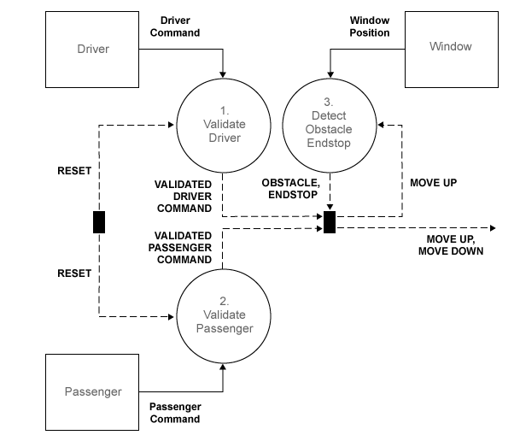

**Skills Used while Modelling:**

1. ***Call-backs****: Call-back function is used to open scopes at start function.*
2. ***Data Inspector****: The output data i.e, position and gear angle is logged and all the runs of the model is displayed in the data inspector.*
3. ***Signal Builder:*** *Signal Builder is used to generate the inputs which are given as the test input to the system.*
4. ***Look-Up Table****: LUT is used in driver_switch and passenger_switch of the power_window model.*
5. ***MATLAB function block****: This is used in both driver_switch and passenger_switch to decide whether to moveUp or MoveDown for the window.*
6. ***Solver Selection****: The model is simulated using ode23*