Creating an EC2 instance

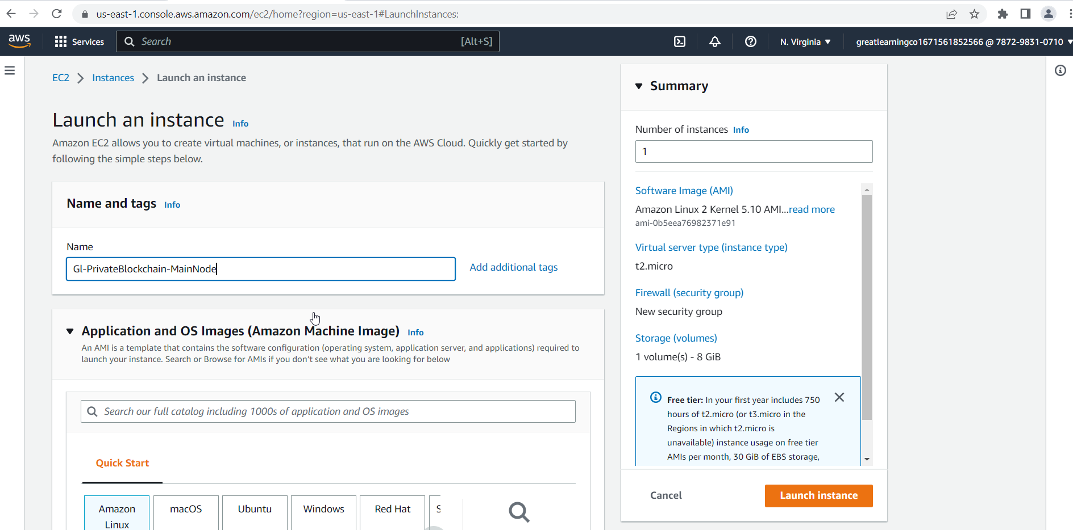

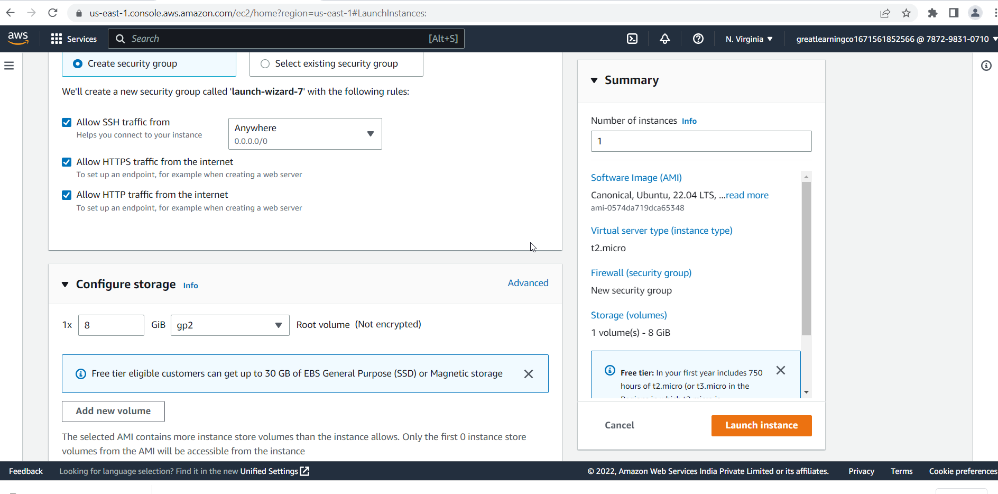

Creating a Security Group

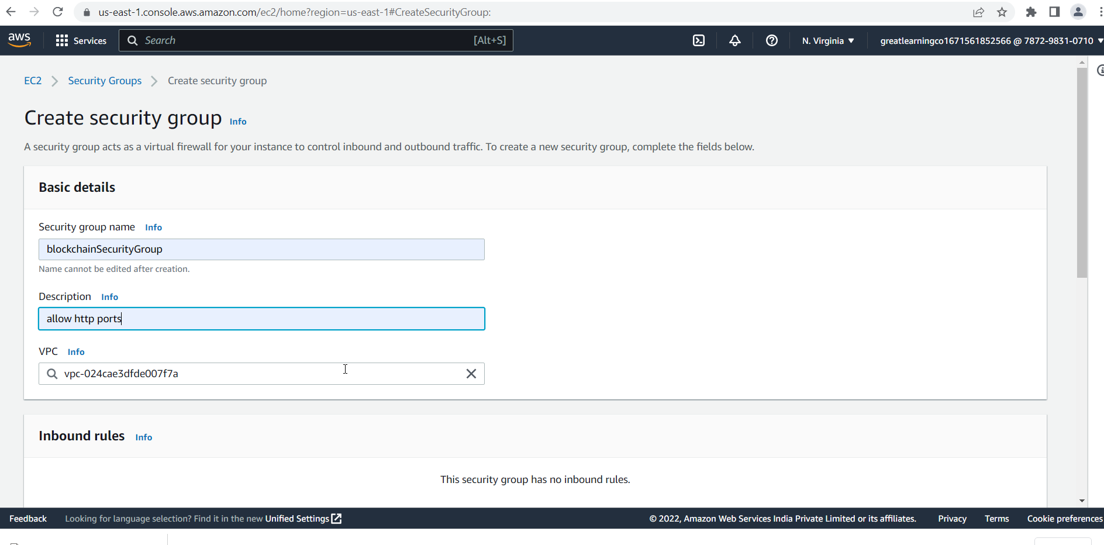

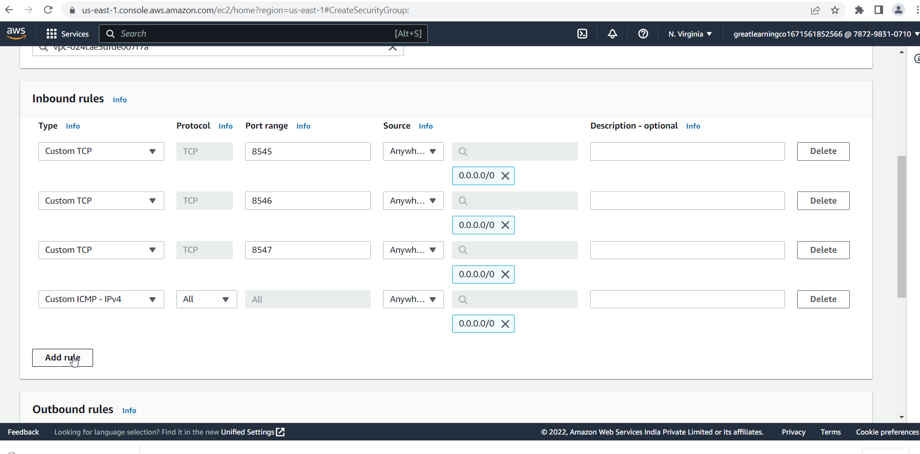

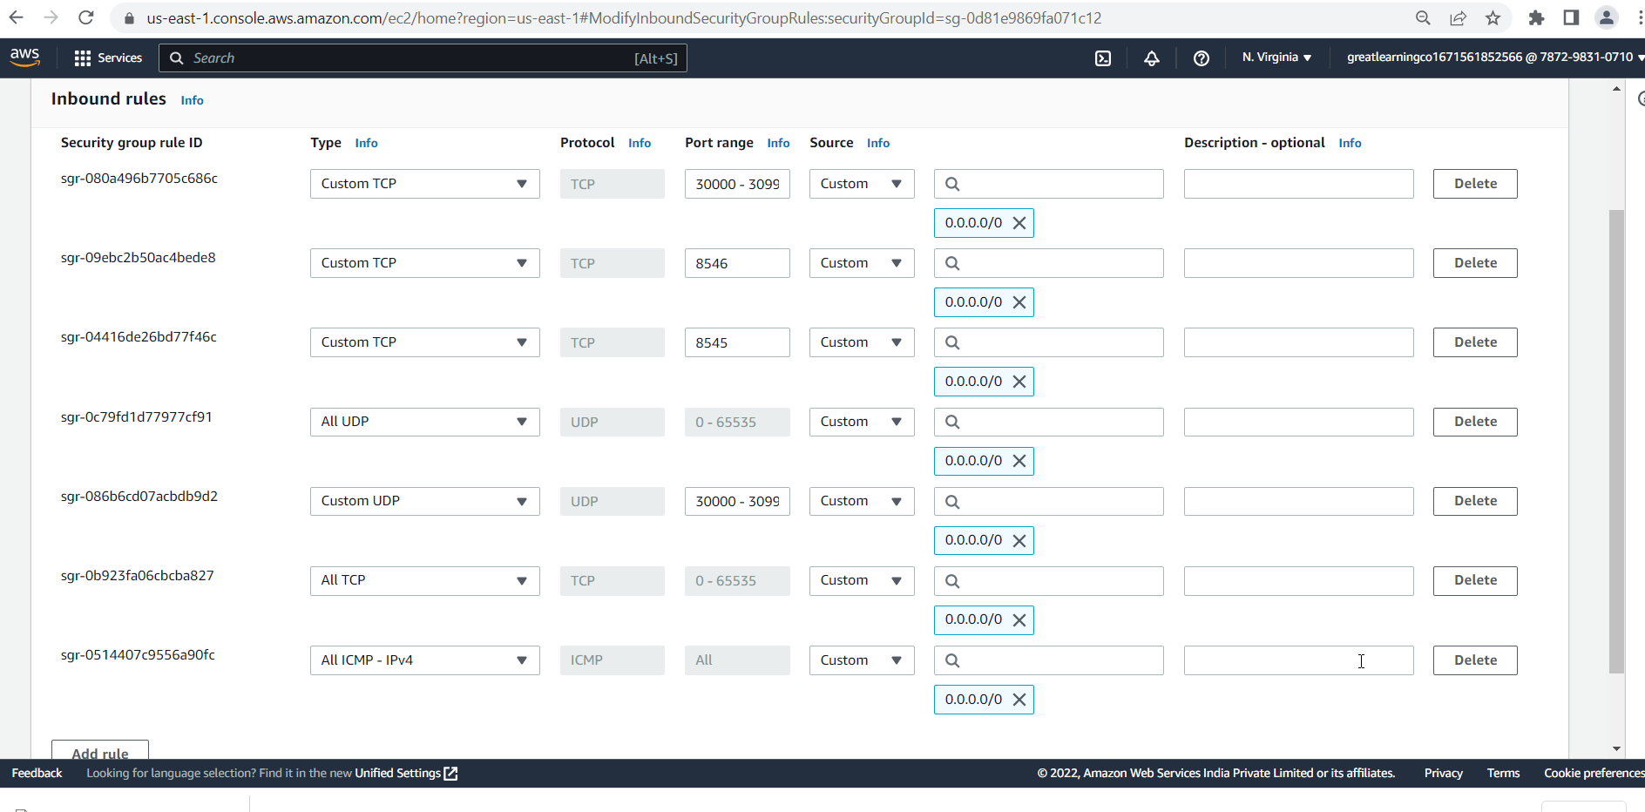

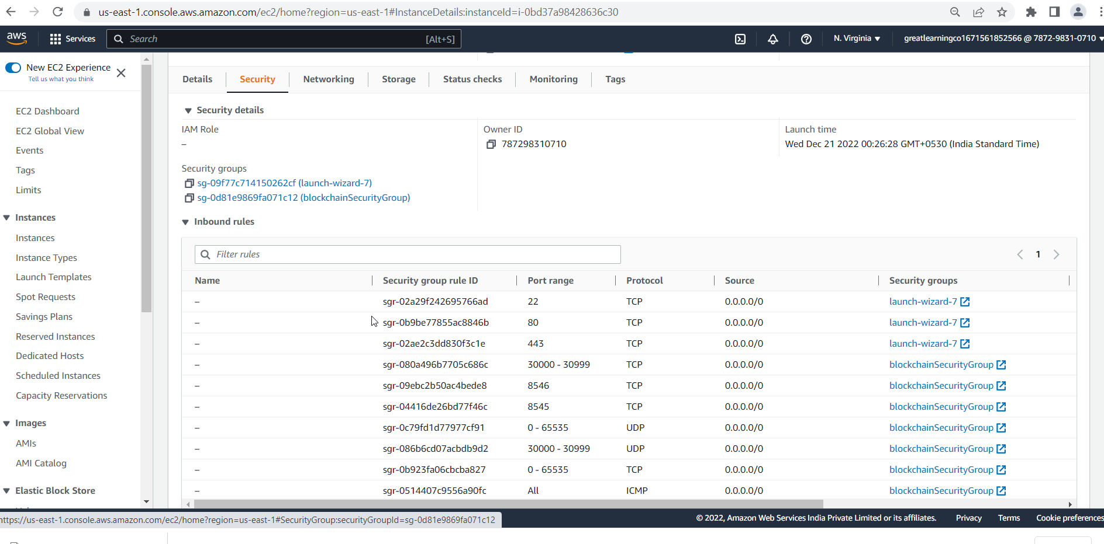

Installing Ethereum on EC2 instance

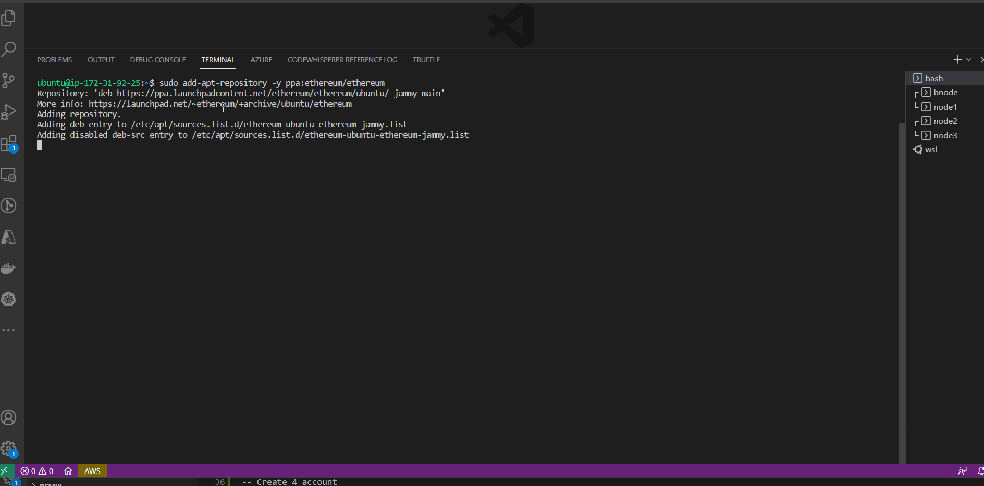

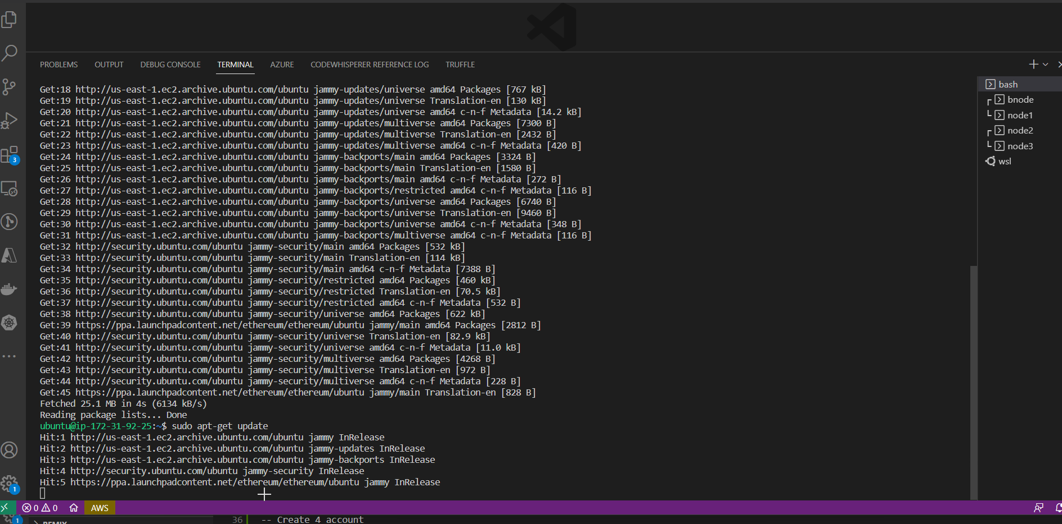

Setup directory to create Private Network

Create accounts

Create Bootnode

Setup genesis block

Initialize node

Download keystore

Start Bootnode

Start Node1

Start Node2

Start Node3

Curl Operation on localhost

Curl Operation from local System

Connect to Matamask

Connect to Remix