## **GDGC Mobile App**

### **1. Project Overview**

A **Flutter** app for **Google Developer Groups On-Campus (GDGC)** at **VNRVJIET**. The app allows users to view upcoming events, register for events, and get notifications on updates. Users can also manage their profiles.

### **2. Features**

* **Event Listings**: View upcoming events with details.
* **Notify Me**: Get notified when event info is updated.
* **Register Now**: Register for events directly from the app.
* **Profile Management**: View and edit user profile.

### **3. Installation**

1. Clone the repository: git clone https://github.com/VarunKeta/GDGC_AppDev_Assignment.git
2. Navigate to project main directory
3. Install dependencies: flutter pub get
4. Run the app: flutter run

### **4. App Structure**

* main.dart: App entry point.
* home_page.dart: Home page with GDGC categories.
* events_page.dart: Lists upcoming events and allows notifications/registration.
* profile_page.dart: Manage user profiles.

### **5. Screenshots**

Include screenshots in the following areas:

* **Home Page**: Display categories of GDGC (e.g., Web Development, etc.).
* **Events Page**: Show events with "Notify me" and "Register now" buttons.
* **Popup Dialogs**: Show popups for event notifications and registration.
* **Profile Page**: Show user profile details (Name, Email, etc.).

### **6. Future Enhancements**

* Firebase notifications for real-time updates.
* Improved UI and state management.
* Add user authentication for personalized event interactions.

## **GDGC Mobile App**

### **1. Project Overview**

This project is a mobile application built using **Flutter** and **Dart** for **GDGC (Google Developer Groups On-Campus)** at **VNRVJIET**. The app allows users to view upcoming events, register for events, and get notified about updates. Additionally, users can manage their profiles.

### **2. Features**

* **Event Listings:** Displays a list of upcoming events with details like the name, date, venue, and description.
* **Notify Me:** Users can choose to be notified when the event information is updated.
* **Register Now:** Users can register for events through the app.
* **Profile Management:** Users can view and edit their profiles.

### **3. Installation**

**1. Clone the repository:**  
git clone https://github.com/VarunKeta/GDGC_AppDev_Assignment.git

**2.Navigate to the project folder**

**3.Install the required dependencies:**  
flutter pub get

**4.Run the app:**  
flutter run

### **4. App Structure**

* main.dart: Entry point of the application.
* home_page.dart: The home page which contains a brief description of GDGC activities.
* events_page.dart: Displays the list of upcoming GDGC events and handles notifications and registrations.
* profile_page.dart: Displays and allows users to edit their profile.

#### **5.1. Home Page**

#### 

* **Position:** After the "App Structure" section.
* **Purpose:** This demonstrates the main page layout and content about what GDGC does.

#### **5.2. Event Listings**

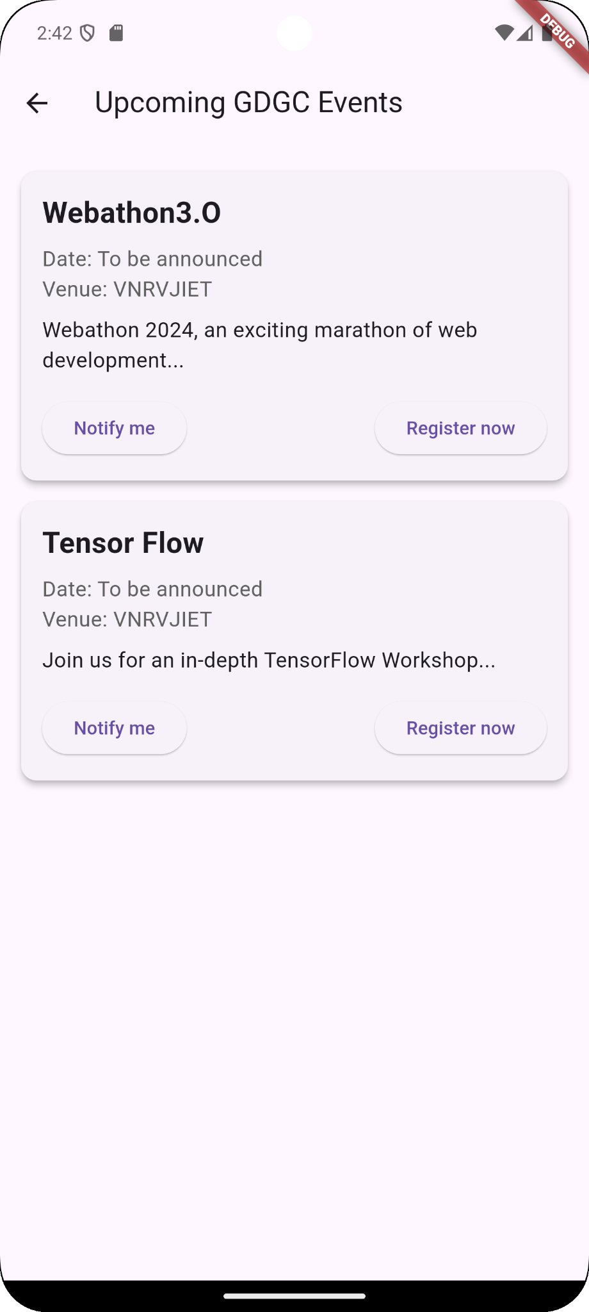

* **Position:** In the "Features" section under **Event Listings**.
* **Purpose:** To show how events are displayed with the "Notify me" and "Register now" buttons.

#### **5.3. Register & Notify Popup**

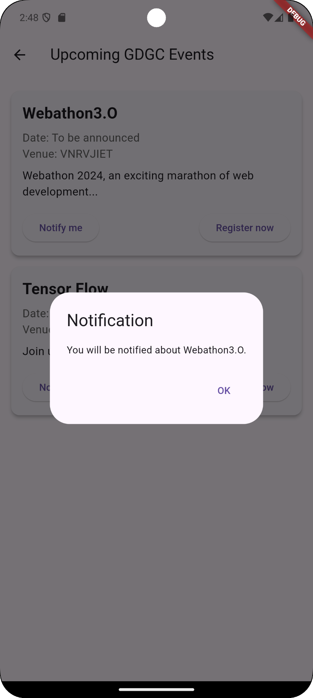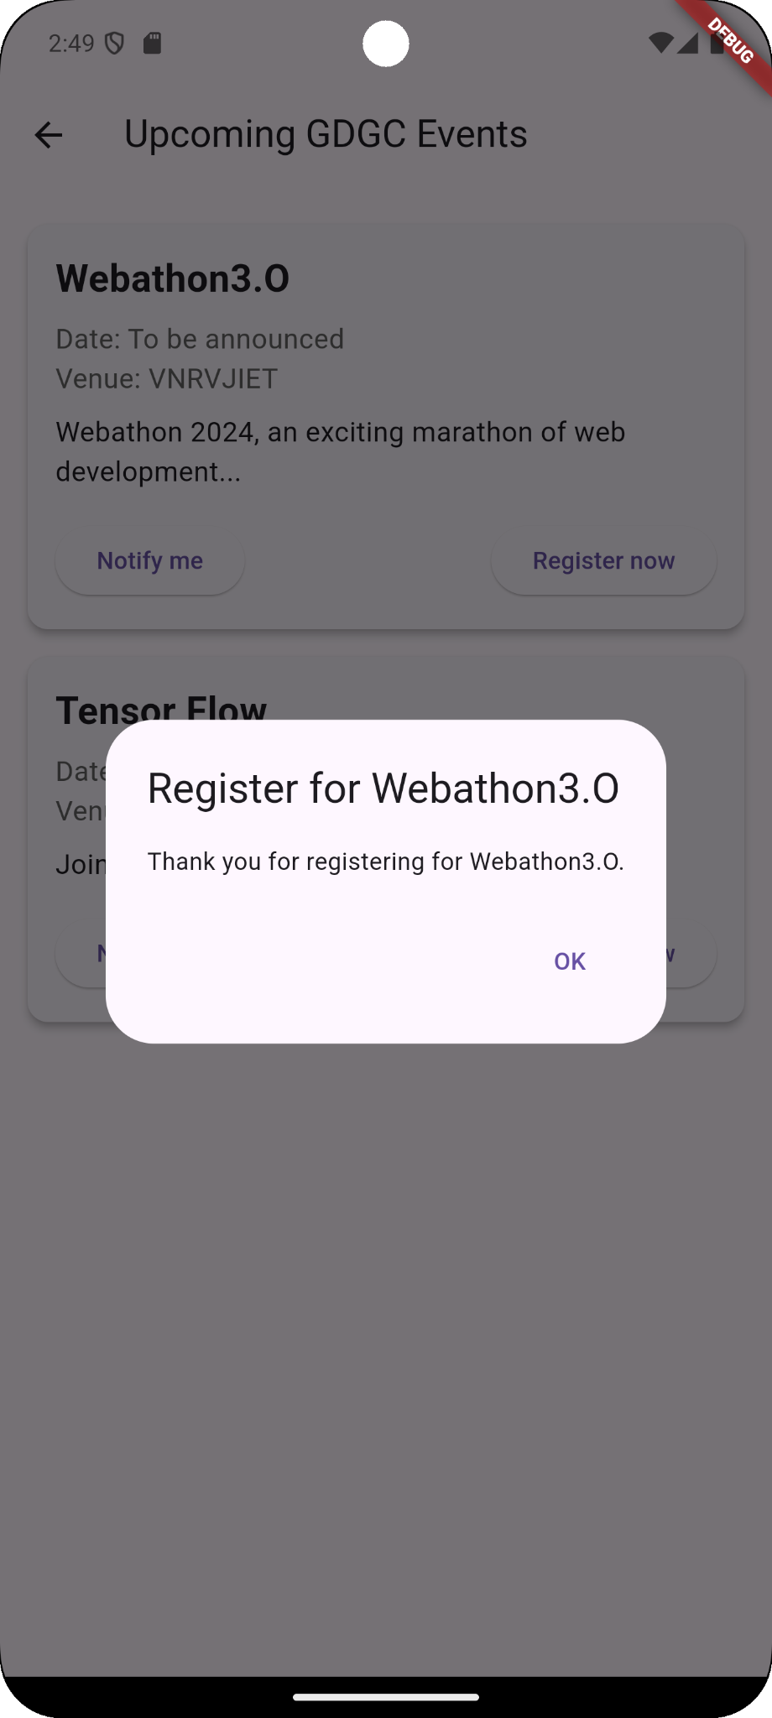

* **Position:** Under the "Features" section (after **Notify Me** and **Register Now** features).
* **Purpose:** This displays how users interact with the app for notifications and registration.

#### **5.4. Profile Page**

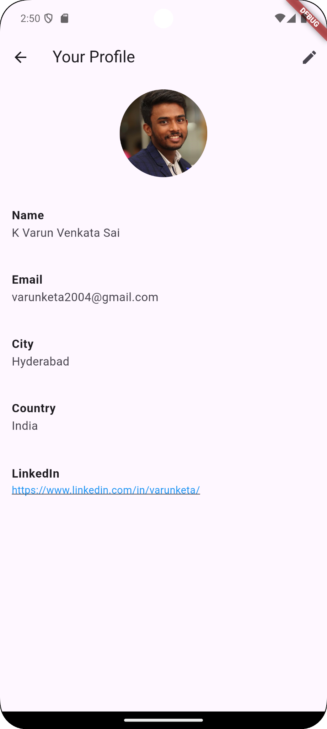

* **Position:** Under the "Profile Management" feature in the "Features" section.
* **Purpose:** This shows how the profile page looks, including the layout and the option to edit user details.