**Multiple Disease Prediction System**

**Abstract**

Machine learning has various applications and one of them is healthcare. There should be much more advanced

medical facilities so as to provide the best possible treatment for the patients

Machine learning has various applications and one of them is healthcare. There should be much more advanced medical facilities so as to provide the best possible treatment for the patients We can say that when machine learning implemented in healthcare can lead to a high increase in patient satisfaction. Multi Disease Prediction” system based on predictive modeling predicts the disease of the user on the basis of the symptoms that user provides as an input to the system. Many of the existing machine learning models for health care analysis are concentrating on one disease per analysis. Like one analysis if for diabetes analysis, one for cancer analysis, one for skin diseases like that. There is no common system where one analysis can perform more than one disease prediction. In this article proposing a system which used to predict multiple diseases. In this Paper proposed to analyze Diabetes analysis, Diabetes analysis, Heart disease. This project proposes a Support Vector Machine (SVM) technique as the backbone of computer-aided diagnostic tools for more accurately forecasting heart disease risk levels.SVM modeling is a promising classification approach for predicting medication adherence in CVD patients. This predictive model helps stratify the patients so that evidence-based decisions can be made and patients managed appropriately. bagging and boosting approaches using DTB algorithms were implemented on the experimental data to predict diabetes risk at an early stage. While bagging and random forest classifiers were selected for the bagging approach, AdaBoost, MultiBoost, and real AdaBoost algorithms Later other diseases like skin diseases, fever analysis and many more diseases can be included. To implement multiple disease analysis used machine learning algorithms while analysing the diseases all the parameters which causes the disease is included so it possible to detect the maximum effects which the disease will cause. This project can help a lot of people as one can monitor the persons’ condition and take the necessary precautions thus increasing the life expectancy.

**CHAPTER 1**

**INTRODUCTION**

* 1. **Overview:**

In this digital world, data is an asset, and enormous data was generated in all the fields. Data in the healthcare industry consists of all the information related to patients. Here a general architecture has been proposed for predicting the disease in the healthcare industry. Many of the existing models are concentrating on one disease per analysis. Like one analysis for diabetes analysis, one for cancer analysis, one for skin diseases like that. There is no common system present that can analyze more than one disease at a time. Thus, we are concentrating on providing immediate and accurate disease predictions to the users about the symptoms they enter along with the disease predicted. So, we are proposing a system which used to predict multiple diseases During a lot of analysis over existing systems in health care analysis considered only one disease at a time. For example, is used to analyse diabetes, article is used to analyse diabetes is used to predict heart disease . Maximum articles focus on a particular disease. When any organization wants to analyse their patient’s health reports then they have to deploy many models. The approach in the existing system is useful to analyse only particular disease. Now a day’s mortality got increased due to exactly not identifying exact disease. Even the patient got cured from one disease may be suffering from another disease. In real life, I faced that situation. My father got cured from the accident. My father got discharged from hospital but after a few days he got expired. Internally suffering from heart issues which is not identified. Like this many instances observed in many people’s life stories.

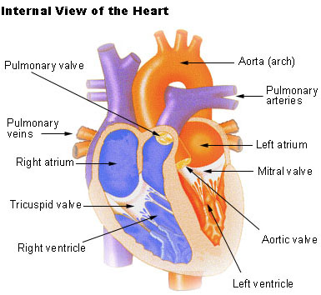

Analyzing the disease. Due to that may be not possible to identify the diseases which will be caused due to the effect of that disease. For example, due to diabetes, there may be chance of heart disease, neuropath, retinopathy, hearing loss, and dementia.

**Structure of the Heart**

The human [heart](https://api.seer.cancer.gov/rest/glossary/latest/id/5502b492e4b0c48f31d64b2b) is a four-chambered muscular [organ](https://api.seer.cancer.gov/rest/glossary/latest/id/54da499ae4b07fe4ff776889), shaped and sized roughly like a man's closed fist with two-thirds of the [mass](https://api.seer.cancer.gov/rest/glossary/latest/id/5520eecfe4b0bc5c16bfb7b9) to the left of midline.

The heart is enclosed in a [pericardial sac](https://api.seer.cancer.gov/rest/glossary/latest/id/5520547ce4b0bc5c16bf9707) that is lined with the [parietal](https://api.seer.cancer.gov/rest/glossary/latest/id/55022631e4b0c48f31d620fc) layers of a [serous membrane](https://api.seer.cancer.gov/rest/glossary/latest/id/550583c8e4b0c48f31d6f6e3). The [visceral](https://api.seer.cancer.gov/rest/glossary/latest/id/5502266ce4b0c48f31d6211d) layer of the serous membrane forms the [epicardium](https://api.seer.cancer.gov/rest/glossary/latest/id/5502b606e4b0c48f31d64bb5).

**Layers of the Heart Wall**

Three layers of [tissue](https://api.seer.cancer.gov/rest/glossary/latest/id/55097ed2e4b0c48f31d89a03) form the heart wall. The outer layer of the heart wall is the epicardium, the middle layer is the [myocardium](https://api.seer.cancer.gov/rest/glossary/latest/id/5502b4ebe4b0c48f31d64b4f), and the inner layer is the [endocardium](https://api.seer.cancer.gov/rest/glossary/latest/id/5502b634e4b0c48f31d64bf8).

**Chambers of the Heart**

The [internal](https://api.seer.cancer.gov/rest/glossary/latest/id/55022573e4b0c48f31d62074) [cavity](https://api.seer.cancer.gov/rest/glossary/latest/id/5522c2dfe4b0bc5c16c04c7c) of the heart is divided into four chambers:

* Right atrium
* Right ventricle
* Left atrium
* Left ventricle

The two [atria](https://api.seer.cancer.gov/rest/glossary/latest/id/558d96c3e4b084b72edb2d11) are thin-walled chambers that receive [blood](https://api.seer.cancer.gov/rest/glossary/latest/id/54ac2835e4b0d965833ce0f4) from the [veins](https://api.seer.cancer.gov/rest/glossary/latest/id/5502b787e4b0c48f31d64ced). The two ventricles are thick-walled chambers that forcefully [pump](https://api.seer.cancer.gov/rest/glossary/latest/id/555388b1e4b0426fced97655) blood out of the heart. Differences in thickness of the heart chamber walls are due to variations in the amount of myocardium present, which reflects the amount of force each chamber is required to generate.

The right [atrium](https://api.seer.cancer.gov/rest/glossary/latest/id/558d96c3e4b084b72edb2d11) receives deoxygenated blood from systemic veins; the left atrium receives oxygenated blood from the [pulmonary](https://api.seer.cancer.gov/rest/glossary/latest/id/5553881de4b0426fced975a1) veins.

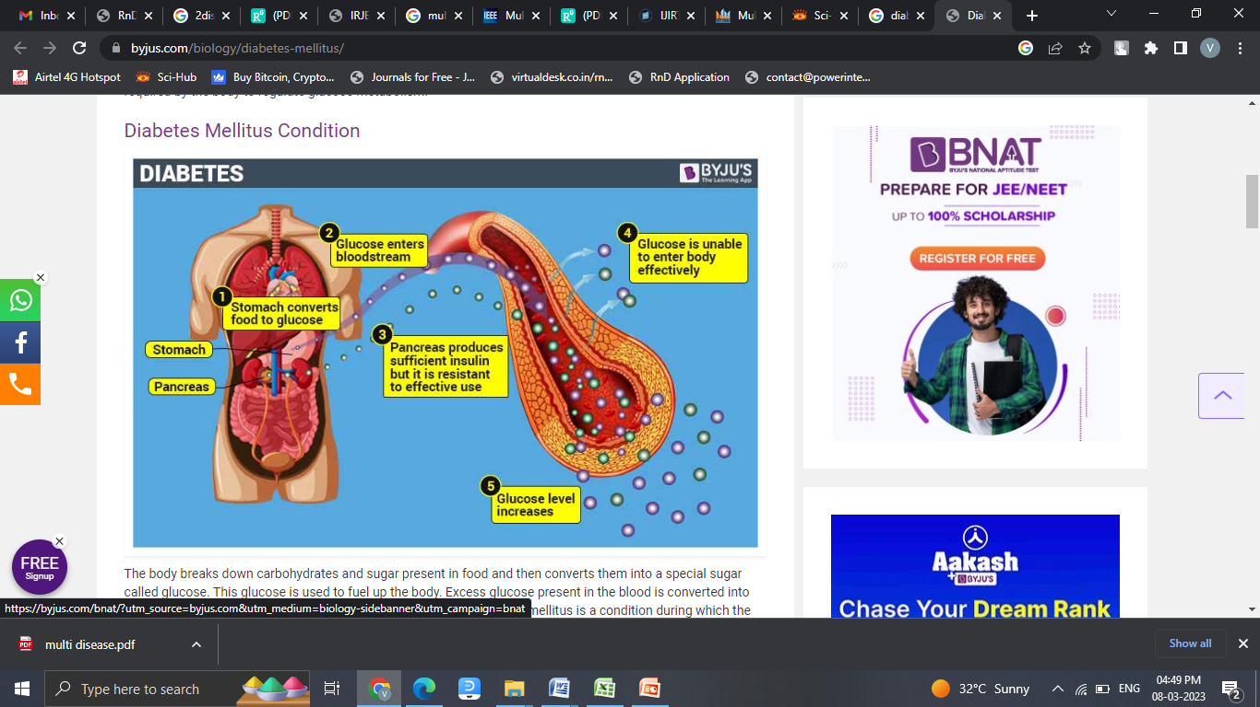

Machine learning has various applications and one of them is healthcare. There should be much more advanced

medical facilities so as to provide the best possible treatment for the patients

**1.2 Problem Identified**

It's a major challenge in the medical or healthcare industries to offer the highest quality services to all patients, and only those who can afford it can benefit from it. There is a vast amount of healthcare data available that is not being mined in a more efficient and reliable manner to uncover secret knowledge for successful decision-making There are instruments available which can predict heart disease but either it is expensive or are not efficient to calculate chance of heart disease in human. Early detection of cardiac diseases can decrease the mortality rate and overall complications. However, it is not possible to monitor patients every day in all cases accurately and consultation of a patient for 24 hours by a doctor is not available since it requires more sapience, time and expertise. Since we have a good amount of data in today’s world, we can use various machine learning algorithms to analyze the data for hidden patterns. The hidden patterns can be used for health diagnosis in medicinal data.

* 1. **Machine Learning**

Machine learning is a branch of AI. Other tools for reaching AI include rule-based engines, evolutionary algorithms, and Bayesian statistics. While many early AI programs, like IBM’s Deep Blue, which defeated Garry Kasparov in chess in 1997, were rule-based and dependent on human programming, machine learning is a tool through which computers have the ability to teach themselves, and set their own rules. In 2016, Google’s DeepMind beat the world champion in Go by using machine learning–training itself on a large data set of expert moves.

* + 1. **Machine Learning Work**

Machine Learning algorithm is trained using a training data set to create a model. When new input data is introduced to the ML algorithm, it makes a prediction on the basis of the model.

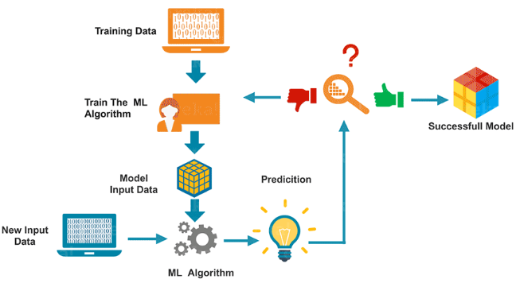

The prediction is evaluated for accuracy and if the accuracy is acceptable, the Machine Learning algorithm is deployed. If the accuracy is not acceptable, the Machine Learning algorithm is trained again and again with an augmented training data set. This is just a very high-level example as there are many factors and other steps involved.

* + 1. **Types of Machine Learning**

Machine learning is sub-categorized to three types:

* Supervised Learning – Train Me!
* Unsupervised Learning – I am self-sufficient in learning
* Reinforcement Learning – My life My rules! (Hit & Trial)

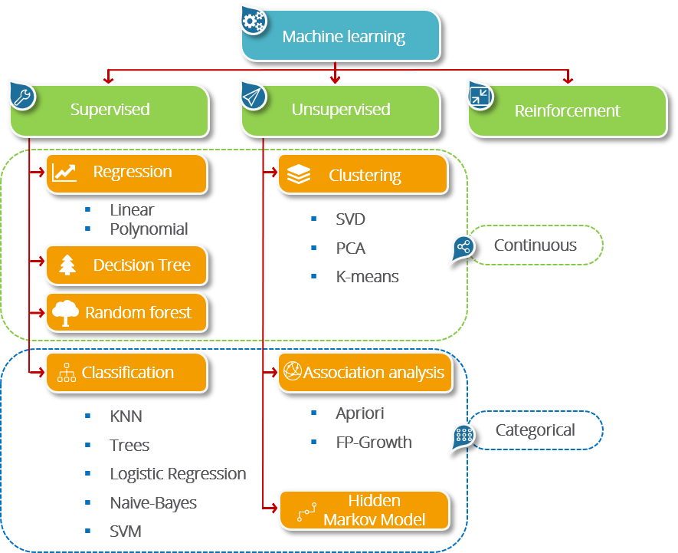

**Supervised Learning: More Control, Less Bias**

Supervised machine learning algorithms apply what has been learned in the past to new data using labelled examples to predict future events. By analysing a known training dataset, the learning algorithm produces an inferred function to predict output values. The system can provide targets for any new input after sufficient training. It can also compare its output with the correct, intended output to find errors and modify the model accordingly.

**Unsupervised Learning: Speed and Scale**

Unsupervised machine learning algorithms are used when the information used to train is neither classified nor labelled. Unsupervised learning studies how systems can infer a function to describe a hidden structure from unlabelled data. At no point does the system know the correct output with certainty. Instead, it draws inferences from datasets as to what the output should be.

**Reinforcement Learning: Rewards Outcomes**

Reinforcement machine learning algorithms are a learning method that interacts with its environment by producing actions and discovering errors or rewards. The most relevant characteristics of reinforcement learning are trial and error search and delayed reward. This method allows machines and software agents to automatically determine the ideal behaviour within a specific context to maximize its performance. Simple reward feedback — known as the reinforcement signal — is required for the agent to learn which action is best.

**1.3Objective**

* The objective of developing a machine learning intelligence framework for heart disease diagnosis is to potentialize the system in predicting the heart disease in order to increase the survival rate of patients by the accurate, precise and early detection of disease.
* In multiple diseases prediction system a user can analyse more than one disease on a single website. The user doesn’t need to traverse different places in order to predict whether he/she has a particular disease or not. In multiple diseases prediction system, the user needs to select the name of the particular disease, enter its parameters and just click on submit. The corresponding machine learning model will be invoked and it would predict the output and display it on the screen.

**CHAPTER 2**

**LITERATURE SURVEY**

[1]The main aim of the paper is ,as heart plays an important role in living organisms. So the diagnosis and prediction of heart related disease should be perfect and correct because it is very crucial which can cause death cases related to heart .So Machine learning and Artificial Intelligence supports in predicting any kind of natural events .So in this paper they calculate accuracy of machine learning for predicting heart disease using k-nearest neighbor ,decision tree, linear regression and SVM by using UCI repositor dataset for training and testing . They also compared the algorithm and their accuracy SVM 83 %,Decision tree 79%,Linear regression 78%,k-nearest neighbour 87%.

[2] The system defines that liver diseases is causing high number of deaths in India and is also considered as a life threating disease in the world. As it is difficult to detect the liver disease at early stage .So using automated program using machine learning algorithms we can detect the liver disease accurately .They used and compared SVM ,Decision Tree and Random forest algorithm and measures precision, accuracy and recall metrics for quantitative measurement. The accuracy are 95%,87%,92% respectively

[3] The study for the best medical diagnosis mining technique was performed by K.M. Al-Aidaroos, A.A. Bakar, and Z. Othman. For this study, the authors compared Nave Baeyes to five other classifiers: LR, KStar (K*), Decision Tree (DT), Neural Network (NN), and a basic rule-based algorithm (ZeroR). The efficiency of all algorithms was evaluated using 15 real-world medical problems from the UCI machine learning repository (Asuncion and Newman, 2007). In the experiment, NB outperformed the other algorithms in 8 of the 15 data sets, leading to the conclusion that the predictive accuracy results in Nave Baeyes are superior to other techniques

[4] 1. According to the paper focuses about as diabetes is one of the dangerous diseases in the world , it can cause many varieties of disorders which includes blindness etc .In this paper they have used machine learning techniques to find out diabetes disease as it is easy and flexible to forecast whether the patient has illness or not . Their aim of this analysis was to invent a system that can help the patient to detect the diabetes disease of the patient with accurate results. Here they used mainly 4 main algorithms Decision Tree , Naïve Bayes , and SVM algorithms and compared their accuracy which is 85%,77%, 77.3% respectively . They also used ANN algorithm after the training process to see the reactions of the network which states whether the disease is classified properly or not . Here they compared the precision recall and F1 score support ad accuracy of all the models

Marjia et al, [5] developed heart disease prediction using KStar, j48, SMO, and Bayes Net and Multilayer perception using WEKA software. Based on performance from different factor SMO and Bayes Net achieve optimum performance than KStar, Multilayer perception and J48 techniques using kfold cross validation. The accuracy performances achieved by those algorithms are still not satisfactory. Therefore, the accuracy’s performance is improved more to give better decision to diagnosis disease.

S. Seema et al,[6] focuses on techniques that can predict chronic disease by mining the data containing in historical health records using Naïve Bayes, Decision tree, Support Vector Machine(SVM) and Artificial Neural Network(ANN). A comparative study is performed on classifiers to measure the better performance on an accurate rate. From this experiment, SVM gives highest accuracy rate, whereas for diabetes Naïve Bayes gives the highest accuracy. R. Sharmila et al, [7] proposed to use non- linear classification algorithm for heart disease prediction. It is proposed to use bigdata tools such as Hadoop Distributed File System (HDFS), Mapreduce along with SVM for prediction of heart disease with optimized attribute set. This work made an investigation on the use of different data mining techniques for predicting heart diseases. It suggests to use HDFS for storing large data in different nodes and executing the prediction algorithm using SVM in more than one node simultaneously using SVM. SVM is used in parallel fashion which yielded better computation time than sequential SVM.

Jayami Patel et al, [7] suggested heart disease prediction using data mining and machine learning algorithm. The goal of this study is to extract hidden patterns by applying data mining techniques. The best algorithm J48 based on UCI data has the highest accuracy rate compared to LMT.

Purushottam et al, [8] proposed an efficient heart disease prediction system using data mining. This system helps medical practitioner to make effective decision making based on the certain parameter. By testing and training phase a certain parameter, it provides 86.3% accuracy in testing phase and 87.3% in training phase.

**CHAPTER 3**

**SYSTEM ANALYSIS**

**3.1Existing System**

**Naive Bayes**

The Naïve Bayes Classifier technique is mainly applicable when the dimensionality of the inputs is high. Despite its simplicity, Naive Bayes can often outperform more sophisticated classification methods. Naïve Bayes model recognizes the characteristics of patients with heart disease. It shows the probability of each input attribute for the predictable state.

Naive Bayes or Bayes’ Rule is the basis for many machine learning and data mining methods. The rule (algorithm) is used to create models with predictive capabilities. It provides new ways of exploring and understanding data.

Many of existing analysis involved analysing particular disease. When a user wants to analyse diabetes needs to use one analysis and same user wants to analyse heart disease then user has to use one more model. This is a time taking process. And also if any user having more than one disease but in existing system if it is able to predict only one disease then there is a chance of mortality rate increase due to not able to predict the other disease in advance. **Random Forest**

Random Forest is essentially an ensemble of unpruned classification trees. It gives excellent performance on a number of practical problems, largely because it is not sensitive to noise in the data set, and it is not subject to overfitting. It works fast, and generally exhibits a substantial performance improvement over many other tree-based algorithms. Random forests are built by combining the predictions of several trees, each of which is trained in isolation. There are three main choices to be made when constructing a random tree.

**Active Contour Model (ACM) filter**

Active contour models (ACMs) have been widely applied to image segmentation since their introduction. ACMs can obtain closed object contours as segmentation results, which can be conveniently used for shape analysis and recognition. The active contours can utilize various types of prior knowledge, such as image intensity distribution information, boundary shape information, and texture information, to obtain accurate results for object boundaries in image analysis.

.

**3.1.1Disadvantages**

* One algorithm may work well on a specific dataset while it cannot show a good performance on some others.
* So, selecting a suitable algorithm for a specific dataset is a big challenge in bioinformatics.
* Consequently, selecting good feature selection or classification algorithms is also a big challenge in this field.
* ML/DM algorithms commonly need massive datasets to be trained.
* These datasets must be inclusive and unbiased with high quality.
* Datasets also need time to be collected.
* RF does not improve the classification accuracy.
* It show a higher computational cost and training time.
* The classification performance is slightly worst.
* All these models cannot be generalized enough to produce quality prediction about tissues diagnosis in the rest of the patients.
* ANN prone to data-overfitting.
* lack of transparency in the “hidden layers” of neural networks

**3.2Proposed System**

In multi disease model prediction, it is possible to predict more than one disease at a time. So user no need to traverse many models to predict the diseases. It will reduce time and also due to predicting multiple diseases at a time there is a chance of reducing mortality rate. The proposed framework employs data mining techniques to detect Chronic diseases early. Machine learning is the process of programming computers to improve their output based on examples or previous data. The study of computer systems that learn from data and experience is known as machine learning. Training and Testing are the two stages of the machine learningalgorithm. Prediction of a disease based on the signs and medical history of the patient Machine learning has been a stumbling block for decades .

* **x2 statistical model for features refinement**

A chi-square test is used in statistics to test the independence of two events. Given the data of two variables, we can get observed count O and expected count E. Chi-Square measures how expected count E and observed count O deviates each other.

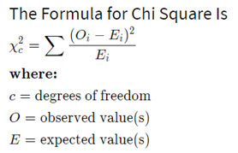

* **SVM**

Support vector machines (SVMs) are powerful yet flexible supervised machine learning algorithms which are used both for classification and regression. But generally, they are used in classification problems. In 1960s, SVMs were first introduced but later they got refined in 1990. SVMs have their unique way of implementation as compared to other machine learning algorithms. Lately, they are extremely popular because of their ability to handle multiple continuous and categorical variables.

The SVM is a learning algorithm for classification. It tries to find the optimal separating hyper plane such that the expected classification error for unseen patterns is minimized. For linearly non-separable data the input is mapped to high-dimensional feature space where they can be separated by a hyper plane. This projection into high dimensional feature space is efficiently performed by using kernels. More precisely, given a set of training samples and the corresponding decision values -1, 1 the SVM aims to find the best separating hyper plane given by the equation WTx+b that maximizes the distance between the two classes.

An SVM model is basically a representation of different classes in a hyperplane in multidimensional space. The hyperplane will be generated in an iterative manner by SVM so that the error can be minimized. The goal of SVM is to divide the datasets into classes to find a maximum marginal hyperplane (MMH).

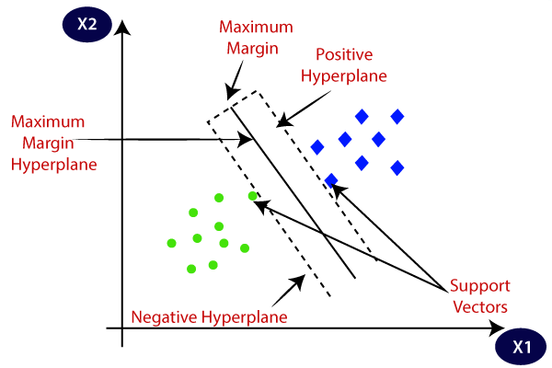

The followings are important concepts in SVM −

**Support Vectors** − Data points that are closest to the hyperplane is called support vectors. Separating line will be defined with the help of these data points.

**Hyperplane** − As we can see in the above diagram, it is a decision plane or space which is divided between a set of objects having different classes.

**3.2.1Advantages**

* It may result in early detection that leads to a decrease in mortality rate.
* ML can provide a priori probability of disease and use this probability to selectively target patients for angiography. Tis can save in cost and time for other patients. The side effects of angiography are also eliminated for them.
* Using DL can extract hidden patterns in the collected data. Tis may lead to finding new methods for early detection in many diseases like CAD.
* This is a novel method that builds on current research to derive quick and precise diagnostics.
* The method significantly outperforms other published research in this area due to its superior accuracy.
* intention is to accurately classify the presence of diseases.

**CHAPTER4**

**System Requirements**

**4.1Hardware Requirements**

* Processors:
* Intel® Core™ i5 processor 4300M at 2.60 GHz or 2.59 GHz (1 socket, 2 cores, 2 threads per core), 8 GB of DRAM
* Disk space: 320 GB
* Operating systems: Windows® 10, macOS*, and Linux*

**4.2Software Requirements**

* Server Side : Python 3.7.4(64-bit) or (32-bit)
* Client Side : HTML, CSS, Bootstrap
* IDE : Flask 1.1.1
* Back end : MySQL 5.
* Server : Wampserver 2i
* OS : Windows 10 64 –bit or Ubuntu 18.04 LTS “Bionic Beaver”

**\**

**CHAPTER 5**

**SOFTWARE DESCRIPTION**

**5.1Python 3.7.4**

Python is a general-purpose interpreted, interactive, object-oriented, and high-level programming language. It was created by Guido van Rossum during 1985- 1990. Like Perl, Python source code is also available under the GNU General Public License (GPL). This tutorial gives enough understanding on Python programming language.

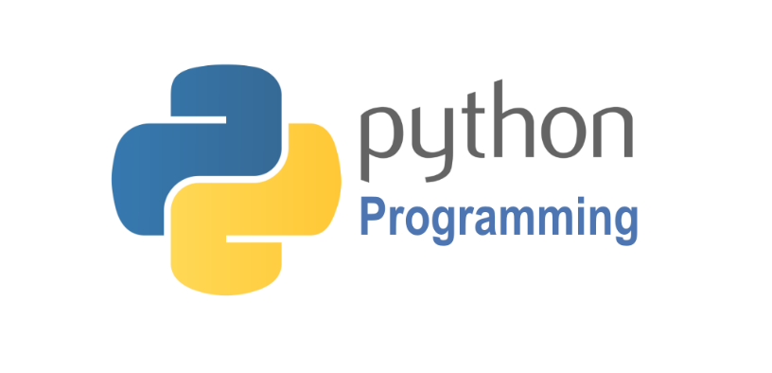

Python is a high-level, interpreted, interactive and object-oriented scripting language. Python is designed to be highly readable. It uses English keywords frequently where as other languages use punctuation, and it has fewer syntactical constructions than other languages. Python is a MUST for students and working professionals to become a great Software Engineer specially when they are working in Web Development Domain.

Python is currently the most widely used multi-purpose, high-level programming language. Python allows programming in Object-Oriented and Procedural paradigms. Python programs generally are smaller than other programming languages like Java. Programmers have to type relatively less and indentation requirement of the language, makes them readable all the time. Python language is being used by almost all tech-giant companies like – Google, Amazon, Facebook, Instagram, Dropbox, Uber… etc. The biggest strength of Python is huge collection of standard library which can be used for the following:

* Machine Learning
* GUI Applications (like Kivy, Tkinter, PyQtetc. )
* Web frameworks like Django (used by YouTube, Instagram, Dropbox)
* Image processing (like OpenCV, Pillow)
* Web scraping (like Scrapy, BeautifulSoup, Selenium)
* Test frameworks
* Multimedia
* Scientific computing
* Text processing and many more..

Pandas

pandas is a fast, powerful, flexible and easy to use open source data analysis and manipulation tool, built on top of the Python programming language.pandas is a Python package that provides fast, flexible, and expressive data structures designed to make working with "relational" or "labeled" data both easy and intuitive. It aims to be the fundamental high-level building block for doing practical, real world data analysis in Python.



Pandas is mainly used for data analysis and associated manipulation of tabular data in Data frames. Pandas allows importing data from various file formats such as comma-separated values, JSON, Parquet, SQL database tables or queries, and Microsoft Excel. Pandas allows various data manipulation operations such as merging, reshaping, selecting, as well as data cleaning, and data wrangling features. The development of pandas introduced into Python many comparable features of working with Data frames that were established in the R programming language. The panda’s library is built upon another library NumPy, which is oriented to efficiently working with arrays instead of the features of working on Data frames.

NumPy

NumPy, which stands for Numerical Python, is a library consisting of multidimensional array objects and a collection of routines for processing those arrays. Using NumPy, mathematical and logical operations on arrays can be performed.



NumPy is a general-purpose array-processing package. It provides a high-performance multidimensional array object, and tools for working with these arrays.

Matplotlib

Matplotlib is a comprehensive library for creating static, animated, and interactive visualizations in Python. Matplotlib makes easy things easy and hard things possible.



Matplotlib is a plotting library for the Python programming language and its numerical mathematics extension NumPy. It provides an object-oriented API for embedding plots into applications using general-purpose GUI toolkits like Tkinter, wxPython, Qt, or GTK.

Seaborn

Seaborn is a library for making statistical graphics in Python. It builds on top of [matplotlib](https://matplotlib.org/) and integrates closely with [pandas](https://pandas.pydata.org/) data structures.Visualization is the central part of Seaborn which helps in exploration and understanding of data.



Seaborn offers the following functionalities:

* Dataset oriented API to determine the relationship between variables.
* Automatic estimation and plotting of linear regression plots.
* It supports high-level abstractions for multi-plot grids.
* Visualizing univariate and bivariate distribution.

Scikit Learn

scikit-learn is a Python module for machine learning built on top of SciPy and is distributed under the 3-Clause BSD license.

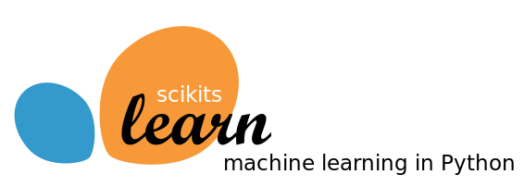

Scikit-learn (formerly scikits. learn and also known as sklearn) is a free software machine learning library for the Python programming language. It features various classification, regression and clustering algorithms including support-vector machines, random forests, gradient boosting, k-means and DBSCAN, and is designed to interoperate with the Python numerical and scientific libraries NumPy and SciPy.

MySQL

MySQL tutorial provides basic and advanced concepts of MySQL. Our MySQL tutorial is designed for beginners and professionals. MySQL is a relational database management system based on the Structured Query Language, which is the popular language for accessing and managing the records in the database. MySQL is open-source and free software under the GNU license. It is supported by Oracle Company.MySQL database that provides for how to manage database and to manipulate data with the help of various SQL queries. These queries are: insert records, update records, delete records, select records, create tables, drop tables, etc. There are also given MySQL interview questions to help you better understand the MySQL database.



MySQL is currently the most popular database management system software used for managing the relational database. It is open-source database software, which is supported by Oracle Company. It is fast, scalable, and easy to use database management system in comparison with Microsoft SQL Server and Oracle Database. It iscommonly used in conjunction with PHP scripts for creating powerful and dynamic server-side or web-based enterprise applications. It is developed, marketed, and supported by MySQL AB, a Swedish company, and written in C programming language and C++ programming language. The official pronunciation of MySQL is not the My Sequel; it is My Ess Que Ell. However, you can pronounce it in your way. Many small and big companies use MySQL. MySQL supports many Operating Systems like Windows, Linux, MacOS, etc. with C, C++, and Java languages.

The Apache Web Server

In addition to PHP, MySQL, JavaScript, and CSS, there’s actually a fifth hero in the dynamic Web: the web server. In the case of this book, that means the Apache web server. We’ve discussed a little of what a web server does during the HTTP server/client exchange, but it actually does much more behind the scenes. For example, Apache doesn’t serve up just HTML files—it handles a wide range of files, from images and Flash files to MP3 audio files, RSS (Really Simple Syndication) feeds, and more. Each element a web client encounters in an HTML page is also requested from the server, which then serves it up. But these objects don’t have to be static files, such as GIF images. They can all be generated by programs such as PHP scripts. That’s right: PHP can even create images and other files for you, either on the fly or in advance to serve up later. To do this, you normally have modules either precompiled into Apache or PHP or called up at runtime. One such module is the GD library (short for Graphics Draw), which PHP uses to create and handle graphics.

Apache also supports a huge range of modules of its own. In addition to the PHP module, the most important for your purposes as a web programmer are the modules that handle security. Other examples are the Rewrite module, which enables the web server to handle a varying range of URL types and rewrite them to its own internal requirements, and the Proxy module, which you can use to serve up often-requested pages from a cache to ease the load on the server. Later in the book, you’ll see how to actually use some of these modules to enhance the features provided by the core technologies we cover. About Open Source Whether or not being open source is the reason these technologies are so popular has often been debated, but PHP, MySQL, and Apache are the three most commonly used tools in their categories. What can be said, though, is that being open-source means that they have been developed in the community by teams of programmers writing the features they themselves want and need, with the original code available for all to see and change. Bugs can be found and security breaches can be prevented before they happen. There’s another benefit: all these programs are free to use. There’s no worrying about having to purchase additional licenses if you have to scale up your website and add more servers. And you don’t need to check the budget before deciding whether to upgrade to the latest versions of these products.

WampServer

WampServer is a Windows web development environment. It allows you to create web applications with Apache2, PHP and a MySQL database. Alongside, PhpMyAdmin allows you to manage easily your database.



WAMPServer is a reliable web development software program that lets you create web apps with MYSQL database and PHP Apache2. With an intuitive interface, the application features numerous functionalities and makes it the preferred choice of developers from around the world. The software is free to use and doesn’t require a payment or subscription.

Bootstrap 4

Bootstrap is a free and open-source tool collection for creating responsive websites and web applications. It is the most popular HTML, CSS, and JavaScript framework for developing responsive, mobile-first websites.



It solves many problems which we had once, one of which is the cross-browser compatibility issue. Nowadays, the websites are perfect for all the browsers (IE, Firefox, and Chrome) and for all sizes of screens (Desktop, Tablets, Phablets, and Phones). All thanks to Bootstrap developers -Mark Otto and Jacob Thornton of Twitter, though it was later declared to be an open-source project.

Easy to use: Anybody with just basic knowledge of HTML and CSS can start using Bootstrap

Responsive features: Bootstrap's responsive CSS adjusts to phones, tablets, and desktops

Mobile-first approach: In Bootstrap, mobile-first styles are part of the core framework

Browser compatibility: Bootstrap 4 is compatible with all modern browsers (Chrome, Firefox, Internet Explorer 10+, Edge, Safari, and Opera)

Using an IDE

As good as dedicated program editors can be for your programming productivity, their utility pales into insignificance when compared to Integrated Developing Environments (IDEs), which offer many additional features such as in-editor debugging and program testing, as well as function descriptions and much more.

Web Framework

Web Application Framework or simply Web Framework represents a collection of libraries and modules that enables a web application developer to write applications without having to bother about low-level details such as protocols, thread management etc.

Flask

[Flask](http://flask.pocoo.org/) is a web framework. This means flask provides you with tools, libraries and technologies that allow you to build a web application. This web application can be some web pages, a blog, a wiki or go as big as a web-based calendar application or a commercial website.



Flask is often referred to as a micro framework. It aims to keep the core of an application simple yet extensible. Flask does not have built-in abstraction layer for database handling, nor does it have formed a validation support. Instead, Flask supports the extensions to add such functionality to the application.  Although Flask is rather young compared to most [Python](https://quintagroup.com/services/python) frameworks, it holds a great promise and has already gained popularity among Python web developers. Let’s take a closer look into Flask, so-called “micro” framework for Python.

**CHAPTER 6**

**6.1 Modules Description**

**1.1 Multi Disease UI Diagnosis Model**

In this module we developed UI-based interface designed to be used by doctors, nurses and hospital administration staff, Patient – untrained in data science – to predict, forecast and recommendation System.In order to facilitate operations, a simple user interface was designed using the Flask Framework. This interface can accurately infer the edge contour, assisting users in segmentation. The module should be able to collect data from a user's blood sugar readings, insulin dosages, and other relevant health metrics.This module developing the user interface, data collection and analysis, and reporting features.

**2. Diabetes Model Train and Build**

**2.1. Dataset Collection**

The datasets consist of several medical predictor variables and one target variable, Outcome. Predictor variables includes the number of pregnancies the patient has had, their BMI, insulin level, age, and so on.

* **Pregnancies**: Number of times pregnant
* **Glucose**: Plasma glucose concentration a 2 hours in an oral glucose tolerance test
* **BloodPressure**: Diastolic blood pressure (mm Hg)
* **SkinThickness**: Triceps skin fold thickness (mm)
* **Insulin**: 2-Hour serum insulin (mu U/ml)
* **BMI**: Body mass index (weight in kg/(height in m)^2)
* **DiabetesPedigreeFunction**: Diabetes pedigree function
* **Age**: Age (years)
* **Outcome**: Class variable (0 or 1)

Number of Observation Units: 768

Variable Number: 9

**2.1.2 Data Set Acquisition**

**2.2.1. Diabetes Lab Test Sample Data**

In this module, we load the CSV file format Diabetes Lab Test Sample Data to our web screening tool. The Diabetes Disease Dataset consists of 9 features for 400 people7 features are numerical, while 8 are categorical which is stored in CSV file format.The dataset contains 768 observables with eight feature variables and one target variable.RangeIndex: 768 entries, 0 to 767.Data columns (total 9 columns).

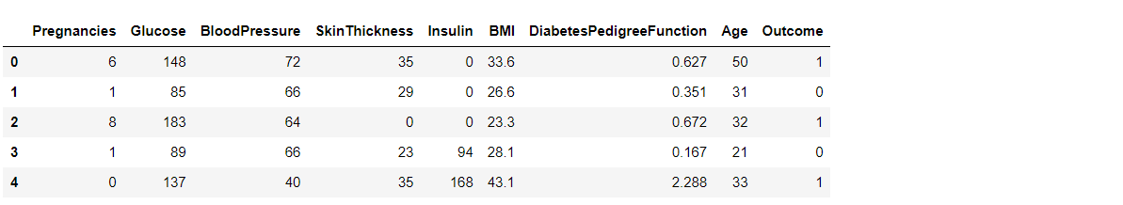

**2.1.3 Dataset Pre-processing**

**2.1.3.1** **Data Preprocessing**

Before feeding the data into the Prediction model, following data cleaning and preprocessing steps are performed

● Checking null values and filling using forward fill method

● Converting data into different cases

● Standardizing the data using mean and standard deviation

● Splitting the dataset into training and testing sets

**1. Formatting:** The data set is used for implementation is taken from UCI repository, it may contain certain attributes whose names are not clear in the (dataset name) also contain certain unrelated attribute which is not useful for the greater performance of proposed work . An attribute name as “Thal” has been removed from dataset by using following command in R, Dataset$Thal<-Null

**2. Cleaning:** This part of pre-processing belongs to remove or fixing of missing out entry in the data frame. Row containing these incomplete columned to be removed also for removing certain redundant entries in data frame this step is recommend

**3. Sampling:** Sampling is also done on the dataset to enhance the performance of the algorithm on sample data set may lead algorithm to take longer time.

**heart.CSV**

**Formatting**

**Cleaning**

**Storage**

**Sampling**

**2.3 Clustering**

The pre-processed data is clustered using clustering algorithms like K-Nearest Neighbour (KNN) tocluster relevant data in database.KNN algorithm provides a simplest way to classify the givendataset using k no. of clusters. We define k centroids, one foreach cluster. In this algorithm we choose k no. of clusters (kfixed), find the centroids and distance between the objects tocentroids, then we group them based o minimum distance loop isgenerated and iterated until there are no more changes to be doneto change the centroids position after every loop. The main aimof this algorithm is to minimize the objective function

**Preprocessed Data**

**KNN**

**Storage**

**2.4 Feature Selection**

1. the effect of selected factors on diabetes using logistic regression. Its shows that age, education, BMI, systolic BP, diastolic BP, direct cholesterol, and total cholesterol are statistically significant factors for diabetes disease at 5% level of significance and the rest of the factors are insignificant. These seven factors are used for ML-based system to classify and predict of diabetes disease.
2. Effect of selected factors on the diabetes using logistic regression

| **Factors** | **OR** | **p value** | **95% CI for OR** | |
| --- | --- | --- | --- | --- |
| **Lower** | **Upper** |
| Age (years) | 1.055 | < 0.001 | 1.047 | 1.064 |
| Gender |  |  |  |  |
| Female (ref) | 1.000 |  |  |  |
| Male | 1.270 | 0.086 | 0.967 | 1.670 |
| Race |  |  |  |  |
| Black (ref) | 1.000 |  |  |  |
| Hispanic | 0.746 | 0.206 | 0.470 | 1.167 |
| Mexican | 0.858 | 0.465 | 0.567 | 1.290 |
| Other | 1.109 | 0.623 | 0.732 | 1.670 |
| White | 0.469 | 0.263 | 0.358 | 0.619 |
| Education |  |  |  |  |
| 8th grade (ref) | 1.000 |  |  |  |
| 9–11th grade | 0.577 | 0.005 | 0.394 | 0.844 |
| College grad | 0.641 | 0.019 | 0.441 | 0.932 |
| High school | 0.746 | 0.010 | 0.526 | 1.060 |
| Some college | 0.786 | 0.030 | 0.559 | 1.112 |
| Marital status |  |  |  |  |

**2.4.1Data Visualization**

The correlation between each column are visualized using heatmap. From the output, the lighter colors indicate more correlation. We notice the correlation between pairs of features, like age and pregnancies, or BMI and skin thickness, etc.

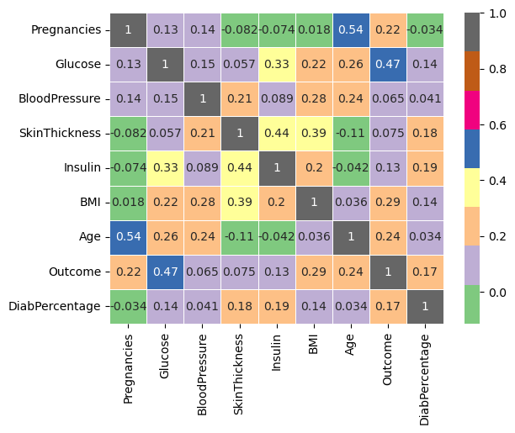

In feature selection, irrelevant features areeliminated and the most important or relevant features areapplied to the network. Thus, if we supply all features toSVM, some features may be noisy and if they are learned inthe training process, they may degrade generalization of thenetwork although the network will show good performanceon the training data. That is why large number of features arealso considered one of the main causes of over fitting. Thus,searching out optimal subset of features by eliminating noisyfeatures can help SVM to show good performance on bothtraining and testing data.In this module, we use *­X*2 statistical model to eliminate irrelevantfeatures.

**2.5.Diabetes Disease Classification**

In this module, we used Ensemble learning as the classifiers. Ensemble learning is a successful paradigm of machine learning which merges a set of learners instead of using a single learner to predict unknown target attributes. In this structure, all output values obtained from each learner are combined by using a voting mechanism to make final class label prediction. The main goal of ensemble learning is to form a strong classifier consisting of multiple learners to obtain more accurate classification results.

Ensemble learning techniques are mainly group under four categories: bagging, boosting, voting, and stacking. In this study, bagging and boosting approaches which are widely preferred ensemble learning methods are implemented on the experimental data and compared with each other.

**2.6.1. Bagging**

Bagging, for bootstrap aggregation, is a frequently used ensemble technique that creates multiple training sets using a bootstrap method. In the bootstrap method, multiple training sets are constructed by choosing random and repeatable samples from the original dataset. After creating training subsets, multiple learning models are generated by training each learner in the ensemble structure with these subsets. Last, the predictions obtained from each model are aggregated to obtain the final decision.

* Random forest: the random forest algorithm, proposed by Leo Breiman and Adele Cutler, is a bagging algorithm which generates a forest with multiple decision trees. It classifies the unknown target attribute of a new sample by taking a majority vote over all the decision trees in the forest.

**2.6.2. Boosting**

In the boosting method, the aim is to acquire a strong classifier from a set of weak learners. According to this approach, the samples in the training set are reweighted during the learning phase to generate multiple learners.

* AdaBoost: AdaBoost (adaptive boosting), introduced by Yoav Freund and Robert Schapire, is a boosting algorithm that earned Gödel Prize in 2013. In this algorithm, the weight of misclassified samples in the training set is increased in each iteration. Thus, the chance of selecting misclassified samples for the training set is increased and more samples are classified correctly.

SVM (Support Vector Machine) is a class of FFN (Feed Forward Networks) like outspread premise Function systems, established by vapnik. Support vector machine can be used for design order additionally nonlinear regression. SVM is nearly accurate execution of the arrangement of compositional hazard decrease. This standard is relying upon the truth of the blunder rate of a learning machine on the test information is compassed by the expansion of the preparation mistake rate and term that relies upon the vapnik chervonenkis (VC) measurement. The SVM can offer fine speculation accomplishment on design order debate. The SVM algorithm was developed for prediction by using an 𝜀–insensitive loss function

**2.5 Prediction**

**1.Diabetes Predictor**

The model should learn to predict instances as either having diabetes disease or not having it, based on the input features.

**1.1. Input Diabetes Target Value**

In this module the user of the system input the diabetes disease attributes values to the system through web interface.

**1.2. Prediction**

In this module, the eigen vectors is the "ordinary" distance between two points that one would measure with a ruler, and is given by the Pythagorean formula. By using this formula as distance, eigen space (or even any inner product space) becomes a metric space. The associated norm is called the Euclidean norm. Older literature refers to the metric as Pythagorean metric.

The eigen distance between points p and q is the length of the line segment connecting them: p.q In Cartesian coordinates, if p = (p, p,..., p ) and q = (q , q ,..., q ) are two points in Euclidean n space, then the distance from p to q, or from q to p is given by the following heterogeneous value difference metric.

**Trained Data File**

***Eigen***

**Stastical**

**Test Data**

**Result visualization**

**Stastical**

In this module, the Euclidean distance or Euclidean metric is the "ordinary" distance between two points that one would measure with a ruler, and is given by the Pythagorean formula. By using this formula as distance, Euclidean space (or even any inner product space) becomes a metric space. The associated norm is called the Euclidean norm. Older literature refers to the metric as Pythagorean metric

**2.6. End User Module**

**1 Patient or Doctor or User**

* + Register
  + Login
  + Add Biographic and Demographic Information
  + Test Diabetes
  + Receive recommendation
  + Logout

**2. Admin**

* + Login
  + Import Dataset
  + Train the Model
  + Customize Recommendation
  + Track user accounts
  + Report
  + Logout

**2.7.Performance Analysis**

valuate the classification model: Evaluate the performance of the classification model on the testing set using metrics such as accuracy, precision, recall, and F1 score. You can also use cross-validation to estimate the generalization performance of the model.

If the actual value of the target in the dataset is True and the classifier predicts it as such, then the prediction is a True Positive (TP). On the contrary, if the classifier predicts it as False, then the prediction is a False Negative (FN). Similarly, if the actual value of the target in the dataset is False and the classifier predicts it as such, then the prediction is True Negative (TN). On the contrary, if the classifier predicts it as True, then the prediction is False Positive (FP).

Finding out how the developed predictive model performs becomes easy with the help of the confusion matrix.

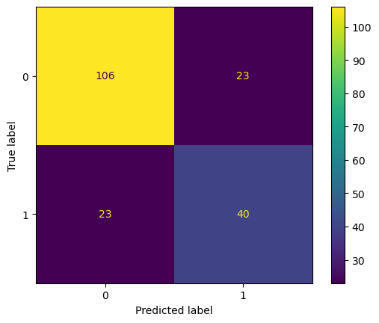

The following metrics are used to evaluate the proposed model.

Accuracy (Acc) is the percentage of the correct predictions that a classifier has made compared with the actual values of the target in the testing phase.



Sensitivity (Sens) gives information about the percentage of True Positives that are correctly classified during the test.



Specificity (Spec) gives information about of True Negatives that are correctly classified during the test.



Precision (Pre) is the percentage of instances that a classifier has labelled as positive with respect to the total predictive positives (the exactness of a classifier).



F1-score shows the harmonic mean of precision and recall.



**Trained Data File**

***Euclidean***

**Stastical**

**Test Data**

**Result visualization**

**Stastical**

**Result Analysis**

**Stastical**

**Accuracy**

**Stastical**

**Sensitivity**

**Stastical**

**Specificity**

**Stastical**

**Dataset Introduction**

Diabetes analysis initially Pima Indian Diabetes Dataset, the data set which was acquired from a hospital in Frankfurt, Germany are used. For diabetic retinopathy over 150 GB image data from the UCI machine learning repository are used. For heart disease analysis Cleveland, Hungarian and Switzerland heart disease patient’s data sets are used. And for cancer disease prediction used Heart disease Data Set which is available in machine learning repository. In the current analysis in addition to those data sets used other live data sets by visiting corresponding hospitals. The importance of this analysis is by consulting the doctors collected the necessary parameters which will cause the disease and also due to that disease any other disease likely to occur. After doing this analysis there is a chance of reducing mortality ratio because if can able to predict the maximum diseases chances of occurring so that can warn the patients in advance for treatment

**Table Database Description**

|  |  |  |
| --- | --- | --- |
| **Field** | **Description** | **Range and Values** |
| Age | Age of the patient | 0-100 in years |
| Sex | Gender of the patient | 0-1 (1:Male 0:Female) |
| Chest Pain | Type of chest pain | 1-4 (1: Typical Angina, 2: Atypical Angina, 3: Non-anginal, 4: Asymptotic ) |
| Resting Blood Pressure | Blood pressure during rest | mm Hg |
| Cholesterol | Serum Cholesterol | mg / dl |
| Fasting Blood Sugar | Blood sugar content before food intake if >120 mg/dl | 0-1 (0: False, 1: True) |
| ECG | Resting Electrocardiographic results | 0-1 (0: Normal, 1: Having ST-T wave) |
| Max Heart Rate | Maximum heart beat rate. | Beats/min |
| Exercise Induced Angina | Has pain been induced by exercise | 0-1 (0: No, 1: Yes) |
| Old Peak | ST depression induced by exercise relative to rest | 0-4 |
| Slope of Peak Exercise | Slope of the peak exercise ST segment | 1-3 (1: Up sloping, 2: Flat, 3: Down sloping) |
| Ca | Number of vessels colored by fluoroscopy | 0-3 |
| Thal |  | 3- normal  6-Fixed Defect  7- Reversible Defect |
| Num | Diagnostics of Heart Disease | * 1. (0: <50% Narrowing   1: >50% Narrowing) |

The dataset consists of 303 individuals data. There are 14 columns in the dataset, which are described below.

1. ***Age***: displays the age of the individual.
2. ***Sex***: displays the gender of the individual using the following format :  
   1 = male  
   0 = female
3. ***Chest-pain type***: displays the type of chest-pain experienced by the individual using the following format :  
   1 = typical angina  
   2 = atypical angina  
   3 = non — anginal pain  
   4 = asymptotic
4. ***Resting Blood Pressure***: displays the resting blood pressure value of an individual in mmHg (unit)
5. ***Serum Cholestrol***: displays the serum cholesterol in mg/dl (unit)
6. ***Fasting Blood Sugar***: compares the fasting blood sugar value of an individual with 120mg/dl.  
   If fasting blood sugar > 120mg/dl then : 1 (true)  
   else : 0 (false)
7. ***Resting ECG***: displays resting electrocardiographic results  
   0 = normal  
   1 = having ST-T wave abnormality  
   2 = left ventricular hyperthrophy
8. ***Max heart rate achieved***: displays the max heart rate achieved by an individual.
9. ***Exercise induced angina*** :  
   1 = yes  
   0 = no
10. ***ST depression induced by exercise relative to rest***: displays the value which is an integer or float.
11. ***Peak exercise ST segment*** :  
    1 = upsloping  
    2 = flat  
    3 = downsloping
12. ***Number of major vessels (0–3) colored by flourosopy*** : displays the value as integer or float.
13. ***Thal*** : displays the thalassemia :  
    3 = normal  
    6 = fixed defect  
    7 = reversible defect
14. ***Diagnosis of heart disease*** : Displays whether the individual is suffering from heart disease or not :  
    0 = absence  
    1, 2, 3, 4 = present.

**Why these parameters:**

In the actual dataset, we had 76 features but for our study, we chose only the above 14 because:

1. **Age**: Age is the most important risk factor in developing cardiovascular or heart diseases, with approximately a tripling of risk with each decade of life. Coronary fatty streaks can begin to form in adolescence. It is estimated that 82 percent of people who die of coronary heart disease are 65 and older. Simultaneously, the risk of stroke doubles every decade after age 55.
2. **Sex**: Men are at greater risk of heart disease than pre-menopausal women. Once past menopause, it has been argued that a woman’s risk is similar to a man’s although more recent data from the WHO and UN disputes this. If a female has diabetes, she is more likely to develop heart disease than a male with diabetes.
3. **Angina (Chest Pain)**: Angina is chest pain or discomfort caused when your heart muscle doesn’t get enough oxygen-rich blood. It may feel like pressure or squeezing in your chest. The discomfort also can occur in your shoulders, arms, neck, jaw, or back. Angina pain may even feel like indigestion.
4. **Resting Blood Pressure**: Over time, high blood pressure can damage arteries that feed your heart. High blood pressure that occurs with other conditions, such as obesity, high cholesterol or diabetes, increases your risk even more.
5. **Serum Cholesterol**: A high level of low-density lipoprotein (LDL) cholesterol (the “bad” cholesterol) is most likely to narrow arteries. A high level of triglycerides, a type of blood fat related to your diet, also ups your risk of a heart attack. However, a high level of high-density lipoprotein (HDL) cholesterol (the “good” cholesterol) lowers your risk of a heart attack.
6. **Fasting Blood Sugar**: Not producing enough of a hormone secreted by your pancreas (insulin) or not responding to insulin properly causes your body’s blood sugar levels to rise, increasing your risk of a heart attack.
7. **Resting ECG**: For people at low risk of cardiovascular disease, the USPSTF concludes with moderate certainty that the potential harms of screening with resting or exercise ECG equal or exceed the potential benefits. For people at intermediate to high risk, current evidence is insufficient to assess the balance of benefits and harms of screening.
8. **Max heart rate achieved**: The increase in cardiovascular risk, associated with the acceleration of heart rate, was comparable to the increase in risk observed with high blood pressure. It has been shown that an increase in heart rate by 10 beats per minute was associated with an increase in the risk of cardiac death by at least 20%, and this increase in the risk is similar to the one observed with an increase in systolic blood pressure by 10 mm Hg.
9. **Exercise induced angina**: The pain or discomfort associated with angina usually feels tight, gripping or squeezing, and can vary from mild to severe. Angina is usually felt in the center of your chest but may spread to either or both of your shoulders, or your back, neck, jaw or arm. It can even be felt in your hands. o Types of Angina a. Stable Angina / Angina Pectoris b. Unstable Angina c. Variant (Prinzmetal) Angina d. Microvascular Angina.
10. **Peak exercise ST segment**: A treadmill ECG stress test is considered abnormal when there is a horizontal or down-sloping ST-segment depression ≥ 1 mm at 60–80 ms after the J point. Exercise ECGs with up-sloping ST-segment depressions are typically reported as an ‘equivocal’ test. In general, the occurrence of horizontal or down-sloping ST-segment depression at a lower workload (calculated in METs) or heart rate indicates a worse prognosis and higher likelihood of multi-vessel disease. The duration of ST-segment depression is also important, as prolonged recovery after peak stress is consistent with a positive treadmill ECG stress test. Another finding that is highly indicative of significant CAD is the occurrence of ST-segment elevation > 1 mm (often suggesting transmural ischemia); these patients are frequently referred urgently for coronary angiography.

**1System Architecture**

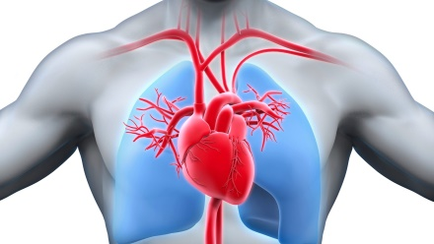

**Preprocessing**

**Feature Extraction**

**SVM Classifier**

**Classified Result**

**Preprocessing**

**Feature Extraction**

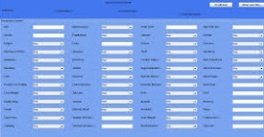

**Prediction**

**Analysis**

**Recommendation**

**Forecasting**



**Training phase**

**Testing phase**

**Storage**

**Feature Selection**

**Feature Selection**

DFD

Level0

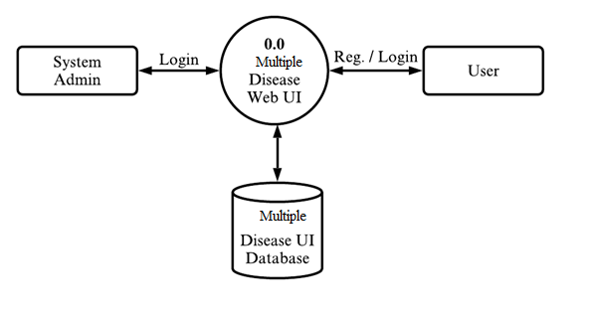

Level 1

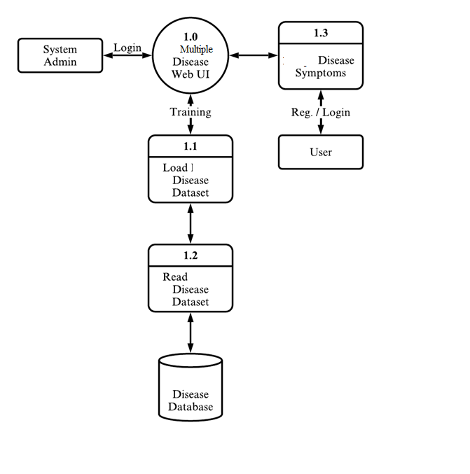

Level 2

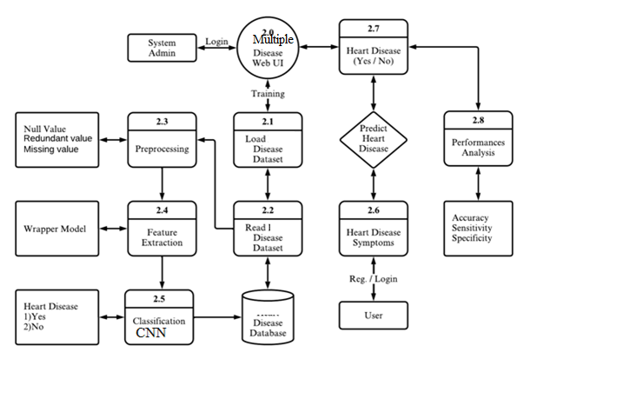

**CHAPTER 7**

**SYSTEM TESTING**

In this phase of methodology, testing was carried out on the several application modules. Different kind of testing was done on the modules which are described in the following sections. Generally, tests were done against functional and non-functional requirements of the application following the test cases. Testing the application again and again helped it to become a reliable and stable system.

**7.1Usability Testing**

This was done to determine the usability of the application that was developed. This helped to check whether the application would be easy to use or what pitfalls would the users come through. This was used to determine whether the application is user friendly. It was used to ascertain whether a new user can easily understand the application even before interacting with it so much. The major things checked were: the system flow from one page to another, whether the entry points, icons and words used were functional, visible and easily understood by user.

**7.2Functional Testing**

Functional Testing is defined as a type of testing which verifies that each function of the software application operates in conformance with the requirement specification. This testing mainly involves black box testing and it is not concerned about the source code of the application. Functional tests were done based on different kind of features and modules of the application and observed that whether the features are met actual project objectives and the modules are hundred percent functional. Functional tests, as shown in the following Table-1 to Table-5, were done based on use cases to determine success or failure of the system implementation and design. For each use case, testing measures were set with results being considered successful or unsuccessful. Below are the tables which are showing some of the major test cases along with their respective test results.

**7.3System Testing**

In this phase of methodology, testing was carried out on the several application modules. Different kind of testing was done on the modules which are described in the following sections. Generally, tests were done against functional and non-functional requirements of the application following the test cases. Testing the application again and again helped it to become a reliable and stable system.

**7.4 Unit Testing**:Before you can test an entire software program, make sure the individual parts work properly on their own. Unit testing validates the function of a unit, ensuring that the inputs (one to a few) result in the lone desired output. This testing type provides the foundation for more complex integrated software. When done right, unit testing drives higher quality application code and speeds up the development process. Developers often execute unit tests through test automation.

**7.5Integration Testing** Integration testing is often done in concert with unit testing. Through integration testing, QA professionals verify that individual modules of code work together properly as a group. Many modern applications run on microservices, self-contained applications that are designed to handle a specific task. These microservices must be able to communicate with each other, or the application won’t work as intended. Through integration testing, testers ensure these components operate and communicate together seamlessly.

**7.6TEST CASES**

**7.6.1Signup/Registration Test Case**

|  |  |
| --- | --- |
| Identifier | Test Case-1 |
| Test Case | Signup |
| Description | To register new account in the application. |
| Pre-requisite | 1) Username and email must not exist previously. |
| Test procedure | 1. Select Sign Up from themenu. 2. Fill in username, email, and password and retype password accordingly. 3. Click on Sign Upbutton |
| Expected Result | 1. User can register to the applicationsuccessfully. 2. Username, email and password stored in the user table in the database. |
| Pass/Fail | Pass |

**7.6.2Login Test Case**

|  |  |
| --- | --- |
| Identifier | Test Case-2 |
| Test Case | Login |
| Description | To login new account in the application |
| Pre-requisite | 1) Registration must be done previously. |
| Test procedure | 1. Select Log In from themenu. 2. Fill in username and passwordaccordingly. 3. Click on Log In button. |
| Expected Result | 1. User can login to the applicationsuccessfully. 2. User should access the application features which areallowed |
| Pass/Fail | Pass |

**CHAPTER 8**

**8.1Conclusion**

Multi disease prediction model is used to predict multiple diseases at a time. Here based on the user input disease will be predicted. The choice will be given to user. If the user want to predict particular disease or if the user don’t enter any disease type then based on user entered inputs corresponding disease model will be invoked and predicted. In this project, the machine learning based support vector machine classification and prediction models were developed and evaluated based on diagnostic performance of coronary heart disease in patients using sensitivity, specificity, precision, FScore, AUC, DOR, 95% confidence interval for DOR, and K-S test.The advantage of multi disease prediction model in advance can predict the probability of occurrence of various disease and also can reduce mortality ratio. The aim of this project is to predict disease based on symptoms. Thus, the models can be used to aid healthcare professionals and patients throughout the world to advance both public health and global health, especially in developing countries and resource-limited areas where there are fewer cardiac specialists available.

The project is set up in such a way that the device takes the user’s symptoms as input and generates an output, which is disease prediction. A prediction accuracy probability of 95% is obtained on average. The grails system was used to successfully incorporate Disease Predictor

**.8.2 FUTURE SCOPE**

In the future we can add more diseases in the existing API. We can try to improve the accuracy of prediction in order to decrease the mortality rate. Try to make the system user-friendly and provide a chatbot for normal queries. In future research, we would investigate other enhanced methods that would further raise the diagnostic accuracy of the deep learning model by utilizing deep learning based on morphologic class pattern predictions in order to further enhance the performances of the SVM models for heart disease diagnoses in patients worldwide. Furthermore, current advances in deep learning, including recurrent neural network, deep convolutional neural network, long short-term memory neural network, deep brief network based on restricted Boltzmann machines, and deep auto-encoder may be utilized to further increase the accuracy of heart disease diagnoses for patients.

**CHAPTER 10**

**Refrences**

[1] K. Polaraju, D. Durga Prasad, “Prediction of Heart Disease using Multiple Linear Regression Model”, International Journal of Engineering Development and Research Development, ISSN:2321-9939, 2017. [2] Marjia Sultana, Afrin Haider, “Heart Disease Prediction using WEKA tool and 10-Fold cross-validation”, The Institute of Electrical and Electronics Engineers, March 2017.

[3] Dr.S.SeemaShedole, KumariDeepika, “Predictive analytics to prevent and control chronic disease”, https://www.researchgate.net/punlication/316530782, January 2016.

[4] Ashok kumarDwivedi, “Evaluate the performance of different machine learning techniques for prediction of heart disease using ten-fold cross-validation”, Springer, 17 September 2016.

[5] MeghaShahi, R. Kaur Gurm, “Heart Disease Prediction System using Data Mining Techniques”, Orient J. Computer Science Technology, vol.6 2017, pp.457-466.

[6] Mr. ChalaBeyene, Prof. Pooja Kamat, “Survey on Prediction and Analysis the Occurrence of Heart Disease Using Data Mining Techniques”, International Journal of Pure and Applied Mathematics, 2018. [7] R. Sharmila, S. Chellammal, “A conceptual method to enhance the prediction of heart diseases using the data techniques”, International Journal of Computer Science and Engineering, May 2018.

[7] Al-Aidaroos, K., Bakar, A., & Othman, Z. (2012). Medical Data Classification with Naive Bayes Approach. Information Technology Journal .

[8] Darcy A. Davis, N. V.-L. (2008). Predicting Individual Disease Risk Based on Medical History.

[9] JyotiSoni, Ansari, U., Sharma, D., & Soni, S. (2011). Predictive Data Mining for Medical Diagnosis: An Overview of Heart Disease Prediction.

[10] K.M. Al-Aidaroos, A. B. (n.d.). K.M. AlAidaroos, A. B. (n.d.). 2012. Medical Data Classification with Naive Bayes Approach .

[11] NisharBanu, MA; Gomathy, B.; (2013). Disease Predicting System Using Data Mining Techniques.