To generate text summary we have bundled of traditional summary algorithms such as Gensim, Luhn, Sumy, LSA, NLP and many more are available. In propose work already we have experimented with NLP summary and as second algorithm we have decided to experiment with advance text summarization algorithms such as BERT or Transformers.

Transformers algorithms trained on large amount of datasets and are capable of generated accurate summary and this algorithms already utilizing in GPT versions so we have as part of enhancement of this project we are using Transformer algorithm and then comparing its precision with traditional NLP summary.

Below are the comparison of both NLP and Transformer summary algorithms performances.

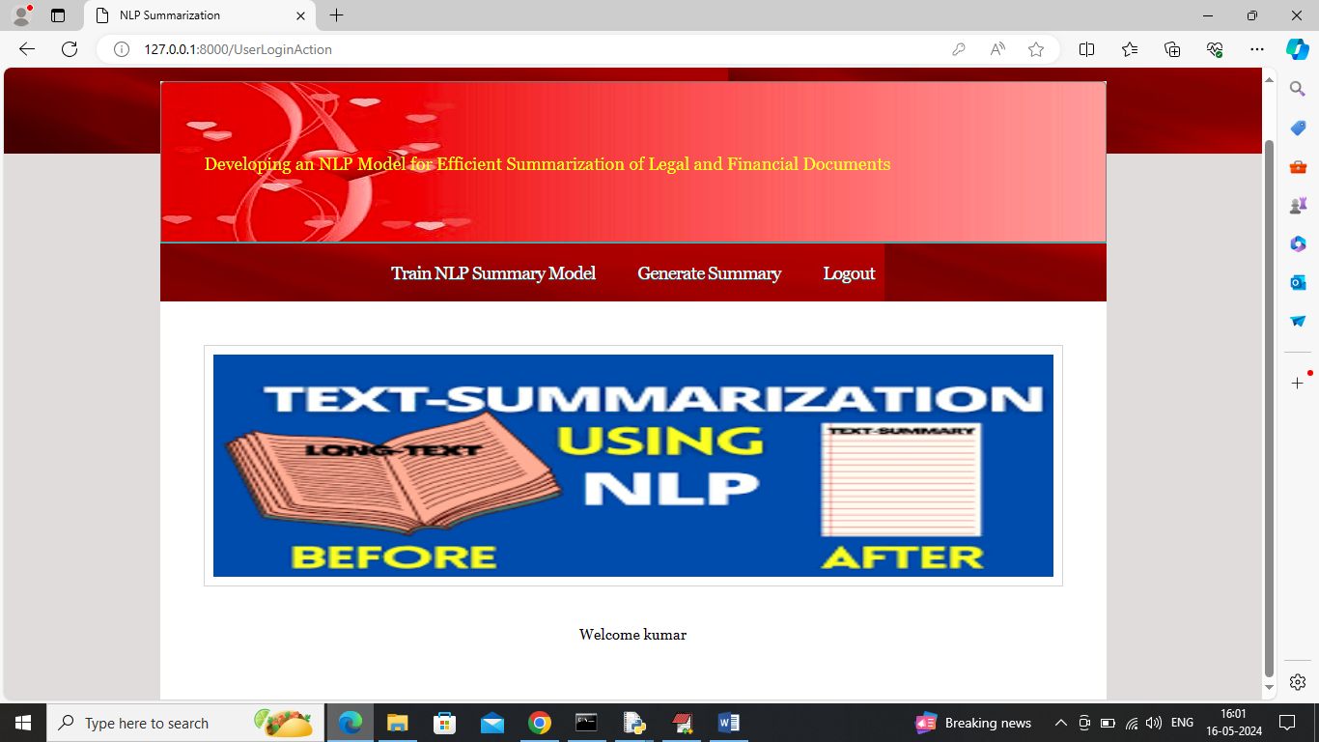

In above screen user can click on ‘Train NLP Summary Model’ link to train NLP and transformer algorithms and then perform summary prediction on test data to calculate precision and other metrics

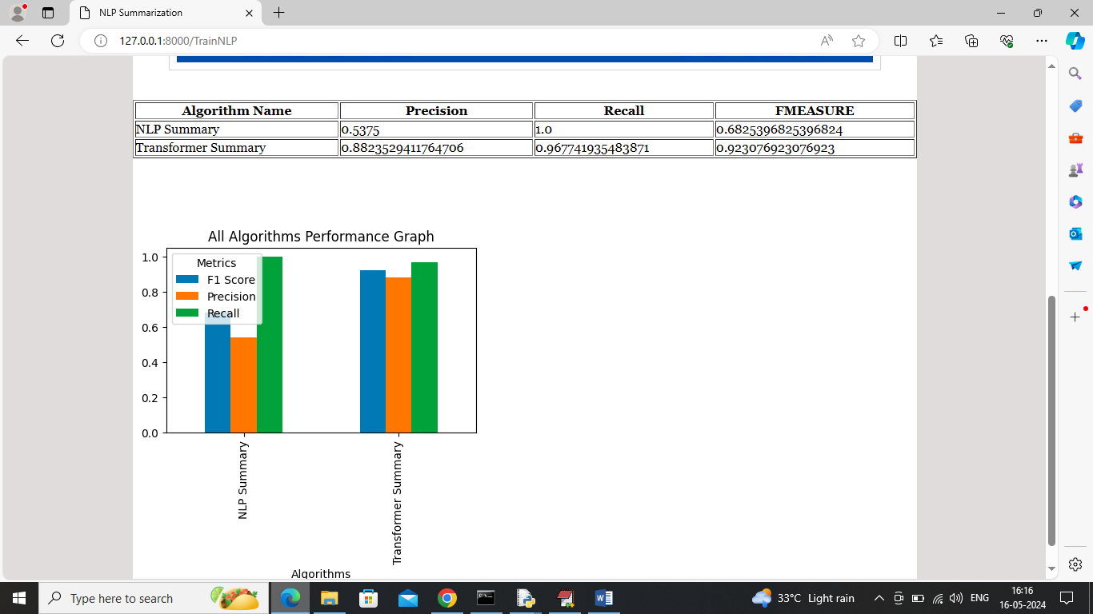

In above screen in tabular format can see comparison between NLP and transformers and can see transformers got better precision and FMEASURE compare to NLP. In above graph x-axis represents algorithm names and y-axis represents precision, recall and FMEASURE in different color bars.

Rest of the execution is same as old code and in above screens we are showing output new Transformer summary algorithm and comparison with NLP.