**Quick Start User Guide**

Please go through System Architecture document to understand detailed functionality of each page.

**View Book**

To check Availability or Non-Availability of the searched book.

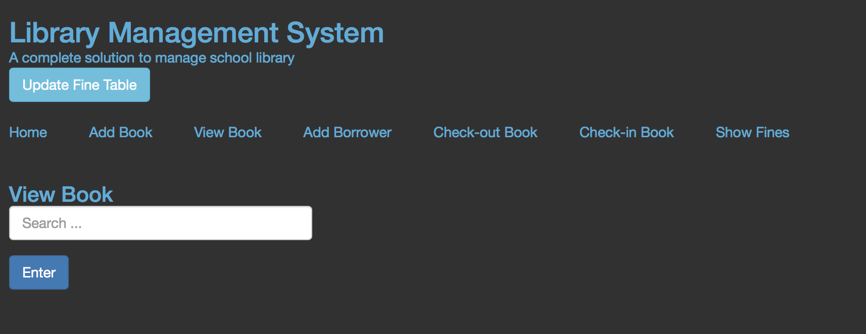

**Add Book (Additionally Functionality)**

To add a new book in the library.

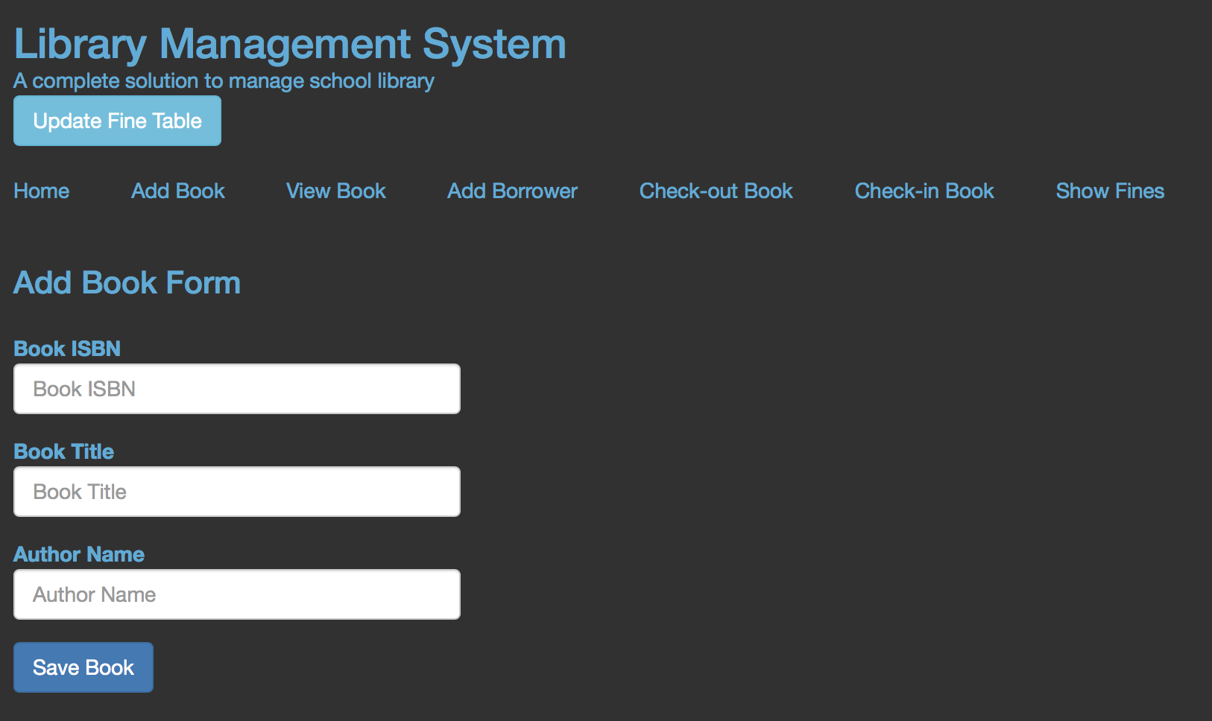

**Add Borrower**

To add borrower details, if a borrower is not present in the system.

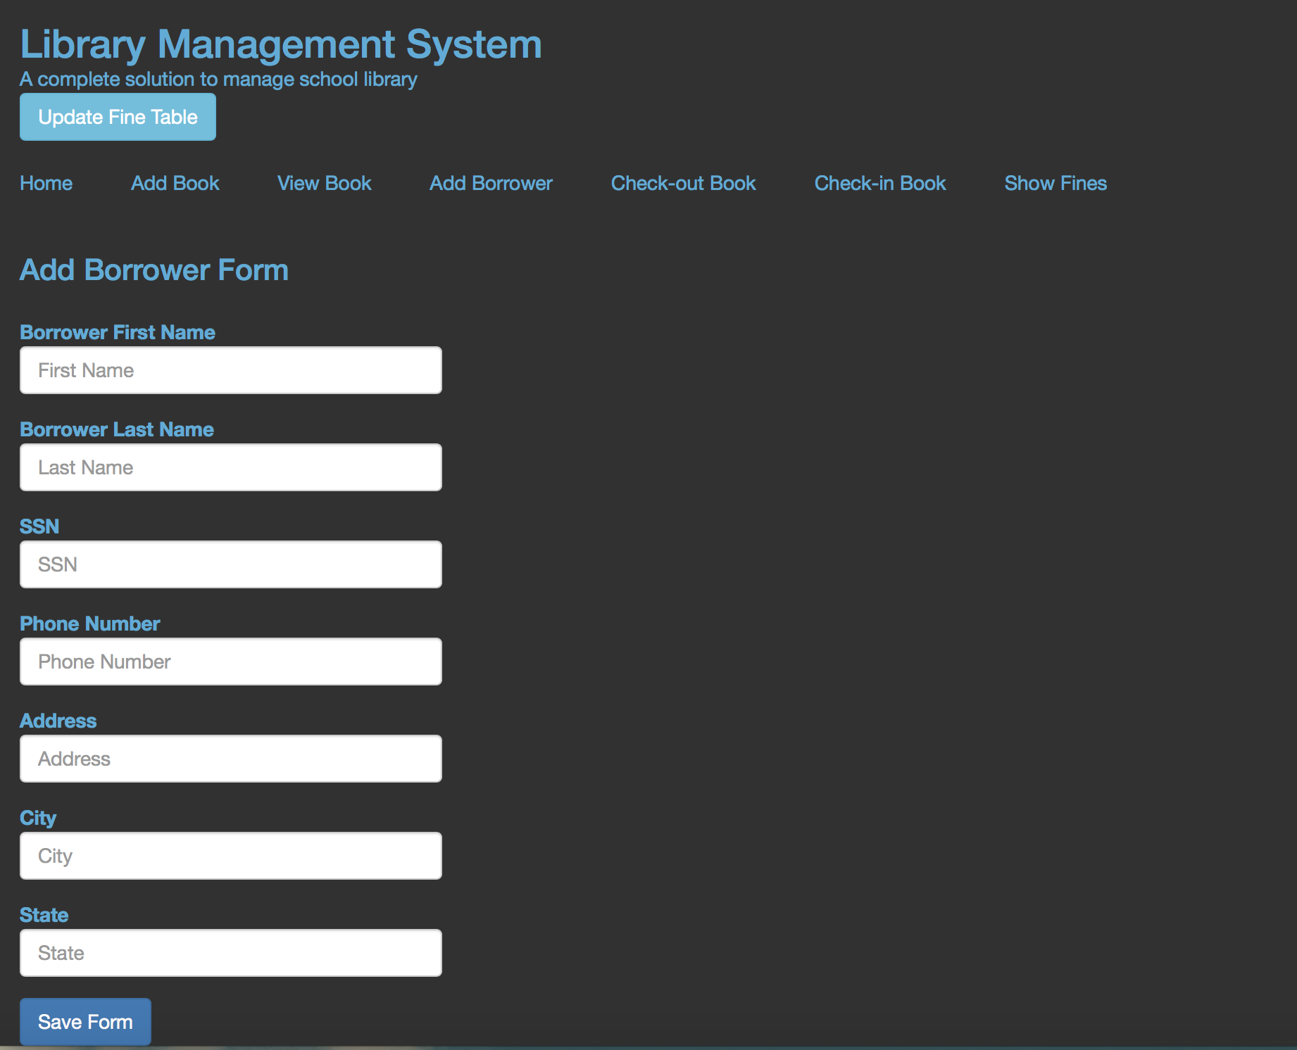

**Checkout-Book**

To checkout a book.

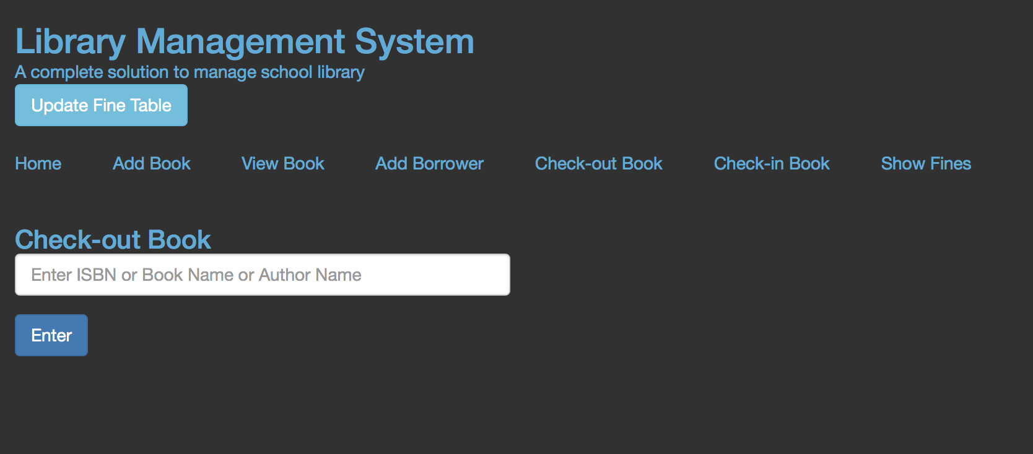

**Check-in Book**

To check-in a book.

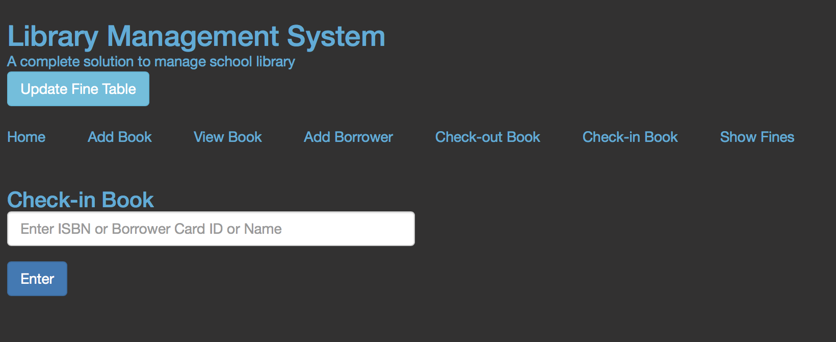

**Show Fines**

Show aggregate fines of each borrower if any. A librarian can click “Show more” to see individual fines.

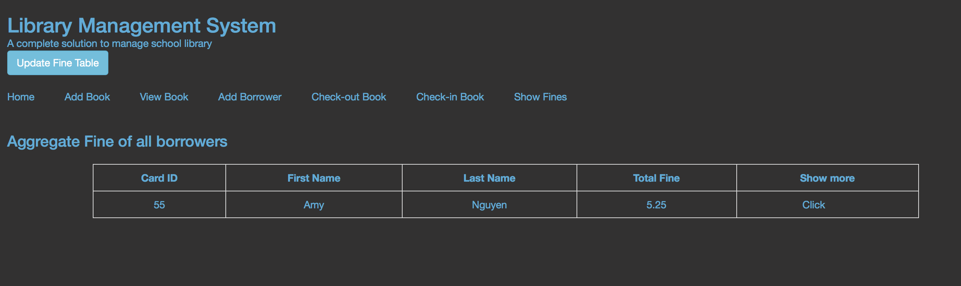

**Update Fine Table**

A trigger to update FINES relation.

