COMET CLUBS
Object Oriented Analysis and Design

Table of Contents
Part I: Use Case Analysis 3
Revision History 4
1. Domain Model 5
2. Use Case Diagrams (UCD) 5
2.1. UCD Level 0 5
2.2. UCD Level 1 5
2.3. UCD Prioritization 5
3. Use Case Descriptions 5
3.1. UC xx 5
3.1.1 UC xx Main Flow 5
3.1.2 UC xx «Includes» 5
3.1.3 UC xx «Extends» 5
3.1.4 UC xx Supplementary Specification 5
3.2. UC yy 5
3.2.1. UC yy Main Flow 5
3.2.2. UC yy «Includes» 5
3.2.3. UC yy «Extends» 5
3.2.4. UC yy Supplementary Specification 5
4. Supplementary Specification 5
5. System Sequence Diagrams 6
6. Operation Contracts 6
Part II: Use Case Design 7
Revision History 8
1. Software Architecture 9
2. Use Case Realizations 9
3. Design Class Diagrams 9
Part III: Implementation 10
Revision History 11

Part I: Use Case Analysis

Version 1.3
Date: 04/20/2018

Version - description | Date | Description | Author
vs 1.0 - Inception draft | 03/30/2018 | Created Domain model and Use Case 0 and 1
Elaboration 1 draft 1 | 04/13/2018 | Updated Domain model and Use Case 0 and 1.  Created Fully Dressed Use Case and Black Box Sequence Diagram
Elaboration 1 draft 2 | 04/20/2018 | Updated Fully Dressed Use Case and Black Box Sequence Diagram.  Created Use Case Realization and Design Class Diagram.

Revision History

Domain Model

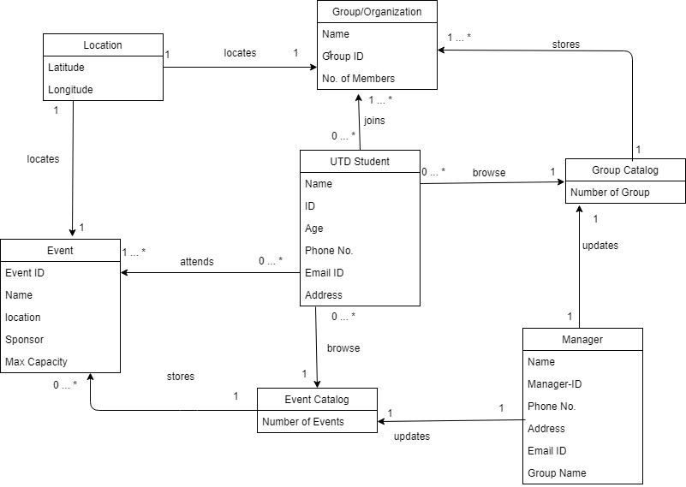

Use Case Diagrams (UCD)

UCD Level 0
2.1.1 Diagram
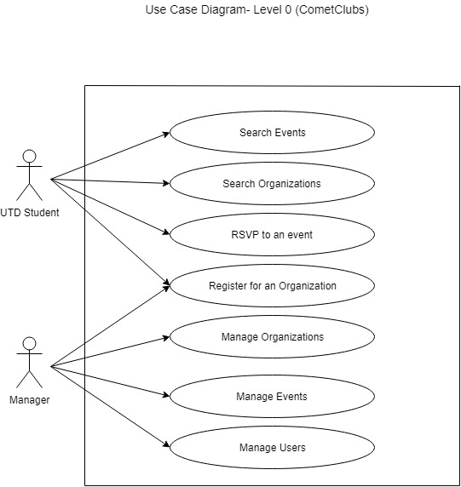

2.1.2 UC Descriptions in brief format

UCD Level 1

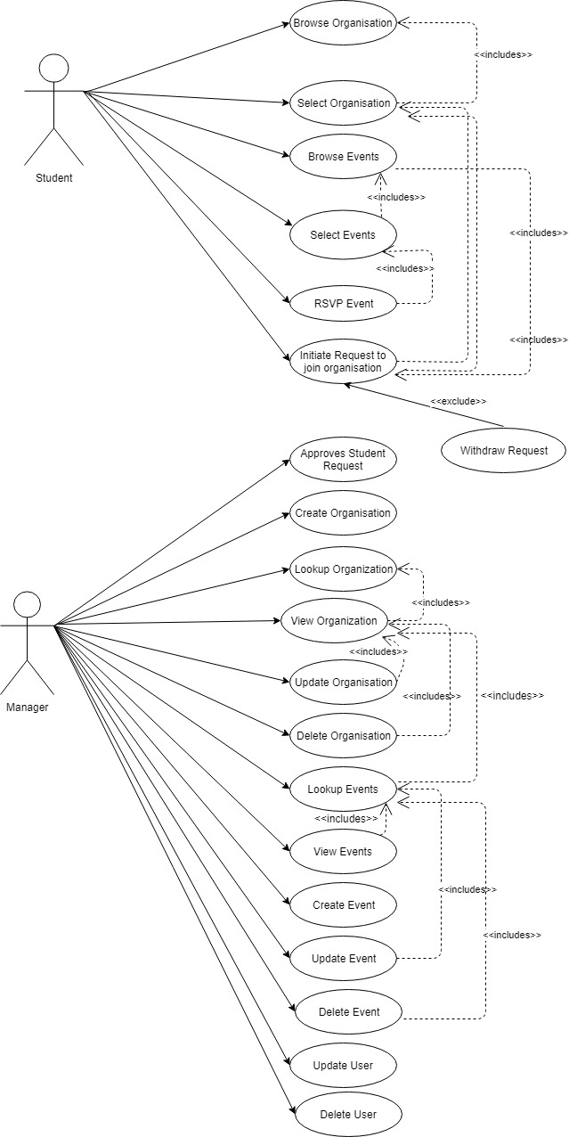

UCD Prioritization (at level 0)

- RSVP to an event
- Register for an organization
- Search Events
- Search Organization
- Manage Organizations
- Manage Events
- Manage Users

Use Case Specifications in Fully Dressed Format

UC

Level 1 UCD for UC 1

Base Use Cases

Use Case: RSVP Event
ID: 1 Type: Base
Brief Description: To initiate a join request for an event.
Primary Actors: UTD Student
Secondary Actors: None
Preconditions: Student has selected a particular event
Main Flow:
1. Include (Select Event)
2. The student clicks on the RSVP button.
3. The system displays success message
Postconditions: The student has RSVP’d to the event.
Alternative Flows: None
Non-Functional Requirements:
- System response time should be less for processing the request.
- It is easier to find the RSVP button.
Technology and Data Variation List:
Open Issues:

«Includes» Use Cases
Use Case: Select Event
ID: 2 Type: Include
Brief Description: To view event details.
Primary Actors: UTD Student
Secondary Actors None
Preconditions: Student has browsed through Organization events
Main Flow:
1. Include (Browse Events)
2. The user clicks on a particular event.
3. The system displays the event details.
Postconditions: The user has viewed the details of a particular event.
Alternative Flows: None
Non-Functional Requirements:
- System response time should be less for processing the request.
- Details are clearly formatted (User friendly).
Technology and Data Variation List:
Open Issues:

«Includes» Use Cases
Use Case : Browse Events
ID:3 Type: Include
Brief Description: To browse events.
Primary Actors: UTD Student
Secondary Actors: None
Preconditions: Student has selected the required Organization
Main Flow:
1. Include (Initiate Request to join Organization)
2. The system displays the event catalog.
Postconditions: The student can scroll through the Organization events.
Alternative Flows: None
Non-Functional Requirements:
- System response time should be less for processing the request.
- Details are clearly formatted (User friendly).
Technology and Data Variation List:
Open Issues:

«Includes» Use Cases
Use Case : Initiate Request to join Organization
ID: 4 Type: Include
Brief Description: To initiate join Organization request.
Primary Actors: UTD Student
Secondary Actors: None
Preconditions: Student has viewed the Organization details
Main Flow:
1. Include (Select Organization)
2. Student clicks on “Join Organization” button
Extension point: cancel request, extension: Withdraw request
Postconditions: Student has joined the Organization
Alternative Flows: None
Non-Functional Requirements:
- System response time should be less for processing the request.
- Details are clearly formatted (User friendly).
Technology and Data Variation List:
Open Issues:

«Includes» Use Cases
Use Case : Select Organization
ID: 6 Type: Include
Brief Description: To view Organization details
Primary Actors: UTD Student
Secondary Actors: None
Preconditions: Student has browsed through Organizations
Main Flow:
1. Include (Browse Organization)
2. User selects an Organization
Postconditions: Student has viewed the Organization details
Alternative Flows: None
Non-Functional Requirements:
- System response time should be less for processing the request.
- Details are clearly formatted (User friendly).
Technology and Data Variation List:
Open Issues:

«Includes» Use Cases
Use Case : Browse Organization
ID: 7 Type: Include
Brief Description: To browse Organization.
Primary Actors: UTD Student
Secondary Actors: None
Preconditions: Student has logged in to the application
Main Flow:
1. Student clicks on the “Browse Organization” tab
2. System displays a list of Organizations
Postconditions: Student is able to scroll through the Organization list.
Alternative Flows: None
Non-Functional Requirements:
- System response time should be less for processing the request.
- Details are clearly formatted (User friendly).
Technology and Data Variation List:
Open Issues:

«Extends» Use Cases
Use Case : Withdraw Request
ID: 5 Type: Extends
Brief Description: Student withdraws request to join Organization
Primary Actors: UTD Student
Secondary Actors: None
Segment 1
Preconditions: Student has successfully submitted request to join Organization
Main Flow:
1. Student clicks on Withdraw request button
Postconditions: Students request to join Organization should be successfully withdrawn
Non-Functional Requirements:
Technology and Data Variation List:
Open Issues:

3.2 Casual description of Use Cases:
- Approves Student Request : The manager selects 'Approve Requests' tab on the dashboard. The system displays a list of requests pending for approval. The manager selects a request. The system displays the request details. The manager clicks on approve button.

- Create Organization : The manager clicks on create organization. The system displays a new form. The manager fills the organization details in the form. The manager clicks on save organization. The system adds the new organization in the catalog and displays the confirmation message.

- Lookup Organization: The manager selects 'browse organization tab. The system displays the a list of organization. The manager scrolls through the organization list.

- View Organization: The manager browses through the organization list. The manager selects a particular organization. The system fetches and displays details of that organization. The manager then clicks on a particular organization and can view the details.

- Update Organization: The Manager browses the organization. The manager selects the particular organization. The system displays organization details. The manager updates organization details. The system saves the updated information.

- Delete Organization: The Manager browses the organization. The manager selects the particular organization. The system displays organization details. The manager clicks on the delete button to delete the selected organization.

- Lookup Events: The manager selects an organization. The system displays the list of events. The manager scrolls through the event list.

- View Events: The manager browses through the events list. The manager selects a particular event. The system fetches and displays details of that event.

- Create Event : The manager clicks on create event. The system displays a new form. The manager fills the event details in the form. The manager clicks on save event button. The system adds the new event in the catalog and displays the confirmation message.

- Update Event : The Manager browses the events. The manager selects the particular event. The system displays the event details. The manager updates event details. The system saves the updated information.

- Delete Event : The Manager browses the event. The manager selects the particular event. The system displays event details. The manager clicks on the delete button to delete the selected event.

- Update User : The Manager browses the users. The manager selects the particular user. The system displays the user details. The manager updates user details.

- Delete User : The Manager searches the user and deletes the user information.

System Supplementary Specification
- Hardware/Software Requirements:
This section lists any design constraints on the system being built.
  - Android Application Requirements
The mobile application requires around 25 MB RAM and 100 MB disk space.
  - Internet Browsers
The web application shall be compliant with any version of Google Chrome, Mozilla Firefox, Safari and Internet Explorer.
  - Android Compliance
The mobile application must be compliant with Android v4 and above.
- Robustness:
The errors in the application will be added in an error log. Fatal errors will result in shutting down of the application. The error log will include all the details regarding type of error, description of the error, details of the device its running and the date and time when the error occurred.
- Usability:
The user interface for every case of use such as event browsing, event rsvp, browsing organizations, adding or removing events shall be designed for users familiar with mobile application in such a way that no additional training will be required for using the application.
- Availability:
The application should be available 24 hours a day, 7 days a week.
- Performance
The system shall support up to 2000 simultaneous users against the application at any given time.

System Sequence Diagrams
    - UC 1 (RSVP Event)
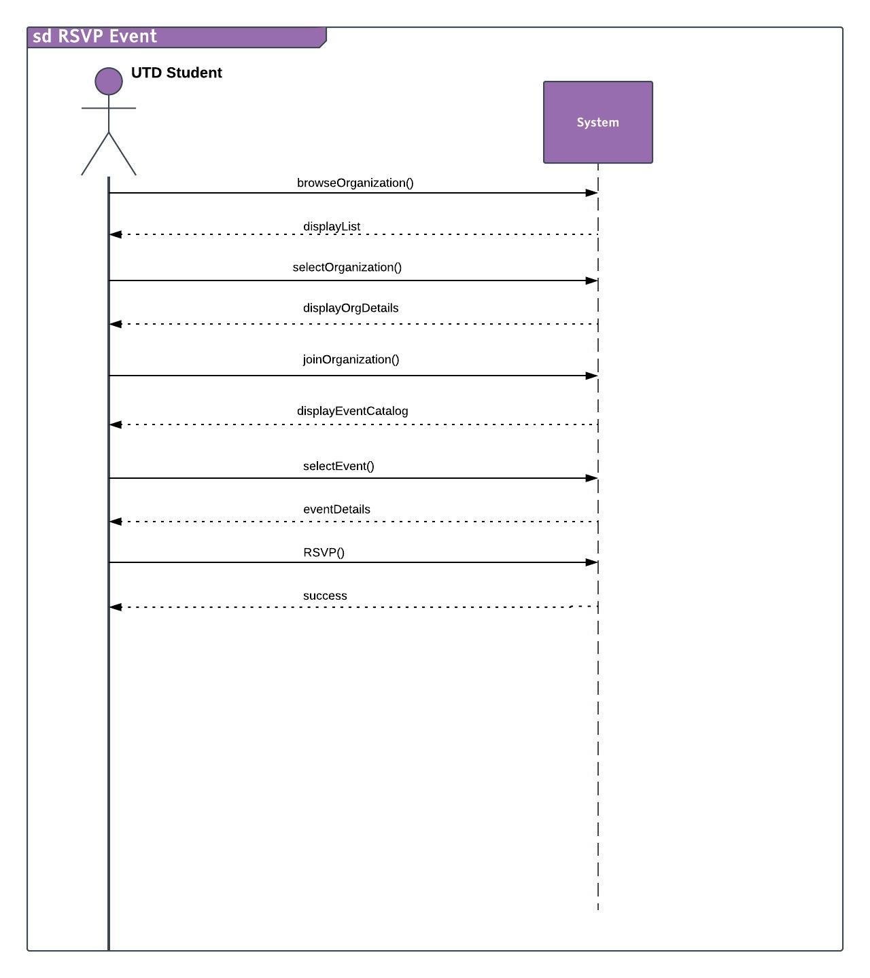

Operation Contracts:

Contract CO1: browseOrganization
Operation : browseOrganization()
Cross References : Browse Organization
Preconditions : UTD Student is logged in
Postconditions : - 1) Organization Catalog instance oc was created.
2) attributes of oc were initialized

Contract CO2: selectOrganization
Operation : selectOrganization()
Cross References : Select Organization
Preconditions : Student is in the process to RSVP for an event
Postconditions : 1) Organization instance o was created (Instance Creation)
- Attributes of o were initialized (attribute modification)

Contract CO3: joinOrganization
Operation : joinOrganization ()
Cross References : Initiate Request to join Organization
Preconditions : Student is in the process to RSVP for an event
Postconditions : 1) Event Catalog instance ec is created (Instance Creation)
2) Attributes of o were updated (attribute modification)
3) ec was associated with instance “o” (association formed)

Contract CO4: selectEvent
Operation : selectEvent()
Cross References : Select Events
Preconditions : Student is in the process to RSVP for an event
Postconditions : 1) Event instance e was created (Instance Creation)
2) attributes of e were initialized (attribute modification)

Contract CO5: RSVP
Operation : RSVP()
Cross References : RSVP Event
Preconditions : Student is in the process to RSVP for an event
Postconditions : 1) attributes of e were initialized (attribute modification)

Part II: Use Case Design

Version X.X
Date

Revision History
Version | Date | Description | Author
1.0 |  | First draft. To be refined primarily during elaboration.
1.4
Elaboration 1 Draft 1
…

Software Architecture

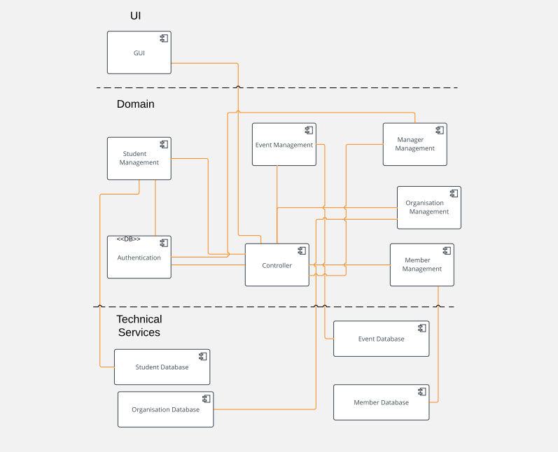

Use Case Realizations

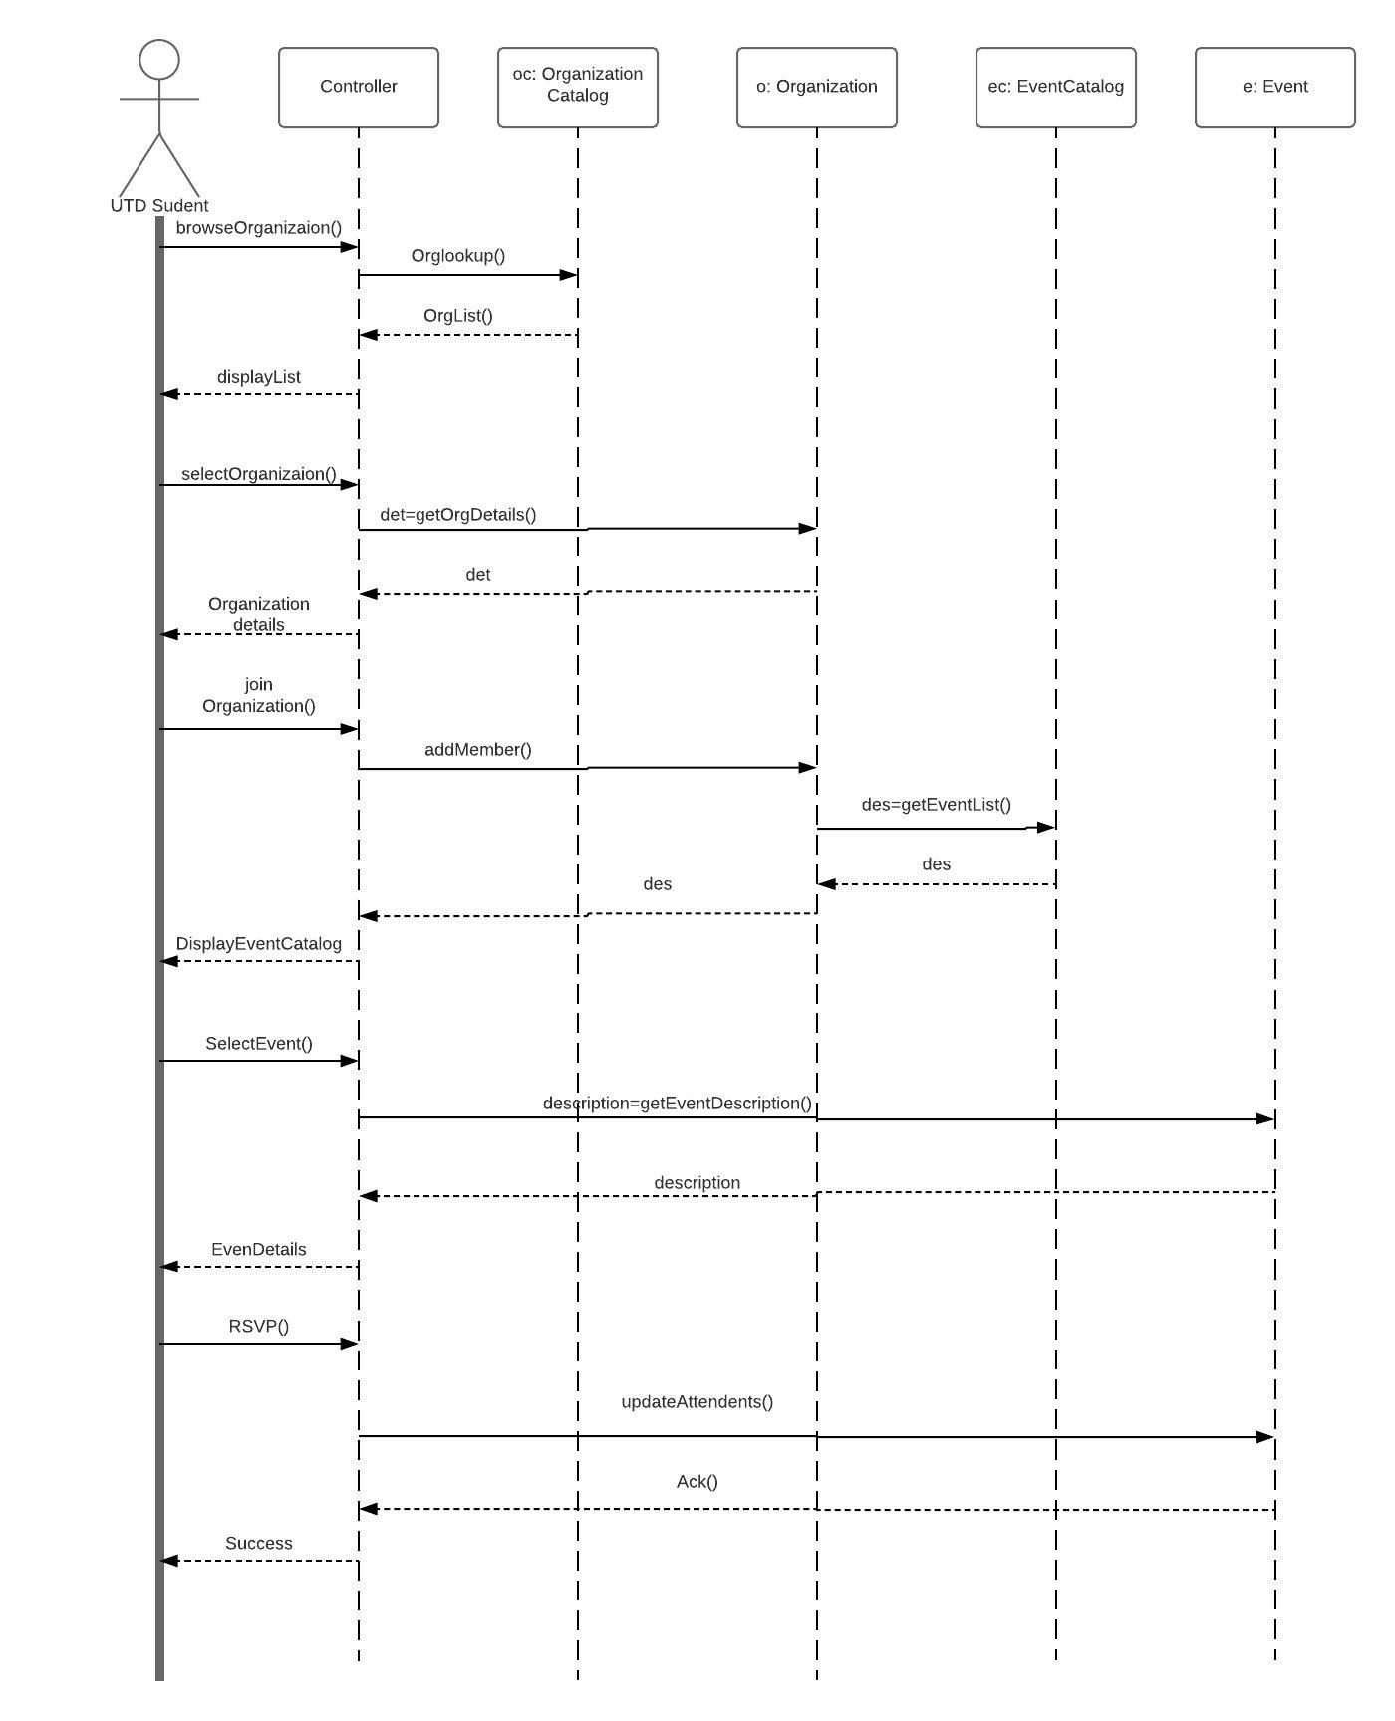

Design Class Diagrams

