API

1-To add Candidates

Url- <http://localhost:50080/candidate/add>

**Method-** Post

**Header-** Content-Type: application/json

**Parameter-**

{

"candidate_uuid":"atestuuidlstrwewillchange",

"candidate_name":"Vinayak Ji",

"candidate_email":"vinayak@gmail.com",

"candidate_address":"Ayodhya"

}

**Response-**

{

"candidate_status": "ACTIVE",

"candidate_is_deleted": "NO",

"_id": "5f6abd89ee74fe4ccc891673",

"candidate_uuid": "atestuuidlstrwewillchange",

"candidate_name": "Vinayak Ji",

"candidate_email": "vinayak@gmail.com",

"candidate_address": "Ayodhya",

"candidate_created_date": "2020-09-23T03:14:17.319Z",

"candidate_updated_date": "2020-09-23T03:14:17.319Z",

"__v": 0

}

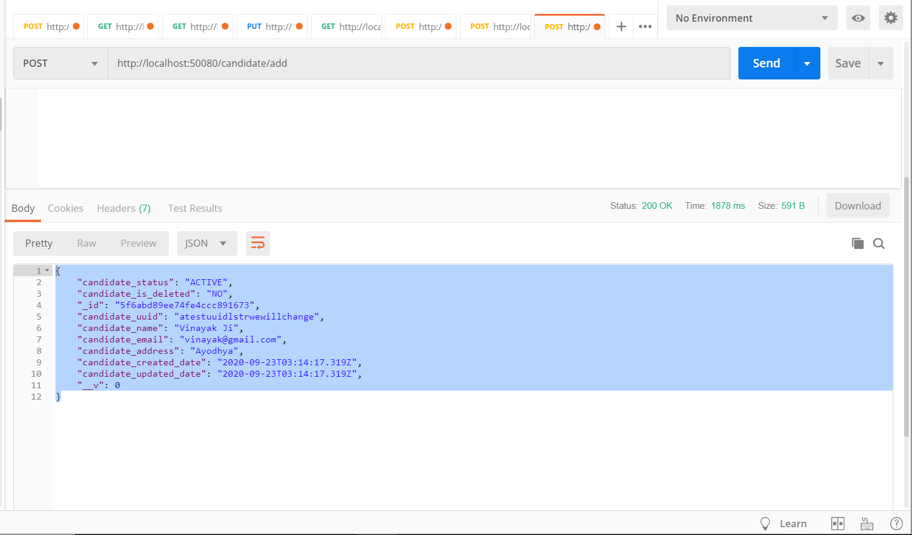

2- To add test score

URL- <http://localhost:50080/testscore/add>

**Method-** Post

**Header-** Content-Type: application/json

**Parameter-**

{

"testscore_uuid":"testuuidchange",

"candidate_uuid":"ram",

"testscore_round_name":"secondround",

"testscore_score":"20"

}

**Response-**

{

"testscore_status": "ACTIVE",

"testscore_is_deleted": "NO",

"_id": "5f6ac4fa5bc9ea53505e5f86",

"testscore_uuid": "testuuidchange",

"candidate_uuid": "ram",

"testscore_round_name": "secondround",

"testscore_created_date": "2020-09-23T03:46:02.398Z",

"testscore_updated_date": "2020-09-23T03:46:02.398Z",

"__v": 0

}

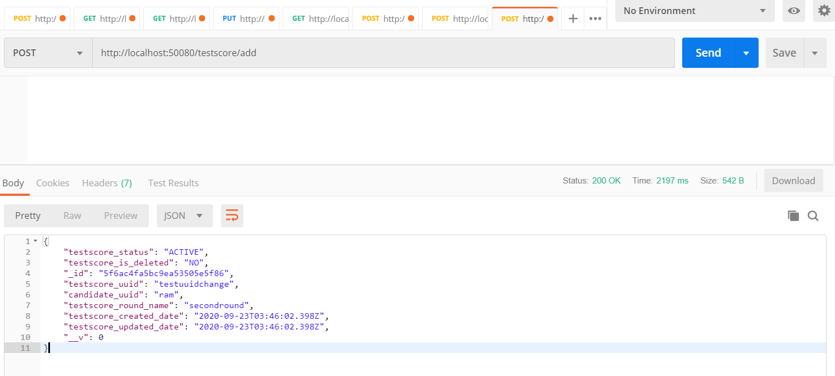

3- List of student score

URL- <http://localhost:50080/testscore/list>

**Method-** GET

**Header-** Content-Type: application/json

**Response-**

[

{

"testscore_status": "ACTIVE",

"testscore_is_deleted": "NO",

"_id": "5f6a3d2209cfe35ff855ec8d",

"testscore_uuid": "dfdsfdsfsdfsdfsdf",

"candidate_uuid": "dsdasdasdasdasd",

"testscore_round_name": "first",

"testscore_created_date": "2020-09-22T18:06:26.585Z",

"testscore_updated_date": "2020-09-22T18:06:26.586Z",

"__v": 0

}]

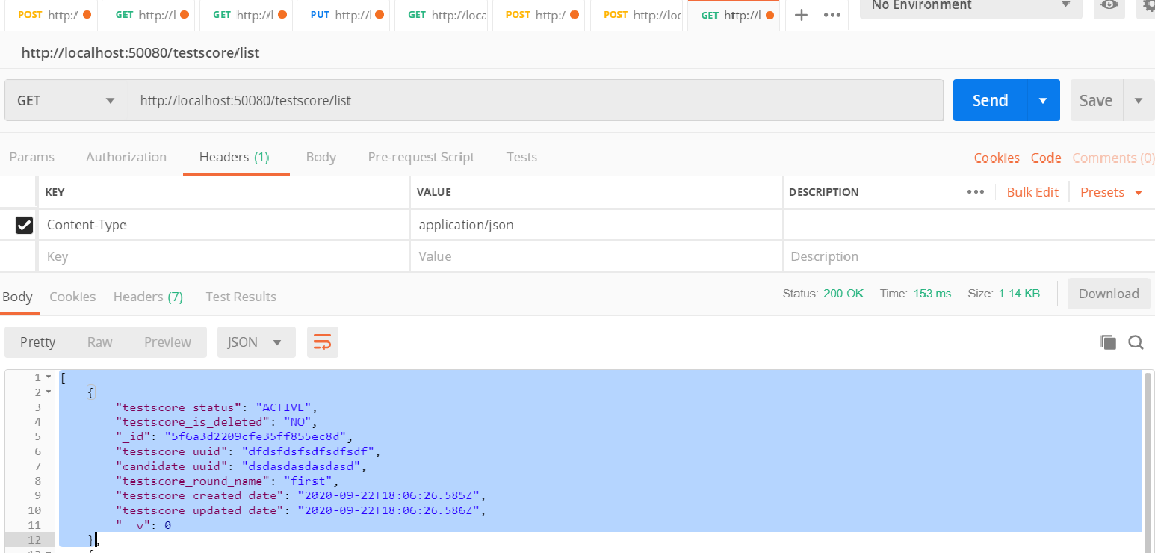

4- Update the record

URL- <http://localhost:50080/testscore/update>

**Method-** Post

**Header-** Content-Type: application/json

**Parameter-**

{

"_id":"5f6add07c690b3311879cdfa",

"testscore_round_name":"first",

"testscore_score": "40"

}

**Response-**

{

"testscore_status": "ACTIVE",

"testscore_is_deleted": "NO",

"_id": "5f6add07c690b3311879cdfa",

"testscore_uuid": "testuuidchange",

"candidate_uuid": "ram",

"testscore_round_name": "first",

"testscore_score": "40",

"testscore_created_date": "2020-09-23T05:28:39.236Z",

"testscore_updated_date": "2020-09-23T05:28:39.237Z",

"__v": 0

}

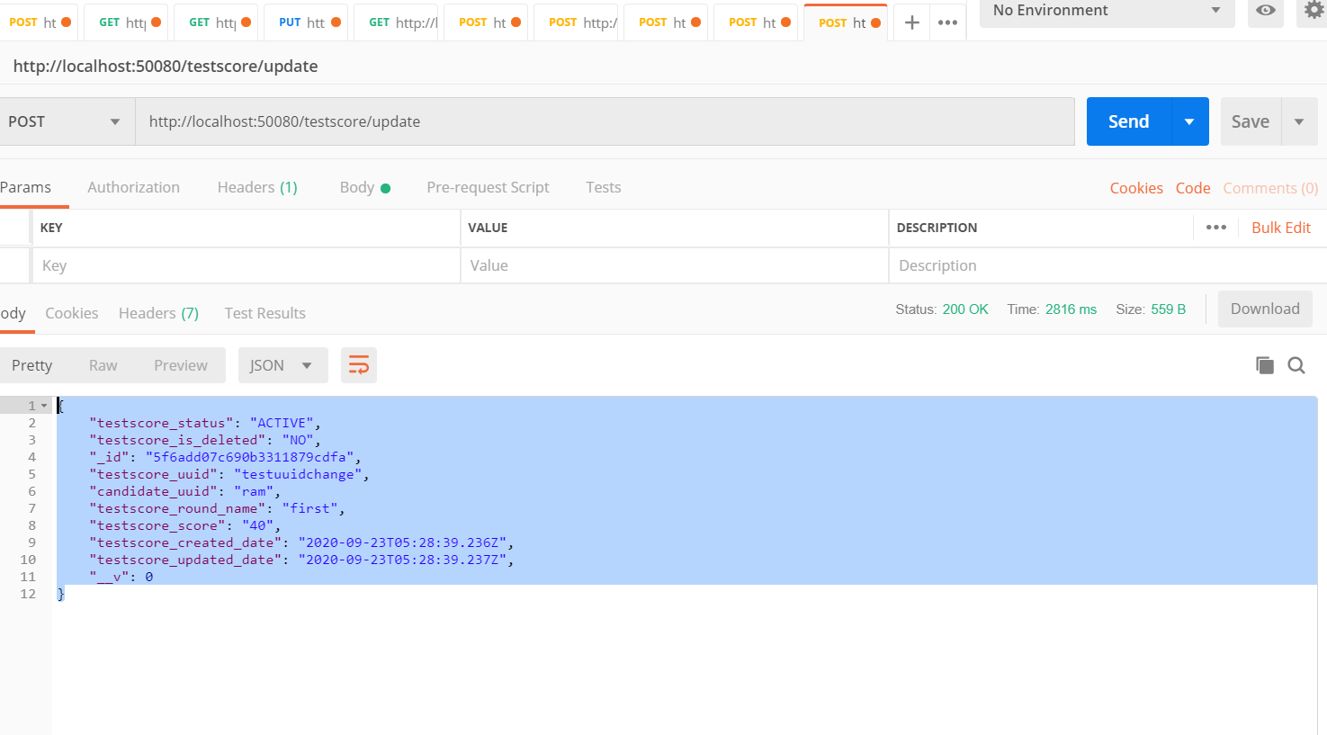

5- Get Test score by Candidate id

URL- <http://localhost:50080/testscore/dsdasdasdasdasd>

**Method-** GET

**Header-** Content-Type: application/json

**Response-**

{

"testscore_status": "ACTIVE",

"testscore_is_deleted": "NO",

"_id": "5f6a3d2209cfe35ff855ec8d",

"testscore_uuid": "dfdsfdsfsdfsdfsdf",

"candidate_uuid": "dsdasdasdasdasd",

"testscore_round_name": "first",

"testscore_created_date": "2020-09-22T18:06:26.585Z",

"testscore_updated_date": "2020-09-22T18:06:26.586Z",

"__v": 0

}

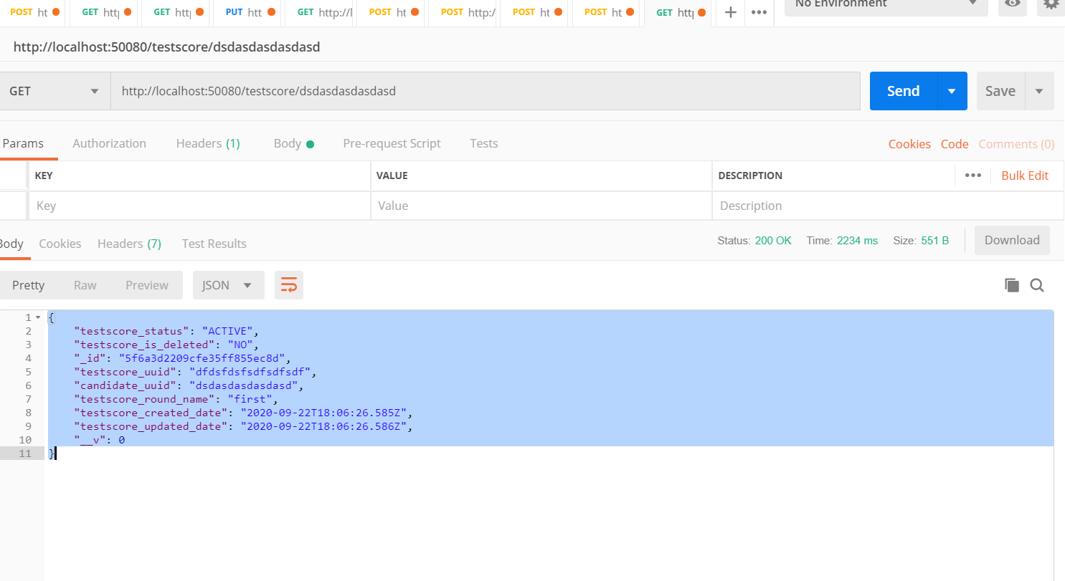

6- Get highest mark

URL- <http://localhost:50080/testscore/highest>

**Method-** GET

**Header-** Content-Type: application/json

**Response-**

[

{

"testscore_status": "ACTIVE",

"testscore_is_deleted": "NO",

"_id": "5f6a3d2209cfe35ff855ec8d",

"testscore_uuid": "dfdsfdsfsdfsdfsdf",

"candidate_uuid": "dsdcvxvcvxcvxvxsdasd",

"testscore_round_name": "second",

"testscore_created_date": "2020-09-22T18:06:26.585Z",

"testscore_updated_date": "2020-09-22T18:06:26.586Z",

"__v": 0,

"testscore_score": 39

}

]

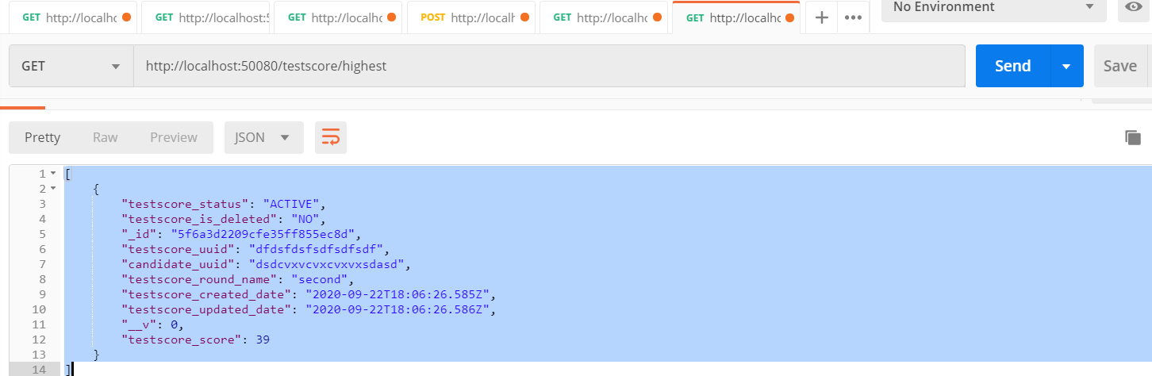

7- Get Average mark

URL- <http://localhost:50080/testscore/average>

**Method-** GET

**Header-** Content-Type: application/json

**Response-**

[

{

"_id": "dsdcvxvcvxcvxvxsdasd",

"average_score": 38.5

},

{

"_id": "ram",

"average_score": 26

}

]

