Remember how we do multiplication?
Start from right to left, perform multiplication on every pair of digits, and add them together. Let's draw the process! From the following draft, we can immediately conclude:
`num1[i] * num2[j]` will be placed at indices `[i + j`, `i + j + 1]`

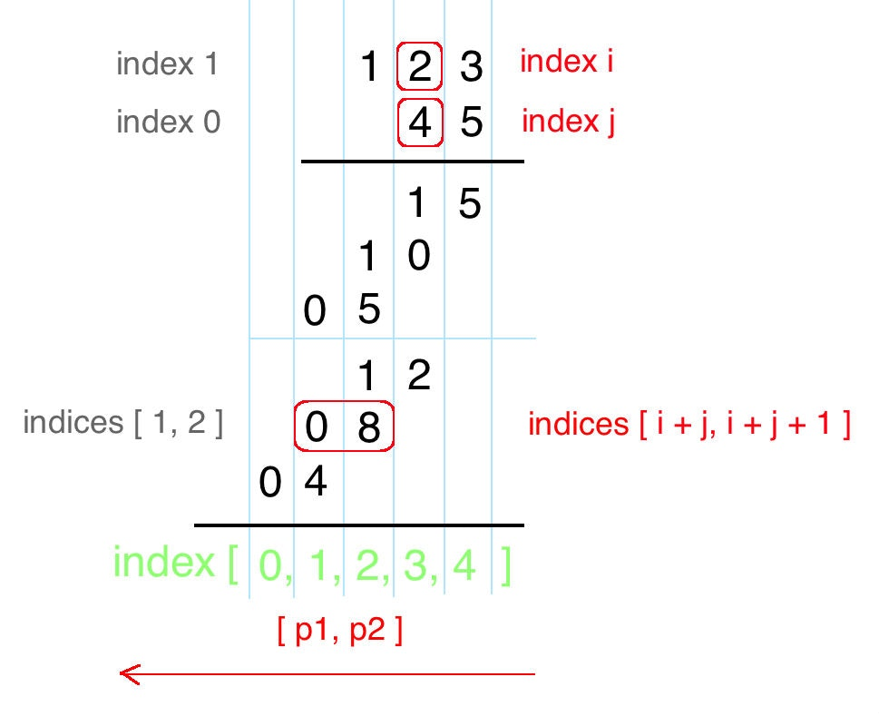

Here is my solution. Hope it helps!
public String multiply(String num1, String num2) {
int m = num1.length(), n = num2.length();
int[] pos = new int[m + n];

for(int i = m - 1; i >= 0; i--) {
for(int j = n - 1; j >= 0; j--) {
int mul = (num1.charAt(i) - '0') * (num2.charAt(j) - '0');
int p1 = i + j, p2 = i + j + 1;
int sum = mul + pos[p2];

pos[p1] += sum / 10;
pos[p2] = (sum) % 10;
}
}

StringBuilder sb = new StringBuilder();
for(int p : pos) if(!(sb.length() == 0 && p == 0)) sb.append(p);
return sb.length() == 0 ? "0" : sb.toString();
}

