**Exercises screenshots**

Name: Varun Raj S

Date: 01/04/2024

1. **Perform the following DB operations using MongoDB.**
2. Create a database “Student” with the following attributes Rollno, Age, ContactNo, Email-id:



1. Insert appropriate values

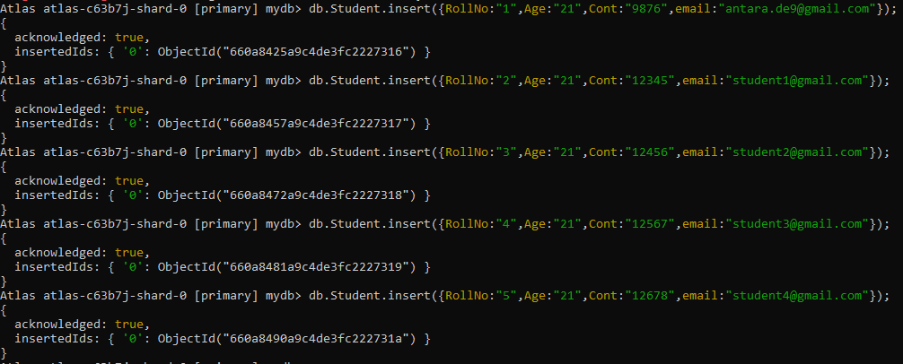

1. Write query to update Email-Id of a student with rollno 10.

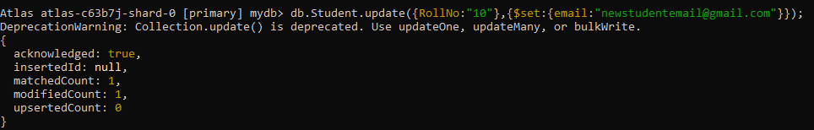

1. Replace the student name from “ABC” to “FEM” of rollno 11:

