**Multiplexer**

A Multiplexer, also known as Mux, is an electronic device primarily used in digital communication systems. It is a combinational circuit that selects one out of multiple input signals and forwards the selected input into a single output line.

The selection of the input signal in a multiplexer is accomplished by controlling the binary value on the selection lines. The number of selection lines determines the number of input lines the multiplexer can accept. For instance, a 2-to-1 multiplexer can accept two input signals and one selection line, while a 4-to-1 multiplexer can accept four input signals and two selection lines.

Multiplexers play a vital role in electronic and communication systems as they come in handy when dealing with limited resources such as limited channels, bandwidth, and data transmission lines. Additionally, they are used in digital circuits as data selectors to create a single data line or to break data streams into multiple lines.

In a nutshell, multiplexers are crucial devices in digital systems as they facilitate the transfer of multiple data streams over a single line, thus reducing the overall complexity of the system while improving its efficiency and speed Advantages and Disadvantages

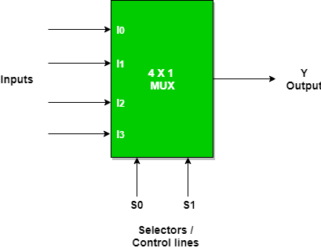

Advantages of Multiplexer:

* Enables combining multiple signals into a single one for transmission and storage
* Increases data transmission efficiency by reducing the number of necessary connections or channels
* Reduces hardware complexity and cost by using lesser number of components
* Streamlines signal routing and switching operations for automated data processing systems

Disadvantages of Multiplexer:

* May increase signal delay or noise due to signal path length, routing, or interference
* May amplify or distort signals if improper selection or setup of signals occurred
* May require more power consumption and cooling due to increased data rates and processing
* May pose security risks if unauthorized access or manipulation of signals occurred

# Applications of Multiplexer

Multiplexers are widely used in various fields and applications due to their advantages. Some of the applications of multiplexers are:

1. Telecommunications: Multiplexers are extensively used in telecommunications to combine multiple signals into a single transmission line, which reduces the number of required connections or channels.

2. Data Storage: Multiplexers enable data storage by combining multiple signals into one and transmitting them to the storage device.

3. Digital Circuits: Digital circuits use multiplexers for various operations such as selecting inputs, routing signals, and creating logic functions.

1. Networking: Multiplexers play a significant role in networking by allowing multiple users to share a communication channel or network.
2. Instrumentation: In instrumentation systems, multiplexers are used for signal selection and routing between different sensors or instruments.

# Techniques of Multiplexing

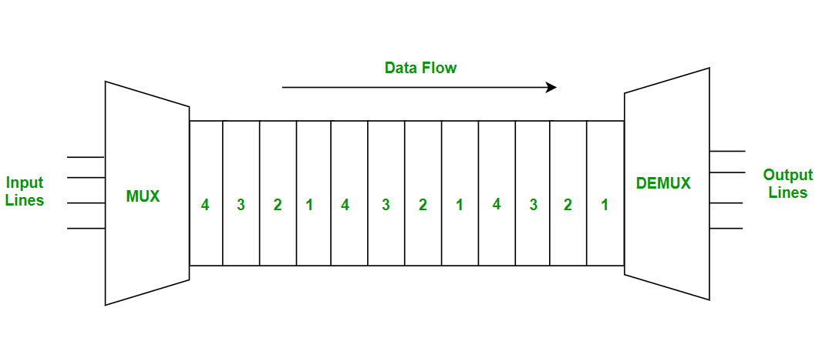**Time Division Multiplexing (TDM)** is a method of transmitting multiple signals simultaneously over a single transmission path by dividing the signal into several time slots. Each time slot is assigned to a different signal, with each signal taking its turn to transmit during its assigned time slot.

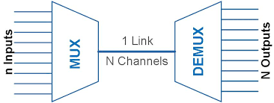**Space Division Multiplexing (SDM)** is a technique in which multiple signals are transmitted simultaneously over different physical paths. This is often used in communication systems that utilize multiple antennae or fiber optic cables.

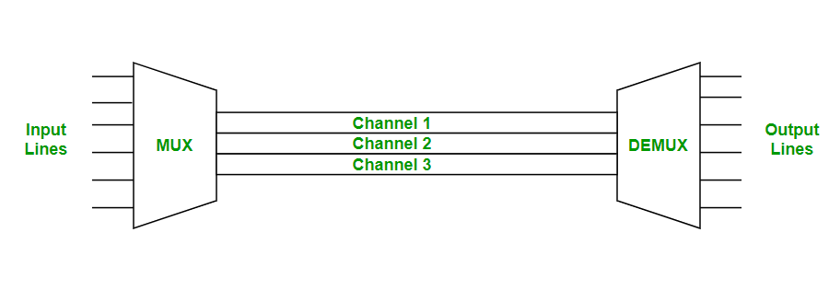**Frequency Division Multiplexing (FDM)** is a technique that divides the available frequency spectrum into multiple channels, with each channel being allocated to a different signal. This technique is commonly used in radio and television broadcasting.

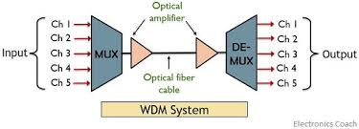**Wavelength Division Multiplexing (WDM)** is a method of multiplexing multiple optical carrier signals onto a single optical fiber by using different wavelengths of light. This technique is commonly used in fiber optic communication systems.

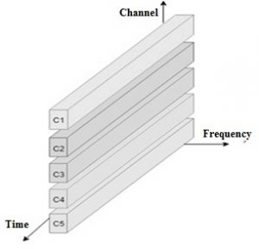**Code Division Multiplexing (CDM)** is a technique for transmitting multiple signals simultaneously over a single transmission path by assigning each signal a unique code. The signals are combined using the codes, and then separated at the receiving end using the same codes.