**Docker Project**

GitHUb Repo: <https://github.com/mmumshad/simple-webapp-flask>

There is a simple web application based on Python Flask. It just prints a message on the screen. Let’s try to deploy this application into a container first and test it. Then dockerize the application.

Here we created a EC2 ubuntu instance and install docker in it. Then docker run ubuntu instance with appending bash command. So that we start ubuntu container to test the application inside it. Then execute all the below commands: enter **exit** and then hit enter. 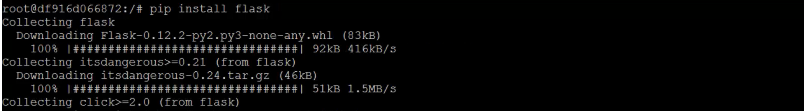Now we can run the webserver using flask command. But we need the source code.

Copy the source code the GitHub repo in **app.py** and put that in **‘/opt/app.py’.**

Source Code: 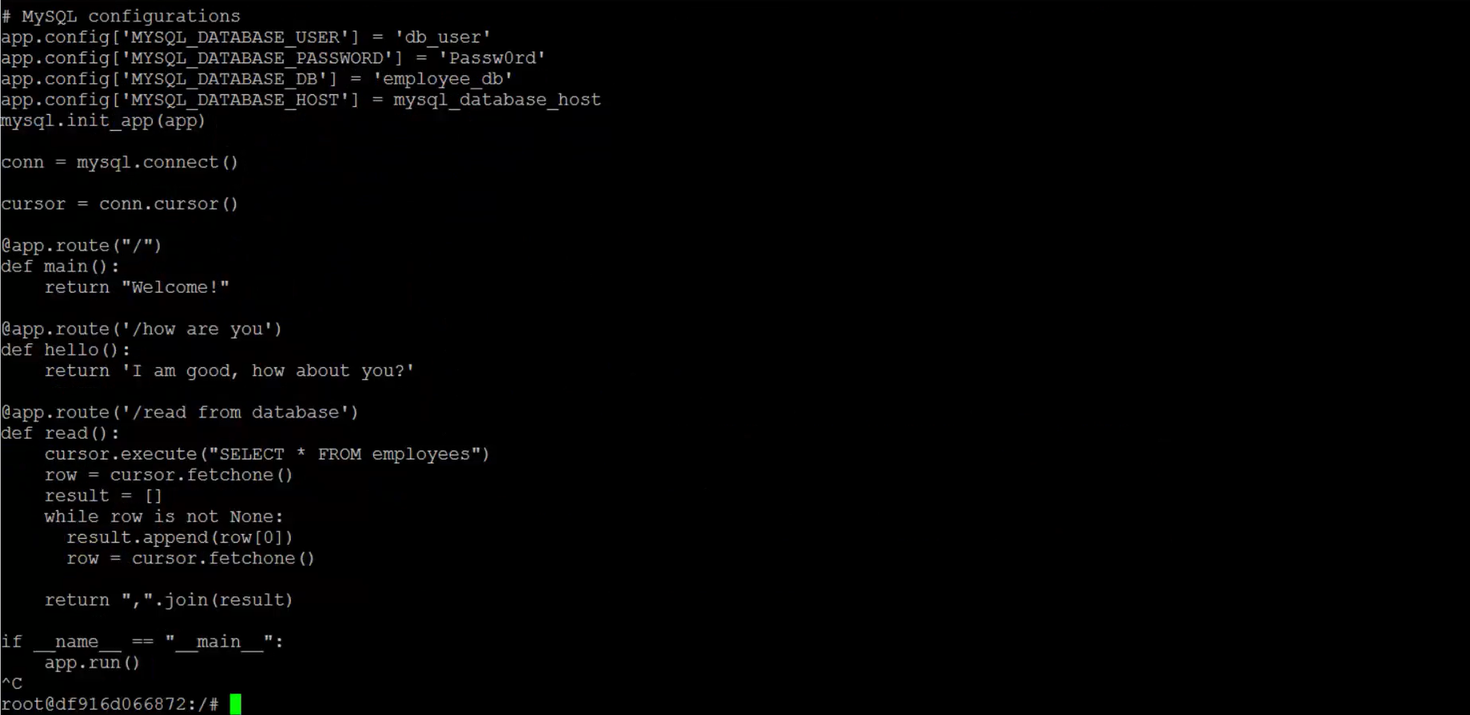Now, the only way to access my application is go to web browser inside the Docker host and access it from web browser inside the host.

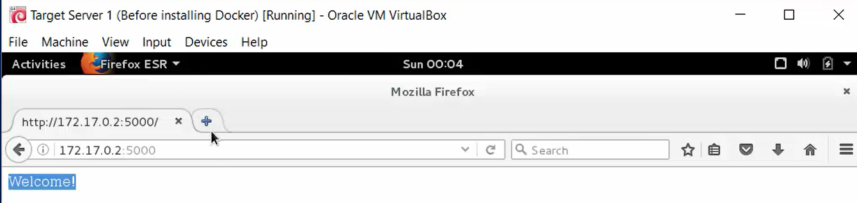This shows app is working. Now check history and copy the commands used to dockerize te deploy of this using image. 

Now, exit from this container. Back to Docker host. Create a folder for your project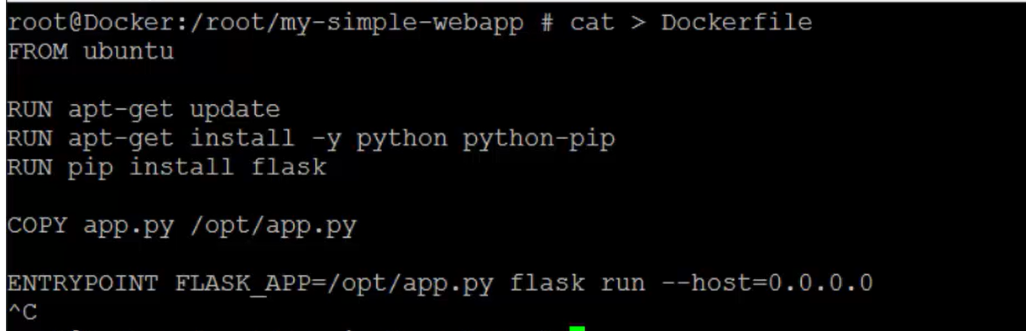Now copy the source code into app.pyPaste the previous source code and then hit enter. Build the docker image using **docker build .**

**Building docker image - **It will start cretaing image. All the steps in docker file are executing one by one. 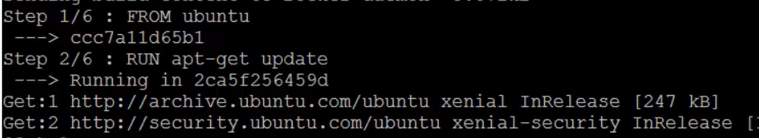Successfully Image is built.

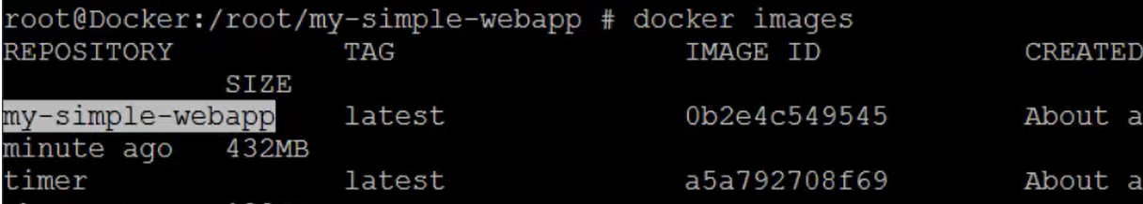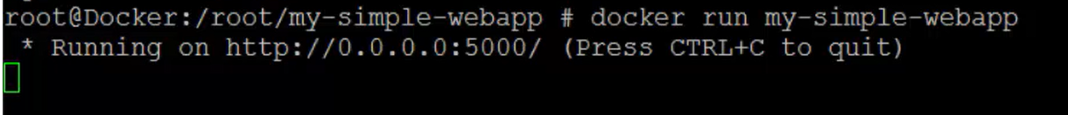App is running and listening on 5000. Open browser in the host. 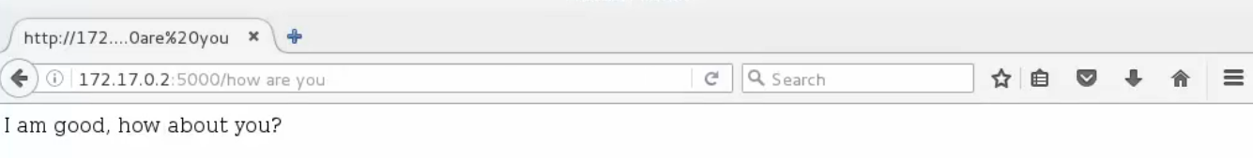You can push this to docker hub account. 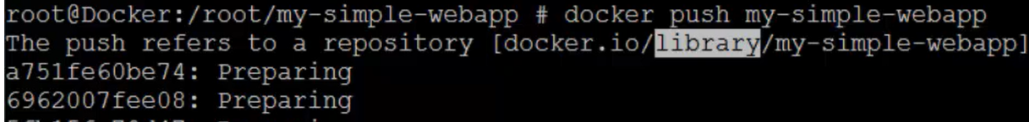But it aks for Login first, enter dockerhub account ID and password. 